Supplementary Table 1. Prior studies that examined the relationship between CYP2D6 metabolic status and personality traits or susceptibility to stress, anxiety, and depression.
Authors | Study Population, Country | CYP2D6 Alleles Tested | Metabolic Classification | Instrument | Main Findings
Suzuki et al. 2003 [1] | First-year nursing students, Japan | *10 | *10/*10 (68) vs *1/*1 (65) and *1/*10 (92) | TCI | No significant differences in TCI subitem scores
Kirchheiner et al. 2006 [2] | Healthy individuals, German | *3-*6, whole-gene duplication | 18 PMs (2 inactive alleles), 80 IMs (1 active allele and 1 inactive allele), 122 EMs (2 active alleles), 2 UMs (>2 active alleles) | NEO-FFI | Higher levels of conscientiousness in female PMs; no significant associations detected for the other personality dimensions
Bijl et al. 2009 [3] | The elderly (aged 55 or older), the Netherlands | *4 | PMs (*4/*4), IM (*1/*4), EMs (*1/*1) | CES-D | *4 homozygotes not prone to depression (major or minor) or anxiety
Iwashima et al. 2007 [4] | Medical students and staff, Japan | *2-*11, *14, *15, *17-*20, *25, *26, *29-*31, *35, *36, *40, *41, *1×N, *2×N, *4×N | 1 PM (2 inactive alleles), 75 IMs (2 reduced-function alleles or 1 reduced- function allele and 1 inactive allele), 262 EMs (1-2 active alleles), 4 UMs (>2 active alleles) | TCI | No significant differences in TCI subitem scores
Bertilsson et al. 1989 [5] | Healthy individuals, Sweden | No genotyping performed; phenotyping based on urinary ratios of debrisoquine / 4-hydroxydebrisoquine | MR >12.6: 45 PMs; 83 EMs | EPQ, KSP | Lower KSP psychasthenia (lack of energy) scores in PMs
Gan et al. 2004 [6] | Otherwise healthy individuals undergoing elective orthopaedic surgery, Malaysia | *3-*5, *9, *10,*17, whole-gene duplication | 13 “slow” metabolisers (*4/*10, *5/*10, *10/*10, *10/*17), 25 IMs (*1/*4, *1/*5, *1/*9, *1/*10), 10 EMs (*1/*1) | Type A and Type B personality | IMs and “slow” metabolisers more likely to exhibit Type B personality
Llerena et al. 1993 [7] | 225 healthy individuals, Spain | Phenotyping based on debrisoquine / 4-hydroxydebrisoquine ratios | MR >12.6: 39 PMs; 129 EMs | KSP | Poor metabolisers more susceptible to anxiety and less socialised
González et al. 2008 [8] | Students and staff from a hospital, Cuba | *3-*6, *10, *17, *1×N, *2×N, *4×N; and phenotyping based on urinary ratios of debrisoquine / 4-hydroxydebrisoquine | 8 PMs (MR >12.6), 65 slow metabolisers (0.77 < MR ≤ 12.6), 113 IMs (0.28 < MR ≤ 0.77), 67 EMs (MR ≤0.28); 6 individuals with no active genes, 67 with 1 active gene, 159 with 2 active genes, 14 with >2 active genes | KSP | Heightened anxiety in PMs
Peñas-LLedó et al. 2009 [9] | Students and staff from a university hospital and medical school, Spain | *3-*6, *10, *17, *1×N, *2×N, *4×N | 11 PMs, 133 EMs | KSP, TCI-Revised, CANTAB, SCL-90-R | Higher levels of KSP impulsiveness in PMs than EMs
Abbreviations: MR, metabolic ratio; PM, poor metaboliser; EM, extensive metaboliser; KSP, Karolinska Scales of Personality; CES-D, Center for Epidemiological Studies Depression Scale; EPQ, Eysenck Personality Questionnaire; NEO-FFI, NEO Five-Factor Inventory; TCI, Temperament and Character Inventory; CANTAB, Cambridge Neuropsychological Test Automated Battery; SCL-90-R, Symptom Checklist-90-Revised
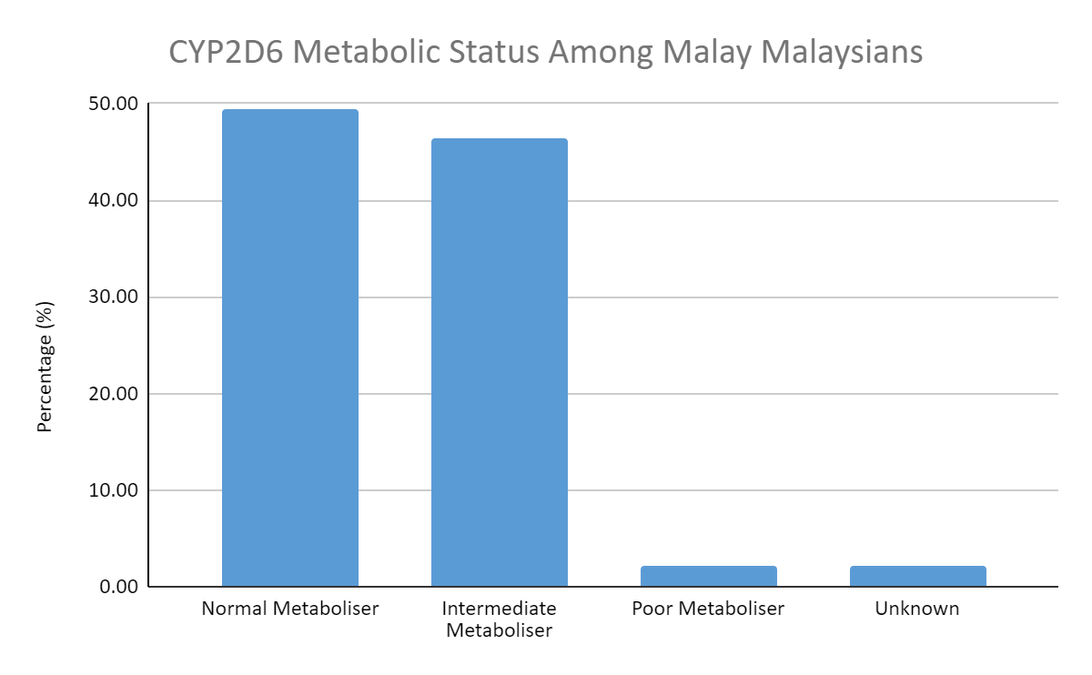
Supplementary Figure 1. By nanopore sequencing (Oxford Nanopore Technologies, UK), CYP2D6 alleles were exhaustively genotyped in a predominantly Malay group of Malaysians (n=95). The metabolic status was assigned according to the following scheme: Activity score >2.25, ultrarapid metaboliser; 1.25-2.25, normal metaboliser; >0 and <1.25, intermediate metaboliser; 0, poor metaboliser. The participants with unknown metabolic status harboured CYP2D6 alleles whose functional significance has not been confirmed.

R code used to perform the linear regression analysis:
Scores <- read.delim(
"F:/Work-related/Coding Practice/Python/icgc_analysis/CYP2D6_Scores.txt",
header = TRUE, sep = "\t")
Scores$Gender <- factor(
Scores$Gender,
levels = c(1, 2),
labels = c("female", "male"))
Scores$BMI <- factor(
Scores$BMI,
levels = c(1, 2, 3, 4),
labels = c("underweight", "normal", "overweight", "obese"))
reg1 <- lm(Depression_Score ~ Activity_Score +
Gender +
Num_Comorbidities +
Age +
BMI,
data = Scores)
summary(reg1)
reg2 <- lm(Anxiety_Score ~ Activity_Score +
Gender +
Num_Comorbidities +
Age +
BMI,
data = Scores)
summary(reg2)
reg3 <- lm(Stress_Score ~ Activity_Score +
Gender +
Num_Comorbidities +
Age +
BMI,
data = Scores)
summary(reg3)

