Table of Contents Graphic
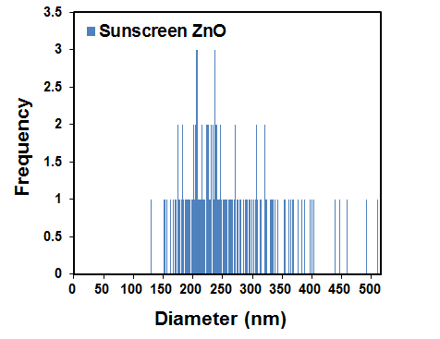




Size distribution




Nanocosmetics
Salesclerks

Oxidative Stress
Brief Summary
Current evidence suggests that the likelihood of harm from the use of sunscreens that contain NPs is low. Sunscreens reduce skin cancer risk, which far outweighs the potential risks of long-term use.

