Tensor-valued diffusion MRI detects brain microstructure changes in HIV infected individuals with cognitive impairment.

Md Nasir Uddin^{1,2,*}, Meera V. Singh^{1, 3}, Abrar Faiyaz⁴, Filip Szczepankiewicz⁵, Markus Nilsson⁶, Zachary D. Boodoo³, Karli R. Sutton³, Madalina E. Tivarus^{7,8}, Jianhui Zhong^{2,7,9}, Lu Wang¹⁰ , Xing Qiu¹⁰, Miriam T. Weber^{1,11}, and Giovanni Schifitto^{1,4,7}

¹ Department of Neurology, University of Rochester, Rochester, NY, USA
² Department of Biomedical Engineering, University of Rochester, Rochester, NY, USA
³ Department of Microbiology and Immunology, University of Rochester, Rochester, NY, USA
⁴ Department of Electrical and Computer Engineering, University of Rochester, Rochester, NY, USA
⁵ Clinical Sciences Lund, Medical Radiation Physics, Lund University, Lund, Sweden
⁶ Clinical Sciences Lund, Diagnostic Radiology, Lund University, Lund, Sweden
⁷ Department of Imaging Sciences, University of Rochester, Rochester, NY, USA
⁸ Department of Neuroscience, University of Rochester, Rochester, NY, USA
⁹ Department of Physics and Astronomy, University of Rochester, Rochester, NY, USA
¹⁰ Department of Biostatistics and Computational Biology, University of Rochester, Rochester, NY, USA
¹¹ Department of Obstetrics and Gynecology, University of Rochester, Rochester, NY, USA

*Address Correspondence to:
Md Nasir Uddin, PhD
Department of Neurology
University of Rochester
601 Elmwood Ave
Rochester, NY 14642
Phone: 585-275-5885
Email: nasir_uddin@urmc.rochester.edu

Supplementary Figure 1: Relationships between Total cognitive scores and b-tensor encoding metrics in four white matter tracts encompassing coherent, crossing, and fanning fibers such as Genu of Corpus Callosum (GCC), Anterior Corona Radiata (ACR), Forceps Minor (FMin), Superior Fronto-Occipital Fasciculus (SFOF).
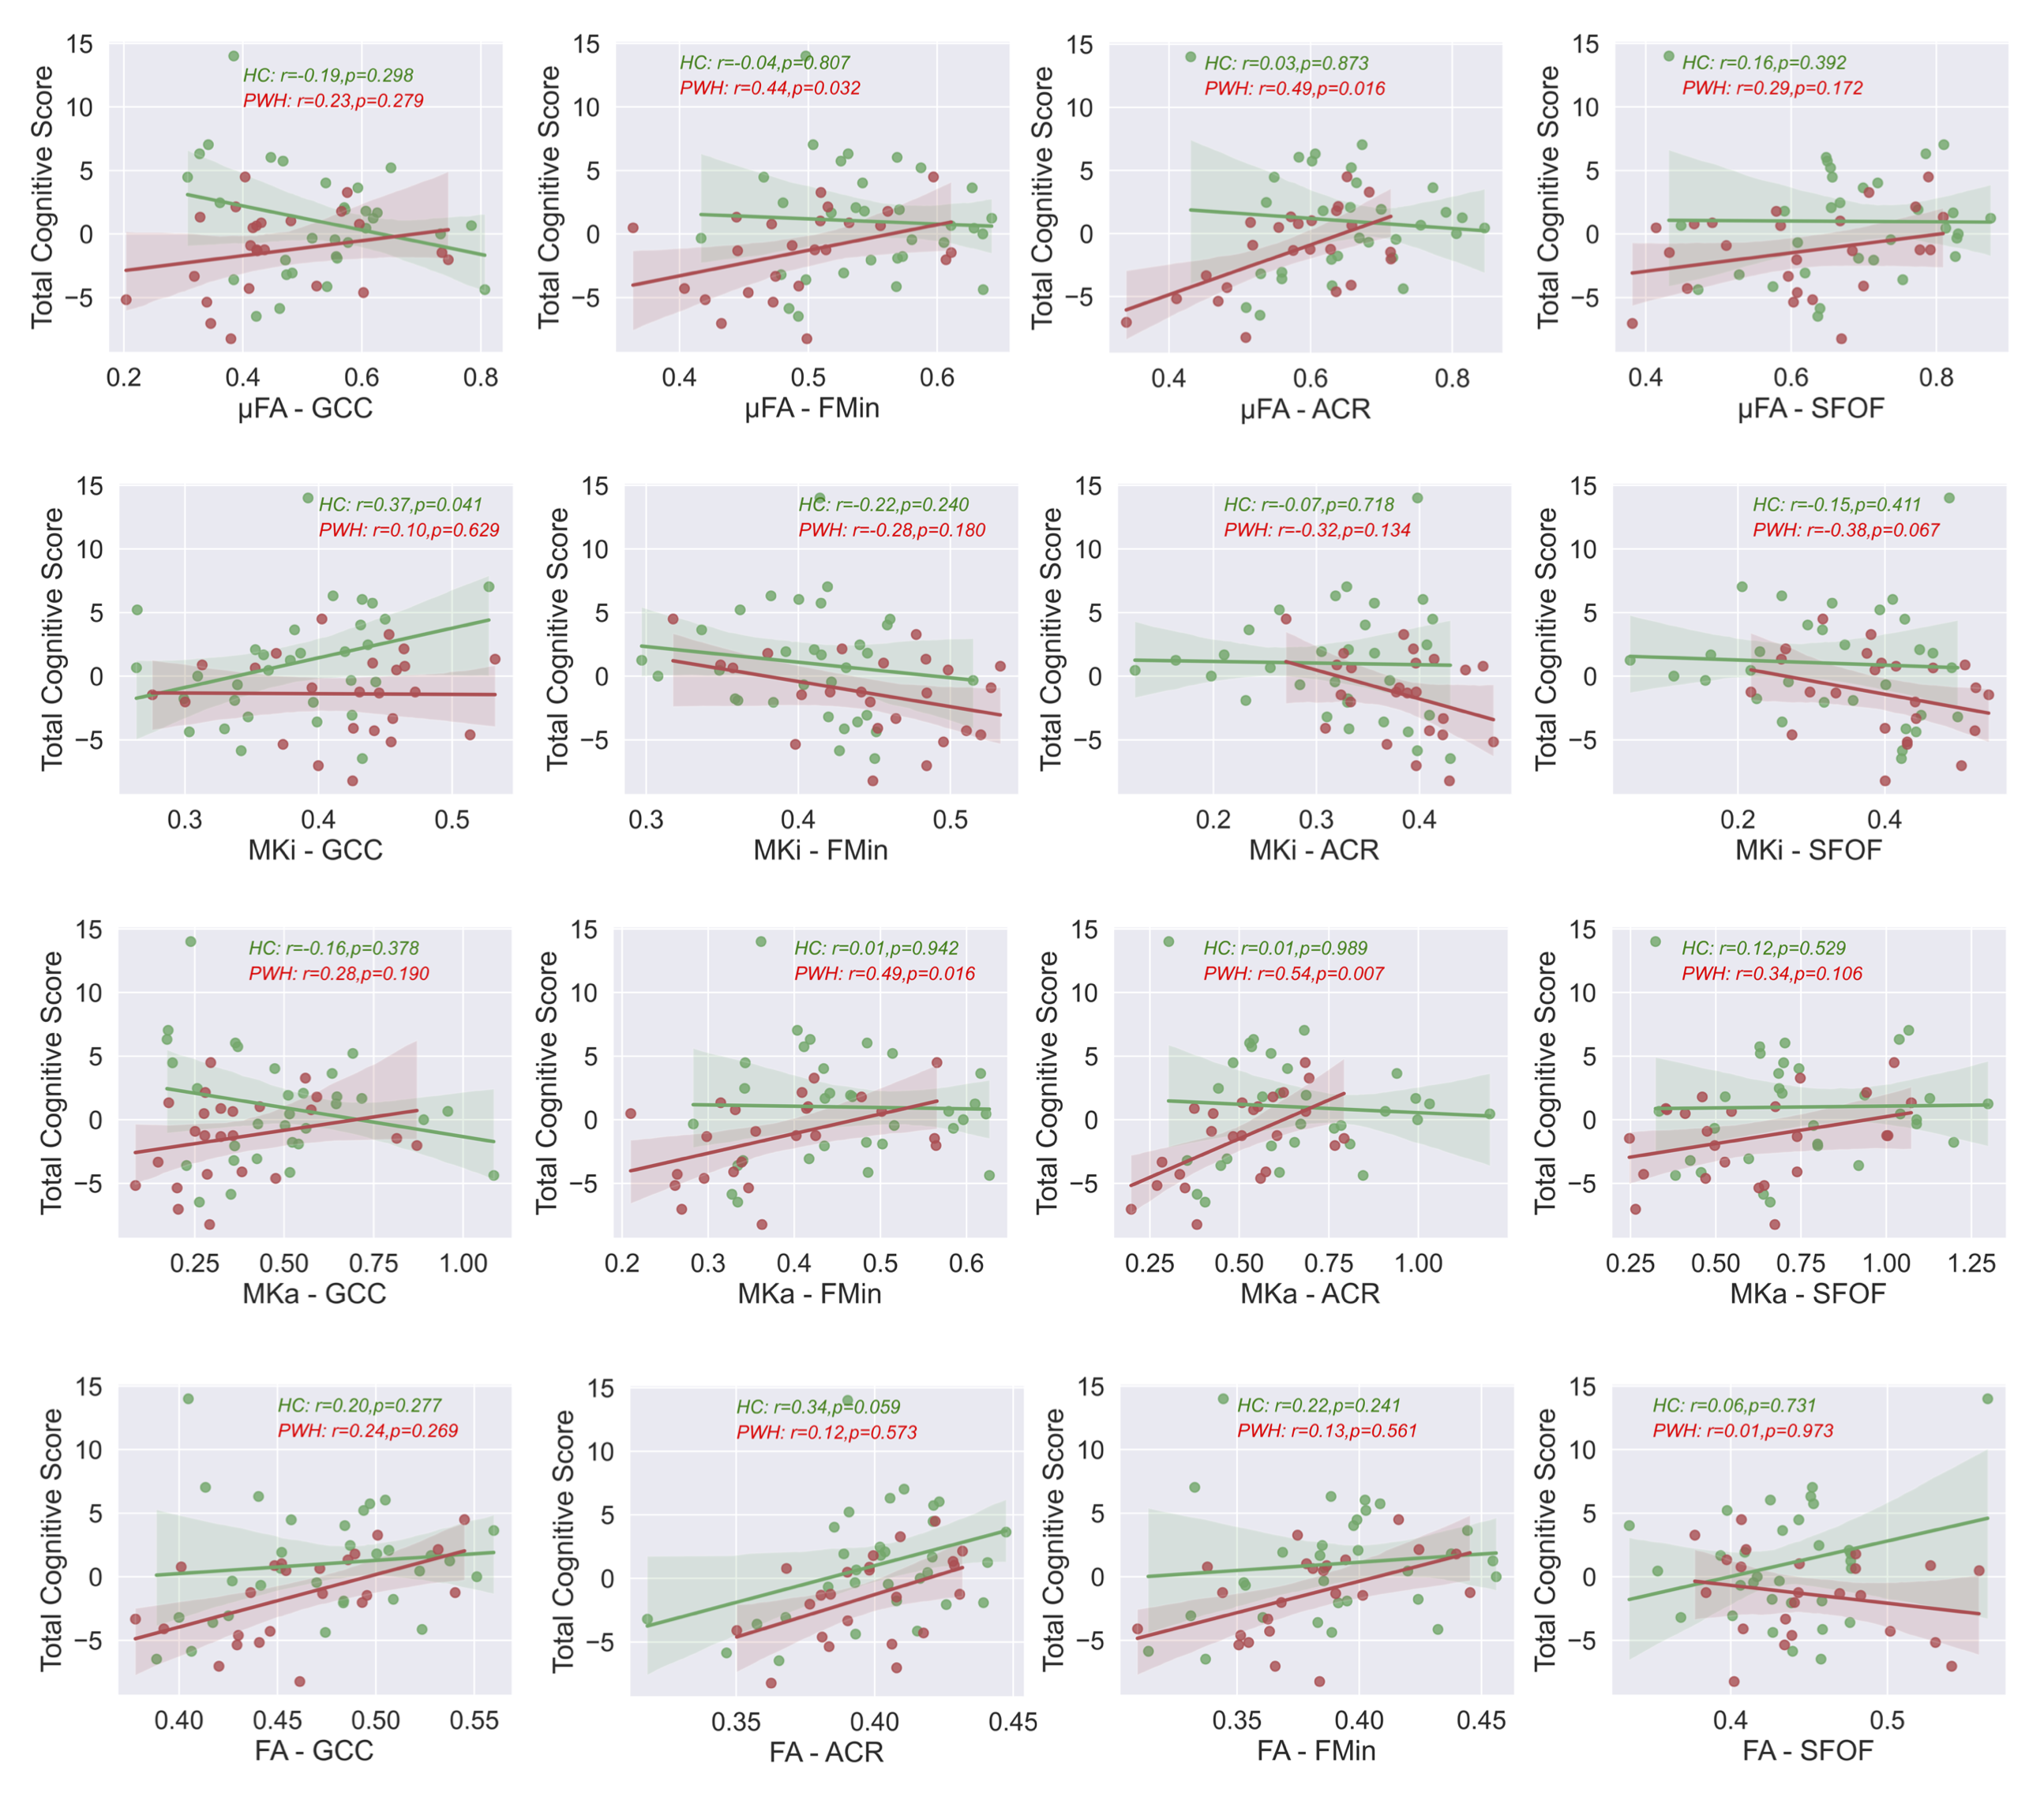

Supplementary Table 1: Spearman correlations between MRI metrics (µFA and FA) and cognitive domain scores.
Spearman | Cohort | µFA vs. EXE | FA vs. EXE | µFA vs. ATT | FA vs. ATT | µFA vs. MOT | FA vs. MOT
GWM | HC | 0.43 (0.014) | 0.13 (0.497) | 0.32 (0.082) | 0.19 (0.315) | 0.46 (0.008) | 0.09 (0.627)
GWM | PWH | 0.63 (0.001) | 0.58 (0.004) | 0.45 (0.025) | 0.11 (0.605) | 0.69 (0.000) | 0.54 (0.007)
CGM | HC | 0.19 (0.304) | 0.25 (0.162) | 0.26 (0.156) | 0.39 (0.030) | 0.31 (0.093) | 0.27 (0.135)
CGM | PWH | 0.62 (0.001) | 0.54 (0.008) | 0.49 (0.015) | 0.37 (0.079) | 0.50 (0.013) | 0.42 (0.043)
SGM | HC | 0.47 (0.007) | 0.04 (0.839) | 0.32 (0.081) | 0.09 (0.240) | 0.38 (0.032) | 0.05 (0.789)
SGM | PWH | 0.57 (0.003) | 0.41 (0.053) | 0.59 (0.002) | 0.24 (0.270) | 0.49 (0.013) | 0.14 (0.513)
Bold font indicates correlations that were statistically significant. EXE: executive function; ATT: Attention; MOT: Motor skills; GWM: Global white matter; CGM: Cortical gray matter; SGM: Subcortical gray matter.

Supplementary Table 2: Two-Way ANOVA to measure the effects of imaging metrics, HIV status, and their interactions on executive functioning scores.
B-tensor encoding metrics vs. Executive Function Z score |  | µFA |  |  |  | MKi |  |  |  | MKa
 |  | Estimate | Std. Error | t value | Pr(>|t|) | Estimate | Std. Error | t value | Pr(>|t|) | Estimate | Std. Error | t value | Pr(>|t|)
Global White Matter  (GWM) | Intercept | -5.54 | 1.85 | -3.00 | 0.004 | 2.81 | 0.91 | 3.08 | 0.003 | -2.81 | 0.91 | -3.10 | 0.003
Global White Matter  (GWM) | GWM | 8.23 | 2.78 | 2.96 | 0.005 | -8.36 | 2.60 | -3.22 | 0.002 | 3.87 | 1.27 | 3.05 | 0.004
Global White Matter  (GWM) | HIV Status | -0.27 | 2.62 | -0.10 | 0.919 | 0.89 | 1.44 | 0.62 | 0.539 | -0.21 | 1.30 | -0.16 | 0.871
Global White Matter  (GWM) | HIV-GWM interaction | 0.69 | 4.03 | 0.17 | 0.865 | -2.07 | 3.97 | -0.52 | 0.604 | 0.55 | 1.89 | 0.29 | 0.773
Cortical Gray Matter  (CGM) | Intercept | -3.09 | 2.25 | -1.37 | 0.176 | 3.42 | 1.65 | 2.07 | 0.043 | -1.27 | 1.06 | -1.20 | 0.237
Cortical Gray Matter  (CGM) | CGM | 5.56 | 4.17 | 1.34 | 0.188 | -8.01 | 3.75 | -2.14 | 0.038 | 2.59 | 2.29 | 1.13 | 0.265
Cortical Gray Matter  (CGM) | HIV Status | -5.11 | 3.42 | -1.50 | 0.14 | 4.54 | 2.79 | 1.63 | 0.109 | -2.33 | 1.63 | -1.43 | 0.16
Cortical Gray Matter  (CGM) | HIV-CGM Interaction | 9.73 | 6.39 | 1.52 | 0.134 | -10.25 | 6.28 | -1.63 | 0.109 | 5.17 | 3.58 | 1.44 | 0.155
Subcortical Gray Matter  (SGM) | Intercept | -3.27 | 1.32 | -2.48 | 0.017 | 4.16 | 1.32 | 3.16 | 0.003 | -1.78 | 0.70 | -2.55 | 0.014
Subcortical Gray Matter  (SGM) | SGM | 5.80 | 2.39 | 2.43 | 0.019 | -10.12 | 3.11 | -3.25 | 0.002 | 3.26 | 1.31 | 2.49 | 0.016
Subcortical Gray Matter  (SGM) | HIV Status | -4.03 | 2.63 | -1.54 | 0.131 | 1.73 | 2.54 | 0.68 | 0.500 | -1.33 | 1.34 | -0.99 | 0.326
Subcortical Gray Matter  (SGM) | HIV-SGM Interaction | 7.34 | 4.79 | 1.53 | 0.132 | -3.81 | 5.90 | -0.65 | 0.522 | 2.27 | 2.47 | 0.92 | 0.363

Supplementary Table 3: Two-Way ANOVA to measure the effects of imaging metrics, HIV status, and their interactions on attention scores.

 |  | µFA |  |  |  | MKi |  |  |  | MKa
B-tensor encoding metrics vs. Attention Function Z score |  | Estimate | Std. Error | t value | Pr(>|t|) | Estimate | Std. Error | t value | Pr(>|t|) | Estimate | Std. Error | t value | Pr(>|t|)
Global White Matter  (GWM) | Intercept | -4.91 | 1.97 | -2.50 | 0.016 | 2.12 | 1.01 | 2.11 | 0.040 | -2.30 | 0.97 | -2.36 | 0.022
Global White Matter  (GWM) | GWM | 7.19 | 2.96 | 2.43 | 0.019 | -6.56 | 2.87 | -2.29 | 0.026 | 3.05 | 1.36 | 2.24 | 0.030
Global White Matter  (GWM) | HIV Status | 2.52 | 2.79 | 0.90 | 0.372 | -0.58 | 1.59 | -0.36 | 0.718 | 0.84 | 1.40 | 0.61 | 0.548
Global White Matter  (GWM) | HIV-GWM interaction | -3.35 | 4.29 | -0.78 | 0.439 | 2.49 | 4.38 | 0.57 | 0.572 | -0.76 | 2.03 | -0.37 | 0.711
Cortical Gray Matter  (CGM) | Intercept | -5.29 | 2.24 | -2.36 | 0.022 | 4.31 | 1.67 | 2.58 | 0.013 | -2.00 | 1.04 | -1.91 | 0.061
Cortical Gray Matter  (CGM) | CGM | 9.53 | 4.14 | 2.30 | 0.025 | -10.19 | 3.79 | -2.69 | 0.010 | 4.03 | 2.25 | 1.79 | 0.079
Cortical Gray Matter  (CGM) | HIV Status | -0.07 | 3.39 | -0.02 | 0.984 | 1.29 | 2.82 | 0.46 | 0.648 | -0.82 | 1.60 | -0.51 | 0.612
Cortical Gray Matter  (CGM) | HIV-CGM Interaction | 0.73 | 6.35 | 0.12 | 0.909 | -2.34 | 6.36 | -0.37 | 0.715 | 2.37 | 3.51 | 0.67 | 0.503
Subcortical Gray Matter  (SGM) | Intercept | -2.36 | 1.34 | -1.76 | 0.084 | 2.57 | 1.41 | 1.82 | 0.074 | -1.31 | 0.72 | -1.82 | 0.075
Subcortical Gray Matter  (SGM) | SGM | 4.03 | 2.43 | 1.66 | 0.103 | -6.49 | 3.34 | -1.94 | 0.057 | 2.22 | 1.35 | 1.65 | 0.104
Subcortical Gray Matter  (SGM) | HIV Status | -4.15 | 2.67 | -1.55 | 0.127 | 1.41 | 2.73 | 0.52 | 0.606 | -1.15 | 1.37 | -0.84 | 0.404
Subcortical Gray Matter  (SGM) | HIV-SGM Interaction | 8.00 | 4.87 | 1.64 | 0.107 | -2.62 | 6.33 | -0.42 | 0.680 | 2.44 | 2.53 | 0.96 | 0.34

Supplementary Table 4: Two-Way ANOVA to measure the effects of imaging metrics, HIV status, and their interactions on motor scores.
 |  | µFA |  |  |  | MKi |  |  |  | MKa
B-tensor encoding metrics vs. Motor Function Z score |  | Estimate | Std. Error | t value | Pr(>|t|) | Estimate | Std. Error | t value | Pr(>|t|) | Estimate | Std. Error | t value | Pr(>|t|)
Global White Matter  (GWM) | Intercept | -5.57 | 1.82 | -3.06 | 0.004 | 2.75 | 0.96 | 2.88 | 0.006 | -2.74 | 0.90 | -3.04 | 0.004
Global White Matter  (GWM) | GWM | 8.65 | 2.74 | 3.16 | 0.003 | -7.46 | 2.72 | -2.75 | 0.008 | 4.12 | 1.26 | 3.27 | 0.002
Global White Matter  (GWM) | HIV Status | -0.06 | 2.59 | -0.02 | 0.982 | 0.07 | 1.51 | 0.05 | 0.963 | -0.13 | 1.29 | -0.10 | 0.919
Global White Matter  (GWM) | HIV-GWM interaction | -0.22 | 3.97 | -0.06 | 0.957 | -0.91 | 4.15 | -0.22 | 0.827 | -0.14 | 1.87 | -0.07 | 0.943
Cortical Gray Matter  (CGM) | Intercept | -6.04 | 2.22 | -2.72 | 0.009 | 5.25 | 1.67 | 3.14 | 0.003 | -2.54 | 1.04 | -2.44 | 0.018
Cortical Gray Matter  (CGM) | CGM | 11.49 | 4.10 | 2.80 | 0.007 | -11.61 | 3.80 | -3.06 | 0.004 | 5.91 | 2.26 | 2.62 | 0.011
Cortical Gray Matter  (CGM) | HIV Status | 0.47 | 3.36 | 0.14 | 0.889 | -0.41 | 2.82 | -0.15 | 0.884 | 0.14 | 1.61 | 0.09 | 0.931
Cortical Gray Matter  (CGM) | HIV-CGM Interaction | -1.43 | 6.30 | -0.23 | 0.821 | 0.12 | 6.37 | 0.02 | 0.985 | -1.13 | 3.52 | -0.32 | 0.749
Subcortical Gray Matter  (SGM) | Intercept | -2.35 | 1.40 | -1.69 | 0.098 | 3.71 | 1.38 | 2.70 | 0.01 | -1.37 | 0.73 | -1.86 | 0.068
Subcortical Gray Matter  (SGM) | SGM | 4.58 | 2.53 | 1.81 | 0.076 | -8.44 | 3.25 | -2.60 | 0.012 | 2.94 | 1.38 | 2.14 | 0.037
Subcortical Gray Matter  (SGM) | HIV Status | -2.82 | 2.78 | -1.02 | 0.315 | 0.75 | 2.66 | 0.28 | 0.779 | -0.37 | 1.40 | -0.26 | 0.795
Subcortical Gray Matter  (SGM) | HIV-SGM Interaction | 4.42 | 5.07 | 0.87 | 0.387 | -2.48 | 6.17 | -0.40 | 0.69 | -0.21 | 2.59 | -0.08 | 0.935

