Supplementary material for

Simultaneous removal of Eriochrome Black T and chromate anions from aqueous solution using functionalized magnetic polymers

Huda M. Alghamdi, Rihab M. Mohammad, Khalid Z. Elwakeel∗
University of Jeddah, College of Science, Department of Chemistry, Jeddah, Saudi Arabia.

Table S1. BET surface area, pore volume and pore diameter of R-DETA and R-Dithizone adsorbents
Adsorbent | BET surface area (m² g⁻¹)* | Pore volume (cm³ g⁻¹) ** | Pore diameter (Å) **
R-DETA | 11.0 | 0.207 | 7.5
R-Dithizone | 9.5 | 0.192 | 6.3

*BET specific surface area measured by multipoint method.
**Pore volume and pore radius calculated with BJH method on N₂ desorption

Table S2. Elemental analysis of MCGMA and R-DETA and R-Dithizone adsorbents

Adsorbent | C (%) | H (%) | N (%) | N (mmol g⁻¹) | O (%) | S (%) | S (mmol g⁻¹)
MCGMA | 36.10 | 7.00 | 4.40 | 3.14 | 25.6 | - | -
R-DETA | 31.16 | 5.94 | 14.01 | 10.0 | 24.72 | - | -
R-Dithizone | 39.26 | 4.99 | 10.14 | 7.24 | 17.50 | 3.77 | 1.17

Table S3. The adsorption capacities of different adsorbents regarding Cr(VI) and EBT
Adsorbent | Pollutant | pH | Q_{max} (mg g⁻¹) | Equilibrium time (min) | Temp. (ºC) | Reference
Chitosan-SiO₂-TiO₂ | Cr(VI) | 3 | 182.43 | 120 | 25 ± 1 | [1]
Ionic liquid filled chitosan capsules | Cr(VI) | 2 | 110.94  ± 5.07 |  | 20 ± 1 | [2]
Chitosan/ploy (vinyl alcohol) porous microspheres were successfully prepared throughgelation and freeze-drying process | Cr(VI) | 3 | 334.7 | 60 | 25 ± 1 | [3]
Zirconium-based MOF and chitosan composites | Cr(VI) | 5 | 320.0 | 30 | 25 ± 1 | [4]
Zr⁴⁺ cross-linked chitosan-thiourea composite | Cr(VI) | 2 | 246.72  289.47  323.86 | 90 | 25 ± 1  35 ± 1  40 ± 1 | [5]
Poly[(glycidyl methacrylate)-co-(ethylene glycol dimethacrylate)] | Cr(VI) | 2 | 214 | 60 | 70 ± 1 | [6]
Ethylenediaminetetraacetic -crosslinking-chitosan/polypyrrole | Cr(VI) | 6 | 401.25 |  | 25 ± 1 | [7]
Activated carbon derived from Eichhornia crassipes | Cr(VI) | 5 | 26.66 | 90 | 25 ± 1 | [8]
Coffee Polyphenol-Formaldehyde/Acetaldehyde Resin | Cr(VI) | 2 |  | 150 | 25 ± 1 | [9]
SiO₂/polyaniline composite | Cr(VI) | 5-6 | 285.5 | 60 | - | [10]
R-DETA | Cr(VI) | 3.3 | 192.90 | 180 | 25 ± 1 | This study
R-Dithizone | Cr(VI) | 3.3 | 227.74 | 180 | 25 ± 1 | This study
SiO₂/polyaniline composite | EBT | 5-6 | 90.23 | 60 | - | [10]
Acid and alkaline activated volcanic ash-based geopolymers.  Acid activation (GPAc); alkaline activation (GPAlk) | EBT | 3-6 | GPAc = 10.34  GPAlk = 8.15 | 30 | 25 ± 1 | [11]
Sodium zinc phosphate/polyaniline nanocomposite | EBT | 2 | 234.4 | 150 | - | [12]
MgCO₃/MnCO₃  (Abbreviated as MC) and MgMn₂O₄/Mn₂O₃ (Abbreviated as MO) | EBT | 3 | MC= 416.67  MO= 386.10 | - | 25 ± 1 | [13]
R-DETA | EBT | 3.3 | 323.4281 | 180 | 25 ± 1 | This study
R-Dithizone | EBT | 3.3 | 199.3166 | 180 | 25 ± 1 | This study

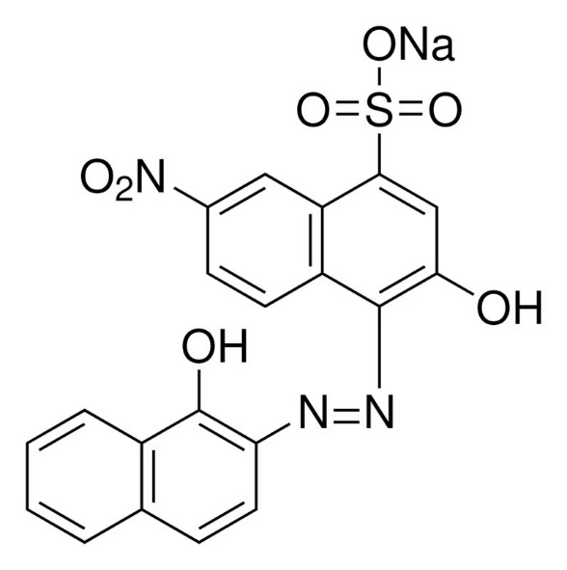

Scheme S1: Eriochrome Black T chemical structure

Figure S1: TEM images of magnetite NPs

R-DETA | R-Dithizone
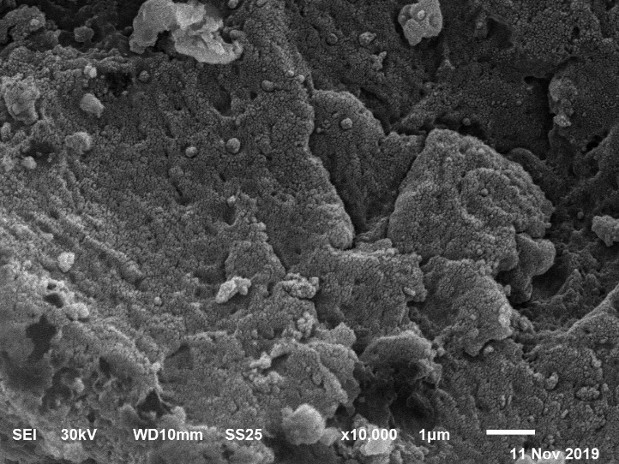 | 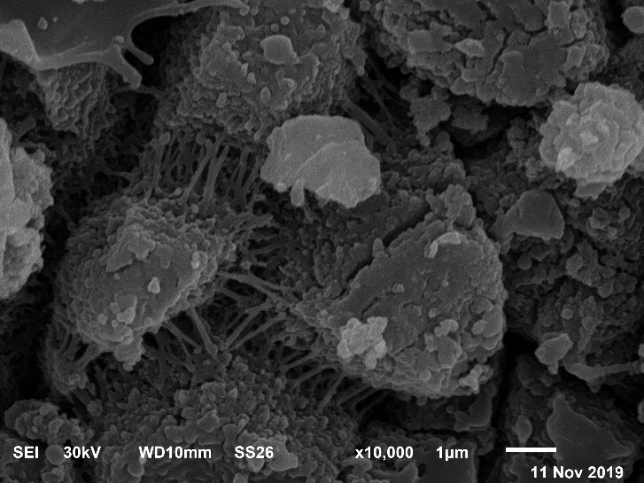
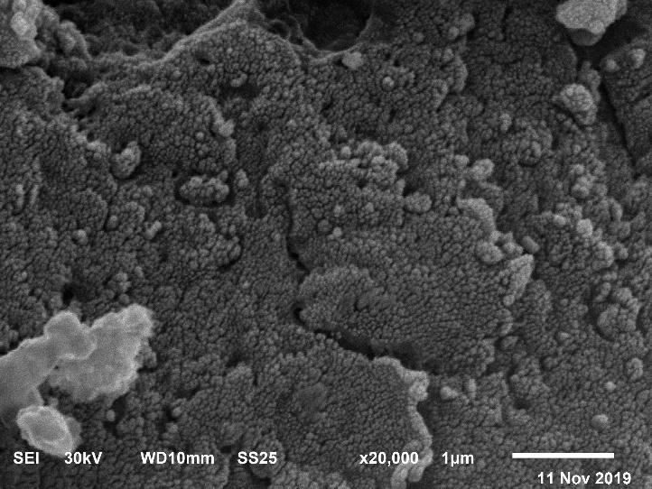 | 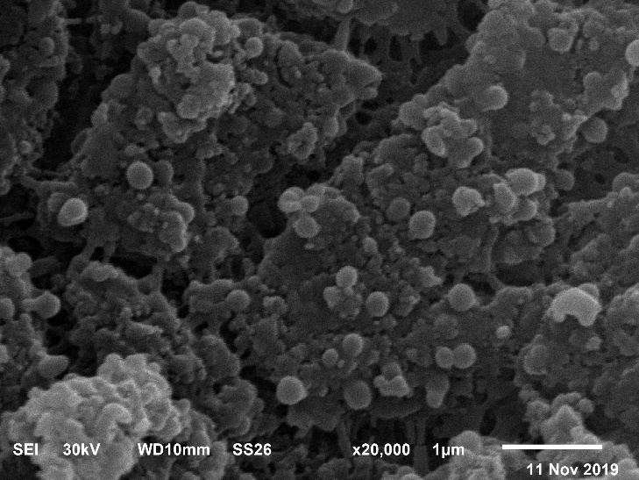
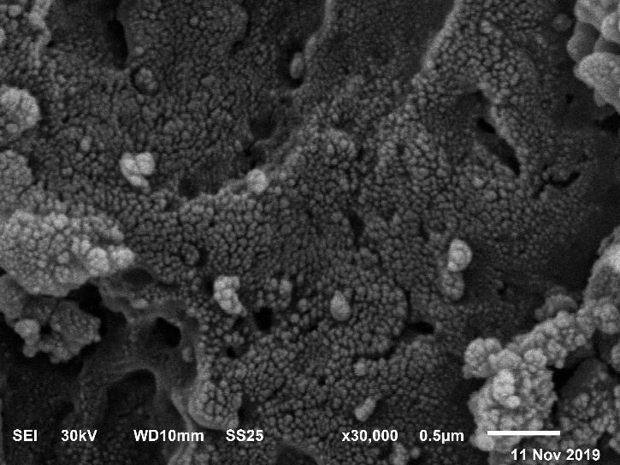 | 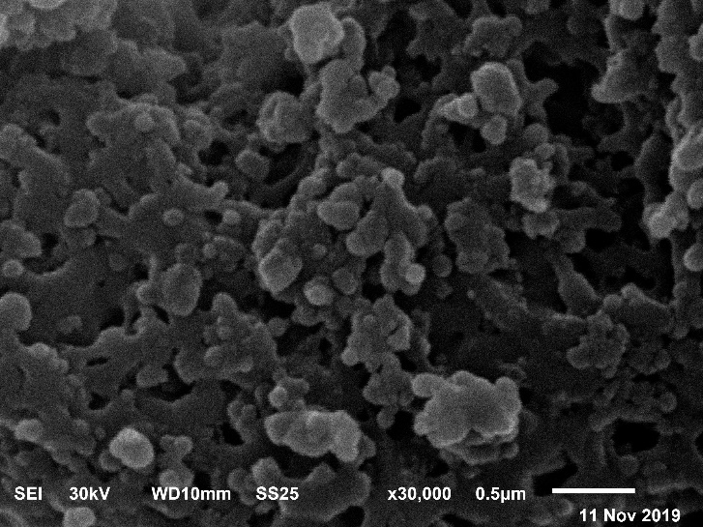

Figure S2: SEM photos of R- DETA (left column) and R-Dithizone adsorbents (right column).

R-DETA | R-Dithizone

Figure S3: TEM photos of R- DETA (left column) and R-Dithizone adsorbents (right column).

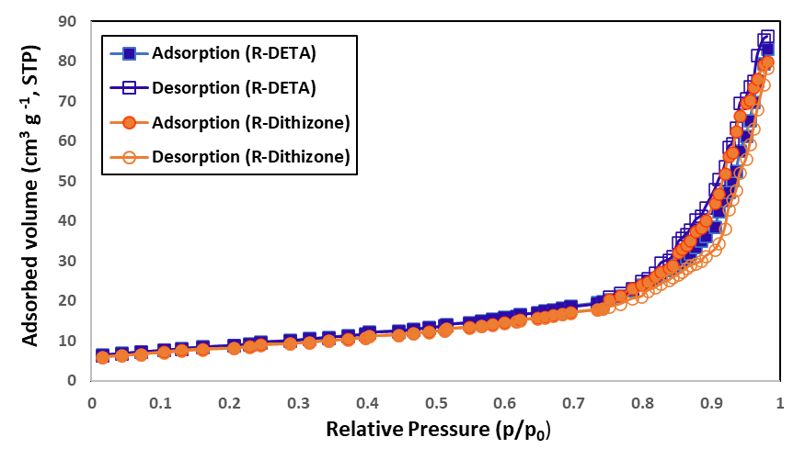

Figure S4: Nitrogen adsorption/desorption curves of R-DETA and R-Dithizone adsorbents.

Figure S5: Vibrating sample magnetometry (VSM) curves for Fe₃O₄ NPs, MCGMA, R-DETA and R-Dithizone adsorbents

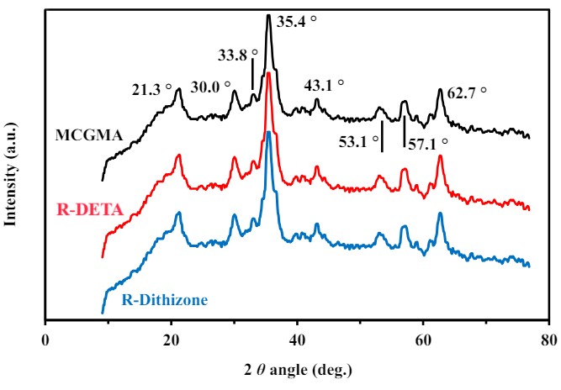

Figure S6: XRD patterns for MCGMA, R-DETA and R-Dithizone

Figure S7: Differential light scattering (DLS) for Fe3O4 NPs, MCGMA, R-DETA and R-Dithizone adsorbents

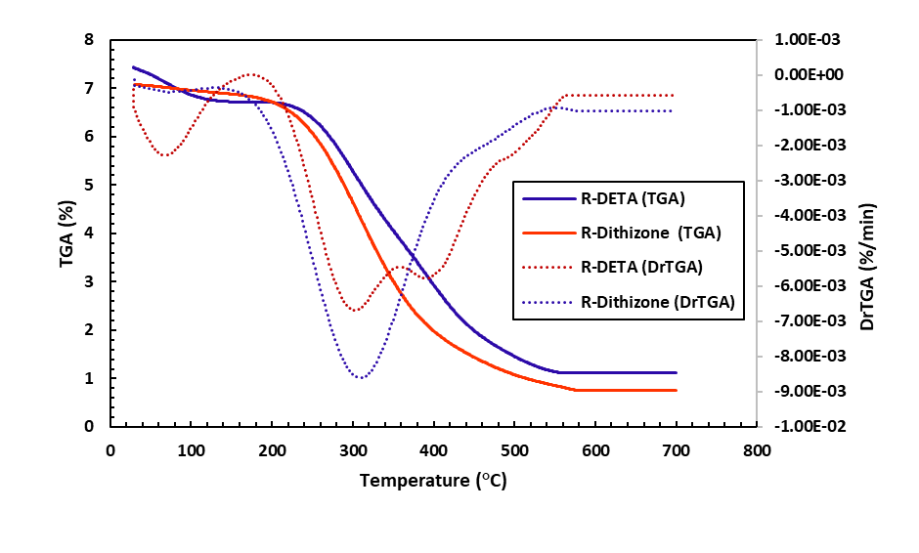

Figure S8: Thermogravimetric analysis (TGA) of R-DETA and R-Dithizone sorbents

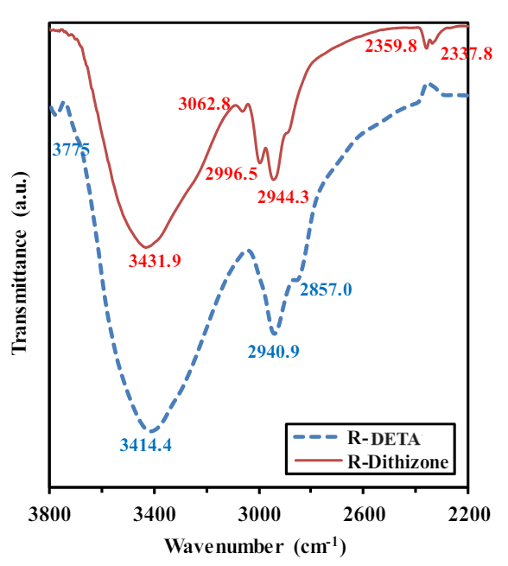

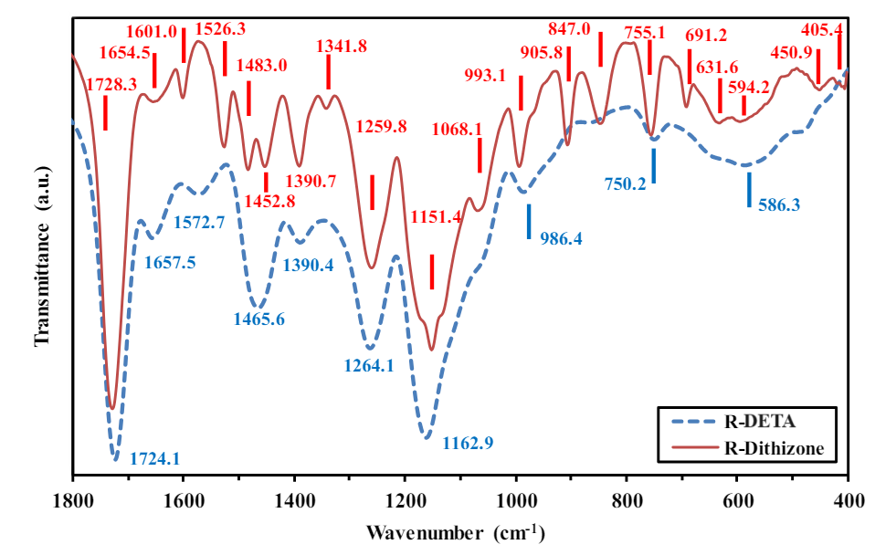

Figure S9: FTIR spectra of R-DETA and R-Dithizone adsorbents.

Figure S10: Zeta potential plots for R-DETA and R-Dithizone adsorbents

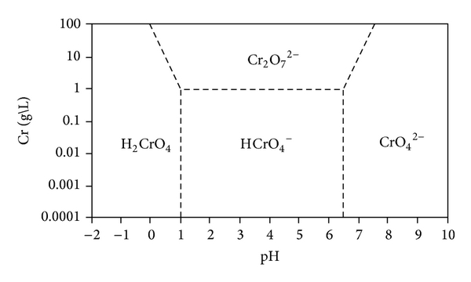

Figure S11: Chormium(VI) speciation at different pH values [9]

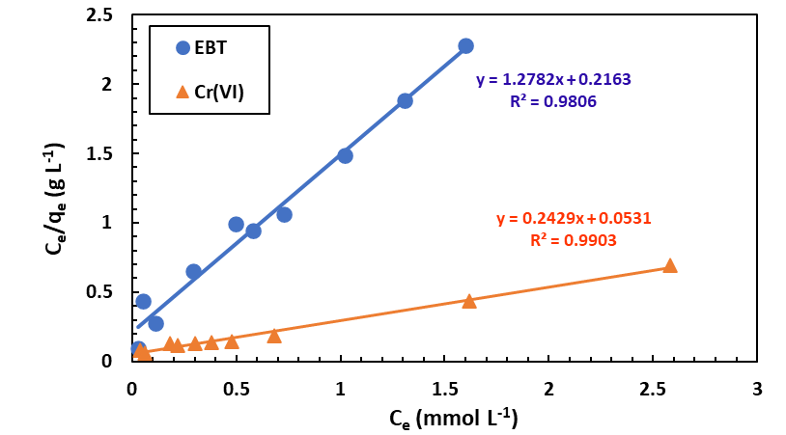

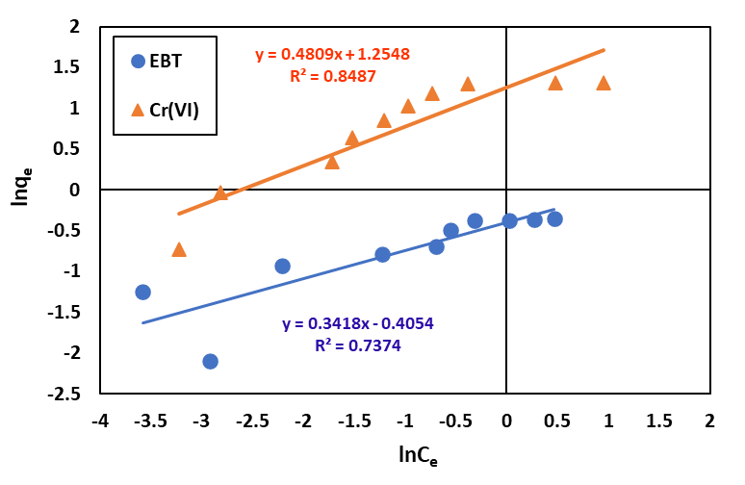

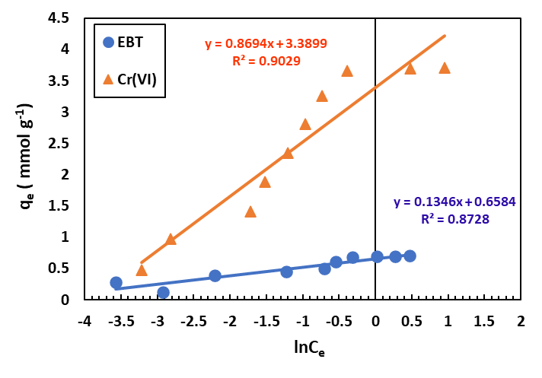

Figure S12: Linear sorption isotherms of EBT and Cr(VI) sorption from their binary solution on R-DETA (Sorbent mass 0.05 g; V: 0.025 L; t: 180 min; temperature: 25 ± 1°C; agitation speed: 200 rpm; pH₀: 3.3).
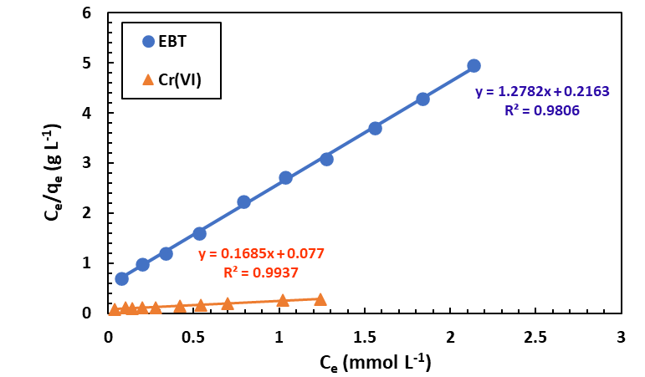

Figure S13: Linear sorption isotherms of EBT and Cr(VI) sorption from their binary solution on R-dithizone (Sorbent mass 0.05 g; V: 0.025 L; t: 180 min; temperature: 25 ± 1°C; agitation speed: 200 rpm; pH₀: 3.3).

References

[1] R. El Kaim Billah, A. Shekhawat, S. Mansouri, H. Majdoubi, M. Agunaou, A. Soufiane, R. Jugade, Adsorptive removal of Cr(VI) by Chitosan-SiO2-TiO2 nanocomposite, Environ. Nanotechnol. Monit. Manag. 18 (2022) 100695. https://doi.org/10.1016/j.enmm.2022.100695.
[2] X. Lin, X. He, L. Lei, Y. Zhao, L. Cui, G. Wu, Development of ionic liquid filled chitosan capsules to remove Cr(VI) from acidic solution: Adsorption properties and mechanism, J. Environ. Chem. Eng. 10(4) (2022) 108081. https://doi.org/10.1016/j.jece.2022.108081.
[3] W. Song, T. Tong, J. Xu, N. Wu, L. Ren, M. Li, J. Tong, Preparation and application of green chitosan/ploy (vinyl alcohol) porous microspheres for the removal of hexavalent chromium, Materials Science and Engineering: B 284 (2022) 115922. https://doi.org/10.1016/j.mseb.2022.115922.
[4] F.M. Valadi, S. Shahsavari, E. Akbarzadeh, M.R. Gholami, Preparation of new MOF-808/chitosan composite for Cr(VI) adsorption from aqueous solution: Experimental and DFT study, Carbohydr. Polym. 288 (2022) 119383. https://doi.org/10.1016/j.carbpol.2022.119383.
[5] C. Xu, Y. Xu, D. Zhong, H. Chang, J. Mou, H. Wang, H. Shen, Zr4+ cross-linked chitosan-thiourea composite for efficient detoxification of Cr(VI) ions in aqueous solution, Carbohydr. Polym. 296 (2022) 119872. https://doi.org/10.1016/j.carbpol.2022.119872.
[6] B.M. Marković, I.S. Stefanović, R.V. Hercigonja, M.V. Pergal, J.P. Marković, A.E. Onjia, A.B. Nastasović, Novel hexamethylene diamine-functionalized macroporous copolymer for chromium removal from aqueous solutions, Polym. Int. 66(5) (2017) 679-689. https://doi.org/10.1002/pi.5306.
[7] Y. Shi, J. Feng, Z. Zhang, N. Cao, J. Li, H. Li, L. Li, Q. Hua, Q. Ma, K. Zhang, Simultaneous removal of Cr(VI) anions and metal cations by EDTA-crosslinking-chitosan/polypyrrole composites, Sep. Purif. Technol. 327 (2023) 124926. https://doi.org/10.1016/j.seppur.2023.124926.
[8] J. Fito, S. Tibebu, T.T.I. Nkambule, Optimization of Cr (VI) removal from aqueous solution with activated carbon derived from Eichhornia crassipes under response surface methodology, BMC Chemistry 17(1) (2023) 4. 10.1186/s13065-023-00913-6.
[9] K. Mulani, S. Daniels, K. Rajdeo, S. Tambe, N. Chavan, Adsorption of chromium (VI) from aqueous solutions by coffee polyphenol-formaldehyde/acetaldehyde resins, Journal of Polymers 2013 (2013).
[10] H. Hajjaoui, A. Soufi, M. Khnifira, M. Abdennouri, F.Z. Mahjoubi, N. Barka, Mono and binary mixture removal of eriochrome black T and Cr(VI) from water by SiO2/polyaniline composite, Mater. Chem. Phys. 296 (2023) 127220. https://doi.org/10.1016/j.matchemphys.2022.127220.
[11] S. Tome, D.T. Hermann, V.O. Shikuku, S. Otieno, Synthesis, characterization and application of acid and alkaline activated volcanic ash-based geopolymers for adsorptive remotion of cationic and anionic dyes from water, Ceram. Int. 47(15) (2021) 20965-20973. https://doi.org/10.1016/j.ceramint.2021.04.097.
[12] H. Hajjaoui, A. Soufi, H. Khiar, M. Abdennouri, M. Achak, N. Barka, Preparation of sodium zinc phosphate/polyaniline nanocomposite for Cr(VI) and eriochrome black T adsorption from water, Mater. Today Commun. 36 (2023) 106755. https://doi.org/10.1016/j.mtcomm.2023.106755.
[13] N.S. Al-Kadhi, F.A. Saad, R.K. Shah, E.S. Al-Farraj, G.S. El-Sayyad, E.A. Abdelrahman, A Facile Sol-gel Synthesis and Characterization of MgCO3/MnCO3 and MgMn2O4/Mn2O3 Novel Nanostructures With Remarkably High Adsorption Activity Toward Eriochrome Black T Dye, J. Inorg. Organomet .Polym. Mater. 33(7) (2023) 2046-2057. 10.1007/s10904-023-02660-6.

∗Corresponding author: University of Jeddah, College of Science, Department of Chemistry, Jeddah, Saudi Arabia (K.Z. Elwakeel). E-mail address: kelwkeel@uj.edu.sa

