Supplementary Material
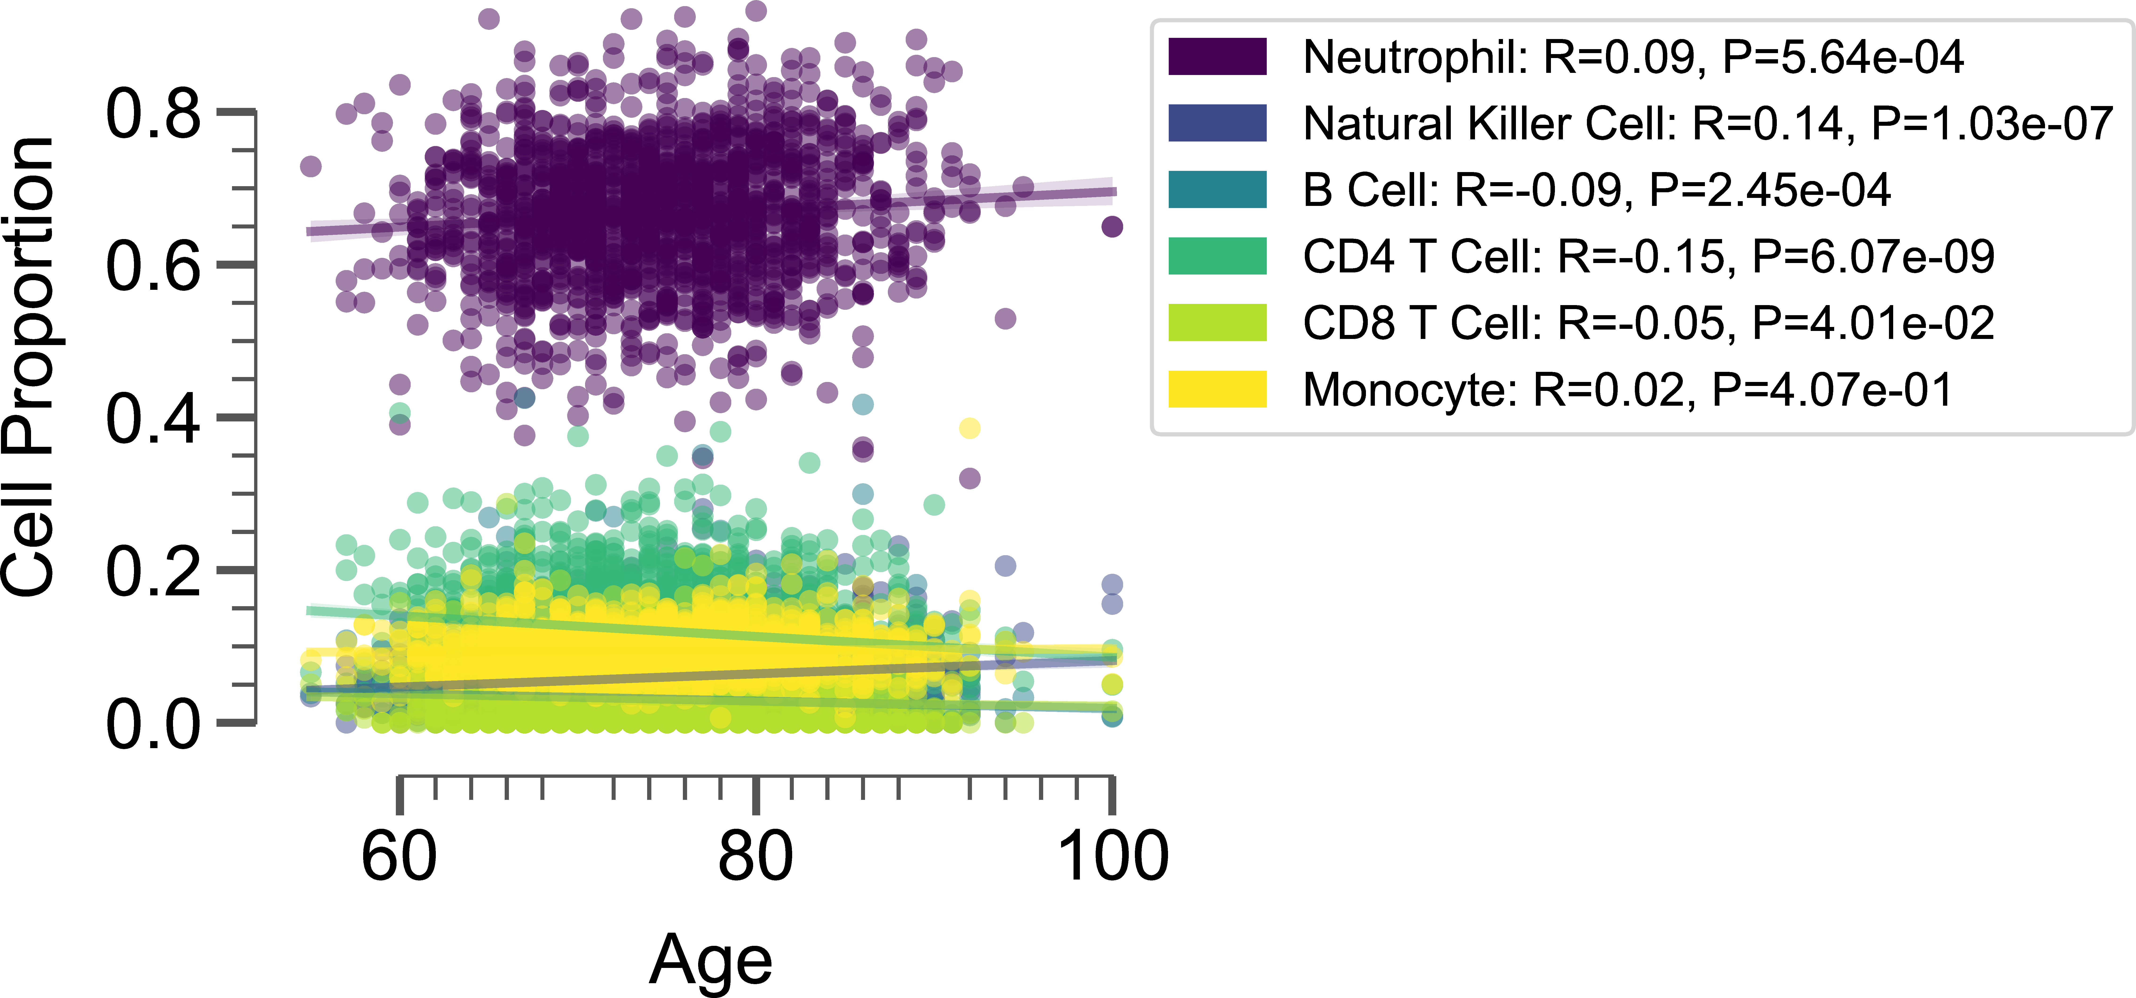
Supplementary Figure 1. Scatter plot showing the relationship between deconvoluted blood cell composition and chronological age for the NAS cohort. The points are colored based on the cell type. The regression lines are shown. Pearson’s R-value and P-value are shown in the top right of the plot.

Supplementary Figure 2. Forest plots displaying the hazard ratios (HR) and 95% confidence intervals (CI) for the association between six deconvoluted blood cell composition (per standard deviation increase, adjusted for age) and six event categories: healthspan (a), lifespan (b), dementia (c), stroke (d), operation (e), and cancer (f). The point and error bar are colored by the rank of association. Hazard ratios and P values are annotated on the plot.

