  - Figure Suppl. 1 Samples collection sites
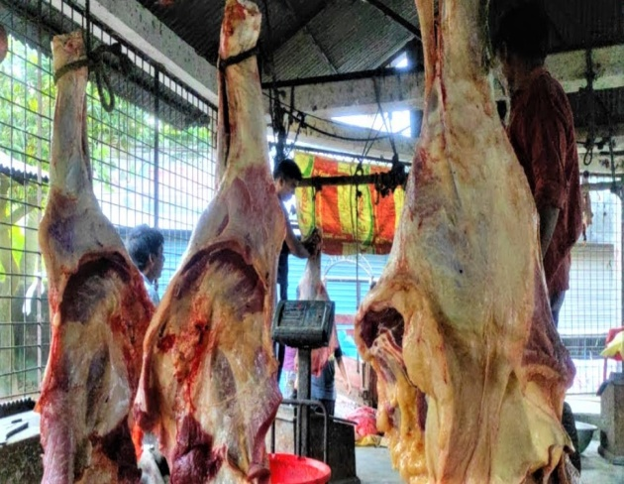 | 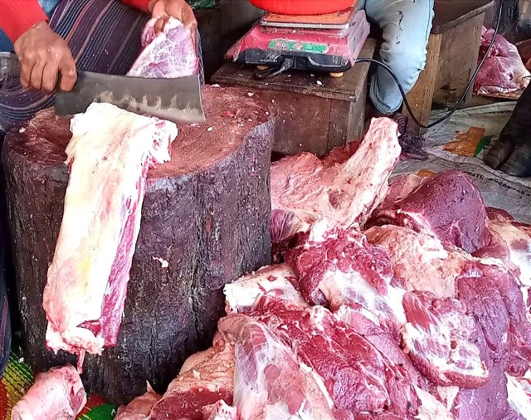 | 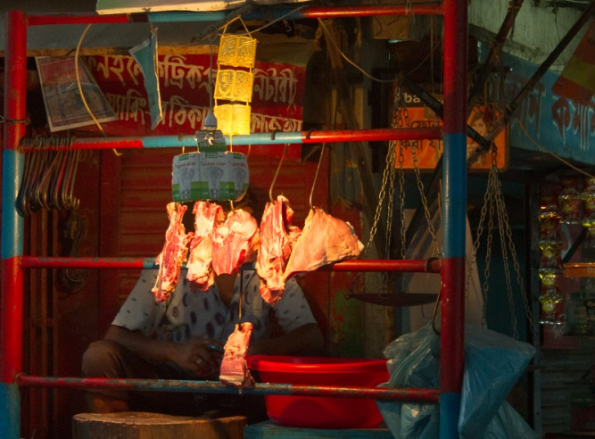
Beef from slaughter house | Open butcher shop | Sampling at evening
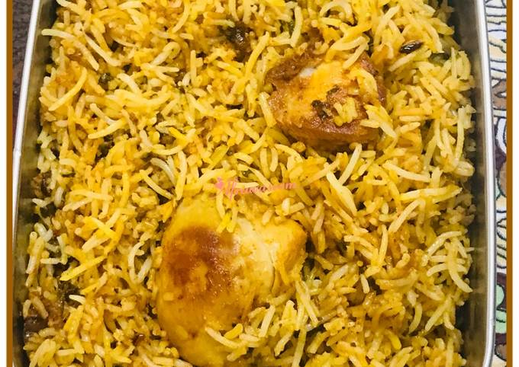 | 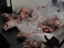 | 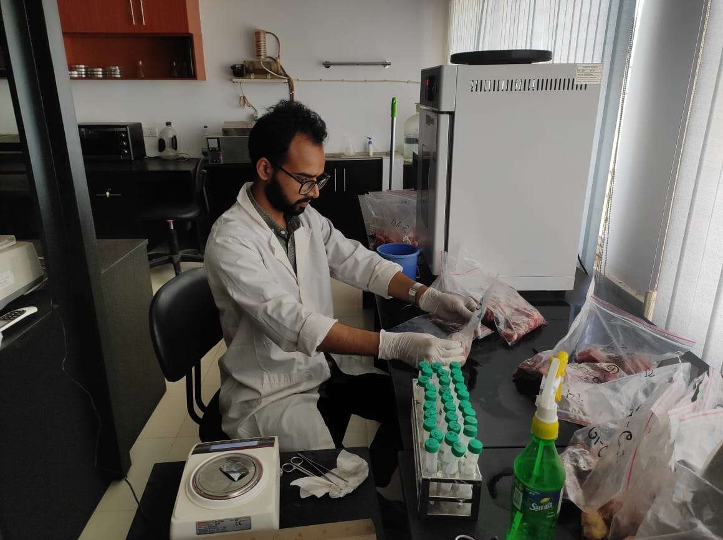
Standard RTE (Bryani) | Accumulating samples | Collecting RTE in zipper bags

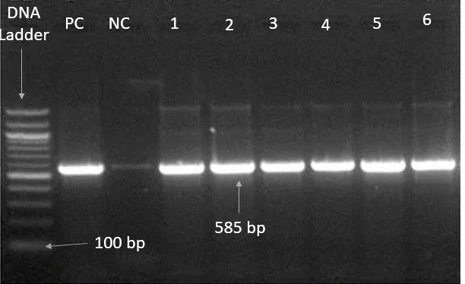
Figure Suppl. 2.i Molecular detection of E. coli isolates

Figure 2.i: Amplified DNA of malB promoter of 16s rRNA gene of E. coli. The positive isolates amplified at 585 bp. (Lane M: 100bp DNA Ladder; Lane NC: (-ve) Control; Lane PC: (+ve) control; Lane 1-6: E. coli positive isolates).

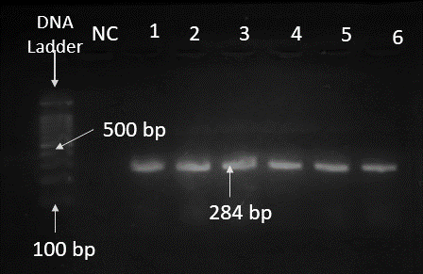
Figure Suppl. 2.ii Molecular detection of Salmonella spp. isolates

Figure 2.ii: Amplified DNA of invA gene of Salmonella spp. The positive isolates identified to show the band size at 284 bp. (Lane M: 100bp DNA Ladder; Lane NC: (-ve) Control; Lane 1-6: Salmonella spp. positive isolates).
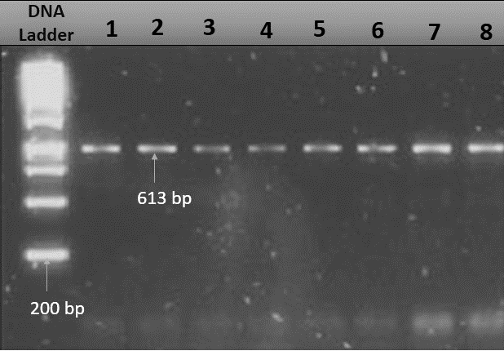
Figure Suppl. 2.iii Molecular detection of Shigella spp. isolates

Figure 2.iii: Amplified DNA of ipaH gene of Shigella spp. The positive isolates showed the band size at 613 bp. (Lane M: 100bp DNA Ladder; Lane 1-6: Shigella spp. positive isolates).

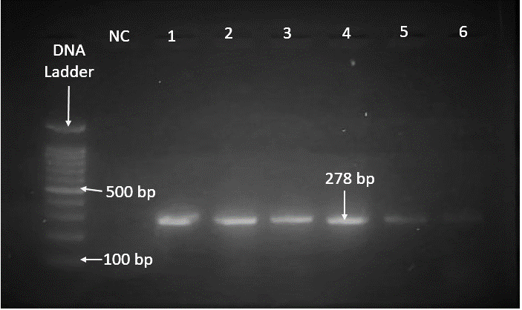
Figure Suppl. 2.iv Molecular detection of Staphylococcus aureus isolates

Figure 2.iv: Amplified DNA of nuc gene of S. aureus. The positive isolates revealed at 278 bp size. (Lane M: 100bp DNA Ladder; Lane NC: (-ve) Control; Lane 1-6: S. aureus positive isolates).

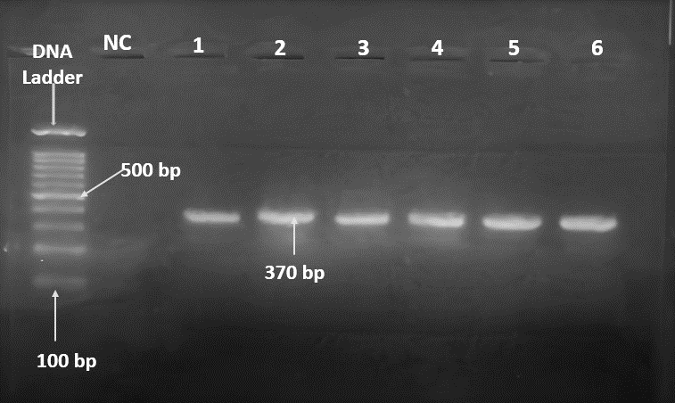
Figure Suppl. 2.v Molecular detection of Listeria spp. isolates

Figure 2.v: Amplified DNA of prs gene of Listeria spp. The positive isolates identified the band size at 370 bp. (Lane M: 100bp DNA Ladder; Lane NC: (-ve) Control; Lane 1-6: Listeria spp. positive isolates).

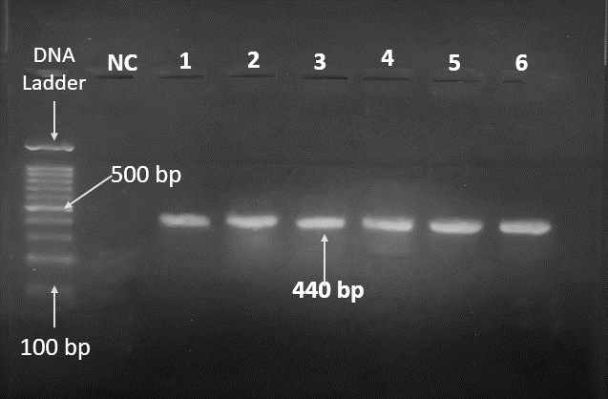
Figure Suppl. 2.vi Molecular detection of Campylobacter spp. isolates

Figure 2.vi: Amplified DNA of 16s rRNA gene of Campylobacter spp. The positive isolates resulted with the band at 440 bp. (Lane M: 100bp DNA Ladder; Lane NC: (-ve) Control; Lane 1-6: Campylobacter spp. positive isolates).

Supplementary Tables
Table: Suppl. 1 Prevalence of different food borne pathogens in raw beef and RTE samples at DCC
Bacteria | Prevalence
Bacteria | DCC RAW (n=60) |  |  |  | DCC RTE (n=60)
Bacteria | Slaughter house (n=20) | Open butcher (n=20) | Evening shop (n=20) | Total Raw (n=60) | Standard (n=20) | Medium (n=20) | Low (n=20) | Total RTE (n=60)
Escherichia coli | 5 (25%) | 3 (15%) | 7 (35%) | 15 (25%) | 6 (30%) | 6 (30%) | 6 (30%) | 18 (30%)
Salmonella spp. | 16 (80%) | 5 (25%) | 7 (35%) | 28 (46.67%) | 0 (0%) | 0 (0%) | 2 (10%) | 2 (3.33%)
Shigella spp. | 12 (60%) | 20 (100%) | 8 (40%) | 40 (66.67%) | 3 (15%) | 3 (15%) | 3 (15%) | 9 (15%)
Staphylococcus aureus | 20 (100%) | 18 (90%) | 20 (100%) | 58 (96.67%) | 4 (20%) | 5 (25%) | 6 (30%) | 15 (25%)
Listeria spp. | 8 (40%) | 20 (100%) | 12 (60%) | 40 (66.67%) | 5 (25%) | 3 (15%) | 5 (25%) | 13 (21.67%)
Campylobacter spp. | 8 (40%) | 6 (30%) | 10 (50%) | 24 (40%) | 3 (15%) | 4 (20%) | 6 (30%) | 14 (23.33%)
Abbreviation: DCC, Dhaka City Corporation; RTE, Ready-to-Eat

Table: Suppl. 2 Total aerobic count of raw beef and RTE samples
Category of sample: | DCC-RAW | Category of sample: | DCC-RTE
SAMPLE CODE | cfu/gm (10^6) | SAMPLE CODE | cfu/gm (10^6)
A1 | 0.5 | H1 | 0
A2 | 1.3 | H2 | 0
A3 | 1.2 | H3 | 3.4
A4 | 0.4 | H4 | 0
A5 | 0.7 | H5 | 3.3
A6 | 2.3 | H6 | 2.6
A7 | 1.3 | H7 | 1.6
A8 | 0.9 | H8 | 0
A9 | 0.6 | H9 | 2.4
A10 | 0.7 | H10 | 2.1
A11 | 1.2 | H11 | 1.1
A12 | 0.9 | H12 | 0.8
A13 | 1 | H13 | 0.4
A14 | 2.2 | H14 | 0.9
A15 | 0.8 | H15 | 1.2
A16 | 0.9 | H16 | 2.1
A17 | 0.3 | H17 | 2.1
A18 | 0.6 | H18 | 3.3
A19 | 0.9 | H19 | 2.6
A20 | 1.6 | H20 | 2.2
B1 | 1.2 | M1 | 0
B2 | 2.4 | M2 | 3.7
B3 | 3.3 | M3 | 3.5
B4 | 4.4 | M4 | 0
B5 | 2.4 | M5 | 2.3
B6 | 3.5 | M6 | 0
B7 | 3.6 | M7 | 0
B8 | 1.3 | M8 | 2.2
B9 | 3.3 | M9 | 4.5
B10 | 3.7 | M10 | 3.7
B11 | 2.5 | M11 | 0
B12 | 3.6 | M12 | 0
B13 | 1.8 | M13 | 2.3
B14 | 2.9 | M14 | 7.4
B15 | 3.7 | M15 | 0
B16 | 2.6 | M16 | 2.3
B17 | 2.5 | M17 | 0.4
B18 | 4.3 | M18 | 0.8
B19 | 3.2 | M19 | 0
B20 | 0.1 | M20 | 2.1
C1 | 0.3 | L1 | 0.8
C2 | 1.7 | L2 | 0
C3 | 0.5 | L3 | 2.1
C4 | 0.6 | L4 | 3.2
C5 | 0.3 | L5 | 1.1
C6 | 0.7 | L6 | 2.3
C7 | 2.2 | L7 | 1.9
C8 | 2.2 | L8 | 0
C9 | 1.6 | L9 | 1.7
C10 | 2.1 | L10 | 2.3
C11 | 1.9 | L11 | 1.7
C12 | 2 | L12 | 0
C13 | 1.5 | L13 | 1.8
C14 | 1.7 | L14 | 0
C15 | 1.1 | L15 | 2.4
C16 | 0.9 | L16 | 2.4
C17 | 0.6 | L17 | 2.2
C18 | 2.1 | L18 | 1.5
C19 | 0.7 | L19 | 0.7
C20 | 3.2 | L20 | 0
Abbreviation: DCC, Dhaka City Corporation; RTE, Ready-to-Eat; cfu/gm, Colony Forming Unit per Gram

Table: Suppl. 3.i Standard Plate Count of raw beef samples of DCC
Category of sample: |  | RAW (A: Slaughter house, B: Open butcher shop, C: wet market at evening)
Location: |  | DCC
Sample code | cfu/gm (10^5)
Sample code | E. coli | Salmonella spp. | Shigella spp. | S. aureus | Listeria spp. | Campylobacter spp.
A1 | 0 | 0.5 | 2.1 | 0.03 | 0 | 3.65
A2 | 0 | 1.7 | 4.22 | 3.2 | 0 | 3.52
A3 | 0 | 0.6 | 3.23 | 3.1 | 0.38 | 3.2
A4 | 0 | 2.4 | 1.9 | 0.57 | 0.32 | 0
A5 | 0.7 | 3.7 | 3.2 | 1.68 | 0 | 3.1
A6 | 0 | 6 | 3.2 | 2.5 | 0 | 2.5
A7 | 0 | 0 | 4.5 | 1.6 | 0 | 3.6
A8 | 0 | 5.6 | 3.25 | 4.2 | 0.28 | 0.93
A9 | 0.21 | 5.4 | 2.56 | 3.4 | 0 | 0
A10 | 0 | 1.3 | 2.26 | 3.6 | 0 | 3.2
A11 | 0 | 7.8 | 4.8 | 2.6 | 0.4 | 3.12
A12 | 0 | 5 | 2.4 | 1.5 | 0.6 | 2.02
A13 | 0 | 0 | 3.9 | 1.78 | 0 | 0
A14 | 0 | 0 | 7.8 | 4.58 | 0 | 1.4
A15 | 0 | 3.5 | 2.58 | 4.6 | 0 | 0
A16 | 0.12 | 3.5 | 3.9 | 5.02 | 0.86 | 0
A17 | 0 | 0 | 3.5 | 3.21 | 0.4 | 0.24
A18 | 1.5 | 5.2 | 3.2 | 4.82 | 0 | 0
A19 | 1.9 | 4.8 | 3.02 | 1.7 | 0 | 1.5
A20 | 0 | 3 | 3.6 | 1.56 | 0.78 | 0
B1 | 0 | 0 | 4.5 | 0.02 | 0.95 | 0.38
B2 | 0 | 0 | 3.23 | 0.43 | 0.13 | 0.27
B3 | 0 | 0 | 2.2 | 3.26 | 0.31 | 0
B4 | 0 | 0 | 4.6 | 0 | 1.12 | 0.66
B5 | 0 | 0 | 5.06 | 1.12 | 4.1 | 0.35
B6 | 0 | 0 | 3.5 | 0.63 | 3.5 | 3.2
B7 | 1.4 | 4.3 | 4.1 | 0.57 | 3.6 | 0.47
B8 | 0 | 0 | 4.3 | 0.22 | 2.56 | 3.4
B9 | 0 | 0 | 3.56 | 0.31 | 4.5 | 3.6
B10 | 0 | 2.8 | 4.26 | 3.12 | 2.9 | 0.32
B11 | 0 | 0 | 3.2 | 0 | 1.2 | 2.5
B12 | 0 | 0 | 2.6 | 0.46 | 2.5 | 0.26
B13 | 0 | 0 | 1.8 | 0.76 | 2.8 | 0.37
B14 | 5 | 4.6 | 1.67 | 0.9 | 2.9 | 0
B15 | 0 | 2.8 | 3.48 | 2.85 | 3.4 | 1.9
B16 | 15 | 3 | 4.39 | 1.67 | 3.5 | 2.4
B17 | 0 | 0 | 4.75 | 3.55 | 2.6 | 1.6
B18 | 0 | 0 | 2.86 | 3.6 | 3.5 | 0
B19 | 0 | 0 | 2.32 | 3.2 | 1.26 | 0
B20 | 0 | 0 | 1.12 | 2.4 | 2.45 | 0
C1 | 0 | 2.3 | 2.28 | 1.12 | 5.6 | 0
C2 | 3.5 | 0 | 5.6 | 2.3 | 0.77 | 0
C3 | 5.3 | 3.5 | 3.5 | 0.25 | 3.1 | 3.1
C4 | 7 | 0 | 4.2 | 0.48 | 3.1 | 0
C5 | 0 | 0 | 1.12 | 1.12 | 3.05 | 0
C6 | 0 | 0 | 8.4 | 2.08 | 3.6 | 0
C7 | 6.2 | 0 | 8.9 | 3.21 | 0 | 2.41
C8 | 0 | 2.3 | 5.6 | 2.44 | 0.78 | 0
C9 | 0 | 0 | 6.8 | 3.56 | 0 | 0
C10 | 0 | 3.9 | 3.5 | 4.44 | 0.42 | 0
C11 | 0 | 0 | 3.1 | 2.5 | 0 | 0
C12 | 4.5 | 0 | 2.55 | 3.4 | 0 | 2.5
C13 | 7.8 | 0 | 7.9 | 2.9 | 0 | 0
C14 | 0 | 5 | 2.2 | 2.46 | 3.2 | 0
C15 | 0 | 0 | 3.8 | 2.76 | 0.56 | 0
C16 | 6.5 | 6.5 | 2.6 | 2.3 | 0.7 | 2.1
C17 | 0 | 7.8 | 2.53 | 3.8 | 0.56 | 3.02
C18 | 0 | 0 | 6.1 | 3.22 | 0 | 2.6
C19 | 0 | 0 | 5.3 | 2.9 | 0 | 2.4
Abbreviation: DCC, Dhaka City Corporation; cfu/gm, Colony Forming Unit per Gram
Table: Suppl. 3.ii Standard Plate Count of RTE samples of DCC
Category of sample: |  | RTE (H: High category Restaurant, M: Medium category, L: Low category)
Location: |  | DCC
sample code | cfu/gm (10^5)
sample code | E. coli | Salmonella spp. | Shigella spp. | S. aureus | Listeria spp. | Campylobacter spp.
H1 | 0 | 0 | 0 | 0 | 0 | 0
H2 | 0 | 0 | 0 | 0 | 0 | 0
H3 | 0 | 0 | 0 | 0.1 | 0 | 0
H4 | 0 | 0 | 0 | 0 | 0 | 0
H5 | 0.3 | 0 | 0.1 | 0 | 0 | 0.22
H6 | 0 | 0 | 0 | 1.2 | 1.1 | 0
H7 | 1.2 | 0 | 0 | 0 | 0 | 0
H8 | 0 | 0 | 0 | 0 | 0 | 0
H9 | 0 | 0 | 0 | 0 | 0.75 | 0.1
H10 | 1.5 | 0 | 0 | 0 | 0 | 0
H11 | 0 | 0 | 0.6 | 0 | 0 | 0.5
H12 | 1.6 | 0 | 0 | 0.5 | 0.6 | 0
H13 | 0 | 0 | 0 | 0 | 0 | 0.65
H14 | 0 | 0 | 0 | 0 | 0 | 0.12
H15 | 0 | 0 | 1.2 | 0 | 0 | 0
H16 | 0.4 | 0 | 0 | 0 | 0.82 | 0
H17 | 0 | 0 | 0 | 0 | 0 | 1.2
H18 | 1.55 | 0 | 0 | 0 | 0 | 1.4
H19 | 0 | 0 | 0 | 0.6 | 0 | 0
H20 | 0 | 0 | 0 | 0 | 1.12 | 0
M1 | 0 | 0 | 0 | 0 | 0 | 1.32
M2 | 0 | 0 | 0 | 1.1 | 0 | 0
M3 | 1.5 | 0 | 0 | 0 | 0 | 0.56
M4 | 0 | 0 | 0 | 0 | 0 | 0
M5 | 0 | 0 | 0 | 0.3 | 0.76 | 0
M6 | 0 | 0 | 0 | 0 | 0 | 0
M7 | 0 | 0 | 0 | 0 | 0 | 0
M8 | 1.33 | 0 | 0.5 | 0 | 0.65 | 1.8
M9 | 0 | 0 | 0 | 2.1 | 0 | 0
M10 | 1.6 | 0 | 0 | 0 | 0 | 0
M11 | 0 | 0 | 0 | 0 | 0 | 0
M12 | 0 | 0 | 0 | 0 | 0 | 0
M13 | 1.45 | 0 | 1.5 | 0 | 0 | 0
M14 | 0 | 0 | 0 | 0.36 | 0.48 | 0
M15 | 0 | 0 | 0 | 0 | 0 | 0
M16 | 1.4 | 0 | 0 | 0 | 0 | 0
M17 | 0 | 0 | 0.4 | 0 | 0 | 0.4
M18 | 0 | 0 | 0 | 0.45 | 0 | 0
M19 | 0 | 0 | 0 | 0 | 0 | 0
M20 | 1.6 | 0 | 0 | 0 | 0 | 0
L1 | 0 | 0 | 0 | 0.02 | 0 | 1.6
L2 | 0.8 | 0 | 0 | 0 | 0 | 0.21
L3 | 0 | 0 | 0 | 1.2 | 0 | 0
L4 | 0 | 0 | 0.3 | 0 | 0.46 | 0.56
L5 | 0.74 | 0 | 0 | 0 | 0 | 0
L6 | 0 | 0 | 0 | 0.21 | 0 | 0
L7 | 0.46 | 0 | 0 | 0 | 1.1 | 0
L8 | 0 | 0 | 0 | 0 | 0 | 0
L9 | 0.56 | 0 | 0 | 0.3 | 0 | 0
L10 | 0 | 0 | 0 | 0 | 0 | 1.3
L11 | 0 | 0 | 1.22 | 0 | 0.45 | 0
L12 | 0 | 0 | 0 | 0 | 0 | 0
L13 | 1.5 | 0 | 0 | 0.56 | 0 | 0
L14 | 0 | 0 | 0 | 0 | 0 | 0
L15 | 0 | 0 | 1.3 | 0 | 0 | 0
L16 | 0 | 0 | 0 | 0 | 0.36 | 1.2
L17 | 1 | 0 | 0 | 0 | 0 | 0
L18 | 0 | 0 | 0 | 0 | 1.8 | 0.5
L19 | 0 | 0 | 0 | 1.45 | 0 | 0
L20 | 0 | 0 | 0 | 0 | 0 | 0
Abbreviation: DCC, Dhaka City Corporation; RTE, Ready-to-Eat; cfu/gm, Colony Forming Unit per gram

Table Suppl. 4.i Antibiotic resistance profile of Escherichia coli isolated from raw beef and RTE
Antibiotic class | Specific antibiotic tested | Concentration | Interpretive categories and zone diameter breakpoints (nearest whole mm) |  |  | No. of isolates/Total isolates
Antibiotic class |  |  | S | I | R | S | I | R
Aminoglycosides | Streptomycin | 10 μg | ≥ 15 | 12-14 | ≤ 11 | 7/33 | 5/33 | 21/33
Aminoglycosides | Gentamycin | 10 μg | ≥ 15 | 13-14 | ≤ 12 | 9/33 | 5/33 | 19/33
Aminoglycosides | Amikacin | 30 μg | ≥ 17 | 15-16 | ≤14 | 8/33 | 11/33 | 14/33
Macrolides | Azithromycin | 15 μg | ≥ 13 | - | ≤ 12 | 11/33 | 8/33 | 14/33
Tetracyclines | Tetracycline | 30 μg | ≥ 25 | 12-14 | ≤ 11 | 4/33 | 8/33 | 21/33
Quinolones | Ciprofloxacin | 5 μg | ≥ 31 | 21-30 | ≤ 20 | 6/33 | 9/33 | 18/33
Quinolones | Norfloxacin | 10 μg | ≥ 17 | 13-16 | ≤ 12 | 8/33 | 11/33 | 14/33
Sulfonamides | Sulfamethoxazole-Trimethoprim | 25 μg | ≥ 16 | 11-15 | ≤ 10 | 6/33 | 9/33 | 18/33
Penicillin | Ampicillin | 10 μg | ≥ 17 | 14-16 | ≥ 13 | 0/33 | 0/33 | 33/33
Penicillin | Amoxicillin | 25 μg | ≥ 28 | 14-17 | ≥ 13 | 4/33 | 4/33 | 25/33
Cephalosporins | Cefoxitin | 30 μg | ≥ 23 | 15-22 | ≤14 | 6/33 | 9/33 | 18/33
Cephalosporins | Ceftriaxone | 30 μg | ≥ 26 | 23-25 | ≤ 22 | 9/33 | 5/33 | 19/33
Cephalosporins | Ceftazidime | 30 μg | ≥ 21 | 18-20 | ≤ 17 | 6/33 | 8/33 | 19/33
Monobactam | Aztreonam | 30 μg | ≥ 21 | 18-20 | ≤ 17 | 25/33 | 0/33 | 8/33
Carbapenem | Meropenem | 30 μg | ≥ 23 | 20-22 | ≤ 19 | 19/33 | 8/33 | 6/33
Carbapenem | Imipenem | 30 μg | ≥ 23 | 20-22 | ≤ 19 | 11/33 | 8/33 | 14/33
Glycopeptide | Vancomycin | 30 μg | ≥ 17 | 15-16 | ≤ 14 | 5/33 | 7/33 | 21/33
Abbreviation: S, sensitive; I, intermediate; R, resistant; mm, millimeter

Table Suppl. 4.ii Antibiotic resistance profile of Salmonella spp. isolated from raw beef and RTE
Antibiotic class | Specific antibiotic tested | Concentration | Interpretive categories and zone diameter breakpoints (nearest whole mm) |  |  | No. of isolates/Total isolates
Antibiotic class | Specific antibiotic tested | Concentration | S | I | R | S | I | R
Aminoglycosides | Streptomycin | 10 μg | ≥ 15 | 12-14 | ≤ 11 | 5/30 | 10/30 | 15/30
Aminoglycosides | Gentamycin | 10 μg | ≥ 15 | 13–14 | ≤ 12 | 13/30 | 7/30 | 10/30
Aminoglycosides | Amikacin | 30 μg | ≥ 17 | 15–16 | ≤ 14 | 10/30 | 3/30 | 17/30
Macrolides | Azithromycin | 15 μg | ≥ 13 | - | ≤ 12 | 6/30 | 9/30 | 15/30
Tetracyclines | Tetracycline | 30 μg | ≥ 15 | 12-14 | ≤ 11 | 10/30 | 3/30 | 17/30
Quinolones | Ciprofloxacin | 5 μg | ≥ 26 | 22-25 | ≤ 21 | 12/30 | 7/30 | 11/30
Quinolones | Norfloxacin | 10 μg | ≥ 17 | 13-16 | ≤ 12 | 8/30 | 0/30 | 22/30
Sulfonamides | Sulfamethoxazole-Trimethoprim | 25 μg | ≥ 16 | 11-15 | ≤ 10 | 6/30 | 10/30 | 14/30
Penicillin | Ampicillin | 10 μg | ≥ 17 | 14-16 | ≤13 | 0/30 | 0/30 | 30/30
Penicillin | Amoxicillin | 25 μg | ≥ 18 | 14-17 | ≤ 13 | 0/30 | 0/30 | 30/30
Cephalosporins | Cefoxitin | 30 μg | ≥ 18 | 15-17 | ≤ 14 | 5/30 | 2/30 | 23/30
Cephalosporins | Ceftriaxone | 30 μg | ≥ 23 | 20-22 | ≤19 | 3/30 | 5/30 | 22/30
Cephalosporins | Ceftazidime | 30 μg | ≥ 21 | 18-20 | ≤ 17 | 6/30 | 3/30 | 21/30
Monobactam | Aztreonam | 30 μg | ≥ 21 | 18-20 | ≤ 17 | 7/30 | 6/30 | 17/30
Carbapenem | Meropenem | 30 μg | ≥ 23 | 20-22 | ≤ 19 | 4/30 | 0/30 | 26/30
Carbapenem | Imipenem | 30 μg | ≥ 23 | 20-22 | ≤ 19 | 7/30 | 6/30 | 17/30
Abbreviation: S, sensitive; I, intermediate; R, resistant; mm, millimeter
Table Suppl. 4.iii Antibiotic resistance profile of Shigella spp. isolated from raw red beef and RTE
Antibiotic class | Specific antibiotic tested | Concentration | Interpretive categories and zone diameter breakpoints (nearest whole mm) |  |  | No. of isolates/Total isolates
Antibiotic class | Specific antibiotic tested | Concentration | S | I | R | S | I | R
Aminoglycosides | Streptomycin | 10 μg | ≥ 15 | 12-14 | ≤ 11 | 12/49 | 10/49 | 27/49
Aminoglycosides | Gentamycin | 10 μg | ≥ 15 | 13–14 | ≤ 12 | 18/49 | 10/49 | 21/49
Aminoglycosides | Amikacin | 30 μg | ≥ 17 | 15–16 | ≤ 14 | 15/49 | 0/49 | 34/49
Macrolides | Azithromycin | 15 μg | ≥ 13 | - | ≤ 12 | 9/49 | 4/49 | 36/49
Tetracyclines | Tetracycline | 30 μg | ≥ 15 | 12-14 | ≤ 11 | 17/49 | 11/49 | 21/49
Quinolones | Ciprofloxacin | 5 μg | ≥ 26 | 22-25 | ≤ 21 | 10/49 | 0/49 | 39/49
Quinolones | Norfloxacin | 10 μg | ≥ 17 | 13-16 | ≤ 12 | 15/49 | 10/49 | 24/49
Sulfonamides | Sulfamethoxazole-Trimethoprim | 25 μg | ≥ 16 | 11-15 | ≤ 10 | 16/49 | 11/49 | 22/49
Penicillin | Ampicillin | 10 μg | ≥ 17 | 14-16 | ≤13 | 0/49 | 0/49 | 49/49
Penicillin | Amoxicillin | 25 μg | ≥ 18 | 14-17 | ≤ 13 | 0/49 | 0/49 | 49/49
Cephalosporins | Cefoxitin | 30 μg | ≥ 18 | 15-17 | ≤ 14 | 7/49 | 11/49 | 31/49
Cephalosporins | Ceftriaxone | 30 μg | ≥ 23 | 20-22 | ≤19 | 10/49 | 11/49 | 28/49
Cephalosporins | Ceftazidime | 30 μg | ≥ 21 | 18-20 | ≤ 17 | 4/49 | 0/49 | 45/49
Monobactam | Aztreonam | 30 μg | ≥ 21 | 18-20 | ≤ 17 | 9/49 | 0/49 | 40/49
Carbapenem | Meropenem | 30 μg | ≥ 23 | 20-22 | ≤ 19 | 20/49 | 12/49 | 17/49
Carbapenem | Imipenem | 30 μg | ≥ 23 | 20-22 | ≤ 19 | 16/49 | 8/49 | 25/49
Abbreviation: S, sensitive; I, intermediate; R, resistant; mm, millimeter

Table Suppl. 4.iv Antibiotic resistance profile of Staphylococcus aureus isolated from raw beef and RTE
Antibiotic class | Specific antibiotic tested | Concentration | Interpretive categories and zone diameter breakpoints (nearest whole mm) |  |  | No. of isolates/Total isolates
Antibiotic class | Specific antibiotic tested | Concentration | S | I | R | S | I | R
Aminoglycosides | Streptomycin | 10 μg | ≥ 15 | 13–14 | ≤ 12 | 16/73 | 9/73. | 48/73
Aminoglycosides | Gentamycin | 10 μg | ≥ 15 | 13–14 | ≤ 12 | 21/73 | 16/73 | 36/73
Macrolides | Azithromycin | 15 μg | ≥ 18 | 14–17 | ≤ 13 | 33/73 | 11/73. | 29/73
Tetracyclines | Tetracycline | 30 μg | ≥ 19 | 15–18 | ≤ 14 | 39/73 | 11/73. | 23/73
Quinolones | Ciprofloxacin | 5 μg | ≥ 21 | 16-20 | ≤ 15 | 9/73. | 11/73. | 53/73
Quinolones | Norfloxacin | 10 μg | ≥ 17 | 13-16 | ≤ 12 | 11/73. | 26/73 | 36/73
Sulfonamides | Sulfamethoxazole-Trimethoprim | 25 μg | ≥ 16 | 11-15 | ≤ 10 | 0/73 | 7/73. | 66/73
Penicillin | Ampicillin | 10 μg | ≥ 29 | 28-22 | ≤ 22 | 0/73 | 0/73 | 73/73
Penicillin | Oxacillin | 10 μg | ≥ 25 | 24-21 | ≤20 | 0/73 | 0/73 | 73/73
Penicillin | Amoxicillin | 25 μg | ≥ 29 | – | ≤ 28 | 0/73 | 0/73 | 73/73
Cephalosporins | Cefoxitin | 30 μg | ≥ 21 | 14–20 | ≤ 13 | 7/73. | 9/73. | 57/73
Oxazolidinones | Linezolid | 10 μg | ≥ 21 | - | ≤20 | 22/73 | 16/73 | 35/73
Glycopeptide | Vancomycin | 30 μg | ≥ 17 | 15-16 | ≤ 14 | 65/73 | 0/73 | 8/73.
Abbreviation: S, sensitive; I, intermediate; R, resistant; mm, millimeter

Table Suppl. 4.v Antibiotic resistance profile of Listeria spp. isolated from raw red beef and RTE
Antibiotic class | Specific antibiotic tested | Concentration | Interpretive categories and zone diameter breakpoints (nearest whole mm) |  |  | No. of isolates/Total isolates
Antibiotic class | Specific antibiotic tested | Concentration | S | I | R | S | I | R
Aminoglycosides | Streptomycin | 10 μg | ≥ 15 | 12-14 | ≤ 11 | 7/53 | 12/53 | 34/53
Aminoglycosides | Gentamycin | 10 μg | ≥ 15 | 13-14 | ≤ 12 | 10/53 | 6/53 | 37/53
Aminoglycosides | Amikacin | 30 μg | ≥ 17 | 15–16 | ≤ 14 | 11/53 | 7/53 | 35/53
Macrolides | Azithromycin | 15 μg | ≥ 13 | - | ≤ 12 | 3/53 | 0/53 | 50/53
Tetracyclines | Tetracycline | 30 μg | ≥ 15 | 12-14 | ≤ 11 | 5/53 | 20/53 | 28/53
Quinolones | Ciprofloxacin | 5 μg | ≥ 26 | 22-25 | ≤ 21 | 12/53 | 10/53 | 31/53
Quinolones | Norfloxacin | 10 μg | ≥ 17 | 13-16 | ≤ 12 | 10/53 | 16/53 | 27/53
Sulfonamides | Sulfamethoxazole-Trimethoprim | 25 μg | ≥ 16 | 11-15 | ≤ 10 | 13/53 | 13/53 | 27/53
Penicillin | Ampicillin | 10 μg | ≥ 17 | 14-16 | ≤13 | 0/53 | 0/53 | 53/53
Penicillin | Amoxicillin | 25 μg | ≥ 18 | 14-17 | ≤ 13 | 0/53 | 0/53 | 53/53
Cephalosporins | Cefoxitin | 30 μg | ≥ 18 | 15-17 | ≤ 14 | 10/53 | 6/53 | 37/53
Cephalosporins | Ceftriaxone | 30 μg | ≥ 23 | 20-22 | ≤19 | 4/53 | 0/53 | 49/53
Cephalosporins | Ceftazidime | 30 μg | ≥ 21 | 18-20 | ≤ 17 | 12/53 | 6/53 | 35/53
Monobactam | Aztreonam | 30 μg | ≥ 21 | 18-20 | ≤ 17 | 16/53 | 11/53 | 26/53
Carbapenem | Meropenem | 30 μg | ≥ 23 | 20-22 | ≤ 19 | 12/53 | 0/53 | 41/53
Carbapenem | Imipenem | 30 μg | ≥ 23 | 20-22 | ≤ 19 | 17/53 | 12/53 | 24/53
Abbreviation: S, sensitive; I, intermediate; R, resistant; mm, millimeter

Table Suppl. 4.vi Antibiotic resistance profile of Campylobacter spp. isolated from raw red beef and RTE
Antibiotic class | Specific antibiotic tested | Concentration | Interpretive categories and zone diameter breakpoints (nearest whole mm) |  |  | No. of isolates/Total isolates
Antibiotic class | Specific antibiotic tested | Concentration | S | I | R | S | I | R
Aminoglycosides | Streptomycin | 10 μg | ≥ 15 | 12-14 | ≤ 11 | 6/38 | 12/38 | 20/38
Aminoglycosides | Gentamycin | 10 μg | ≥ 15 | 13–14 | ≤ 12 | 10/38 | 11/38 | 17/38
Aminoglycosides | Amikacin | 30 μg | ≥ 17 | 15–16 | ≤ 14 | 14/38 | 10/38 | 14/38
Macrolides | Azithromycin | 15 μg | ≥ 13 | - | ≤ 12 | 10/38 | 8/38 | 20/38
Tetracyclines | Tetracycline | 30 μg | ≥ 15 | 12-14 | ≤ 11 | 15/38 | 6/38 | 17/38
Quinolones | Ciprofloxacin | 5 μg | ≥ 26 | 22-25 | ≤ 21 | 10/38 | 6/38 | 22/38
Quinolones | Norfloxacin | 10 μg | ≥ 17 | 13-16 | ≤ 12 | 10/38 | 8/38 | 20/38
Sulfonamides | Sulfamethoxazole-Trimethoprim | 25 μg | ≥ 16 | 11-15 | ≤ 10 | 13/38 | 0/38 | 25/38
Penicillin | Ampicillin | 10 μg | ≥ 17 | 14-16 | ≤13 | 0/38 | 0/38 | 38/38
Penicillin | Amoxicillin | 25 μg | ≥ 18 | 14-17 | ≤ 13 | 0/38 | 0/38 | 38/38
Cephalosporins | Cefoxitin | 30 μg | ≥ 18 | 15-17 | ≤ 14 | 5/38 | 0/38 | 33/38
Cephalosporins | Ceftriaxone | 30 μg | ≥ 23 | 20-22 | ≤19 | 6/38 | 0/38 | 32/38
Cephalosporins | Ceftazidime | 30 μg | ≥ 21 | 18-20 | ≤ 17 | 8/38 | 7/38 | 23/38
Monobactam | Aztreonam | 30 μg | ≥ 21 | 18-20 | ≤ 17 | 14/38 | 5/38 | 19/38
Carbapenem | Meropenem | 30 μg | ≥ 23 | 20-22 | ≤ 19 | 11/38 | 0/38 | 27/38
Carbapenem | Imipenem | 30 μg | ≥ 23 | 20-22 | ≤ 19 | 9/38 | 11/38 | 18/38
Abbreviation: S, sensitive; I, intermediate; R, resistant; mm, millimeter

