Commercially available snail secretion filtrates: evaluation of extraction methods and functional properties

Maria Francesca Di Filippo¹, Luisa Stella Dolci², Francesca Bonvicini³, Francesca Sparla⁴, Giovanna Angela Gentilomi^{3,5}, Silvia Panzavolta^{1*}, Nadia Passerini⁶, Beatrice Albertini⁶
¹Department of Chemistry “G. Ciamician”, University of Bologna, Via Selmi 2, 40126, Bologna, Italy;
² Department of Industrial Chemistry "Toso Montanari", University of Bologna, Viale del Risorgimento 4,
40136, Bologna, Italy
³Department of Pharmacy and Biotechnology, University of Bologna, Via Massarenti 9, 40138, Bologna, Italy
⁴Department of Pharmacy and Biotechnology, University of Bologna, Via Irnerio 42, 40138, Bologna, Italy
⁵ Microbiology Unit, IRCCS Azienda Ospedaliero-Universitaria di Bologna, Via Massarenti 9, 40138, Bologna, Italy
⁶Department of Pharmacy and Biotechnology, University of Bologna, Via S. Donato 19/2, 40127, Bologna, Italy;

*Corresponding author
silvia.panzavolta@unibo.it
Department of Chemistry G. Ciamician
University of Bologna
Via Selmi 2 40126 Bologna Italy
Phone: +39 051 2099566

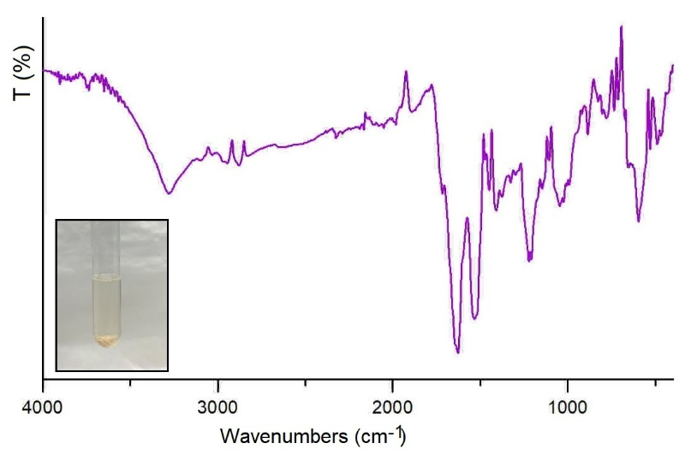

Figure S1. Digital image of the brown residue collected from SSF C1, and the relative FT-IR spectrum.

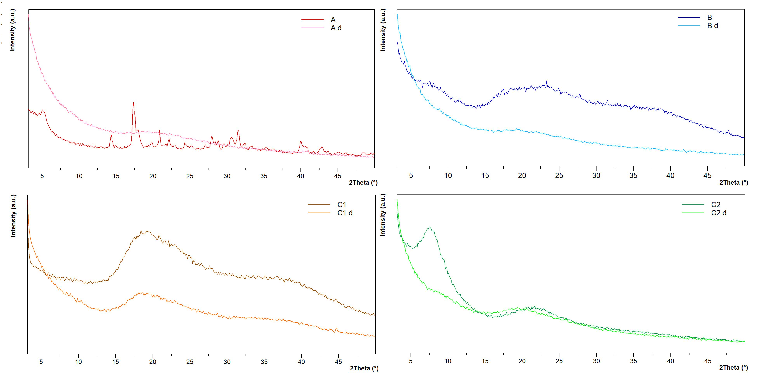
Figure S2. X-Rays diffraction patterns collected on freeze-dried SSFs, before and after dialysis: A as received (red line) and after dialysis (pink); B as received (blue line) and after dialysis (light blue); C1 as received (brown line) and after dialysis (orange); C2 as received (green line) and after dialysis (light green).

Table S1. ICP analysis of dialyzed SSF A
Element | Wavelength (nm) | Concentration (mg/Kg) | %RSD
Al | 394.401 | 0.08 | 1.57
P | 214.915 | ND
Se | 206.275 | ND
Zn | 213.857 | 0.49 | 0.94
Fe | 371.993 | 0.15 | 0.79
Ca | 616.217 | 13.46 | 0.31
Ba | 553.548 | 0.07 | 1.02
Cu | 324.754 | 0.24 | 0.86
Ni | 341.476  361.939 | ND  ND
K | 769.897 | 6.89 | 0.23
Pb | 405.781 | ND
Cr | 367.558  425.433 | ND  ND
Mg | 383.829 | 1.05 | 0.52
Mn | 403.449 | 0.005 | 3.05
Na | 589.592 | 4.91 | 0.94
ND= Not Detectable

Table S2. ICP analysis of dialyzed SSF B
Element | Wavelength (nm) | Concentration (mg/Kg) | %RSD
Al | 394.401 | 0.03 | 1.57
P | 214.915 | ND
Se | 206.275 | ND
Zn | 213.857 | 0.72 | 0.51
Fe | 373.486 | 0.16 | 0.13
Ca | 422.673 | 19.38 | 0.28
Ba | 553.548 | 0.06 | 0.77
Cu | 327.395 | 0.24 | 0.55
Ni | 341.476  361.939 | ND  ND
K | 769.897 | 6.00 | 0.85
Pb | 405.781 | ND
Cr | 367.558 | ND
Mg | 285.213 | 0.94 | 1.27
Mn | 403.307 | 6.59 | 0.86
Na | 589.592 | 6.42 | 0.18
ND= Not Detectable

Table S3. ICP analysis of dialyzed SSF C1
Element | Wavelength (nm) | Concentration (mg/Kg) | %RSD
Al | 394.401 | 0.04 | 2.09
P | 214.915 | ND
Se | 206.275 | ND
Zn | 213.857 | 0.49 | 0.30
Fe | 373.486 | 0.09 | 0.08
Ca | 422.673 | 9.45 | 0.14
Ba | 553.548 | 0.16 | 0.27
Cu | 324.754 | 0.09 | 14.63
Ni | 341.476  361.939 | ND  ND
K | 769.897 | 2.59 | 0.33
Pb | 405.781 | 0.01 | 10.31
Cr | 425.433 | 0.004 | 2.10
Mg | 383.829 | 0.46 | 0.34
Mn | 403.449 | 0.005 | 1.80
Na | 589.592 | 2.05 | 1.19
ND= Not Detectable

Table S4. ICP analysis of dialyzed SSF C2
Element | Wavelength (nm) | Concentration (mg/Kg) | %RSD
Al | 394.401 | 0.32 | 28.58
P | 213.618 | 14.69 | 0.95
Se | 206.275 | 19.05 | 4.84
Zn | 213.857 | 0.57 | 1.37
Fe | 371.993 | 0.09 | 3.91
Ca | 422.673 | 3.02 | 1.54
Ba | 705.994 | 0.15 | 0.90
Cu | 327.395 | 0.95 | 2.49
Ni | 361.939 | 0.05 | 0.71
K | 769.897 | 8.36 | 1.05
Pb | 405.781 | 0.11 | 11.18
Cr | 425.433 | 0.10 | 1.12
Mg | 285.213 | 0.24 | 1.37
Mn | 403.307 | 0.008 | 1.03
Na | 589.592 | ND
ND= Not Detectable

