Year | Santiago Centro |  | Duration* | El Bosque |  | Duration* | Cerro Navia |  | Duration*
Year | Start | End | Duration* | Start | End | Duration* | Start | End | Duration*
2011 | 28-11 | 30-11 | 3 | 28-11 | 30-11 | 3 | 28-11 | 30-11 | 3
2011 | 24-12 | 27-12 | 4 | - | - | - | 24-12 | 27-12 | 4
2012 | 08-02 | 10-02 | 2 | - | - | - | 08-02 | 10-02 | 2
2012 | 01-03 | 04-03 | 4 | 01-03 | 04-03 | 4 | 01-03 | 04-03 | 4
2012 | 07-03 | 10-03 | 4 | 07-03 | 09-03 | 3 | 07-03 | 09-03 | 3
2012 | 29-03 | 31-03 | 3 | - | - | - | 29-03 | 31-03 | 3
2013 | 27-12 | 29-12 | 3 | 27-12 | 29-12 | 3 | 27-12 | 29-12 | 3
2014 | 06-03 | 08-03 | 3 | 06-03 | 08-03 | 3 | 06-03 | 08-03 | 3
2014 | - | - | - | 20-03 | 22-03 | - | - | - | -
2015 | 08-01 | 11-01 | 4 | 08-01 | 11-01 | 4 | - | - | -
2015 | 24-01 | 26-01 | 3 | - | - | - | - | - | -
2015 | 31-01 | 02-02 | 3 | - | - | - | 31-01 | 02-02 | 3
2015 | 11-02 | 13-02 | 3 | 11-02 | 13-02 | 3 | 11-02 | 13-02 | 3
2015 | 08-03 | 21-03 | 14 | 08-03 | 12-03 | 5 | 08-03 | 12-03 | 5
 |  |  |  | 14-03 | 20-03 | 7 | 15-03 | 20-03 | 6
2015 | 24-12 | 28-12 | 5 | 24-12 | 28-12 | 5 | 24-12 | 28-12 | 5
2016 | 19-02 | 24-02 | 6 | 20-02 | 24-02 | 5 | 19-02 | 24-02 | 6
2016 | 28-02 | 02-03 | 4 | - | - | - | - | - | -
*$\sum{day; if Tx>P90(Tx) to 3 days or more}$
Tabla SI1. Dates of HW in the communes under study.

Tabla SI2. Dates of WD in the communes under study.
 | Period | WD | Anomaly (°C) | Temperature Max (°C) | WD total
Santiago Centro | 2011-2012 | 38 | 1.3 | 32.6 | 152
Santiago Centro | 2012-2013 | 22 | 1.3 | 33.0 | 152
Santiago Centro | 2013-2014 | 28 | 1.7 | 33.0 | 152
Santiago Centro | 2014-2015 | 39 | 1.4 | 32.7 | 152
Santiago Centro | 2015-2016 | 25 | 1.5 | 33.1 | 152
El Bosque | 2011-2012 | 27 | 1.1 | 32.2 | 123
El Bosque | 2012-2013 | 19 | 0.9 | 32.5 | 123
El Bosque | 2013-2014 | 25 | 1.3 | 32.6 | 123
El Bosque | 2014-2015 | 29 | 1.4 | 32.9 | 123
El Bosque | 2015-2016 | 23 | 1.2 | 32.9 | 123
Cerro Navia | 2011-2012 | 34 | 1.3 | 32.5 | 132
Cerro Navia | 2012-2013 | 18 | 1.3 | 32.8 | 132
Cerro Navia | 2013-2014 | 26 | 1.5 | 32.9 | 132
Cerro Navia | 2014-2015 | 30 | 1.6 | 32.8 | 132
Cerro Navia | 2015-2016 | 24 | 1.3 | 32.9 | 132

Table SI3. Percentage of deaths differentiated by age groups, and cause for each county.
County/ Causes (*)
Time Frame | Age Group | Santiago Centro (%) |  |  | El Bosque (%) |  |  | Cerro Navia (%)
Time Frame | Age Group | CV | CR | TC | CV | CR | TC | CV | CR | TC
2011-2012 | 0 - 8 | 0 | 0 | 2 | 0 | 0 | 2 | 2 | 0 | 3
2011-2012 | 9 - 24 | 0 | 0 | 1 | 3 | 0 | 2 | 0 | 0 | 1
2011-2012 | 25 - 64 | 12 | 14 | 21 | 20 | 17 | 27 | 21 | 50 | 27
2011-2012 | 65+ | 88 | 88 | 77 | 76 | 83 | 69 | 77 | 50 | 70
2012-2013 | 0 - 8 | 1 | 0 | 2 | 0 | 0 | 1 | 0 | 0 | 1
2012-2013 | 9 - 24 | 1 | 3 | 2 | 0 | 0 | 0 | 0 | 6 | 2
2012-2013 | 25 - 64 | 22 | 13 | 21 | 23 | 16 | 25 | 26 | 0 | 20
2012-2013 | 65+ | 76 | 85 | 74 | 77 | 84 | 73 | 74 | 94 | 77
2013-2014 | 0 - 8 | 1 | 0 | 3 | 0 | 0 | 2 | 0 | 0 | 2
2013-2014 | 9 - 24 | 0 | 0 | 1 | 2 | 0 | 1 | 2 | 0 | 1
2013-2014 | 25 - 64 | 15 | 12 | 22 | 24 | 17 | 29 | 19 | 21 | 29
2013-2014 | 65+ | 84 | 88 | 75 | 75 | 83 | 68 | 79 | 79 | 68
2014-2015 | 0 - 8 | 0 | 0 | 2 | 0 | 0 | 1 | 0 | 0 | 2
2014-2015 | 9 - 24 | 1 | 0 | 1 | 0 | 0 | 1 | 0 | 0 | 1
2014-2015 | 25 - 64 | 17 | 16 | 23 | 21 | 6 | 23 | 17 | 17 | 23
2014-2015 | 65+ | 82 | 84 | 74 | 79 | 94 | 75 | 83 | 83 | 74
2015-2016 | 0 - 8 | 0 | 3 | 3 | 0 | 0 | 3 | 0 | 0 | 2
2015-2016 | 9 - 24 | 0 | 0 | 1 | 0 | 0 | 1 | 0 | 0 | 2
2015-2016 | 25 - 64 | 21 | 15 | 24 | 21 | 14 | 25 | 16 | 33 | 20
2015-2016 | 65+ | 79 | 82 | 72 | 79 | 86 | 71 | 84 | 67 | 76

Table SI4. Percentage of admission differentiated by age groups, and cause for each county
County/ Causes (*)
Time Frame | Age Group | Santiago Centro (%) |  |  | El Bosque (%) |  |  | Cerro Navia (%)
Time Frame | Age Group | CV | CR | TC | CV | CR | TC | CV | CR | TC
2011-2012 | 0 - 8 | 1 | 30 | 11 | 2 | 27 | 11 | 0 | 22 | 11
2011-2012 | 9 - 24 | 3 | 10 | 13 | 4 | 11 | 21 | 3 | 10 | 20
2011-2012 | 25 - 64 | 51 | 38 | 59 | 42 | 23 | 46 | 43 | 38 | 50
2011-2012 | 65+ | 46 | 22 | 17 | 52 | 39 | 21 | 53 | 29 | 20
2012-2013 | 0 - 8 | 0 | 31 | 11 | 1 | 33 | 12 | 0 | 28 | 10
2012-2013 | 9 - 24 | 2 | 12 | 13 | 4 | 10 | 18 | 2 | 13 | 18
2012-2013 | 25 - 64 | 54 | 36 | 61 | 45 | 27 | 49 | 45 | 31 | 50
2012-2013 | 65+ | 43 | 21 | 16 | 50 | 30 | 21 | 53 | 28 | 22
2013-2014 | 0 - 8 | 0 | 28 | 10 | 0 | 36 | 11 | 0 | 27 | 12
2013-2014 | 9 - 24 | 3 | 12 | 12 | 3 | 10 | 20 | 2 | 11 | 18
2013-2014 | 25 - 64 | 49 | 36 | 61 | 46 | 24 | 49 | 43 | 31 | 49
2013-2014 | 65+ | 47 | 23 | 17 | 51 | 29 | 21 | 55 | 31 | 21
2014-2015 | 0 - 8 | 1 | 27 | 10 | 1 | 36 | 11 | 0 | 31 | 15
2014-2015 | 9 - 24 | 3 | 11 | 12 | 2 | 10 | 18 | 5 | 17 | 17
2014-2015 | 25 - 64 | 52 | 39 | 62 | 46 | 25 | 49 | 44 | 24 | 49
2014-2015 | 65+ | 44 | 23 | 16 | 51 | 29 | 22 | 50 | 28 | 19
2015-2016 | 0 - 8 | 1 | 29 | 10 | 1 | 33 | 12 | 1 | 41 | 12
2015-2016 | 9 - 24 | 2 | 12 | 11 | 3 | 13 | 17 | 1 | 16 | 17
2015-2016 | 25 - 64 | 51 | 38 | 62 | 46 | 26 | 50 | 42 | 24 | 51
2015-2016 | 65+ | 46 | 21 | 17 | 50 | 28 | 21 | 56 | 19 | 20

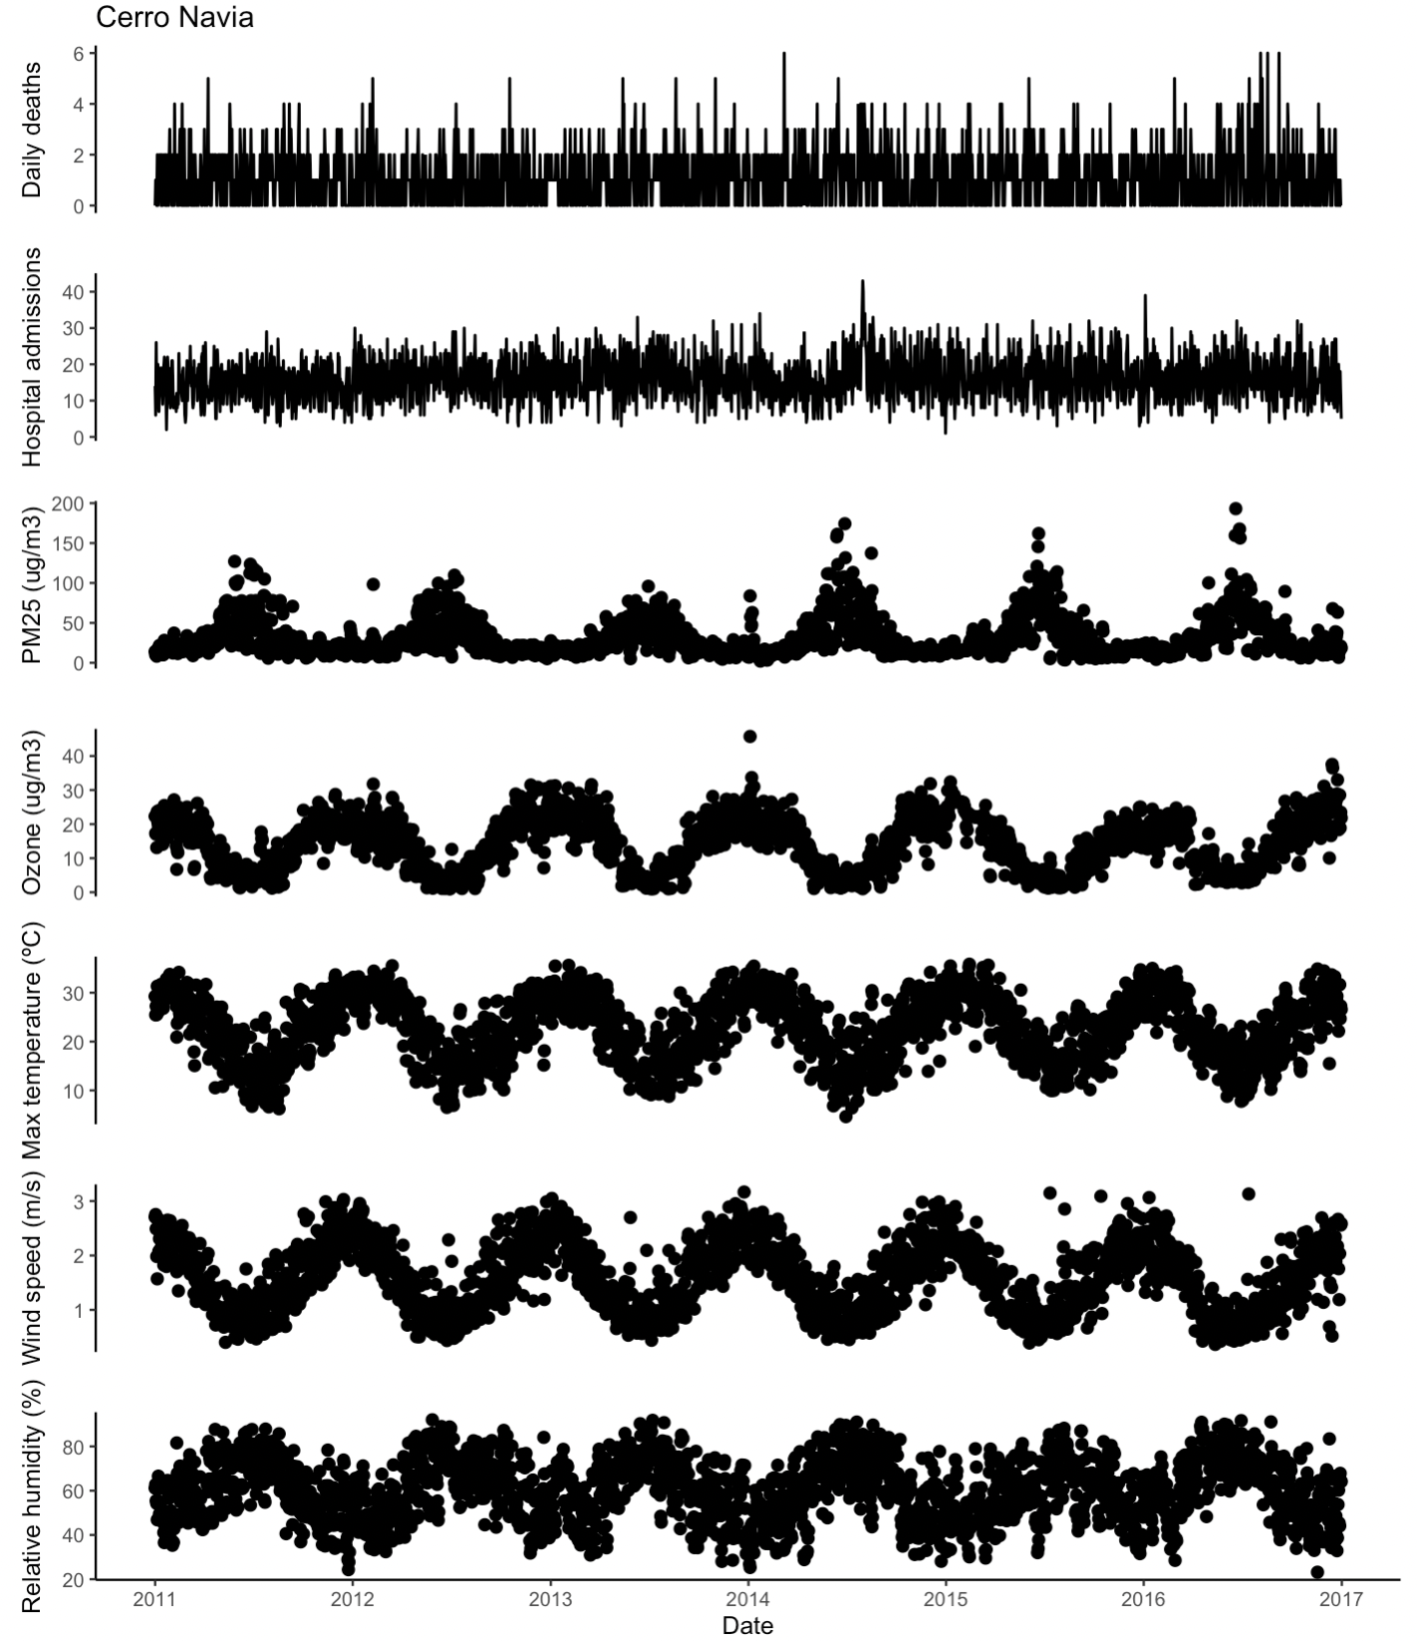

Figure SI1. Time series meteorological, air pollution, and health outcomes for Cerro Navia (2011-2016).

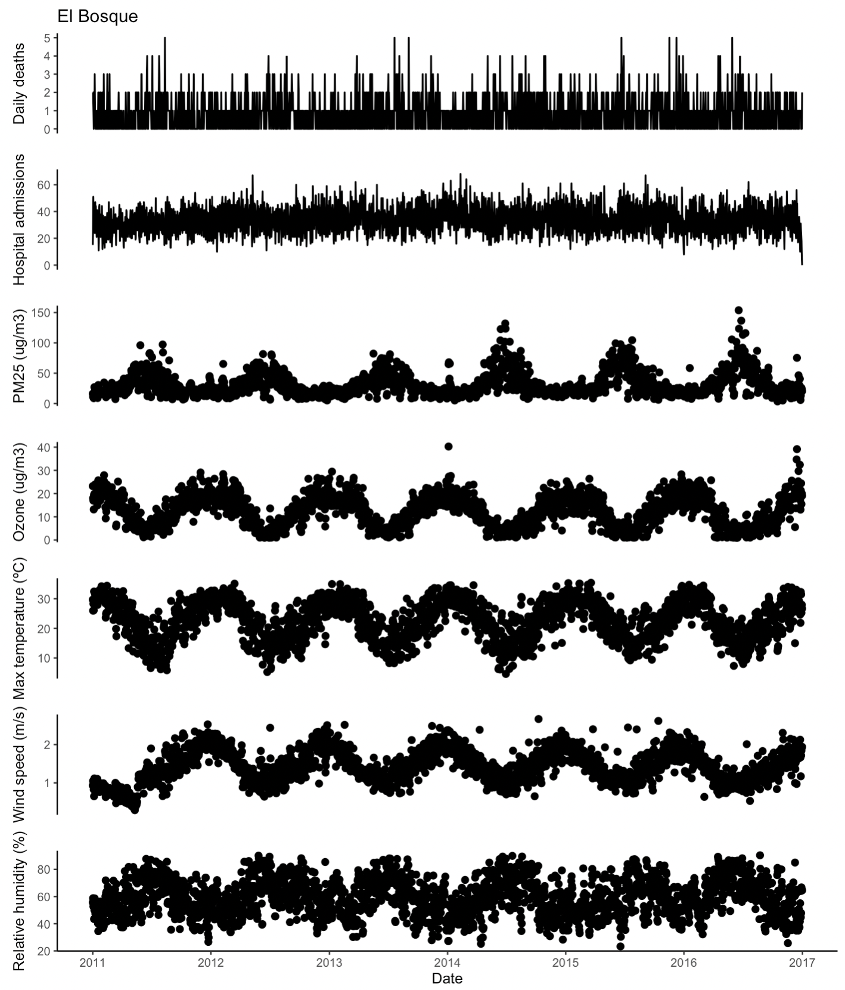

Figure SI2. Time series meteorological, air pollution, and health outcomes for El Bosque (2011-2016).

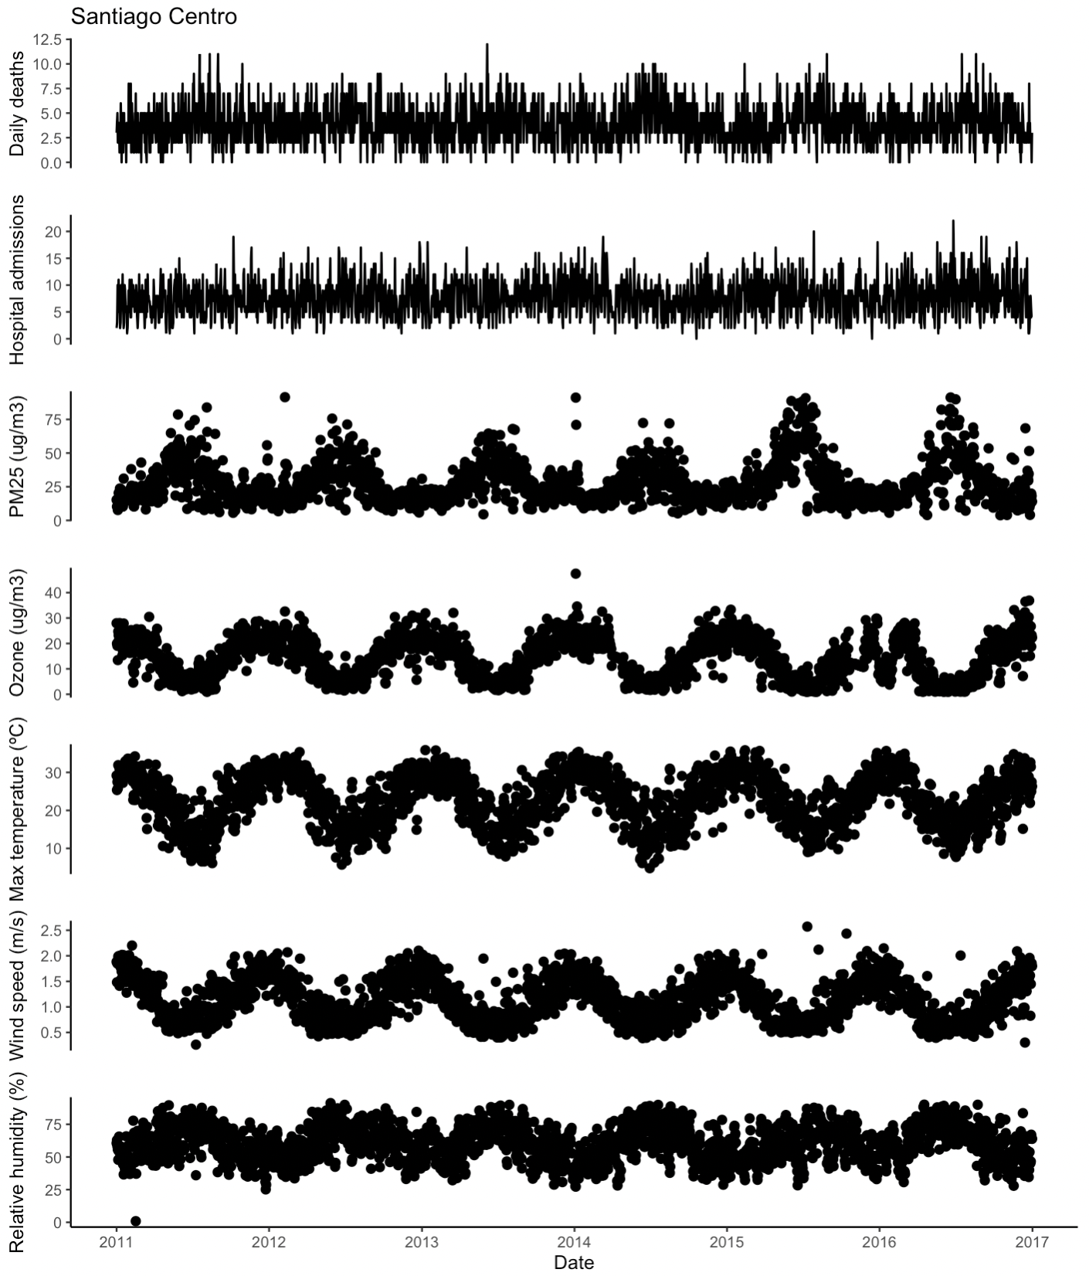
Figure SI3. Time series meteorological, air pollution, and health outcomes for Santiago Centro (2011-2016).

