Table S1: Nutrients content in the shoot part of purslane plants grown under different slumgum treatments (S= solid slumgum; TS= solid slumgum transformed with P. chrysogenum ; L= liquid slumgum; TL= liquid slumgum transformed with P. chrysogenum ).
 | Foliar N (g/Kg) | Foliar C (g/Kg) | Foliar P (g/ Kg) | Foliar K (g/ Kg) | Foliar Ca (g/ Kg) | Foliar Mg (g/Kg) | Foliar Fe (g/Kg)
Control | 0.093 ± 0.006 a | 3.75 ± 0.037 | 0.052 ± 0.007 a | 0.53 ± 0.005 b | 0.15 ± 0.005 c | 0.11 ± 0.011 c | 0.39 ± 0.07 b
S | 0.090 ± 0.011 a | 3.77 ± 0.005 | 0.065 ± 0.002 a | 0.47 ± 0.022 a | 0.08 ± 0.017 a | 0.07 ± 0.008 a | 0.28 ± 0.06 ab
TS | 0.130 ± 0.007 b | 3.74 ± 0.016 | 0.104 ± 0.010 b | 0.48 ± 0.004 a | 0.12 ± 0.003 b | 0.09 ± 0.006 bc | 0.15 ± 0.01 a
L | 0.100 ± 0.003 a | 3.77 ± 0.025 | 0.097 ± 0.008 b | 0.46 ± 0.020 a | 0.11 ± 0.010 ab | 0.08 ± 0.005 ab | 0.20 ± 0.05 a
TL | 0.090 ± 0.004 a | 3.76 ± 0.048 | 0.100 ± 0.011 b | 0.45 ± 0.017 a | 0.10 ± 0.009 ab | 0.07 ± 0.003 ab | 0.18 ± 0.04 a
ANOVA F values (P values)  Slumgum type (S)  Transformation (T)  S x T | 2.81 (0.094)  3.39 (0.087)  14.77 (0.002) | 0.21 (0.814)  0.49 (0.497)  0.11 (0.748) | 5.64 (0.016)  6.27 (0.025)  4.75 (0.047) | 7.80 (0.005)  0.06 (0.817)  0.40 (0.537) | 12.34 (<0.001)  2.31 (0.151)  6.08 (0.027) | 10.99 (0.001)  1.90 (0.190)  5.30 (0.037) | 3.36 (0.067)  2.39 (0.146)  1.43 (0.253)
Mean±standard error, n=5. Significance of effects of slumgum type (S), transformation (T) and their interaction (SxT) on the measured variables is also shown (F values (P values)). P-values in bold indicate a significant (P<0.05) effect of the experimental factors. When the interaction between factors was significant, values in columns sharing the same letter do not differ significantly (P < 0.05) as determined by the Tukey HSD test.

Table S2: Chemical and physico-chemical properties of the rhizospheric soil of purslane plants grown under different slumgum treatments (S= solid slumgum; TS= solid slumgum transformed with P. chrysogenum ; L= liquid slumgum; TL= liquid slumgum transformed with P. chrysogenum ).
 | TN (g/Kg) | TC (g/Kg) | TP (g/ Kg) | TK (g/ Kg) | OM (g/ Kg) | AP (g/Kg) | pH | EC
Control | 0.014 ± 0.001 | 0.867 ± 0.046 | 0.0081 ± 0.0003 | 0.045 ± 0.001 | 0.25 ± 0.024 | 0.45 ± 0.027 | 7.99 ± 0.15 | 126 ± 5.8 a
S | 0.022 ± 0.002 | 0.842 ± 0.069 | 0.0085 ± 0.0001 | 0.051 ± 0.006 | 0.26 ± 0.039 | 0.47 ± 0.044 | 8.27 ± 0.05 | 145 ± 6.5 ab
TS | 0.016 ± 0.002 | 0.811 ± 0.065 | 0.0074 ± 0.0007 | 0.039 ± 0.003 | 0.25 ± 0.032 | 0.50 ± 0.048 | 8.32 ± 0.05 | 153 ± 11 b
L | 0.017 ± 0.002 | 0.886 ± 0.044 | 0.0089 ± 0.0007 | 0.051 ± 0.004 | 0.28 ± 0.018 | 0.45 ± 0.011 | 8.14 ± 0.06 | 124 ± 2.9 a
TL | 0.018 ± 0.002 | 0.866 ± 0.069 | 0.0083 ± 0.0006 | 0.050 ± 0.002 | 0.30 ± 0.018 | 0.51 ± 0.017 | 8.29 ± 0.02 | 125 ± 4.4 a
ANOVA F values (P values)  Slumgum type (S)  Transformation (T)  S x T | 3.51 (0.058)  0.94 (0.348)  3.86 (0.070) | 0.40 (0.678)  0.22 (0.649)  0.01 (0.920) | 1.08 (0.366)  2.54 (0.133)  0.19 (0.669) | 2.40 (0.127)  3.71 (0.075)  2.03 (0.176) | 0.91 (0.424)  0.01 (0.919)  0.36 (0.558) | 0.03 (0.970)  1.48 (0.246)  0.10 (0.757) | 3.13 (0.068)  2.17 (0.158)  0.43 (0.523) | 6.84 (0.006)  0.42 (0.525)  0.29 (0.599)
Mean±standard error, n=5. Significance of effects of slumgum type (S), transformation (T) and their interaction (SxT) on the measured variables is also shown (F values (P values)). P-values in bold indicate a significant (P<0.05) effect of the experimental factors. When the interaction between factors was significant, values in columns sharing the same letter do not differ significantly (P < 0.05) as determined by the Tukey HSD test. TN (soil total nitrogen), TC (soil total carbon), TP (soil total phosphorous), TK (soil total potassium), OM (soil organic matter), AP (available phosphorous), EC (electrical conductivity).

Table S3: Results of a permutational multivariate analysis of variance (PERMANOVA) testing the effects of the experimental factors (slumgum type, transformation with Penicillum chrysogenum and their interaction) on soil fungal (A) and bacterial (B) community structure, using Hellinger-based distances as a measure of dissimilarity and 999 permutations. P-values in bold with an asterisk indicate a significant (P<0.05) effect of the experimental factors (S: slumgum type; T: transformation with P. chrysogenum; S*T: slumgum x transformation interaction).

A) | R² | pseudo-F | p-value
S | 0.081 | 1.965 | 0.049*
T | 0.141 | 3.422 | 0.001***
S*T | 0.116 | 2.802 | 0.010**
B) | R2 | pseudo-F | p-value
S | 0.082 | 1.852 | 0.024*
T | 0.088 | 1.966 | 0.029*
S*T | 0.162 | 3.646 | 0.001***

Table S4: Results of the two-way ANOVAs (F- and P-values) testing the effects of the experimental factors (slumgum type (S); transformation with Penicillum chrysogenum (T) and their interaction (SxT)) on the relative abundances (%) of fungal sequences belonging to 4 significant fungal phylum. P-values in bold indicate a significant (P<0.05) effect of the experimental factors.
 |  | Ascomycota | Mortierellomycota | Basidiomycota | Mucoromycota
S | F | 17.282 | 24.052 | 12.140 | 85.760
(df=2) | P | <0.001 | <0.001 | 0.001 | <0.001
T | F | 0.537 | 2.174 | 7.576 | 0.860
(df=1) | P | 0.476 | 0.162 | 0.016 | 0.369
S x T | F | 1.091 | 2.786 | 7.059 | 0.639
(df=1) | P | 0.314 | 0.117 | 0.020 | 0.437

Table S5: Results of the two-way ANOVAs (F- and P-values) testing the effects of the experimental factors (slumgum type (S); transformation with Penicillum chrysogenum (T) and their interaction (SxT)) on the relative abundances (%) of fungal sequences belonging to 21 significant fungal genus. P-values in bold indicate a significant (P<0.05) effect of the experimental factors.
 | S (df=2) |  | T (df=1) |  | SxT (df=1)
Genus | F | P | F | P | F | P
Humicola | 1.835 | 0.196 | 14.938 | 0.002 | 7.544 | 0.016
Mortierella | 21.647 | <0.001 | 3.877 | 0.069 | 3.879 | 0.069
Preussia | 12.967 | <0.001 | 2.857 | 0.113 | 10.622 | 0.006
Botryotrichum | 9.595 | 0.002 | 1.440 | 0.250 | 12.822 | 0.003
Alternaria | 39.632 | <0.001 | 53.140 | <0.001 | 50.765 | <0.001
Bisifusarium | 1.618 | 0.233 | 8.493 | 0.011 | 11.164 | 0.005
Peziza | 1.770 | 0.206 | 5.750 | 0.031 | 4.215 | 0.059
Podospora | 2.628 | 0.107 | 0.571 | 0.462 | 5.260 | 0.038
Stachybotrys | 7.366 | 0.007 | 9.088 | 0.009 | 2.548 | 0.133
Mucor | 86.771 | <0.001 | 0.820 | 0.380 | 0.694 | 0.419
Neocosmospora | 7.530 | 0.006 | 0.017 | 0.897 | 0.028 | 0.869
Wardomycopsis | 8.201 | 0.004 | 1.774 | 0.204 | 6.306 | 0.025
Aspergillus | 7.952 | 0.005 | 6.288 | 0.025 | 0.027 | 0.871
Solicoccozyma | 6.736 | 0.009 | 0.849 | 0.372 | 0.981 | 0.339
Hormiactis | 14.567 | <0.001 | 0.617 | 0.445 | 5.991 | 0.028
Myceliophthora | 11.897 | <0.001 | 4.404 | 0.054 | 5.092 | 0.041
Geomyces | 0.877 | 0.438 | 5.521 | 0.034 | 12.590 | 0.003
Purpureocillium | 0.077 | 0.926 | 11.628 | 0.004 | 2.406 | 0.143
Acremonium | 6.801 | 0.009 | 0.158 | 0.697 | 3.862 | 0.070
Canaryomices | 23.560 | <0.001 | 4.880 | 0.044 | 13.595 | 0.002
Ochroconis | 58.168 | <0.001 | 65.842 | <0.001 | 49.991 | <0.001

Table S6: Results of the two-way ANOVAs (F- and P-values) testing the effects of the experimental factors (slumgum type (S); transformation with Penicillum chrysogenum (T) and their interaction (SxT)) on the relative abundances (%) of fungal sequences belonging to 6 different functional guilds. P-values in bold indicate a significant (P<0.05) effect of the experimental factors.
 |  | Plant Pathogens | Parasites | Lichenized | Symbiotrophs | Endophytes | Saprotrophs
S | F | 4.771 | 0.375 | 0.073 | 5.004 | 13.976 | 3.686
(df=2) | P | 0.026 | 0.694 | 0.930 | 0.023 | <0.001 | 0.050
T | F | 19.291 | 32.564 | 0.079 | 0.033 | 3.870 | 28.381
(df=1) | P | <0.001 | <0.001 | 0.783 | 0.858 | 0.069 | <0.001
S x T | F | 13.554 | 5.658 | 1.869 | 1.042 | 6.484 | 12.731
(df=1) | P | 0.002 | 0.032 | 0.193 | 0.325 | 0.023 | 0.003

Table S7: Results of the two-way ANOVAs (F- and P-values) testing the effects of the experimental factors (slumgum type (S); transformation with Penicillum chrysogenum (T) and their interaction (SxT)) on the relative abundances (%) of bacterial sequences belonging to 7 significant bacterial phylum. P-values in bold indicate a significant (P<0.05) effect of the experimental factors.
 | S (df=2) |  | T (df=1) |  | SxT (df=1)
Phylum | F | P | F | P | F | P
Actinomycetota | 11.214 | 0.001 | 13.004 | 0.003 | 27.743 | <0.001
Pseudomonadota | 11.598 | 0.001 | 5.038 | 0.041 | 27.047 | <0.001
Bacillota | 35.272 | <0.001 | 8.225 | 0.012 | 0.876 | 0.365
Chloroflexota | 4.515 | 0.031 | 1.494 | 0.242 | 3.649 | 0.077
Cyanobacteriota | 3.028 | 0.081 | 4.712 | 0.048 | 9.754 | 0.007
Verrucomicrobiota | 5.523 | 0.017 | 0.065 | 0.802 | 0.613 | 0.447
Myxococcota | 18.211 | <0.001 | 16.223 | 0.001 | 0.250 | 0.625

Table S8: Results of the two-way ANOVAs (F- and P-values) testing the effects of the experimental factors (slumgum type (S); transformation with Penicillum chrysogenum (T) and their interaction (SxT)) on the relative abundances (%) of bacterial sequences belonging to 13 significant bacterial genus. P-values in bold indicate a significant (P<0.05) effect of the experimental factors.
 | S (df=2) |  | T (df=1) |  | SxT (df=1)
Genus | F | P | F | P | F | P
Microbacterium | 8.292 | 0.004 | 0.905 | 0.357 | 7.164 | 0.018
Bacillus | 7.382 | 0.006 | 2.327 | 0.149 | 0.148 | 0.706
Virgibacillus | 54.572 | <0.001 | 1.638 | 0.221 | 2.282 | 0.153
Ilumatobacter | 15.301 | <0.001 | 3.497 | 0.083 | 0.257 | 0.620
Gitt-GS-136 | 5.629 | 0.016 | 0.913 | 0.356 | 1.369 | 0.261
TM7a | 80.517 | <0.001 | 0.297 | 0.594 | 2.260 | 0.155
Myxococcus | 12.131 | <0.001 | 12.268 | 0.004 | 1.142 | 0.303
Rhizobium | 10.077 | 0.002 | 5.015 | 0.042 | 1.719 | 0.211
IMCC26256 | 15.063 | <0.001 | 2.494 | 0.137 | 5.097 | 0.040
Flavitalea | 7.315 | 0.007 | 0.406 | 0.534 | 1.284 | 0.276
Candidatus | 5.508 | 0.017 | 0.009 | 0.925 | 1.412 | 0.254
Rubellimicrobium | 12.969 | <0.001 | 3.316 | 0.090 | 0.222 | 0.645
Staphylococcus | 9.799 | 0.002 | 3.402 | 0.086 | 1.986 | 0.181

Table S9: Results of the two-way ANOVAs (F- and P-values) testing the effects of the experimental factors (slumgum type (S); transformation with Penicillum chrysogenum (T) and their interaction (SxT)) on the relative expression of functional predicted genes related to N, C and P cycling. P-values in bold indicate a significant (P<0.05) effect of the experimental factors.
 |  | S (df=2) |  | T (df=1) |  | S x T (df=1)
 |  | F | P | F | P | F | P
 |  | Nitrogen cycle
Nitrogen  Fixation | nifH | 3.899 | 0.051 | 0.000 | 1.000 | 6.205 | 0.026
Nitrogen  Fixation | nifD | 1.409 | 0.277 | 0.000 | 1.000 | 5.793 | 0.030
Nitrogen  Fixation | nifK | 1.436 | 0.271 | 0.000 | 1.000 | 5.819 | 0.030
Denitrification | narG | 40.51 | <0.001 | 7.079 | 0.019 | 1.844 | 0.196
Denitrification | narH | 38.93 | <0.001 | 7.214 | 0.018 | 1.609 | 0.225
Denitrification | nirK | 5.945 | 0.014 | 4.067 | 0.063 | 34.96 | <0.001
Denitrification | narI | 3.948 | 0.044 | 0.112 | 0.743 | 5.551 | 0.034
Denitrification | norB | 12.01 | <0.001 | 10.94 | 0.005 | 22.27 | <0.001
Denitrification | norC | 11.61 | 0.001 | 12.97 | 0.003 | 0.000 | 1.000
Denitrification | nosZ | 1.153 | 0.344 | 0.000 | 1.000 | 0.922 | 0.353
Nitrification | amoA | 0.000 | 1.000 | 0.000 | 1.000 | 0.000 | 1.000
Nitrification | amoB | 0.000 | 1.000 | 0.000 | 1.000 | 0.000 | 1.000
Nitrification | amoC | 0.000 | 1.000 | 0.000 | 1.000 | 11.74 | 0.004
Nitrification | hao | 0.000 | 1.000 | 0.000 | 1.000 | 0.000 | 1.000
Carbon cycle
 | malZ | 0.005 | 0.995 | 1.656 | 0.219 | 10.44 | 0.006
 | Catalase | 0.611 | 0.557 | 1.162 | 0.299 | 9.886 | 0.007
 | bglx | 0.202 | 0.819 | 3.567 | 0.080 | 26.76 | <0.001
 | Gpx | 3.376 | 0.064 | 4.715 | 0.048 | 1.953 | 0.184
 | FUCA | 1.794 | 0.202 | 2.620 | 0.128 | 13.87 | 0.002
 | ppc | 7.964 | 0.005 | 1.223 | 0.287 | 34.28 | <0.001
Phosphate cycle
 | phnX | 1.599 | 0.237 | 4.496 | 0.052 | 0.334 | 0.573
 | ppk | 3.228 | 0.070 | 4.279 | 0.058 | 2.403 | 0.143

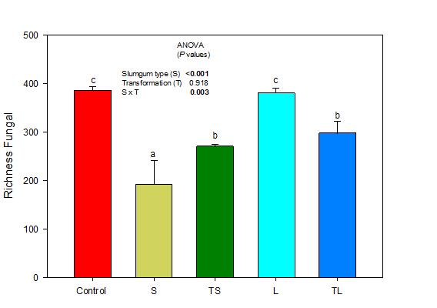
A
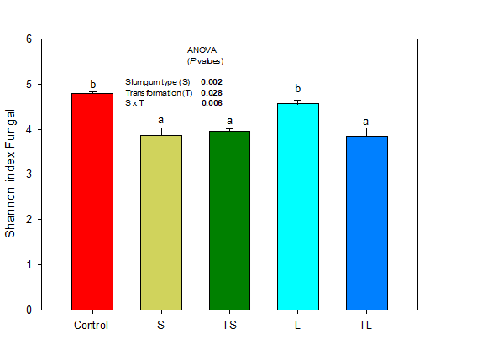
B

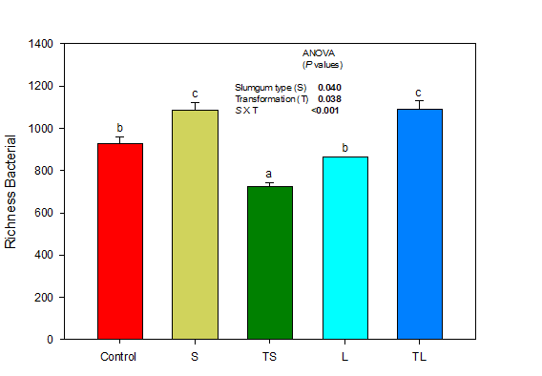
C
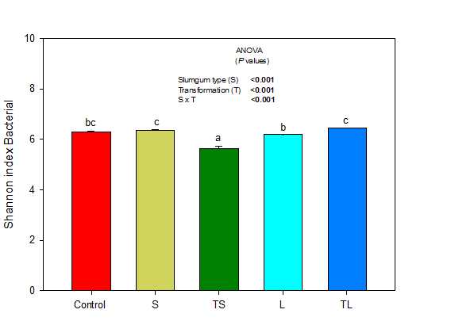
D
Figure S1: Mean OTU richness and Shannon-Wiener diversity indexes for the overall soil fungal (A, B) and bacterial (C, D) community in rhizospheric soil samples under different slumgum treatments (S= solid slumgum; TS= solid slumgum transformed with P. chrysogenum; L= liquid slumgum; TL= liquid slumgum transformed with P. chrysogenum ). N=4. Significance of effects of slumgum type (S), transformation (T) and their interaction (SxT) on the measured variables is also shown (P values). P-values in bold indicate a significant (P<0.05) effect of the experimental factors. When the interaction between factors was significant, values in columns sharing the same letter do not differ significantly (P < 0.05) as determined by the Tukey HSD test. Bars represent standard error.

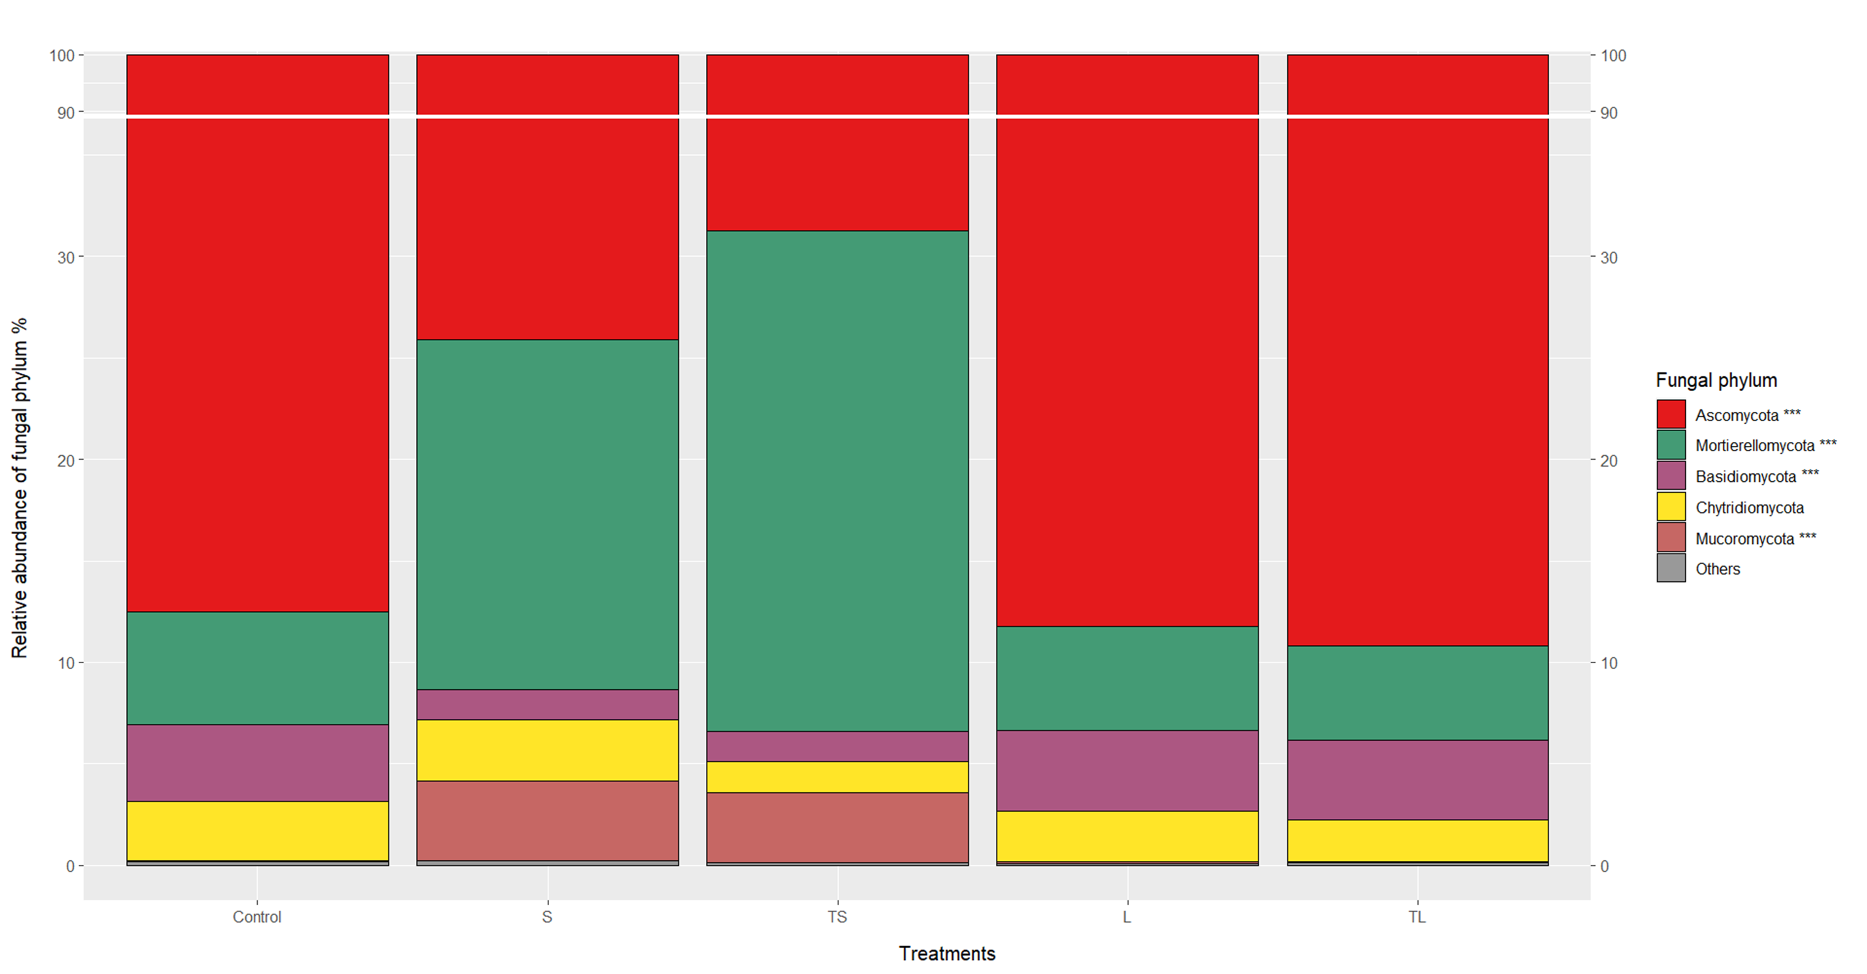
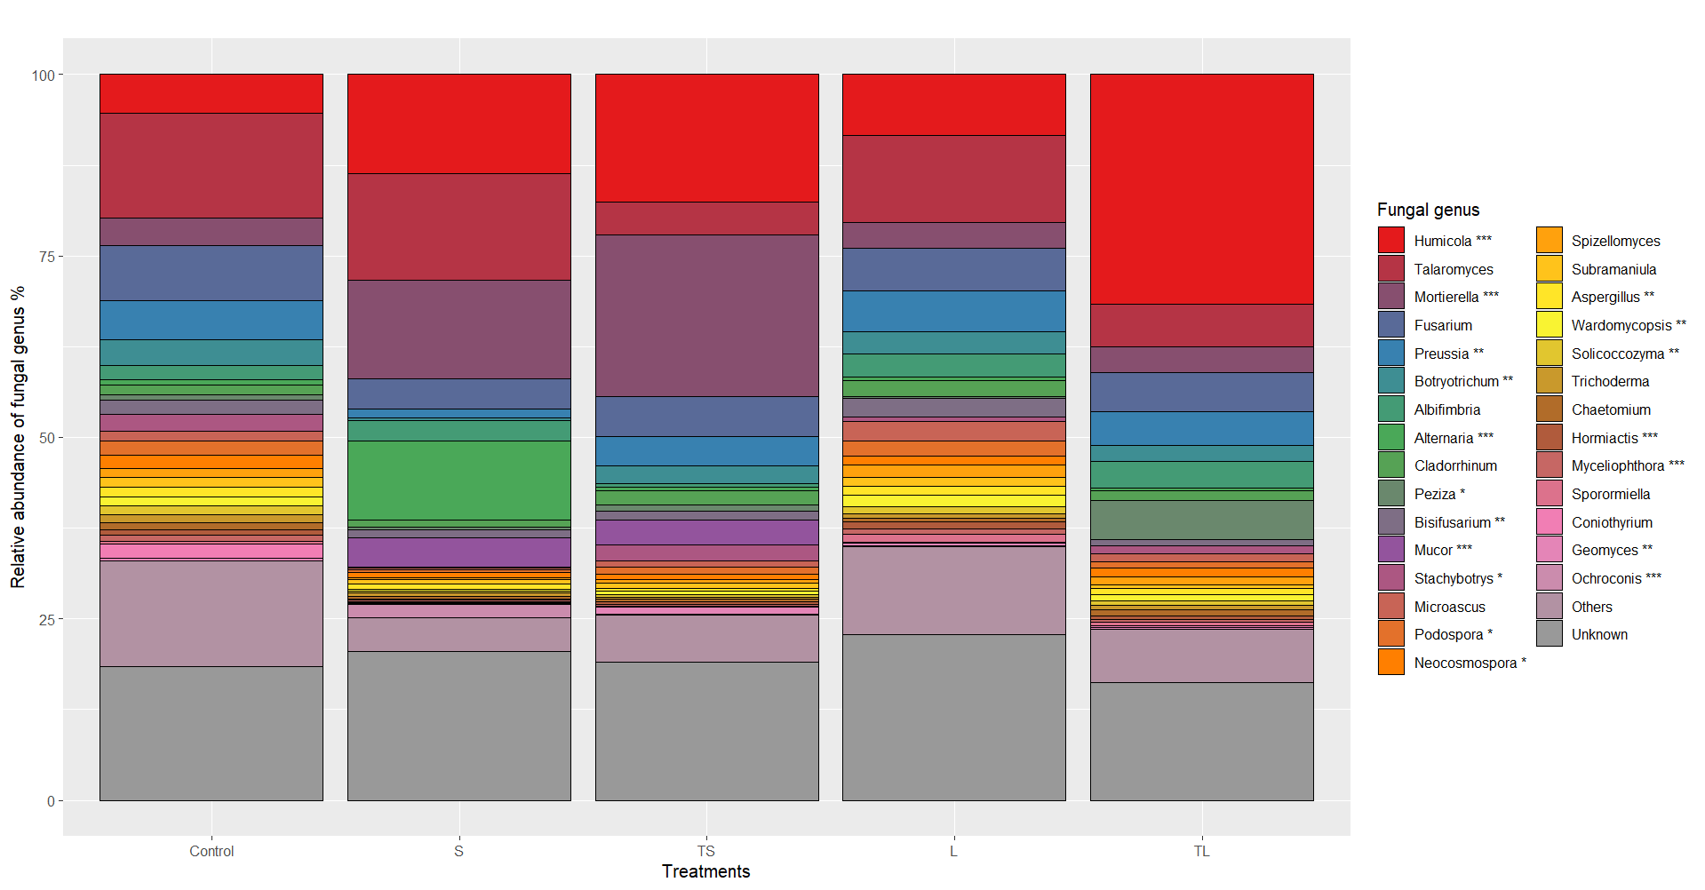

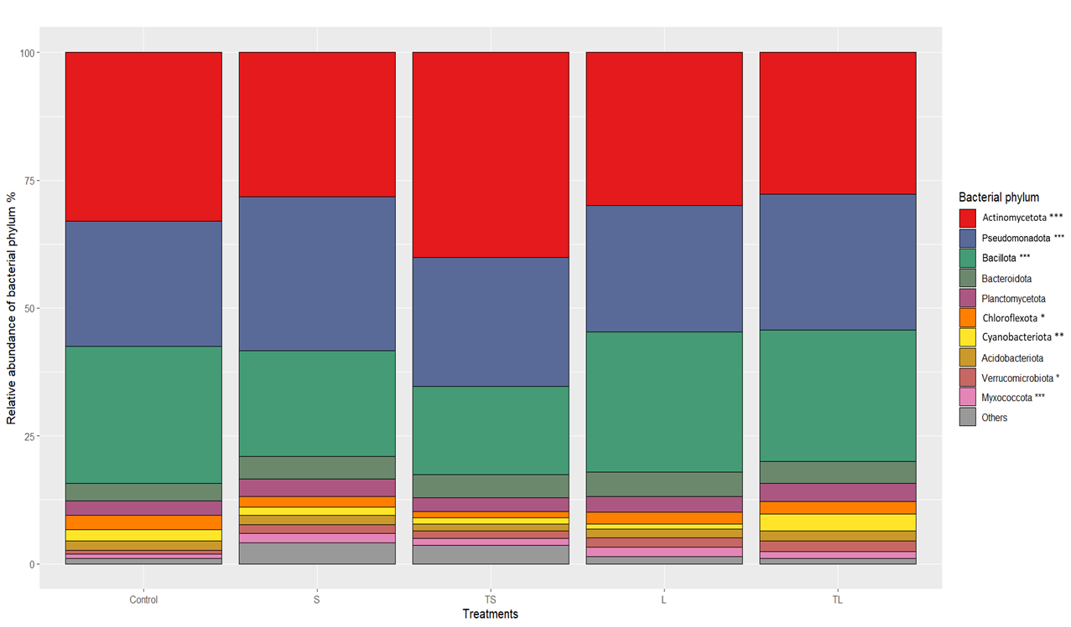
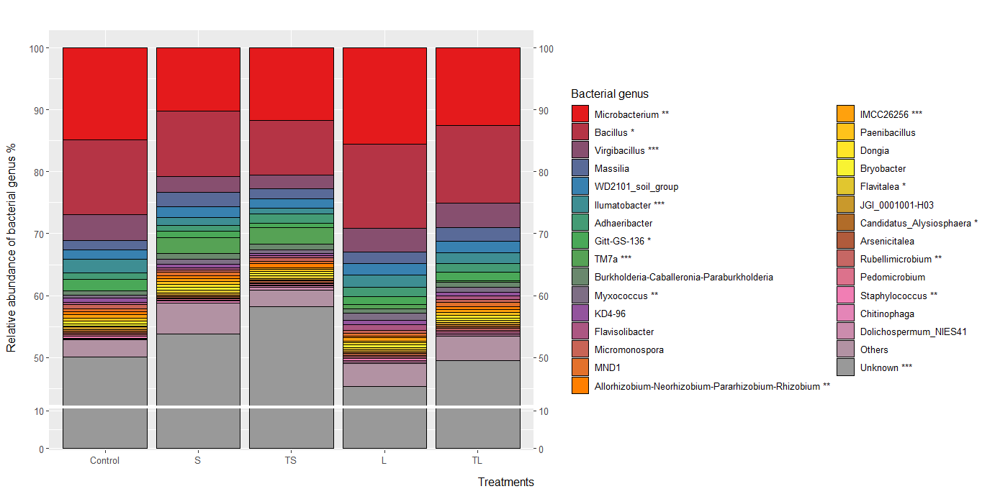
Figure S2: Relative abundances of the dominant fungal (A-B) and bacterial (C-D) phyla and genus of the rhizospheric soil of purslane under different slumgum treatments (S= solid slumgum; TS= solid slumgum transformed with P. chrysogenum ; L= liquid slumgum; TL= liquid slumgum transformed with P. chrysogenum ). For each phylum and genus, significant differences were assessed by the Tukey´s post-hoc test calculated at p < 0.05 and indicated by an asterisk, *p < 0.05; **p < 0.01; ***p < 0.001.

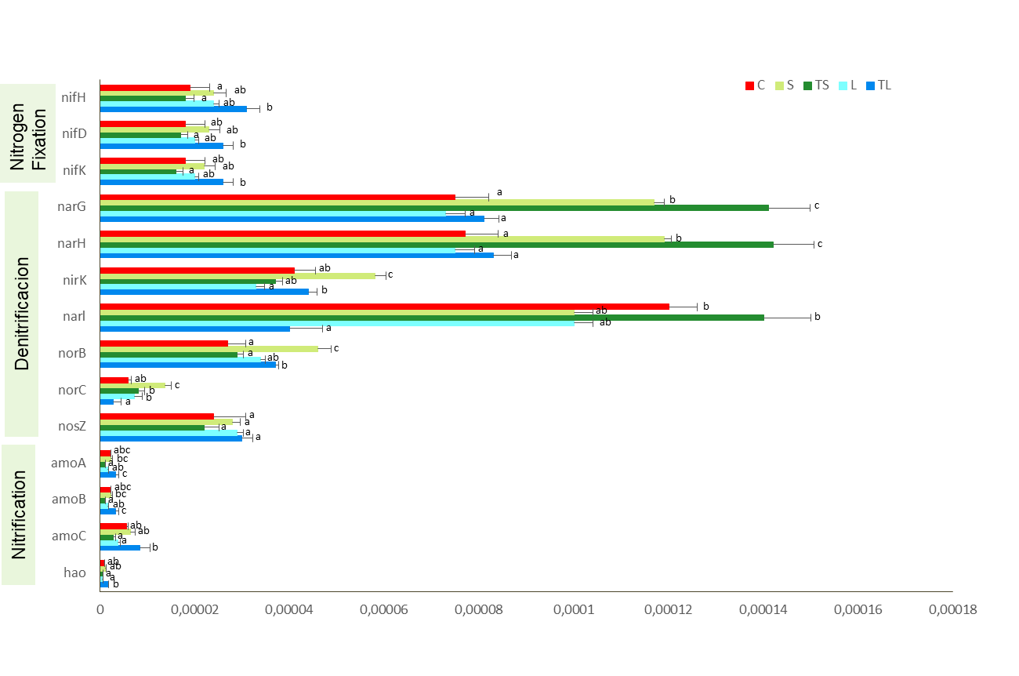
Figure S3: Relative abundance of functional predicted genes related to N, C and P cycling in rhizospheric soil under different slumgum treatments (S= solid slumgum; TS= solid slumgum transformed with P. chrysogenum ; L= liquid slumgum; TL= liquid slumgum transformed with P. chrysogenum ). N=4. For each gene, bars followed by the same letter are not significantly different according to Tukey’s HSD-test (p < 0.05). Bars represent standard error.
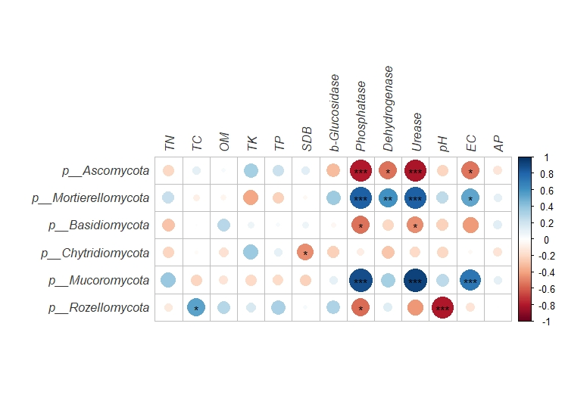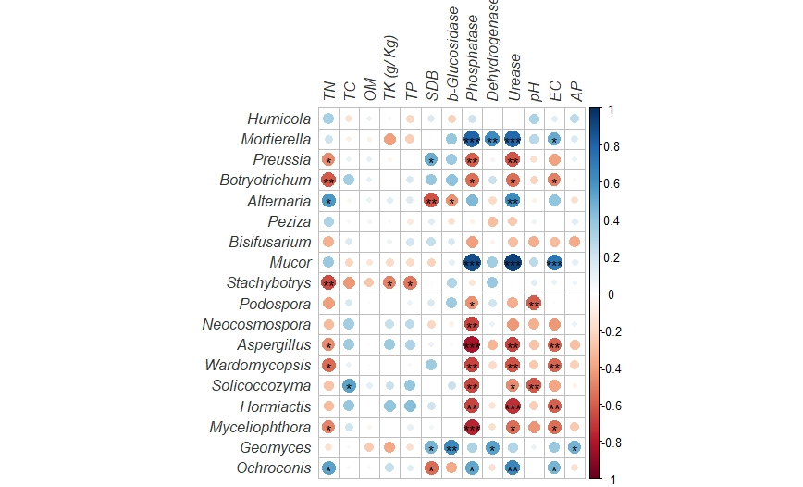
B
A

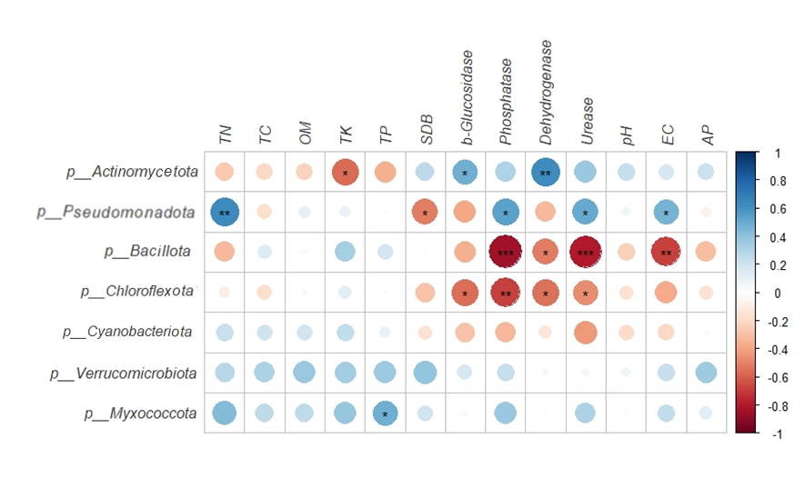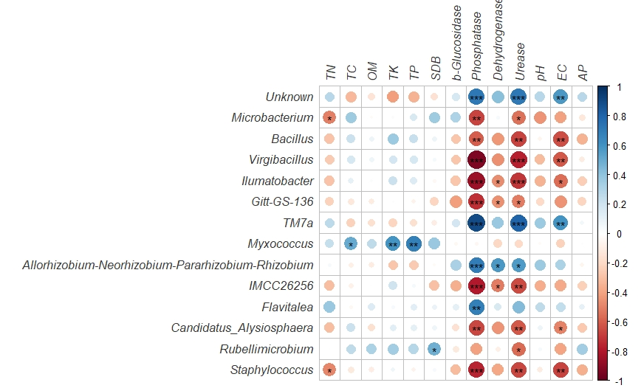
D
C

Figure S4: Correlations between the significant fungal (A,B) and bacterial (C,D) phyla and genus and soil properties and plant biomass. The R value is shown in different colours in the figure. If the P-value is < 0.05, it is marked with an asterisk. *0.01 < P ≤ 0.05; **0.001 < P ≤ 0.01; ***P ≤ 0.001.

