SUPPLEMENTARY MATERIAL

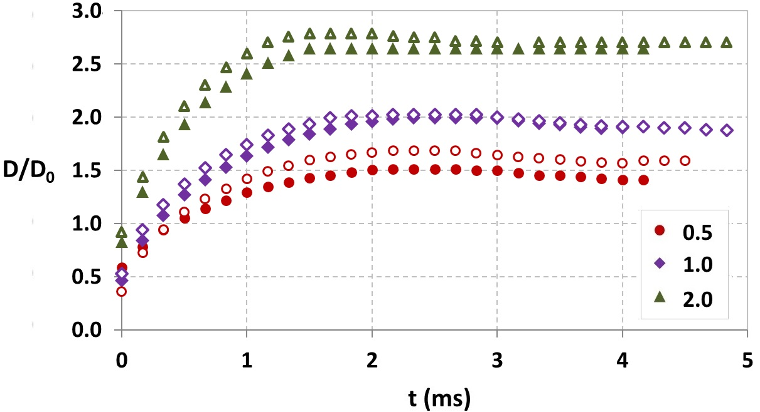
Fig.S1: The temporal variation of the contact diameter (D) which are non-dimensionalised by the initial droplet diameter (D₀) on the surface 1:30 [the open symbols represent the values for water droplets and the closed symbols represent the values for 1 g/l PEO droplets respectively]
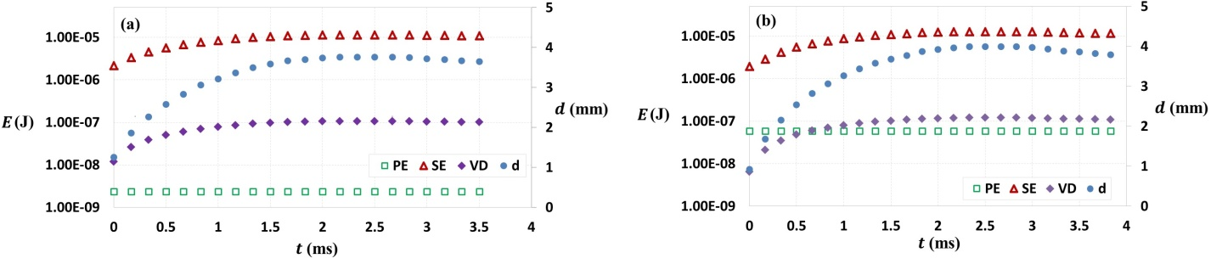
Fig.S2: The temporal variation of the energies for droplets of 1 g/l PEO on (a) 1:10 surface and (b) 1:30 surface, both at a velocity of 1 m/s (PE: potential energy due to substrate deformation caused by the impact of the droplets, SE: surface energy of the droplets, VD: viscous dissipation) [secondary axis shows the instantaneous contact diameter (d) of the droplet]
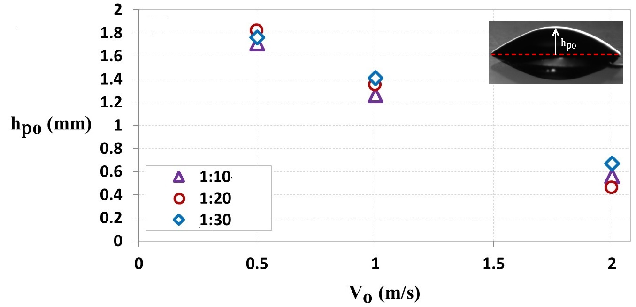

Fig.S3: The initial peak height of the droplet for different velocities on different substrates.

