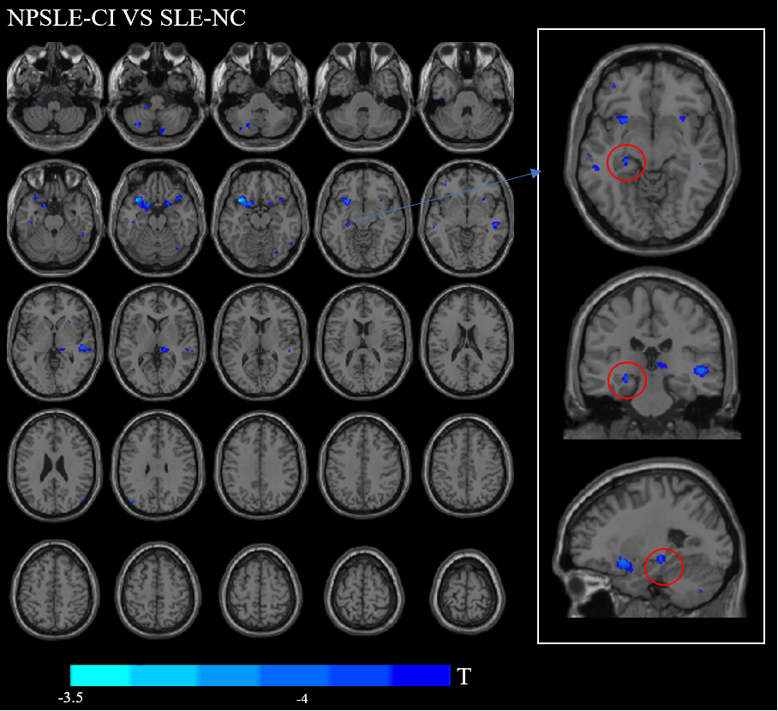
Supplementary Figure 1: Brain regions with significant brain gray matter volume changes in the SLE-CI group compared to the SLE-NC group. The cold color represents the gray matter reduction area in the SLE-CI group; the gray matter volume atrophy in the left hippocampus domain in the SLE-CI group is highlighted in the right white box, and the lower blue indicates the T value colorbar.

