Accurate Protein-Ligand Binding Free Energy Estimation by Applying QM/MM Calculations on Multi-Conformers Predicted from a Classical Mining Minima Approach
Supporting Information

Farzad Molani and Art E. Cho*
Korea University, inCerebro, Co., Ltd.

Figures

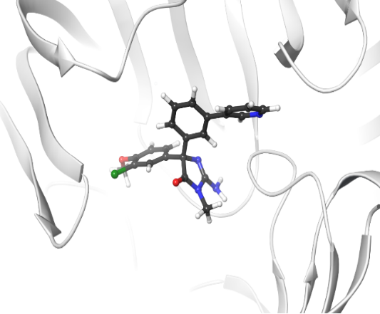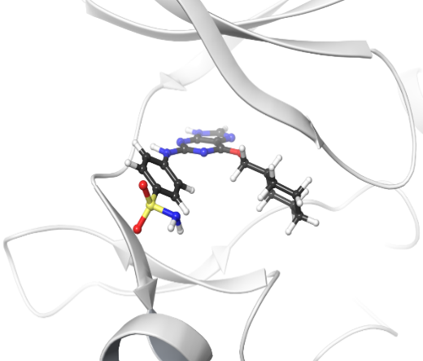
46L_BACE(P2)
1h1s_CDK2
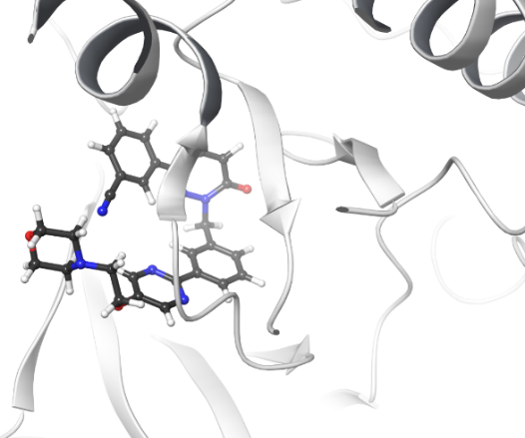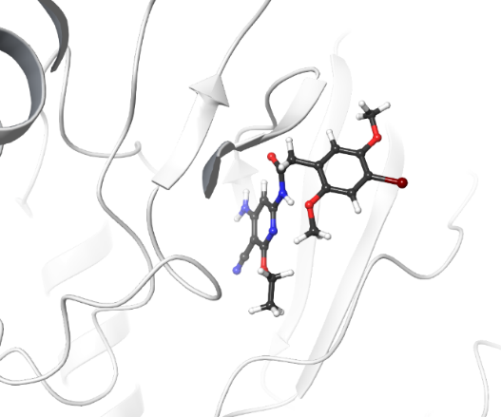
17124_JNK1
21_CMET
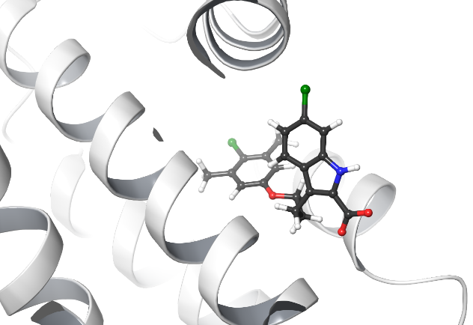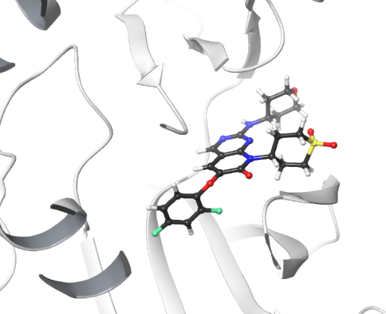
2q_P38
53_MCL1
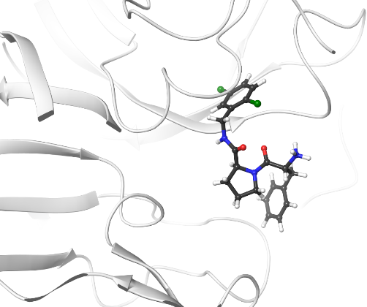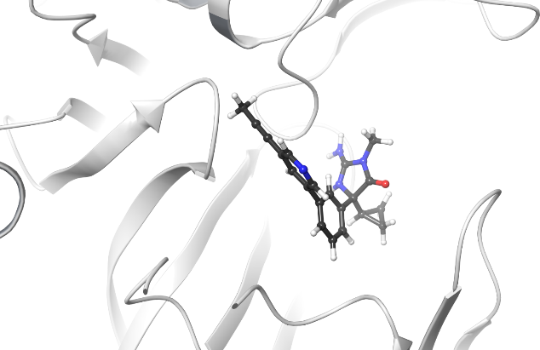
Ejm_46_TYk2
24_BACE
6a_Thrombin
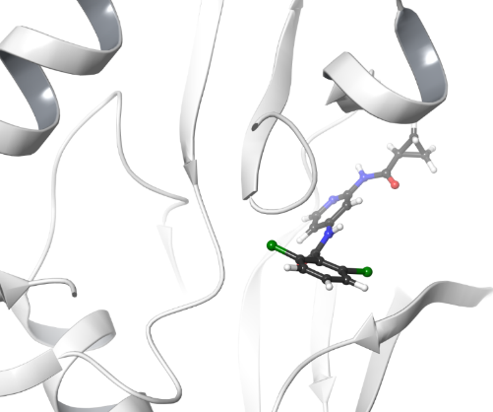
Figure S1 Reference ligand at its relative target.

Table S1 Detailed of average energy components for different receptors and percentage of each component on sum of absolute value of all the components.
 |  | ΔE_{PB} | ΔE_{coul} | ΔE_{vdW} | ΔW% | ΔU%
TYK2 | MM-VM2 | 35.35 | -24.71 | -43.11 | 36.7 | 63.3
TYK2 | Qcharge-MC-FEPr | 44.00 | -34.89 | -41.92 | 38.5 | 61.5
JNK1 | MM-VM2 | 41.80 | -30.94 | -43.63 | 38.2 | 61.8
JNK1 | Qcharge-MC-FEPr | 52.76 | -42.38 | -44.03 | 40.0 | 60.0
BACE | MM-VM2 | 46.51 | -45.88 | -36.41 | 37.1 | 62.9
BACE | Qcharge-MC-FEPr | 93.68 | -119.80 | -32.08 | 38.5 | 61.5
BACE(P2) | MM-VM2 | 45.26 | -33.45 | -39.73 | 37.6 | 62.4
BACE(P2) | Qcharge-MC-FEPr | 67.93 | -74.79 | -37.49 | 38.1 | 61.9
CDK2 | MM-VM2 | 25.55 | -14.07 | -49.96 | 32.1 | 67.9
CDK2 | Qcharge-MC-FEPr | 41.02 | -35.35 | -48.00 | 35.3 | 64.7
CMET | MM-VM2 | 30.96 | -20.21 | -52.74 | 33.1 | 66.9
CMET | Qcharge-MC-FEPr | 43.50 | -36.30 | -52.12 | 35.4 | 64.6
P38 | MM-VM2 | 38.08 | -20.75 | -46.40 | 39.1 | 60.9
P38 | Qcharge-MC-FEPr | 42.94 | -18.10 | -46.42 | 40.9 | 59.1
Thrombin | MM-VM2 | 207.55 | -203.36 | -48.34 | 45.4 | 54.6
Thrombin | Qcharge-MC-FEPr | 228.75 | -229.83 | -46.44 | 45.5 | 54.5
MCL1 | MM-VM2 | 94.72 | -88.62 | -46.01 | 42.1 | 57.9
MCL1 | Qcharge-MC-FEPr | 107.12 | -101.83 | -45.16 | 42.7 | 57.3

