Table of Contents
Figure S1 PCA plots 2
Figure S2 Manhattan plots 3
Figure S3 Local manhattan plots and forest plots 4
Figure S4 Local manhattan plots and forest plots 5
Figure S5 Local manhattan plots and forest plots 6
Figure S6 Local manhattan plots and forest plots 7
Figure S7 Local manhattan plots near meta-analysis specific loci 8
Figure S8 Local manhattan plots near ADAD Genes APP and GRN 9
Figure S9 Local manhattan plots near ADAD Genes PSEN1 and PSEN2 10
Figure S10 Local manhattan plotss from conditional analyses 11
Figure S11 Local manhattan plots from conditional analyses 12
Figure S12 Local manhattan plots from conditional analyses 13
Figure S13 Local manhattan plots from conditional analysis 14
Figure S14 Correlation between EOAD at different age cutoffs 15
Figure S15 Bar Plots of polygenic risk score (PRS) logistic model fit (R²) 16
Figure S16 Proteomic analysis of prioritized genes. 17

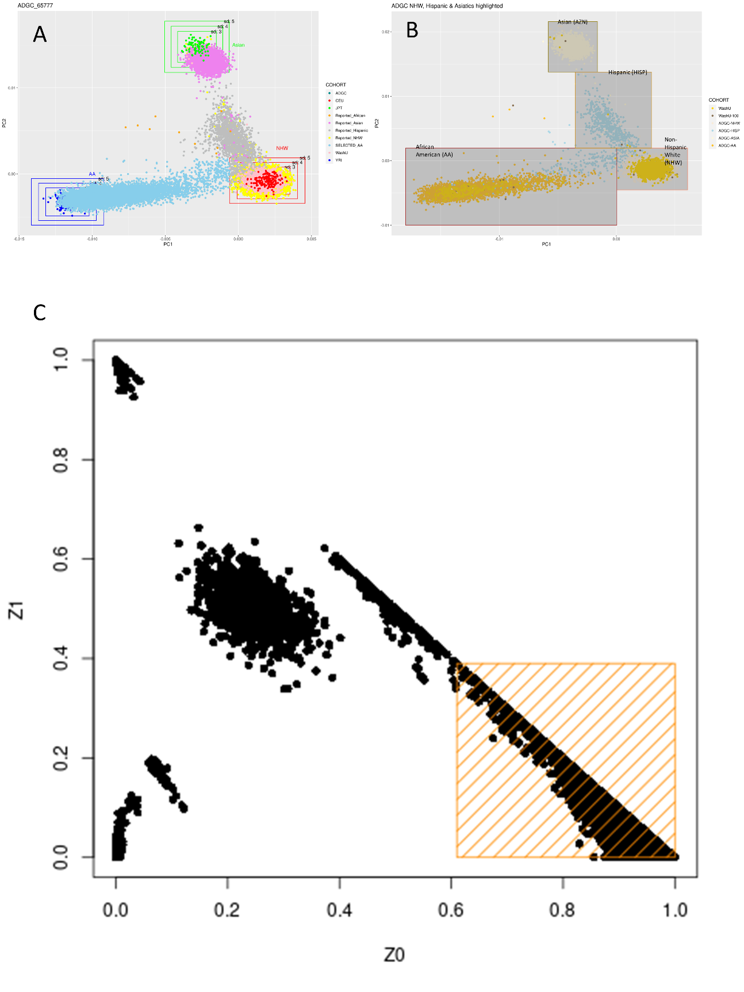
Figure S1 PCA plots
Plots of ADGC and Knight-ADRC participants (A-B) used to determine similarity to known ancestries, and IBD plot of all participants (C). The orange highlighted section shows the cutoff for unrelated individuals.
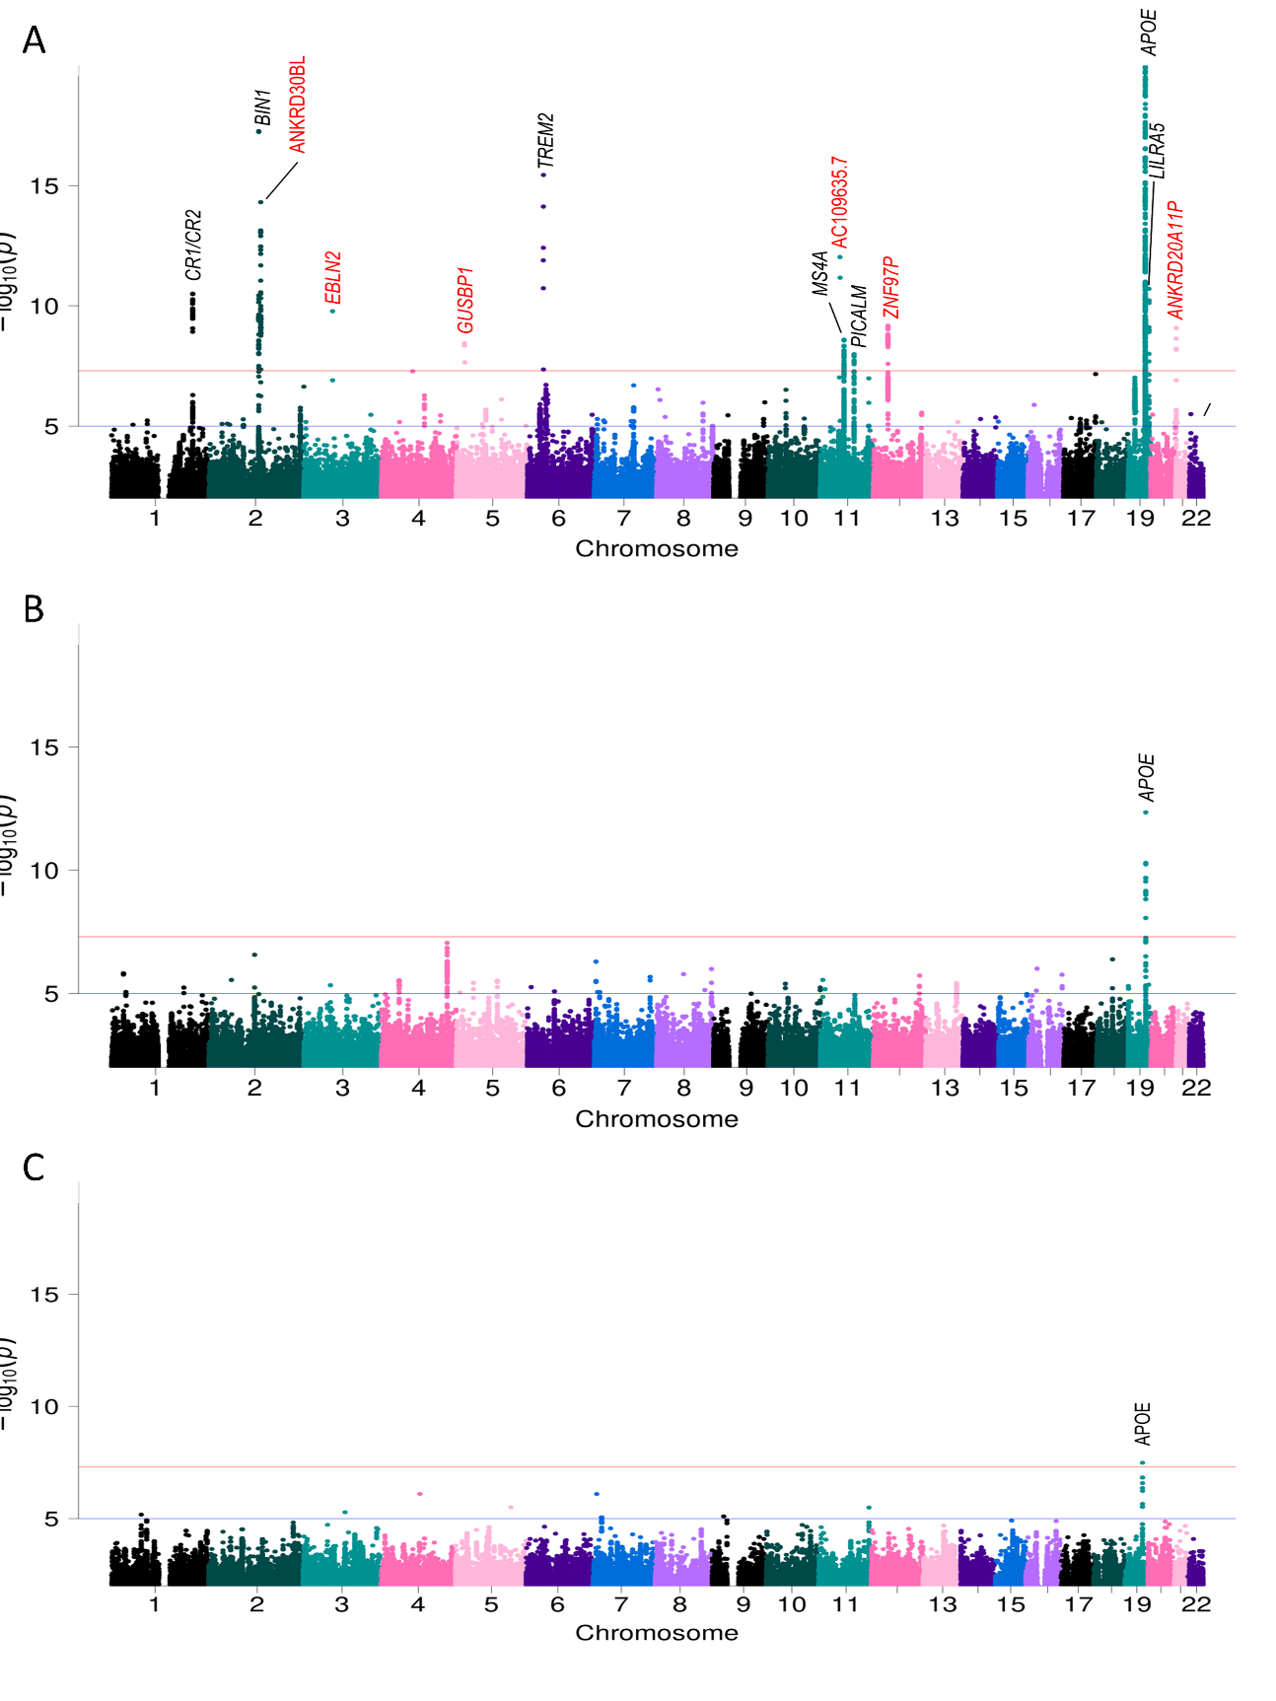
Figure S2 Manhattan plots
Manhattan plots from African American (A), Asian (B), and non-Hispanic White (C) single ancestry analyses. The red line represents the genome-wide significance threshold of 5×10⁻⁰⁸ and the blue line represent the suggestive threshold of 1×10⁻⁰⁵. Loci are annotated with the nearest gene to the sentinel variant. Novel loci are highlighted with red text.

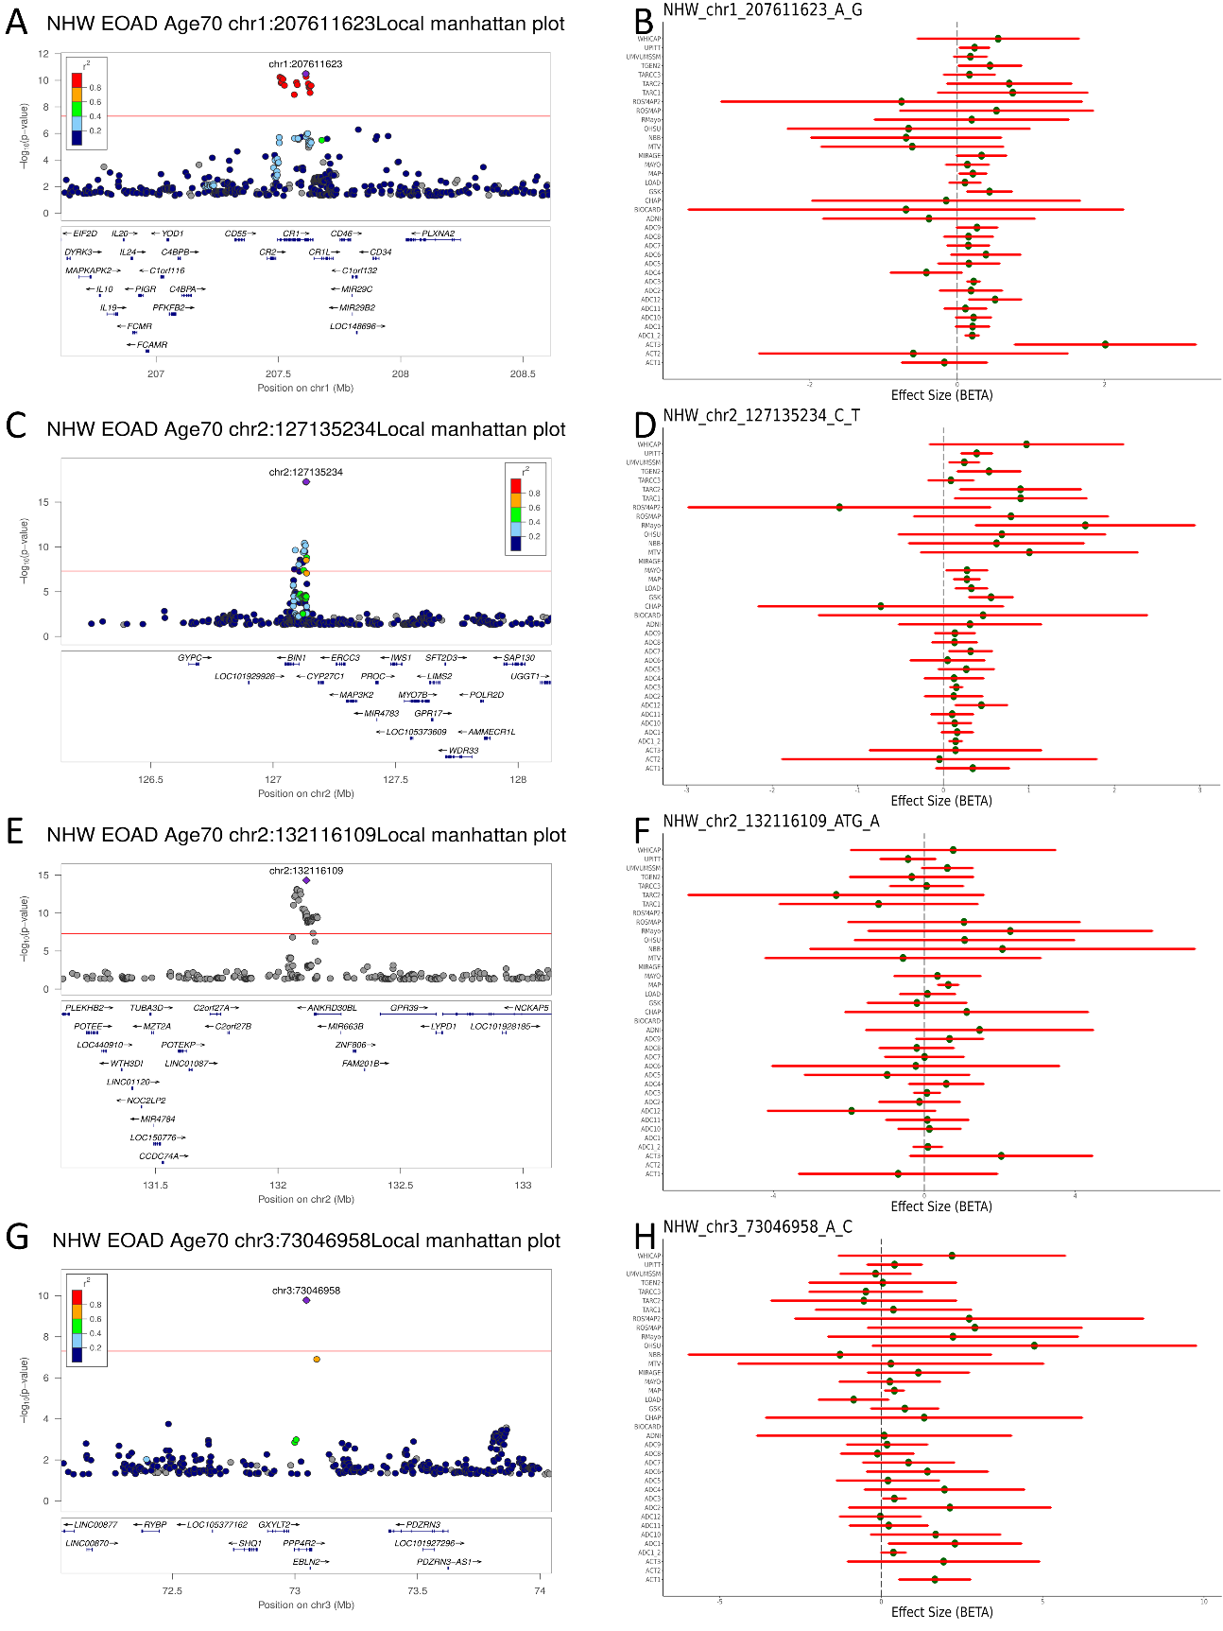
Figure S3 Local manhattan plots and forest plots
Local and forest plots for the sentinel SNP in genome-wide significant loci; CR1 (A-B), BIN1 (C-D), ANKRD30BL (E-F) and EBLN2 (G-H) . The red line in local plots is the genome-wide significance threshold P=5×10⁻⁰⁸
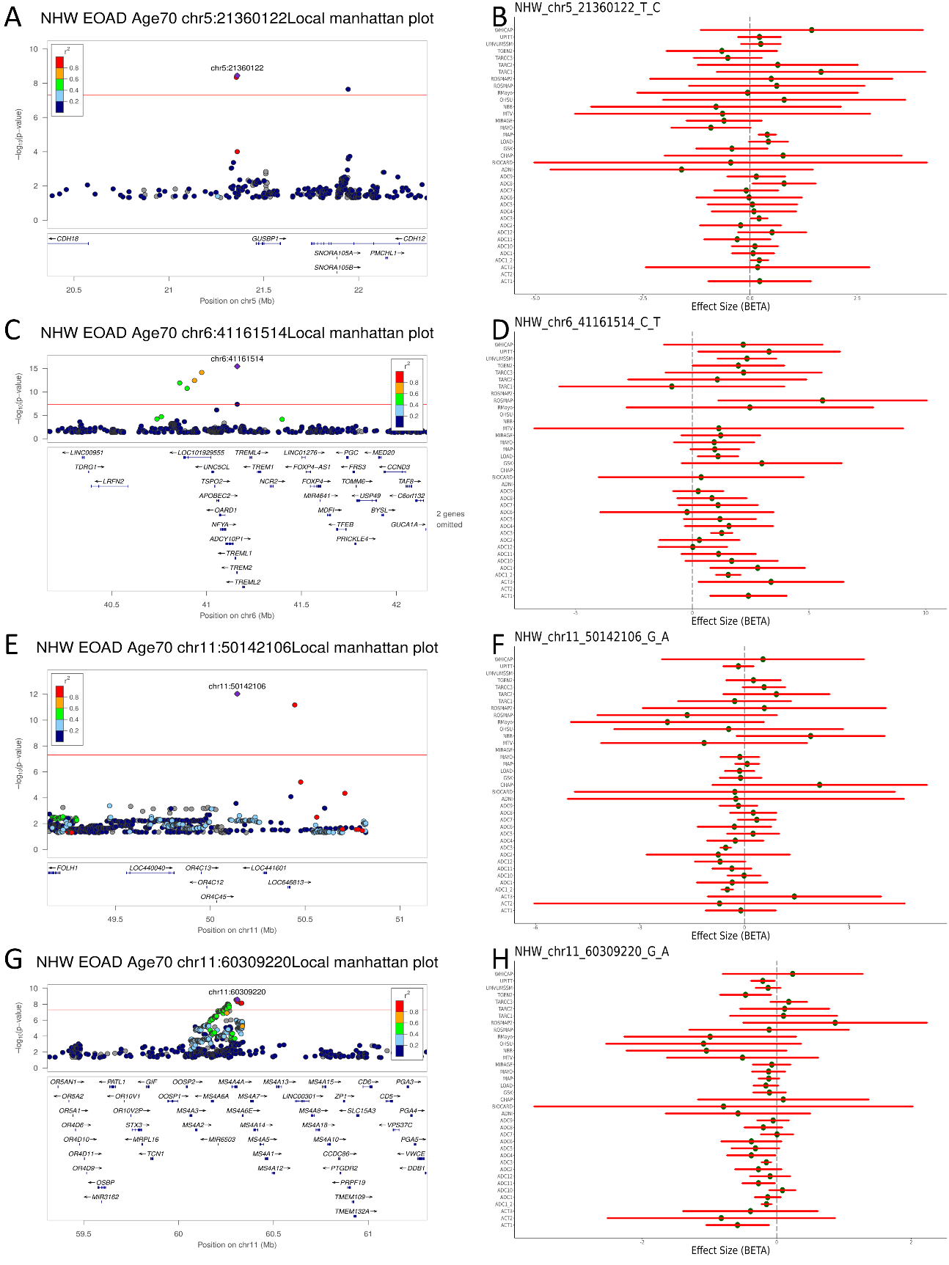
Figure S4 Local manhattan plots and forest plots
Local and forest plots for the sentinel SNP in genome-wide significant loci; GUSBP1 (A-B), TREM2 (C-D), AC109635.7 (E-F) and MS4A (G-H) . The red line in local plots is the genome-wide significance threshold P=5×10⁻⁰⁸
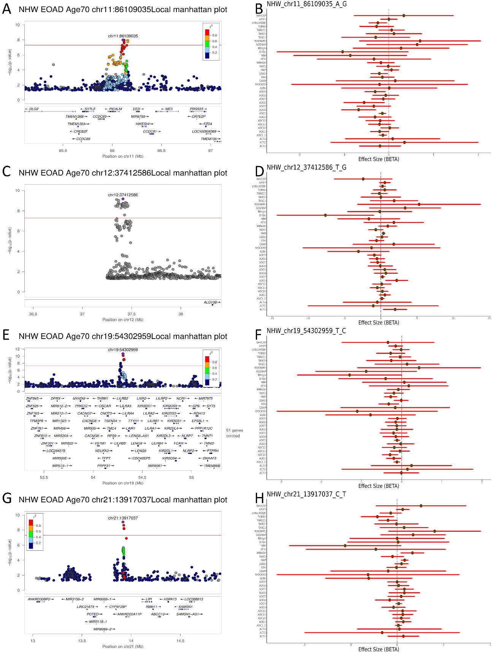
Figure S5 Local manhattan plots and forest plots
Local and forest plots for the sentinel SNP in genome-wide significant loci; PICALM (A-B), AK6P2 (C-D), SSBP4 (E-F) and ANKRD2011AP (G-H) . The red line in local plots is the genome-wide significance threshold P=5×10⁻⁰⁸
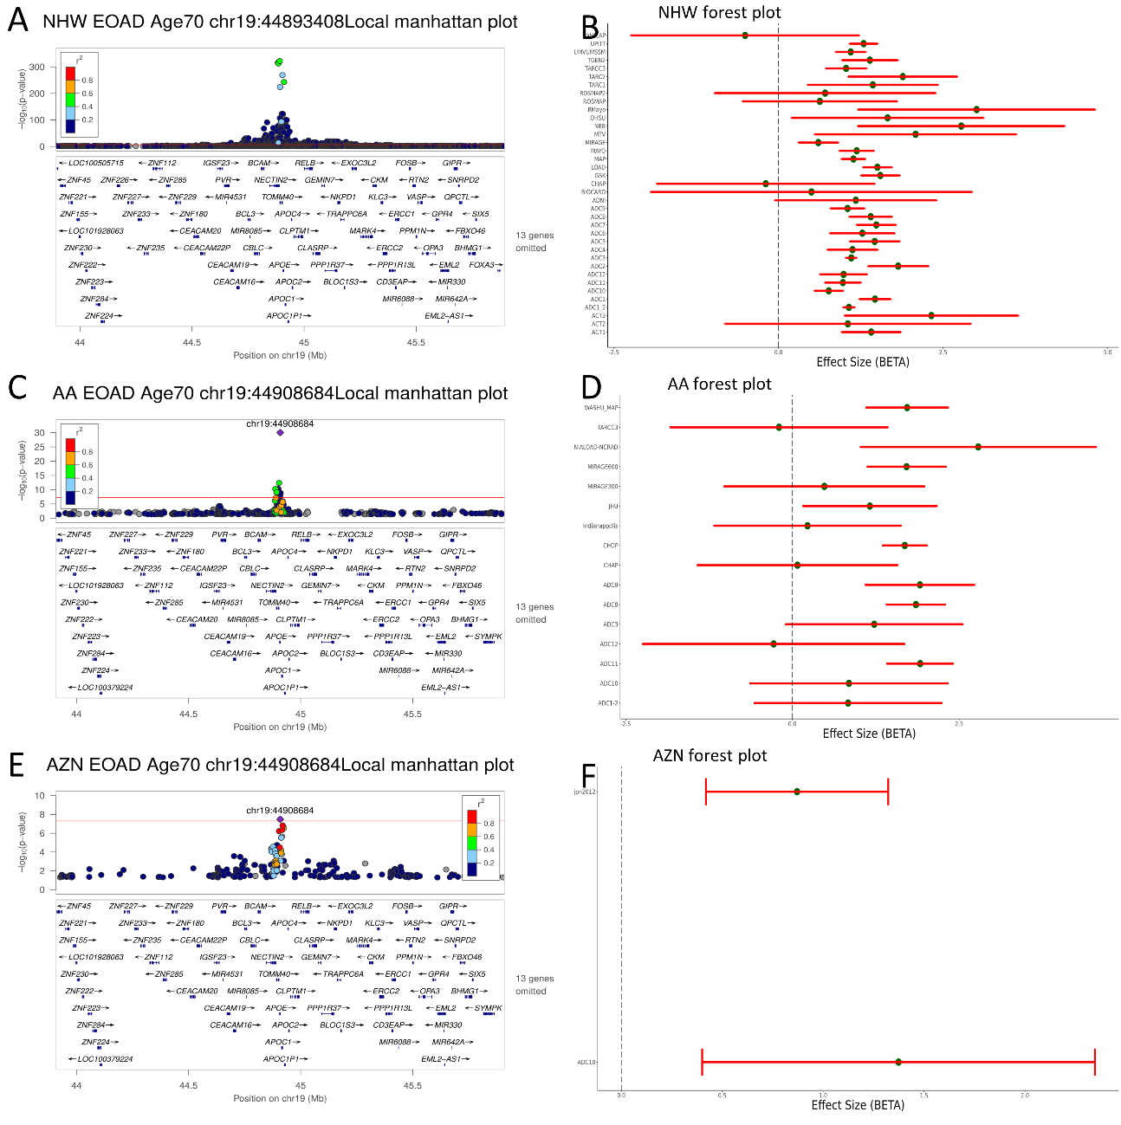
Figure S6 Local manhattan plots and forest plots
Local and forest plots for the APOE locus in; NHW (A-B), AA (C-D), and AZN (E-F). The red line in local plots is the genome-wide significance threshold P=5×10⁻⁰⁸
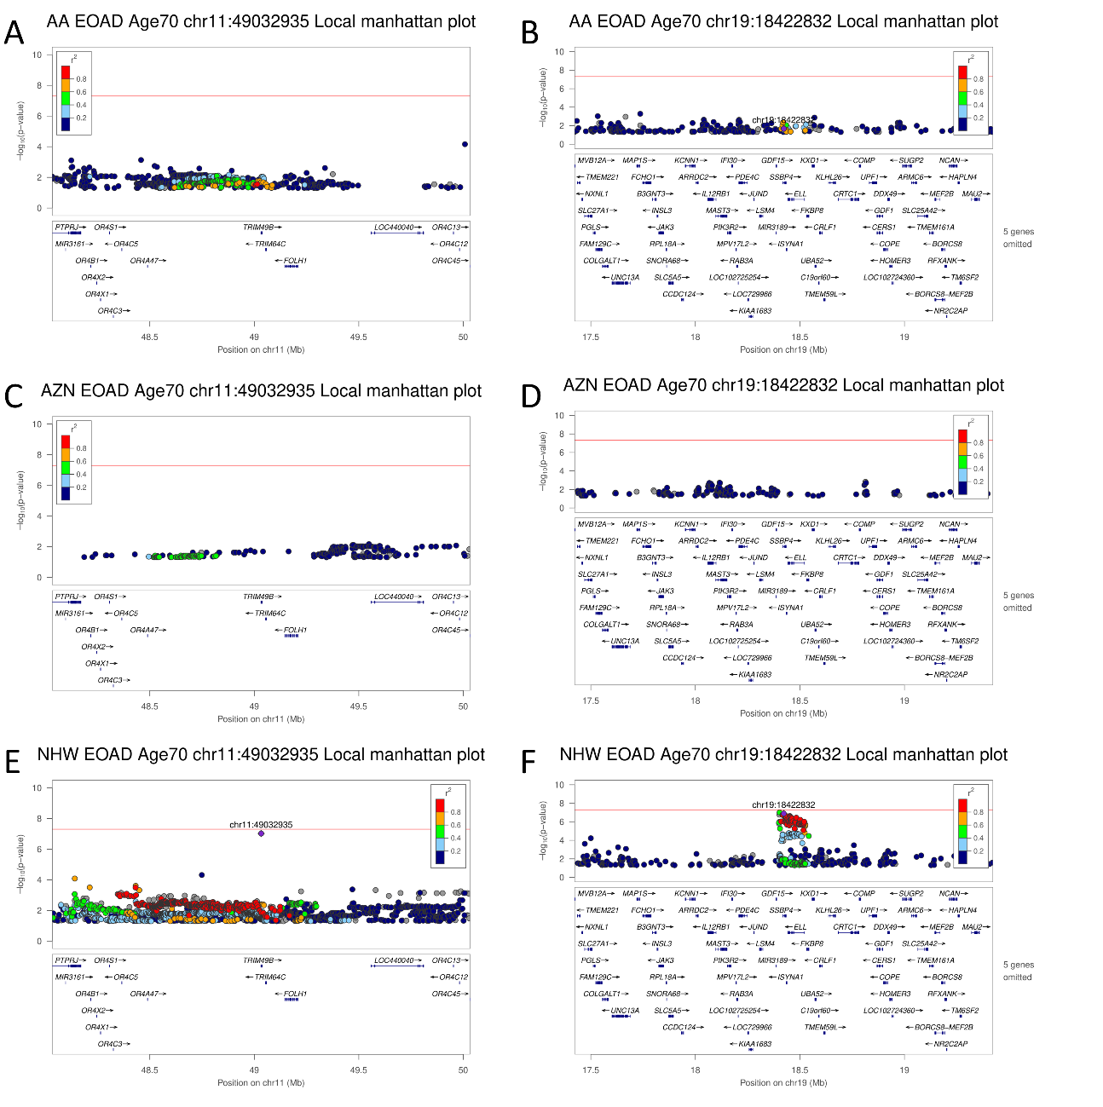
Figure S7 Local manhattan plots near meta-analysis specific loci
Local Manhattan plots of meta-analysis specific loci near TRIM49B (A,C,E) and near SSBP4 (B,D,F) in AA (A-B), AZN (C-D), and NHW (E-F) single variant analyses. The red line in each plot is the genome-wide significance threshold P=5×10⁻⁰⁸
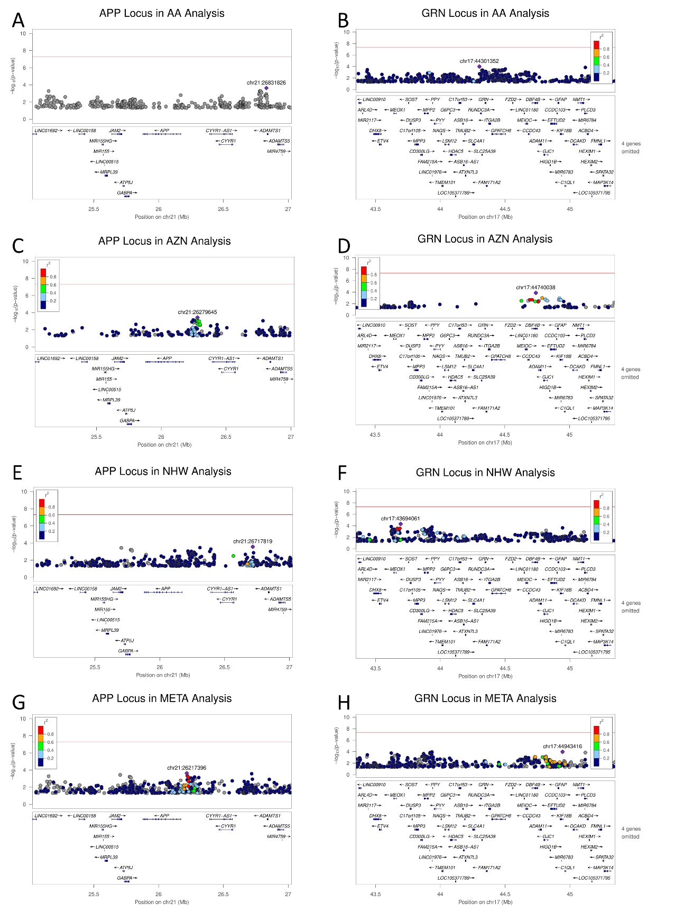
Figure S8 Local manhattan plots near ADAD Genes APP and GRN
Local Manhattan plots for loci near known autosomal dominant Alzheimer Disease (ADAD) genes APP (A,C,E,G) and GRN (B,D,F,H) in AA (A-B), AZN (C-D), and NHW (E-F) single variant analyses and trans-ancestry meta-analysis (G-H). The red line in each plot is the genome-wide significance threshold P=5×10⁻⁰⁸

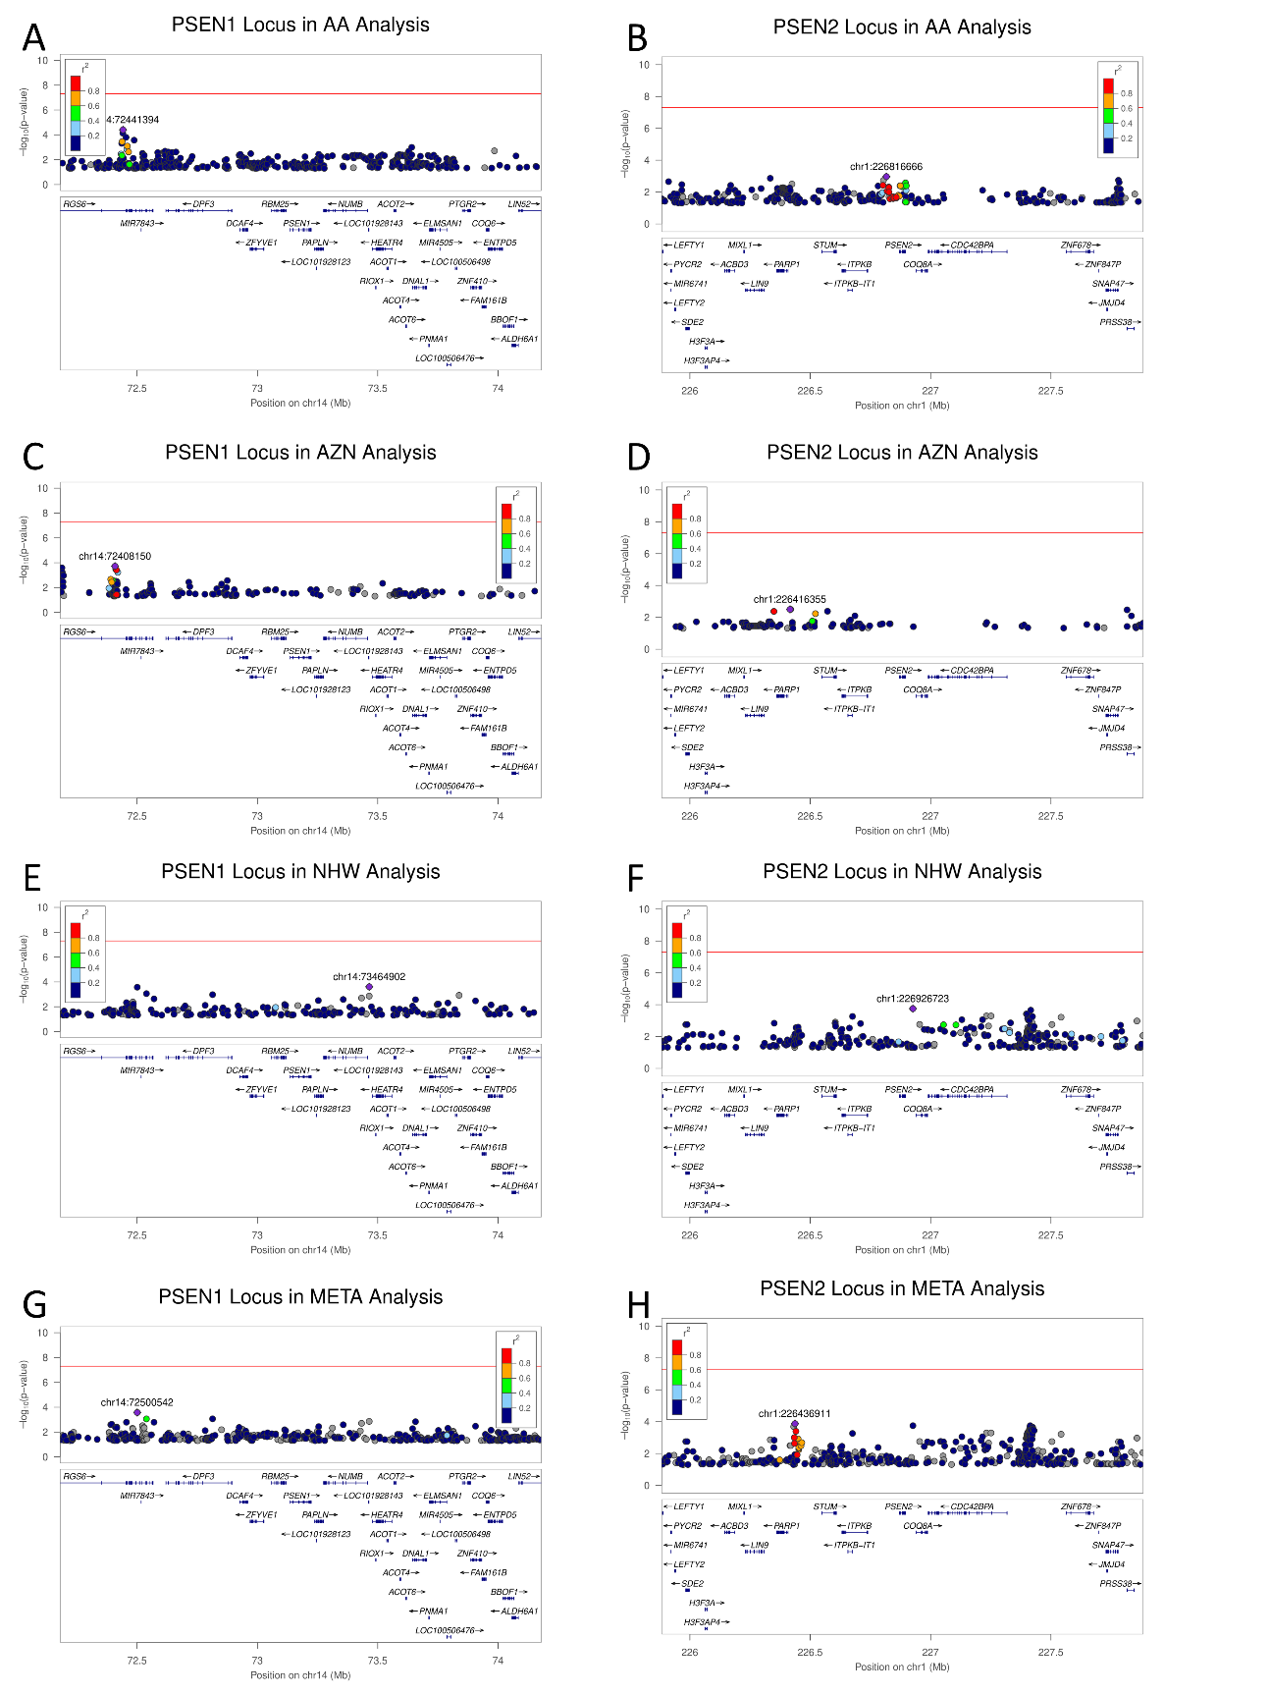
Figure S9 Local manhattan plots near ADAD Genes PSEN1 and PSEN2
Local Manhattan plots for loci near known autosomal dominant Alzheimer Disease (ADAD) genes PSEN1 (A,C,E,G) and PSEN2 (B,D,F,H) in AA (A-B), AZN (C-D), and NHW (E-F) single variant analyses and trans-ancestry meta-analysis (G-H). The red line in each plot is the genome-wide significance threshold P=5×10⁻⁰⁸
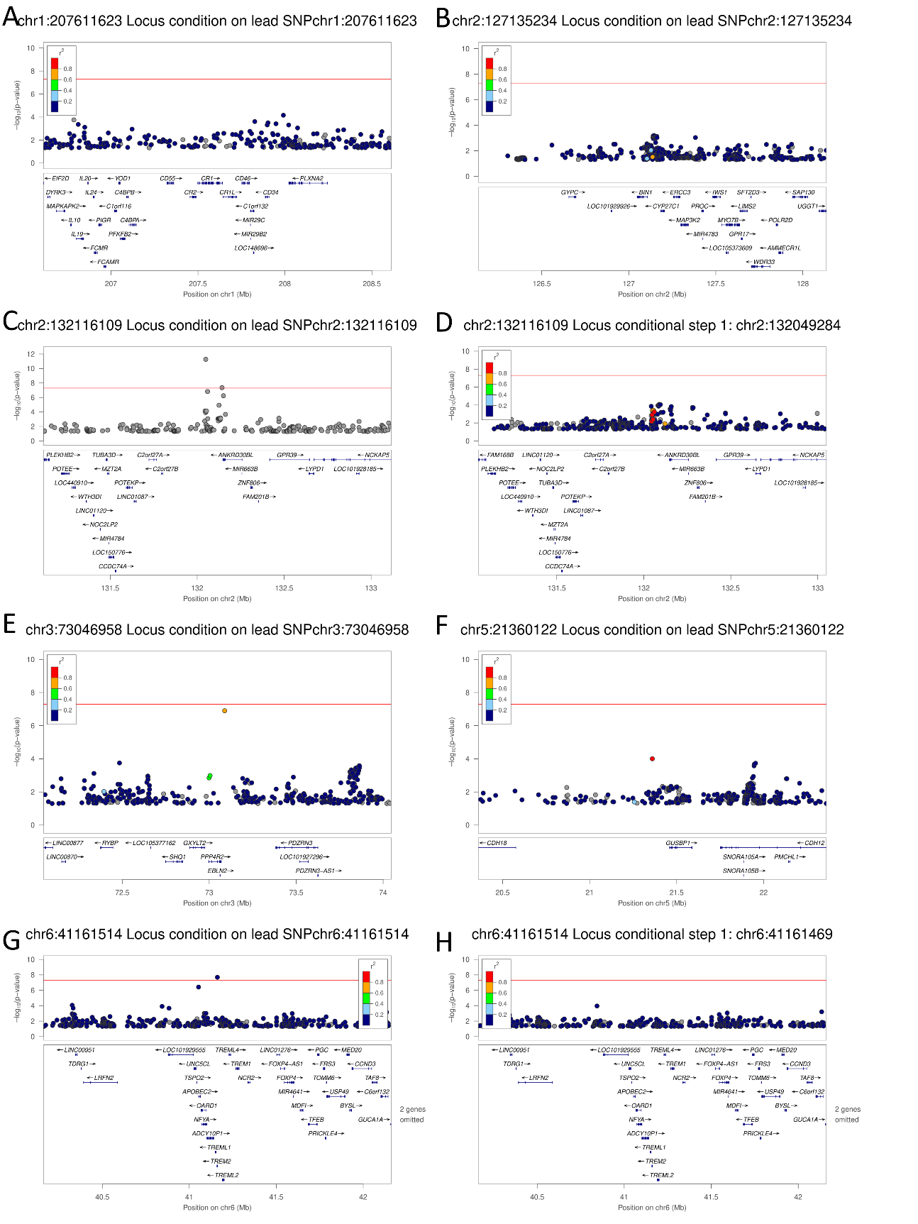
Figure S10 Local manhattan plotss from conditional analyses
Shown are local manhattan plots from conditional analysis on the top hit(s) in loci near; CR1 (A), BIN1 (B), ANKRD30BL (C-D), EBLN2 (E), GUSBP1 (F), TREM2 (G-H) in NHW single variant analysis. The red line in each plot is the genome-wide significance threshold P=5×10⁻⁰⁸
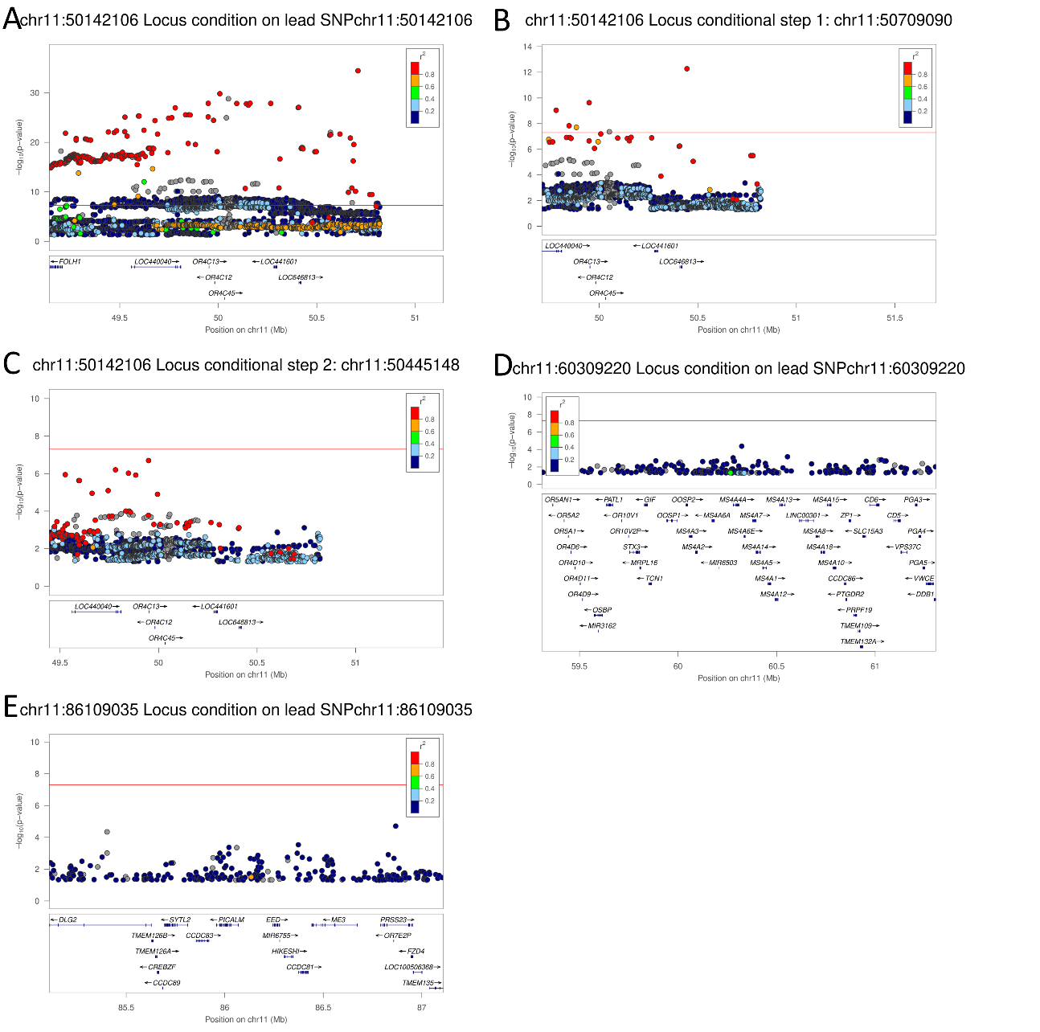
Figure S11 Local manhattan plots from conditional analyses
Shown are local manhattan plots from conditional analysis on the top hit(s) in loci near; AC109635.7 (A-C), MS4A (D), PICALM (E) in NHW single variant analysis. The red line in each plot is the genome-wide significance threshold P=5×10⁻⁰⁸
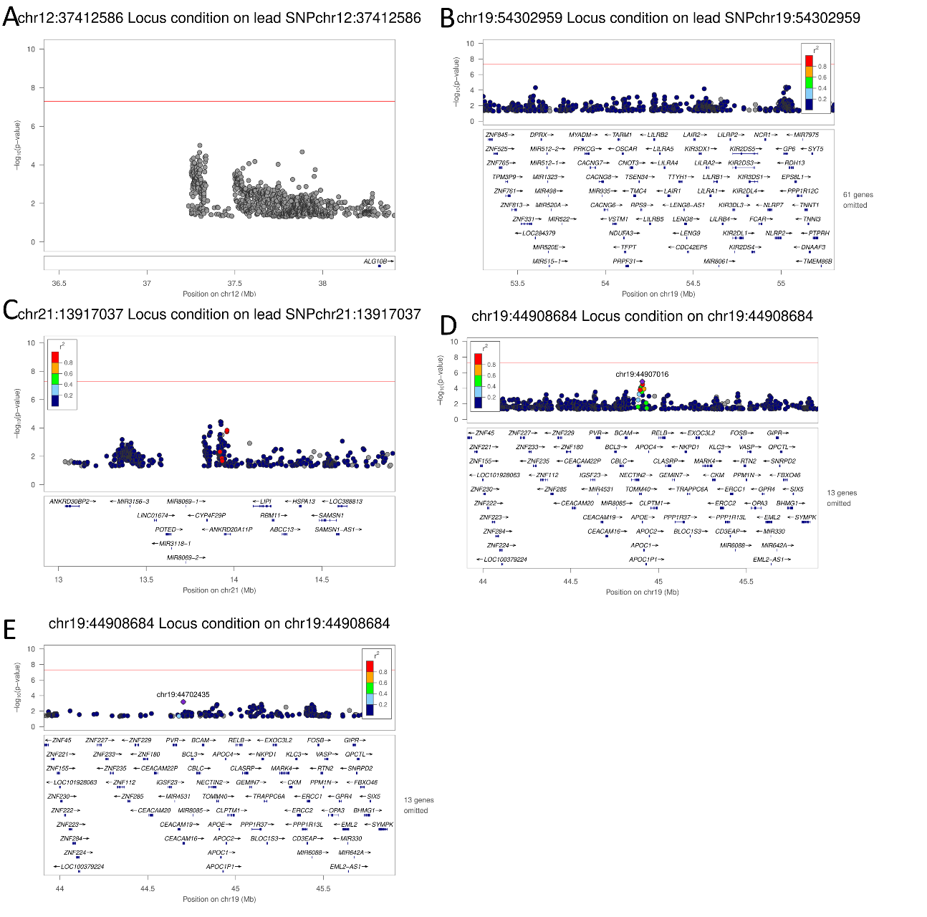
Figure S12 Local manhattan plots from conditional analyses
Shown are local manhattan plots from conditional analysis on the top hit(s) in loci near; AK6P2 (A), LILRA5 (B), ANKRD20A11P (C) in NHW single variant analysis, and APOE in AA (D) and AZN (E) single variant analyses. The red line in each plot is the genome-wide significance threshold P=5×10⁻⁰⁸
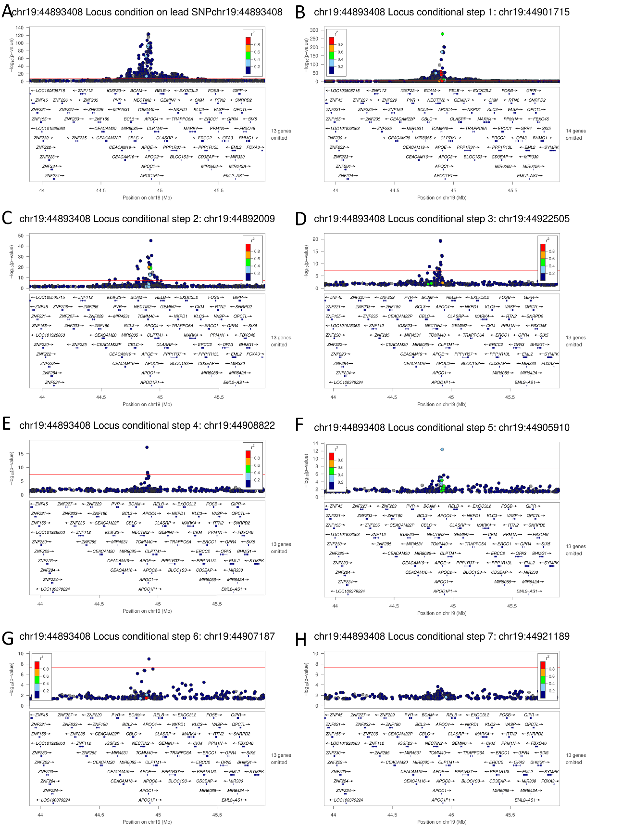
Figure S13 Local manhattan plots from conditional analysis
Shown are local manhattan plots from conditional analysis on the top hits in the APOE/TOMM40 locus in the NHW single variant analysis. The red line in each plot is the genome-wide significance threshold P=5×10⁻⁰⁸
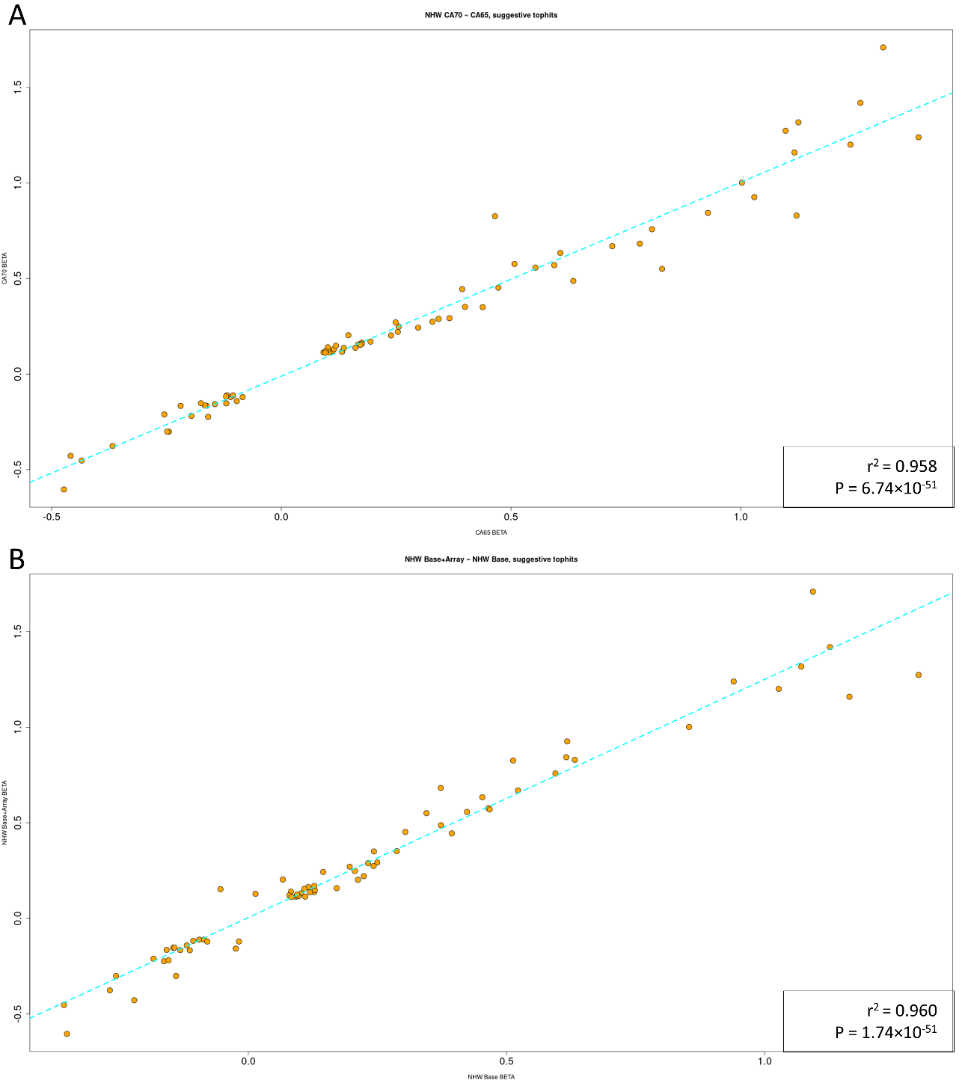
Figure S14 Correlation between EOAD at different age cutoffs
Effect size correlation dot plots for comparing suggestive peaks between EOAD age cutoffs (A) and an alternative single variant analysis model (B) in NHW subjects. the Age cut-off dot plot compares the effect sizes for EOAD cases ≤70 years old (y-axis) vs EOAD cases ≤65 years old (x-axis). The alternative model dot plot compares the effect sizes for our base model (STATUS ~ SEX + SNP + PC1-PC10 + Array) vs a relaxed model (STATUS ~ SEX + SNP + PC1-PC10).
Figure S15 Bar Plots of polygenic risk score (PRS) logistic model fit (R²)
Using PRSice2, risk scores were calculated for NHW, AZN, and AA populations using Bellenguez, Shigemizu, and Kunkle summary statistics at P thresholds 5x10-08, 5x10-05, 5x10-02, and 5x10-01. PRS with (A,C,E) and without the APOE region included (B,D,F) were used in logistic regression against EOAD status in NHW (A-B), AZN (C-D), and AA (E-F). Each bar is annotated with the P-value for each model.
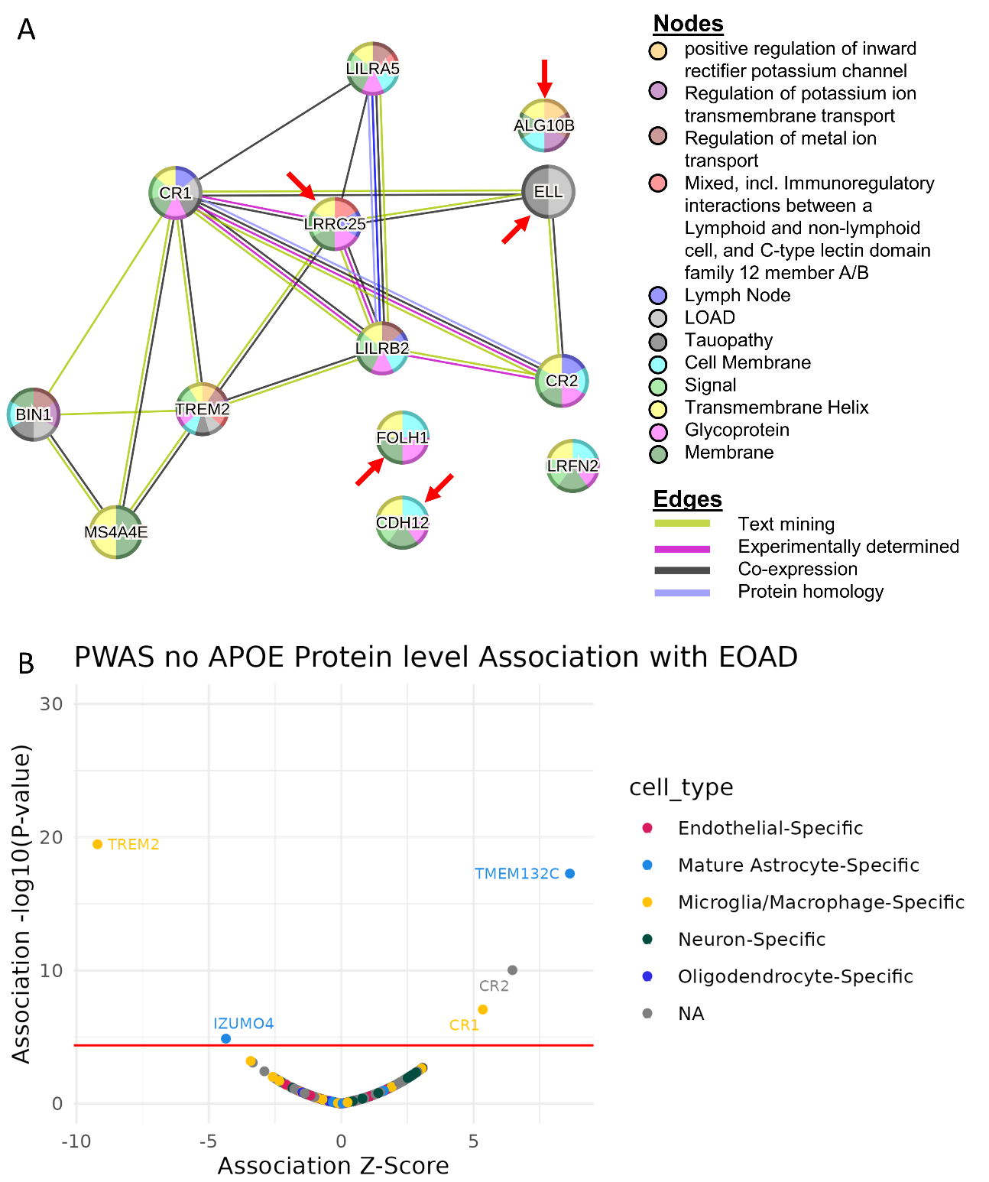
Figure S16 Proteomic analysis of prioritized genes.
STRING protein-protein interaction network analysis (A). Volcano plot (B) of PWAS results shows the direction and Z-score of proteins significantly associated with EOAD. Genes/proteins which are in novel loci are highlighted with a red arrow. The pleiotropic APOE region is not included in either plot.

