Table of Contents
Figure E1 Overlap of GTEx and MetaBrain eQTLs in prioritization methods 3
Figure E2 Manhattan plots of MAGMA gene-based analysis 4
Figure E3 Tissue expression of novel prioritized Genes 5
Figure E4 Prioritized gene ontology enrichment 6
Figure E5 FUMA gene-set analysis on prioritized genes 7
Figure E6 Prioritized gene disease and pathway 8

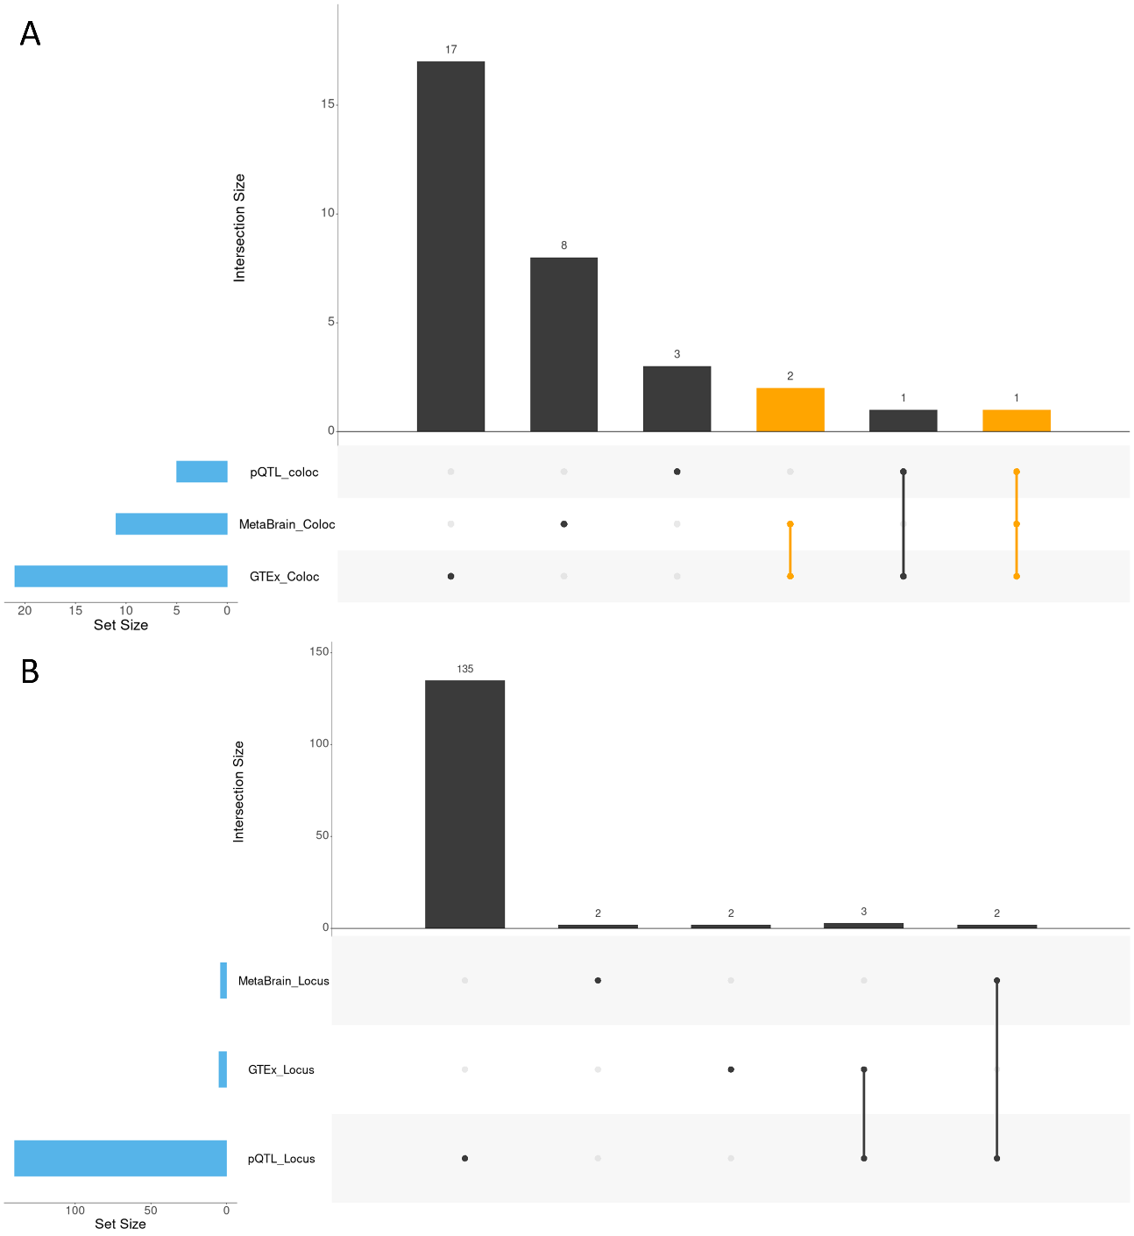
Figure E1 Overlap of GTEx and MetaBrain eQTLs in prioritization methods
Overview of the genes within 1MB of the lead SNP from EOAD GWAS loci that are both in GTEx and MetaBrain datasets. Overlap is checked separately for colocalization hits (A) and locus overlap hits (B). Sets where GTEx and MetaBrain overlapped are highlighted orange.

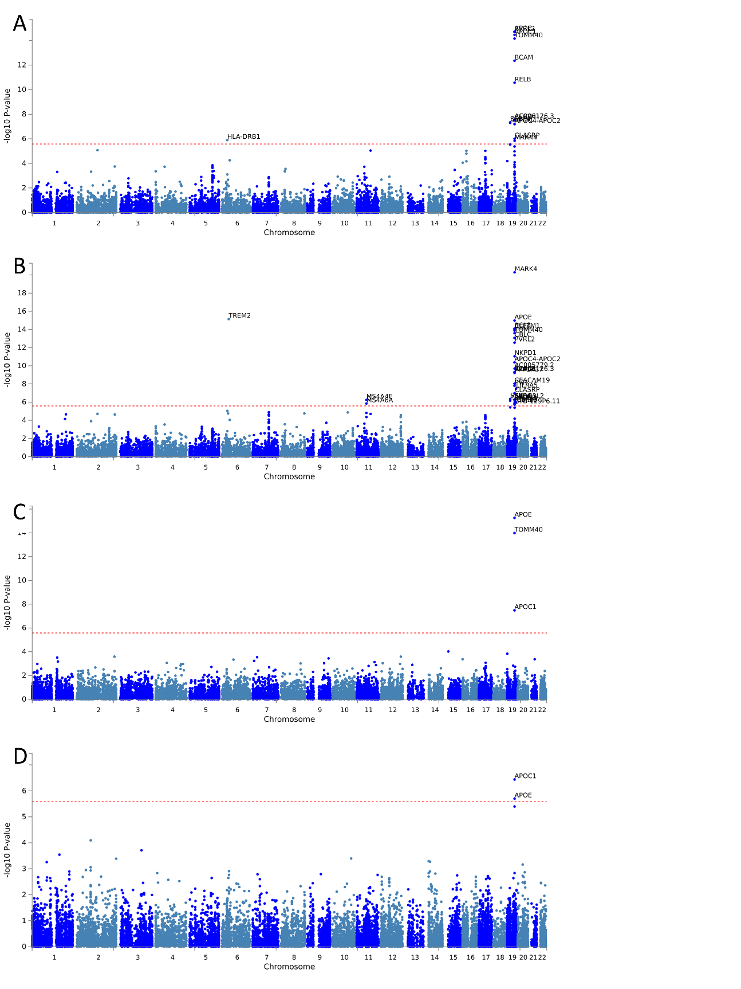
Figure E2 Manhattan plots of MAGMA gene-based analysis
results for Meta-analysis (A), non-Hispanic Whites (B), African Americans (C) and Asians (D). Manhattan plots are generated by FUMA online software which has MAGMA Integrated. The red line represents the Bonferroni corrected P-value (P=0.05 / n genes). Genes passing the threshold in each plot are annotated

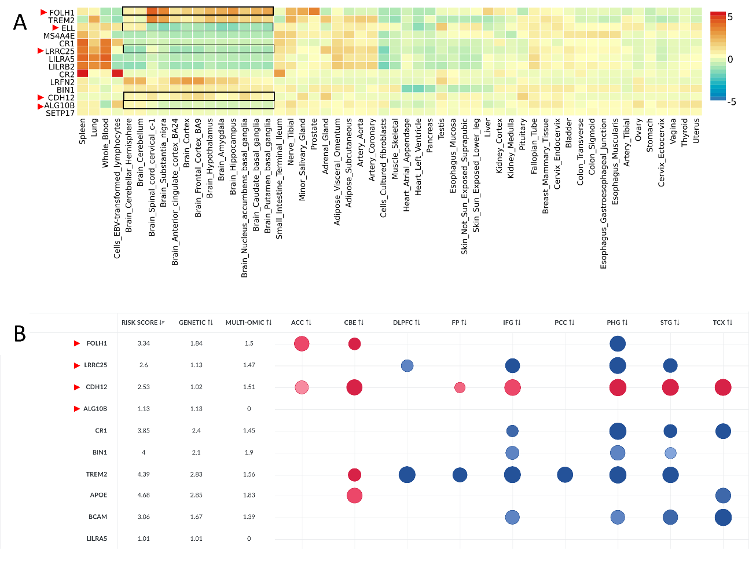
Figure E3 Tissue expression of novel prioritized Genes
Cell-type and expression-based results of genes passing the prioritization score threshold (expect genes in the APOE region). Results come from FUMA analysis of expression relative to the average normalized expression in GTEx v8 54 tissue types (A) and Agora significant (adjusted P < 0.05) differential expression in AD relevant brain types in cases vs controls (B). A deeper red/orange indicates higher expression than a deeper cyan/blue in GTEx, and the opposite is true for Agora data. The size of the circle in Agora data represents the p-value with A larger circle indicating a stronger p-value. Genes from novel loci are indicated with a red arrow

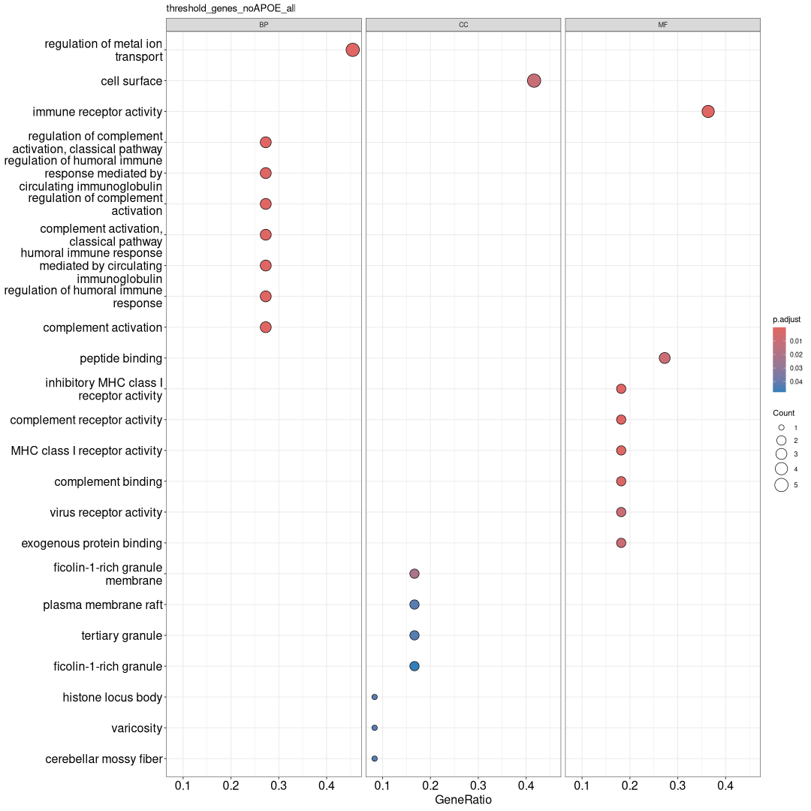
Figure E4 Prioritized gene ontology enrichment
Results of gene ontology (GO) term enrichment from cluster profiler. The top eight significant (adjusted P < 0.05) GO terms in biological processes (BP; Left), cellular components (CC; middle), and molecular functions (MF; right) from the set of genes passing the prioritization minimum score threshold. Genes from the APOE region are excluded.

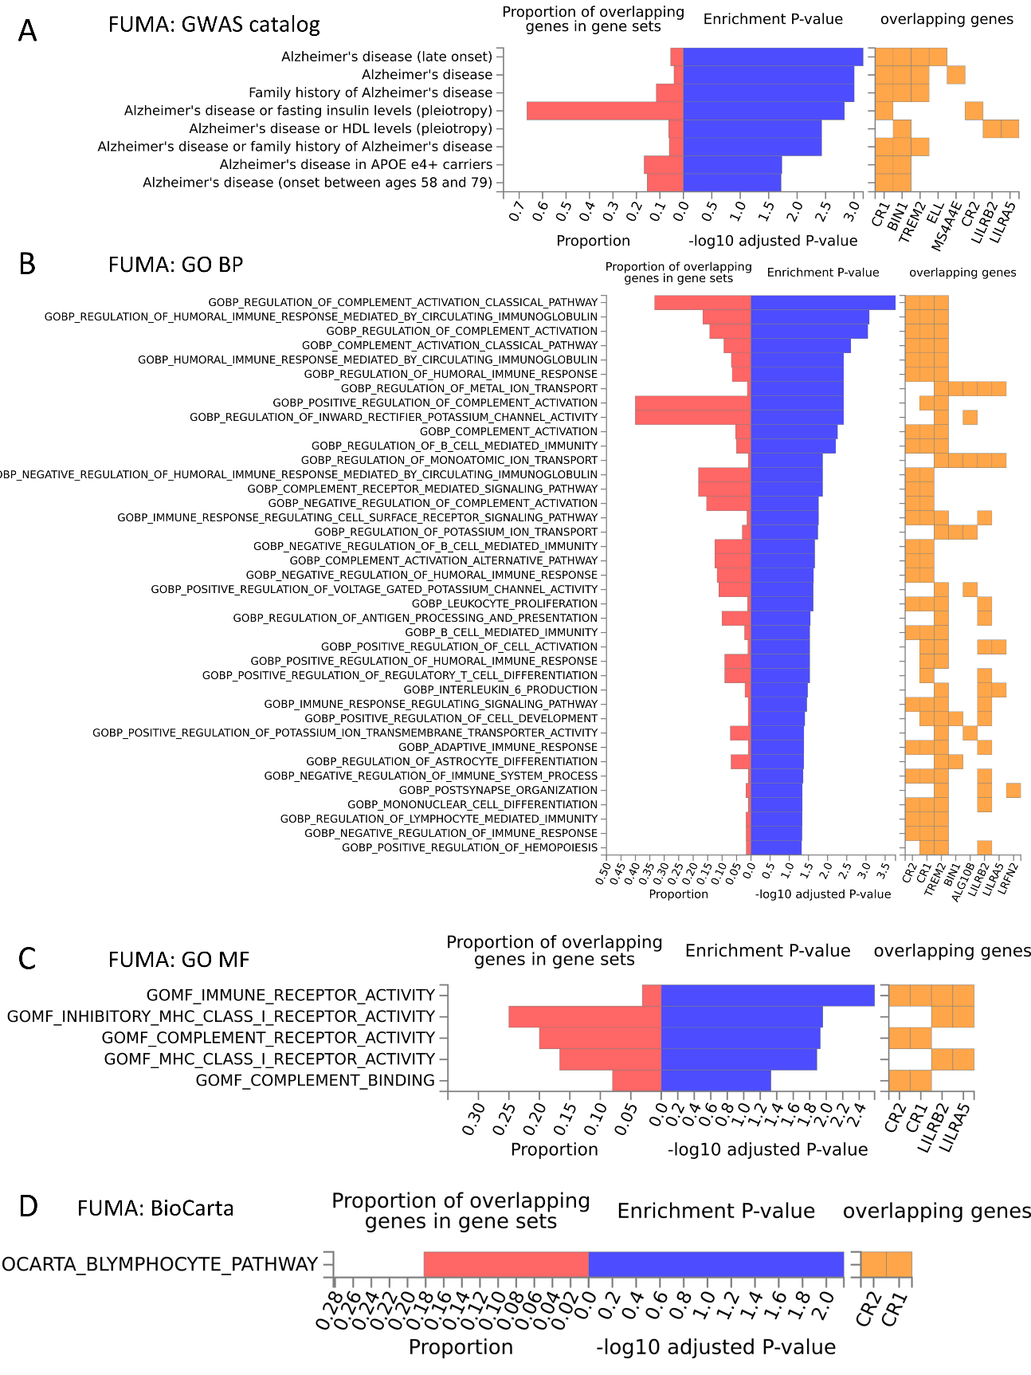
Figure E5 FUMA gene-set analysis on prioritized genes
FUMA gene set analysis enrichment results for genes passing the minimum prioritization score threshold, including GWAS catalog hits (A); gene ontology (GO) term enrichment in biological processes (BP; B), and molecular functions (MF; C); and BioCarta pathways enrichment (D). Genes from the APOE region were excluded

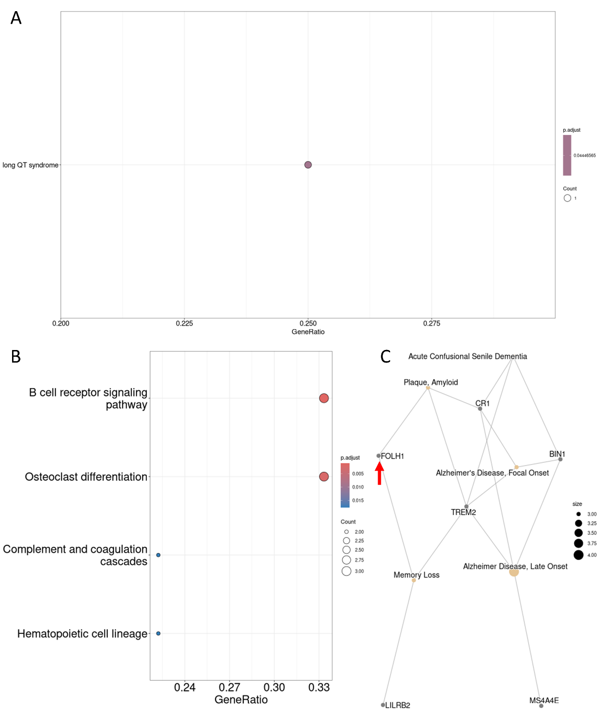
Figure E6 Prioritized gene disease and pathway
Results from disease ontology (DO; A), KEGG pathway (B), disease-gene network (DGN; C) and enrichment analyses. All results shown are significant (P<0.05) after adjusting the P value for the number of observed and background genes. Genes from novel GWAS loci in DGN plot are indicated with a red arrow

