Table 1 Pruritus: odds ratio table (control arm as reference)
Study | Diagnosis | Inhibitor | N (contr/imm) | N events (contr/imm) | OR (95% CI)† |  | p value
Hodi et al., 2010 | Melanoma | CTLA4 | 132/511 | 14/119 | 2.56 (1.42–4.62) | 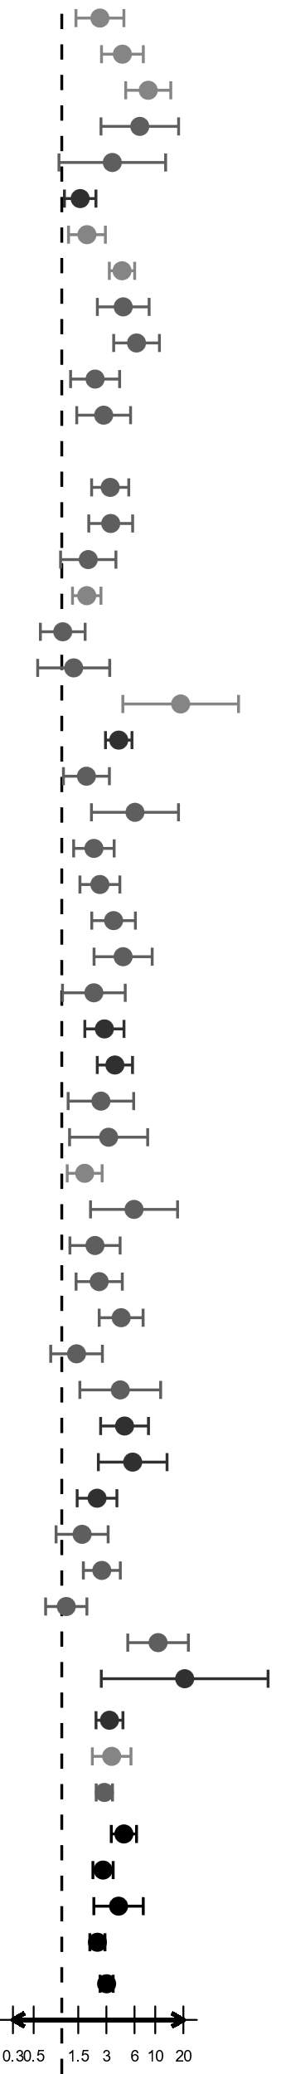  ⠀ | 0.002
Robert et al., 2011 | Melanoma | CTLA4 | 251/247 | 22/74 | 4.45 (2.66–7.45) | ⠀ | <0.001
Ribas et al., 2013 | Melanoma | CTLA4 | 319/325 | 16/100 | 8.42 (4.83–14.66) | ⠀ | <0.001
Borghaei et al., 2015 | Lung | PD1 | 268/287 | 5/33 | 6.83 (2.63–17.78) | ⠀ | <0.001
Brahmer et al., 2015 | Lung | PD1 | 129/131 | 3/10 | 3.47 (0.93–12.92) | ⠀ | 0.063
Motzer et al., 2015 | Renal | PD1 | 397/406 | 50/75 | 1.57 (1.07–2.32) | ⠀ | 0.022
Robert et al., 2015 | Melanoma | PD1 | 205/206 | 40/64 | 1.86 (1.18–2.93) | ⠀ | 0.007
Eggermont et al. 2016 | Melanoma | CTLA4 | 474/471 | 70/204 | 4.41 (3.23–6.03) | ⠀ | <0.001
Herbst et al. 2016 | Lung | PD1 | 309/703 | 11/101 | 4.55 (2.40–8.60) | ⠀ | <0.001
Reck et al., 2016 | Lung | CTLA4 | 561/562 | 15/83 | 6.31 (3.59–11.08) | ⠀ | <0.001
Antonia et al., 2017 | Lung | PDL1 | 234/475 | 14/60 | 2.27 (1.24–4.16) | ⠀ | 0.008
Carbone et al., 2017 | Lung | PD1 | 263/267 | 13/34 | 2.81 (1.45–5.45) | ⠀ | 0.002
Govindan et al., 2017 | Lung | CTLA4 | 106/98 | 0/13 | Not evaluable | ⠀ | ⠀
NCT02279732 | Lung | CTLA4 | 473/475 | 27/79 | 3.30 (2.09–5.21) | ⠀ | <0.001
Rittmeyer et al., 2017 | Lung | PDL1 | 578/609 | 18/59 | 3.34 (1.94–5.73) | ⠀ | <0.001
Barlesi et al., 2018 | Lung | PDL1 | 365/393 | 13/26 | 1.92 (0.97–3.79) | ⠀ | 0.061
Eggermont et al., 2018 | Melanoma | PD1 | 502/509 | 58/99 | 1.85 (1.30–2.63) | ⠀ | <0.001
Gandhi et al., 2018 | Lung | PD1 | 202/405 | 21/43 | 1.02 (0.59–1.78) | ⠀ | 0.933
Horn et al., 2018 | Lung | PDL1 | 196/198 | 9/12 | 1.34 (0.55–3.26) | ⠀ | 0.518
Larkin et al., 2018 | Melanoma | PD1 | 102/268 | 2/73 | 18.72 (4.50–77.85) | ⠀ | <0.001
Motzer et al., 2018 | Renal | CTLA4+PD1 | 535/547 | 58/181 | 4.07 (2.94–5.63) | ⠀ | <0.001
Paz-Ares et al., 2018 | Lung | PD1 | 280/278 | 21/36 | 1.83 (1.04–3.23) | ⠀ | 0.036
Reck et al., 2016 | Lung | PD1 | 265/282 | 4/24 | 6.07 (2.08–17.74) | ⠀ | <0.001
Socinski et al., 2018 | Lung | PDL1 | 394/400 | 25/52 | 2.21 (1.34–3.63) | ⠀ | 0.002
Socinski et al., 2018 | Lung | PDL1 | 394/393 | 25/58 | 2.56 (1.56–4.18) | ⠀ | <0.001
Mok et al., 2019 | Lung | PD1 | 615/636 | 18/62 | 3.58 (2.09–6.13) | ⠀ | <0.001
Paz-Ares et al., 2019 | Lung | CTLA4+PD1 | 266/266 | 10/40 | 4.53 (2.21–9.27) | ⠀ | <0.001
Paz-Ares et al., 2019 | Lung | PDL1 | 266/265 | 10/21 | 2.20 (1.02–4.77) | ⠀ | 0.045
Rini, Plimack, et al., 2019 | Renal | PD1 | 425/429 | 25/65 | 2.86 (1.76–4.63) | ⠀ | <0.001
Rini, Powles, et al., 2019 | Renal | PDL1 | 446/451 | 30/95 | 3.70 (2.40–5.71) | ⠀ | <0.001
West et al., 2019 | Lung | PDL1 | 131/473 | 7/61 | 2.62 (1.17–5.88) | ⠀ | 0.019
Wu et al., 2019 | Lung | PD1 | 156/337 | 5/32 | 3.17 (1.21–8.30) | ⠀ | 0.019
Gutzmer et al., 2020 | Melanoma | PDL1 | 281/230 | 47/60 | 1.76 (1.14–2.70) | ⠀ | 0.010
Herbst et al., 2020 | Lung | PDL1 | 263/286 | 4/24 | 5.93 (2.03–17.33) | ⠀ | 0.001
Jotte et al., 2020 | Lung | PDL1 | 334/666 | 13/56 | 2.27 (1.22–4.21) | ⠀ | 0.009
Rizvi et al., 2020 | Lung | PDL1 | 352/369 | 18/44 | 2.51 (1.42–4.44) | ⠀ | 0.002
Rizvi et al., 2020 | Lung | CTLA4+PD1 | 352/371 | 18/70 | 4.32 (2.51–7.41) | ⠀ | <0.001
Rudin et al., 2020 | Lung | PD1 | 223/223 | 18/25 | 1.44 (0.76–2.72) | ⠀ | 0.263
Zhou et al., 2020 | Lung | PD1 | 198/213 | 5/21 | 4.22 (1.56–11.43) | ⠀ | 0.005
Choueiri et al., 2021 | Renal | PD1 | 320/320 | 15/60 | 4.69 (2.60–8.46) | ⠀ | <0.001
Choueiri et al., 2021 | Renal | CTLA4+PD1 | 320/50 | 15/11 | 5.74 (2.46–13.37) | ⠀ | <0.001
Motzer et al., 2021 | Renal | PD1 | 340/352 | 26/58 | 2.38 (1.46–3.89) | ⠀ | <0.001
Nishio et al., 2021 | Lung | PDL1 | 274/291 | 16/27 | 1.65 (0.87–3.13) | ⠀ | 0.127
Owonikoko et al., 2021 | Lung | PD1 | 273/278 | 32/73 | 2.68 (1.70–4.23) | ⠀ | <0.001
Owonikoko et al., 2021 | Lung | CTLA4+PD1 | 273/279 | 32/36 | 1.12 (0.67–1.86) | ⠀ | 0.673
Paz-Ares et al., 2021 | Lung | CTLA4+PD1 | 349/358 | 8/72 | 10.73 (5.08–22.65) | ⠀ | <0.001
NCT03260894 | Renal | PD1 | 63/64 | 1/16 | 20.67 (2.65–161.37) | ⠀ | 0.004
Total: Renal | Renal | ⠀ | 2526/2619 | 205/561 | 3.24 (2.32–4.51) | ⠀ | <0.001
Total: Melanoma | Melanoma | ⠀ | 2266/2767 | 269/793 | 3.42 (2.12–5.50) | ⠀ | <0.001
Total: Lung | Lung | ⠀ | 8057/11267 | 353/1387 | 2.85 (2.33–3.49) | ⠀ | <0.001
Total: antiCTLA4 | ⠀ | CTLA4 | 2316/2689 | 164/672 | 4.62 (3.38–6.31) | ⠀ | <0.001
Total: antiPD1 | ⠀ | PD1 | 5535/6594 | 373/1004 | 2.76 (2.15–3.55) | ⠀ | <0.001
Total: antiCTLA4+antiPD1 | ⠀ | CTLA4+PD1 | 2095/1871 | 141/410 | 4.05 (2.20–7.44) | ⠀ | <0.001
Total: antiPDL1 | ⠀ | PDL1 | 4508/5499 | 249/655 | 2.40 (2.00–2.90) | ⠀ | <0.001
Total | ⠀ | ⠀ | 12849/16653 | 827/2741 | 3.02 (2.57–3.55) | ⠀ | <0.001
† Control arm as a reference group. Q-test for subgroup difference was used for type of diagnosis and types of immunotherapy. There was significant difference among types of immunotherapy (p=0.003) but no difference between diagnoses (p=0.695).

Table 2 Pruritus:odds ratio according to diagnosis and type of immunotherapy
Study arm | Diagnosis & Inhibitor |  |  | p value
  OR (95% CI)†
Total | Renal & CTLA4+PD1 | 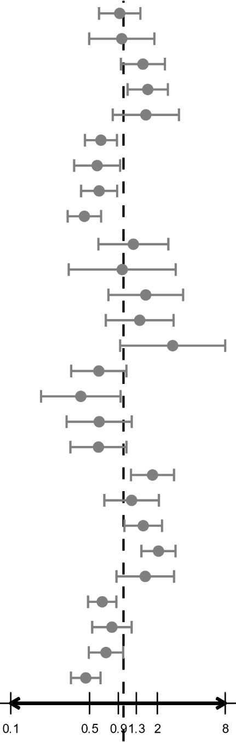  0.93 (0.61–1.41) | ⠀ | 0.723
 | Renal & PDL1 | 0.97 (0.50–1.88) | ⠀ | 0.919
 | Melanoma & PD1 | 1.49 (0.95–2.33) | ⠀ | 0.083
 | Melanoma & CTLA4 | 1.64 (1.09–2.48) | ⠀ | 0.018
 | Melanoma & PDL1 | 1.58 (0.80–3.11) | ⠀ | 0.185
 | Lung & PD1 | 0.63 (0.46–0.88) | ⠀ | 0.006
 | Lung & CTLA4 | 0.58 (0.37–0.93) | ⠀ | 0.025
 | Lung & CTLA4+PD1 | 0.61 (0.42–0.88) | ⠀ | 0.008
 | Lung & PDL1 | 0.45 (0.32–0.63) | ⠀ | <0.001
Control arm | Renal & CTLA4+PD1 | 1.22 (0.60–2.50) | ⠀ | 0.579
 | Renal & PDL1 | 0.98 (0.33–2.91) | ⠀ | 0.964
 | Melanoma & PD1 | 1.58 (0.74–3.38) | ⠀ | 0.242
 | Melanoma & CTLA4 | 1.39 (0.70–2.78) | ⠀ | 0.347
 | Melanoma & PDL1 | 2.73 (0.93–7.99) | ⠀ | 0.066
 | Lung & PD1 | 0.60 (0.34–1.06) | ⠀ | 0.081
 | Lung & CTLA4 | 0.42 (0.19–0.94) | ⠀ | 0.035
 | Lung & CTLA4+PD1 | 0.61 (0.31–1.18) | ⠀ | 0.144
 | Lung & PDL1 | 0.60 (0.34–1.06) | ⠀ | 0.081
Immunotherapy | Renal & CTLA4+PD1 | 1.81 (1.17–2.81) | ⠀ | 0.008
 | Renal & PDL1 | 1.18 (0.68–2.06) | ⠀ | 0.558
 | Melanoma & PD1 | 1.50 (1.02–2.20) | ⠀ | 0.040
 | Melanoma & CTLA4 | 2.05 (1.44–2.90) | ⠀ | <0.001
 | Melanoma & PDL1 | 1.56 (0.87–2.81) | ⠀ | 0.138
 | Lung & PD1 | 0.65 (0.49–0.87) | ⠀ | 0.003
 | Lung & CTLA4 | 0.79 (0.53–1.18) | ⠀ | 0.251
 | Lung & CTLA4+PD1 | 0.70 (0.49–0.99) | ⠀ | 0.046
 | Lung & PDL1 | 0.46 (0.34–0.63) | ⠀ | <0.001
† Renal & PD1 as reference group.

Table 3 Pruritus: Heterogeneity
Group | Number of studies | N (control/immuno) | Q (p value) | I2 (95% CI) [%]
Renal | 7 | 2526/2619 | 22.1 (0.002) | 68.3 (33.5–84.9)
Melanoma | 8 | 2266/2767 | 45.5 (<0.001) | 84.6 (71.5–91.7)
Lung | 27 | 8057/11267 | 73.1 (<0.001) | 59.0 (39.1–72.4)
CTLA4 | 7 | 2316/2689 | 13.5 (0.036) | 55.6 (0.0–80.9)
PD1 | 20 | 5237/6594 | 51.9 (<0.001) | 63.4 (40.8–77.3)
CTLA4+PD1 | 6 | 1491/1871 | 22.8 (<0.001) | 78.1 (51.7–90.1)
PDL1 | 13 | 3805/5499 | 13.6 (0.405) | 4.1 (0.0–56.9)
Total | 42 | 12849/16653 | 141.9 (<0.001) | 67.6 (56.1–76.0)

Table 4 Xerodermia: : odds ratio table (control arm as reference)
Study | Diagnosis | Inhibitor | N (contr/imm) | N events (contr/imm) | OR (95% CI)† |  | p value
Borghaei et al., 2015 | Lung | PD1 | 268/287 | 8/20 | 2.43 (1.05–5.63) | 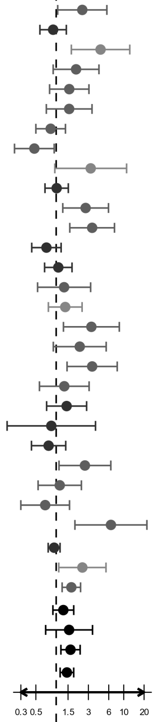  ⠀ | 0.037
Motzer et al., 2015 | Renal | PD1 | 397/406 | 44/41 | 0.90 (0.57–1.41) | ⠀ | 0.650
Robert et al., 2015 | Melanoma | PD1 | 205/206 | 5/21 | 4.54 (1.68–12.29) | ⠀ | 0.003
Herbst et al. 2016 | Lung | PD1 | 309/703 | 8/35 | 1.97 (0.90–4.30) | ⠀ | 0.088
Antonia et al., 2017 | Lung | PDL1 | 234/475 | 12/37 | 1.56 (0.80–3.06) | ⠀ | 0.192
Carbone et al., 2017 | Lung | PD1 | 263/267 | 11/17 | 1.56 (0.72–3.39) | ⠀ | 0.264
Rittmeyer et al., 2017 | Lung | PDL1 | 578/609 | 34/30 | 0.83 (0.50–1.37) | ⠀ | 0.466
Gandhi et al., 2018 | Lung | PD1 | 202/405 | 18/18 | 0.48 (0.24–0.94) | ⠀ | 0.031
Larkin et al., 2018 | Melanoma | PD1 | 102/268 | 3/24 | 3.25 (0.96–11.02) | ⠀ | 0.059
Motzer et al., 2018 | Renal | CTLA4+PD1 | 535/547 | 53/55 | 1.02 (0.68–1.51) | ⠀ | 0.935
Socinski et al., 2018 | Lung | PDL1 | 394/400 | 9/24 | 2.73 (1.25–5.95) | ⠀ | 0.012
Socinski et al., 2018 | Lung | PDL1 | 394/393 | 9/29 | 3.41 (1.59–7.30) | ⠀ | 0.002
Rini, Plimack, et al., 2019 | Renal | PD1 | 425/429 | 39/29 | 0.72 (0.43–1.18) | ⠀ | 0.194
Rini, Powles, et al., 2019 | Renal | PDL1 | 446/451 | 37/40 | 1.08 (0.67–1.72) | ⠀ | 0.759
West et al., 2019 | Lung | PDL1 | 131/473 | 6/28 | 1.31 (0.53–3.24) | ⠀ | 0.557
Gutzmer et al., 2020 | Melanoma | PDL1 | 281/230 | 25/27 | 1.36 (0.77–2.42) | ⠀ | 0.292
Jotte et al., 2020 | Lung | PDL1 | 334/666 | 5/32 | 3.32 (1.28–8.60) | ⠀ | 0.013
Rizvi et al., 2020 | Lung | PDL1 | 352/369 | 7/16 | 2.23 (0.91–5.50) | ⠀ | 0.080
Rizvi et al., 2020 | Lung | CTLA4+PD1 | 352/371 | 7/24 | 3.41 (1.45–8.02) | ⠀ | 0.005
Rudin et al., 2020 | Lung | PD1 | 223/223 | 10/13 | 1.32 (0.57–3.07) | ⠀ | 0.522
Choueiri et al., 2021 | Renal | PD1 | 320/320 | 15/21 | 1.43 (0.72–2.82) | ⠀ | 0.305
Choueiri et al., 2021 | Renal | CTLA4+PD1 | 320/50 | 15/2 | 0.85 (0.19–3.82) | ⠀ | 0.829
Motzer et al., 2021 | Renal | PD1 | 340/352 | 27/22 | 0.77 (0.43–1.39) | ⠀ | 0.387
Nishio et al., 2021 | Lung | PDL1 | 274/291 | 7/19 | 2.66 (1.10–6.44) | ⠀ | 0.030
Owonikoko et al., 2021 | Lung | PD1 | 273/278 | 14/16 | 1.13 (0.54–2.36) | ⠀ | 0.746
Owonikoko et al., 2021 | Lung | CTLA4+PD1 | 273/279 | 14/10 | 0.69 (0.30–1.58) | ⠀ | 0.376
Paz-Ares et al., 2021 | Lung | CTLA4+PD1 | 349/358 | 3/19 | 6.46 (1.90–22.05) | ⠀ | 0.003
Total: Renal | Renal | ⠀ | 2463/2555 | 215/210 | 0.93 (0.76–1.14) | ⠀ | 0.501
Total: Melanoma | Melanoma | ⠀ | 588/704 | 33/72 | 2.44 (1.09–5.46) | ⠀ | 0.030
Total: Lung | Lung | ⠀ | 4184/6847 | 152/387 | 1.68 (1.22–2.30) | ⠀ | 0.001
Total: antiPD1 | ⠀ | PD1 | 3327/4144 | 202/277 | 1.28 (0.89–1.82) | ⠀ | 0.179
Total: antiCTLA4+antiPD1 | ⠀ | CTLA4+PD1 | 1829/1605 | 92/110 | 1.55 (0.70–3.45) | ⠀ | 0.279
Total: antiPDL1 | ⠀ | PDL1 | 3418/4357 | 151/282 | 1.63 (1.18–2.26) | ⠀ | 0.003
Total | ⠀ | ⠀ | 7235/10106 | 400/669 | 1.44 (1.15–1.82) | ⠀ | 0.002
† Control arm as a reference group.
Q-test for subgroup difference was used for type of diagnosis and types of immunotherapy. There was significant difference among diagnoses (p=0.001) but no difference between types of immunotherpy (p=0.602).

Table 5 Xerodermia: OR according to diagnosis and type of immunotherapy
Study arm | Inhibitor | OR (95% CI)† |  | p value
Total | Renal & CTLA4+PD1 | 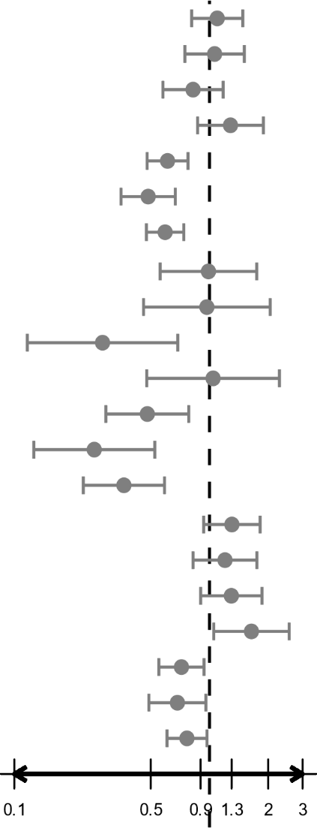 | ⠀ | 0.554
  1.10 (0.81–1.48)
 | Renal & PDL1 | 1.06 (0.75–1.51) | ⠀ | 0.735
 | Melanoma & PD1 | 0.82 (0.58–1.17) | ⠀ | 0.284
 | Melanoma & PDL1 | 1.28 (0.87–1.89) | ⠀ | 0.211
 | Lung & PD1 | 0.61 (0.48–0.78) | ⠀ | <0.001
 | Lung & CTLA4+PD1 | 0.48 (0.35–0.67) | ⠀ | <0.001
 | Lung & PDL1 | 0.59 (0.48–0.74) | ⠀ | <0.001
Control arm | Renal & CTLA4+PD1 | 0.99 (0.56–1.75) | ⠀ | 0.966
 | Renal & PDL1 | 0.97 (0.46–2.05) | ⠀ | 0.935
 | Melanoma & PD1 | 0.28 (0.12–0.69) | ⠀ | 0.005
 | Melanoma & PDL1 | 1.04 (0.48–2.28) | ⠀ | 0.915
 | Lung & PD1 | 0.48 (0.29–0.78) | ⠀ | 0.003
 | Lung & CTLA4+PD1 | 0.26 (0.13–0.52) | ⠀ | <0.001
 | Lung & PDL1 | 0.36 (0.23–0.59) | ⠀ | <0.001
Immunotherapy | Renal & CTLA4+PD1 | 1.30 (0.93–1.82) | ⠀ | 0.121
 | Renal & PDL1 | 1.20 (0.82–1.75) | ⠀ | 0.342
 | Melanoma & PD1 | 1.29 (0.90–1.86) | ⠀ | 0.163
 | Melanoma & PDL1 | 1.64 (1.05–2.56) | ⠀ | 0.029
 | Lung & PD1 | 0.72 (0.55–0.94) | ⠀ | 0.015
 | Lung & CTLA4+PD1 | 0.68 (0.49–0.96) | ⠀ | 0.027
 | Lung & PDL1 | 0.77 (0.61–0.97) | ⠀ | 0.027
† Renal & PD1 as reference group.

Table 6 Xerodermia: Heterogeneity
Group | Number of studies | N (control/immuno) | Q (p value) | I2 (95% CI) [%]
Renal | 6 | 2463/2555 | 3.3 (0.776) | 0.0 (0.0–70.8)
Melanoma | 3 | 588/704 | 4.9 (0.085) | 59.4 (0.0–88.4)
Lung | 14 | 4184/6847 | 37.0 (0.002) | 56.8 (25.7–74.8)
PD1 | 12 | 3029/4144 | 28.7 (0.002) | 61.7 (28.3–79.6)
CTLA4+PD1 | 5 | 1359/1605 | 12.1 (0.016) | 67.0 (14.5–87.3)
PDL1 | 9 | 2847/4357 | 16.2 (0.063) | 44.4 (0.0–73.3)
Total | 23 | 7235/10106 | 60.1 (<0.001) | 56.8 (33.5–71.9)

