Supplementary Information

Additional file1: Figure S1.
Figure S1. Blood pressure was measured in the tail artery of rats using non-invasive blood pressure monitor. A showed a rat connected to a blood pressure measuring instrument. B showed blood pressure measurement data display interface of SoftronBP-2010A.
Additional file2: Figure S2.

Figure S2. Muscle force measurement system for isolated rat left ventricular papillary muscle.
Additional file3: Figure S3.
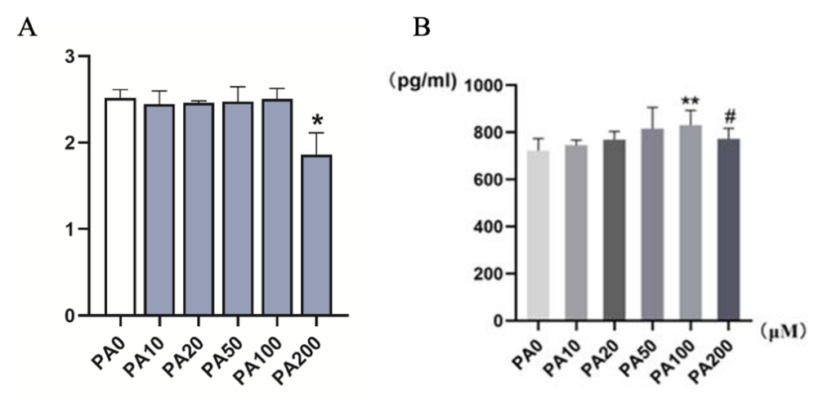
Figure S3. Cell viability and cell damage assessment. A. CCK-8 assay: H9C2 cells were treated with different concentrations of PA to observe cell viability, *p<0.05. B. cTnT level in the cell supernatant under the PA concentration gradient detected by ELISA. **p <0.01, PA100μM vs. PA0 group; #p<0.05, PA200μM vs. PA100μM group.
Additional file4: Figure S4.
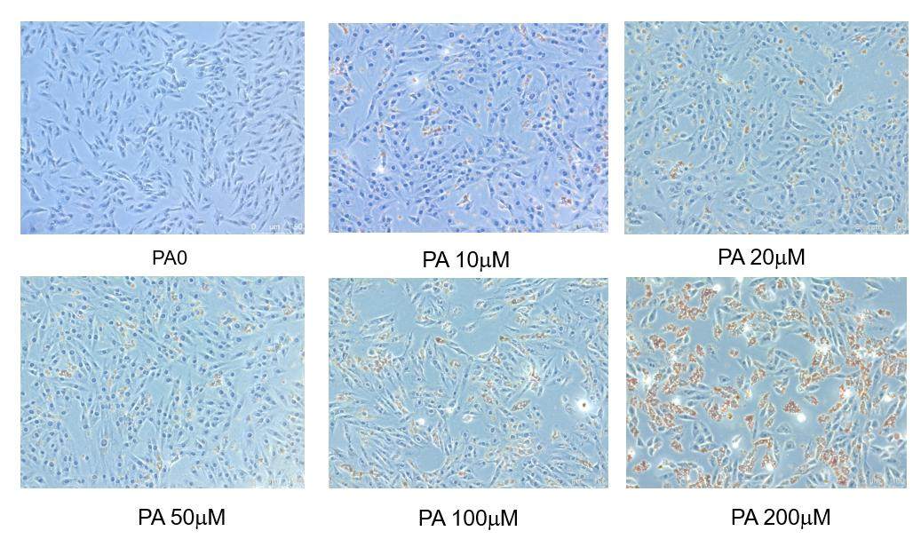
Figure S4. Oil red O staining by treatment of PA at different concentrations.

Additional file5: Figure S5.
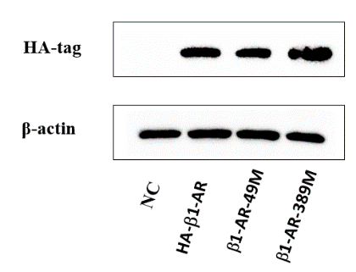
Figure S5. Expression of β₁-AR in cell protein after transfection of β₁-AR wild-type and mutant (NC indicates no transfection in H9C2 cells).
Additional file6: Figure S6.
Figure S6. Representative images of successful mode of Wistar rats fed for 16w on ordinary diet (A) and high-fat diet (B), respectively. C. Plot of body weight change of Wistar rats fed for different diets. **p <0.01.

Additional file7: Figure S7.
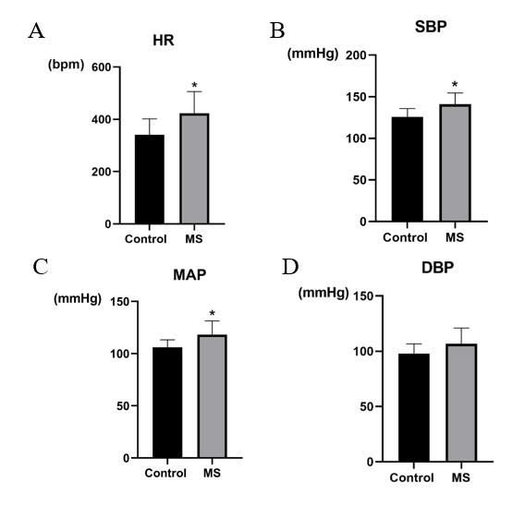
Figure S7. Changes in heart rate (HR), systolic pressure (SBP), mean arterial pressure (MAP), diastolic pressure (DBP) in rats in Control and MS, * p<0.05.
Additional file8: Figure S8.
Figure S8. Changes in plasma adiponectin (Adiponectin), leptin (Leptin) and C peptide (C-peptide) in Control and MS rats at 16w. ** p<0.01.

