Supplemental Note.
- Estimate of distribution parameters with unscreened controls
Suppose we have a case sample and only a population (not a screened control) sample and from these estimated the means $m_{1}$, $m_{p}$ and variances${ σ}_{1}^{2}$, $σ_{p}^{2}$ of the distribution of PRS in cases and in the population, respectively. Let $p_{1}$ be the density of the PRS distribution in cases, $p_{0}$ the density in non-cases and $p_{p}$ the density in the population, with disease prevalence $K$. Then $p_{p} = K p_{1} + \left(1-K\right)p_{0}$, which gives
$$p_{0}=\frac{p_{p}-Kp_{1}}{1-K} .$$
Then we find the mean and variance of the distribution in non-cases as follows,
$$m_{0}=\frac{m_{p}-Km_{1}}{1-K}$$
by linearity, and
$$σ_{0}^{2}-m_{0}^{2}=\frac{1}{1-K} (σ_{p}^{2}-m_{p}^{2})-\frac{K}{1-K} (σ_{1}^{2}-m_{1}^{2}),$$
which upon using the above expression for $m_{0}$ gives
$$σ_{0}^{2}=\frac{σ_{p}^{2}-Kσ_{1}^{2}}{1-K}-\frac{K{\left(m_{p}-m_{1}\right)}^{2}}{{\left(1-K\right)}^{2}} .$$

- Estimate of probability of disease by linear regression with logistic link function
Suppose $p_{1}$and $p_{0}$ are the probability densities of the PRS distribution in cases and in non-cases, respectively. The probability of disease can be estimated from these distributions and the disease prevalence $K$ by logistic regression; in an interval of PRS between $x$ and $x+dx$, we expect $N K p_{1}(x) dx$ cases and $N \left(1-K\right)p_{0}(x) dx$ non-cases in a (large) population of $N$ individuals, and by integrating over $x$, can find the log-likelihood function for the logistic model of Eq. (3). As the maximum likelihood condition gives rise to implicit equations that cannot easily be solved, we use the alternative approach of linear regression with the logistic link function, taking as data the log odds ratio at each value x of the PRS and the probability density of the PRS in the population as weight. More precisely, we consider the linear regression model
$$y=α+β x+ϵ$$
with variables $x$, distributed according to the joint distribution of PRS in the population with density $p_{p}(x)=K p_{1}(x) + \left(1-K\right)p_{0}(x)$, and the logarithm of the odds ratio $y=\log{\frac{K p_{1}\left(x\right)}{\left(1-K\right)p_{0}\left(x\right)}}$ , corresponding to the raw probability function
$$\hat{P}\left(x\right)=\frac{1}{1+e^{-y}}=\frac{Kp_{1}\left(x\right)}{Kp_{1}\left(x\right)+\left(1-K\right)p_{0}\left(x\right)} .$$
(We note that $\hat{P}$ is unsuitable for direct interpretation as a probability of disease, as it ignores the overall distribution of PRS in the population and generally does not increase with the PRS $x$ throughout; indeed, for normal densities $p_{1}$ and $p_{0}$, the distribution with the larger variance will dominate both tails, independently of the difference of means.)
The least squares method gives the following estimates for the regression parameters,
$$α=\overline{y}-\overline{x}β, β=\frac{\overline{xy}-\overline{x} \overline{y}}{\overline{x^{2}}-{\overline{x}}^{2}} ,$$
where the bar denotes the sample average, here replaced with the population average. Here we have $\overline{x}=m_{p}=Km_{1}+\left(1-K\right)m_{p}$,$\overline{x^{2}}-{\overline{x}}^{2}=σ_{p}^{2}=Kσ_{1}^{2}+\left(1-K\right)σ_{0}^{2}+K\left(1-K\right){\left(m_{1}-m_{0}\right)}^{2}.$ Further, we obtain $\overline{y}=log\frac{K}{1-K}+ \int_{-∞}^{∞}{log\frac{p_{1}\left(x\right)}{p_{0}\left(x\right)} }p_{p}\left(x\right) dx$ and $\overline{xy}=m_{p}log \frac{K⁡}{1-K}+ \int_{-∞}^{∞}{x log \frac{⁡p_{1}\left(x\right)}{p_{0}\left(x\right)} }p_{p}\left(x\right) dx$. Hence
$$β=\frac{1}{σ_{p}^{2}} \int_{-∞}^{∞}{\left(x-m_{p}\right) }p_{p}\left(x\right) log \frac{⁡p_{1}\left(x\right)}{p_{0}\left(x\right)} dx ,$$
$$α=log \frac{⁡K}{1-K}+\int_{-∞}^{∞}{p_{p}\left(x\right) log \frac{⁡p_{1}\left(x\right)}{p_{0}\left(x\right)} }dx-m_{p}β.$$
The two integrals can be worked out explicitly for normal distributions
$$p_{j}(x)=\frac{1}{\sqrt{2πσ_{j}^{2}} } e^{-\frac{{\left(x-m_{j}\right)}^{2}}{2σ_{j}^{2}}} (j∈(0, 1)),$$
as for $j, k∈(0, 1)$
$$\int_{-∞}^{∞}{p_{j}\left(x\right) log p_{k}(x)} dx=\int_{-∞}^{∞}{\frac{-{\left(σ_{j}ξ+m_{j}-m_{k}\right)}^{2}}{2σ_{k}^{2}}} e^{\frac{{-ξ}^{2}}{2}}\frac{dξ}{\sqrt{2π}}-\frac{1}{2}\log\left(2πσ_{k}^{2}\right)=-\frac{1}{2}\left(\frac{σ_{j}^{2}+{\left(m_{j}-m_{k}\right)}^{2}}{σ_{k}^{2}}+\log\left(2πσ_{k}^{2}\right)\right)$$
and
$$\int_{-∞}^{∞}{\left(x-m_p\right) p_{j}\left(x\right) log p_{k}(x)} dx=\int_{-∞}^{∞}{(σ_{j}ξ+m_{j}-m_{p}) \frac{-{\left(σ_{j}ξ+m_{j}-m_{k}\right)}^{2}}{2σ_{k}^{2}}} e^{\frac{{-ξ}^{2}}{2}}\frac{dξ}{\sqrt{2π}}-\frac{m_{j}-m_{p}}{2}\log\left(2πσ_{k}^{2}\right)=\left(m_{k}-m_{j}\right)\frac{σ_{j}^{2}}{σ_{k}^{2}} -\frac{m_{j}-m_{p}}{2}\left(\frac{σ_{j}^{2}+{\left(m_{j}-m_{k}\right)}^{2}}{σ_{k}^{2}}+\log\left(2πσ_{k}^{2}\right)\right),$$
bearing in mind that the first and third moments of the standard normal distribution vanish and the second moment equals 1. Hence, abbreviating
$$r_{1}=\frac{σ_{0}^{2}+{\left(m_{0}-m_{1}\right)}^{2}}{σ_{1}^{2}} , r_{0}=\frac{σ_{1}^{2}+{\left(m_{0}-m_{1}\right)}^{2}}{σ_{0}^{2}} ,$$
we obtain after some calculation
$$β=\frac{m_{1}-m_{0}}{σ_{p}^{2}} \left(K\left(1-K\right)\left(\frac{r_{0}+r_{1}}{2}-1\right)+K\frac{σ_{1}^{2}}{σ_{0}^{2}}+\left(1-K\right)\frac{σ_{0}^{2}}{σ_{1}^{2}} \right) ,$$
$$α=log \frac{K σ_{0}}{\left(1-K\right)σ_{1}}+\frac{1}{2}\left(\left(r_{0}-1\right)K+\left(1-r_{1}\right)\left(1-K\right)\right)-m_{p}β$$
as coefficients for the probability function (3). In the special case $σ_{0}^{2}=σ_{1}^{2}$ the probability function from the regression model (3) with these values of $α, β$ is equal to the raw probability function (2).

- Inclusion of rare variants in the probability
Consider a rare variant SNP allele which appears to be causal by itself and thus contributes to the probability of developing the disease as a separate factor instead of as part of the polygenic risk. Assuming independence, the probability of disease $P$ will then satisfy $1-P=(1-P_{PRS})(1-p_{rare})$, so
$$P=P_{PRS}+p_{rare}-p_{rare}P_{PRS} ,$$
where $P_{PRS}$ is the probability of disease due to the polygenic risk and $p_{rare}$ is the intrinsic probability of the rare variant to cause the disorder.
Suppose the reference study had genotype counts $n_{0}$, $n_{1}$ and $n_{2}=0$ in cases, and $m_{0}$, $m_{1}$ and $m_{2}=0$ in controls. We assume that the variant is so rare that no individuals carry two risk alleles. Then the estimated probability of disease for non-carriers of the variant (in the sample) is $P_{0}=\frac{n_{0}}{n_{0}+m_{0}}=\frac{1}{1+e^{-α}}$ and the probability of disease for carriers of the variant is $P_{1}=\frac{n_{1}}{n_{1}+m_{1}}=\frac{1}{1+e^{-α-β}}$; here $β$ is the log odds ratio. Using the above formula for the combined probability and $P_{1}=\frac{1}{1+ \frac{1-P_{0}}{P_{0}} e^{-β}}$, we find
$$p_{rare}=\frac{P_{1}-P_{0}}{1-P_{0}}=\frac{P_{0}\left(e^{β}-1\right)}{P_{0}\left(e^{β}-1\right)+1}$$
for the intrinsic probability. In order to estimate the intrinsic probability for the rare variant to cause the disease in the population, we use the disease prevalence $K$ as a proxy for the background probability $P_{0}$, assuming the variant to be so rare that it does not affect the population prevalence, and as $e^{β}=OR$, we obtain the estimate
$$p_{rare}=\frac{K\left(OR-1\right)}{K\left(OR-1\right)+1}$$
and hence the combined probability of disease
$$P=P_{PRS}+\frac{K\left(OR-1\right)}{K\left(OR-1\right)+1} (1-P_{PRS}) .$$
If there are several rare variants with intrinsic probabilities $p_{rare,1}$, …, $p_{rare,ν}$, then assuming their effects are mutually independent, the joint probability for disease caused by the rare variants will be $p_{rare}=1-\prod_{j=1}^{ν}{(1-p_{rare,j})}$. However, due to the assumption of very small allele frequencies, it is unlikely that an individual would carry more than one independent rare variant.

- Inclusion of common variants of common with high effect
We propose calculating the probability of disease for a high-effect common variant such as APOE for AD separately per genotype, based on the respective disease prevalence, instead of including the variant in the PRS. The disease prevalence in carriers and non-carriers of the risk allele are not usually known but can be calculated from the genotype counts in cases and non-cases. If the raw genotype data are not available, these counts can be inferred from general information as follows.
Suppose there is a population of $N$ individuals, the risk allele has frequency $f$ in the population and odds ratio $OR$, and the disease prevalence is $K$. Then the allele counts $\tilde{n_{0}}$, $\tilde{n_{1}}$ in cases and $\tilde{m_{0}}$, $\tilde{m_{1}}$ in cases and in controls, respectively, satisfy the equations
$\tilde{n_{0}}+\tilde{m_{0}}=2(1-f)N$, $\tilde{n_{1}}+\tilde{m_{1}}=2fN$, $\tilde{n_{0}}+\tilde{n_{1}}=2KN$, $\tilde{m_{0}}+\tilde{m_{1}}=2(1-K)N$ and $OR=\frac{\tilde{n_{1}} \tilde{m_{0}}}{\tilde{m_{1}} \tilde{n_{0}}}$ . We now express $\tilde{n_{0}}$ by the first equation, substitute for $\tilde{m_{0}}$ from the odds ratio, replace $\tilde{m_{1}}$ by the second equation and then express the remaining unknown $\tilde{n_{1}}$ by the third equation. This gives a quadratic equation for $\tilde{n_{0}}$,
$$0=\left(1-OR\right) {\tilde{n_{0}}}^{2}-2N\left(1+\left(1-OR\right)\left(K-f\right)\right) \tilde{n_{0}}+4K\left(1-f\right)N^{2}$$
and hence
$$\tilde{n_{0}}=\frac{b-\sqrt{b^{2}-16\left(1-OR\right)\left(1-f\right)K}}{2 (1-OR)}N$$
with $b=2(1+\left(1-OR\right)\left(K-f\right))$. This, by means of the above set of equations, determines all allele counts uniquely. In particular, For the genotype counts, we assume HWE in the population to obtain the equations $n_{0}=\frac{\tilde{n_{0}}-n_{1}}{2}$, $n_{2}=\frac{\tilde{n_{1}}-n_{1}}{2}$, $m_{1}=2f(1-f)N-n_{1}$, $m_{0}={\left(1-f\right)}^{2}N-n_{0}$, $m_{2}=f^{2} N-n_{2}$. Here $n_{1}$ is still a free parameter; in fact, the given data do not determine the genotype counts uniquely. If we further assume that HWE also holds in non-cases, an assumption which is not unrealistic if the prevalence is not too high, we have the additional equation $4m_{0}m_{2}=m_{1}^{2}$, and substitution from the last three equations above yields
$$n_{1}=2f\left(1-f\right)N-\frac{\tilde{m_{0}} \tilde{m_{1}}}{\tilde{m_{0}}+\tilde{m_{1}}}=2f\left(1-f\right)N-\frac{2(1-f-ν)(f-K+ν)}{1-K}N,$$
where $ν=\frac{\tilde{n_{0}}}{2N}$ , so the prevalence for genotype 1 is
$$K_{1}=\frac{n_{1}}{n_{1}+m_{1}}=\frac{n_{1}}{2f\left(1-f\right)N}=1-\frac{\left(1-f-ν\right)\left(f-K+ν\right)}{\left(1-K\right)f\left(1-f\right)} .$$
Further, the prevalence for genotypes 0 and 2, respectively, is calculated as
$$K_{0}=\frac{n_{0}}{n_{0}+m_{0}}=\frac{\tilde{n_{0}}-n_{1}}{2{\left(1-f\right)}^{2}N}=1-\frac{{\left(ν-1+f\right)}^{2}}{\left(1-K\right){\left(1-f\right)}^{2}}$$
and
$$K_{2}=\frac{n_{2}}{n_{2}+m_{2}}=\frac{\tilde{n_{1}}-n_{1}}{2f^{2}N}=1-\frac{{\left(ν+f-K\right)}^{2}}{\left(1-K\right)f^{2}} .$$

Supplemental figure 1. The comparison of the theoretical probability of disease using formulae (3), (5) with the probability of disease estimated by logistic regression of simulated genotypes.
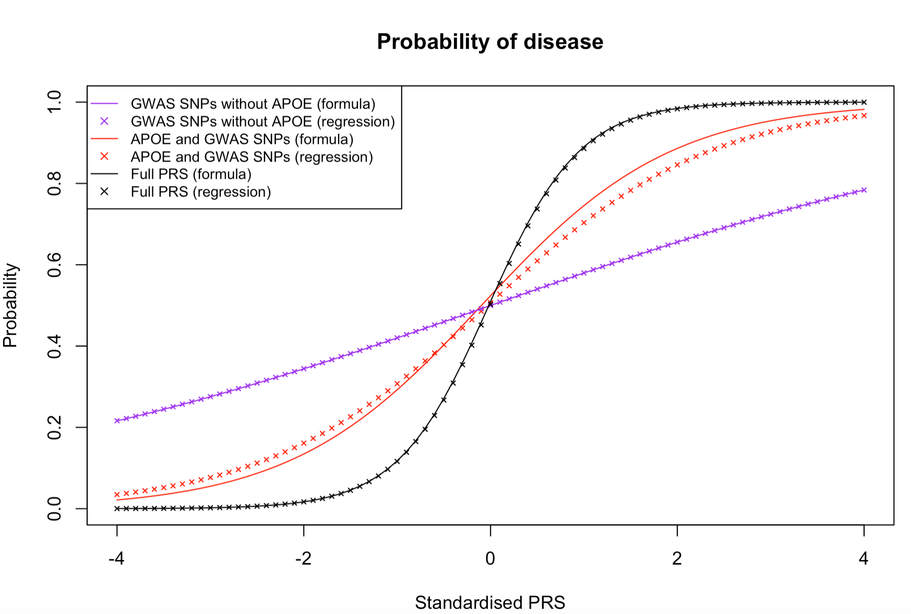
Legend: For the logistic regression results, the data were simulated for the APOE proxy SNP and for the ORS constructed from the 39 GWAS significant SNPs. The independent SNPs were simulated for 10,000 cases and 10,000 controls and added to the PRS weighted by their log odds ratios as effect sizes (see Methods). The regression curves show a fair fit with the theoretical curve in the cases where the PRS is formed from APOE and the 39 GWAS significant SNPs (red curve and points); the other approximations (logistic regression from normally distributed samples for PRS in cases and in non-cases, and linear regression of the raw probability function from a normally distributed sample for PRS in the population) lie close to the shown theoretical curve. In the simulations, the distributions of PRS in cases and in non-cases are skewed away from normality when APOE is included with a moderate number of less highly associated SNPs (histograms not shown); this plausibly explains the discrepancy. When APOE is omitted from the PRS or when it is included with a large number of SNPs of small effect size (in this figure N SNPs=100,000), the fit is perfect (purple and black curves and points).

Supplemental Figure 2. Combined probability of AD calculated with 2% lifetime prevalence of AD, 10% prevalence of AD in 65+ age group, including probability due to presence of a rare variant. The effect size is set to OR=500 reflecting almost fully penetrant mutations in APP, PSEN1, and PSEN2 ¹ genes.
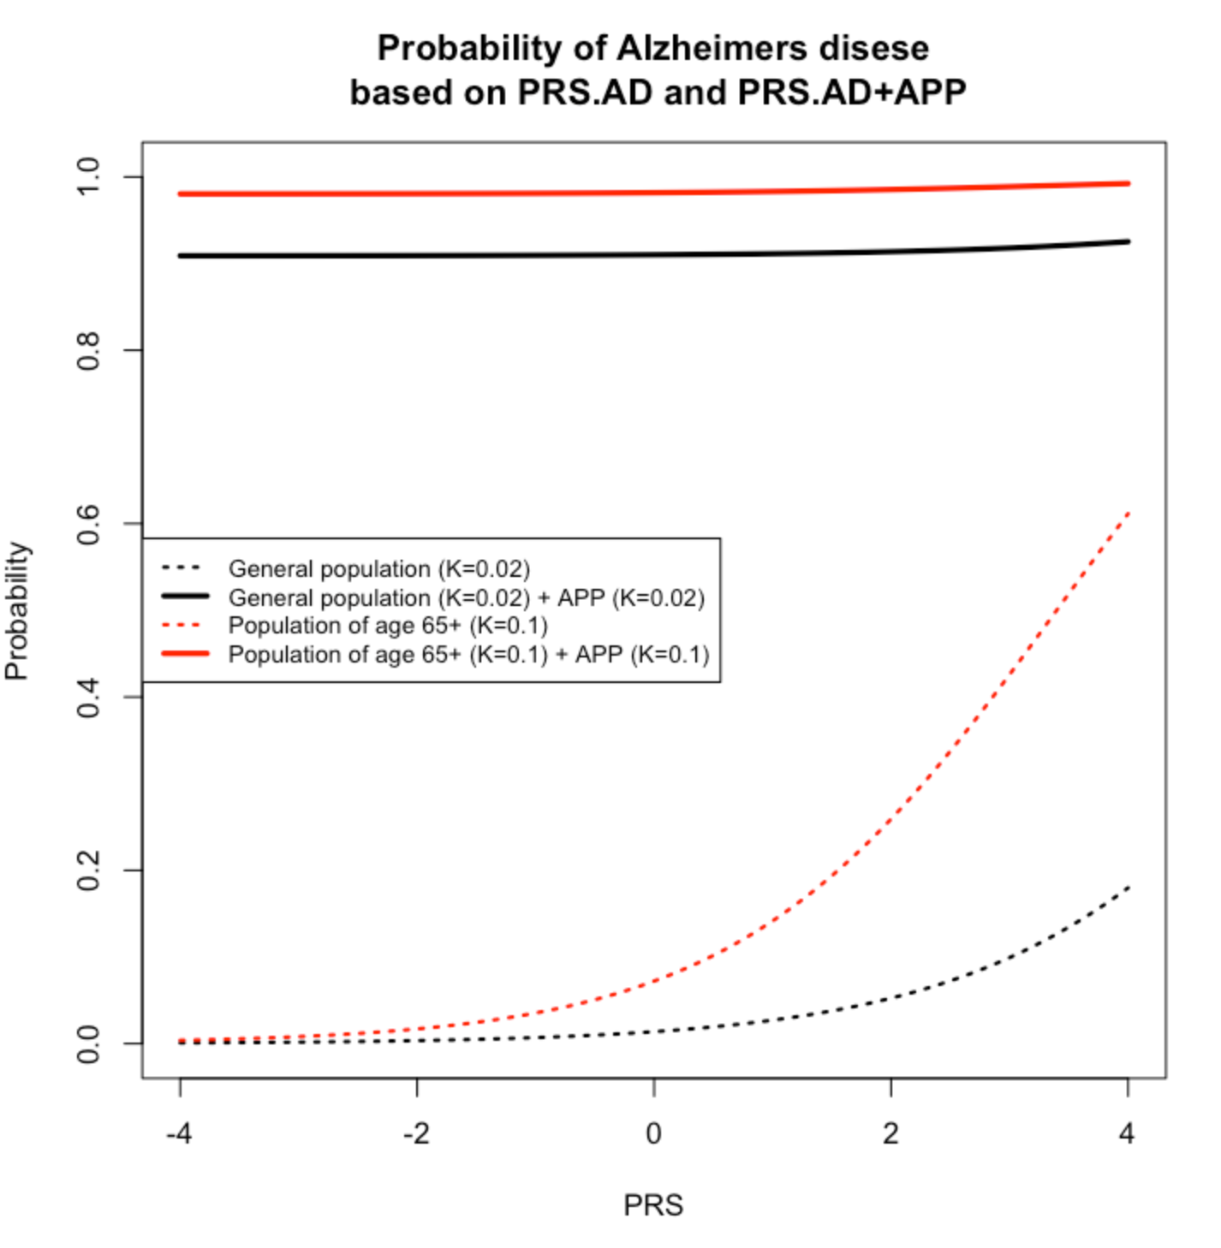
Caption: Since these mutations are associated with very early onset (55 years and below, sometimes as low as 25 years old) and explain only 5–10% of the occurrence of early-onset AD, this figure uses the prevalence K=0.02, the lifetime prevalence of AD.

Supplemental Table 1. Mean and variance for the Alzheimer’s disease genetic risk scores adapted from ².

 | Cases |  | Controls
 | $$m_{1}$$ | $$σ_{1}^{2}$$ | $$m_{0}$$ | $$σ_{0}^{2}$$
ORS | 0.478 | 1.54 | -0.335 | 0.87
PRS | 0.385 | 1.19 | -0.193 | 1.08
PRS.no.APOE | 0.320 | 1.19 | -0.136 | 1.14
PRS.AD | 0.630 | 1.44 | -0.370 | 0.89

ORS (Oligogenic Risk Score): genetic risk score including SNPs with p-value threshold p≤1x10⁻⁵.

PRS (Polygenic Risk Score): genetic risk score including SNPs with p-value threshold p≤0.1.

PRS.no.APOE: Polygenic Risk Score including SNPs with a p value threshold p≤0.1 and excluding SNPs in the APOE region (chr19:44.4-46.5Mb).

PRS.AD: PRS calculated as a weighted sum of PRS.no.APOE and APOE(ε2+ε4), where APOE effects were weighted with effect sizes (B(ε2)=-0.47 and B(ε4)=1.12) as in Kunkle et al. 2019 ³.

1. Van Cauwenberghe C, Van Broeckhoven C, Sleegers K. The genetic landscape of Alzheimer disease: clinical implications and perspectives. Genet Med. 2016;18(5):421-430.
2. Leonenko G, Baker E, Stevenson-Hoare J, et al. Identifying individuals with high risk of Alzheimer’s disease using polygenic risk scores. Nature Communications. 2021;(under review).
3. Kunkle BW, Grenier-Boley B, Sims R, et al. Genetic meta-analysis of diagnosed Alzheimer's disease identifies new risk loci and implicates Abeta, tau, immunity and lipid processing. Nat Genet. 2019;51(3):414-430.

