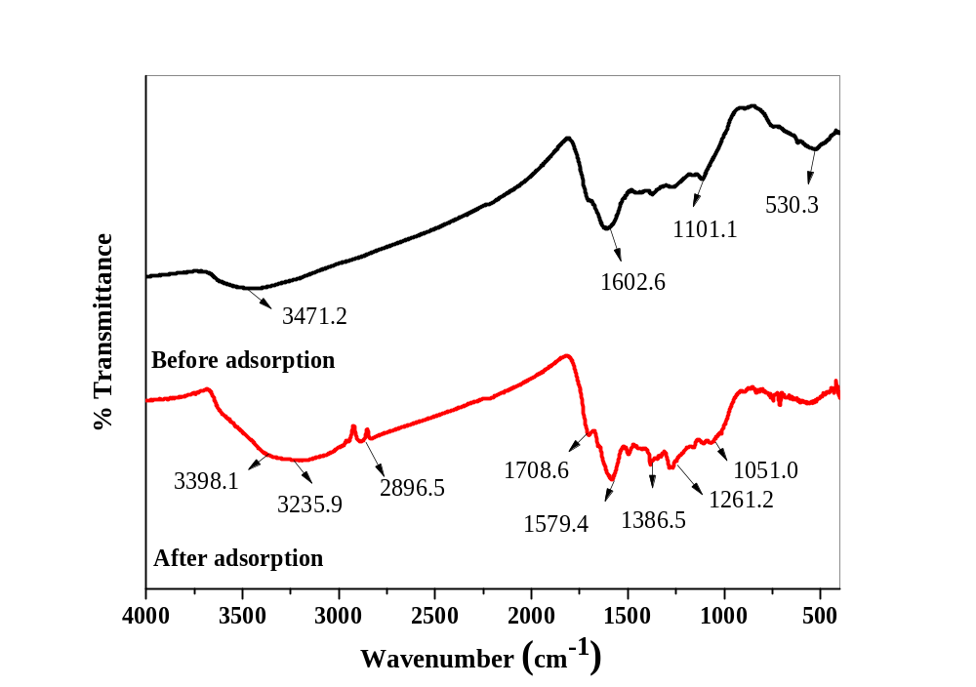
Supplementary Figure 1: FT-IR results of corn-cob biochar before and after sorption.
Supplementary Figure 2: SEM image for surface morphology (pore space) of the corn-cob biochar (a) at 1000x (b) at 2500x (c) at 5000x (d) at 10000x.
Supplementary Figure 3: (a) Biofilm formation on the corn-cob biochar surface, (b) penetration of the bacteria cells inside the corn-cob biochar.
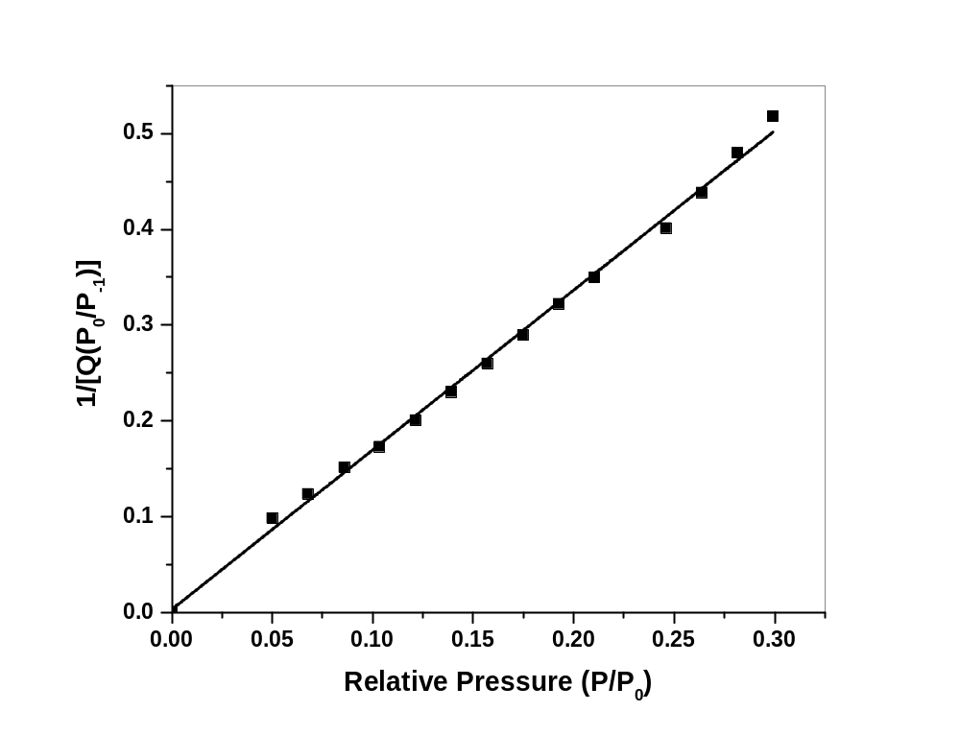
Supplementary Figure 4: BET surface area plot for the corn-cob biochar.

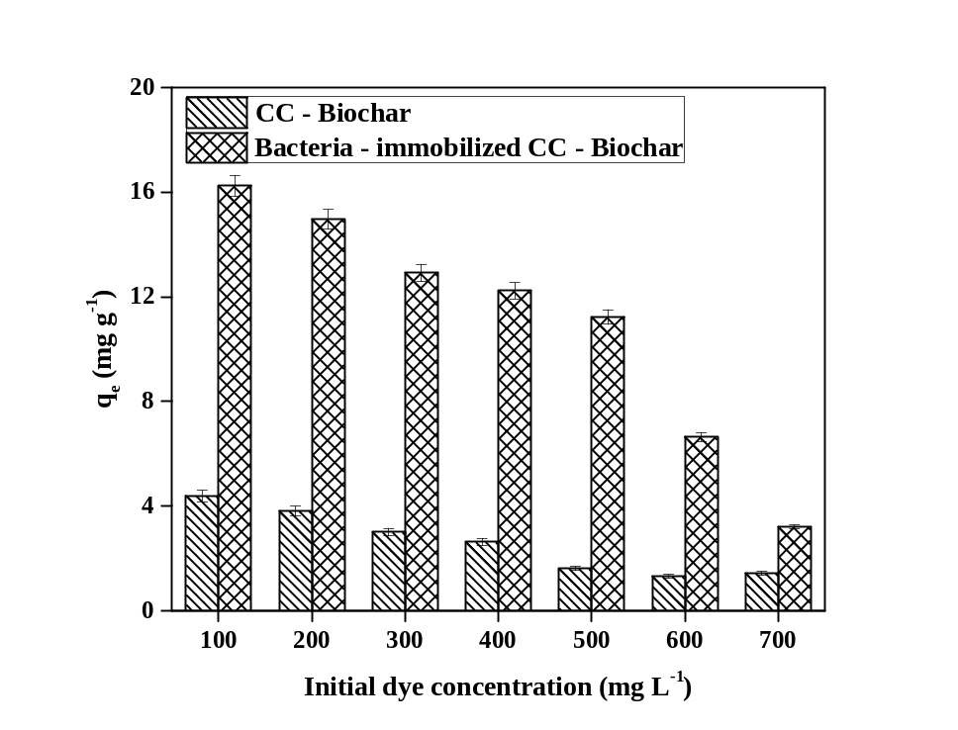
Supplementary Figure 5: Effect of different initial Indanthrene Blue RS concentration on the adsorption capacity of CC-Biochar and Bacteria-immobilized CC-Biochar.

Supplementary Table 1: CHNS analysis of corn-cob biochar before and after sorption.
Element | Before Sorption (%) | After Sorption (%)
C | 78.78 | 70.97
H | 1.13 | 1.22
N | 10.29 | 14.96
S | 0.55 | 0.24

