Transcriptomic profiles link corticostriatal microarchitecture to genetics of neurodevelopment and neuropsychiatric risks
Supplementary methods
fMRI dataset
We obtained two neuropsychiatric datasets (schizophrenia, depression and bipolar disorder) to validate the neural circuits associated with neuropsychiatric risk. The neuroimaging data of patients with schizophrenia and bipolar disorder were acquired from the UCLA Consortium for Neuropsychiatric Phenomics Study (https://www.openfmri.org/dataset/ds000030/). We included 45 schizophrenia patients (age range, 22 to 49 years), 49 patients with bipolar disorder (age range, 21 to 50 years) and 45 healthy controls (age range, 21 to 50 years). Functional MRI and high-resolution T1-weighted data were acquired on a 3T Siemens Trio scanner, with detailed scanning parameters available in a previous study[1]. The neuroimaging depression data were obtained from the OpenNeuro website (https://openneuro.org/datasets/ds002748/versions/1.0.5), comprising 51 patients with depression (age range, 19 to 55 years) and 21 healthy controls (age range, 22 to 52 years). Functional MRI and high-resolution T1-weighted data were acquired on a 3 T Ingenia scanner (Philips), and the scanning parameters were provided in a recent study[2].
fMRI data processing for validation data
Preprocessing of the functional images involved the following steps: (1) discarding the first 10 time points of functional images to account for magnetic stabilization; (2) slice timing correction to compensate for temporal shifts of different slices; (3) within-subject fMRI image realignment to estimate and spatially correct for head motions of different volumes; (4) rigid-body T1 image registration to the functional mean image, then the T1 image normalized to the Montreal MNI_ICBM152 standard space to generate a transformation matrix , and finally aligned the fMRI image to the MNI_ICBM152 standard space using the transformation matrix; (5) functional image resampling to 3×3×3 mm³ voxel size followed by regressing out confounding signals, including linear trends, white matter (WM), cerebrospinal fluid (CSF), and head motion parameters. All data preprocessing was performed using DPABI toolbox (https://rfmri.org/DPABI).
Gene expression data and preprocessing
We utilized left hemisphere microarray-based gene expression data from the Allen Human Brain Atlas[3,4] (AHBA) (http://human.brain-map.org, RRID: SCR_007416). The microarray gene expression data were obtained from six donors (mean age: 42.5 years, 5 males and 1 female), including two complete brains and four left hemispheres. None of the donors had a known history of neuropsychiatric or neurological conditions. Exclusion criteria included ﻿brain injury or disease, ﻿epilepsy, ﻿drug/alcohol dependency, ﻿> 1 hour on ventilator, ﻿positive for infectious disease, ﻿prion disease, ﻿chronic renal failure, ﻿cancer deaths, ﻿brain cancer and ﻿time since death > 30 hours. The gene expression of each sample from all donors was quantified across 58692 probes, resulting in 20,737 gene expression levels per sample. The tissue samples were also spatially registered to the Montreal Neurological Institute (MNI) coordinate space, and the locations of each sample were recorded with MNI coordinates. The gene expression data of the brain samples were preprocessed using an AHBA processing pipeline[5] (https://github.com/BMHLab/AHBAprocessing) with the recommended default setting. Specifically, probe-to-gene reannotation was performed using the latest sequencing database, and probes with values that did not exceed the background noise were filtered. When multiple probes for a gene were available, the probe with the highest correlation with the RNA-seq expression data was selected. Next, each sample was assigned to its nearest cortical parcel of HCP_MMP1.0 parcellation (left hemisphere) with 180 parcels and striatal parcellation with 28 subregions. ﻿These procedures yielded 1290 brain tissue samples covering 176 regions within the left cortex and 86 brain tissue samples covering 26 regions within the striatum, with each sample containing the expression data of 10,027 genes.
Partial least squares regression analysis
Partial least squares (PLS) regression analysis[6] was applied to investigate the relationship between gene expression and cortico-striatal covariation for both the bilateral caudate and putamen. PLS analysis, an unsupervised multivariate statistical technique, decomposes relationships between predictor variables and response variables into orthogonal sets of latent variables with maximum covariance. These latent variables are a linear combination of orthogonal variables. We first aligned the gene expression data (10027 genes) and corticostriatal covariation map to the HCP_MMP1.0 parcellation[7]. The gene expression data and corticostriatal covariation map were used as the predictor variables and the response variables, respectively[8]. The rows (brain regions) of the cortico-striatal covariation matrix were randomly selected and replaced 10000 times[9]. PLS analysis was reperformed using a new bootstrapped corticostriatal covariation matrix to generate a null distribution of the ratio of variance explained, ensuring that the PLS component was significantly greater than expected by chance. For each significant component, a bootstrapping method was employed to evaluate the estimation error associated with the weight of each gene. The weight of each gene was then divided by the estimated error to derive the adjusted weight[8]. Genes were ranked based on their corrected weights, reflecting their contributions to the PLS regression components.

Supplementary Figure
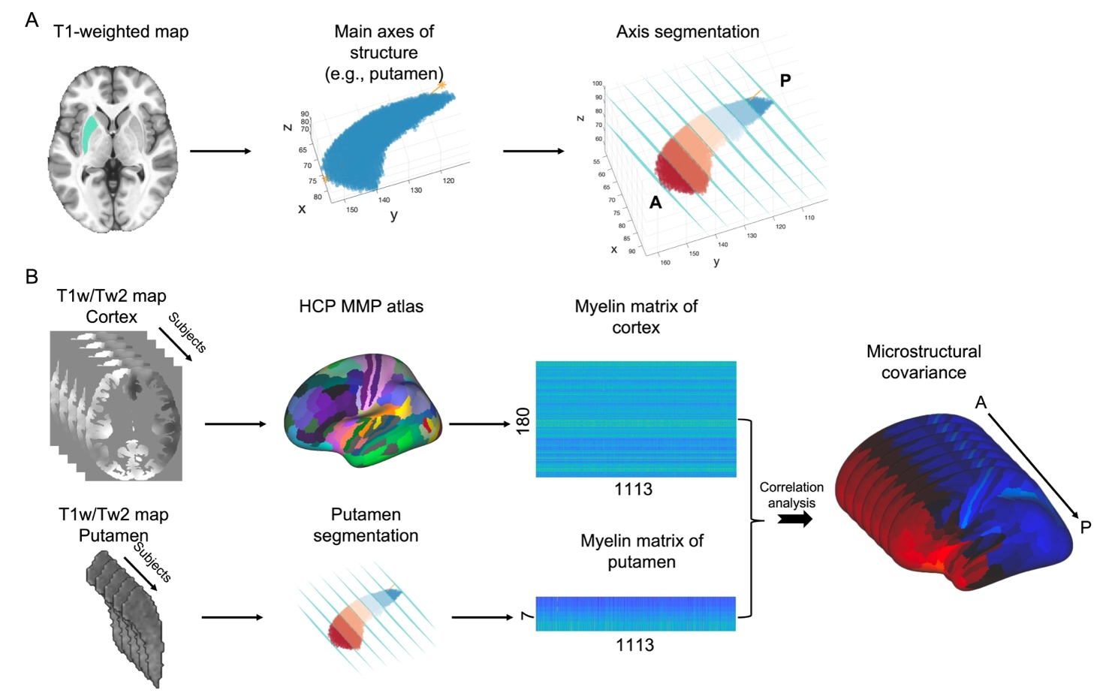
Supplementary Figure 1 Analysis flow chart of microstructural covariance. (A) Striatal segment along anterior-posterior axis. Two hyperplanes were defined for the two extreme data points located at both ends of the anterior-posterior axis. These hyperplanes are perpendicular to the anterior-posterior axis, and the data are segmented by n-1 parallel hyperplanes equally spaced between two data edges (B) Microstructural covariance calculation. First, the T1w/T2w map of the cortex and striatum are projected to HCP MMP atlas and striatal segmentations respectively. Second, the corticostriatal microstructural covariation was calculated as the microstructural correlations between cortical regions and striatal subregions across a large cohort of 1113 subjects.

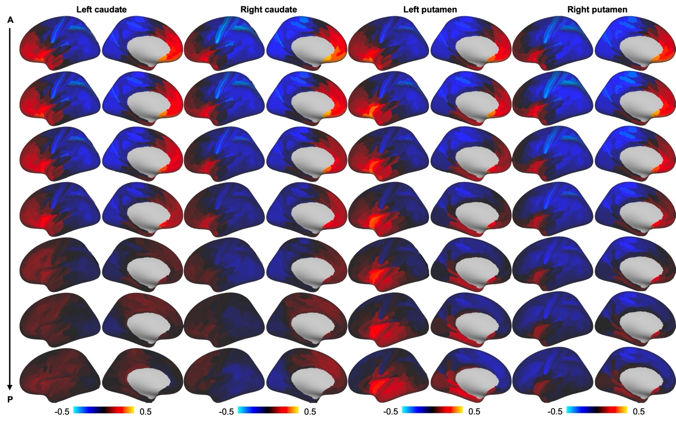
Supplementary Figure 2 Corticostriatal microstructural covariance along anterior-posterior axis of the striatum. The anterior parts of the caudate and putamen demonstrated significant positive correlations with the frontal and anterior temporal cortex but exhibited significant negative correlations with posterior cortical regions, including the sensorimotor and visual cortex. The strength corticostriatal microstructural covariance is decreased along anterior-posterior axis of the striatum.

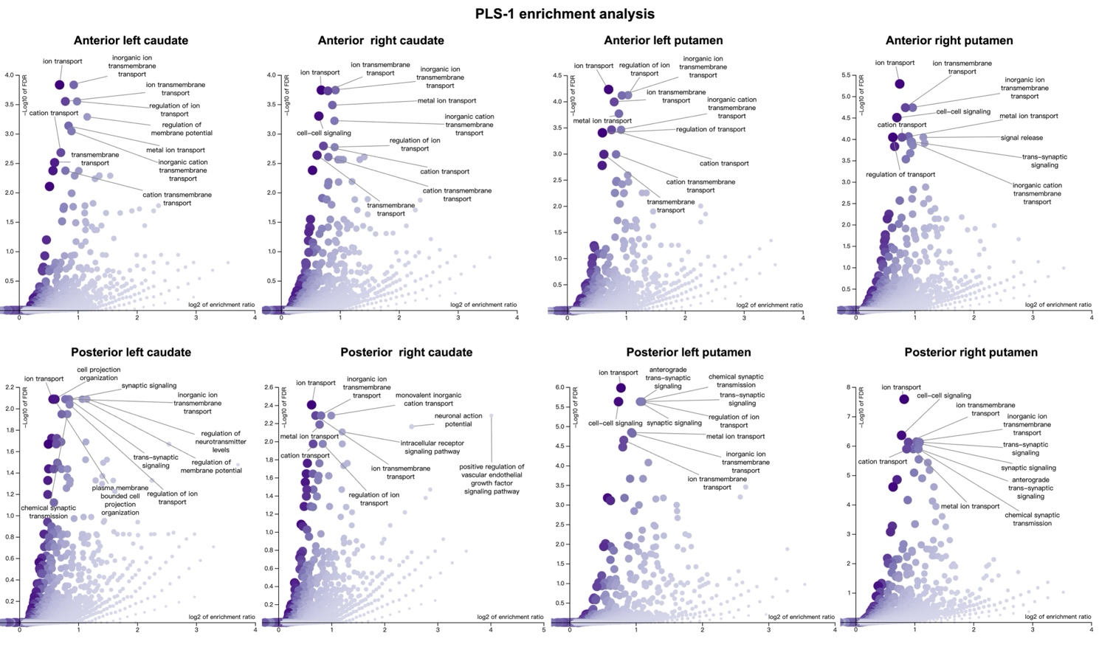
Supplementary Figure 3 PLS-1 of both anterior and posterior striatum are enriched in biological processes. PLS-1 for the anterior striatum was mainly involved in ion transport, transmembrane transport and cation transport. PLS-1 in the posterior striatum was not only engaged in ion transport and transmembrane transport but also associated with the regulation of neurotransmitter levels and chemical synaptic transmission

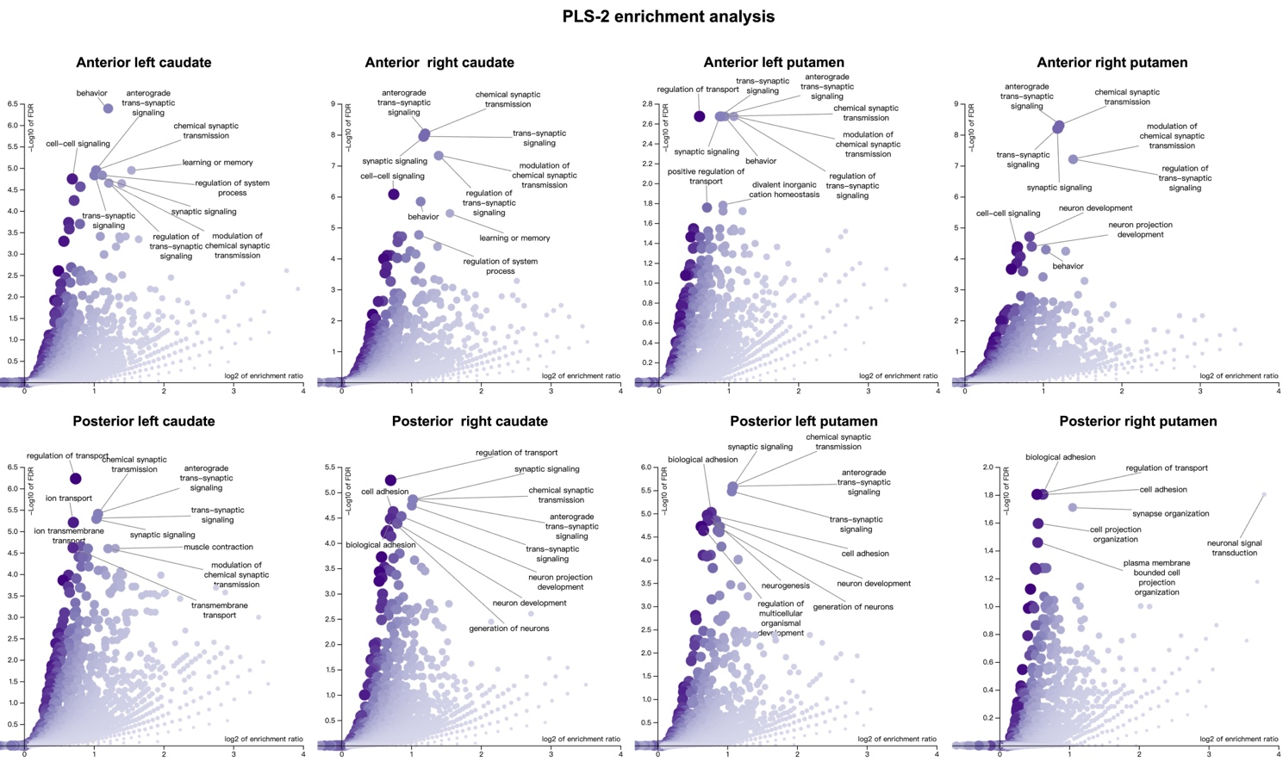
Supplementary Figure 4 PLS-2 of both anterior and posterior striatum are enriched in biological processes. PLS-2 in the anterior striatum was primarily involved in behavior, synaptic signaling, learning or memory and chemical synaptic transmission, whereas PLS-2 in the posterior striatum was primarily associated with the regulation of transport, transsynaptic signaling and neurodevelopment.

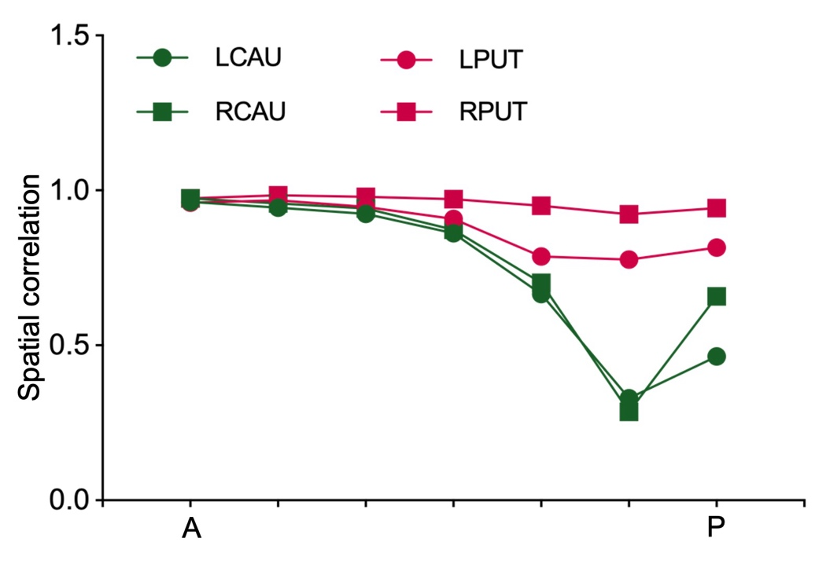
Supplementary Figure 5 Split-half validation results. We observed a high degree of similarity in the pattern of the anterior parts of the striatum between the two randomly groups, while we noted a decrease in similarity in the posterior parts of the striatum, especially bilateral caudate.

Supplementary Table
Supplementary Table 1. Cortico-striatal microstructural covariance gradients along anterior-posterior axis of the striatum with 6 cortical networks.
Left caudate | Anterior |  |  |  |  |  | Posterior
Left caudate | Parcel 1 | Parcel 2 | Parcel 3 | Parcel 4 | Parcel 5 | Parcel 6 | Parcel 7
Anterior cortex | 0.169 | 0.171 | 0.155 | 0.113 | 0.046 | 0.026 | -0.001
Temporal cortex | 0.035 | 0.013 | 0.004 | 0.013 | 0 | -0.020 | -0.01
Auditory cortex | 0.054 | 0.052 | 0.051 | 0.064 | 0.014 | 0.006 | 0
Sensorimotor cortex | -0.102 | -0.088 | -0.066 | -0.053 | 0.014 | 0.041 | 0.003
Posterior cortex | -0.155 | -0.157 | -0.141 | -0.110 | -0.041 | 0.007 | 0.008
Visual cortex | -0.156 | -0.157 | -0.143 | -0.112 | -0.066 | -0.041 | -0.01
Left putamen
Anterior cortex | 0.141 | 0.128 | 0.085 | 0.044 | 0.004 | -0.024 | -0.06
Temporal cortex | 0.054 | 0.066 | 0.077 | 0.067 | 0.072 | 0.081 | 0.104
Auditory cortex | 0.066 | 0.103 | 0.084 | 0.100 | 0.098 | 0.090 | 0.091
Sensorimotor cortex | -0.094 | -0.093 | -0.086 | -0.056 | -0.038 | -0.037 | -0.042
Posterior cortex | -0.164 | -0.167 | -0.133 | -0.095 | -0.063 | -0.045 | -0.023
Visual cortex | -0.144 | -0.131 | -0.096 | -0.068 | -0.042 | -0.017 | 0.013
Right caudate
Anterior cortex | 0.201 | 0.185 | 0.142 | 0.123 | 0.070 | 0.026 | 0.060
Temporal cortex | 0.033 | 0.014 | 0.015 | -0.003 | -0.013 | -0.001 | -0.026
Auditory cortex | 0.068 | 0.076 | 0.078 | 0.048 | 0.025 | -0.005 | -0.005
Sensorimotor cortex | -0.099 | -0.075 | -0.054 | -0.035 | -0.012 | 0.009 | 0.032
Posterior cortex | -0.185 | -0.168 | -0.130 | -0.099 | -0.053 | -0.002 | -0.024
Anterior cortex | -0.181 | -0.172 | -0.135 | -0.108 | -0.073 | -0.022 | -0.064
Right putamen
Anterior cortex | 0.169 | 0.165 | 0.126 | 0.089 | 0.038 | -0.0006 | -0.036
Temporal cortex | 0.062 | 0.066 | 0.070 | 0.062 | 0.066 | 0.079 | 0.103
Auditory cortex | 0.084 | 0.121 | 0.107 | 0.109 | 0.099 | 0.095 | 0.094
Sensorimotor cortex | -0.098 | -0.094 | -0.088 | -0.062 | -0.046 | -0.045 | -0.049
Posterior cortex | -0.192 | -0.197 | -0.165 | -0.130 | -0.089 | -0.061 | -0.037
Anterior cortex | -0.163 | -0.159 | -0.129 | -0.098 | -0.062 | -0.027 | 0.002

Supplementary Table 2. Association between profiles of cortico-striatal microstructural covariance gradient and geodesic distance along anterior-posterior axis of striatum.
 |  | Left caudate |  | Left putamen |  | Right caudate |  | Right putamen
 |  | R | P | R | P | R | P | R | P
Anterior | Parcel 1 | -0.842 | <0.0001 | -0.829 | <0.0001 | -0.816 | <0.0001 | -0.798 | <0.0001
 | Parcel 2 | -0.855 | <0.0001 | -0.766 | <0.0001 | -0.823 | <0.0001 | -0.762 | <0.0001
 | Parcel 3 | -0.872 | <0.0001 | -0.705 | <0.0001 | -0.780 | <0.0001 | -0.729 | <0.0001
 | Parcel 4 | -0.829 | <0.0001 | -0.564 | <0.0001 | -0.841 | <0.0001 | -0.667 | <0.0001
 | Parcel 5 | -0.804 | <0.0001 | -0.366 | <0.0001 | -0.879 | <0.0001 | -0.531 | <0.0001
 | Parcel 6 | -0.608 | <0.0001 | -0.164 | 0.027 | -0.685 | <0.0001 | -0.291 | <0.0001
Posterior | Parcel 7 | -0.219 | 0.003 | 0.113 | 0.130 | -0.788 | <0.0001 | -0.006 | 0.934

Supplementary Table 3. Association between profiles of cortico-striatal microstructural covariance gradient and gene expression profiles of cell type-specific genes along anterior-posterior axis of striatum.
Whole gene |  | Left caudate |  | Left putamen |  | Right caudate |  | Right putamen
 |  | R | P | R | P | R | P | R | P
Anterior | Parcel 1 | -0.739 | <0.0001 | -0.757 | <0.0001 | -0.743 | <0.0001 | -0.759 | <0.0001
 | Parcel 2 | -0.723 | <0.0001 | -0.749 | <0.0001 | -0.754 | <0.0001 | -0.764 | <0.0001
 | Parcel 3 | -0.718 | <0.0001 | -0.733 | <0.0001 | -0.764 | <0.0001 | -0.764 | <0.0001
 | Parcel 4 | -0.745 | <0.0001 | -0.686 | <0.0001 | -0.724 | <0.0001 | -0.750 | <0.0001
 | Parcel 5 | -0.567 | <0.0001 | -0.596 | <0.0001 | -0.696 | <0.0001 | -0.719 | <0.0001
 | Parcel 6 | -0.406 | <0.0001 | -0.460 | <0.0001 | -0.571 | <0.0001 | -0.618 | <0.0001
Posterior | Parcel 7 | -0.062 | 0.413 | -0.302 | <0.0001 | -0.465 | <0.0001 | -0.476 | <0.0001
Neuro-EX
Anterior | Parcel 1 | -0.649 | <0.0001 | -0.668 | <0.0001 | -0.667 | <0.0001 | -0.691 | <0.0001
 | Parcel 2 | -0.632 | <0.0001 | -0.662 | <0.0001 | -0.676 | <0.0001 | -0.698 | <0.0001
 | Parcel 3 | -0.622 | <0.0001 | -0.641 | <0.0001 | -0.684 | <0.0001 | -0.697 | <0.0001
 | Parcel 4 | -0.646 | <0.0001 | -0.600 | <0.0001 | -0.639 | <0.0001 | -0.689 | <0.0001
 | Parcel 5 | -0.469 | <0.0001 | -0.519 | <0.0001 | -0.615 | <0.0001 | -0.658 | <0.0001
 | Parcel 6 | -0.318 | <0.0001 | -0.397 | <0.0001 | -0.507 | <0.0001 | -0.569 | <0.0001
Posterior | Parcel 7 | 0.004 | 0.952 | -0.261 | 0.0046 | -0.425 | <0.0001 | -0.443 | <0.0001
Neuro-IN
Anterior | Parcel 1 | -0.742 | <0.0001 | -0.760 | <0.0001 | -0.749 | <0.0001 | -0.768 | <0.0001
 | Parcel 2 | -0.726 | <0.0001 | -0.755 | <0.0001 | -0.760 | <0.0001 | -0.775 | <0.0001
 | Parcel 3 | -0.718 | <0.0001 | -0.737 | <0.0001 | -0.771 | <0.0001 | -0.774 | <0.0001
 | Parcel 4 | -0.745 | <0.0001 | -0.691 | <0.0001 | -0.727 | <0.0001 | -0.763 | <0.0001
 | Parcel 5 | -0.559 | <0.0001 | -0.599 | <0.0001 | -0.697 | <0.0001 | -0.731 | <0.0001
 | Parcel 6 | -0.378 | <0.0001 | -0.463 | <0.0001 | -0.569 | <0.0001 | -0.631 | <0.0001
Posterior | Parcel 7 | -0.046 | 0.539 | -0.305 | <0.0001 | -0.464 | <0.0001 | -0.488 | <0.0001
Astro
Anterior | Parcel 1 | 0.434 | <0.0001 | 0.433 | <0.0001 | 0.473 | <0.0001 | 0.488 | <0.0001
 | Parcel 2 | 0.412 | <0.0001 | 0.403 | <0.0001 | 0.475 | <0.0001 | 0.4818 | <0.0001
 | Parcel 3 | 0.4031079 | <0.0001 | 0.375 | <0.0001 | 0.476 | <0.0001 | 0.483 | <0.0001
 | Parcel 4 | 0.409 | <0.0001 | 0.3230 | <0.0001 | 0.439 | <0.0001 | 0.470 | <0.0001
 | Parcel 5 | 0.257 | 0.0006 | 0.263 | 0.0004 | 0.448 | <0.0001 | 0.438 | <0.0001
 | Parcel 6 | 0.221 | 0.0032 | 0.157 | 0.037 | 0.424 | <0.0001 | 0.361 | <0.0001
Posterior | Parcel 7 | -0.098 | 0.195 | 0.070 | 0.355 | 0.349 | <0.0001 | 0.279 | 0.0002
Micro
Anterior | Parcel 1 | 0.661 | <0.0001 | 0.694 | <0.0001 | 0.636 | <0.0001 | 0.655 | <0.0001
 | Parcel 2 | 0.656 | <0.0001 | 0.688 | <0.0001 | 0.643 | <0.0001 | 0.651 | <0.0001
 | Parcel 3 | 0.658 | <0.0001 | 0.685 | <0.0001 | 0.637 | <0.0001 | 0.647 | <0.0001
 | Parcel 4 | 0.680 | <0.0001 | 0.640 | <0.0001 | 0.637 | <0.0001 | 0.625 | <0.0001
 | Parcel 5 | 0.558 | <0.0001 | 0.560 | <0.0001 | 0.615 | <0.0001 | 0.591 | <0.0001
 | Parcel 6 | 0.423 | <0.0001 | 0.438 | <0.0001 | 0.451 | <0.0001 | 0.490 | <0.0001
Posterior | Parcel 7 | 0.104 | 0.169 | 0.284 | 0.0001 | 0.372 | <0.0001 | 0.355 | <0.0001

Supplementary Table 4. The difference in the number of overlapping genes between anterior and posterior striatum for cell type-specific gene
 | Left caudate |  | Left putamen |  | Right caudate |  | Right putamen
 | PLS-1 | PLS-2 | PLS-1 | PLS-2 | PLS-1 | PLS-2 | PLS-1 | PLS-2
Astro | 0.244 | <0.001 | 0.355 | <0.001 | 0.728 | <0.001 | 0.932 | <0.001
Micro | 0.714 | 0.147 | 0.458 | 0.109 | 0.834 | 0.025 | 0.455 | 0.067
Neuro-EX | <0.001 | <0.001 | 0.039 | 0.015 | <0.001 | 0.198 | 0.613 | <0.001
Neuro-IN | 0.081 | 0.093 | 0.767 | 0.884 | 0.589 | <0.001 | 0.784 | 0.24

Supplementary Table 5. Split-half validation
 | Left caudate | Right caudate | Left putamen | Right putamen
Anterior parts | 0.963 | 0.974 | 0.960 | 0.974
Anterior parts | 0.944 | 0.958 | 0.968 | 0.984
Anterior parts | 0.925 | 0.941 | 0.946 | 0.980
Anterior parts | 0.862 | 0.874 | 0.908 | 0.972
Posterior parts | 0.665 | 0.702 | 0.787 | 0.951
Posterior parts | 0.323 | 0.286 | 0.776 | 0.923
Posterior parts | 0.464 | 0.658 | 0.815 | 0.943

References
1 Gorgolewski KJ, Durnez J, Poldrack RA. Preprocessed consortium for neuropsychiatric phenomics dataset. F1000Research. 2017;6.
2 Bezmaternykh DD, Melnikov MY, Savelov AA, Kozlova LI, Petrovskiy ED, Natarova KA, et al. Brain networks connectivity in mild to moderate depression: Resting state fmri study with implications to nonpharmacological treatment. Neural Plasticity. 2021;2021.
3 Hawrylycz MJ, Lein ES, Guillozet-Bongaarts AL, Shen EH, Ng L, Miller JA, et al. An anatomically comprehensive atlas of the adult human brain transcriptome. Nature. 2012;489(7416):391-99.
4 Hawrylycz M, Miller JA, Menon V, Feng D, Dolbeare T, Guillozet-Bongaarts AL, et al. Canonical genetic signatures of the adult human brain. Nature neuroscience. 2015;18(12):1832-44.
5 Arnatkeviciute A, Fulcher BD, Fornito A. A practical guide to linking brain-wide gene expression and neuroimaging data. Neuroimage. 2019;189:353-67.
6 Abdi H. Partial least squares regression and projection on latent structure regression (PLS Regression). Wiley interdisciplinary reviews: computational statistics. 2010;2(1):97-106.
7 Glasser MF, Coalson TS, Robinson EC, Hacker CD, Harwell J, Yacoub E, et al. A multi-modal parcellation of human cerebral cortex. Nature. 2016;536(7615):171-78.
8 Whitaker KJ, Vertes PE, Romero-Garcia R, Vasa F, Moutoussis M, Prabhu G, et al. Adolescence is associated with genomically patterned consolidation of the hubs of the human brain connectome. Proc Natl Acad Sci U S A. 2016;113(32):9105-10.
9 Hansen JY, Markello RD, Vogel JW, Seidlitz J, Bzdok D, Misic B. Mapping gene transcription and neurocognition across human neocortex. Nat Hum Behav. 2021;5(9):1240-50.

