Supplementary Material

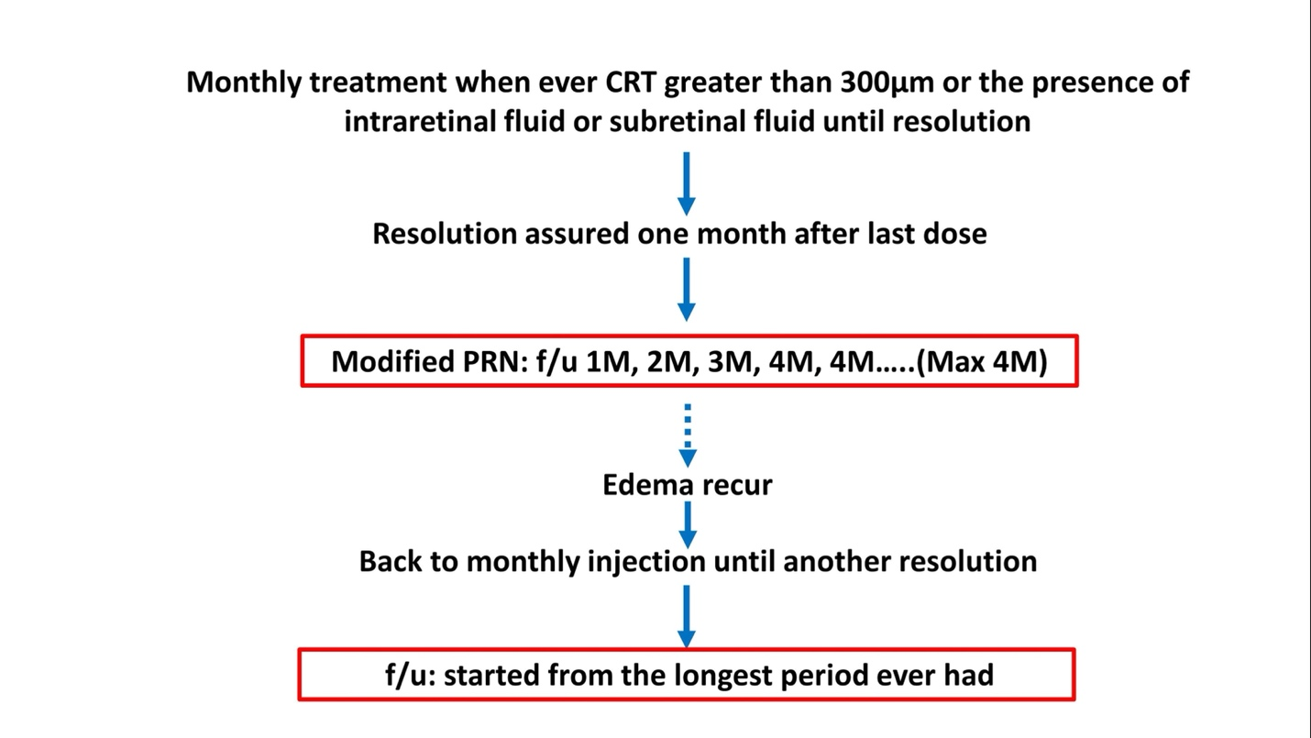
Supplementary Figure 1 A graphical representation of our “One and Stepped PRN protocol.” IVI injections were to be given if macular edema occurred. Macular edema was defined as either central retina thickness (CRT) greater than 300μm or any evidence of intraretinal fluid (IRF) or subretinal fluid (SRF). Patients were to receive monthly IVI treatment until resolution. Once resolution is assured one month after the last injection, the adjusted follow-up phase of the protocol is to be started. The follow-up visits were extended gradually until a maximum of 4 months. If macular edema recurred, monthly treatment would be started again until another resolution was assured one month after the last injection during this course. The next follow-up period would be the longest interval the patient has had previously

