Supplementary Table 1. The definition of the health score from the American Heart Association
Health Metric | Information | Scoring
Health Metric | Information | Points | Status
Diet | Diet was assessed by the available UK Biobank data (10 components) and split into quartiles | 100  80  50  25  0 | ≥95th percentile (adequate components ≥ 6)  75th–94th percentile (adequate components = 4 or 5)  50th–74th percentile (adequate components = 3)  25th–49th percentile (adequate components = 2)  1st–24th percentile (adequate components = 0 or 1)
Physical activity | Self-reported minutes of moderate or vigorous physical activity per week | 100  90  80  60  40  20  0 | ≥150 min/week  ≥120 to <150 min/week  ≥90 to <120 min/week  ≥60 to <90 min/week  ≥30 to <60 min/week  ≥1 to <30 min/week  0 min/week
Nicotine exposure | Nicotine exposure was classified using self-reported information (smoking status, age stopped smoking and second-hand smoke exposure) ¶ | 100  75  50  25  0 | Never smoker  Former smoker, quit ≥5 y  Former smoker, quit 1–<5 y  Former smoker, quit <1 y  Current smoker
Sleep health | Self-reported average hours of sleep duration per day | 100  90  70  40  20  0 | ≥7 to <9 h/day  ≥9 to <10 h/day  ≥6 to <7 h/day  ≥5 to <6 or ≥10 h/day  ≥4 to <5 h/day  <4 h/day
Body mass index | Body weight (kg) divided by height squared (m²) | 100  70  30  15  0 | <25 kg/m²  25.0 to 29.9 kg/m²  30.0 to 34.9 kg/m²  35.0 to 39.9 kg/m²  ≥40.0 kg/m²
Non-HDL cholesterol | Plasma total and HDL cholesterol to estimate non-HDL cholesterol* | 100  60  40  20  0 | <130 mg/dl  ≥130 to 189 mg/dl  ≥160-189 mg/dl  ≥190 to 219 mg/dl  ≥220 mg/dl
HbA1c | Casual HbA1c | 100  60  40  30  20  10  0 | <5.7 %  ≥5.7 to 6.4 %  Diabetes and HbA1c <7.0%  Diabetes and HbA1c ≥7.0 to 7.9%  Diabetes and HbA1c ≥8.0 to 8.9%  Diabetes and HbA1c ≥9.0 to 9.9%  Diabetes and HbA1c ≥10.0%
Blood pressure | Appropriately measured systolic and diastolic blood pressure* | 100  75  50  25  0 | <120 & <80 mmHg  ≥120 to 129 & <80 mmHg  ≥130 to 139 or ≥80 to 89 mmHg  ≥140 to 159 or ≥90 to 99 mmHg  ≥160 or ≥100 mmHg
¶ 20 points were subtracted when people in any category had second-hand smoke exposure.
* 20 points were subtracted when people in any category was using medication or treatment.
For diet, participants were considered to have an adequate intake of the diet component if they achieved the following intake goals: fruit ≥3 servings/day, vegetable ≥3 servings/day, whole grains ≥3 servings/day, (shell)fish ≥2 servings/week, dairy ≥2 servings/day, vegetable oils ≥2 servings/day, refined grains ≤2 servings/day, processed meats ≤1 serving/week, unprocessed meats ≤2 servings/week, and no consumption of sugar-sweetened beverages. Diet was based on the quantification of adequate diet components at population level, which was categorized into five percentile groups: 1st–24th, 25th–49th, 50th–74th, 75th–94th, and ≥95th percentile values, corresponding to 0, 25, 50, 80, and 100 points, respectively.
Physical activity was assessed based on self-reported minutes of moderate or vigorous physical activity per week. 1 minute of vigorous physical activity is equivalent to 2 minutes of moderate physical activity. Physical activity time was classified into seven groups: 0, 1–29, 30–59, 60–89, 90–119, 120–149, and ≥150 min per week, corresponding to 0, 20, 40, 60, 80, 90, and 100 points, respectively.
The information on nicotine exposure was self-reported and collected by questionnaire. There are 5 nicotine exposure categories including current smoker, former smoker (quit<1 year), former smoker (quit 1 to <5 years), former smoker (quit≥5 years), and never smoker, corresponding to 0, 25, 50, 80, and 100 points, respectively. Twenty points were subtracted for adults living with active indoor smokers at home.
Sleep health was a new metric in Life’s Essential 8 goals based on the self-reported average hours of sleep duration per day collected by questionnaire. Sleep health was stratified into six categories: <4, 4 to <5, 5 to <6 or ≥10, 6 to <7, 9 to <10, and 7 to <9 hours, corresponding to 0, 20, 40, 70, 90, and 100 points, respectively.
BMI was calculated as weight in kilograms divided by height in meters squared. BMI levels were categorized into five groups: ≥40.0, 35.0–39.9, 30.0–34.9, 25.0–29.9, and <25.0 kg/m2, corresponding to 0, 15, 30, 70, and 100 points, respectively.
Serum cholesterol was measured at a central laboratory using choline oxidase- peroxidase analysis. Non- high-density lipoprotein (non-HDL) cholesterol was calculated as total cholesterol (TC) minus HDL cholesterol. Non-HDL cholesterol levels were classified as ≥220, 190–219, 160–189, 130–159, and <130 mg/dL, corresponding to 0, 20, 40, 60, and 100 points, respectively. Twenty points were subtracted if the blood lipids levels were drug-treated.
Glycated hemoglobin (HbA1c) was measured by high-performance liquid chromatography methods. Blood glucose levels were classified as diabetes with HbA1c ≥10.0%, diabetes with HbA1c of 9.0–9.9%, diabetes with HbA1c of 8.0–8.9%, diabetes with HbA1c of 7.0–7.9%, diabetes with HbA1c <7.0%, no diabetes and HbA1c of 5.7–6.4%, and no history of diabetes and HbA1c <5.7%, corresponding to 0, 10, 20, 30, 40, 60, and 100 points, respectively.
Blood pressure was measured twice by trained nurse, with average levels of systolic and diastolic blood pressure used in this study. Blood pressure levels were classified as systolic blood pressure ≥160 mmHg or diastolic blood pressure ≥100 mmHg, 140–159 or 90–99 mmHg, 130–139 or 80–89 mmHg, 120–129/<80 mmHg, and <120/80 mmHg, corresponding to 0, 25, 50, 75, and 100, respectively. Twenty points were subtracted if the blood pressure levels were treated.
Subtract 20 points (unless score is 0) for living with active indoor smoker in home.
The mean health score for each individual was derived by summing the eight health metrics and dividing them by 8.
Supplementary Table 2. Percentage of missing values of the covariates
Covariates | Missing percentage
Race/Ethnicity | 0.3%
Townsend deprivation index | 0.1%
Drinking status | 0.1%
Education levels | 1.2%
Occupation status | 0.2%
Duration of hypertension | 2.4%

Supplementary Table 3. Multivariable-adjusted linear regression models for the association between lifestyle score and biomarker levels among patients with hypertension
Biomarkers | Lifestyle score
Biomarkers | β (10⁻⁴) | P- value
Biomarkers of renal function
Cystatin C (mg/L) | -11.41 | <0.001
Creatinine (μmol/L) | -1.84 | <0.001
Urate (μmol/L) | -13.34 | <0.001
Urea (mmol/L) | 0.77 | <0.001
Biomarkers of liver function
Alanine aminotransferase (U/L) | -19.29 | <0.001
Alkaline phosphatase (U/L) | -9.70 | <0.001
Aspartate aminotransferase (U/L) | -0.54 | 0.03
Gamma glutamyltransferase (U/L) | -38.90 | <0.001
Total bilirubin (μmol/L) | 14.61 | <0.001
Total protein (g/L) | 0.76 | <0.001
Albumin (g/L) | 2.33 | <0.001
Biomarkers of lipid profile
Total cholesterol (mmol/L) | -0.17 | 0.34
HDL-cholesterol (mmol/L) | 16.18 | <0.001
LDL-cholesterol (mmol/L) | -2.65 | <0.001
Triglycerides (mmol/L) | -36.49 | <0.001
Apolipoprotein A (g/L) | 7.88 | <0.001
Apolipoprotein B (g/L) | -5.27 | <0.001
Lipoprotein A (nmol/L) | 3.82 | <0.001
Inflammatory biomarkers
High-sensitivity C-reactive protein (mg/L) | -99.15 | <0.001
Biomarkers of glucose metabolism
HbA_{1c} (mmol/mol) | -7.82 | <0.001
Glucose (mmol/L) | -2.98 | <0.001
Multivariable-adjusted models were adjusted for age (continuous, years), sex (male or female), ethnicity (white, or other), drinking status (never drinker, former drinker, or current drinker), education levels (college or university, high school or equivalent, or others), occupation status (employed, or unemployed), Townsend deprivation index (continuous), and use of blood pressure medication (yes, or no).
The levels of biomarkers were nature log-transformed before analyses.
Supplementary Table 4. Risk estimates of infectious diseases associated with the selected biomarkers (1-SD increment) among patients with hypertension
Biomarkers | Infectious diseases
Biomarkers | HR (95% CI) | P
Cystatin C (mg/L) | 1.28 (1.26, 1.29) | <0.001
Urate (μmol/L) | 1.10 (1.09, 1.12) | <0.001
Creatinine (μmol/L) | 1.08 (1.06, 1.10) | <0.001
Alanine aminotransferase (U/L) | 1.04 (1.02, 1.05) | <0.001
Alkaline phosphatase (U/L) | 1.12 (1.11, 1.13) | <0.001
Aspartate aminotransferase (U/L) | 1.07 (1.05, 1.08) | <0.001
Gamma glutamyltransferase (U/L) | 1.16 (1.15, 1.17) | <0.001
Total bilirubin (μmol/L) | 0.95 (0.93, 0.96) | <0.001
Total protein (g/L) | 0.98 (0.97, 0.99) | <0.001
Albumin (g/L) | 0.86 (0.85, 0.87) | <0.001
Total cholesterol (mmol/L) | 0.87 (0.86, 0.88) | <0.001
HDL cholesterol (mmol/L) | 0.89 (0.87, 0.90) | <0.001
LDL cholesterol (mmol/L) | 0.88 (0.87, 0.89) | <0.001
Triglycerides (mmol/L) | 1.05 (1.04, 1.07) | <0.001
Apolipoprotein A (g/L) | 0.90 (0.89, 0.91) | <0.001
Apolipoprotein B (g/L) | 0.91 (0.90, 0.92) | <0.001
High-sensitivity C-reactive protein (mg/L) | 1.23 (1.21, 1.24) | <0.001
HbA_{1c} (mmol/mol) | 1.18 (1.17, 1.19) | <0.001
Glucose (mmol/L) | 1.11 (1.10, 1.12) | <0.001
Multivariable-adjusted models were adjusted for age (continuous, years), sex (male or female), ethnicity (white, or other), drinking status (never drinker, former drinker, or current drinker), education levels (college or university, high school or equivalent, or others), occupation status (employed, or unemployed), Townsend deprivation index (continuous), and use of blood pressure medication (yes, or no).
Supplementary Table 5. Associations between weighted health score and infectious diseases among patients with hypertension
 | The weighted health score |  |  |  | P _{trend}
 | Q1 | Q2 | Q3 | Q4 | P _{trend}
Infectious diseases
Model 1 | Reference | 0.66 (0.64, 0.68) | 0.52 (0.50, 0.54) | 0.44 (0.43, 0.46) | < 0.001
Model 2 | Reference | 0.70 (0.68, 0.72) | 0.57 (0.55, 0.59) | 0.50 (0.48, 0.52) | < 0.001
Model 3 | Reference | 0.72 (0.70, 0.74) | 0.59 (0.57, 0.61) | 0.52 (0.51, 0.54) | < 0.001
Respiratory infectious diseases
Model 1 | Reference | 0.66 (0.56, 0.78) | 0.55 (0.46, 0.65) | 0.46 (0.38, 0.56) | < 0.001
Model 2 | Reference | 0.70 (0.59, 0.83) | 0.60 (0.50, 0.71) | 0.51 (0.42, 0.62) | < 0.001
Model 3 | Reference | 0.71 (0.60, 0.84) | 0.61 (0.51, 0.73) | 0.53 (0.44, 0.64) | < 0.001
Digestive infectious diseases
Model 1 | Reference | 0.65 (0.62, 0.69) | 0.54 (0.50, 0.57) | 0.44 (0.42, 0.47) | < 0.001
Model 2 | Reference | 0.69 (0.66, 0.74) | 0.59 (0.55, 0.62) | 0.49 (0.46, 0.53) | < 0.001
Model 3 | Reference | 0.72 (0.68, 0.76) | 0.62 (0.58, 0.66) | 0.53 (0.49, 0.56) | < 0.001
Blood or sexually transmitted infectious diseases
Model 1 | Reference | 0.45 (0.30, 0.68) | 0.34 (0.21, 0.54) | 0.44 (0.28, 0.68) | < 0.001
Model 2 | Reference | 0.56 (0.37, 0.86) | 0.47 (0.29, 0.76) | 0.63 (0.40, 1.00) | 0.003
Model 3 | Reference | 0.58 (0.38, 0.88) | 0.49 (0.30, 0.79) | 0.66 (0.42, 1.05) | 0.008
Cox proportional hazards models were used to estimate the hazard ratios (HRs) and 95% confidence intervals (CIs) of infectious diseases according to the weighted health score.
Model 1: adjusted for age (continuous, years), sex (male or female), and ethnicity (white, non-white).
Model 2: Model 1 + drinking status (never drinker, former drinker, or current drinker), education levels (college or university, high school or equivalent, or others), employment status (employed, unemployed), household income (<18 000, 18 000-30 999, 31 000-51 999, 52 000-10 000, >100 000), and Townsend deprivation index (continuous).
Model 3: Model 2 + hypertension duration (continuous, years) and use of hypertension medication (yes or no).
Supplementary Table 6 Associations between the health score and infectious diseases among patients with hypertension after excluding the cases that occurred within first two-years of follow-up
 | The health score |  |  |  | P _{trend}
 | Q1 | Q2 | Q3 | Q4 | P _{trend}
Infectious diseases
Model 1 | Reference | 0.71(0.69, 0.73) | 0.57 (0.55, 0.59) | 0.49 (0.48, 0.51) | < 0.001
Model 2 | Reference | 0.74 (0.72, 0.76) | 0.60 (0.58, 0.62) | 0.54 (0.52, 0.56) | < 0.001
Model 3 | Reference | 0.77 (0.75, 0.79) | 0.63 (0.61, 0.65) | 0.56 (0.55, 0.59) | < 0.001
Respiratory infectious diseases
Model 1 | Reference | 0.69 (0.59, 0.81) | 0.59 (0.50, 0.69) | 0.51 (0.43, 0.61) | < 0.001
Model 2 | Reference | 0.71 (0.60, 0.84) | 0.60 (0.50, 0.71) | 0.51 (0.42, 0.62) | < 0.001
Model 3 | Reference | 0.77 (0.66, 0.90) | 0.66 (0.56, 0.78) | 0.56 (0.47, 0.67) | < 0.001
Digestive infectious diseases
Model 1 | Reference | 0.68 (0.65, 0.72) | 0.58 (0.54, 0.61) | 0.49 (0.47, 0.52) | < 0.001
Model 2 | Reference | 0.72 (0.69, 0.77) | 0.63 (0.59, 0.66) | 0.53 (0.50, 0.57) | < 0.001
Model 3 | Reference | 0.75 (0.71, 0.79) | 0.66 (0.62, 0.70) | 0.56 (0.52, 0.59) | < 0.001
Blood or sexually transmitted infectious diseases
Model 1 | Reference | 0.48 (0.33, 0.71) | 0.39 (0.26, 0.59) | 0.47 (0.31, 0.71) | < 0.001
Model 2 | Reference | 0.59 (0.40, 0.89) | 0.52 (0.34, 0.81) | 0.66 (0.43, 1.03) | 0.005
Model 3 | Reference | 0.61 (0.41, 0.91) | 0.53 (0.34, 0.83) | 0.72 (0.45, 1.08) | 0.011
Cox proportional hazards models were used to estimate the hazard ratios (HRs) and 95% confidence intervals (CIs) of infectious diseases according to the health score.
Model 1: adjusted for age (continuous, years), sex (male or female), and ethnicity (white, non-white).
Model 2: Model 1 + drinking status (never drinker, former drinker, or current drinker), education levels (college or university, high school or equivalent, or others), employment status (employed, unemployed), household income (<18 000, 18 000-30 999, 31 000-51 999, 52 000-10 000, >100 000), and Townsend deprivation index (continuous).
Model 3: Model 2 + hypertension duration (continuous, years) and use of hypertension medication (yes or no).
Supplementary Table 7 Associations between the health score and infectious diseases among patients with hypertension after excluding patients with missing covariates
 | The health score |  |  |  | P _{trend}
 | Q1 | Q2 | Q3 | Q4 | P _{trend}
Infectious diseases
Model 1 | Reference | 0.67 (0.65, 0.69) | 0.55 (0.53, 0.57) | 0.45 (0.44, 0.47) | < 0.001
Model 2 | Reference | 0.71 (0.69, 0.73) | 0.60 (0.58, 0.62) | 0.51 (0.49, 0.53) | < 0.001
Model 3 | Reference | 0.73 (0.71, 0.75) | 0.62 (0.60, 0.64) | 0.53 (0.52, 0.55) | < 0.001
Respiratory infectious diseases
Model 1 | Reference | 0.67 (0.57, 0.79) | 0.59 (0.50, 0.69) | 0.49 (0.41, 0.59) | < 0.001
Model 2 | Reference | 0.71 (0.60, 0.84) | 0.65 (0.55, 0.76) | 0.54 (0.45, 0.65) | < 0.001
Model 3 | Reference | 0.72 (0.61, 0.85) | 0.66 (0.56, 0.78) | 0.56 (0.47, 0.67) | < 0.001
Digestive infectious diseases
Model 1 | Reference | 0.68 (0.65, 0.72) | 0.57 (0.53, 0.60) | 0.47 (0.45, 0.50) | < 0.001
Model 2 | Reference | 0.72 (0.69, 0.77) | 0.62 (0.58, 0.65) | 0.49 (0.46, 0.53) | < 0.001
Model 3 | Reference | 0.75 (0.71, 0.79) | 0.65 (0.61, 0.69) | 0.54 (0.50, 0.58) | < 0.001
Blood or sexually transmitted infectious diseases
Model 1 | Reference | 0.48 (0.33, 0.71) | 0.35 (0.22, 0.55) | 0.45 (0.29, 0.69) | < 0.001
Model 2 | Reference | 0.59 (0.40, 0.89) | 0.48 (0.30, 0.77) | 0.60 (0.17, 0.97) | 0.004
Model 3 | Reference | 0.61 (0.40, 0.92) | 0.50 (0.31, 0.80) | 0.65 (0.41, 1.04) | 0.009
Cox proportional hazards models were used to estimate the hazard ratios (HRs) and 95% confidence intervals (CIs) of infectious diseases according to the health score.
Model 1: adjusted for age (continuous, years), sex (male or female), and ethnicity (white, non-white).
Model 2: Model 1 + drinking status (never drinker, former drinker, or current drinker), education levels (college or university, high school or equivalent, or others), employment status (employed, unemployed), household income (<18 000, 18 000-30 999, 31 000-51 999, 52 000-10 000, >100 000), and Townsend deprivation index (continuous).
Model 3: Model 2 + hypertension duration (continuous, years) and use of hypertension medication (yes or no).

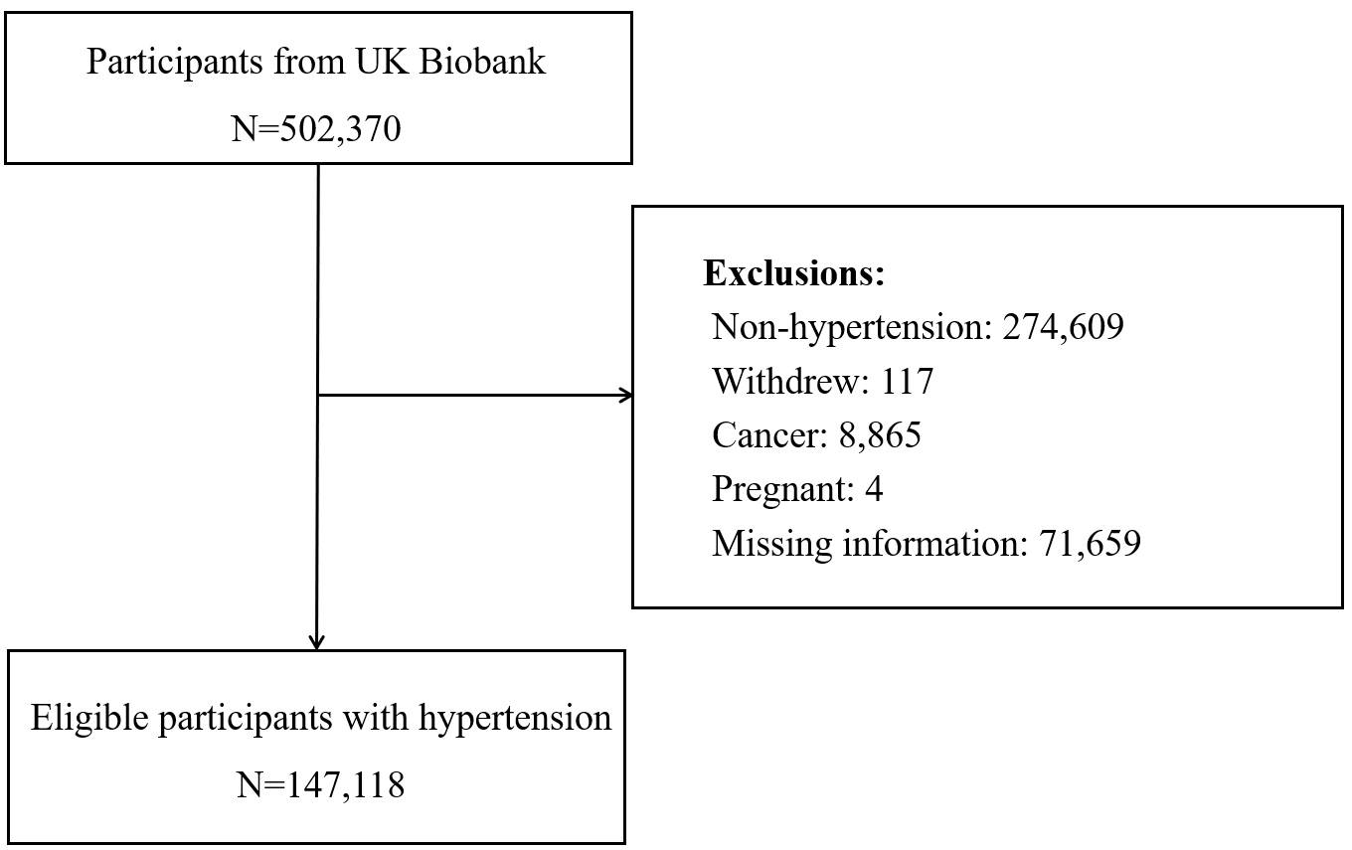
Supplementary Figure 1. Flowchart of the study population
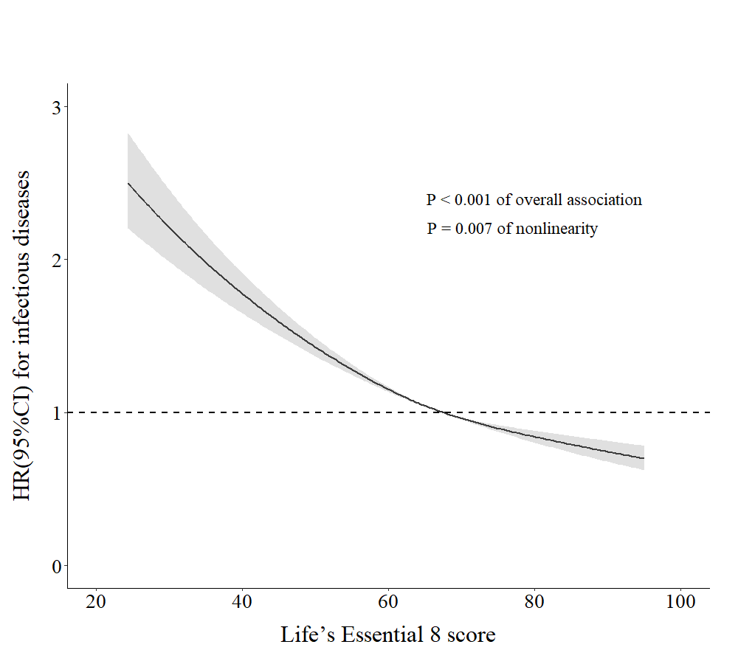
Supplementary Figure 2. Dose–response relationship of the health score with risk of infectious diseases among patients with hypertension. X-axis showed the health score, and y-axis showed the HRs of infectious diseases. Multivariable-adjusted models were adjusted for age, sex, ethnicity, drinking status, education levels, occupation status, Townsend deprivation index, and use of blood pressure medication.
Adjusted HR calculated using median of the health score (67.5) as reference with HR=1

