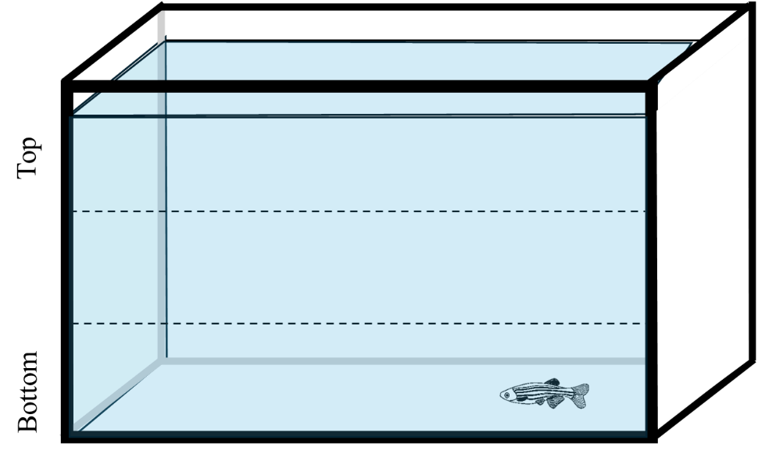
Fig. S1 Depiction of a novel tank with different zones indicated

