Tables
Table A. Sampling sites per year and per area
Zone | Sites 2015 | Sites 2020 | Sites 2022
Boca | 1, 2, 3 | 1, 2 | 1, 2, 3
Marimelli | 4, 5, 6, 7 | 4, 5, 7,8 | 5, 6, 7
Puelo | 8, 9, 10, 11, 12 | 9, 10, 11, 12 | 9, 10, 11, 12
Cochamó | 13, 14 | 13, 14 | 13, 14
Video transects per site (camera type) | 6 (Seaviewer analog and high definition) | 3 (Seaviewer high definition) | 5 (Go Pro Hero 7.0 high definition)
Total video transects | 82 | 38 | 58

Table B Analysis of the effect of the longline pressure index (km of longlines/km of coastline) LPI, on the average, minimum and maximum depth of the M. chilensis and A. atra beds in the Reloncaví Fjord.
Type of model | Modelo | Residual degree of freedom | Residual squares sum | Squares sum | F value | Pr(>F) | AIC
 | M. chilensis
Only intercept | Maximum depth=intercept | 11 | 26.249 |  |  |  | 47.45
Non linear model | Maximum depth=LPI index | 10 | 17.283 | 8.97 | 5.19 | 0.046 | 44.43
Linear model | Maximum depth=LPI index | 10 | 18.693 | 7.56 | 4.04 | 0.072 | 45.37
Only intercep | Mean depth=intercept | 11 | 12.98 |  |  |  | 38.08
Non linear model | Mean depth=LPI index | 10 | 10.179 | 2.80 | 2.75 | 0.128 | 38.43
Linear model | Mean depth=LPI index | 10 | 10.48 | 0.00 |  |  | 39.00
Only intercep | Minimum depth=intercept | 10 | 9.4667 |  |  |  | 36.87
Non linear model | Minimum depth=LPI index | 11 | 9.2053 | 0.26 | 0.28 | 0.605 | 36.87
Linear model | Minimum depth=LPI index | 11 | 9.2037 |  |  |  | 35.21
 | A. atra
Only intercep | Maximum depth=intercept | 11 | 30.99 |  |  |  | 49.44
Non linear model | Maximum depth=LPI index | 10 | 28.25 | 2.74 | 0.97 | 0.3479 | 50.33
Linear model | Maximum depth=LPI index | 10 | 28.521 | 0.00 |  |  | 50.44
Only intercep | Mean depth=intercept | 11 | 17.527 |  |  |  | 42.42
Non linear model | Mean depth=LPI index | 10 | 14.617 | 2.91 | 1.99 | 0.1886 | 42.60
Linear model | Mean depth=LPI index | 10 | 14.832 | 0.00 |  |  | 42.60
Only intercep | Minimum depth=intercept | 11 | 16.917 |  |  |  | 42.32
Non linear model | Minimum depth=LPI index | 10 | 14.489 | 2.43 | 1.68 | 0.2246 | 42.18
Linear model | Minimum depth=LPI index | 10 | 14.63 | 0.00 |  |  | 42.43

Tabla C Linear trend analysis of the i) Puelo river flow between 2013 and 2022, and ii) the mean, maximum and minimum values of the salinity time series between 0 and 20 m depth obtained from IFOP records between 2013 and 2022.
Variable | Sector | Intercept | Pr(>|t|) | Slope | Pr(>|t|)
Minimum Salinity | Puelo | 4.9 | 2.84E-05 | 0.0419 | 0.013
Mean salinity |  | 26.4 | 2.00E-16 | 0.0023 | 0.738
Maximum salinity |  | 32.2 | 2.00E-16 | 0.0018 | 0.117
Minimum Salinity | Marimelli north | 5.9 | 2.20E-06 | 0.0402 | 0.022
Mean salinity |  | 26.8 | 2.00E-16 | 0.0071 | 0.226
Maximum salinity |  | 32.2 | 2.00E-16 | 0.0028 | 0.002
Minimum Salinity | Marimelli south | 5.8 | 2.88E-06 | 0.0442 | 0.011
Mean salinity |  | 26.8 | 2.00E-16 | 0.0068 | 0.243
Maximum salinity |  | 32.2 | 2.00E-16 | 0.0027 | 0.003
Minimum Salinity | Caicura | 20.6 | 2.00E-16 | 0.0440 | 0.049
Mean salinity |  | 30.3 | 2.00E-16 | 0.0069 | 0.026
Maximum salinity |  | 32.1 | 2.00E-16 | 0.0037 | 0.001
Flow | Rio Puelo | 663.2 | 2.00E-16 | -3.5407 | 1.47E-09

Table D Analysis of the effect of the variables; zone, year species and sampling sites on the average, minimum and maximum depth of the M. chilensis and A. atra beds in the Reloncaví Fjord.
Modelo tipo | Predictor variables |  | Degree of freedom |  | AIC
Response variable= Mean depth of mussel beds
GLMM Gamma family | Fixed variables: Zone+Year+Species; Site is the aleatory variable |  | 9 |  | 1038.7
GLMM Gamma family | Individuals/m2+Zone+Year+Species, Site is the aleatory variable |  | 10 |  | 1039.6
GLMM Gamma family | Zone+Year+Species, Zone and Site are aleatory variables |  | 11 |  | 1039.6
GLMM Gamma family | Zone+Year+Species |  | 8 |  | 1053.7
GLMM Gamma family | Zone*Year+Species, Site is the aleatory variable |  |  |  | Failed
GLMM negative binomial family | Zone+Year+Species, Site is the aleatory variable |  |  |  | 1297.4
GLMM negative binomial family | Ind/m1+Zone+Year+Species, Site is the aleatory variable |  | 9 |  | 1299.8
GLMM negative binomial family | Zone*Year+Species, Site is the aleatory variable |  | 8 |  | 1299.8
GLMM Gamma family | Zone+Year+Species, Zone and Site are aleatory variables |  | 6 |  | 1299.4
Response variable= Minimum depth of mussel bed
GLMM Gamma family | Zone+Year+Species, Site is the aleatory variable |  | 9 |  | 1055.8
GLM Gamma family | Zone+Year+Species |  | 8 |  | 1089.9
GLMM negative binomial family | Zone*Year+Species, Zone and Site are aleatory variables |  | 15 |  | Failed
GLMM Gamma family | Zone+Year+Species, Zone and Site are aleatory variables |  | 16 |  | Failed
GLMM Gamma Family | Zone+Year+Species, Site is the aleatory variable |  | 9 |  | 1245.6
GLMM negative binomial family | Individuals/m2+Zone+Year+Species, |  | 10 |  | 1247.4
GLMM negative binomial family | Zone*Year+Species, Zone, aleatory variable and Site |  | 11 |  | 1249.0
GLMM negative binomial family | Zone*Year+Species, Site is the aleatory variable |  | 15 |  | 1249.9
GLMM negative binomial family | Zone+Year+Species |  | 7 |  | 1661.1
 | Response variable: Maximum depth of mussel bed
GLMM Gamma family | Zone+Year+Species, Site is the aleatory variable |  | 9 |  | 1272.5
GLMM Gamma family | Zone+Year+Species, Zone and Site are the aleatory variables |  | 9 |  | 1274.5
GLMM negative binomial family | Zone*Year+Species, Site is the aleatory variable |  | 15 |  | 1386.5
GLM negative binomial family | Individuos/m2+Zone+Year+Species, Site is the aleatory variable |  | 16 |  | 1386.2
GLM negative binomial family | Zone+Year+Species, Site is the aleatory variable |  | 16 |  | 1390.1
GLMM Gamma | Zone*Year, Site is the aleatory variable |  | 8 |  | 1515.7
GLMM familia Gamma | Zone*Year+Species, Zone and Site are aleatory variables |  | 17 |  | 1390.2

Table E Analysis of Deviance and multiple comparison analysis to evaluate the variation of the average depth of M. chilensis and A. atra beds in four areas of Reloncavi Fjord in 2015, 2020 and 2022.
Effect |  | Chi square |  |  | Degree of freedom |  |  | Pr(>Chisq)
Zone |  | 19.501 |  |  | 3 |  |  | 2.15E-04
Year |  | 14.621 |  |  | 2 |  |  | 0.0006686
Species |  | 404.3 |  |  | 1 |  |  | < 2.2e-16
Multiple comparison analysis
Linear Hypotheses | Estimate |  | Standard Error |  |  |  | z value |  |  | Pr(>|z|)
Marimelli -Boca == 0 |  | 0.108207 |  | 0.055758 |  | 1.941 |  |  | 0.30864
Puelo- Boca == 0 |  | 0.20547 |  | 0.055783 |  | 3.683 |  |  | 0.00197
Cochamó-Boca == 0 |  | 0.202253 |  | 0.066004 |  | 3.064 |  |  | 0.01737
Marimelli-Puelo == 0 |  | 0.097262 |  | 0.051998 |  | 1.87 |  |  | 0.34954
Cochamó-Marimelli == 0 |  | 0.094045 |  | 0.06277 |  | 1.498 |  |  | 0.5989
Cochamó-Puelo == 0 |  | -0.003217 |  | 0.062759 |  | -0.051 |  |  | 1
2020 - 2015 == 0 |  | -0.089871 |  | 0.022839 |  | -3.935 |  |  | < 0.001
2022 - 2015 == 0 |  | -0.020637 |  | 0.018256 |  | -1.13 |  |  | 0.83163
2022 - 2020 == 0 |  | 0.069234 |  | 0.023299 |  | 2.972 |  |  | 0.02355
Table F Analysis of deviance and multiple comparison analysis to evaluate the variation of the minimum depth of M. chilensis and A. atra beds in four areas of Reloncavi Fjord in 2015, 2020 and 2022.
Effect | Chi square |  | Degree of freedom |  | Pr(>Chisq)
Zone | 11.415 |  | 3 |  | 0.009681
Year | 25.514 |  | 2 |  | 2.88E-06
Species | 729.014 |  | 1 |  | < 2.2e-16
Multiple comparison analysis
Linear Hypotheses | Estimate | Standard Error |  | z value |  | Pr(>|z|)
Marimelli -Boca == 0 | -0.018 | 0.011 |  | -1.620 |  | 0.514
Puelo- Boca == 0 | -0.029 | 0.011 |  | -2.601 |  | 0.069
Cochamó-Boca == 0 | -0.040 | 0.013 |  | -3.071 |  | 0.017
Puelo-Marimelli == 0 | -0.011 | 0.011 |  | -1.049 |  | 0.871
Cochamó-Marimelli == 0 | -0.023 | 0.013 |  | -1.779 |  | 0.407
Cochamó-Puelo == 0 | -0.012 | 0.013 |  | -0.897 |  | 0.930
2020 - 2015 == 0 | 0.014 | 0.004 |  | 3.614 |  | 0.003
2022 - 2015 == 0 | 0.014 | 0.003 |  | 4.627 |  | < 0.001
2022 - 2020 == 0 | 0.000 | 0.004 |  | 0.054 |  | 1.000

Tabla G Analysis of Deviance and multiple comparison analysis to evaluate the variation of the maximum depth of M. chilensis and A. atra beds in four areas of Reloncavi Fjord in 2015, 2020 and 2022
Effect | Chi square |  | Degree of freedom |  | Pr(>Chisq)
Zone | 14.1679 |  | 3 |  | 0.002685
Year | 8.5362 |  | 2 |  | 0.014008
Species | 360.6815 |  | 1 |  | < 2.2e-16
Multiple comparison analysis
Linear Hypotheses | Estimate | Standard Error |  | z value |  | Pr(>|z|)
Marimelli -Boca == 0 | 0.065 | 0.041 |  | 1.584 |  | 0.538
Puelo- Boca == 0 | 0.172 | 0.040 |  | 4.286 |  | < 0.001
Cochamó-Boca == 0 | 0.097 | 0.050 |  | 1.959 |  | 0.298
Puelo-Marimelli == 0 | 0.107 | 0.038 |  | 2.851 |  | 0.034
Cochamó-Marimelli == 0 | 0.032 | 0.048 |  | 0.680 |  | 0.978
Cochamó-Puelo == 0 | -0.075 | 0.047 |  | -1.609 |  | 0.520
2020 - 2015 == 0 | -0.073 | 0.028 |  | -2.608 |  | 0.067
2022 - 2015 == 0 | 0.036 | 0.022 |  | 1.594 |  | 0.531
2022 - 2020 == 0 | 0.108 | 0.028 |  | 3.824 |  | 0.001

Table H Parameter and their standard error, of the most informative models for estimated average, minimum and maximum depth of M. chilensis and A. atra beds in 2015, 2020 and 2020 in the Reloncaví fjord.

 |  | Average beds depth |  | Maximum beds depth |  |  | Minimum beds depth
Year | Zone | Mean (m) | Standard error | Mean  (m) | Standard error |  | Mean (m) | Standard error
M. chilensis
2015 | Boca | 6.8 | 0.3 | 8.7 |  | 0.3 | 4.9 | 0.4
2020 | Boca | 6.2 | 0.3 | 8.1 |  | 0.3 | 4.4 | 0.4
2022 | Boca | 6.6 | 0.3 | 9 |  | 0.3 | 4.3 | 0.3
2015 | Marimelli | 7.6 | 0.3 | 9.2 |  | 0.3 | 5.6 | 0.4
2020 | Marimelli | 6.9 | 0.3 | 8.6 |  | 0.3 | 5 | 0.3
2022 | Marimelli | 7.4 | 0.3 | 9.6 |  | 0.3 | 4.9 | 0.3
2015 | Puelo | 8.3 | 0.3 | 10.3 |  | 0.3 | 6.1 | 0.4
2022 | Puelo | 8.2 | 0.3 | 10.7 |  | 0.3 | 5.3 | 0.4
2020 | Puelo | 7.6 | 0.3 | 9.6 |  | 0.3 | 5.5 | 0.4
2015 | Cochamó | 8.3 | 0.4 | 9.5 |  | 0.4 | 6.9 | 0.6
2020 | Cochamó | 7.6 | 0.4 | 8.9 |  | 0.4 | 6.2 | 0.6
2022 | Cochamó | 8.1 | 0.4 | 9.9 |  | 0.4 | 6 | 0.6
A. atra
2015 | Boca | 11 | 0.5 | 12.9 |  | 0.4 | 9.5 | 0.7
2015 | Boca | 10.1 | 0.5 | 12 |  | 0.5 | 8.5 | 0.7
2015 | Boca | 10.8 | 0.5 | 13.4 |  | 0.5 | 8.3 | 0.7
2015 | Marimelli | 12.3 | 0.5 | 13.8 |  | 0.4 | 10.9 | 0.7
2020 | Marimelli | 11.2 | 0.5 | 12.8 |  | 0.4 | 9.8 | 0.7
2020 | Marimelli | 12 | 0.5 | 14.3 |  | 0.5 | 9.5 | 0.7
2020 | Puelo | 13.5 | 0.5 | 15.3 |  | 0.5 | 11.9 | 0.8
2020 | Puelo | 12.4 | 0.5 | 14.2 |  | 0.5 | 10.7 | 0.8
2022 | Puelo | 13.3 | 0.5 | 15.9 |  | 0.5 | 10.4 | 0.7
2022 | Cochamó | 13.5 | 0.7 | 14.2 |  | 0.6 | 13.4 | 1.3
2022 | Cochamó | 12.3 | 0.7 | 13.2 |  | 0.6 | 12 | 1.1
2022 | Cochamó | 13.2 | 0.7 | 14.7 |  | 0.6 | 11.7 | 1.1

Figures
Figure 8 Relationship between the Long-line pressure index for 2014, 2018 and 2020 and the minimum, average, and maximum depth of A) M. chilensis and B) A. atra beds in 2015, 2020 and 2022. Continuous black line shows the fitted line for the maximum depth of M. chilensis, which was the only one statistically affected by the LPI.
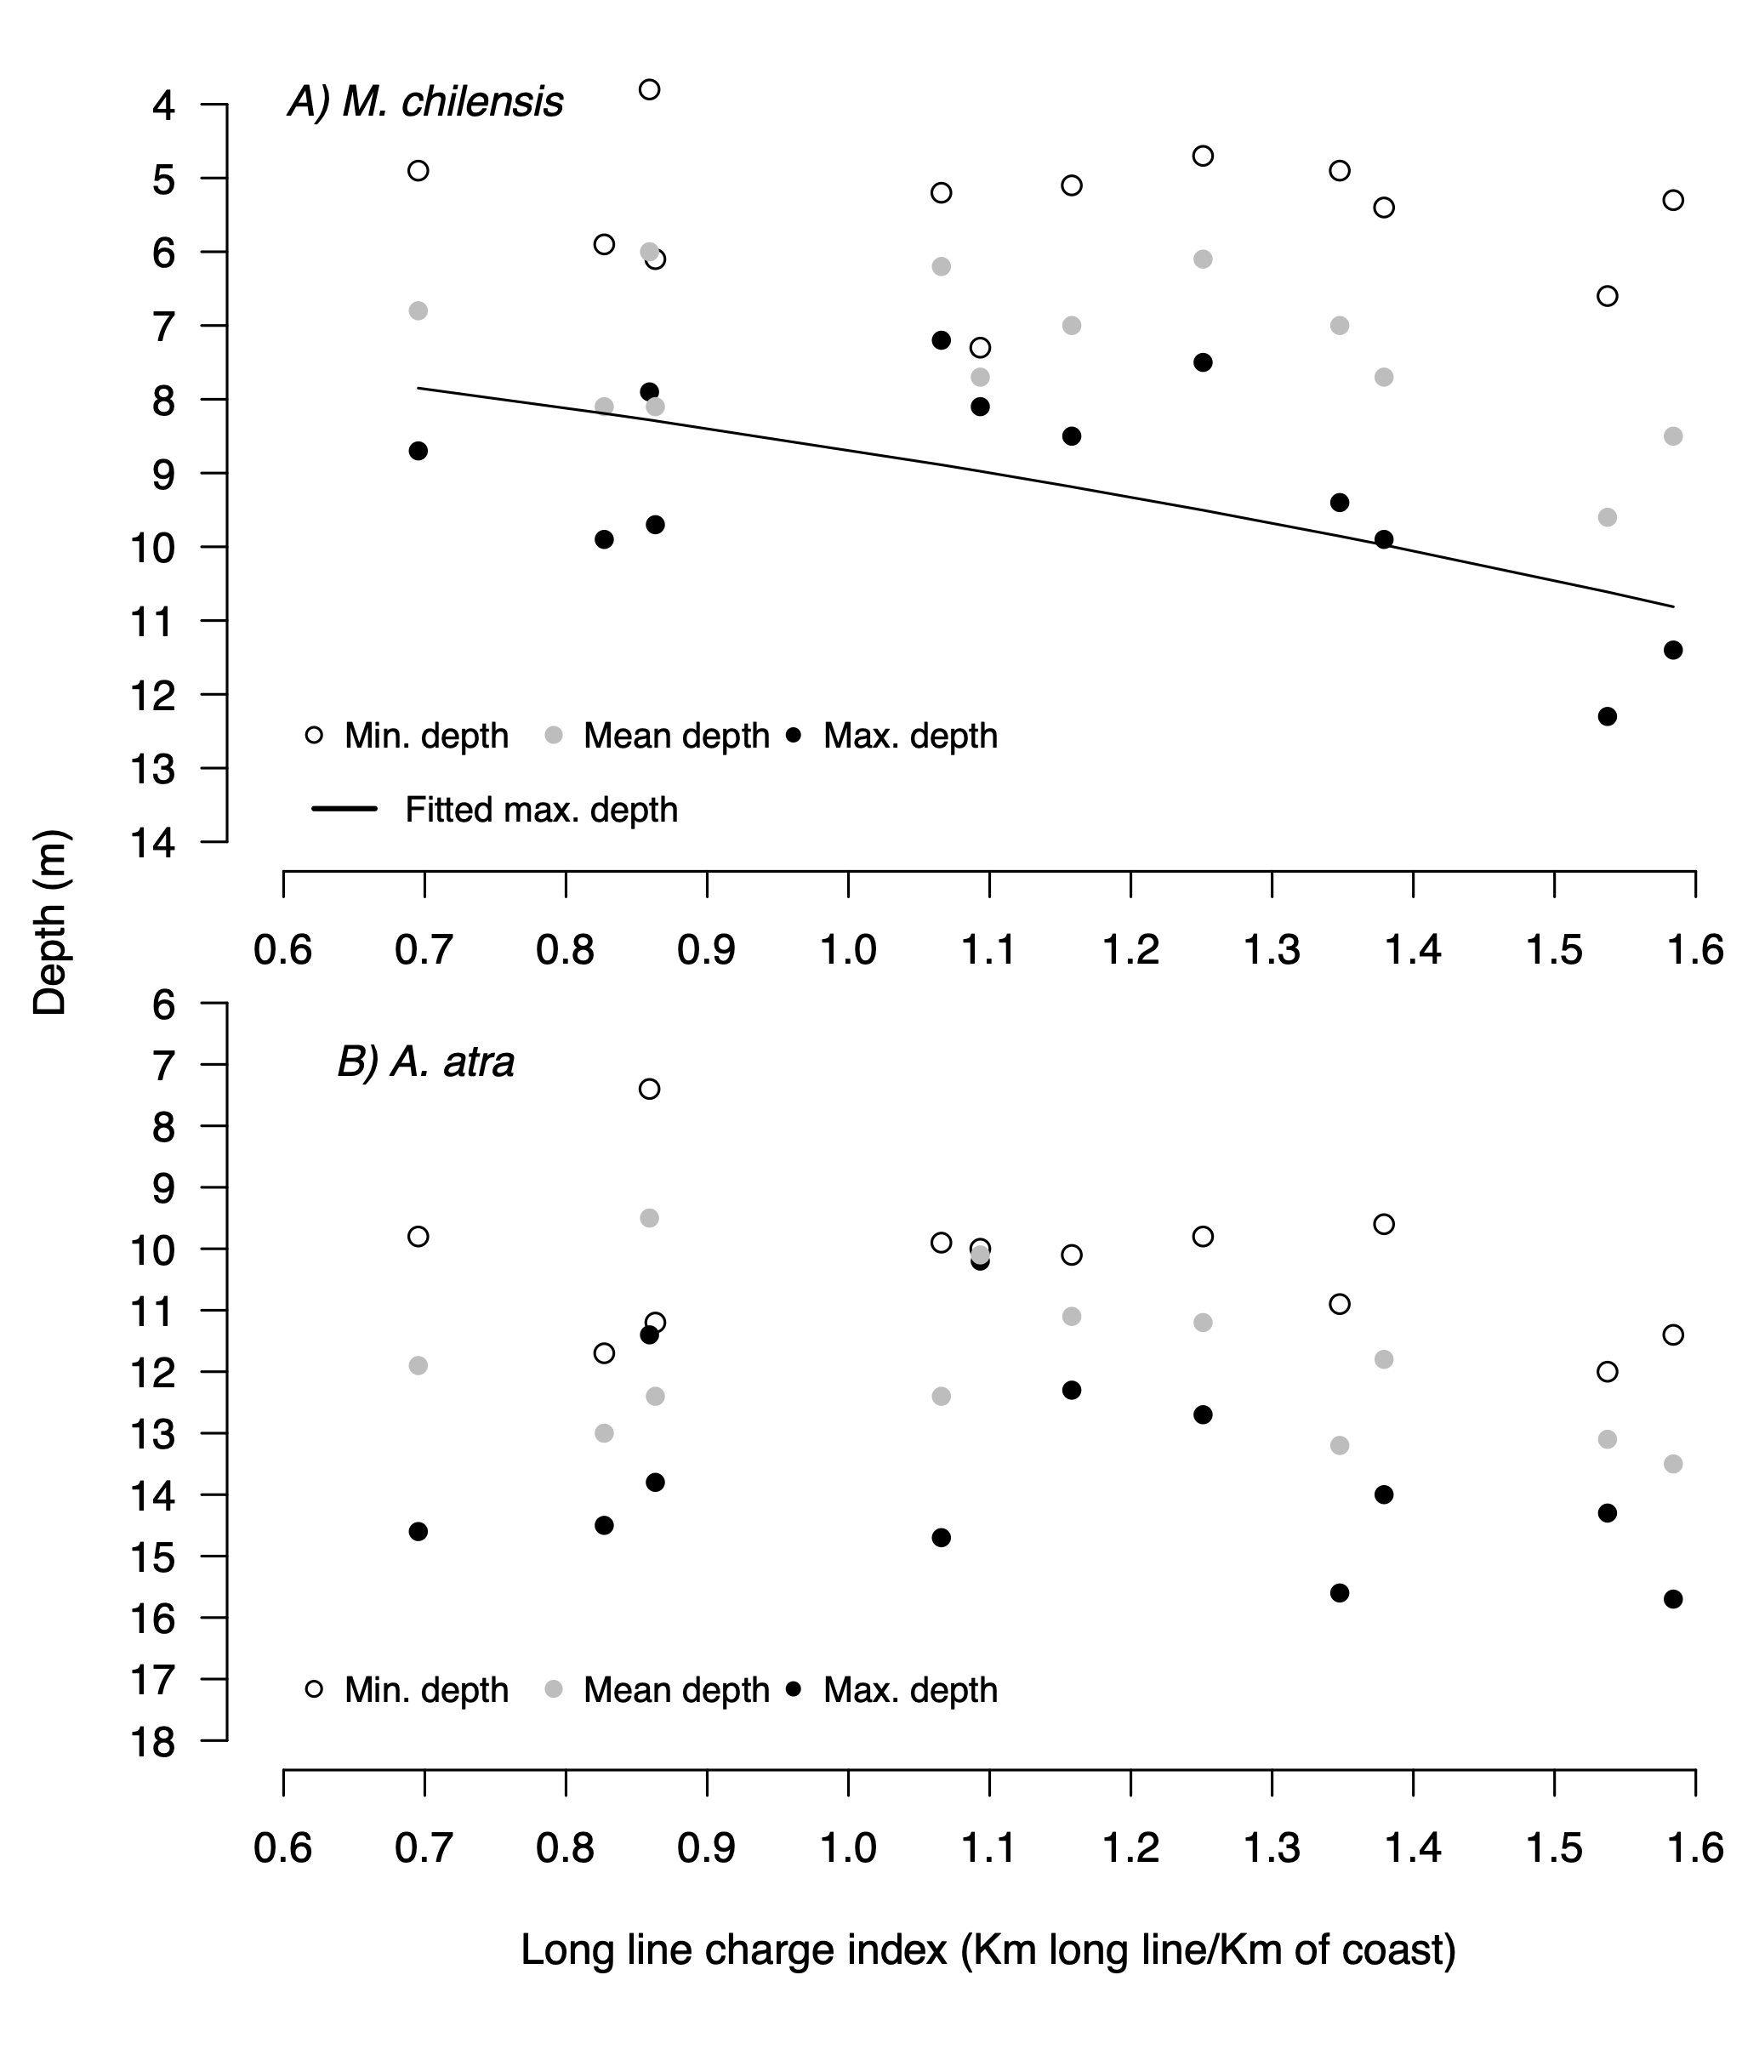

Figure 9: A, B and C) show the observed average, minimum and maximum depth of M. chilensis and A. atra beds in the years 2015, 2020 and 2022, at the sampling sites studied in the Boca, Marimelli, Puelo and Cochamó areas. Vertical dashed lines show the separation between zones.
