Climate Dynamics
Supplementary Information (SI)
for
Enhanced Influence of Indian Ocean Dipole on Sri Lanka Rainfall in Recent Decades
Pathmarasa Kajakokulan^{1*}, Shiromani Jayawardena², Raju Attada³
¹Department of Oceanography and Marine Geology, Faculty of Fisheries and Marine Sciences & Technology, University of Ruhuna, Matara, Sri Lanka.
²Department of Meteorology, Colombo, Sri Lanka.
³Department of Earth and Environmental Sciences, Indian Institute of Science Education and Research Mohali, Sahibzada Ajit Singh Nagar, Punjab 140306, India.

*Corresponding author
Email: kajakokulan45@gmail.com
Department of Oceanography and Marine Geology, Faculty of Fisheries and Marine Sciences & Technology, University of Ruhuna, Matara, Sri Lanka.

ORCID
Pathmarasa Kajakokulan - 0009-0007-7361-9620
Raju Attada – 0000-0002-6194-4561

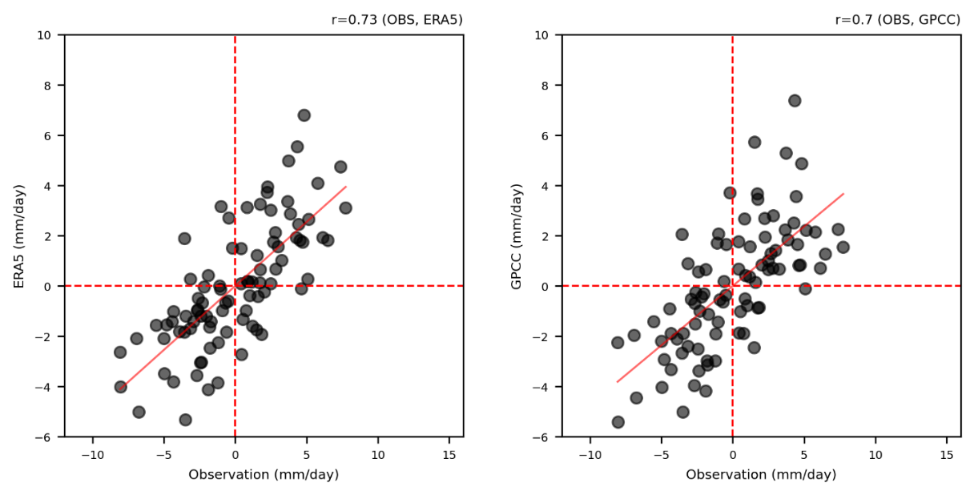
Fig. S1 The correlation between the observations of the precipitation data and a) the ERA5 precipitation and b) the GPCC precipitation.
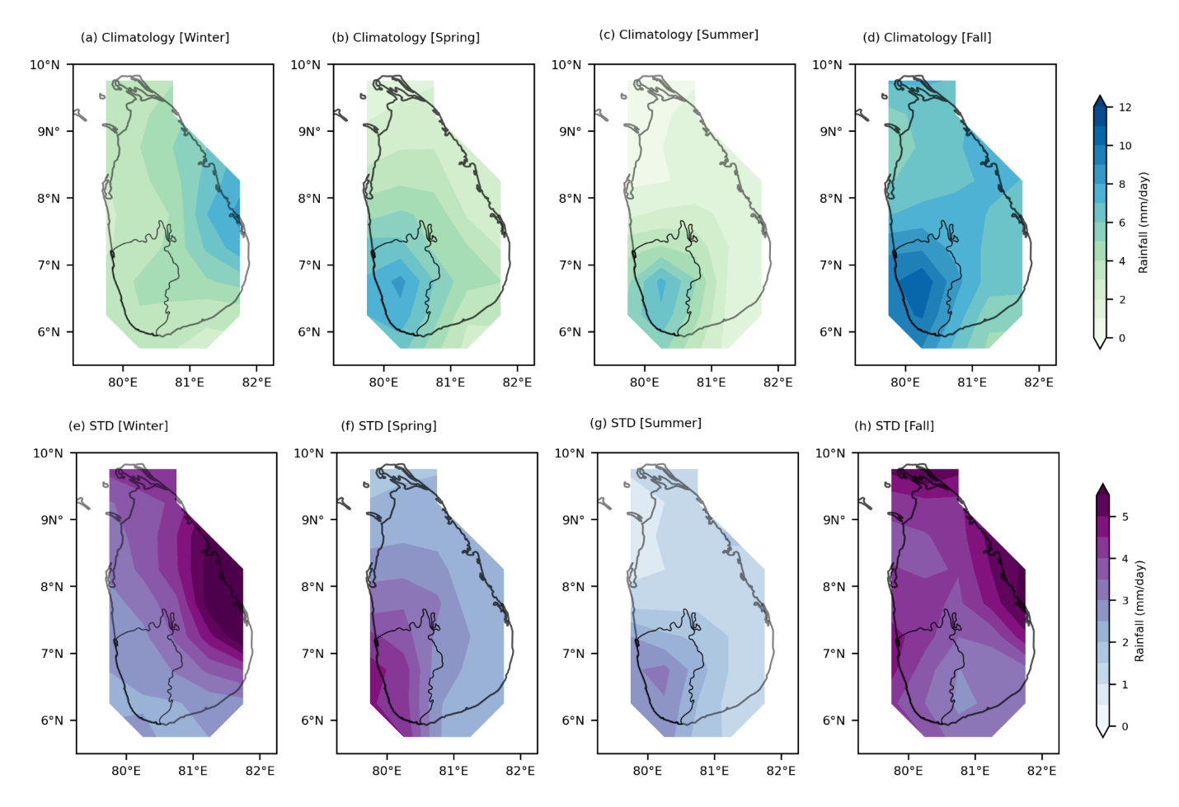
Fig. S2 Climatology of rainfall of Sri Lanka from 1940 to 2020, a) winter, b) spring, c) summer, d) fall. e), f), g), and h) as a), b), c), and d), respectively, but for standard deviation from m GPCC precipitation.

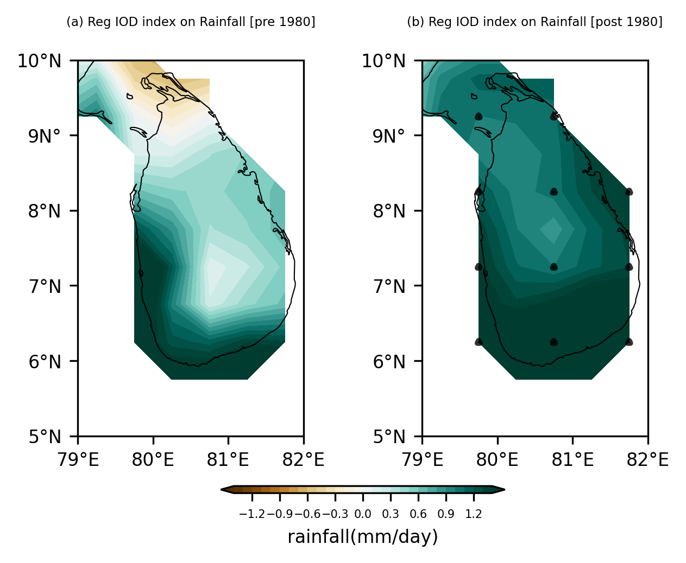
Fig. S3. Correlation between the precipitation anomalies and DMI index during IOD peak fall, a) pre-1980 post-1980s, and b) post-1980 from GPCC data. The map indicates significant regions at a 95% confidence level, which are represented by black dots.

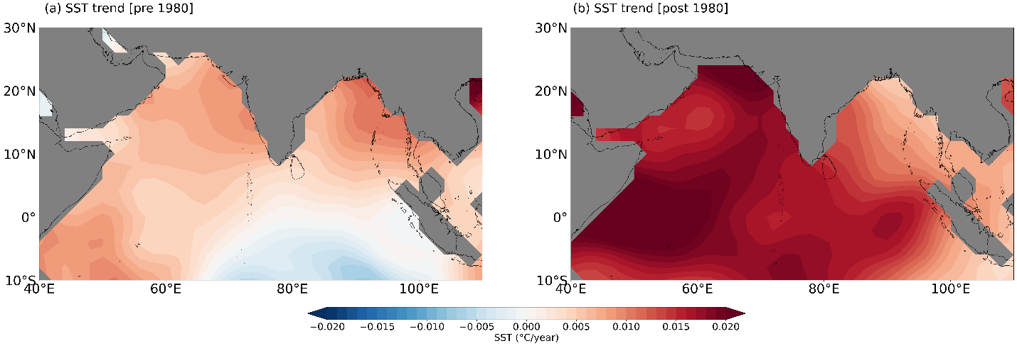
Fig. S4 SST trend, a) Pre-1980 b) post-1980.

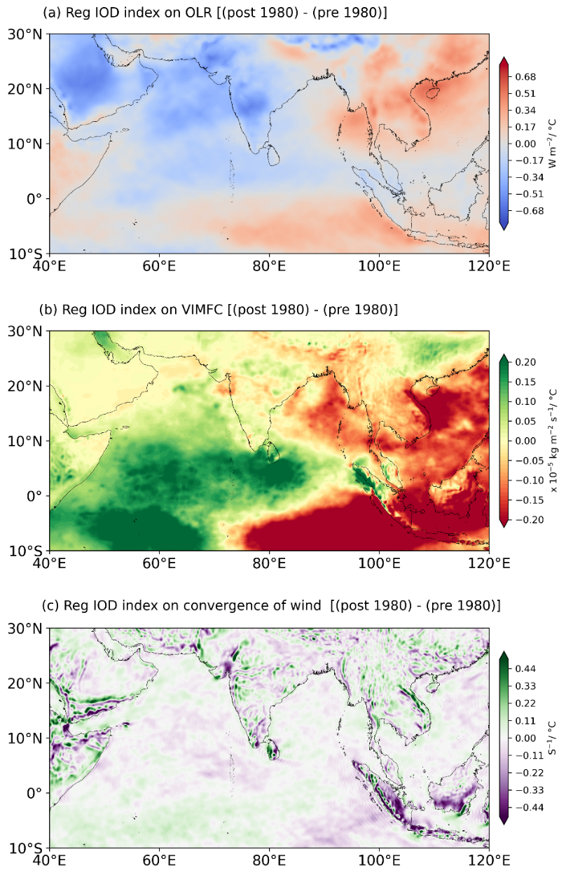
Fig. S5 a) Differences in OLR anomalies regressed onto the DMI index between post-1980 and pre-1980, b) as a) but for VIMFC, c) as a) but for convergence of wind.

