Appendix

Appendix A. Preferred Reporting Items for Systematic Review and Meta-Analysis checklist.

Section and Topic | Item # | Checklist item | Location where item is reported
TITLE
Title | 1 | Circulating prolactin levels and the effect of dopaminergic agonists in systemic lupus erythematosus: a systematic review and meta-analysis | 1
ABSTRACT
Abstract | 2 | Objectives: This systematic review of clinical studies investigated whether circulating PRL levels differed between subjects with systemic lupus erythematosus (SLE) and healthy controls, the correlation between circulating PRL and SLE activity, and the effect of dopaminergic agonists as adjuvant therapy for SLE.  Methods: We searched PubMed, Scopus, Web of Science, Cochrane, Embase, and Google Scholar for case-control and cross-sectional studies investigating circulating PRL levels in subjects with SLE and/or its correlation with disease activity, and clinical trials examining the effect of dopaminergic agonists on SLE activity assessed by the Systemic Lupus Erythematosus Disease Activity Index (SLEDAI) score. The review was registered in PROSPERO (CRD42021237156).  Results: Forty-five studies addressing circulating PRL levels in SLE met our inclusion criteria. SLE was associated with an increased odds of hyperprolactinemia (OR 11.69, 95%CI 5.64-24.22), and circulating PRL levels were significantly higher in subjects with SLE compared with controls (standardized mean difference of 1.96, 95%CI 1.27-2.65,). Circulating PRL was positively correlated with SLE activity assessed by the SLEDAI (correlation coefficient 0.38, 95% CI 0.26-0.48). Two randomized clinical trials with bromocriptine and three prospective open-label trials with quinagolide reported that treatment with dopaminergic agonists was associated with reduced frequency of disease flare and decreased SLEDAI score.  Conclusion: Circulating PRL levels are higher in subjects with SLE compared with healthy controls and are significantly associated with disease activity. In addition, treatment with the dopaminergic agonists bromocriptine and quinagolide reduced SLE disease activity and may be a beneficial adjuvant therapy for the disease. | 2
INTRODUCTION
Rationale | 3 | Systemic lupus erythematosus (SLE) is a challenging autoimmune disease characterized by diverse clinical manifestations virtually affecting any organ system and with varied severity, ranging from mild and restricted skin involvement to life-threatening vital organ impairment [1]. The mechanisms underlying immune dysfunction in SLE are complex and involve multiple molecular pathways [2]. Significant advances in the understanding of SLE pathogenesis over the last decade have highlighted that various genetic, epigenetic, environmental, and hormonal factors interact to alter immune function and lead to autoimmunity and inflammation [2].  Similarly to other autoimmune diseases, SLE is significantly more prevalent in women, with a female-to-male ratio ranging from 8:1 to 15:1 [3, 4]. The latter difference is more pronounced during reproductive age, and SLE activity indicated by disease flares is well-known to increase in pregnancy [5] and with estrogen-containing therapies [6]. The latter aspects suggest that hormonal influences such as sex steroids and prolactin may be involved in its pathophysiology and clinical course.  Prolactin (PRL) is a polypeptide encoded by the PRL gene on chromosome 6 in humans. It is synthesized and secreted by lactotroph cells in the anterior hypophysis and by a myriad of extra-hypophysial sites, such as lymphocytes, ovary, prostate, and adipose tissue, in addition to having many different targets [7]. PRL is well-known for its critical role in stimulating the proliferation and differentiation of mammary cells required for lactation. There is also increasing evidence that PRL has pleiotropic functions, affecting metabolic homeostasis, bone physiology, skin and hair follicles, maternal care, adrenal function, immunity, and inflammatory response [7, 8].  The role of PRL in modulating both innate and acquired immunity raises the question of whether it could be involved in the pathogenesis of autoimmune diseases [9, 10]. Data from preclinical and clinical research indicate that PRL may affect immune function and the clinical phenotype in SLE. It has been shown to impact autoantigen presentation, interfere with the activity of regulatory T cells, and affect B cell tolerance, the production of cytokines, and neutrophil, macrophage, and dendritic cell function [9]. Moreover, hyperprolactinemia is reported in 20 to 30% of subjects with SLE [11], and serum PRL levels were associated with the occurrence of neuropsychiatric, renal, cutaneous, and articular manifestations [12, 13], in addition to anti-dsDNA positivity and higher scores of disease activity [14, 15]. However, the mechanisms underlying higher prolactin levels in SLE are not clear, but there is evidence indicating multiple sources, such as increased production by lymphocytes, the stimulatory action of inflammatory cytokines on lactotrophs to increase pituitary PRL secretion, and genetic factors leading to upregulated PRL gene expression [9].  It is noteworthy, however, that the association between circulating PRL levels and SLE activity is not consistent between different studies. This may be accounted for the heterogeneity in study participants between different studies and the different methods to determine serum prolactin levels or disease activity [9, 16, 17]. | 4
Objectives | 4 | In this setting, we conducted a systematic review and meta-analysis to investigate circulating PRL levels in subjects with SLE compared with healthy controls and examine the correlation between PRL levels and SLE activity. In addition, as a proof of concept for the biologically plausible role of PRL in modulating SLE activity, we conducted a systematic review of clinical trials to investigate the effect of dopamine agonists on SLE activity. | 5
METHODS
Eligibility criteria | 5 | The study questions of the review were created using the PECOS/PICOS acronym (population, exposure/intervention, comparison, outcome, and type of study). For the first review question, whether circulating PRL levels were higher in subjects with SLE compared with healthy controls and were correlated with SLE activity, P was ‘children, men, and nonpregnant and nonlactating women with SLE,’ E was ‘circulating PRL concentration,’ C was ‘healthy subjects’ for case-control studies, O was ‘disease activity assessed by any score,’ and S was ‘cross-sectional or case-control studies.’ Therefore, we searched for studies (i) comparing circulating PRL concentration between subjects with SLE and healthy controls, (ii) comparing the frequency of hyperprolactinemia between subjects with SLE and healthy controls, and/or (iii) addressing the association between circulating PRL levels and SLE activity assessed by a validated score.  For the second review question, whether treatment with dopaminergic agonists affected SLE activity, P was ‘subjects with SLE,’ I was ‘dopamine agonists,’ C was ‘subjects with SLE not treated with dopamine agonists,’ O was ‘disease activity assessed by any score,’ and S was ‘clinical trials or case-control studies.’ The inclusion criteria were clinical trials or case-control studies examining the effect of any dopamine agonist on indicators of SLE activity.  Reviews, case reports, case series, book chapters, and conference abstracts were excluded. Studies involving pregnant women were also excluded. | 5,6
Information sources | 6 | We searched PubMed, Scopus, Web of Science, Cochrane, Embase, and Google Scholar | 6
Search strategy | 7 | We used search terms related to the population (SLE), the exposure (prolactin) or intervention (dopaminergic agonists), and the outcome (disease activity), considering studies published in English, Portuguese, or Spanish. Only the first 100 retrieved records from Google Scholar were considered. The search strategy is presented in Appendices A and B. We also conducted manual searches across reference lists of the included studies | 6
Selection process | 8 | A reference management software (Endnote version 9) was used to collect the references and exclude duplicate studies. Study selection was conducted in two phases. First, two reviewers (A.A.S. e L.F.C.) independently screened the titles and abstracts to select eligible studies. Secondly, the same reviewers independently read the full-text version of the selected studies and applied the inclusion and exclusion criteria. In each phase, disagreements between the two reviewers were resolved by discussion with a third reviewer (A.A.A.). | 6
Data collection process | 9 | For the first review question, the authors, year of publication, country, study design, sample size, age range, sex, method to determine circulating PRL levels, method for SLE activity assessment, and main findings were extracted from the studies. The main findings were extracted considering the following outcomes: (i) hyperprolactinemia rate in subjects with SLE and healthy controls, (ii) circulating PRL levels in subjects with SLE and healthy controls, (iii) hyperprolactinemia rate in subjects with active versus inactive SLE, (iv) circulating PRL levels in subjects with active versus inactive SLE, and (v) the correlation between circulating PRL levels in subjects with SLE and disease activity.  For the second review question, the authors, year of publication, sample size, age range, sex, type of dopamine agonist, method for SLE activity assessment, main findings, and study design were extracted from the included studies.  Data collection was conducted independently by two reviewers (A.A.S. e L.F.C.). Disagreements between the two reviewers were resolved by discussion with a third reviewer (A.A.A.). | 6
Data items | 10a | Outcomes:  (i) hyperprolactinemia rate in subjects with SLE and healthy controls  (ii) circulating PRL levels in subjects with SLE and healthy controls  (iii) hyperprolactinemia rate in subjects with active versus inactive SLE  (iv) circulating PRL levels in subjects with active versus inactive SLE  (v) the correlation between circulating PRL levels in subjects with SLE and disease activity  (vi) the effect of dopaminergic agonists on SLE activity | 6
Data items | 10b | Age, sex, menopausal status, score system used to assess SLE activity | 6
Study risk of bias assessment | 11 | The risk of bias was assessed using the Joanna Briggs Institute Critical Appraisal Checklist [20] for cross-sectional (Appendix C) and case-control studies (Appendix D), for the first review question, and quasi-experimental trials (Appendix E) and randomized clinical trials (Appendix F), for the second review question. The assessment was independently conducted by two reviewers (A.A.S. and L.F.C.) following agreement on scoring decisions. Any disagreement was resolved by discussion with a third reviewer (A.A.A.). A high risk of bias was considered when the study reached 49% or less of the score ‘yes,’ a moderate risk of bias when it reached 50 to 69% of the score ‘yes,’ and a low risk of bias when it reached 70% or more of the score ‘yes’. | 7
Effect measures | 12 | (i) hyperprolactinemia rate in subjects with SLE and healthy controls  (ii) circulating PRL levels in subjects with SLE and healthy controls  (iii) hyperprolactinemia rate in subjects with active versus inactive SLE  (iv) circulating PRL levels in subjects with active versus inactive SLE  (v) the correlation between circulating PRL levels in subjects with SLE and disease activity | 6
Synthesis methods | 13a | Studies were included in the quantitative synthesis if they provided hyperprolactinemia rate in subjects with SLE and healthy controls, circulating prolactin levels in subjects with SLE and healthy controls, hyperprolactinemia rate in subjects with active and inactive SLE, circulating prolactin levels in subjects with active and inactive SLE, correlation between circulating prolactin levels and SLE activity. | 6
Synthesis methods | 13b | Data were tabulated in Microsoft word.  If study values for the Pearson correlation coefficient (r) were not available, the Spearman correlation (rs) coefficient were used to estimate r values using the following formula: r = 2 × sin(rs×p/6)  Circulating PRL levels assessed in mIU/L were converted into ng/mL dividing the results by 21 | 7
Synthesis methods | 13c | Data were tabulated in Microsoft word. | 7
Synthesis methods | 13d | We pooled the following data from individual studies, using random-effect meta-analysis: (i) hyperprolactinemia rate in subjects with SLE and healthy controls, (ii) circulating PRL levels in subjects with SLE and healthy controls, (iii) hyperprolactinemia rate in subjects with active or inactive SLE, and (iv) the correlation between circulating PRL levels in subjects with SLE and disease activity. Data on hyperprolactinemia rate in subjects with SLE and healthy controls were summarized as odds ratio with 95% confidence interval (95%CI), and data on circulating PRL levels in subjects with SLE and healthy controls were reported standardized mean difference with 95% confidence interval.
Synthesis methods | 13e | We planned to conduct subgroup analysis according to age, sex, menopausal status, and type of score system used to assess SLE activity. However, this was not possible due to lack of data reported according to the abovementioned features. | -
Synthesis methods | 13f | - | -
Reporting bias assessment | 14 | - | -
Certainty assessment | 15 | - | -
RESULTS
Study selection | 16a | For the first review question, whether circulating PRL levels were higher in subjects with SLE compared with healthy controls and were correlated with SLE activity, our search retrieved XX studies, of which XX were selected for full-text assessment. Fifty-five studies met our inclusion criteria, and ten were excluded (Figure 1, Appendix G).  For the second review question, whether treatment with dopaminergic agonists affected SLE activity, we identified 468 studies, and eight were selected for full-text assessment (Figure 2). Three studies were excluded: one was excluded because it involved dopamine agonist administration during pregnancy [23], and two were excluded because they did not report SLEDAI scores following dopamine agonist treatment [24, 25].
Study selection | 16b | Appendix G  For the second study question, Three studies were excluded: one was excluded because it involved dopamine agonist administration during pregnancy [23], and two were excluded because they did not report SLEDAI scores following dopamine agonist treatment [24, 25]. | 8
Study characteristics | 17 | Characteristics of studies examining circulating prolactin concentration in systemic lupus erythematosus  Seventeen studies were conducted in Asia [15, 26-41], 12 in America [12, 42-52], 11 in Europe [13, 53-62], and five in Africa [63-67]. Fifteen studies had a cross-sectional design and examined the association between circulating PRL levels and SLE activity, whereas 30 were case-control studies comparing circulating PRL levels between subjects with SLE and healthy controls and/or investigating the association between circulating PRL levels and SLE activity. Sample sizes ranged from 19 to 259 subjects, and most studies described as exclusion criteria conditions affecting circulating PRL levels, such as pregnancy, lactation, renal and hepatic failure, or drugs. The methods to determine circulating PRL concentration varied between studies, and most presented total PRL levels; three also reported free PRL levels [12, 51, 53]. SLE activity was most frequently assessed by the SLE Disease Activity Index (SLEDAI) score and less frequently by the European Consensus Lupus Activity Measure (ECLAM) index [57, 61], the Systemic Lupus Activity Measure (SLAM) index [37, 64], Duke Severity of Illness (DUSOI) score [30], or the combination of signs, symptoms, and serologic markers [54]. Study characteristics are presented in Table 1.  Characteristics of studies examining the effect of dopaminergic agonists on circulating prolactin concentration in systemic lupus erythematosus  The characteristics of the included studies are summarized in Table 2. The studies were conducted in the United States [68], Mexico [69], Poland [55, 56, 69], and China [70]. Three studies were prospective open-label trials [55, 56, 68], and two were randomized clinical trials [69, 70]. Two studies with the prospective open-label design included healthy controls to compare the serum levels of inflammatory markers [55, 56]. Sample sizes ranged from 7 to 38 subjects with SLE. Three studies assessed the effect of bromocriptine on SLE activity [68-70], whereas two studies investigated the impact of quinagolide [55, 56]. Notably, none of the studies included subjects with rapidly progressive or life-threatening SLE. | 8,9
Risk of bias in studies | 18 | All 15 cross-sectional studies addressing the association between circulating prolactin levels and SLE were considered to have a low risk of bias (Appendix C), whereas two case-control studies were considered to have a high risk of bias and 27 to have a low risk of bias (Appendix D).  All three open-label trials investigating the effect of dopaminergic agonists on SLE activity were considered to have a low risk of bias (Appendix E), whereas one randomized clinical trial was considered to have a low risk of bias, and the other randomized clinical trial was considered to have a moderate risk of bias (Appendix F). | 12
Results of individual studies | 19 | Table 1  Table 2
Results of syntheses | 20a | Hyperprolactinemia in systemic lupus erythematosus versus healthy controls  Thirteen case-control studies [29, 38, 44, 47, 49-51, 54, 57, 58, 60, 62, 64] compared the frequency of hyperprolactinemia between subjects with SLE and healthy controls, involving 952 participants. The mean frequency of hyperprolactinemia among subjects with SLE was 30.1%, ranging from 7.1% to 87.5%. Pooling data from individual studies revealed that subjects with SLE had a significantly increased odds of hyperprolactinemia (OR 11.69, 95%CI 5.64-24.22, p < 0.00001, I2 = 0%, Figure 3A)  The frequency of hyperprolactinemia was described in nine cross-sectional studies [13, 15, 31, 32, 37, 39, 45, 59, 63], with a mean of 17%, ranging from 2.19 to 33.3 %.  Funnel plot analysis indicated evidence of small studies effect on the association between hyperprolactinemia and SLE (Appendix H).  Circulating prolactin levels in systemic lupus erythematosus versus healthy controls  Twenty-eight studies compared circulating PRL levels between subjects with SLE and healthy controls, comprising 1,860 individuals [27-30, 33-36, 38, 40, 41, 43, 44, 47-52, 54-58, 60, 62, 65, 67]. Data from 23 studies, including 1,411 subjects [27-30, 33-36, 40, 43, 44, 48-50, 52, 54-58, 60, 62, 67] were pooled and revealed that PRL levels were significantly higher among subjects with SLE than in healthy controls (SMD 1.96, 95%CI 1.27-2.65, p < 0.00001, I2 = 95%, Figure 3B). Data from three studies could not be included in the meta-analysis due to lack of description of error values for serum PRL levels [38, 47, 51]. One study was excluded from the meta-analysis because overall PRL levels in subjects with SLE were not presented but only according to disease activity status [41], and one study was excluded from the meta-analysis because PRL was assessed by an assay with serum levels not comparable to the other studies [65]. Notably, the five excluded studies reported significantly higher circulating PRL levels in individuals with SLE than healthy controls.  Funnel plot analysis indicated evidence of small studies effect on the difference between circulating PRL levels between subjects with SLE and healthy controls (Appendix H).  Hyperprolactinemia and systemic lupus erythematosus activity  Seven studies examined the association between hyperprolactinemia and SLE activity assessed by the SLEDAI [15, 31, 41, 45, 50, 51, 63], and data from six [15, 31, 41, 45, 50, 63] were pooled in the meta-analysis. Hyperprolactinemia was associated with increased SLEDAI scores (OR 3.02, 95% CI 1.52-6.00, p 0.002, I2 = 0%, Figure 4A). Four studies found that hyperprolactinemia was significantly associated with a SLEDAI score greater than 4 [15, 31, 41, 50], which was used as the cutoff value to define disease activity. Only one study used SLEDAI greater than 3 [45] or greater than 5 [63]. The first found that hyperprolactinemia was marginally associated with disease activity, whereas the latter found no association.  One study was not excluded in the meta-analysis because the frequency of hyperprolactinemia was described for various ranges of SLEDAI scores [51] but described that hyperprolactinemia was significantly associated with disease activity. Funnel plot analysis indicated evidence of small studies effect on the association between hyperprolactinemia and SLE activity (Appendix I).  Correlation between circulating prolactin levels and systemic lupus erythematosus activity  A total of 26 studies comprising 1,563 subjects addressed the correlation between circulating PRL levels and disease activity [12, 15, 26, 29, 30, 32-34, 37, 39, 40, 44, 47, 51-53, 57-61, 63-67]. Nineteen studies employing the SLEDAI to assess disease activity and involving 1,153 individuals could be pooled in the meta-analysis [12, 15, 26, 32-34, 39, 40, 44, 47, 51-53, 58, 60, 63, 65-67]. Circulating PRL was positively associated with the SLEDAI score (correlation coefficient: 0.38; 95%CI 0.26-0.48, p < 0.001, I2 = 79.5%, Figure 4B). When data from studies including other score systems to assess SLE activity were pooled, we found that circulating PRL was positively associated with disease activity (correlation coefficient: 0.34; 95%CI 0.21-0.45, p < 0.001, I2 = 81.5%, 24 studies, 1,313 individuals, Appendix J). Among studies included in the latter meta-analysis, two used the ECLAM score to assess disease activity [57, 61], one used the SLAM score [37], and one study used the DUSOI score [30].  Two studies were excluded from the meta-analysis because they did not report the correlation coefficient value [29, 59].  Funnel plot analysis indicated evidence of small studies effect on the correlation between circulating PRL levels and SLE activity (Appendix I). | 9,10
Results of syntheses | 20b | Figure 3  Figure 4 | -
Results of syntheses | 20c | Appendix H, I, J. | -
Results of syntheses | 20d | - | -
Reporting biases | 21 | - | -
Certainty of evidence | 22 | - | -
DISCUSSION
Discussion | 23a | In this systematic review and meta-analysis, we examined whether circulating PRL concentration was different in subjects with SLE compared with healthy controls and whether it was associated with disease activity in SLE. We found that hyperprolactinemia rate and serum PRL levels were significantly higher among individuals with SLE than controls and that serum PRL was moderately correlated with disease activity. In addition, we found that adjunct treatment of SLE with bromocriptine or quinagolide significantly decreased disease activity assessed by the SLEDAI score.  The association between circulating PRL levels and SLE was addressed in a previous meta-analysis of 25 studies comprising 1,056 subjects with SLE and 426 healthy controls, which reported that circulating PRL levels were significantly higher in SLE than controls and were significantly associated with disease activity [17]. Our study contributed with updated data from studies published over the last seven years and by additionally examining the effect of PRL suppression on SLE activity. We conducted a detailed literature search and captured 13 additional studies published until 2016 and six studies published since then. In addition to examining circulating PRL levels in SLE and its association with disease activity, we examined the rate of hyperprolactinemia in subjects in SLE. Hence, our study contributed with updated data from studies published over the last seven years and reinforced the previous findings. Moreover, we additionally examined the effect of dopamine agonists on SLE activity. To our knowledge, this is the first systematic review addressing this question.  The association between circulating PRL and SLE activity in concert with the findings that PRL suppression with dopaminergic agonists decreases disease activity could imply that the association between serum PRL levels and SLE activity is causal. This is further reinforced by the evidence from preclinical studies supporting that the role of PRL in modulating SLE activity is biologically plausible. PRL affects different aspects of innate and acquired immunity. PRL stimulates the inflammatory and phagocytic activity of macrophages [7-9] and enhances antigen presentation by activating dendritic cells and inducing the expression of both class II histocompatibility molecules and costimulatory molecules such as CD40, CD80, and CD86 [9, 71]. Regarding acquired immunity, PRL induces CD4 and CD8 lymphocyte activation by promoting interleukin 2 secretion and inducing the expression of receptors for the latter cytokine, decreasing autoreactive B lymphocyte apoptosis, reducing the threshold for B lymphocyte activation, and increasing immunoglobulin production [9, 71, 72].  Studies involving experimental models of SLE also suggest that hyperprolactinemia may lead to immune dysfunction. In NZB/WF1 mice, which spontaneously develop SLE, hyperprolactinemia induced by pituitary transplants enhances immune dysfunction, organ damage, and increased mortality in both females [73] and males [74]. PRL administration to R4A-γ2B Balb/c mice induced a lupus-like phenotype, which was reversible following PRL discontinuation [75]. However, the same effect of PRL was not observed in R4A-γ2B C57BL/6 mice, suggesting that the effects of PRL on immune function depend upon the genetic background [76]. These findings reinforce the complex pathogenesis of SLE, and it is still unclear how PRL interacts with other factors to affect SLE development and phenotype.  The role of PRL in modulating immune function has attracted attention to its possible role in affecting autoimmune disease development and severity in humans [9]. SLE is considered the prototype systemic autoimmune disease, and there is increasing evidence that PRL may impact immune dysfunction and the clinical phenotype in SLE [9]. Our meta-analysis reinforces that circulating PRL levels are higher in subjects with SLE than healthy controls and that higher PRL levels are associated with disease activity scores. In light of these findings, we sought to investigate whether decreasing serum PRL would affect SLE activity by conducting a systematic review. Despite the scarcity of studies addressing this question, all five studies included in the review demonstrated that suppressing PRL secretion benefits subjects with SLE.  The beneficial impact of PRL suppression with dopaminergic agonists supports the role of PRL in determining SLE activity. However, the latter also points to the potential benefit of dopaminergic signaling itself. Indeed, it was previously shown that bromocriptine can affect the immune system independently from hyperprolactinemia. In cell-based studies, dopaminergic signaling induced by agonists reduced the phagocytic activity of macrophages, decreased B lymphocyte proliferation and differentiation in response to mitogenic stimuli, and inhibited the production of interleukin 1 by T lymphocytes [73, 77]. In addition, Blank et al. (1990) showed that the addition of bromocriptine to cyclosporine in the treatment of subjects with SLE and uveitis reduced the levels of nuclear autoantibodies compared to cyclosporin, independently from circulating prolactin concentrations [78]. However, to our knowledge, no other human studies have addressed whether dopaminergic agonists could affect SLE activity independently from their action to suppress PRL secretion.  It is also unknown whether dopaminergic agonists would be beneficial as monotherapy in subjects with mild disease or how they would affect disease activity compared to established therapy. All included studies in this systematic review assessed the effect of bromocriptine or quinagolide as adjunctive therapy in subjects with SLE. Interestingly, Walker et al. (1999) presented the preliminary findings from a blind randomized clinical trial involving 24 subjects with active SLE, but not organ-threatening disease assigned to receive bromocriptine to lower serum prolactin levels to less than 1 ng/mL (n = 11) or hydroxychloroquine at 6 mg/kg (n = 13). After one year of treatment, the mean SLEDAI score decreased from 8.6 ± 2.6 to 2.5 ± 1.5 in subjects receiving bromocriptine and from 8.2 ± 1.7 to 4.6 ± 1.1 in subjects receiving hydroxychloroquine. Additionally, the proportion of individuals decreasing or stopping prednisone, or starting or increasing prednisone dose was similar in both groups [24]. Although this study was not published as a full-text article, its findings suggest that bromocriptine is comparable to hydroxychloroquine in mild and non-organ-threatening SLE.  Another possibility that should be considered is that circulating PRL may be a biomarker of SLE activity instead of having a significant contributory role in disease activity. Indeed, hyperprolactinemia has been reported in different autoimmune diseases, as thoroughly reviewed elsewhere [16, 79], and also in non-autoimmune inflammatory disorders, such as insulin resistance [80, 81] and atherosclerosis [82, 83]. However, prospective studies are warranted to validate circulating PRL as a disease biomarker.  It is noteworthy that eight studies reported that circulating PRL levels were not different between subjects with SLE and healthy controls [33, 34, 55, 59, 61, 62, 64, 67], and 13 studies found no correlation between circulating PRL and SLE activity [13, 26, 31-34, 39, 42, 54, 58, 63, 64, 67]. The reasons for the inconsistent findings between studies are not clear. However, they could be due to the different characteristics of the participants and to characteristics of the association between PRL and SLE and its activity that were not addressed in the methodological design of the included studies. It is reasonable to speculate that sustained but not sporadic increases in circulating PRL could determine its association with immune dysfunction, and a single measurement of serum PRL levels, as was the case in all included studies, would lead to inappropriate conclusions.  Another point that should be considered in interpreting our findings is that posttranslational changes in PRL may influence the association between PRL and SLE. Three forms of PRL are found in the circulation, including monomeric PRL, dimeric PRL, and macro-PRL, being the latter two biologically inactive [84]. Routine PRL assays cannot distinguish between monomeric PRL and macro-PRL [85], and it is, therefore, possible that hyperprolactinemia found in different studies addressing the association between circulating PRL and SLE vary with respect to the concentration of monomeric PRL that contributes to increased PRL levels. Therefore, hyperprolactinemia may not reflect increased levels of biologically active PRL. Indeed, two studies included in this review found that free (monomeric) PRL, but not total PRL levels, were associated with SLE activity [12, 53]. | 12-15
Discussion | 23b | This systematic review has some limitations that should be considered when interpreting our findings. The studies addressing circulating PRL levels in SLE were overall small and varied in the characteristics of the participants. Many studies included pre and postmenopausal women and men and did not present data according to sex and menopausal status. Therefore, we could not conduct subgroup analysis according to these variables. It is, hence, unknown whether the magnitude of the association between PRL and SLE and its activity varies with age, gender, and menopausal status in women. Moreover, the time since SLE diagnosis varied between subjects in the included studies, but we could not examine its effect on the association between serum PRL and SLE and its activity. | 15
Discussion | 23c | The systematic review addressing the effect of dopaminergic agonists in SLE activity was limited by the impossibility of conducting a meta-analysis due to the heterogeneity of the included studies, such as the type of dopaminergic agonist assessed, the type of population, and the study design. Moreover, the studies were overall small, with few individuals included. | 15
Discussion | 23d | The findings from this systematic review also raise several points that should be addressed in future studies to improve our understanding of the link between PRL and SLE, including whether the association between circulating PRL and SLE varies with age, sex, menopausal status, time since SLE diagnosis, persistent versus sporadic serum PRL elevation, or the increase of different circulating forms of PRL. Given the correlation between PRL and SLE activity, it would also be interesting to explore the role of PRL as a biomarker of disease activity by examining the impact of SLE therapy on circulating PRL in prospective studies. Moreover, it would be important to reassess the effect of dopaminergic agonists on SLE activity, given the availability of cabergoline, which has a more favorable tolerability profile. | 16
OTHER INFORMATION
Registration and protocol | 24a | The review was registered in PROSPERO (CRD42021237156). | 5
Registration and protocol | 24b | PROSPERO (CRD42021237156). | 5
Registration and protocol | 24c | - | -
Support | 25 | None | -
Competing interests | 26 | None | -
Availability of data, code and other materials | 27 | All data are presented in the manuscript. | -

Appendix B. Search strategies with appropriated keywords and MeSH terms for the first review question (‘Are circulating PRL levels higher in subjects with SLE compared with healthy controls and correlated with SLE activity’?).

Database  (search date) | Search | Number of citations
PUBMED  (July 20, 2023;  updated in February 15, 2024) | (“Systemic Lupus Erythematosus” OR “Lupus Erythematosus Disseminatus” OR “Libman-Sacks Disease” OR “Disease, Libman-Sacks” OR “Libman Sacks Disease”) AND (“Mammotropic Hormone, Pituitary” OR “Hormone, Pituitary Mammotropic” OR “Pituitary Mammotropic Hormone” OR “PRL” OR “Prolactin” OR “Lactogenic Hormone, Pituitary” OR “Hormone, Pituitary Lactogenic” OR “Pituitary Lactogenic Hormone” OR “Mammotropin”) AND (“level” OR “activity” OR “correlation”) | 138
EMBASE  (July 20, 2023;  updated in February 15, 2024) | ('systemic lupus erythematosus'/exp) AND ('prolactin'/exp) AND (‘level’ OR ‘correlation’ OR ‘activity’) | 297
SCOPUS  (July 20, 2023;  updated in February 15, 2024) | TITLE-ABS-KEY(“Systemic Lupus Erythematosus” OR “Lupus Erythematosus Disseminatus” OR “Libman-Sacks Disease” OR “Disease, Libman-Sacks” OR “Libman Sacks Disease”) AND TITLE-ABS-KEY(“mammotropic hormone” OR “pituitary hormone” OR “prolactin” OR “lactogenic hormone” OR “mammotropin”) AND TITLE-ABS-KEY(“level” OR “correlation” OR “activity”) | 5
Web of Science (July 20, 2023;  updated in February 15, 2024) | TS=("Systemic Lupus Erythematosus" OR "Lupus Erythematosus Disseminatus" OR "Libman-Sacks Disease" OR "Disease, Libman-Sacks" OR "Libman Sacks Disease") AND TS=("Mammotropic Hormone, Pituitary" OR "Hormone, Pituitary Mammotropic" OR "Pituitary Mammotropic Hormone" OR "Prolactin" OR "Lactogenic Hormone, Pituitary" OR "Hormone, Pituitary Lactogenic" OR "Pituitary Lactogenic Hormone" OR "Mammotropin") AND ALL=("level" OR “correlation” OR “activity”) | 254
Cochrane  (July 20, 2023;  updated in February 15, 2024) | #1: MeSH descriptor: [Lupus Erythematosus, Systemic] explode all trees  #2: MeSH descriptor: [Prolactin] explode all trees  #1 AND #2 | 3
Google Scholar  (July 20, 2023;  updated in February 15, 2024) | (“Systemic Lupus Erythematosus” OR “Libman Sacks Disease”) AND (Prolactin OR “Mammotropic Hormone, Pituitary” OR “Lactogenic Hormone, Pituitary” OR Mammotropin”) AND (“level” OR “activity” OR “correlation”) | 100

Appendix C. Search strategies with appropriated keywords and MeSH terms for the second review question (‘Does treatment with dopaminergic agonists affect activity?’)

Database (search date) | Search | Number of citations
PubMed (July 27, 2023; updated in February 15, 2024) | #1: “Systemic Lupus Erythematosus” OR “Lupus Erythematosus Disseminatus” OR “Libman-Sacks Disease” OR “Disease, Libman-Sacks” OR “Libman Sacks Disease”  AND  #2: “1-((6-allylergolin-8beta-yl)carbonyl)-1-(3-(dimethylamino)propyl)-3-ethylurea” OR “FCE 21336” OR “FCE-21336” OR “Cabaser” OR “Cabaseril” OR “Dostinex” OR “Galastop” OR “Cabergoline Diphosphate” OR “1-Ethyl-2-(3'-dimethylaminopropyl)-3-(6'-allylergoline-8'-beta-carbonyl)urea diphosphate” OR “Agents, Dopamine” OR “Dopaminergic Agents” OR “Agents, Dopaminergic” OR “Dopaminergic Drugs” OR “Drugs, Dopaminergic” OR “Dopamine Drugs” OR “Drugs, Dopamine” OR “Dopamine Effect” OR “Effect, Dopamine” OR “Dopaminergic Effect” OR “Effect, Dopaminergic” OR “Dopaminergic Effects” OR Effects, Dopaminergic” OR “Dopamine Effects” OR Effects, Dopamine” OR “2-Bromo-alpha-ergokryptine” OR “2 Bromo alpha ergokryptine” OR “Bromocryptin” OR “2-Bromoergokryptine” OR “2 Bromoergokryptine” OR “Bromocriptin” OR “2-Bromoergocryptine” OR “2 Bromoergocryptine” OR “2-Bromo-alpha-ergocryptine” OR “2 Bromo alpha ergocryptine” OR “CB-154” OR “CB 154” OR “CB154” OR “Parlodel” OR “2-Bromoergocryptine Mesylate” OR “2 Bromoergocryptine Mesylate” OR “Mesylate, 2-Bromoergocryptine” OR “Bromocriptine Mesylate” OR “Mesylate, Bromocriptine” OR “2-Bromoergocryptine Methanesulfonate” OR “2 Bromoergocryptine Methanesulfonate” OR “Methanesulfonate, 2-Bromoergocryptine”  #3: #1 AND #2 | 58
Scopus (July 27, 2023; updated in February 15, 2024) | TITLE-ABS-KEY(“Systemic Lupus Erythematosus” OR “Lupus Erythematosus Disseminatus” OR “Libman-Sacks Disease” OR “Disease, Libman-Sacks” OR “Libman Sacks Disease”) AND TITLE-ABS-KEY(“1-((6-allylergoline-8beta-yl)carbonyl)-1-(3-(dimethylamino)propyl)-3-ethylurea” OR “FCE 21336” OR “FCE-21336” OR “Cabaser” OR “Cabaseril” OR “Dostinex” OR “Galastop” OR “Cabergoline Diphosphate” OR “1-ethyl-2-(3'-dimethylaminopropyl)-3-(6'-allylergolinee-8'-beta-carbonyl)urea diphosphate” OR “Agents, Dopamine" OR “Dopaminergic Agents” OR “Agents, Dopaminergic” OR “Dopaminergic Drugs” OR “Drugs, Dopaminergic” OR “Dopamine Drugs” OR “Drugs, Dopamine” OR “Dopamine Effect” OR “Effect, Dopamine” OR “Dopaminergic Effect” OR “Effect, Dopaminergic” OR “Dopaminergic Effects” OR “Effects, Dopaminergic” OR “Dopamine Effects” OR “Effects, Dopamine” OR “2-Bromo-alpha-ergokryptine” OR “2 Bromo alpha ergokryptine” OR “Bromocryptin” OR “2-bromoergocryptine” OR “2 bromoergocryptine” OR “Bromocriptin” OR “2-Bromoergocryptine” OR “2 Bromoergocryptine” OR “2-Bromo-alpha-ergocryptine” OR “2 Bromo alpha ergocryptine” OR “cbf-154” OR “cbf 154” OR “cbf154” OR “Parlodel” OR “2-bromoergocryptine mesxylate” OR “2 bromoergocryptine mesxylate” OR “mesxylate, 2-bromoergocryptine” OR “bromocriptine mesxylate” OR “mesxylate, bromocriptine” OR “2-Bromoergocryptine Methanesulfonate” OR “2 Bromoergocryptine Methanesulfonate” OR “Methanesulfonate, 2-Bromoergocryptine”) | 9
Web of Science (July 27, 2023; updated in February 15, 2024) | TS=(“6-allylergolin-8beta-yl carbonyl-1-3-dimethylaminopropyl-3-ethylurea” OR “FCE 21336” OR “FCE-21336” OR “Cabaser” OR “Cabaseril” OR “Dostinex” OR “Galastop” OR “Cabergoline Diphosphate” OR “1-Ethyl-2-3'-dimethylaminopropyl-3-6'-allylergoline-8'-beta-carbonyl urea diphosphate” OR “Agents, Dopamine” OR “Dopaminergic Agents” OR “Agents, Dopaminergic” OR “Dopaminergic Drugs” OR “Drugs, Dopaminergic” OR “Dopamine Drugs” OR “Drugs, Dopamine” OR “Dopamine Effect” OR “Effect, Dopamine” OR “Dopaminergic Effect” OR “Effect, Dopaminergic” OR “Dopaminergic Effects” OR “Effects, Dopaminergic” OR “Dopamine Effects” OR “Effects, Dopamine” OR “2-Bromo-alpha-ergokryptine” AND “2 Bromo alpha ergokryptine” OR “Bromocryptin” OR “2-Bromoergokryptine” OR “2 Bromoergokryptine” OR “Bromocriptin” OR “2-Bromoergocryptine” OR “2 Bromoergocryptine” OR “2-Bromo-alpha-ergocryptine” OR “2 Bromo alpha ergocryptine” OR “CB-154” OR “CB 154” OR “CB154” OR “Parlodel” OR “2-Bromoergocryptine Mesylate” OR “2 Bromoergocryptine Mesylate” OR “Mesylate, 2-Bromoergocryptine” OR “Bromocriptine Mesylate” OR “Mesylate, Bromocriptine” OR “2-Bromoergocryptine Methanesulfonate” OR “2 Bromoergocryptine Methanesulfonate” OR “Methanesulfonate, 2-Bromoergocryptine”) AND TS=(“Systemic Lupus Erythematosus” OR “Lupus Erythematosus Disseminatus” OR “Libman-Sacks Disease” OR “Disease, Libman-Sacks” OR “Libman Sacks Disease”) | 6
EMBASE (July 27, 2023; updated in February 15, 2024) | #1: “systemic lupus erythematosus”/exp AND “dopamine receptor stimulating agent”/exp  #2: “systemic lupus erythematosus”/exp AND “cabergoline”/exp  #3: “systemic lupus erythematosus'/exp AND 'bromocriptine”/exp  #4: #1 OR #2 OR #3 | 378
Cochrane (July 27, 2023; updated in February 15, 2024) | #1: MeSH descriptor: [Lupus Erythematosus, Systemic] explode all trees  #2: MeSH descriptor: [Dopamine Agonists] explode all trees  #3: MeSH descriptor: [Bromocriptine] explode all trees  #4: MeSH descriptor: [Cabergoline] explode all trees  #5: #1 AND (#2 OR #3 OR #4) | 4
Google Scholar (July 27, 2023; updated in February 15, 2024) | (“systemic lupus erythematosus”) AND (“dopamine agonists” OR “bromocriptine” OR “cabergoline” OR “quinagolide”) | 100

Appendix D. Risk of bias summary, assessed by Joanna Briggs Institute Critical Appraisal Checklist for analytical cross-sectional studies: author’s judgments for each included study.
Authors, year | Q1 | Q2 | Q3 | Q4 | Q5 | Q6 | Q7 | Q8 | Total | Risk of bias
Buskila et al. (1996) | Y | Y | Y | Y | Y | U | Y | Y | 87.5% | Low
Ostendorf et al. (1996) | Y | Y | Y | Y | Y | Y | Y | Y | 100% | Low
Rovensky et al. (1997) | Y | Y | Y | Y | N | N | Y | Y | 75% | Low
Gómez-Pérez et al. (2003) | Y | Y | Y | Y | Y | Y | Y | Y | 100% | Low
Leaños-Miranda et al. (2006) | Y | Y | Y | Y | U | U | Y | Y | 75% | Low
Rezaieyazdi et al. (2006) | Y | N | Y | Y | Y | Y | Y | Y | 87.5% | Low
Cárdenas-Mondragón et al. (2007) | Y | Y | Y | Y | U | U | Y | Y | 75% | Low
Jokar et al. (2008) | Y | Y | Y | Y | Y | Y | Y | Y | 100% | Low
Shahin et al. (2011) | Y | Y | Y | Y | Y | Y | Y | Y | 100% | Low
Orbach et al. (2012) | Y | Y | Y | Y | N | N | Y | Y | 75% | Low
Karimifar et al. (2013) | Y | Y | Y | Y | Y | Y | Y | Y | 100% | Low
Aulestia et al. (2016) | Y | Y | Y | Y | Y | Y | Y | Y | 100% | Low
Gomez-Hernandez et al. (2016) | Y | Y | Y | Y | Y | Y | Y | Y | 100% | Low
Abdelaziz et al. (2018) | Y | Y | Y | Y | Y | Y | Y | Y | 100% | Low
Asyraf et al. (2018) | Y | Y | Y | Y | Y | Y | Y | Y | 100% | Low

Legend: Y= Yes; N= No; U = unclear.
Q1 - Were the criteria for inclusion in the sample clearly defined?
Q2 - Were the study subjects and the setting described in detail?
Q3 - Was the exposure measured in a valid and reliable way?
Q4 - Were objective, standard criteria used for measurement of the condition?
Q5 - Were confounding factors identified?
Q6 - Were strategies to deal with confounding factors stated?
Q7 - Were the outcomes measured in a valid and reliable way?
Q8 - Was appropriate statistical analysis used?

Total= ΣY/Applicable Items (the Not Applicable (NA) items were excluded from the sum).

Risk of bias was categorized as high when the study reaches up to 49% score ‘yes’, moderate when the study reached 50% to 69% score ‘yes’, and low when the study reached more than 70% score ‘yes’.

Appendix E. Risk of bias summary, assessed by Joanna Briggs Institute Critical Appraisal Checklist for case-control studies: author’s judgments for each included study.
Authors, year | Q1 | Q2 | Q3 | Q4 | Q5 | Q6 | Q7 | Q8 | Q9 | Q10 | Total | Risk of bias
Lavalle et al. (1987) | Y | Y | Y | Y | Y | N | N | Y | NA | Y | 77.8% | Low
Folomeev et al. (1990) | U | U | U | Y | Y | N | N | Y | NA | Y | 44.4% | High
Jara et al. (1992) | U | U | U | Y | Y | N | N | Y | NA | Y | 44.4% | High
Sequeira et al. (1993) | Y | Y | Y | Y | Y | N | N | Y | NA | Y | 77.8% | Low
El-Garf et al. (1996) | Y | Y | Y | Y | Y | N | N | Y | NA | Y | 77.8% | Low
Ferreira et al. (1998) | Y | Y | Y | Y | Y | N | N | Y | NA | Y | 77.8% | Low
Jimena et al. (1998) | Y | Y | Y | Y | Y | Y | Y | Y | NA | Y | 100% | Low
Mok et al. (1998) | Y | Y | Y | Y | Y | Y | Y | Y | NA | Y | 100% | Low
Chang et al. (1999) | Y | Y | Y | Y | Y | N | N | Y | NA | Y | 77.8% | Low
Mok et al. (2000) | Y | Y | Y | Y | Y | Y | Y | Y | NA | Y | 100% | Low
Cruz et al. (2001) | Y | Y | Y | Y | Y | Y | Y | Y | NA | Y | 100% | Low
Hrycek et al. (2001) | Y | Y | Y | Y | Y | Y | Y | Y | NA | Y | 100% | Low
Jacobi et al. (2001) | Y | Y | Y | Y | Y | Y | Y | Y | NA | Y | 100% | Low
Pacilio et al. (2001) | Y | Y | Y | Y | Y | Y | Y | Y | NA | Y | 100% | Low
Vera-Lastra et al. (2003) | Y | Y | Y | Y | Y | Y | Y | Y | NA | Y | 100% | Low
Kramer et al. (2005) | Y | Y | Y | Y | Y | Y | Y | Y | NA | Y | 100% | Low
Dai et al. (2006) | Y | Y | Y | Y | Y | Y | Y | Y | NA | Y | 100% | Low
Haghighi et al. (2006) | Y | Y | Y | Y | Y | Y | Y | Y | NA | Y | 100% | Low
Elwakkad et al. (2007) | Y | Y | Y | Y | Y | N | N | Y | NA | Y | 77.8% | Low
Hrycek et al. (2001) | Y | Y | Y | Y | Y | Y | Y | Y | NA | Y | 100% | Low
Rastin et al. (2007) | Y | Y | Y | Y | Y | N | N | Y | NA | Y | 77.8% | Low
Shabanova et al. (2008) | Y | Y | Y | Y | Y | Y | Y | Y | NA | Y | 100% | Low
Paraiba et al. (2010) | Y | Y | Y | Y | Y | Y | Y | Y | NA | Y | 100% | Low
Zhu et al. (2015) | Y | Y | Y | Y | Y | Y | Y | Y | NA | Y | 100% | Low
Yang et al. (2016) | Y | Y | Y | Y | Y | N | N | Y | NA | Y | 77.8% | Low
Ribeiro et al. (2016) | Y | Y | Y | Y | Y | Y | Y | Y | NA | Y | 100% | Low
Iqbal et al. (2017) | Y | Y | Y | Y | Y | Y | Y | N | NA | Y | 88.9% | Low
Raeisi et al. (2018) | Y | Y | Y | Y | Y | Y | Y | Y | NA | Y | 100% | Low
Soliman et al. (2018) | Y | Y | Y | Y | Y | Y | Y | Y | NA | Y | 100% | Low
Soliman et al. (2023) | Y | Y | Y | Y | Y | Y | Y | Y | NA | Y | 100% | Low

Legend: Y= Yes; N= No; U = nuclear; NA: not applicable.
Q1 - Were the groups comparable other than the presence of disease in cases or the absence of disease in controls?
Q2 - Were cases and controls matched appropriately?
Q3 - Were the same criteria used for identification of cases and controls?
Q4 - Was exposure measured in a standard, valid and reliable way?
Q5 - Was exposure measured in the same way for cases and controls?
Q6 - Were confounding factors identified?
Q7 - Were strategies to deal with confounding factors stated?
Q8 - Were outcomes assessed in a standard, valid and reliable way for cases and controls?
Q9 - Was the exposure period of interest long enough to be meaningful?
Q10 - Was appropriate statistical analysis used?
Total= ΣY/Applicable Items (the Not Applicable (NA) items were excluded from the sum).
Risk of bias was categorized as high when the study reaches up to 49% score ‘yes’, moderate when the study reached 50% to 69% score ‘yes’, and low when the study reached more than 70% score ‘yes’.
Appendix F. Risk of bias summary, assessed by Joanna Briggs Institute Critical Appraisal Checklist for quasi-experimental trials: author’s judgments for each included study.
Authors, year | Q1 | Q2 | Q3 | Q4 | Q5 | Q6 | Q7 | Q8 | Q9 | Total | Risk of bias
McMurray et al., 1995 | Y | Y | Y | N | Y | Y | Y | Y | Y | 90% | LOW
Hrycek et al., 2001 | Y | Y | Y | N | Y | Y | Y | Y | Y | 90% | LOW
Hrycek et al., 2007 | Y | Y | Y | N | Y | Y | Y | Y | Y | 90% | LOW

Legend: Y= Yes; N= No.
Q1 - Is it clear in the study what is the ‘cause’ and what is the ‘effect’ (i.e. there is no confusion about which variable comes first)?
Q2 - Were the participants included in any comparisons similar?
Q3 - Were the participants included in any comparisons receiving similar treatment/care, other than the exposure or intervention of interest?
Q4 - Was there a control group?
Q5 - Were there multiple measurements of the outcome both pre and post the intervention/exposure?
Q6 - Was follow up complete and if not, were differences between groups in terms of their follow up adequately described and analyzed?
Q7 - Were the outcomes of participants included in any comparisons measured in the same way?
Q8 - Were outcomes measured in a reliable way?
Q9 - Was appropriate statistical analysis used?
Total= ΣY/Applicable Items (the Not Applicable (NA) items were excluded from the sum).
Risk of bias was categorized as high when the study reaches up to 49% score ‘yes’, moderate when the study reached 50% to 69% score ‘yes’, and low when the study reached more than 70% score ‘yes’.

Appendix G. Risk of bias summary, assessed by Joanna Briggs Institute Critical Appraisal Checklist for randomized clinical trials: author’s judgments for each included study.
Authors, year | Q1 | Q2 | Q3 | Q4 | Q5 | Q6 | Q7 | Q8 | Q9 | Q10 | Q11 | Q12 | Q13 | Total | Risk of bias
Alvarez et al., 1998 | Y | Y | Y | Y | Y | N | Y | Y | Y | Y | Y | Y | Y | 92.3% | LOW
Qian et al., 2015 | Y | N | N | N | N | N | Y | Y | Y | Y | Y | Y | Y | 61.5% | MODERATE

Legend: Y= Yes; N= No.
Q1 - Was true randomization used for assignment of participants to treatment groups?
Q2 - Was allocation to treatment groups concealed?
Q3 - Were treatment groups similar at the baseline?
Q4 - Were participants blind to treatment assignment?
Q5 - Were those delivering treatment blind to treatment assignment?
Q6 - Were outcomes assessors blind to treatment assignment?
Q7 - Were treatment groups treated identically other than the intervention of interest?
Q8 - Was follow up complete and if not, were differences between groups in terms of their follow up adequately described and analyzed?
Q9 - Were participants analyzed in the groups to which they were randomized?
Q10 - Were outcomes measured in the same way for treatment groups?
Q11 - Were outcomes measured in a reliable way?
Q12 - Was appropriate statistical analysis used?
Q13 - Was the trial design appropriate, and any deviations from the standard RCT design (individual randomization, parallel groups) accounted for in the conduct and analysis of the trial?
Total= ΣY/Applicable Items (the Not Applicable (NA) items were excluded from the sum).
Risk of bias was categorized as high when the study reaches up to 49% score ‘yes’, moderate when the study reached 50% to 69% score ‘yes’, and low when the study reached more than 70% score ‘yes’.

Appendix H. Excluded articles and reasons for exclusion, for the first review question (‘Are circulating PRL levels higher in subjects with SLE compared with healthy controls and correlated with SLE activity’? n = 10).

Authors | Reason for exclusion
Jara-Quezada et al. (1991) [1] | 1
Pauzner et al. (1994) [2] | 2
Gutiérrez et al. (1995) [3] | 2
Mok et al. (1996) [4] | 3
Neidhart et al. (1996) [5] | 2
Huang et al. (1997) [6] | 4
Miranda et al. (1998) [7] | 1
Scali et al. (1999) [8] | 2
Zoli et al. (1999) [9] | 5
Lastra et al. (2018) [10] | 4

1. Wrong population (pregnant women).
2. Wrong outcome (no definition of disease activity).
3. Reviews, abstracts, or commentaries with no original data.
4. Language other than English, Portuguese, or Spanish.
5. Wrong design (assessment of stimulated PRL levels).

References
1. Jara-Quezada L, Graef A, Lavalle C. Prolactin and gonadal hormones during pregnancy in systemic lupus erythematosus. The Journal of rheumatology. 1991;18(3):349-53.
2. Pauzner R, Urowitz MB, Gladman DD, Gough JM. Prolactin in systemic lupus erythematosus. The Journal of rheumatology. 1994;21(11):2064-7.
3. Gutiérrez MA, Molina JF, Jara LJ, Cuéllar ML, García C, Gutiérrez-Ureña S, et al. Prolactin and systemic lupus erythematosus: prolactin secretion by SLE lymphocytes and proliferative (autocrine) activity. Lupus. 1995;4(5):348-52.
4. Mok CC, Lau CS. Lack of association between prolactin levels and clinical activity in patients with systemic lupus erythematosus. The Journal of rheumatology. 1996;23(12):2185-6.
5. Neidhart M. Elevated serum prolactin or elevated prolactin/cortisol ratio are associated with autoimmune processes in systemic lupus erythematosus and other connective tissue diseases. The Journal of rheumatology. 1996;23(3):476-81.
6. Huang CM, Chou CT. Hyperprolactinemia in systemic lupus erythematosus. Zhonghua yi xue za zhi = Chinese medical journal; Free China ed. 1997;59(1):37-41.
7. Miranda JM, Prieto RE, Paniagua R, Garcia G, Amato D, Barile L, et al. Clinical significance of serum and urine prolactin levels in lupus glomerulonephritis. Lupus. 1998;7(6):387-91.
8. Scali JJ, Bárcena P, Visentini S, Salomón J, Morales E. Hyperprolactinemia, uveitis, and systemic lupus erythematosus: clinical-immunological correlation. Annals of the New York Academy of Sciences. 1999;876:378-82.
9. Zoli A, Ferlisi EM, Pompa A, Barini A, Altomonte L, Mirone L, et al. Basal and after-stimuli test for prolactinemia in systemic lupus erythematosus. Annals of the New York Academy of Sciences. 1999;876:155-8.
10. Vera-Lastra O, Vázquez C, Cruz-Dominguez MP, Jara-Quezada LJ. ABSTRACT NUMBER: 1707
Prolactin and Dehydroepiandrosterone Sulfate in Women with Active Systemic Lupus Erythematosus of Recent Onset Versus Chronic Inactive Patients [abstract]. 2018 ACR/ARHP Annual Meeting: Arthritis and Rheumatology; 2018. p. 808.

Appendix I. Funnel plot to assess publication bias in (A) the association between systemic lupus erythematosus and hyperprolactinemia and (B) and circulating prolactin levels in subjects with systemic lupus erythematosus and healthy controls.
A
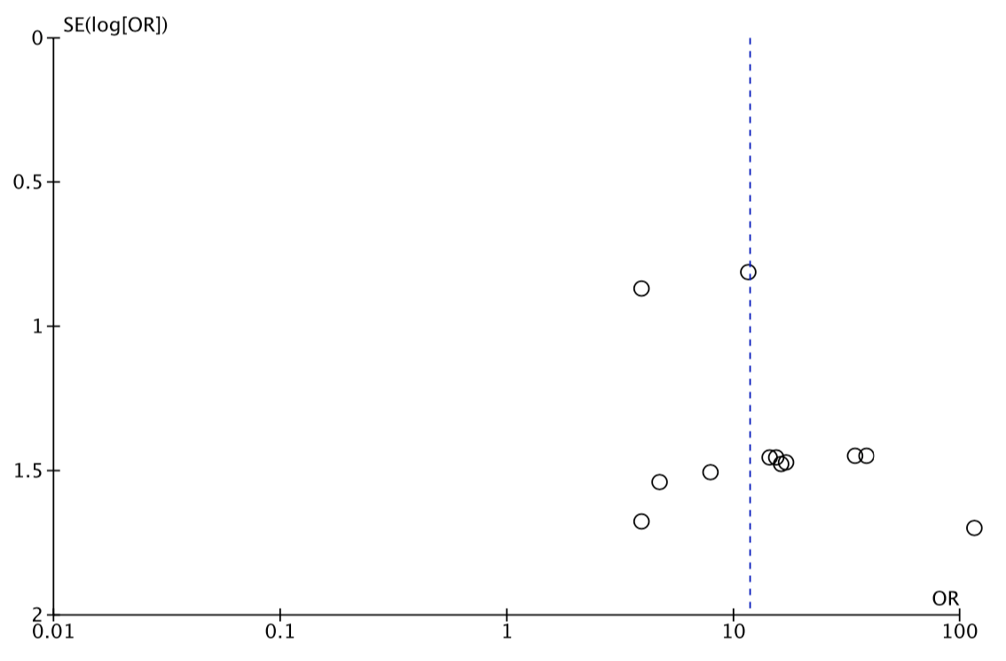

B
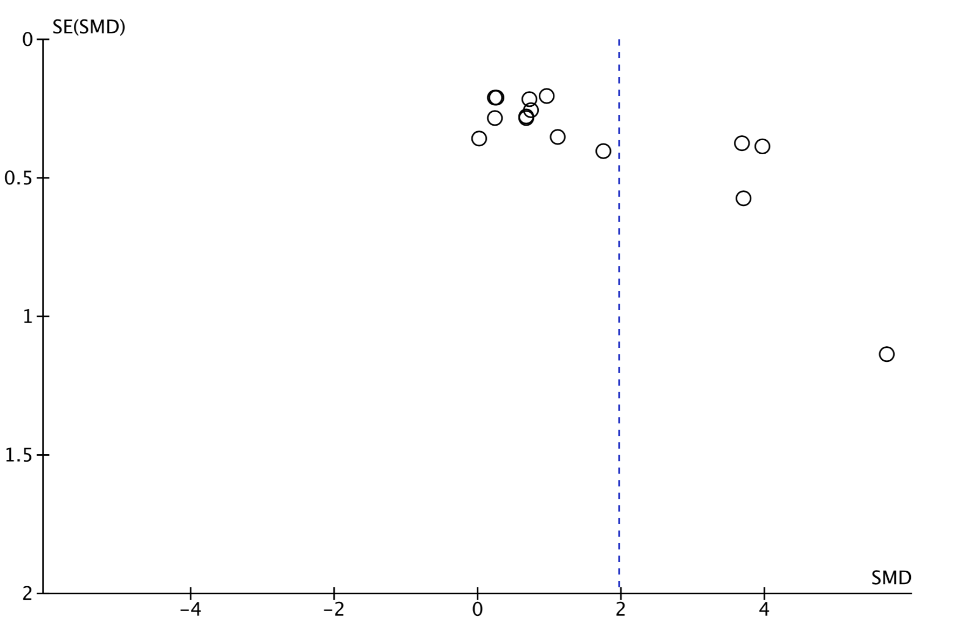

Appendix J. Funnel plot to assess publication bias in (A) hyperprolactinemia and systemic lupus erythematosus activity, and (B) the correlation between circulating prolactin levels and SLE activity in subjects with systemic lupus erythematosus assessed by the SLEDAI (Egger’s regression test: p = 0.0018).

A
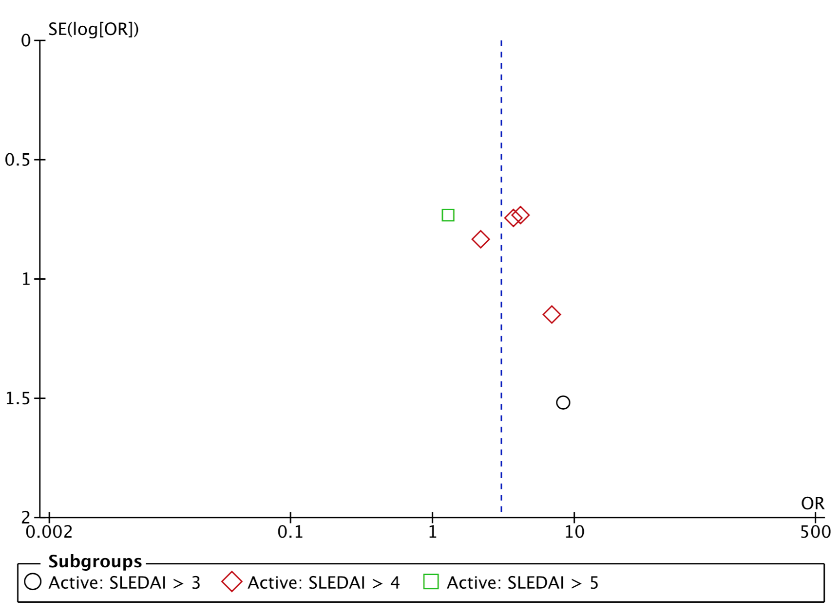
B
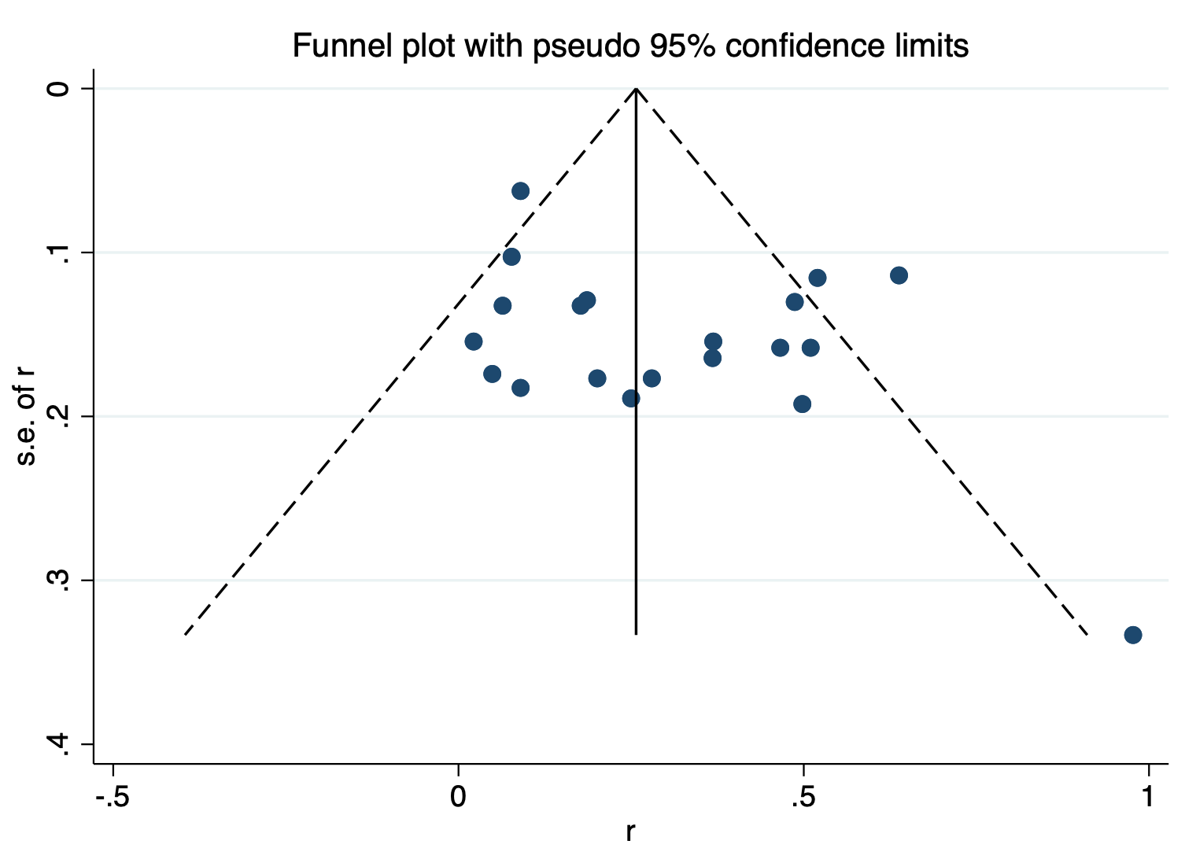

Appendix K. Correlation between circulating prolactin levels and systemic lupus erythematosus activity assessed by different score systems. (A) Forest plot and (B) funnel plot (Egger’s regression test: p = 0.0007).

A
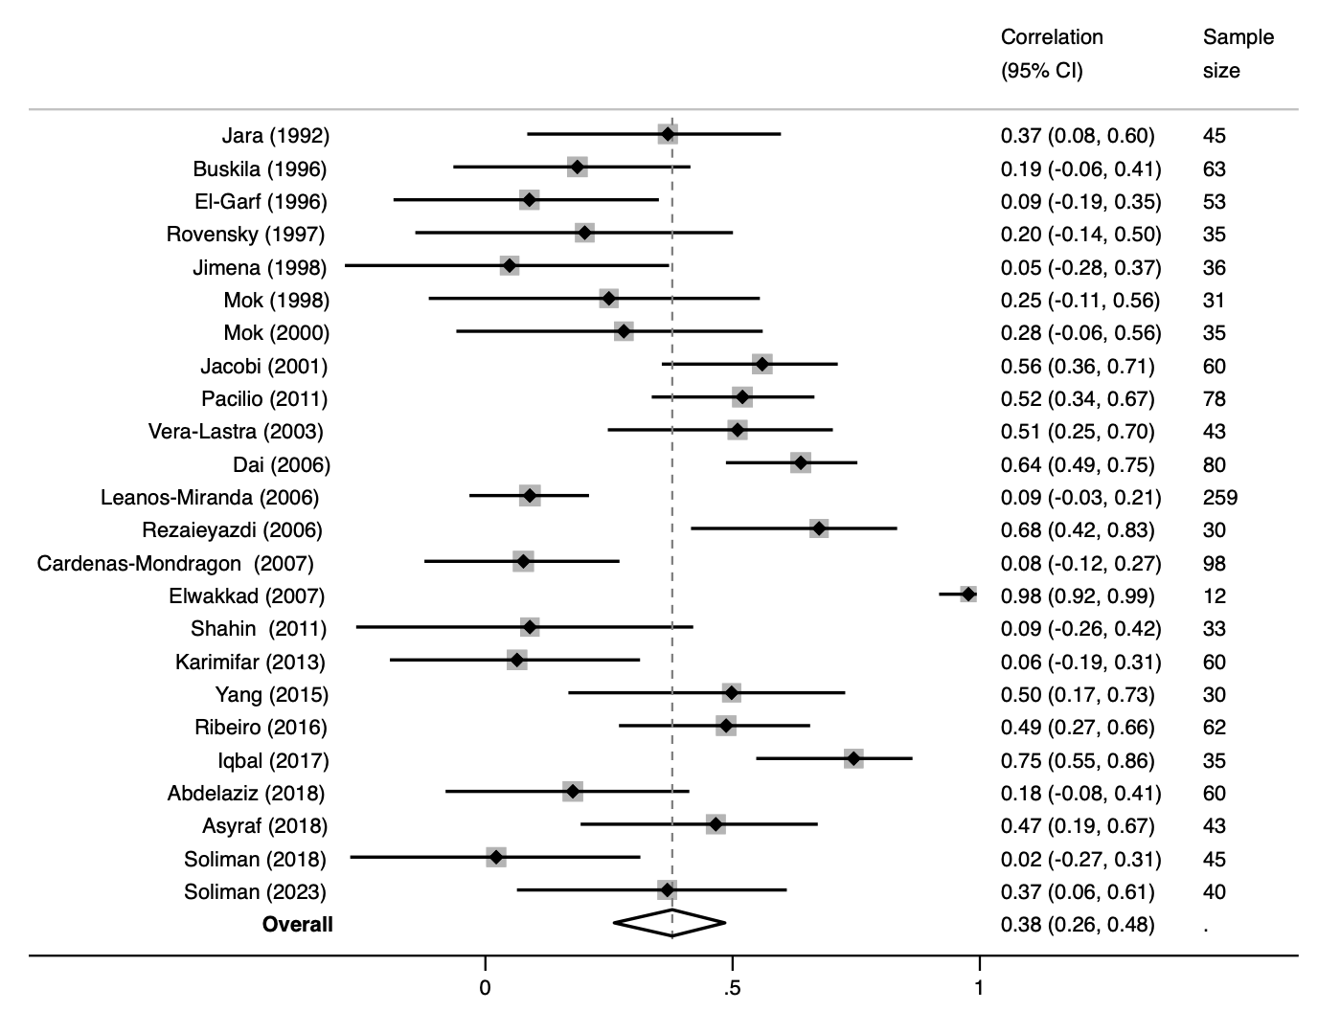

B
