Supplementary Materials

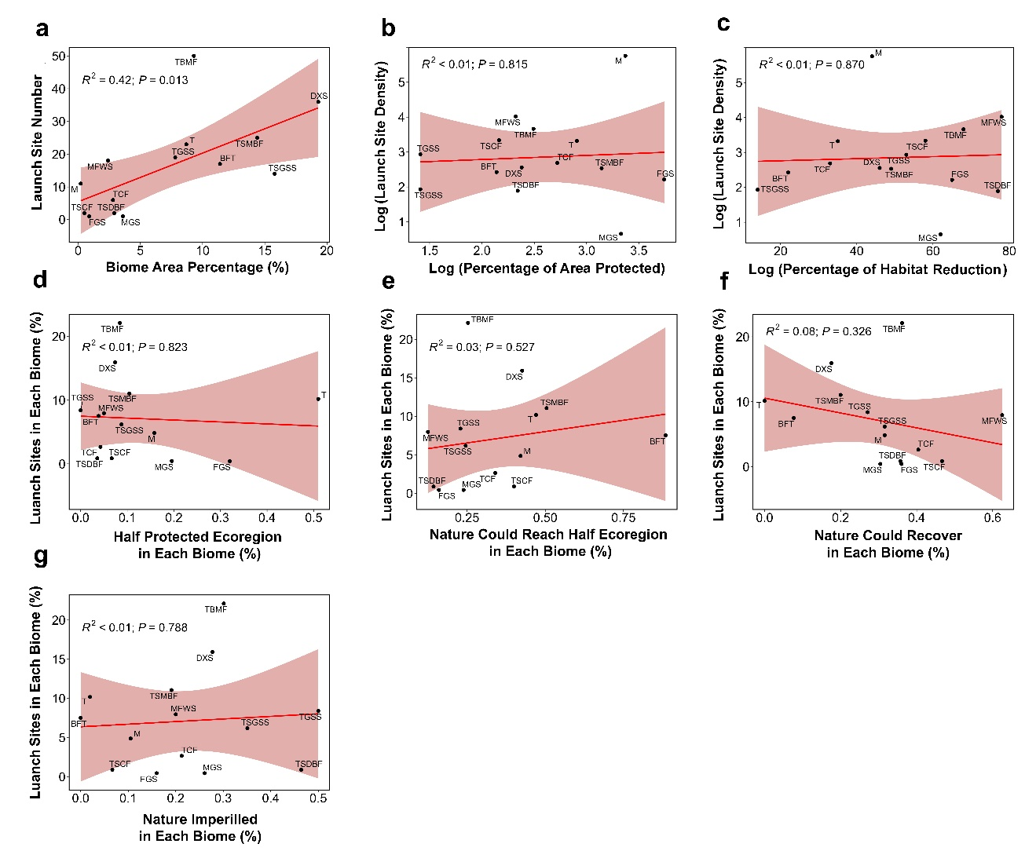
Fig. S1 Determine the associations between RLS and conservation. Regression between RLS number and biome areas (a). Regression between RLS density (RLS number/areas in each biome) and PA proportion (b) and habitat reduction proportion (c). Regression between RLS number and the proportion of half protected ecoregion (d), nature could reach half ecoregion (d), nature could recover (e) and nature imperilled (g). The solid red lines indicate the fitted relationships and the pink background indicates the 95% confidence interval. Data for the figure is based on all RLS including pre-operating, operating and closed sites.

Fig. S2 Overlap between RLS location and ecological/conservation properties. (a) compurgation of RLS among biomes; Pie charts representing the percentage of RLS according to (b) their location in inland or coastal & marine areas and (c) their location within different protection statues. Detail information for each site see Supplementary Table 1. Data for the figure is based on all RLS including pre-operating, operating and closed sites.

Fig. S3 The location of RLS distribution within different protection statues areas. Data for the figure is based on all RLS including pre-operating, operating and closed sites.

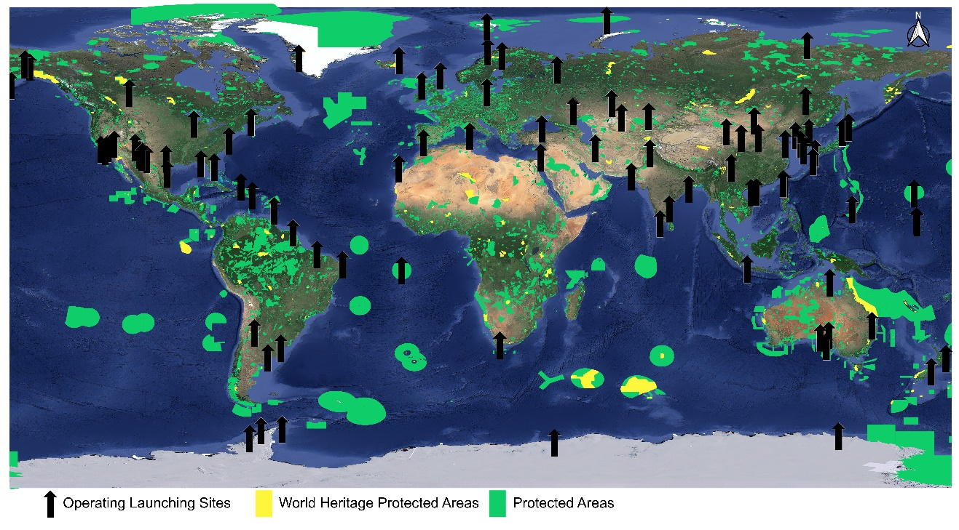
Fig. S4 The location of operating RLS distribution within/near PA and within non-protected areas. Data for the figure is based on operating RLS.

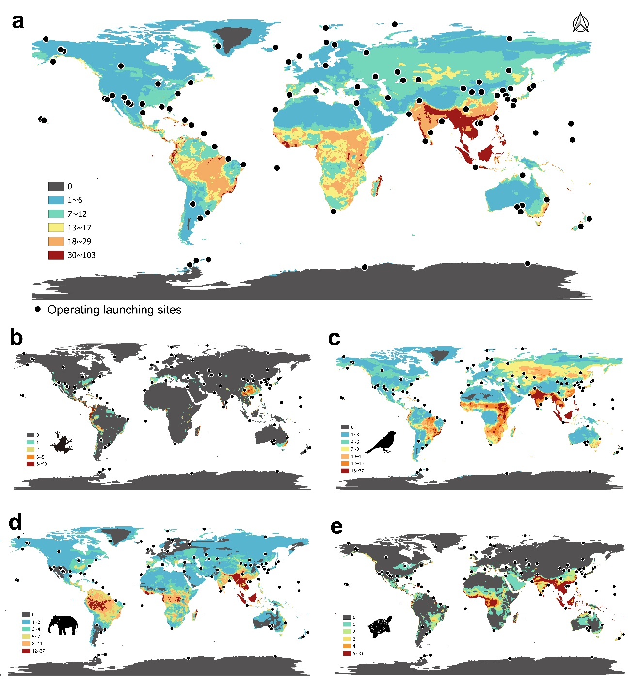
Fig.S5 The mapping of operating RLS in global threaten species distribution map. Total terrestrial vertebrates (a) and four distinct taxonomic groups: amphibians(b), reptiles (c), birds (d), and mammals (e). Data for the figure is based on operating RLS.

