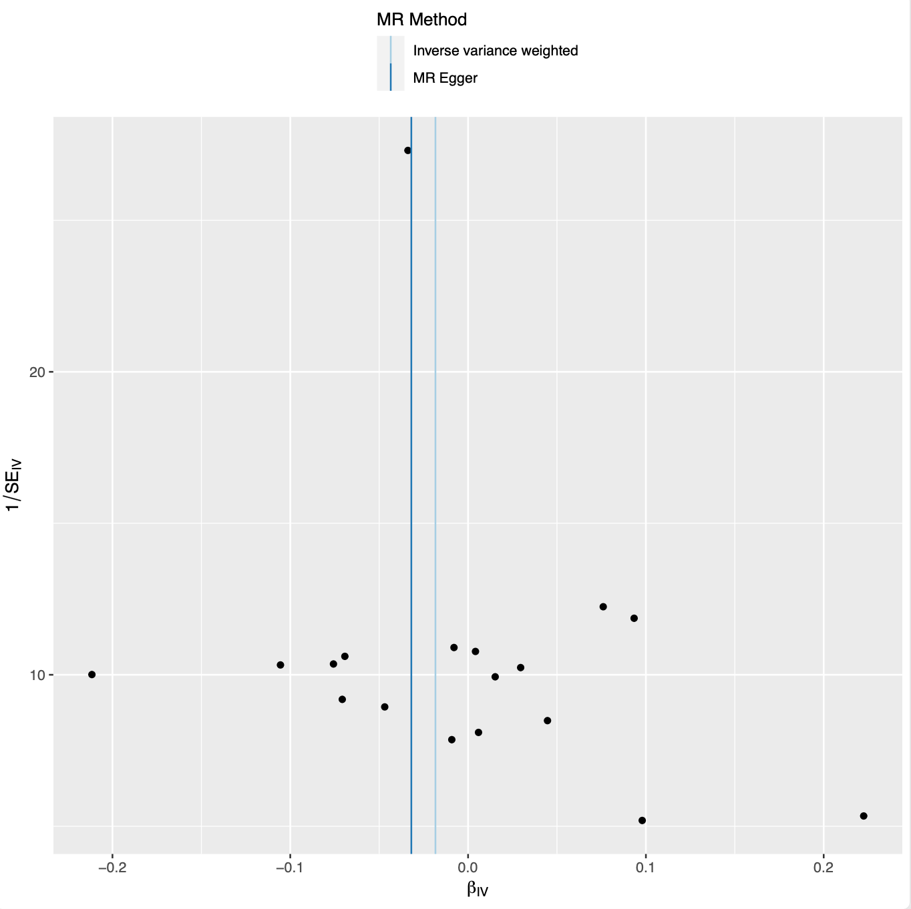
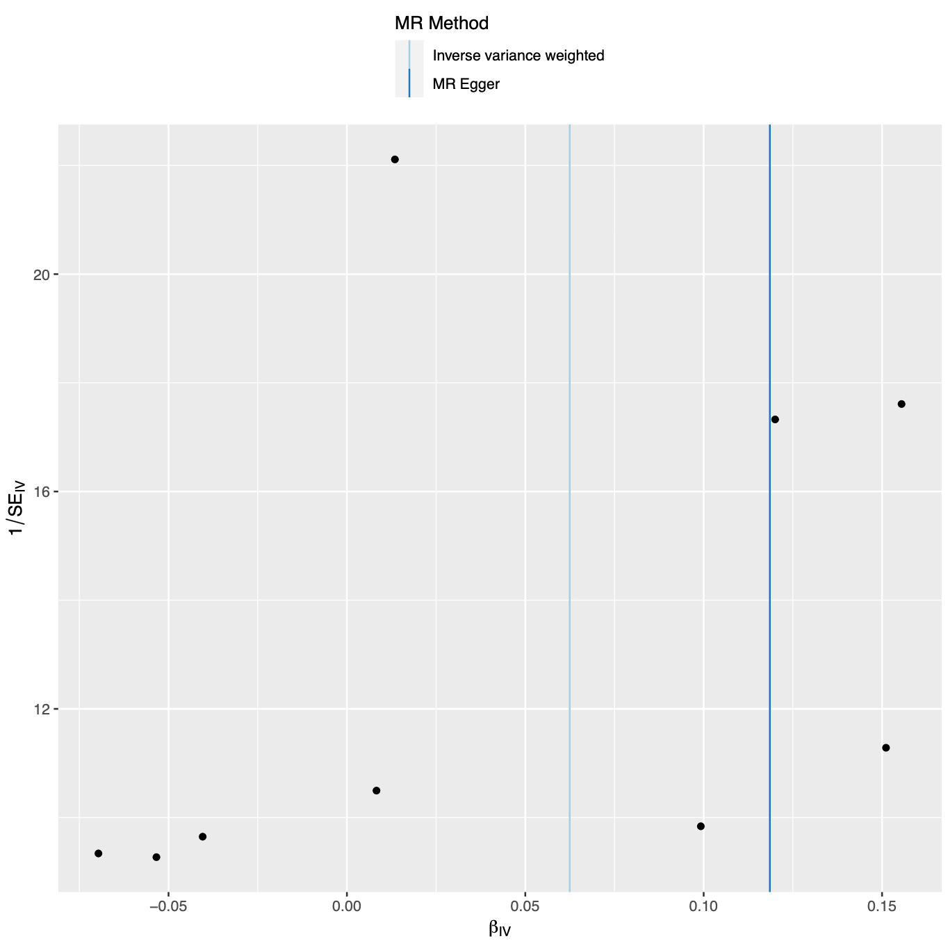
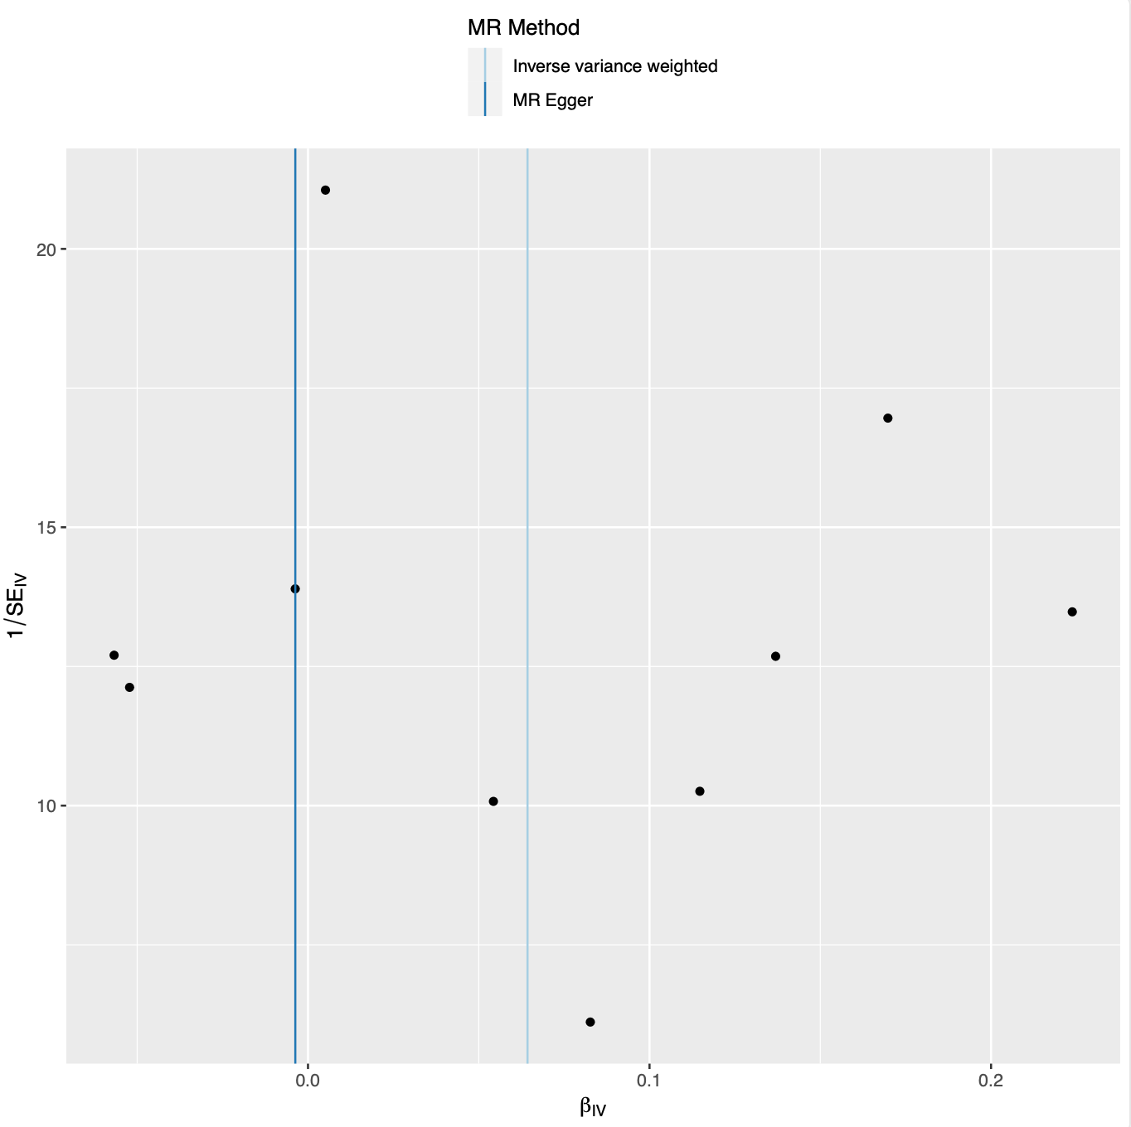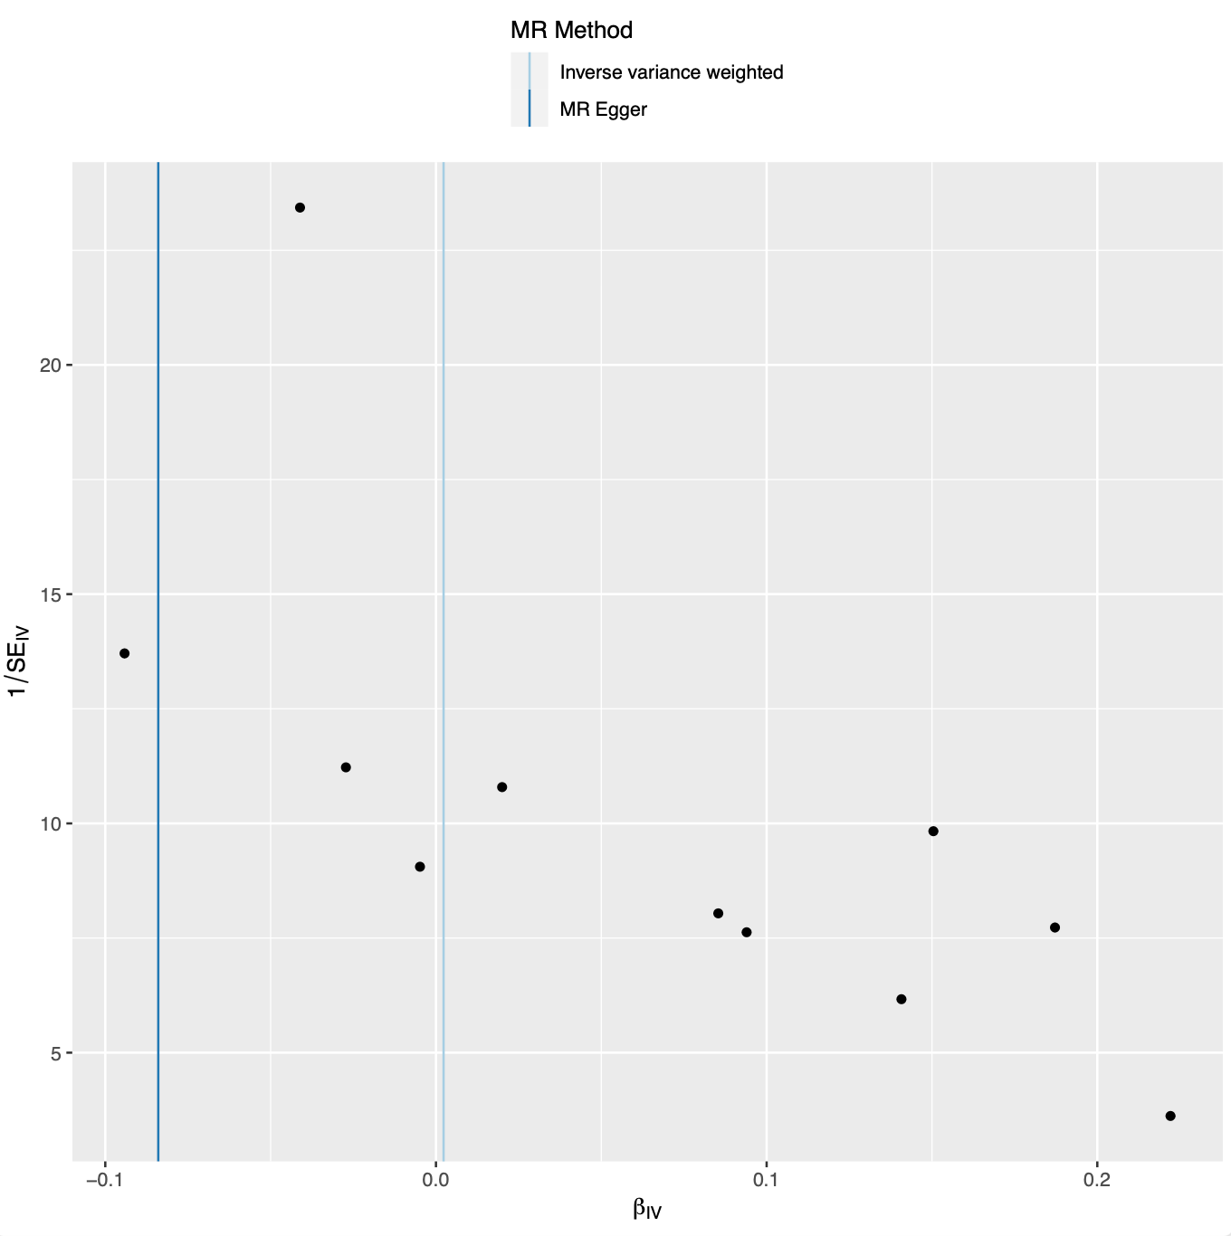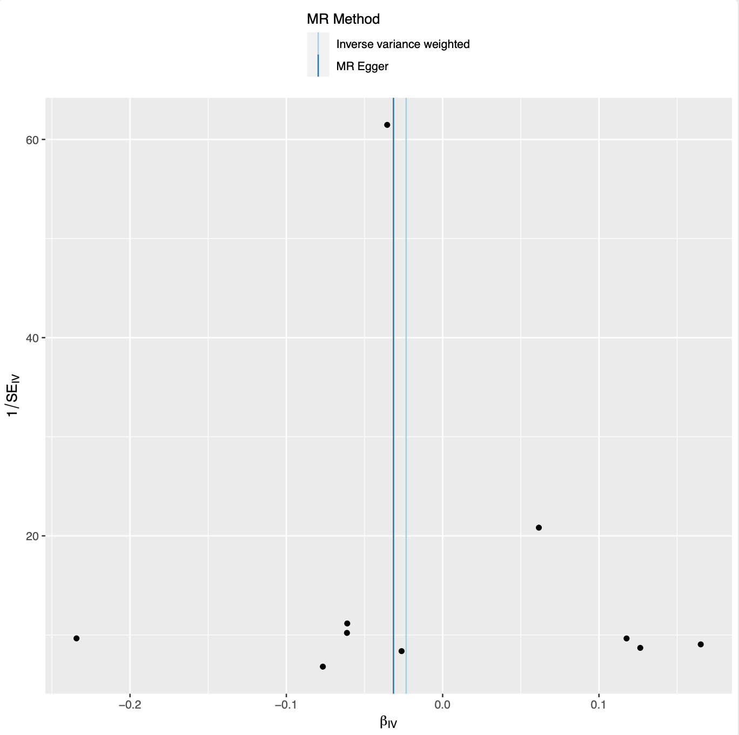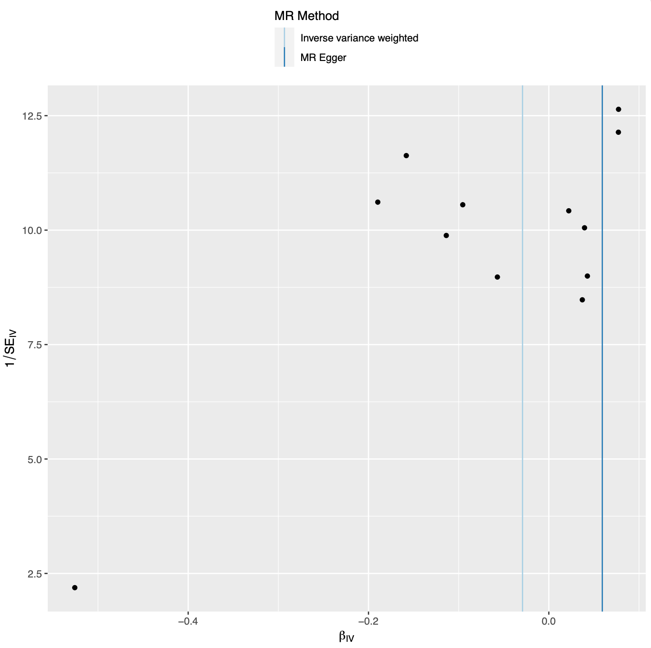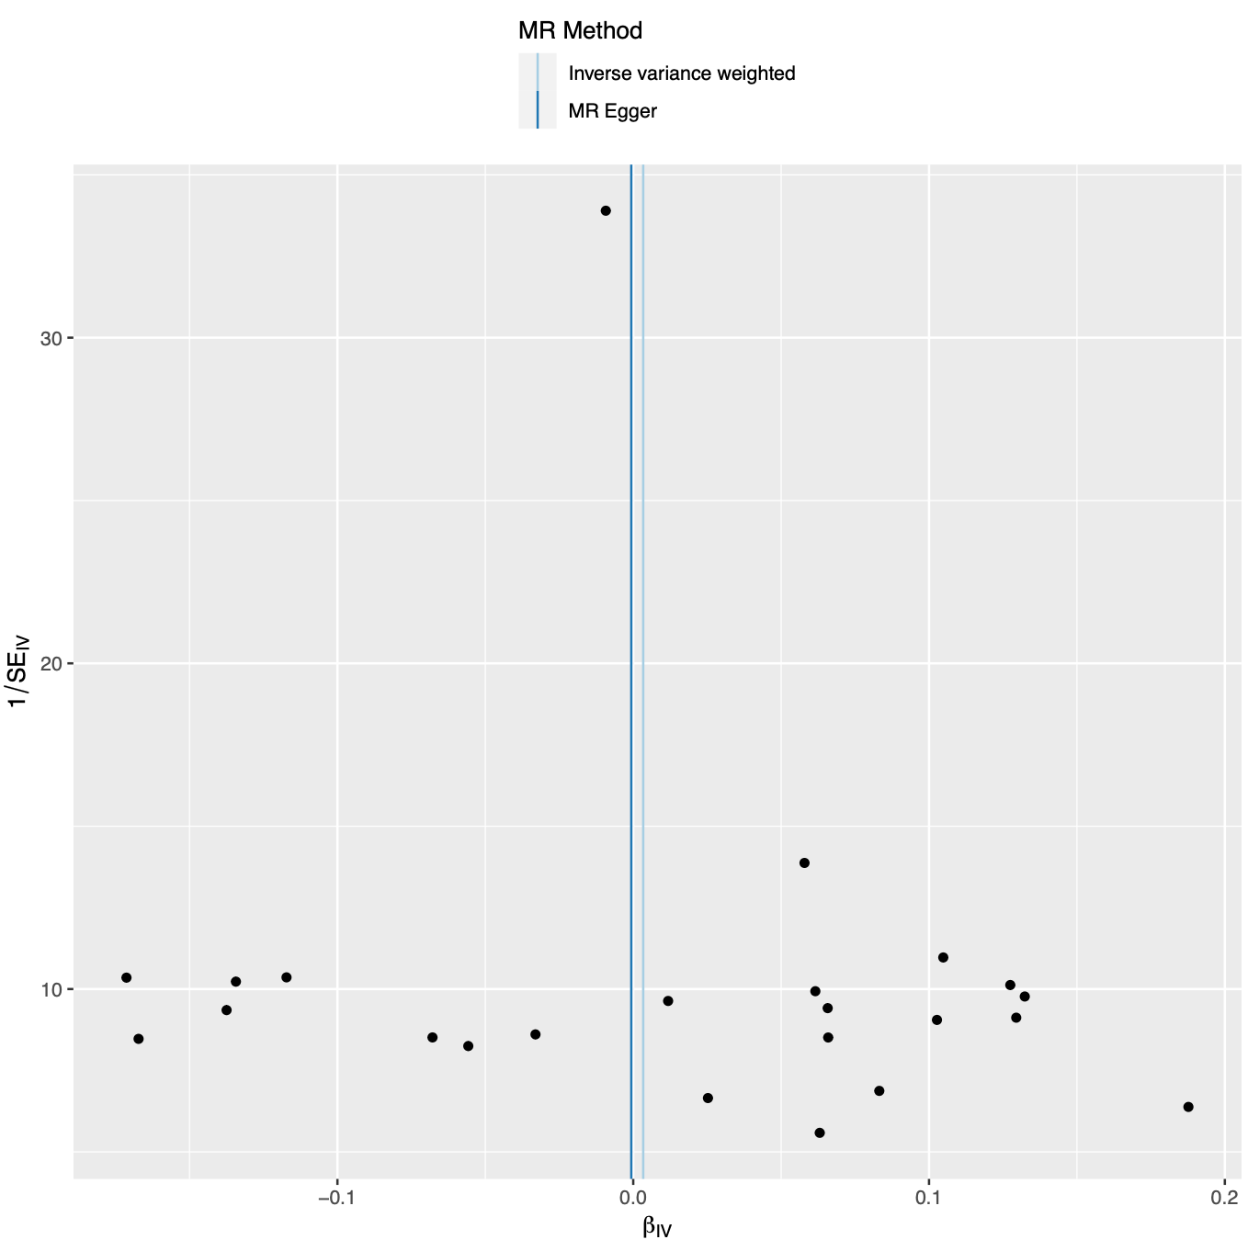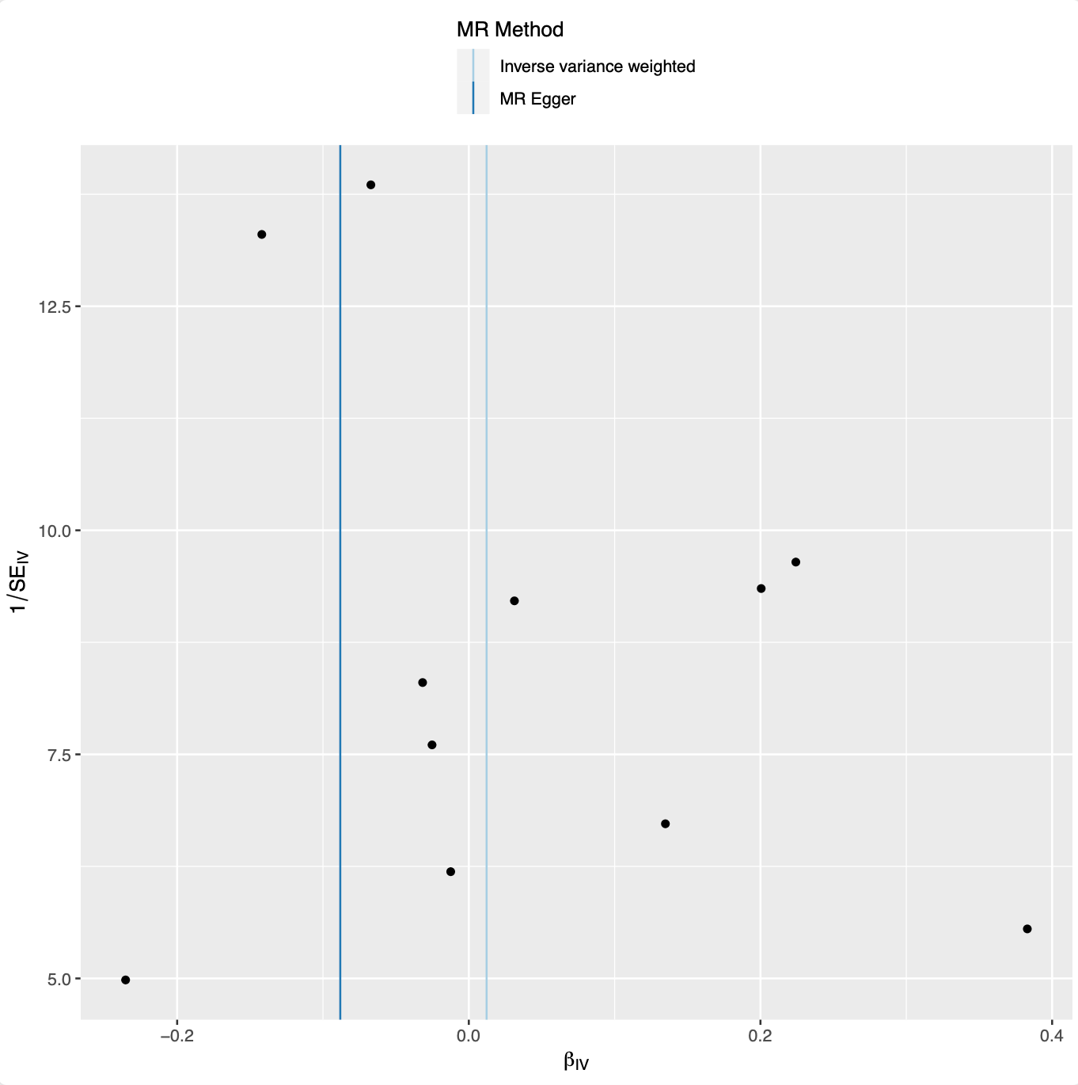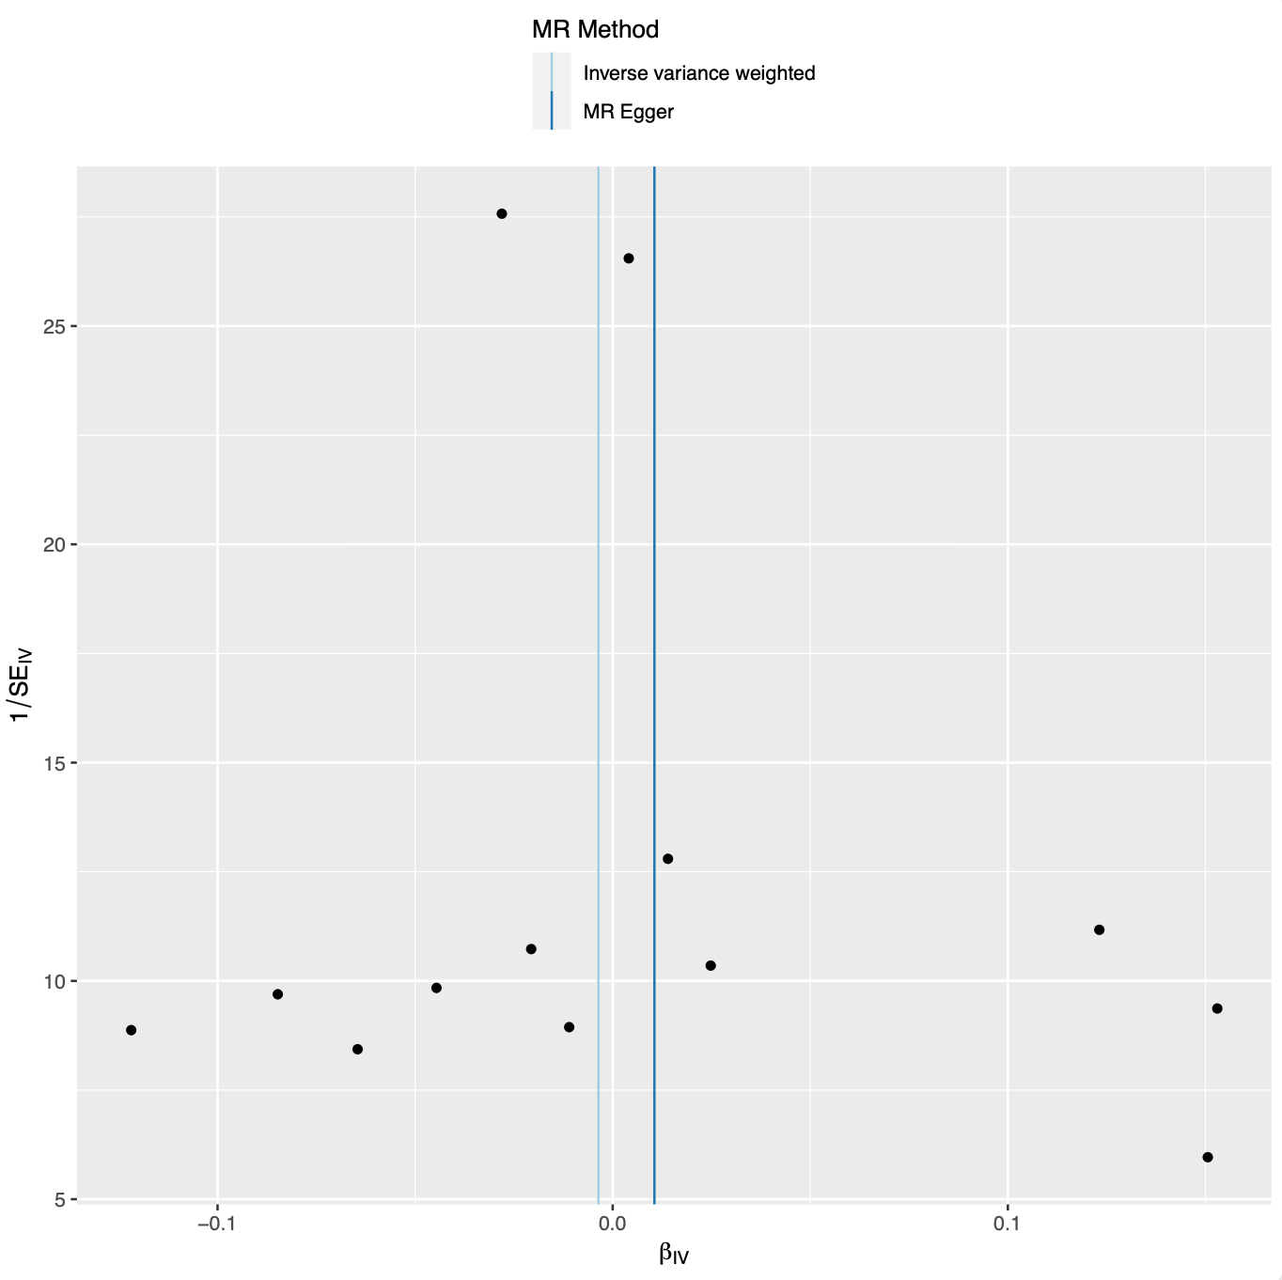
id | trait
prot-a-727 | Cathepsin S
prot-a-722 | Cathepsin F
prot-a-723 | Cathepsin G
prot-a-725 | Cathepsin H
prot-a-718 | Cathepsin B
prot-a-726 | Cathepsin O
prot-a-720 | Cathepsin E
prot-a-729 | Cathepsin X
prot-a-728 | Cathepsin V

