Supplementary Material

Cyclic di-AMP alleviates periodontitis by activating PI3K/Akt/NrF2 pathways
Kaihua Luo^{1, 2} , Qinrui Wu^{1, 2}, Zhengyi Li¹, Yajie Wu^{1, 2}, Zhifei Su^{1, 2}, Fangjie Zhou^{1, 2}, Qinyang Li^{1, 2}, Biao Ren¹, Yuqing Li¹, Jiyao Li^{1, 2*}, Xian Peng^{1*}
¹State Key Laboratory of Oral Diseases & National Center for Stomatology & National Clinical Research Center for Oral Diseases, West China Hospital of Stomatology, Sichuan University, Chengdu 610041, Sichuan, China
²Department of Cariology and Endodontics, West China Hospital of Stomatology, Sichuan University, Chengdu 610041, Sichuan, China
* Correspondence:
Jiyao Li, jiyaoliscu@163.com; Xian Peng, pengx@scu.edu.cn;

Materials and methods:
Reagents
The c-di-AMP (purity ≥ 98%) was obtained from Sigma-Aldrich technology, Co. (Shanghai, China) and diluted in PBS for in vivo and in vitro experiments. LPS from Porphyromonas gingivalis was obtained from Sigma-Aldrich technology, Co. (Shanghai, China). MK-2206 and C176 were purchased from APExBIO (USA).
Animal Experiments
After a 2-week acclimatization period, 6-week-old male C57BL/6 mice were anesthetized using isoflurane, administered at 3-4% for induction and 1.5-2% for maintenance in oxygen via a precision vaporizer. Then, mice were ligatured around the second maxillary molars on the left side to induce experimental periodontitis, using the right side as controls. The mice were randomly divided into three groups (n = 9 per group): with the groups receiving topical applications of phosphate-buffered saline (PBS), 10 µM c-di-AMP, or 100 µM c-di-AMP (3 times a week for 3 weeks). The experiments were started with mice at 6-week of age after 1-week of adaptive feeding and terminated at the 4th week (Fig. 1A). All mice were kept in standard environment with controlled temperature, humidity and a 12 h light/dark cycle under specific-pathogen-free conditions within randomly assigned microisolator cages (3mice/cage) with food and water ad libitum. For μCT analysis, alveolar bone tissue was collected (Miyajima et al. 2014; Morelli et al. 2018; Rekhi et al. 2021). 2-week alveolar bone with gingival tissue were collected from all mice for H&E staining (Leite et al. 2017; Marchesan et al. 2018). Experiments were conducted under conditions authorized by the Institutional Ethical Committee on Experimental Animals (WCHSIRB-D-2020-031) and followed the Animal Research: Reporting of In Vivo Experiments 2.0 (ARRIVE 2.0) guidelines.
Tissue Collection and Preparation
Following the successful establishment of the models, the mice were euthanized and sampled. Alveolar bones and gingival tissue were harvested from the mice, postfixed with 4% paraformaldehyde overnight, and stored in 70% ethanol at 4 °C for long-term storage. Silk samples were collected before euthanasia in sterile Eppendorf tubes and kept at -80℃ for future analysis.
Micro-Computed Tomography Analysis
The microarchitectural properties of alveolar bone tissues were imported with µ-CT system. Parameter settings were as follows: the scanning was performed at 70 kV and 200 μA with 300ms integration time at a voxel resolution of 10μm. The images were reconstructed using mimics (version 21.0, Materialise N.V., Leuven, Belgium). The results of BV/TV, BMD, and CEJ-ABC were obtained within the region of interest, which surrounds the second molar. CEJ-ABC was determined by measuring the average distance between the alveolar bone crest (ABC) and the cementoenamel junction (CEJ) in the sagittal images. And δCEJ-ABC refers to the difference between CEJ-ABC on the left side and CEJ-ABC on the right side. Trabecular bone volume fraction (Bone volume/Total volume, BV/TV) was used to analyze the degree of trabecular bone resorption.
Hematoxylin and Eosin Staining
To assess the severity of the periodontitis condition and the height of the alveolar crest, Hematoxylin and Eosin Staining was processed.
16S rRNA Sequencing and Analysis
The microbiomes of silk ligatures underwent 16S ribosomal RNA (rRNA) analysis. Total genomic DNA was extracted using DNA Extraction Kit following the manufacturer’s instructions. Concentration of DNA was verified with NanoDrop and agarose gel. The genome DNA was used as template for PCR amplification with the barcoded primers and Tks Gflex DNA Polymerase (Takara). For bacterial diversity analysis, V3-V4 variable regions of 16S rRNA genes was amplified with universal primers 343 F and 798 R performed by oebiotech Technology Co., Ltd, Shanghai, China.
Transcriptome sequencing and Analysis
RNA extraction was performed to isolate RNA from the gingival tissues and human gingival epithelial cells. And transcriptome sequencing (RNA-seq) was conducted to analyze the gene expression profile.
Cell Cultures
HGECs were cultured and seeded at a density of 1 × 10⁵/mL in a growth medium (DMEM) in 6-well plates overnight. Different doses of c-di-AMP (0, 10, 100 µM) with or without LPS (1μg/L) were added to the HGECs, and the samples were incubated for 24h.
RT-PCR Analysis
Total RNA extracted from human gingival epithelial cells was used for subsequent Fast TB Green (RR820A, Takara Bio, Japan) quantitative polymerase chain reactions (PCRs), and relative quantitative analysis was performed with the 2−ΔΔCT method. The gene expression of EPHA2, Akt, NFE2L2, IL-6, TNF-α, was quantified with the GAPDH as an internal control. The primer sequences used are shown in Appendix table 1.
Statistical Analysis
Western blot analysis was repeated three times using individually cultured cells. Other in vitro experiments were performed once in triplicate. For in vivo experiments, the total number of mice used is indicated in the figure legends. Data are expressed as means ± standard deviations (SDs), and statistical analysis was performed using one-way ANOVA and Tukey’s honestly using GraphPad Prism 9 (GraphPad Software Inc, San Diego, CA, USA). p-values were expressed as follows: *p < 0.05, ** p < 0.01, and *** p < 0.001.

Supplementary Figures and Tables
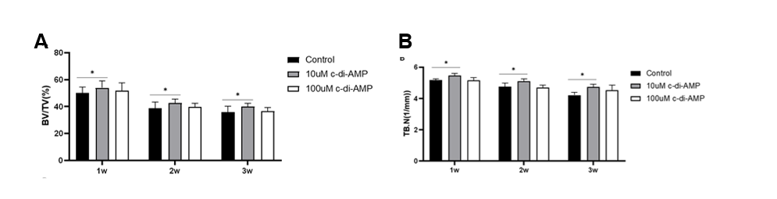
Appendix Figure 1. C-di-AMP inhibits bone destruction in periodontitis induced by ligature placement in mice. (A) bone volume fraction (bone volume/total volume). (B) bone trabecular number (Tb. N). *P < 0.05. One-way analysis of variance.

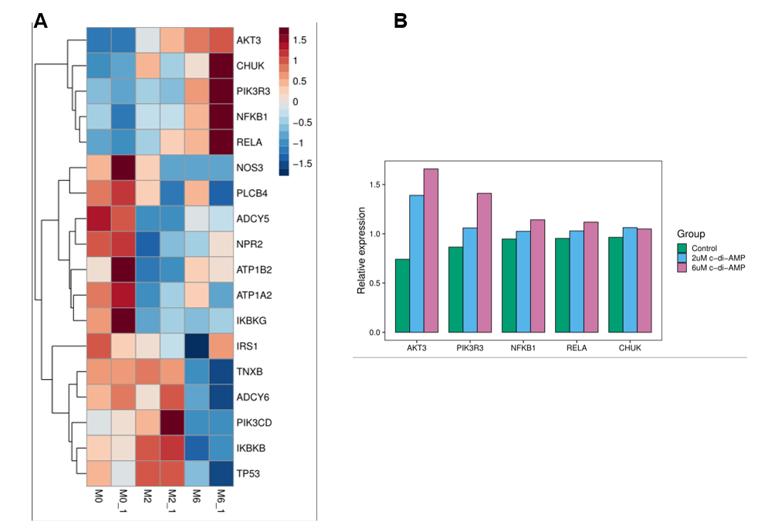
Appendix Figure 2. C-di-AMP promotes the expression of the PI3K/Akt signaling pathway in human gingival epithelial cells. (A) Heatmap of differential gene expression. (B) The expression of top 5 enriched up-regulated genes. One-way analysis of variance.
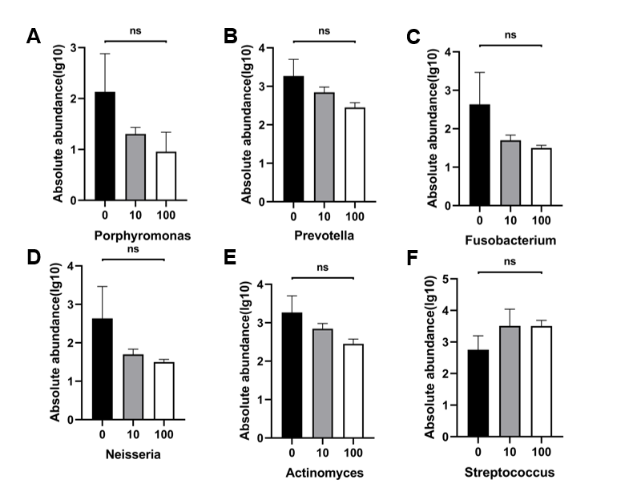
Appendix Figure 3. C-di-AMP exhibits no significant influence on oral microbiota in periodontitis. The absolute abundance of (A) Porphyromonas, (B) Prevotella_9, (C) Fusobacterium, (D) Neisseria, (E) Actinomyces, (F) Streptococcus. One-way analysis of variance.

Appendix table 1. Primers of RT-qPCR
Primers | Forward (5’ to 3’) | Reverse (3’ to 5’)
GAPDH | AATCCCATCACCATCTTCCAG | AAATGAGCCCCAGCCTTC
IL-6 | ACTCACCTCTTCAGAACGAATTG | CCATCTTTGGAAGGTTCAGGTTG
TNF-α | CCTCTCTCTAATCAGCCCTCTG | GAGGACCTGGGAGTAGATGAG
EPHA2 | TGGCTCACACACCCGTATG | GTCGCCAGACATCACGTTG
AKT | AGCGACGTGGCTATTGTGAAG | GCCATCATTCTTGAGGAGGAAGT
NFE2L2 | TCAGCGACGGAAAGAGTATGA | CCACTGGTTTCTGACTGGATGT
16s rRNA | TACGGRAGGCAGCAG | AGGGTATCTAATCCT

Leite FRM, Peres KG, Do LG, Demarco FF, Peres MAA. 2017. Prediction of periodontitis occurrence: Influence of classification and sociodemographic and general health information. Journal of periodontology. 88(8):731-743.
Marchesan J, Girnary MS, Jing L, Miao MZ, Zhang S, Sun L, Morelli T, Schoenfisch MH, Inohara N, Offenbacher S et al. 2018. An experimental murine model to study periodontitis. Nature protocols. 13(10):2247-2267.
Miyajima S, Naruse K, Kobayashi Y, Nakamura N, Nishikawa T, Adachi K, Suzuki Y, Kikuchi T, Mitani A, Mizutani M et al. 2014. Periodontitis-activated monocytes/macrophages cause aortic inflammation. Sci Rep. 4:5171.
Morelli T, Moss KL, Preisser JS, Beck JD, Divaris K, Wu D, Offenbacher S. 2018. Periodontal profile classes predict periodontal disease progression and tooth loss. Journal of periodontology. 89(2):148-156.
Rekhi UR, Catunda RQ, Alexiou M, Sharma M, Fong A, Febbraio M. 2021. Impact of a cd36 inhibitor on porphyromonas gingivalis mediated atherosclerosis. Arch Oral Biol. 126:105129.

