Supplementary Information

Journal of Histochemistry and Cell Biology
Subcellular Localization of the P2X₄ Receptor in Cochlear Sensory Hair Cells
Ziyin Huang^{1,2,3}, Jacqueline M Ross^{4,5}, Shelly CY Lin¹, Kevin Roy¹, Srdjan M Vlajkovic^{1.3}, Peter R. Thorne^{1,2,3} and Haruna Suzuki-Kerr^{1,3}

Affiliations:
1. Department of Physiology, The University of Auckland, New Zealand
2. Department of Audiology, The University of Auckland, New Zealand
3. Eisdell Moore Centre, The University of Auckland, New Zealand
4. Department of Anatomy and Medical Imaging, The University of Auckland, New Zealand
5. Biomedical Research Imaging Unit, The University of Auckland, New Zealand

Corresponding Author:
Haruna Suzuki-Kerr
h.suzuki-kerr@auckland.ac.nz

Suplementary Figure 1
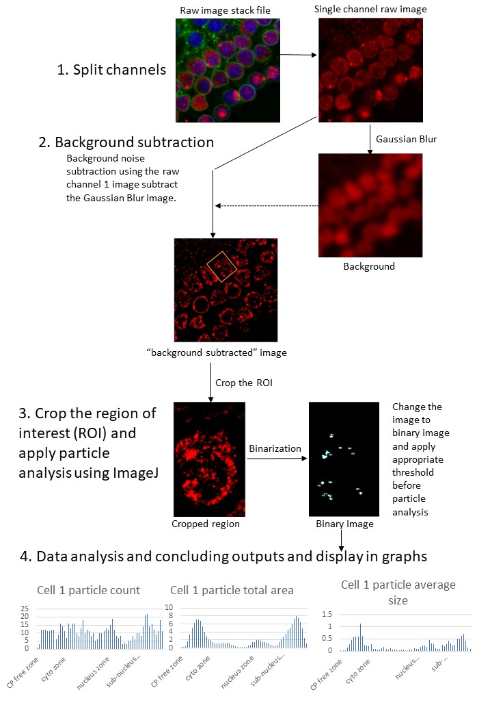

Suplementary Figure 1. Flow chart showing steps of particle analysis by image J. (1) For particle analysis, the original z-stack images were imported into ImageJ software individual channels separately. To separate vesicular/punctate labelling by thresholding, background subtraction was necessary; images from the channel of interest were duplicated and processed using the Gaussian Blur (radius = 40 pixels). (2) These blurred images can be used as “background” for background subtraction using the “image calculator” function of ImageJ. (3) Images were then cropped so that only one cell was analysed at a time. Three OHCs and IHCs were analysed per cochlea, and one OHC was selected from each row. Then the image stack was processed by thresholding into individual binary images. All pixels with grey-scale value over the threshold value are converted to white and rest are converted to black, resulting in images consisting of only pixel value 0 (off) or 1 (on). (4) Particle analysis in ImageJ was used to automatically detect particles to measure the parameters “count” and “total area. “Count” represents the total number of particles in each image and “total area” represents the total area of the particles in each image. The particles’ parameters were set to include any size particle with no limit on their circularity.

Supplementary Figure 2.
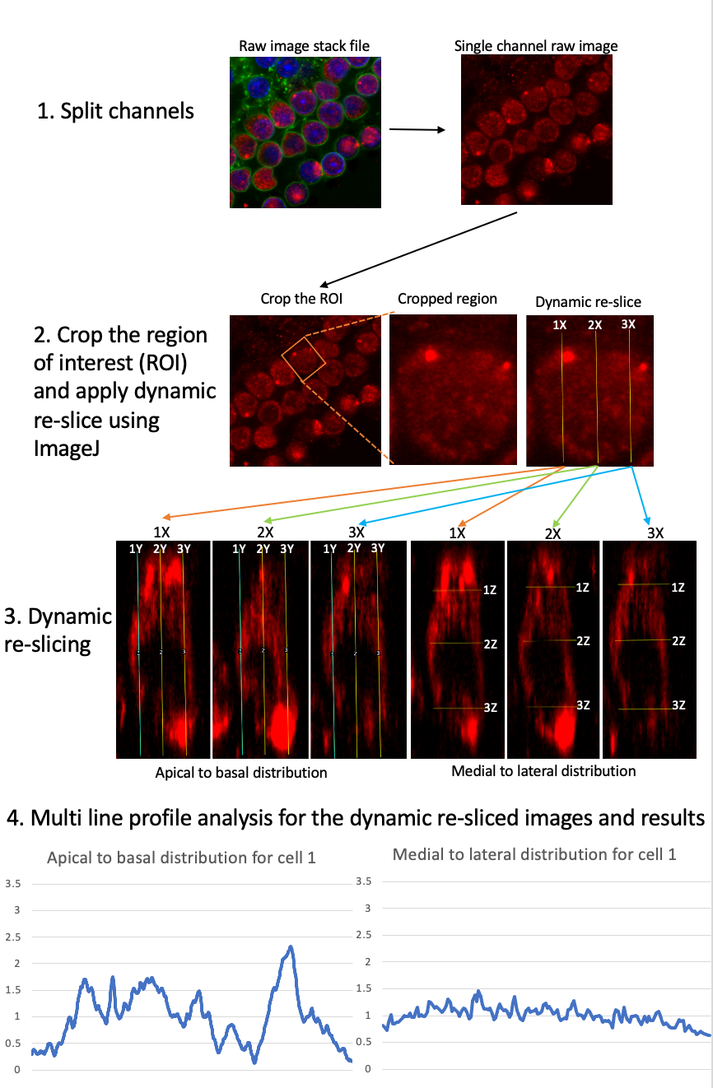
Supplementary Figure 2. Flow chart showing steps of line plot profile analysis with ImageJ
(1) ImageJ “Line plot profile” analysis was performed to quantify the intensity of immunofluorescent signals. Raw Z-stack images were imported into ImageJ and channels split. (2) The region of interest (ROI) was selected around one cell to analyse one cell at a time. (3) To quantify relative signal intensity from apical to basal direction, 9 different line profiles across the cell and medial to lateral intensity signals along with another 9 different line profiles across the same cell. To achieve this, first, the dynamic re-slice method was used for the image stack, to reconstruct a lateral view of the selected cell at 3 different positions (1X, 2X, 3X) shown in “dynamic re-slice” in step 2. The 2X measurement positions were designed to go through the middle of the nucleus. The 1X and 3X measurement position are determined by the 2X measurement position where both left and right are 3 μm from the middle measurement position. After reconstructing the lateral view of the selected cell, 3 line profiles for apical to basal analysis were generated (1Y, 2Y, 3Y) which follows the same method where the 2Y passes through the middle of the nucleus, where 1Y and 3Y are 3 3 μm from 2Y laterally (step 3). The medial and lateral line profiles were similar and 3-line plot profile positions (1Z, 2Z, 3Z) were generated. 2Z was made sure to go through the nucleus but also being the half point of the lateral viewed cell, where 1Z and 3Z were 10 microns from 2Z. Taken together, these steps define nine distinct lines across the apical-basal and the medial-lateral axis of the cell (3). (4) At each of these 9 lines, the “line profile plot” function of ImageJ was used to measure intensity from apical to basal as well as medial to lateral. For each point, the “line profile plot” function quantifies the greyscale pixel value to produce about 900 data points along apical to basal and about 400 data points along the medial to lateral axis.

Supplementary Figure 3. Co-localization analysis
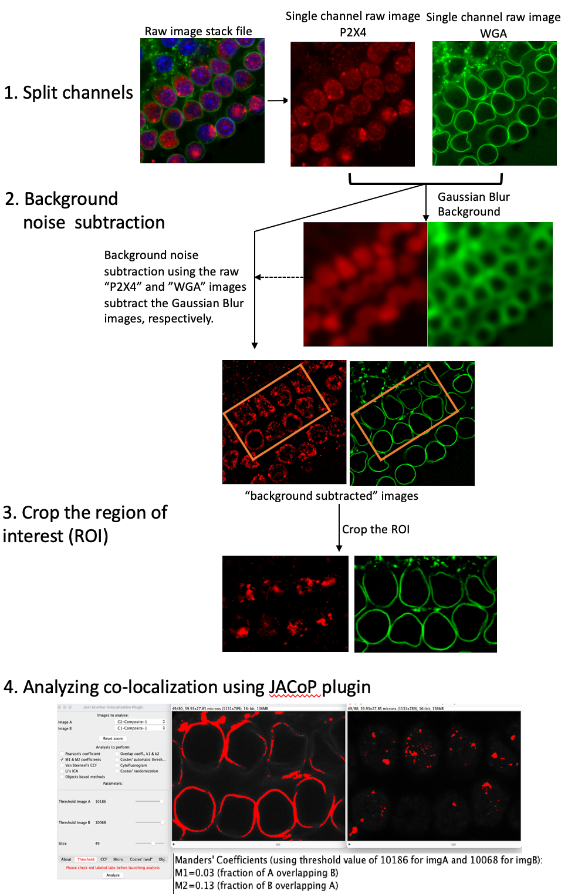

Supplementary Figure 3. Co-localization analysis
The JACoP plugin for ImageJ software was used for analysing the co-localization of P2X₄ and subcellular markers. (1) Raw Z-stack images of IHCs and OHCs were taken by sequential scan, and as multiple channels stack. (2) Similarly to particle analysis, background subtraction was necessary to separate vesicular/punctate labelling by thresholding. As a part of the background subtraction step, images from the channel of interest were duplicated and processed using the Gaussian Blur (radius = 40 pixels) to remove noise and background signals. 40 pixels radius was selected as it blurs the image so hardly any particles could be visualized. These blurred images can be used as “background”. This was then subtracted from the original image by the “image calculator” function of ImageJ to produce the final “background-subtracted images”. (3) Following the background subtraction, images were cropped so that only the region of interest was selected. The regions of interested were selected to include as many as possible complete cells and exclude signals from adjacent cells and background signals. The typical region of interest contained 8 cells.
(4) JACoP automatically calculates Manders’ colocalization coefficients as the primary output. Manders’ colocalization coefficient is based on Pearson’s correlation but average intensity values were taken out from the Pearson’s equation(Dunn, Kamocka, & McDonald, 2011). The results were displayed as M1 and M2. M1 is defined as the ratio of the “summed intensities of pixels from the green image for which the intensity in the red channel is above zero” to the “total intensity in the green channel”. M2 is identified as the same as the red and green reversed. High M1 and M2 coefficients indicate that a large proportion of one signal co-occurs with the other signal. Manders’ colocalization coefficient analysis has an advantage over other methods in that this method can be used reliably even when signals from two channels have different levels of intensity/distribution, and also when the immunolabeling is sparse and the image contains a lot of black/empty space within the field of view (Bolte & Cordelières, 2006). Manders’ colocalization coefficients require thresholding for both channels which has been incorporated as part of the JACoP plugin programme. The appropriate thresholding was selected to maintain consistency for each image stack, as described in supplementary figure 1. The results of the Manders’ colocalization coefficient, M1 and M2, is given as a value between 0-1.0. Colocalization analyses were conducted for each subcellular marker separately with 3 cochleae for each marker, and the mean and standard error of the mean (SEM) were calculated.
Supplementary Figure 4.
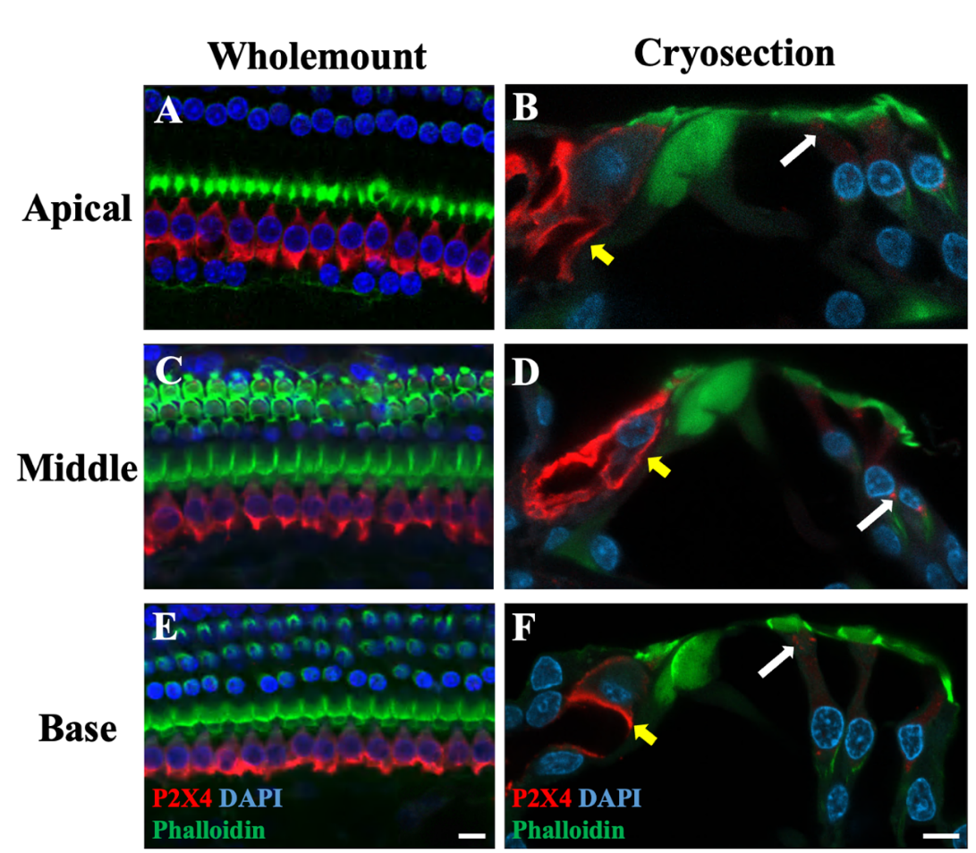

OoC Wholemounts (A, C, E) and 20μm thick cryosections (B,D, F) were prepared from adult rat cochlea within the apical (A & B), middle (C&D) and base (E& F) and labelled with anti-P2X₄ antibody (red), phalloidin (green) and DAPI (blue). n=3 cochleae were examined. Scale bars = 10 μm. Expression of P2X₄ in IHC and OHC were observed irrespective of different location within the cochlea.

Supplementary Figure 5. Quantification of P2X4 expression by line profile.
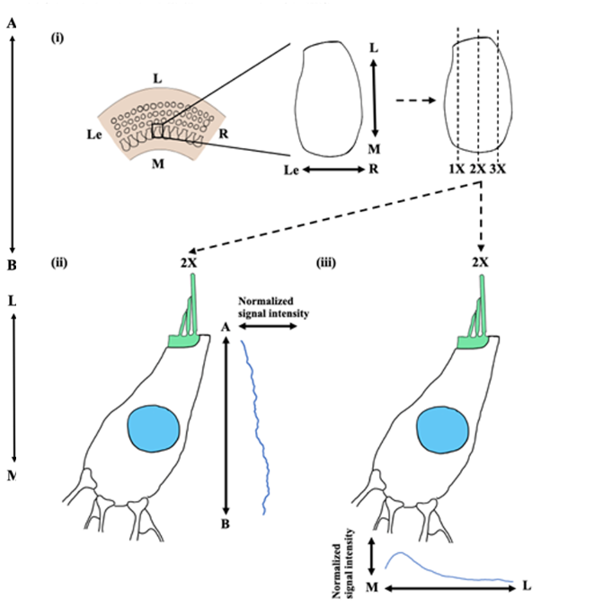P2X₄ expression within IHCs quantified as relative intensity. Nine IHCs were selected from 3 adult Wistar rat cochlea with 3 IHCs from each cochlea. (i) A schematic example showing lateral-medial and right-left axes. Three cross-sectional locations were selected for the line plot profile analysis to measure grey-scale signal intensity. (ii) Analysis of apical to basal signal distribution from the P2X₄ immunolabeling. (iv) Analysis of medial to lateral signal distribution from the P2X₄ immunolabeling. Axis in the figure are: [A] apical [B] basal [L] lateral (towards lateral wall side) [M] medial (towards modiolus side) [Le] left [R] right.

Supplementary Figure 6. Line profiling for OHC.
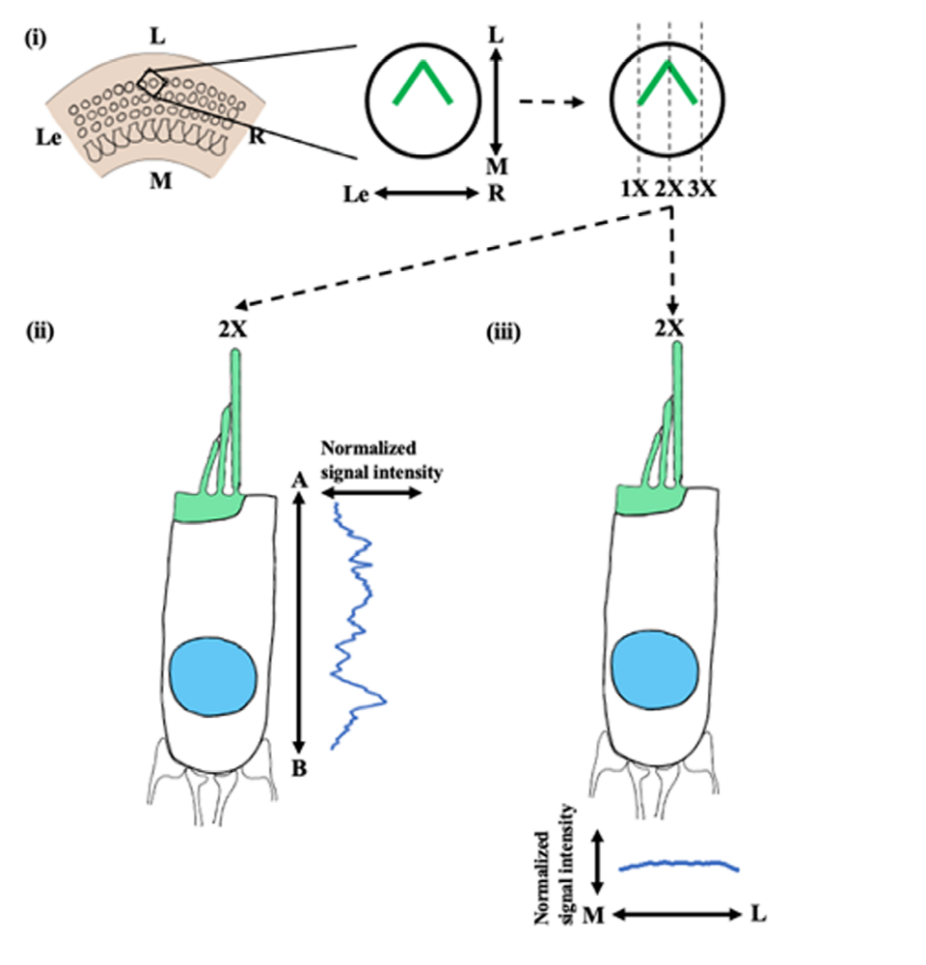P2X₄ expression within OHCs quantified as relative intensity. Nine OHCs were selected from 3 adult Wistar rat cochlea with 3 OHCs from each cochlea. (i) A schematic example showing lateral-medial and right-left axes. Three cross-sectional locations were selected for the line plot profile analysis to measure grey-scale signal intensity. (ii) Analysis of apical to basal signal distribution from the P2X₄ immunolabeling. (iv) Analysis of medial to lateral signal distribution from the P2X₄ immunolabeling. Axes in the figure are: [A] apical [B] basal [L] lateral (towards lateral wall side) [M] medial (towards modiolus side) [Le] left [R] right.

References:

Bolte, S., & Cordelières, F. P. (2006). A guided tour into subcellular colocalization analysis in light microscopy. Journal of microscopy, 224(3), 213-232.
Dunn, K. W., Kamocka, M. M., & McDonald, J. H. (2011). A practical guide to evaluating colocalization in biological microscopy. American Journal of Physiology-Cell Physiology, 300(4), C723-C742.

