Supplementary Table 1: Sequences of sgRNA, HDR block, and Sanger primers
NAME | GUIDE SEQUENCE 5’-3' | GENOME | HDR DONOR SEQUENCE 5’-3'
GREB1L | TCTGGAAATTGTATCGGCTG | hg38 | TGGTTTTCCTGACTTCAGGGTTTTCTGGA  AATTGTATCGGCCGTGGAGAAAGAGGAT  TTCGATATTTCACGGAATTTTCCAA
FGF3 | CGGGTCTTGAAGCCCCTGCG | hg38 | AACAGGGAGGACTTCTGTGTGCGGCGGG  TCTTGAAGCCCCCGCGGGGCCGGCCCTT  GCCGTTCACAGACACGTACCACAGT
PBXIP1 | GGGCCTCAACAGCTCTGCCC | hg38 | CAGCCCTGGGGTGCCCGGTACTTGGGCC  TCAACAGCTCTGCTCAGGATGGCAGGGG  GTCATGGCTGTCCTTAGTCCCTTCCC
GREB1L | AGTGGTAGAGAGGGCAGAGA |  | CCCCTTCCCAAGAGACGAAT
FGF3 | AGTCAGAGTCAAGAGGCTGC |  | TTTGGCACTGGACCGAACA
PBXIP1 | CATGACGGAAGATGCCATCC |  | CCCACCTCTTCTTCAGTGCT

Supplementary Table 2: Off-target sequencing analysis

Target Sequence 5’-3' | PAM site | Score | #MM | Gene | Locus  GRCh38/hg38 | Primer sequence 5’-3' | Mutation
FGF3
GGGTTCCTGAAGCCCCTGCA | GAG | 22 | 4 | - | Chr17:46891780 | AAACCTTCTCCCTCCCAAAG  CCTGTAATCCCAGCTACTCCA | No
CAGGGCATGAGGCCCCTGCG | TGG | 25 | 4 | - | Chr17:81689914 | AGTGTGGAGAACACGGGAAG  AACATGGCATCGCTCTCTTT | No
AGGGCCTTGAAGCCCCTGCT | GGG | 27 | 3 | - | ChrX:17659060 | AGGGCTGCTTCCTCTTGAA  CTTGTCCAGAGCCAAAGTCC | No
TGGG-CTTGAAGCCCCTGTG | AGG | 32 | 3 | - | Chr9:18055863 | CACGAGGAGTCGTAAGCACA  CAGTTCCTAAGGCCTCTTTCC | No
CAGGTCTGGAAGCCCCGGCG | CAG | 32 | 3 | DISP3 | Chr1:11534485 | ACACACGCACCACTCCATT  TTTAGGTGGCCAAAGTCCAG | No
PBXIP1
CTGCCTCCACAGCTCTGCCC | CAG | 4 | 3 | - | Chr20:37388157 | CTGAGTGCTTGAAGTTGCGT  GTTCAAGCGATCCTCCTGC | No
TGCCCTC-ACAGCTCTGCCC | TGG | 5 | 3 | - | Chr12:4827719 | GTTTTGGCCGTTTCAAGCAC  ACCGAGTTCCAACACTGAGT | No
GGCTCTCAGCAGCTCTGCCC | GGG | 7 | 3 | - | Chr10:95291214 | CTGGAGGTCTATCTGCTGGG  CGGGCAAGTCTTCTCACCTA | No
GGGCTCTCAGCAGCTCTGCCC | GGG | 10 | 2 | - | Chr10:95291213 | CTGGAGGTCTATCTGCTGGG  CGGGCAAGTCTTCTCACCTA | No
GGGCGTC-ACAGCTCTACCC | TGG | 10 | 3 | - | Chr12:34265005 | GGTGTGCCTCCATCTTCTCTCAG  CAGCACTCACGGATTTC | No
GREB1L
ACTGAAAATTGTATCAGCTG | GGG | 20 | 3 | - | Chr15:79626682 | AACCTCTCTTGACTCTGGGT  GGTGTTCACTATACAGACATCCT | No
TCAGGAAATTGCATCAGCTG | CAG | 32 | 3 | - | Chr5:14532526 | AAAACCAAGACATCACCCCG  AGAGATAGAGTTGCTCCACCTC | No
TATGGATATTGTATCAGCTG | GAG | 34 | 3 | - | Chr11:93256237 | TGCCCCAGGTGTAATCAAATG  TGTCACAAGCCTTTCTACATTTG | No
TCAGGACGTTGTATCGACTG | AGG | 39 | 4 | PLA2G4F | Chr15:42142060 | CGCTGTGAAATGAGTGCTGT  TGGGTCTCAGCGTTCAGAT | No
TCTAAAAATTGTAT-GGCTG | GGG | 44 | 3 | - | Chr11:124808824 | TGCACAAGAATCTCAAAACTCAA  CCTCTCACCATTTCCAGGCA | No
Nucleotide Highlighted with Red show mismatches (MM)

Family ID | Phenotype | Gene | Variant Characteristics | Frequency |  | Pathogenicity Scores |  |  | ACMG Criteria | ACMG Classification and scores^{d}
 |  |  |  | gnomAD  (v4) | Internal controls (1612 samples) | REVELª | MAVERICK^{b} | AlphaMissense^{c} | ACMG Criteria | ACMG Classification and scores^{d}
Family 1 | Bilateral Michel Aplasia, SNHL | FGF3 | NM_005247.4  c.493A>G  p.Arg165Gly | N/A | N/A | 0.6 | 0.16 | 0.8 | PM2_sup,PP3_mod, PM3_sup | VUS  (4)
Family 2 | Unilateral Common Cavity, SNHL | GREB1L | NM_001142966.3  c.556T>C  p.Cys186Arg | N/A | N/A | 0.8 | 0.9 | 1 | PM2_sup, PP3_mod, PS2_mod | VUS  (5)
Family 3 | Bilateral Cochlear Aplasia, SNHL | PBXIP1 | NM_020524.4  c.1722G>A  p.Trp574* | N/A | N/A | N/A | 1 | N/A | N/A | N/A
Supplementary Table 3: Details of phenotypes and identified variants

Abbreviations: SNHL; Sensorineural Hearing Loss, gnomAD; Genome Aggregation Database, N/A; Not Available, REVEL; Rare Exome Variant Ensemble Learner, MAVERICK; Mendelian Approach to Variant Effect pRedICtion built-in Keras, sup; supporting, mod; moderate, VUS; Variant of Uncertain Significance
All the genomic coordinates are from GRCh37/hg19 reference assembly.
ªPMID: 27666373, ^{b}PMID: 37443090, ^{c} PMID: 37733863, ^{d}PMID: 32720330

Supplementary Table 4: Homozygous regions present in the proband of family 3.
Individual ID | Chromosomal location (hg19)
II:1 | 1 : 84,864,256-90,179,532
II:1 | 1 : 109,268,573-118,644,430
II:1 | 1 : 149,906,413- 158,813,819*
II:1 | 5 : 52,096,889-56,778,103
II:1 | 5 : 70,308,251-73,992,881
II:1 | 5 : 112,162,854-114,462,355
II:1 | 10 : 97,141,523-105,824,333
II:1 | 15 : 62,456,358-68,649,587
II:1 | 17 : 617,869-9,586,165
II:1 | 17 : 71,746,796-74,733,099
II:1 | 21 : 30,339,120-36,080,290
* PBXIP1c.1722G>A; p.Trp574* variant is at Chr1:154918428

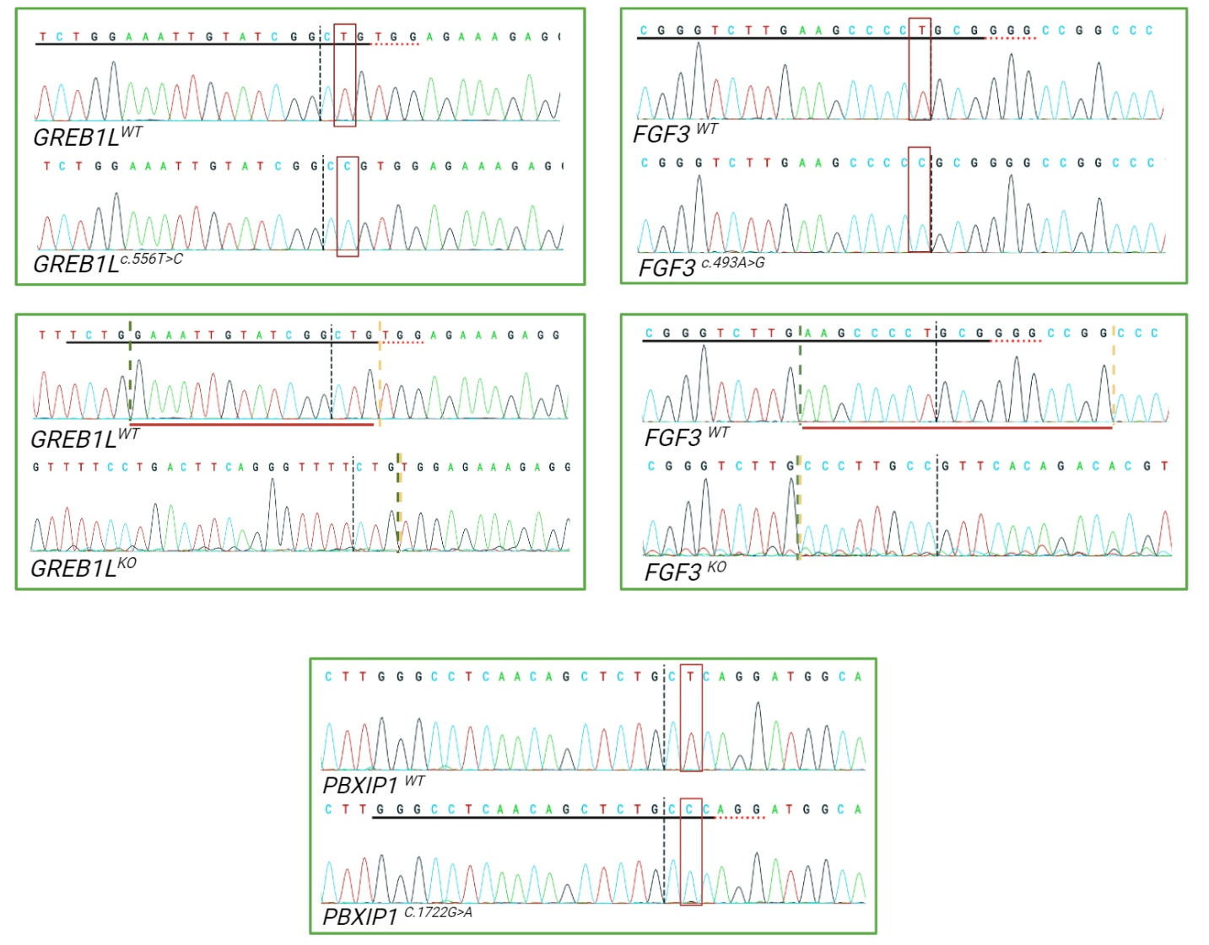

Figure S1: Confirmation of variant-bearing iPSCs via Sanger sequencing.
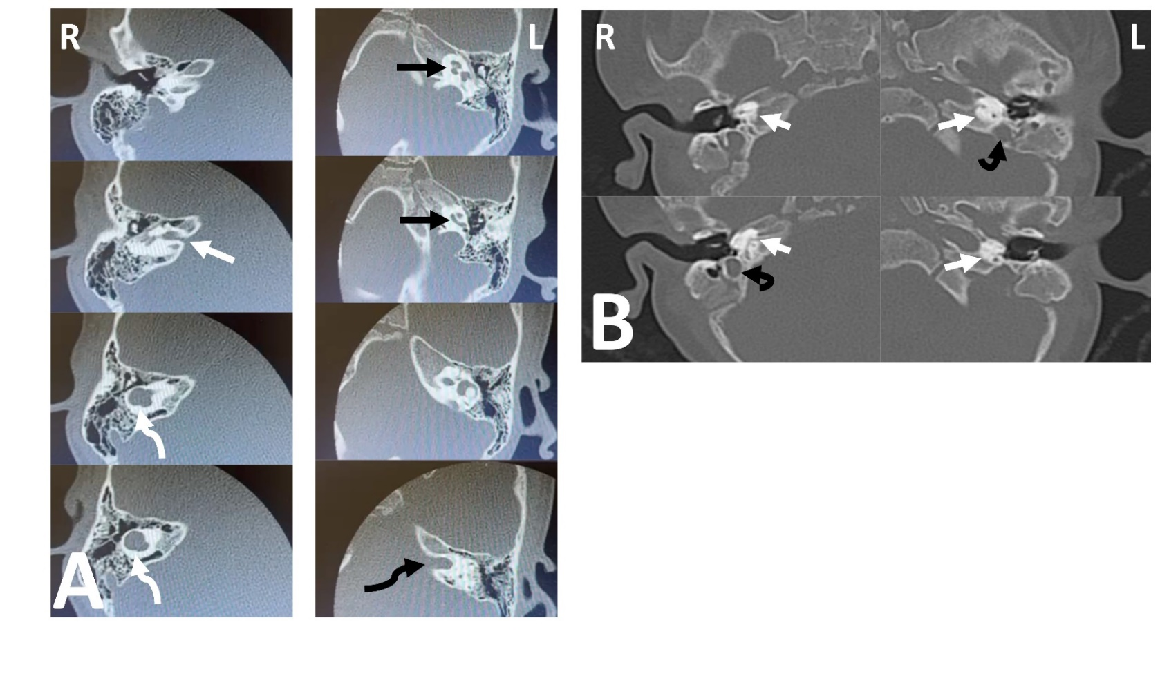
Figure S2: Inner ear imaging details from available probands. (A) CT scans for proband (II:1) from family 2 showing absence of the cochlea with a dilated vestibule (curved white arrow) on the right side (common cavity). IAC is narrow on the right side (white arrow). Normal cochlea (black arrow) and IAC (curved black arrow) is visible on the left side; (B) Proband from family 3 (II:1) with bilateral cochlear aplasia. Contiguous axial CT slices reveal bilateral cochlear aplasia with only sclerotic bone (arrow) and deformed cystic vestibule (curved arrow).

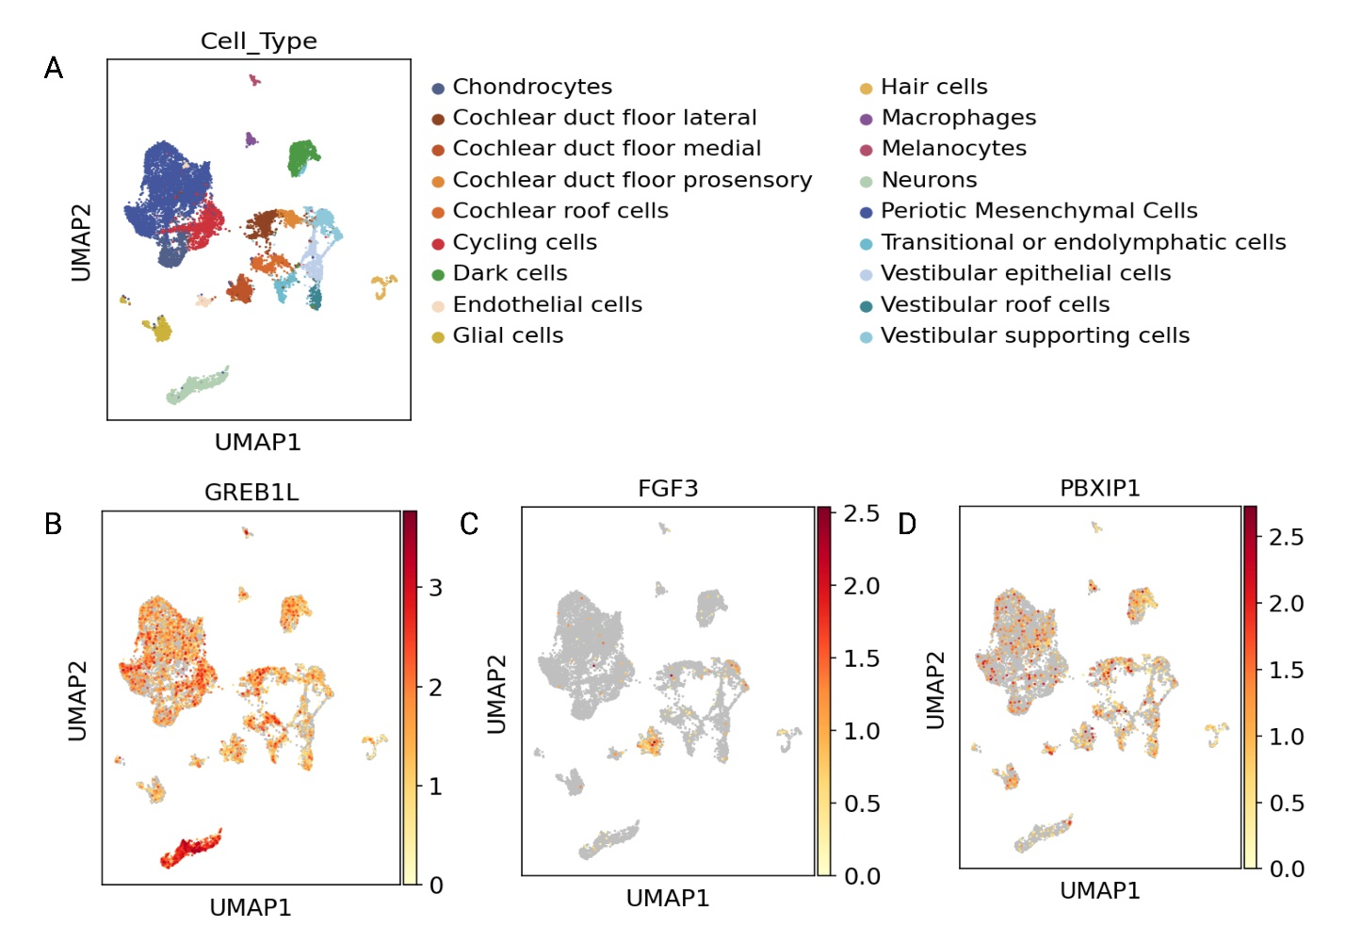
Figure S3: U-map plots of GREB1L, FGF3, and PBXIP1 snRNAseq-based expression in different cell clusters of developing human cochlea (https://umgear.org/).(A) shows localization of different cell types and (B) shows gene specific expression.

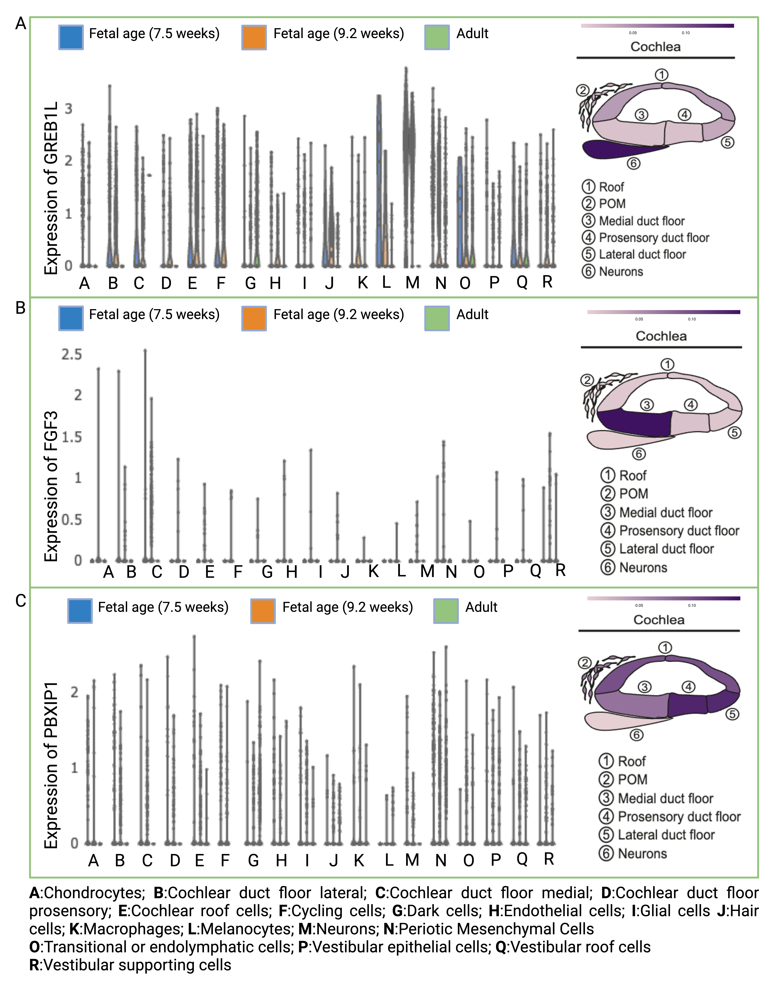 Figure S4: snRNA-seq profile of GREB1L, FGF3, and PBXIP1 expression in human cochlea at different ages as well as spatial localization (https://umgear.org/).
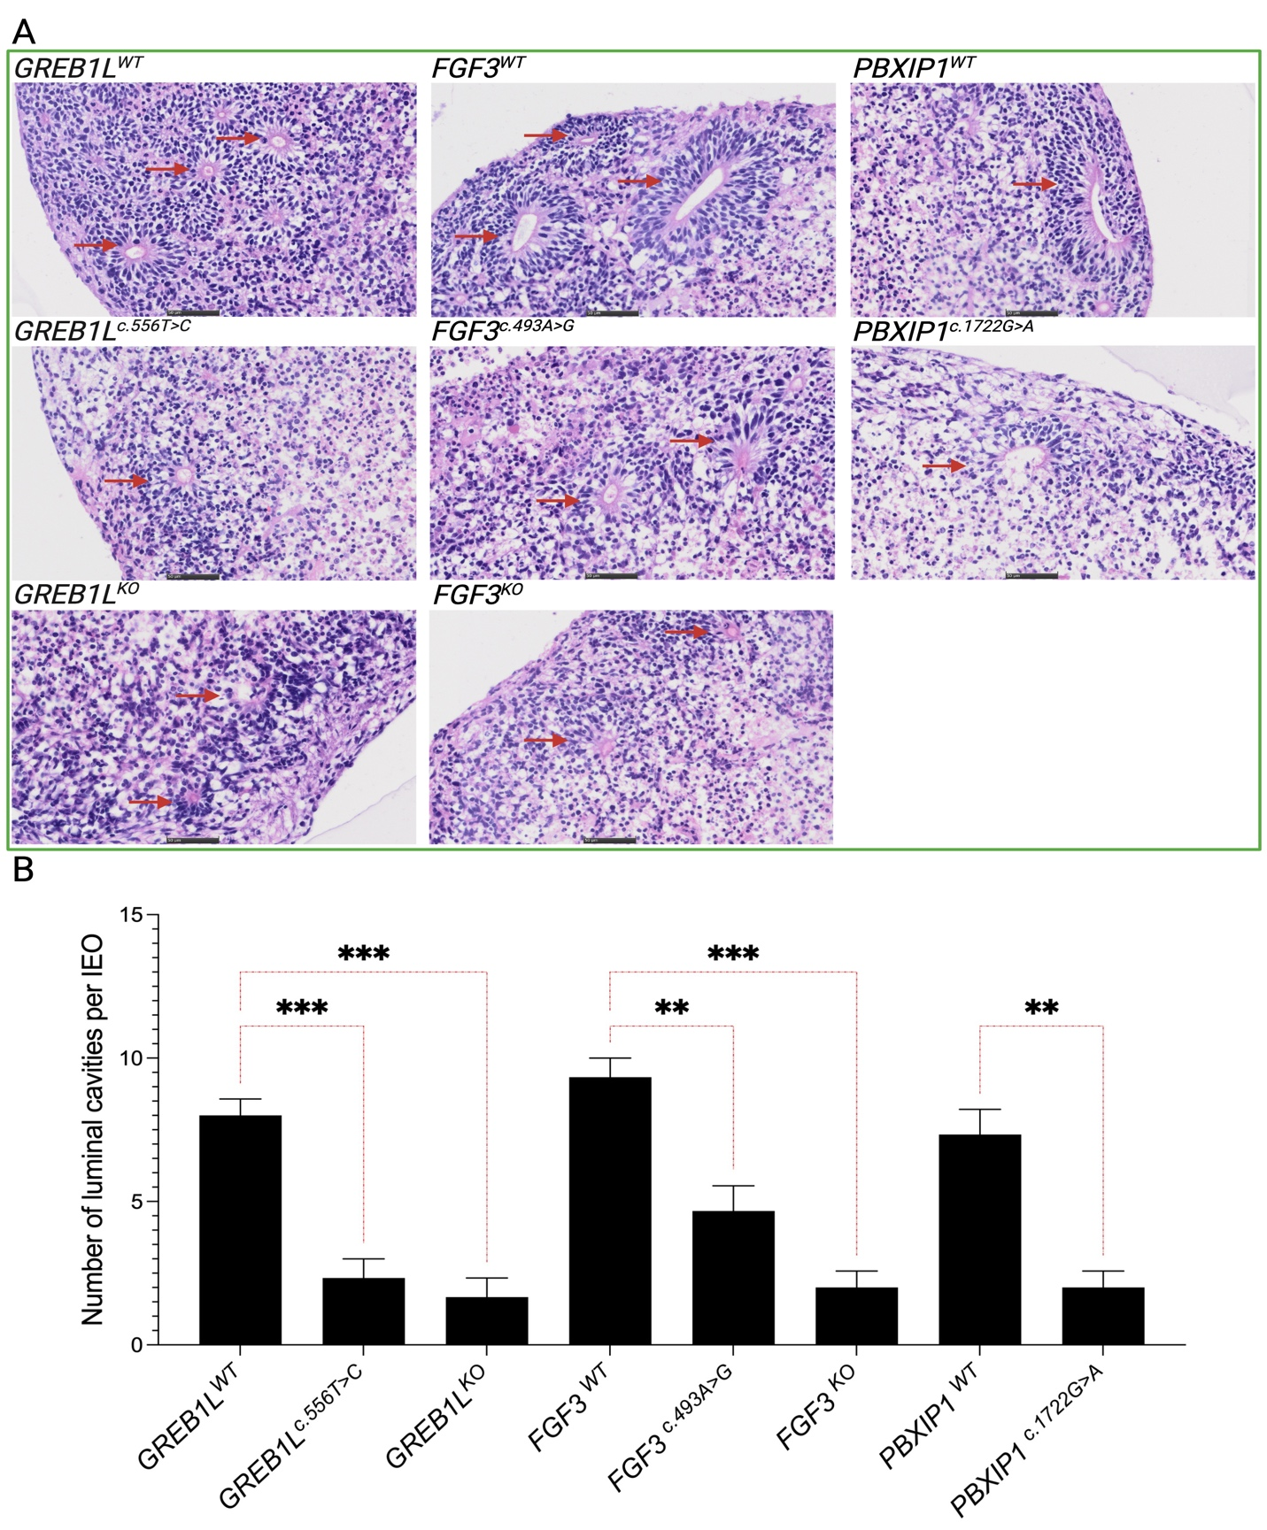
Figure S5: Representative images and statistical analysis of day 35 IEO (n=3) showing the effect of FGF3^{KO}, FGF3^{c.493A>G}, GREB1L^{KO}, GREB1L ^{c.556T>C}, and PBXIP1^{c.1722G>A} on the numbers of luminal spaces and cell confluence around luminal spaces/cavities that mature into hair cell-like cells bearing cavities.

