Supplemental:
S Table 1. Analysis of variance summary statistics with all interactions for soil extractable inorganic nitrogen (EIN) for the entire season (Fig. 2), net nitrogen mineralization (Nmin) rates over the entire season (Fig. 3), EIN from approximately tassel (VT) – physiological maturity (PM) (Fig. 4), Net Nmin rates from approximately VT - PM (Fig. 5), soil N-acquiring enzyme activity leucine amino peptidase (LAP) from approximately VT - PM (Fig. 6 & 8) and b-1,4-N-acetyl-glucosaminidase (NAG) from approximately VT - PM (Fig. 7 & 9). Bold values indicate significance at p < 0.05.
Full Season soil extractable inorganic N |  |  |  |  |  | Full Season net N mineralization rates
Source of Variance | NumDF | DenDF | F value | Pr(>F) |  | NumDF | DenDF | F value | Pr(>F)
Irr (W) | 1 | 2 | 7.89 | 0.107 |  | 1 | 2 | 4.88 | 0.158
N Fertilizer (N) | 2 | 8 | 29.95 | < 0.001 |  | 2 | 8 | 1.98 | 0.200
Sampling Event (S) | 7 | 180 | 7.78 | < 0.001 |  | 6 | 156 | 18.52 | < 0.001
Year (Y) | 1 | 180 | 22.98 | < 0.001 |  | 1 | 156 | 9.39 | 0.003
W x N | 2 | 8 | 7.00 | 0.018 |  | 2 | 8 | 2.43 | 0.150
W x S | 7 | 180 | 1.57 | 0.146 |  | 6 | 156 | 0.98 | 0.440
N x S | 14 | 180 | 1.67 | 0.065 |  | 12 | 156 | 1.43 | 0.157
W x Y | 1 | 180 | 0.07 | 0.785 |  | 1 | 156 | 0.02 | 0.884
N x Y | 2 | 180 | 1.62 | 0.200 |  | 2 | 156 | 4.45 | 0.013
S x Y | 7 | 180 | 16.73 | < 0.001 |  | 6 | 156 | 12.79 | < 0.001
W x N x S | 14 | 180 | 0.64 | 0.828 |  | 12 | 156 | 0.84 | 0.610
W x N x Y | 2 | 180 | 1.48 | 0.229 |  | 2 | 156 | 2.58 | 0.079
W x S x Y | 7 | 180 | 2.26 | 0.031 |  | 6 | 156 | 1.11 | 0.360
N x S x Y | 14 | 180 | 1.14 | 0.328 |  | 12 | 156 | 2.50 | 0.005
W x N x S x Y | 14 | 180 | 0.66 | 0.813 |  | 12 | 156 | 1.70 | 0.070
Soil extractable inorganic N (VT - PM) |  |  |  |  |  | Net N Mineralization (VT - PM)
Source of Variance | NumDF | DenDF | F value | Pr(>F) |  | NumDF | DenDF | F value | Pr(>F)
Irr (W) | 1 | 2 | 14.78 | 0.061 |  | 1 | 2 | 2.10 | 0.285
N Fertilizer (N) | 2 | 8 | 14.77 | 0.002 |  | 2 | 8 | 1.32 | 0.319
Sampling Event (S) | 3 | 84 | 8.90 | < 0.001 |  | 2 | 60 | 4.16 | 0.020
Year (Y) | 1 | 84 | 61.29 | < 0.001 |  | 1 | 60 | 0.01 | 0.924
W x N | 2 | 8 | 3.83 | 0.068 |  | 2 | 8 | 5.29 | 0.034
W x S | 3 | 84 | 0.02 | 0.995 |  | 2 | 60 | 2.50 | 0.091
N x S | 6 | 84 | 1.76 | 0.118 |  | 4 | 60 | 1.45 | 0.229
W x Y | 1 | 84 | 3.24 | 0.075 |  | 1 | 60 | 0.43 | 0.514
N x Y | 2 | 84 | 0.32 | 0.728 |  | 2 | 60 | 0.58 | 0.563
S x Y | 3 | 84 | 15.80 | < 0.001 |  | 2 | 60 | 11.31 | < 0.001
W x N x S | 6 | 84 | 1.34 | 0.250 |  | 4 | 60 | 1.54 | 0.203
W x N x Y | 2 | 84 | 0.55 | 0.578 |  | 2 | 60 | 0.98 | 0.383
W x S x Y | 3 | 84 | 2.21 | 0.093 |  | 2 | 60 | 1.63 | 0.204
N x S x Y | 6 | 84 | 0.52 | 0.793 |  | 4 | 60 | 0.12 | 0.976
W x N x S x Y | 6 | 84 | 0.28 | 0.946 |  | 4 | 60 | 2.20 | 0.080
 | Leucine Amino Peptidase (LAP) |  |  |  |  | b-1,4-N-acetyl-glucosaminidase (NAG)
Source of Variance | NumDF | DenDF | F value | Pr(>F) |  | NumDF | DenDF | F value | Pr(>F)
Irr (W) | 1 | 2 | 0.01 | 0.943 |  | 1 | 2 | 0.01 | 0.928
N Fertilizer (N) | 2 | 8 | 6.87 | 0.018 |  | 2 | 8 | 9.22 | 0.008
Sampling Event (S) | 3 | 84 | 41.21 | < 0.001 |  | 3 | 84 | 10.76 | < 0.001
Year (Y) | 1 | 84 | 182.20 | < 0.001 |  | 1 | 84 | 184.28 | < 0.001
W x N | 2 | 8 | 1.10 | 0.378 |  | 2 | 8 | 1.66 | 0.250
W x S | 3 | 84 | 5.92 | 0.001 |  | 3 | 84 | 4.26 | 0.008
N x S | 6 | 84 | 0.53 | 0.784 |  | 6 | 84 | 0.75 | 0.612
W x Y | 1 | 84 | 10.11 | 0.002 |  | 1 | 84 | 0.03 | 0.868
N x Y | 2 | 84 | 0.20 | 0.821 |  | 2 | 84 | 1.91 | 0.155
S x Y | 3 | 84 | 6.79 | < 0.001 |  | 3 | 84 | 42.24 | < 0.001
W x N x S | 6 | 84 | 1.05 | 0.396 |  | 6 | 84 | 1.15 | 0.341
W x N x Y | 2 | 84 | 0.19 | 0.824 |  | 2 | 84 | 0.43 | 0.652
W x S x Y | 3 | 84 | 8.40 | < 0.001 |  | 3 | 84 | 4.77 | 0.004
N x S x Y | 6 | 84 | 0.76 | 0.603 |  | 6 | 84 | 0.88 | 0.516
W x N x S x Y | 6 | 84 | 1.66 | 0.140 |  | 6 | 84 | 1.13 | 0.354

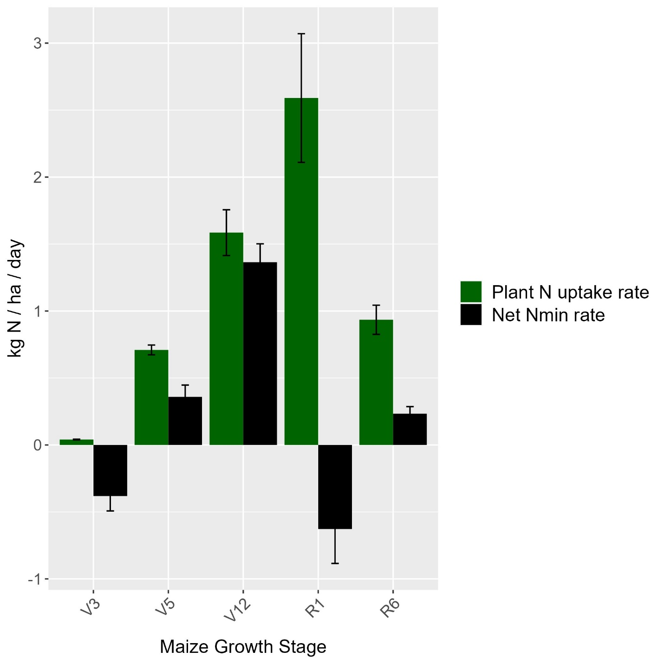
S Figure 1. Average plant nitrogen uptake and net nitrogen mineralization (Nmin) rates at different maize growth stages across both growing years and treatments. Growth stage corresponds to plant developmental stage when plant biomass samples were harvested. Net Nmin rates are presented as average rates between growth stages indicated. See methods for determining plant N uptake and Nmin rates. Error bars depict $±$ one SE
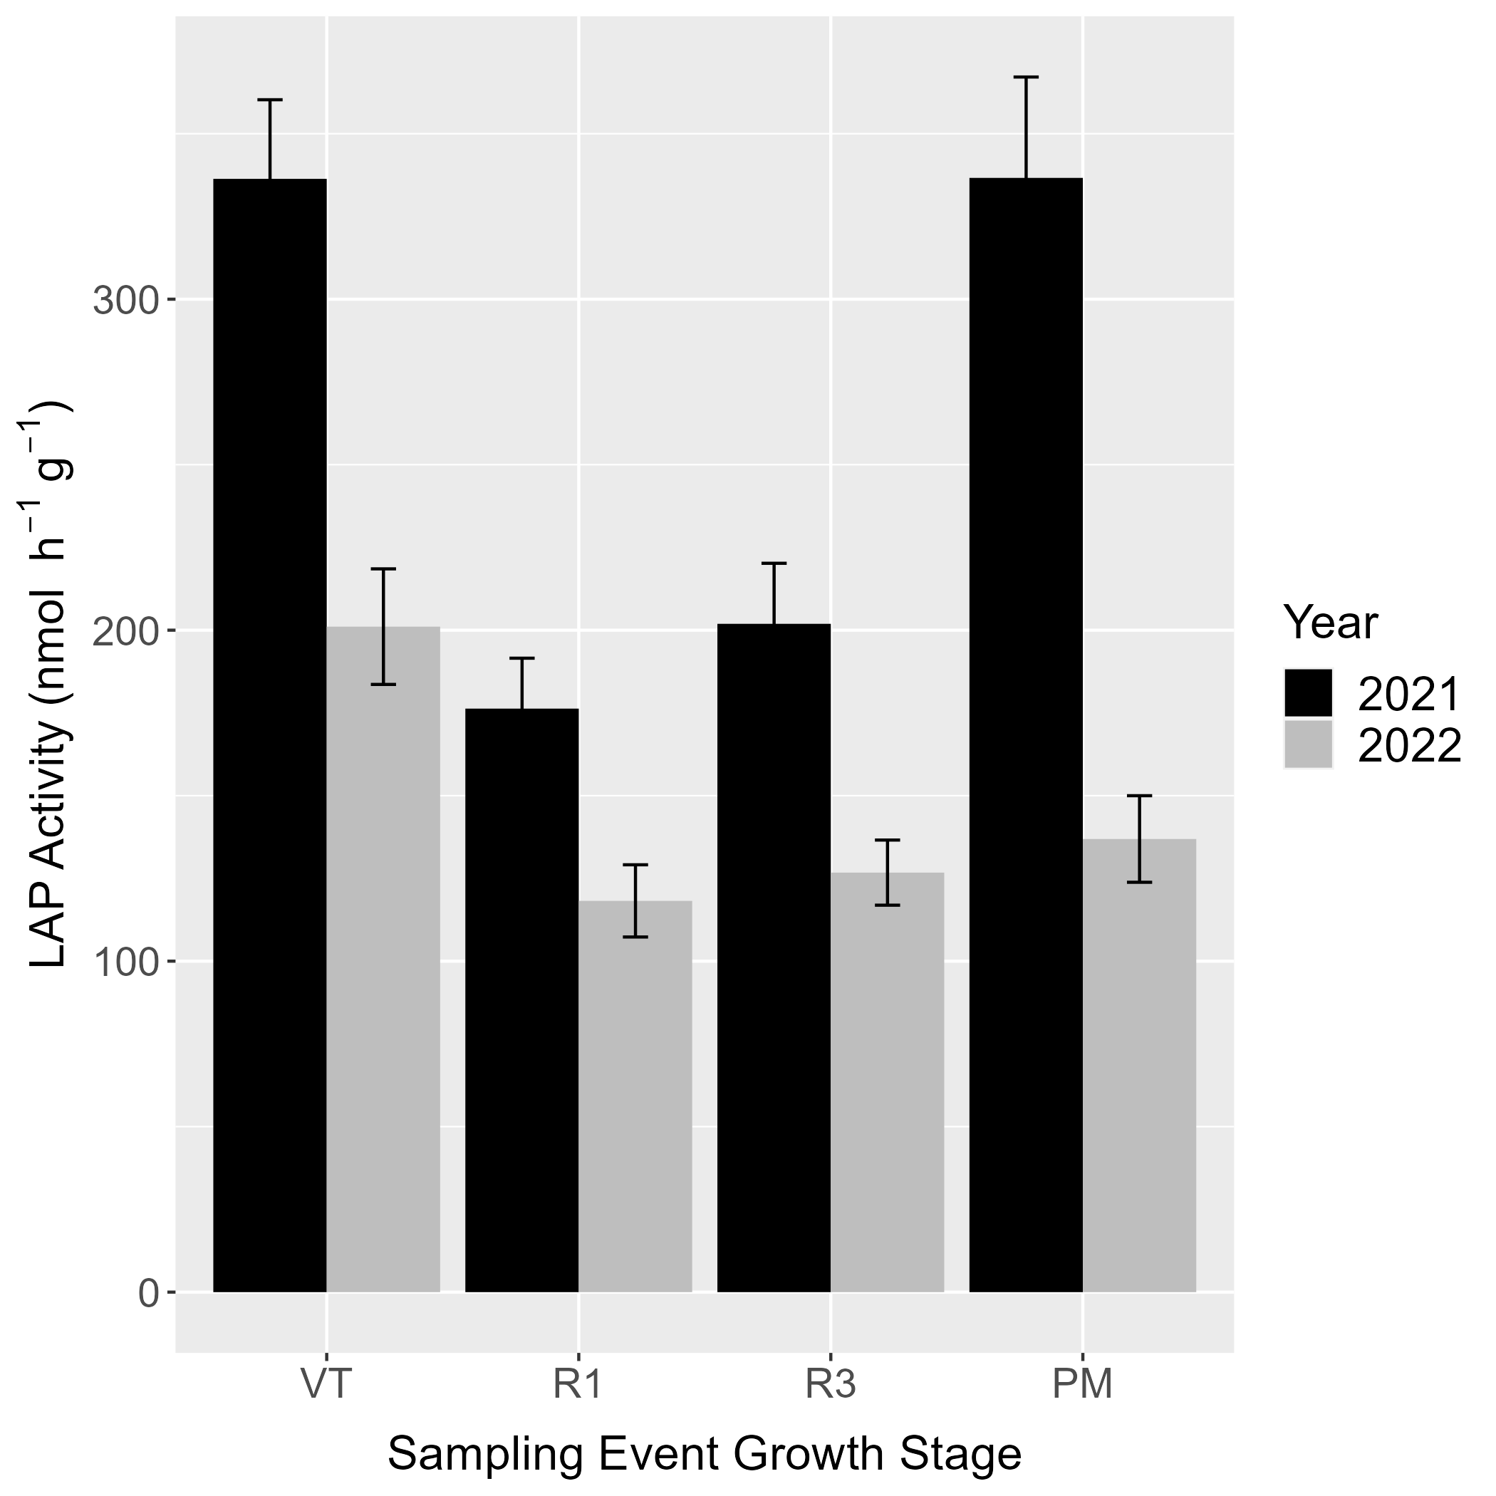
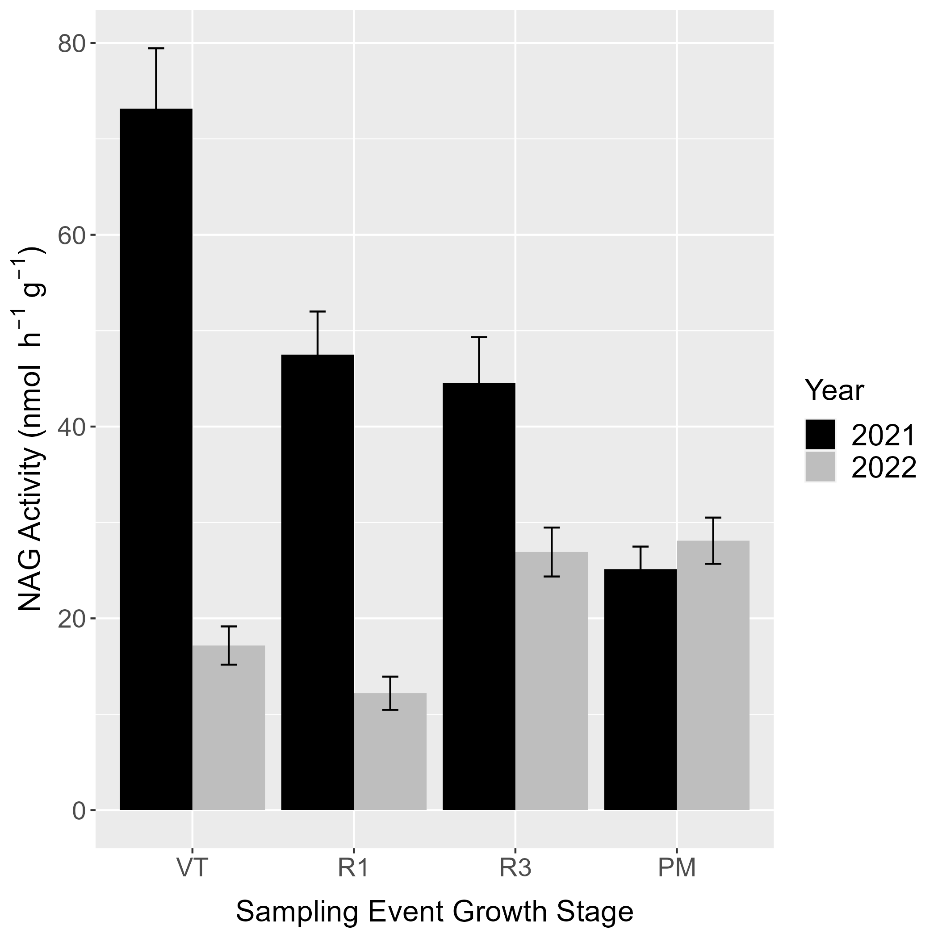
S Figure 2. Soil enzyme activity panel A) corresponds to L-leucine amino peptidase (LAP) activity and panel B) corresponds to activity β-1,4-N-acetyl-glucosaminidase (NAG) activity. Both panel A and B show enzyme activity in in top 0 – 15 cm by maize growth stage and growing season averaged across nitrogen fertilizer and irrigation treatments. Error bars depict $±$ one SE.
A)
B)

