Supplementary material

Figure S1. (A) Correlation between current annual mean temperature and primary productivity (R² = 0.92, p < 0.01). (B) Correlation between vegetation cover and annual precipitation (R² = 0.74, p < 0.01). (C) Correlation between current annual mean temperature and mean LGM temperature (R² = 0.94, p < 0.01). Only values extracted from the assemblages used here are represented in the correlations.

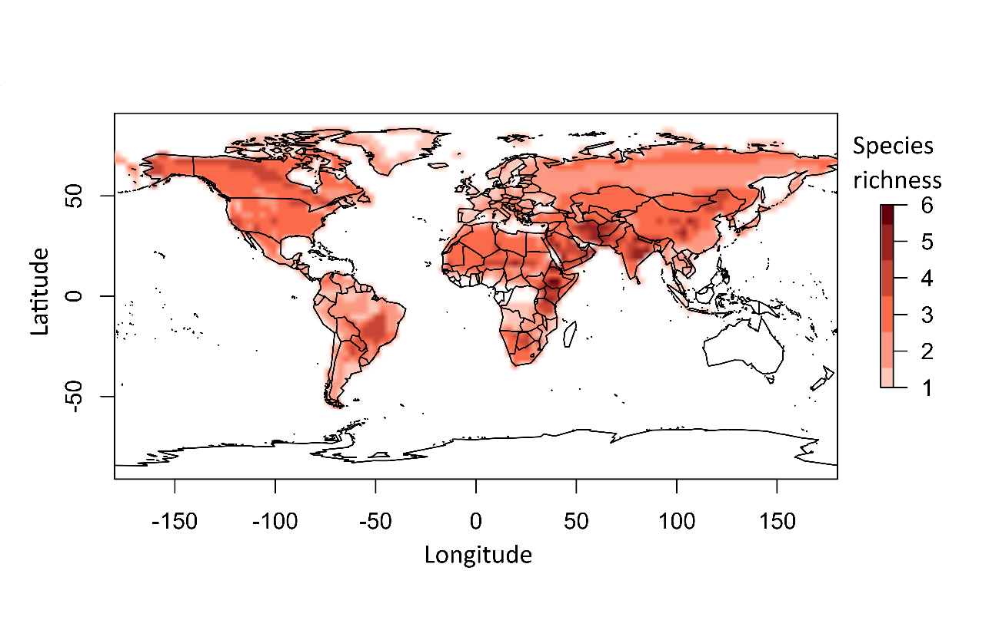Figure S2. Species richness spatial gradient for all 36 Canidae species in this study.

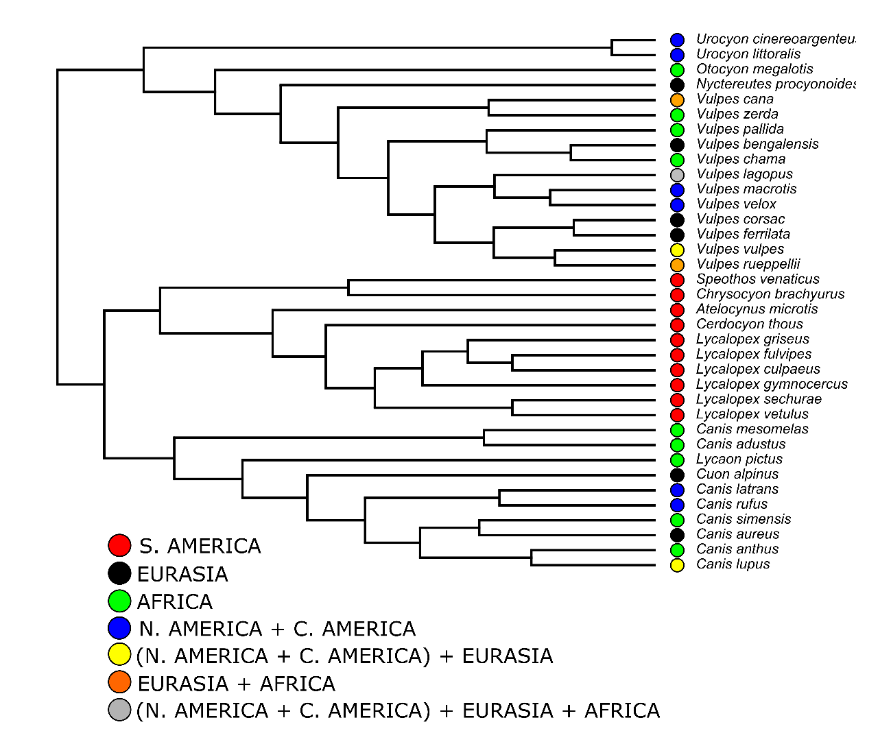Figure S3. Species distributions along the tips of the phylogeny from Porto et al. (2019) that is used in our study.

Figure S4. Best-fitting Structural Equation Model for the positive NRI values during the sensitivity analyses. Positive and negative effects are indicated by red and blue arrows, respectively. Arrow thickness is scaled to illustrate the relative effect of each variable. Only significant effects (arrows) are shown (p < 0.05).
Figure S5. Best-fitting Structural Equation Model for the negative NRI values during the sensitivity analyses. Positive and negative effects are indicated by red and blue arrows, respectively. Arrow thickness is scaled to illustrate the relative effect of each variable. Only significant effects (arrows) are shown (p < 0.05).

Figure S6. Best-fitting Structural Equation Model NRI values with regional pools during the sensitivity analyses. Positive and negative effects are indicated by red and blue arrows, respectively. Arrow thickness is scaled to illustrate the relative effect of each variable. Only significant effects (arrows) are shown (p < 0.05).

Figure S7. Association between NRI values obtained using a global pool of species and using a regional pool for our sensitivity analyses.

Table S1. Body size of the 36 species of canids used in this study. The body size measurements used here are actually the head + body length measurements obtained from the females of each species.
Species | Body size (cm)
Atelocynus microtis | 86
Canis adustus | 85.5
Canis aureus | 78
Canis anthus | 78
Canis latrans | 84
Canis lupus | 108.5
Canis mesomelas | 88
Canis rufus | 112
Canis simensis | 94.4
Cerdocyon thous | 67.25
Chrysocyon brachyurus | 105
Cuon alpinus | 111.75
Lycaon pictus | 115.75
Nyctereutes procyonoides | 59.75
Otocyon megalotis | 53.35
Lycalopex culpaeus | 69
Lycalopex fulvipes | 52.15
Lycalopex griseus | 58.05
Lycalopex gymnocercus | 65.85
Lycalopex sechurae | 64
Lycalopex vetulus | 58.5
Speothos venaticus | 66.25
Urocyon cinereoargenteus | 56.9
Urocyon littoralis | 53
Vulpes bengalensis | 47
Vulpes cana | 57.35
Vulpes chama | 57.35
Vulpes corsac | 47.5
Vulpes ferrilata | 56.25
Vulpes macrotis | 50.25
Vulpes pallida | 46.5
Vulpes rueppellii | 47.5
Vulpes velox | 52
Vulpes vulpes | 63.5
Vulpes zerda | 36.4
Vulpes lagopus | 60

Table S2. Akaike information criterion ranking of the six Structural Equation Models tested for NRI values during the sensitivity analysis of assemblages with three or less species.
 | Models | df | AIC | ΔAIC | Weights
 | Model 1 | 12 | 9340.90 | 2374.69 | 0
 | Model 2 | 12 | 9339.90 | 2373.69 | 0
 | Model 3 | 16 | 6978.38 | 12.17 | 0.002
 | Model 4 | 15 | 6966.21 | 0 | 0.997
 | Model 5 | 18 | 10188.78 | 3222.57 | 0
 | Model 6 | 19 | 9640.05 | 2673.84 | 0

Table S3. Akaike information criterion ranking of the six Structural Equation Models tested for NRI values during the sensitivity analysis of assemblages with four or more species.
 | Models | df | AIC | ΔAIC | Weights
 | Model 1 | 12 | 25997.58 | 6948.47 | 0
 | Model 2 | 12 | 25994.58 | 6945.47 | 0
 | Model 3 | 16 | 19094.33 | 45.22 | 1.51E-10
 | Model 4 | 15 | 19049.10 | 0 | 0.999
 | Model 5 | 18 | 28836.21 | 9787.11 | 0
 | Model 6 | 19 | 28215.47 | 9166.36 | 0

Table S4. Results of the best-fitting Structural Equation Model (model 4) for NRI values during the sensitivity analyses of assemblages with three or less species.
 | Regressions |  |  | Estimate | Std. error | p | Effect
 | NRI ~ |  | Body size dissimilarity | -2.93 | 0.191 | < 0.01 | -0.461
 |  |  | Human footprint | -0.002 | 0.003 | 0.494 | -0.022
 |  |  | Temperature | -0.007 | 0.001 | < 0.01 | -0.188
 |  |  | Vegetation cover | 0.013 | 0.001 | < 0.01 | 0.588
 |  |  | Felidae richness | 0.015 | 0.01 | 0.133 | 0.034
 |  |  | LGM temperature | 0.223 | 0.033 | < 0.01 | 0.285
 | Temperature ~ |  | Human footprint | 0.832 | 0.067 | < 0.01 | 0.376
 | Vegetation cover ~ |  | Human footprint | -0.030 | 0.002 | < 0.01 | -0.284
 |  |  | Temperature | 0.041 | 0.001 | < 0.01 | 0.874
 | Body size dissimilarity ~ |  | Temperature | -0.001 | 0 | < 0.01 | -0.187
 |  |  | Vegetation cover | -0.035 | 0.005 | < 0.01 | -0.288
 |  |  | LGM temperature | -0.002 | 0 | < 0.01 | -0.343
 | * P of the six models (<0.01)

Table S5. Results of the best-fitting Structural Equation Model (model 4) for NRI values during the sensitivity analyses of assemblages with four or more species.
 | Regressions |  |  | Estimate | Std. error | p | Effect
 | NRI ~ |  | Body size dissimilarity | 2.972 | 0.207 | < 0.01 | 0.224
 |  |  | Human footprint | 0.006 | 0.002 | < 0.05 | -0.048
 |  |  | Temperature | -0.035 | 0.001 | < 0.01 | -0.575
 |  |  | Vegetation cover | 0.068 | 0.018 | < 0.01 | -0.059
 |  |  | Felidae richness | 0.038 | 0.006 | < 0.01 | 0.102
 |  |  | LGM temperature | 0.016 | 0.003 | < 0.01 | 0.377
 | Temperature ~ |  | Human footprint | 0.701 | 0.041 | < 0.01 | 0.338
 | Vegetation cover ~ |  | Human footprint | 0.031 | 0.001 | < 0.01 | 0.284
 |  |  | Temperature | -0.007 | 0.001 | < 0.01 | -0.134
 | Body size dissimilarity ~ |  | Temperature | -0.001 | 0 | < 0.01 | -0.263
 |  |  | Vegetation cover | -0.040 | 0.002 | < 0.01 | -0.456
 |  |  | LGM temperature | 0.001 | 0 | < 0.01 | 0.323
 | * P of the six models (<0.01)

Table S6. Akaike information criterion ranking of the six Structural Equation Models tested during our sensitivity analyses using positive NRI values.
 | Models | df | AIC | ΔAIC | Weights
 | Model 1 | 12 | 22509.16 | 5535.41 | 0
 | Model 2 | 12 | 22505.16 | 5531.41 | 0
 | Model 3 | 16 | 16975.93 | 2.18 | 0.377
 | Model 4 | 15 | 16973.75 | 0 | 0.622
 | Model 5 | 18 | 25801.42 | 8827.67 | 0
 | Model 6 | 19 | 25419.01 | 8445.26 | 0

Table S7. Results of the best-fitting Structural Equation Model (model 4) for positive NRI values during the sensitivity analyses.
 | Regressions |  |  | Estimate | Std. error | p | Effect
 | Positive NRI ~ |  | Body size dissimilarity | 0.151 | 0.082 | 0.067 | 0.033
 |  |  | Human footprint | 0.002 | 0.001 | 0.138 | 0.026
 |  |  | Temperature | -0.012 | 0 | < 0.01 | -0.465
 |  |  | Vegetation cover | 0.148 | 0.008 | < 0.01 | 0.325
 |  |  | Felidae richness | -0.006 | 0.003 | < 0.05 | -0.039
 |  |  | LGM temperature | 0.009 | 0 | < 0.01 | 0.486
 | Temperature ~ |  | Human footprint | 0.732 | 0.046 | < 0.01 | 0.329
 | Vegetation cover ~ |  | Human footprint | -0.025 | 0.0,30 | < 0.01 | 0.193
 |  |  | Temperature | -0.001 | 0.001 | 0.350 | -0.021
 | Body size dissimilarity ~ |  | Temperature | -0.001 | 0 | < 0.01 | -0.101
 |  |  | Vegetation cover | -0.050 | 0.002 | < 0.01 | -0.498
 |  |  | LGM temperature | 0 | 0 | < 0.01 | 0.079
 | * P of the six models (<0.01)

Table S8. Akaike information criterion ranking of the six Structural Equation Models tested during our sensitivity analyses using negative NRI values.
 | Models | df | AIC | ΔAIC | Weights
 | Model 1 | 12 | 9388.44 | 3286.52 | 0
 | Model 2 | 12 | 9385.44 | 3283.52 | 0
 | Model 3 | 16 | 6104.40 | 2.48 | 0.322
 | Model 4 | 15 | 6101.92 | 0 | 0.677
 | Model 5 | 18 | 10344.46 | 4242.54 | 0
 | Model 6 | 19 | 9498.67 | 3396.75 | 0

Table S9. Results of the best-fitting Structural Equation Model (model 4) for negative NRI values during the sensitivity analyses.
 | Regressions |  |  | Estimate | Std. error | p | Effect
 | Negative NRI ~ |  | Body size dissimilarity | -0.022 | 0.117 | 0.805 | -0.006
 |  |  | Human footprint | 0 | 0.001 | 0.708 | 0.009
 |  |  | Temperature | -0.012 | 0.001 | < 0.01 | -0.556
 |  |  | Vegetation cover | 0.130 | 0.023 | < 0.01 | 0.206
 |  |  | Felidae richness | 0.005 | 0.001 | < 0.01 | 0.286
 |  |  | LGM temperature | 0.004 | 0.001 | < 0.01 | 0.344
 | Temperature ~ |  | Human footprint | 0.812 | 0.055 | < 0.01 | 0.408
 | Vegetation cover ~ |  | Human footprint | -0.009 | 0.002 | < 0.01 | -0.133
 |  |  | Temperature | 0.022 | 0.001 | < 0.01 | 0.652
 | Body size dissimilarity ~ |  | Temperature | 0.001 | 0 | < 0.01 | 0.216
 |  |  | Vegetation cover | -0.131 | 0.004 | < 0.05 | -0.815
 |  |  | LGM temperature | 0 | 0 | < 0.05 | -0.044
 | * P of the six models (<0.01)

Table S10. Akaike information criterion ranking of the six Structural Equation Models tested during our sensitivity analyses using regional pools.
 | Models | df | AIC | ΔAIC | Weights
 | Model 1 | 12 | 37463.98 | 7810.58 | 0
 | Model 2 | 12 | 37461.98 | 7808.53 | 0
 | Model 3 | 16 | 29655.83 | 2.43 | 0.228
 | Model 4 | 15 | 29653.40 | 0 | 0.771
 | Model 5 | 18 | 42669.82 | 13016.42 | 0
 | Model 6 | 19 | 41577.48 | 11924.08 | 0

Table S11. Results of the best-fitting Structural Equation Model (model 4) using regional pools during the sensitivity analyses.
 | Regressions |  |  | Estimate | Std. error | p | Effect
 | NRI ~ |  | Body size dissimilarity | 1.313 | 0.156 | < 0.01 | 0.105
 |  |  | Human footprint | 0.013 | 0.002 | < 0.01 | 0.082
 |  |  | Temperature | -0.045 | 0.001 | < 0.01 | -0.603
 |  |  | Vegetation cover | -0.146 | 0.018 | < 0.01 | -0.101
 |  |  | Felidae richness | 0.054 | 0.007 | < 0.01 | -0.115
 |  |  | LGM temperature | 0.025 | 0.001 | < 0.01 | 0.478
 | Temperature ~ |  | Human footprint | 0.759 | 0.036 | < 0.01 | 0.356
 | Vegetation cover ~ |  | Human footprint | -0.191 | 0.052 | < 0.01 | 0.131
 |  |  | Temperature | 0.006 | 0.001 | < 0.01 | 0.111
 | Body size dissimilarity ~ |  | Temperature | -0.001 | 0.000 | < 0.01 | -0109
 |  |  | Vegetation cover | -0.062 | 0.002 | < 0.01 | -0.539
 |  |  | LGM temperature | -0.000 | 0.000 | < 0.01 | 0.088
 | * P of the six models (<0.01)

