Supporting Information

Nanoscale Covalent Organic Frameworks for Enhanced Photocatalytic Hydrogen Production
Wei Zhao¹, Liang Luo¹, Muyu Cong², Xueyan Liu², Zhiyun Zhang², Mounib Bahri³, Boyu Li¹, Jing Yang¹, Miaojie Yu^{1,2}, Lunjie Liu⁴, Yu Xia⁴, Nigel D Browning³, Wei-Hong Zhu², Weiwei Zhang*² and Andrew I. Cooper*¹
¹ Leverhulme Research Centre for Functional Materials Design, Materials Innovation Factory and Department of Chemistry, University of Liverpool, Liverpool, UK.
² Key Laboratory for Advanced Materials and Institute of Fine Chemicals, School of Chemistry and Molecular Engineering, East China University of Science and Technology, Shanghai, China
³ Albert Crewe Centre for Electron Microscopy, University of Liverpool, Liverpool, L69 3GL, UK.
⁴ Department of Materials Science and Engineering, Southern University of Science and Technology, Shenzhen, 518055, China.

Table of contents
- Instrumentation and materials 2
- Characterization of COFs 8
- References 78

Instrumentation and materials
1,3,5-Triformylphloroglucinol (TFP), benzidine (BD) and acetic acid were obtained from Fluorochem Ltd. [2,2'-Bipyridine]-5,5'-diamine (BpyD) was obtained from BLD pharm Ltd. Hexadecyl trimethyl ammonium bromide (CTAB) and sodium dodecyl sulfate (SDS) were purchased Sigma-Aldrich Ltd. Anhydrous solvents were purchased from Acros Organics or Fisher Scientific. All chemicals were used as received without further purification.
Solution nuclear magnetic resonance (NMR). ¹H spectra were recorded in solution on a Bruker Avance 400 NMR spectrometer at 400 MHz and 100 MHz, respectively.
Fourier-transform infrared spectroscopy (FT-IR). IR spectra were recorded on a Bruker Tensor 27 FT-IR spectrometer using KBr pellets.
Powder X-ray diffraction (PXRD). PXRD measurements were performed on a PANalytical X’Pert PRO MPD, using in high throughput transmission mode with Kα focusing mirror and PIXCEL 1D detector with a Cu X-ray source.
Structural modelling of COFs. Structural atomistic simulations of the possible framework structures were carried out using Material Studio software. The simulated PXRD patterns were determined by the Reflex module. The space group for simulated structures was selected as P1.
Thermogravimetric analysis (TGA). TGA analysis was performed on an EXSTAR6000 under a flow of nitrogen by heating from room temperature to 800 °C at a rate of 10 °C min⁻¹.
Gas sorption analysis. The surface areas and nitrogen adsorption isotherms of samples (at 77.3 K) were obtained using a Micromeritics ASAP 2020 volumetric adsorption analyzer. Before analysis, the samples were degassed at 120 °C for 12 h under vacuum (10⁻⁵ bar). Pore size distributions of COFs were obtained by fitting the density functional theory (DFT) model to the adsorption data.
Elemental analysis (EA). EA was determined on Thermo EA1112 Flash CHNS-O analyzer with standard microanalytical procedures.
X-ray photoelectron spectroscopy (XPS). XPS data were measured in powder (without surfactants) form using an ESCALAB 250Xi instrument (Thermo Fisher Scientific) with a monochromatized Al Kα line source.
Solid-state ¹³C CP (Cross Polarization) MAS (Magic Angle Spinning) NMR. Solid-state ¹³C NMR experiments were performed under 25 ℃ on a Bruker Avance III HD 400WB (9.4 T) spectrometer, operating at 100.6 MHz for ¹³C, at a spinning speed of 13 kHz on a 4.0 mm CPMAS probe. Activated samples were packed into zirconia rotors inside a glove box under nitrogen. CP spectra were acquired under dry air with ¹H π/2 pulse of 2.3 μs, a contact time of 3 ms and a recycle time of 2 s.
Scanning electron microscopy (SEM). SEM images were collected on a Hitachi S-4800 cold field emission scanning electron microscope. Samples were prepared by depositing the dry powders on 15 mm Hitachi M4 aluminum stubs using an adhesive high-purity carbon tape before coating with a 2 nm layer of gold using an Emitech K550X automated sputter coater.
Transmission electron microscopy (TEM). TEM images were obtained on a JEOL 2100FCs microscopy at an accelerating voltage of 200 kV. The samples were prepared by drop-casting sonicated ethanol suspensions of the materials onto a copper grid.
Cryo-Transmission Electron Microscopy (Cryo-TEM). The Cryo-TEM was carried out with a FEI Talos F200X G2 and this microscope was optimized for liquid samples. Specimen preparation was carried out as follow: a small drop of FNP sample was deposited on lacey carbon coated-300 mesh copper grid. Excess liquid was removed by blotting with a filter paper, leaving a thin film of the solution on the grid. The sample was vitrified in liquid ethane and transferred to the microscope, continuously kept below −170 °C and protected against atmospheric conditions. The analysis was performed by setting the microscope at an acceleration voltage of 200 kV and the high-resolution images were recorded under low electron conditions with a camera of Ceta 4K*4K 200kV.”
Scanning transmission electron microscopy (STEM). STEM and element mapping were collected on a Talos F200X transmission electron microscope, and samples were casted on a copper grid with holey carbon supporting films.
Transient Absorption spectroscopy (TAS): The femtosecond pump-probe TAS measurements were performed using a regenerative amplified Ti:sapphire laser system (Coherent; 800 nm, 70 fs, 6 mJ/pulse and 1 kHz repetition rate) as the laser source and a Femto-100 spectrometer (Time-Tech LLC). Briefly, the 800 nm output pulse from the regenerative amplifier was split in two parts with a 50% beam splitter. The transmitted part was used to pump a TOPAS Optical Parametric Amplifier (OPA) which generated a wavelength-tunable laser pulse from 250 nm to 2.5 μm as pump beam. The reflected 800 nm beam was split again into two parts. One part with <10% was attenuated with a neutral-density filter and focused into a CaF2 crystal to generate a white light continuum (WLC) used for probe beam. The probe beam was focused with an Al parabolic reflector onto the sample. After the sample, the probe beam was collimated and then focused into a fiber-coupled spectrometer with CMOS sensors and detected at a frequency of 1 KHz. The intensity of the pump pulse used in the experiment was controlled by a variable neutral-density filter wheel. The intensity of the pump pulse was 400 µw and pump wavelength was 400 nm. The delay between the pump and probe pulses was controlled by a motorized delay stage. The pump pulses were chopped by a synchronized chopper at 500 Hz and the absorbance change was calculated with two adjacent probe pulses (pump-blocked and pump-unblocked). The samples were placed in 1 mm airtight cuvettes and were measured in an argon atmosphere.
Atomic force microscopy (AFM). AFM images were obtained on a Bruker Dimension ICON. The data were processed using NanoScope Analysis 2.0. Operation mode: Tapping mode in air. The radius of curvature of the tip: ~5 nm.
UV-visible absorption spectra. UV-visible absorption spectra of the polymers were measured on a Shimadzu UV-2550 UV-vis spectrometer by measuring the reflectance of powders in the solid state.
Cyclic voltammetry (CV). CV curves were carried out using a Bio-logic SP200 electrochemical workstation in a normal three electrode cell (glassy carbon as the working electrode, Pt wire as counter electrode and Ag/AgCl electrode as the reference electrode). The experiments were carried out in acetonitrile solutions with 0.1 M tetra-n-butylammonium hexafluorophosphate (TBAPF₆) as the supporting electrolyte at a scan rate of 100 mV s⁻¹. The ferrocenium/ferrocene (Fc/Fc⁺) redox couple was used as an external potential reference.
E_{HOMO} = - (E_{ox,onset} - E^{(1/2)}Fc/Fc⁺ + 4.8) eV vs. vacuum
E_{LUMO} = E_{HOMO} + E_{g} vs. vacuum
Reference: E^{(1/2)}Fc/Fc⁺ = (0.10+0.03)/2=0.455
High-throughput photocatalytic H₂ production experiment. Nano-COF colloids were added into sample vials (volume = 12.5 mL) and purged with nitrogen in a Chemspeed Technologies Sweigher robot for 6 hours. The robotic liquid transfer head was used to transfer sacrificial electron donor aqueous solution and H₂PtCl₆ via the liquid handling system under theses inert conditions from stock jars inside the system into the sample vials. The capper/crimper tool then capped/crimped the vials automatically, again under inert conditions. All sample vials were ultrasonicated in an ultrasonic bath for 10 minutes before removing the vials and illuminating them with a solar simulator (AM1.5G, Class AAA, IEC/JIS/ASTM, 1440 W Xe, 12 × 12 in., MODEL:94123A) for 1 hour while constantly being agitated with a rocker/roller device. Gaseous products were analyzed on an Agilent HS-GC injecting a sample from the headspace via a transfer line (temperature 90 °C) onto a 5 Å molecular sieve column (temperature: 45 °C) with helium as the carrier gas at a flow rate of 30 mL min^{–1}. Hydrogen was detected with a pulsed discharge detector referencing against standard gas with a known concentration of hydrogen. Any hydrogen dissolved in the reaction mixture was not measured and the pressure increase generated by the evolved hydrogen was neglected in the calculations. No hydrogen evolution was observed from sacrificial electron donor aqueous solution under solar simulator illumination in absence of a photocatalyst.
Kinetic H₂ production experiment. A flask was charged with TFP-BpyD nano-COF colloid (0.25 mL) or TFP-BD nano-COF colloid (0.5mL), diluted hexachloroplatinic acid solution as a platinum precursor (15 % wt vs photocatalysts), ascorbic acid aqueous solution (0.2 M, 25 mL), and sealed with a septum. The resulting solutions were ultrasonicated for 5 minutes before degassing thoroughly by N₂ bubbling for 30 minutes. The reaction mixture was illuminated with a 300 W Newport Xe light-source (Model: 6258, Ozone free) for the time specified at a fixed distance under atmospheric pressure. The Xe-light source was cooled by water circulating through a metal jacket. Gas samples were taken with a gas-tight syringe and run on a Bruker 450-GC gas chromatograph equipped with a Molecular Sieve 13X 60-80 mesh 1.5 m × ⅛” × 2 mm ss column at 50 °C with an argon flow of 40 mL min^{–1}. Hydrogen was detected with a thermal conductivity detector, referencing against standard gases with known concentrations of hydrogen. Hydrogen dissolved in the reaction mixture was not measured and the pressure increase generated by the evolved hydrogen was neglected in the calculations. The rates were determined from a linear regression fit and the error is given as the standard deviation of the amount of hydrogen evolved. No hydrogen evolution was observed for a mixture of H₂PtCl₆ and ascorbic acid aqueous solution under λ > 295 nm illumination in absence of a photocatalyst.
External quantum efficiency (EQE) measurements. The external quantum efficiency for the photocatalytic H₂ evolution was measured using λ = 420 nm (80 mW), λ = 515 nm (45 mW) and λ = 595 nm (90 mW) LEDs controlled by an IsoTech IPS303DD power supply. For the measurement, TFP-BpyD nano-COF colloid (0.4 mL) or TFP-BD nano-COF (0.8mL) was suspended in an aqueous solution containing ascorbic acid (0.2 M, 39.6 or 39.2 mL) with diluted H₂PtCl₆ solution as a platinum precursor (15 wt%) before illuminating with the LED. The light intensity was measured with a ThorLabs S120VC photodiode power sensor controlled by a ThorLabs PM100D Power and Energy Meter Console and the external quantum efficiency was estimated using the equation below:

$$EQE=2×\frac{moles of hygrogen evolved}{moles of incident photons}×100\%$$

Time-correlated single photon counting (TCSPC) measurements. All TSCPC experiments were carried out for emission at 371 nm. TCSPC experiments were measured on an Edinburgh FLS1000 Photoluminescent Spectrometer equipped with Fluoracle software for data acquisition and analysis. The instrument response was measured with colloidal silica (LUDOX® HS-40, Sigma-Aldrich) at the excitation wavelength. Lifetimes were fitted in the FAST software using three exponential decay method.
Quantum yield (QY) measurements. Samples were measured using Edinburgh FLS1000. It is a modular fluorescence spectrometer for measuring spectra from 200 to 900 nm. The system is constructed from the light source, excitation monochromator, sample chamber, emission monochromator and detector. The Xe2 is a 450 W xenon arc lamp that emits continuous radiation from 230 nm to >1000 nm. The light from the xenon arc is focused into the monochromator using a high-reflectivity off-axis ellipsoidal mirror, ensuring excellent focus at the entrance slit and completely uniform illumination of the monochromator grating. The monochromators in the FLS1000 are of Czerny-Turner configuration with 325 mm or 2 x 325 mm focal length and feature triple grating turrets with up to three gratings on each turret and computer-controlled slits. The grating turrets are micro-stepper motor driven with a minimum step size of 0.01 nm, a maximum slew rate of 250 nm/s can be achieved. Detector: PMT-900 with the wavelength coverage from 200-850 nm. It operates at the -21.8 °C.

Characterization of COFs
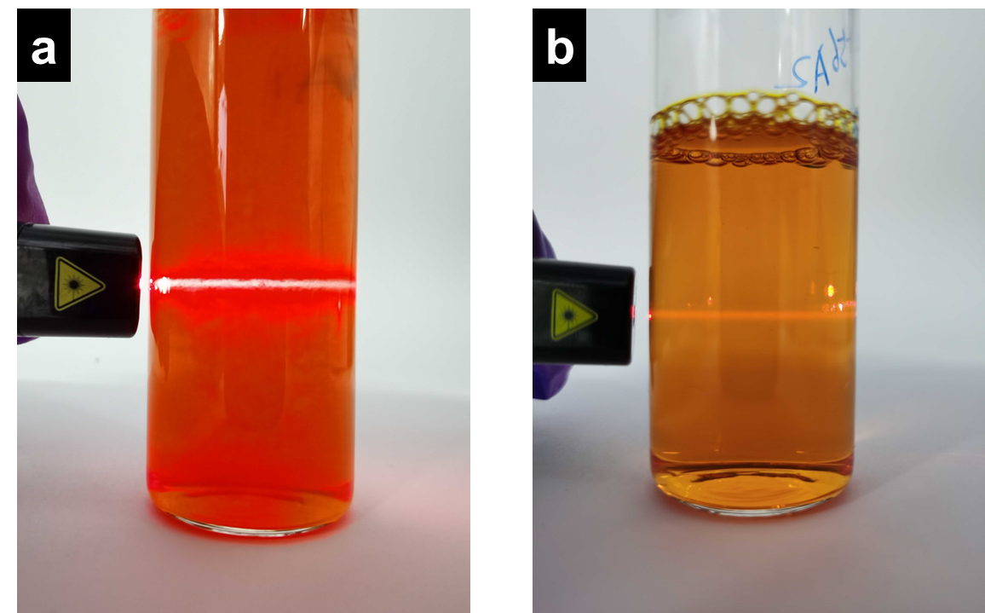
Supplementary Figure 1. Digital images of TFP-BpyD nano-COF (a) and TFP-BD nano-COF (b) showing Willis-Tyndall scattering behavior using a laser pointer.

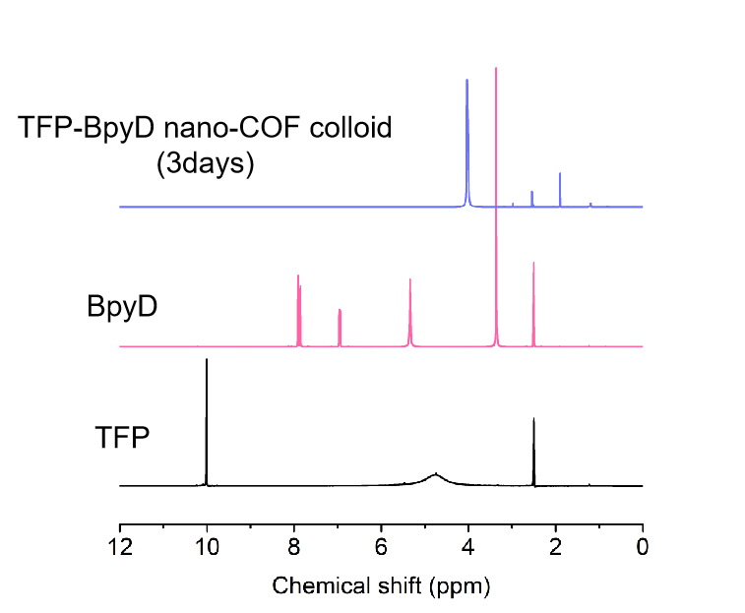
Supplementary Figure 2. ¹H NMR spectra of TFP-BpyD nano-COF colloid after 3-days reaction time, as compared with TFP and BpyD monomers. The peaks of colloid below 4 ppm are from the surfactants.

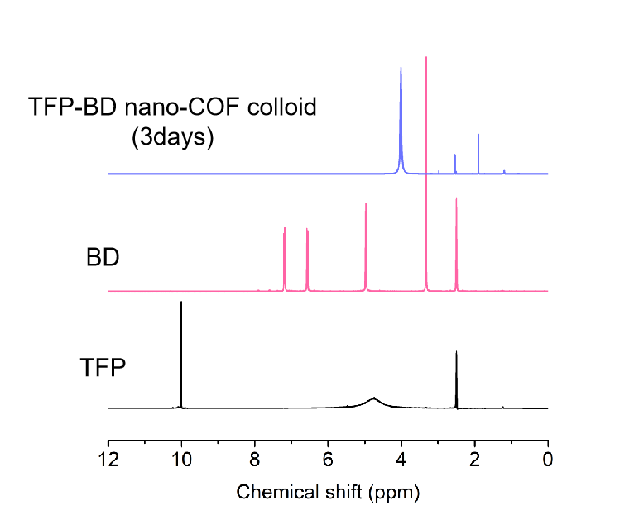
Supplementary Figure 3. ¹H NMR spectra of TFP-BD nano-COF colloid after 3-days reaction, as compared with TFP and BD monomers. The peaks of colloid below 4 ppm are from the surfactants.

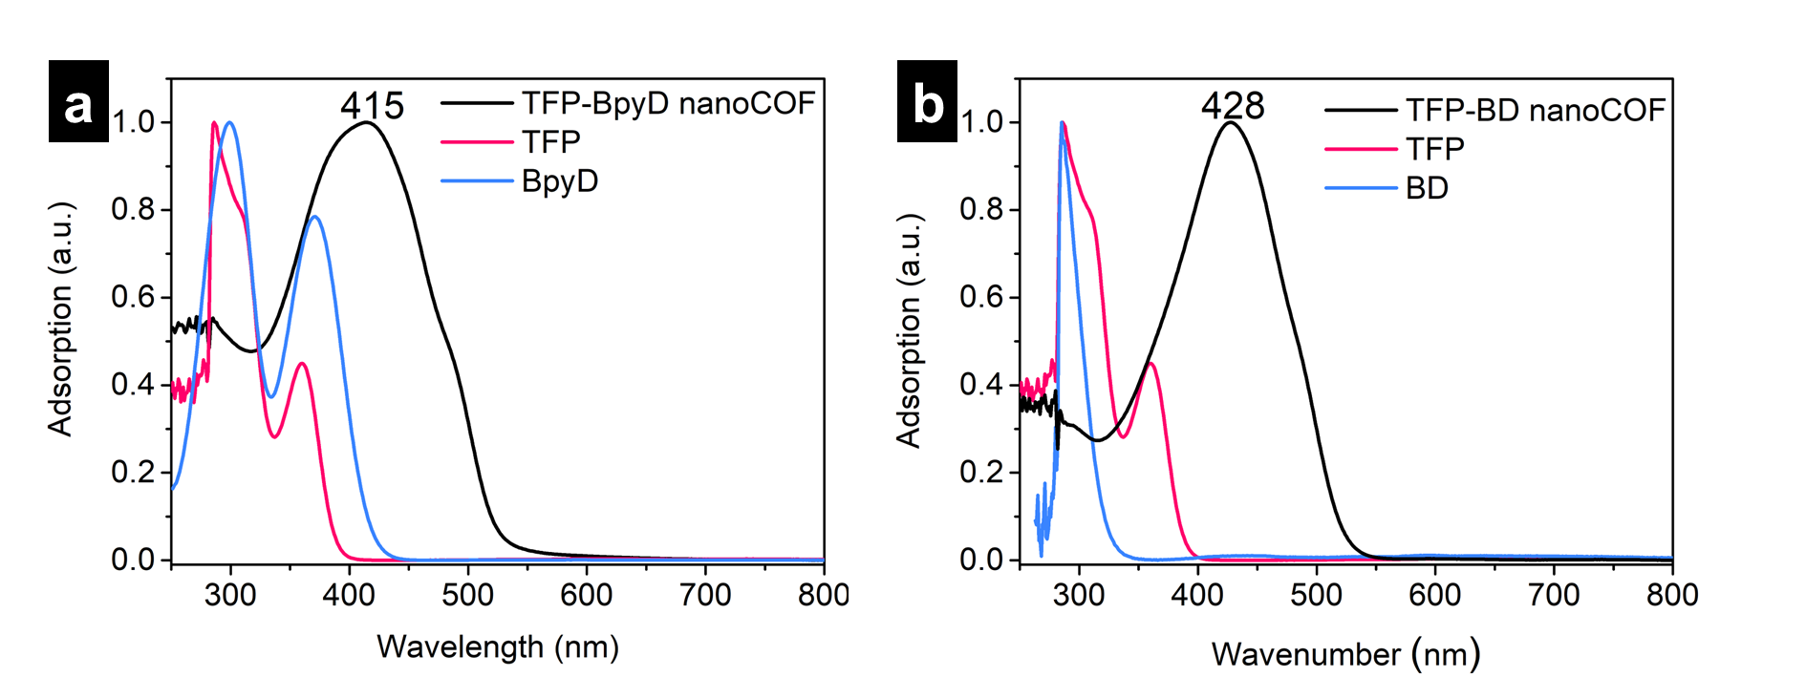
Supplementary Figure 4. UV-vis spectra of TFP-BpyD nano-COF (a) and TFP-BD nano-COF (b) colloids. Conditions: 0.10 mL TFP-BpyD nano-COF, TFP-BD nano-COF, TFP, BpyD and BD solutions were diluted by water to a total volume of 3 mL.

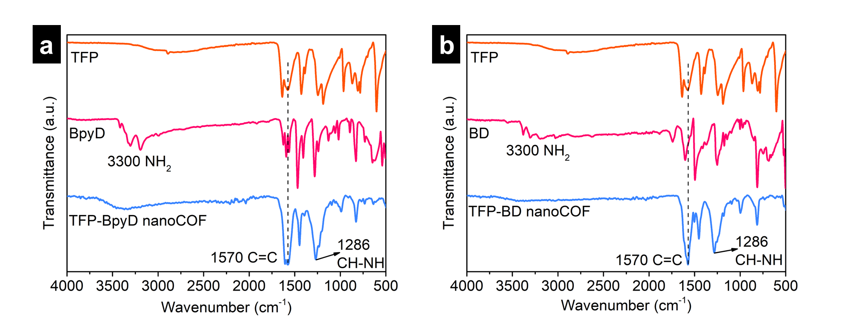
Supplementary Figure 5. FT-IR spectra of TFP-BpyD nano-COF (a) and TFP-BD nano-COF (b) compared with the spectra of the corresponding starting materials.

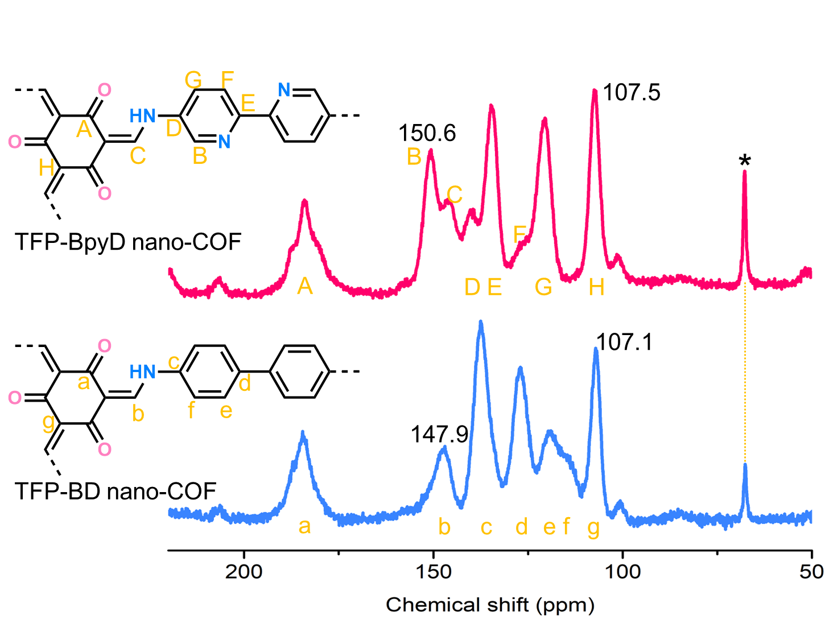
Supplementary Figure 6. ¹³C CP-MAS solid-state NMR spectra of TFP-BpyD and TFP-BD nano-COF. The absence of the peak at 192 ppm in the ¹³C CP-MAS NMR spectra indicated the total consumption of the starting materials. Both nano-COFs showed a clear signal near 184 and 148 ppm, corresponding to the carbonyl carbons and -CH-NH-, respectively. Spinning sidebands are denoted with asterisks.

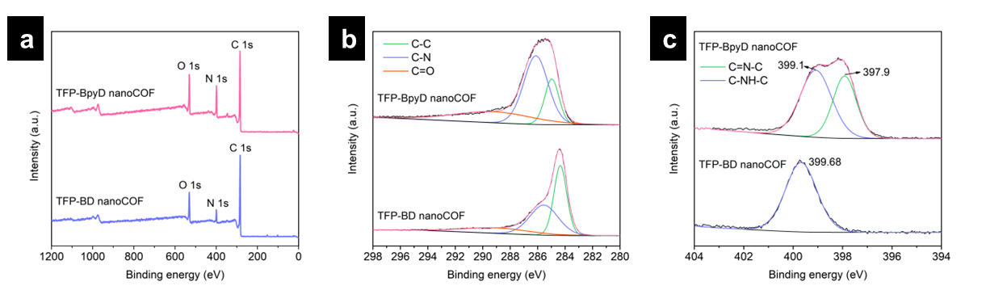
Supplementary Figure 7. XPS survey spectra of TFP-BpyD and TFP-BD nano-COF (a). High-resolution XPS spectra of C 1s (b) and N 1s (c) for TFP-BpyD and TFP-BD nano-COF. The full survey spectra confirmed the presence of C, N, and O elements of both nano-COFs. High-resolution XPS spectra of C 1s for both nano-COFs show the presence of ketoenamine C=O. High-resolution N 1s XPS spectrum of TFP-BpyD nano-COF can be deconvoluted into two individual peaks at 399.1 and 397.9 eV, attributable to the keto-enamine N (−C−HN−C−) and pyridinic N (−C=N−C−), respectively.

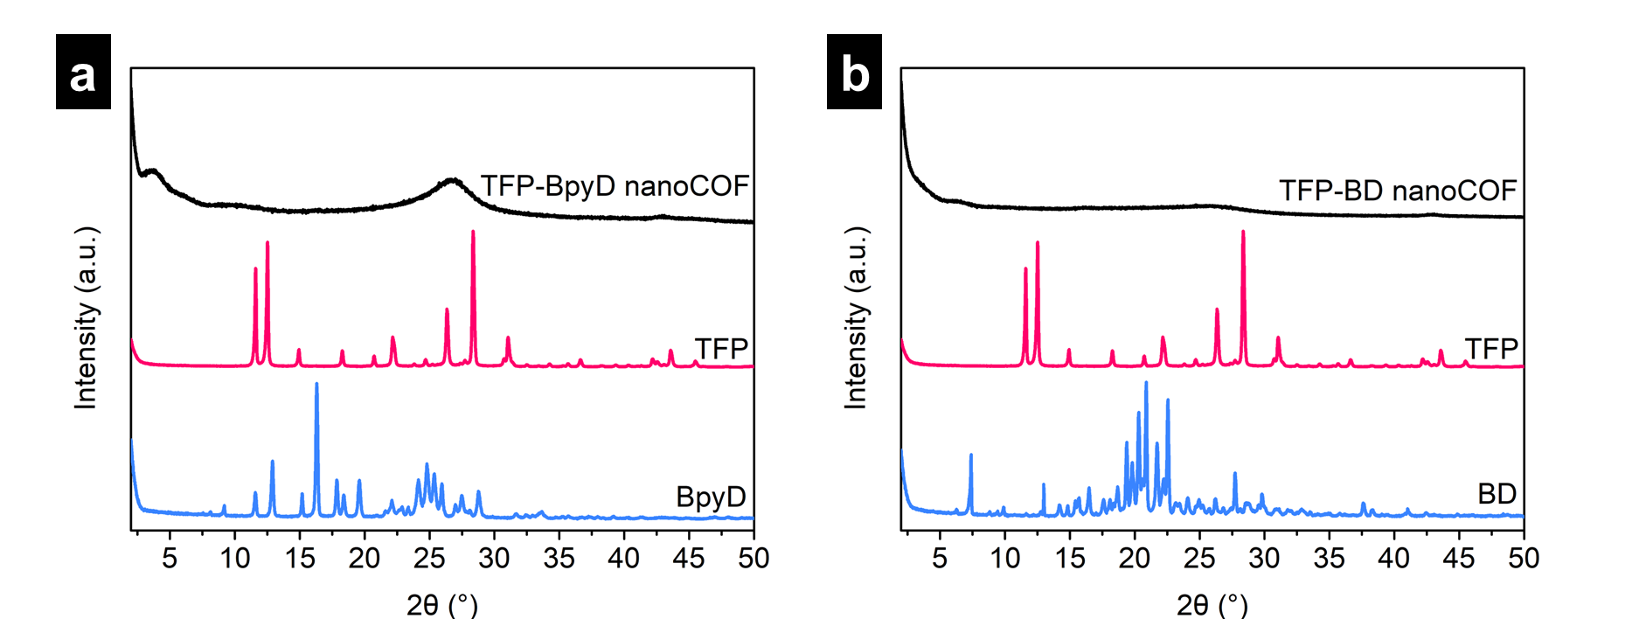
Supplementary Figure 8. PXRD patterns of TFP-BpyD nano-COF (a) and TFP-BD nano-COF (b), as compared with PXRD patterns for the respective crystalline monomers.

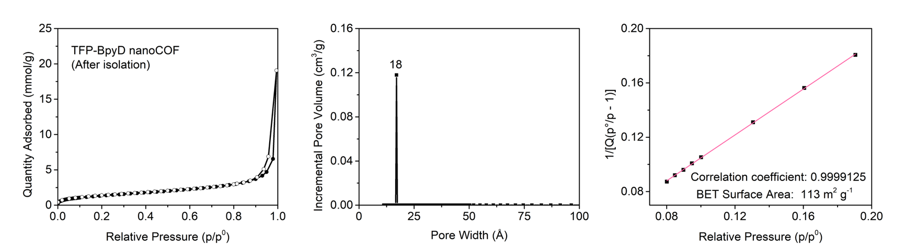
Supplementary Figure 9. N₂ adsorption and desorption profiles at 77.3 K (left), pore size distribution profile calculated by DFT (center) and BET surface area plot derived from N₂ sorption isotherm of TFP-BpyD nano-COF (right).

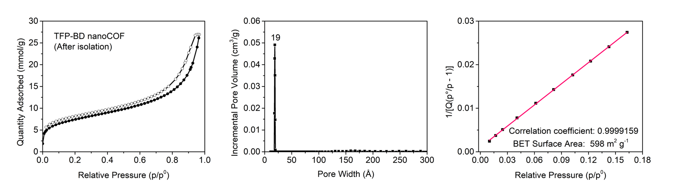
Supplementary Figure 10. N₂ adsorption and desorption profiles at 77.3 K, pore size distribution profile calculated by DFT and BET surface area plot derived from N₂ sorption isotherm of TFP-BD nano-COF.

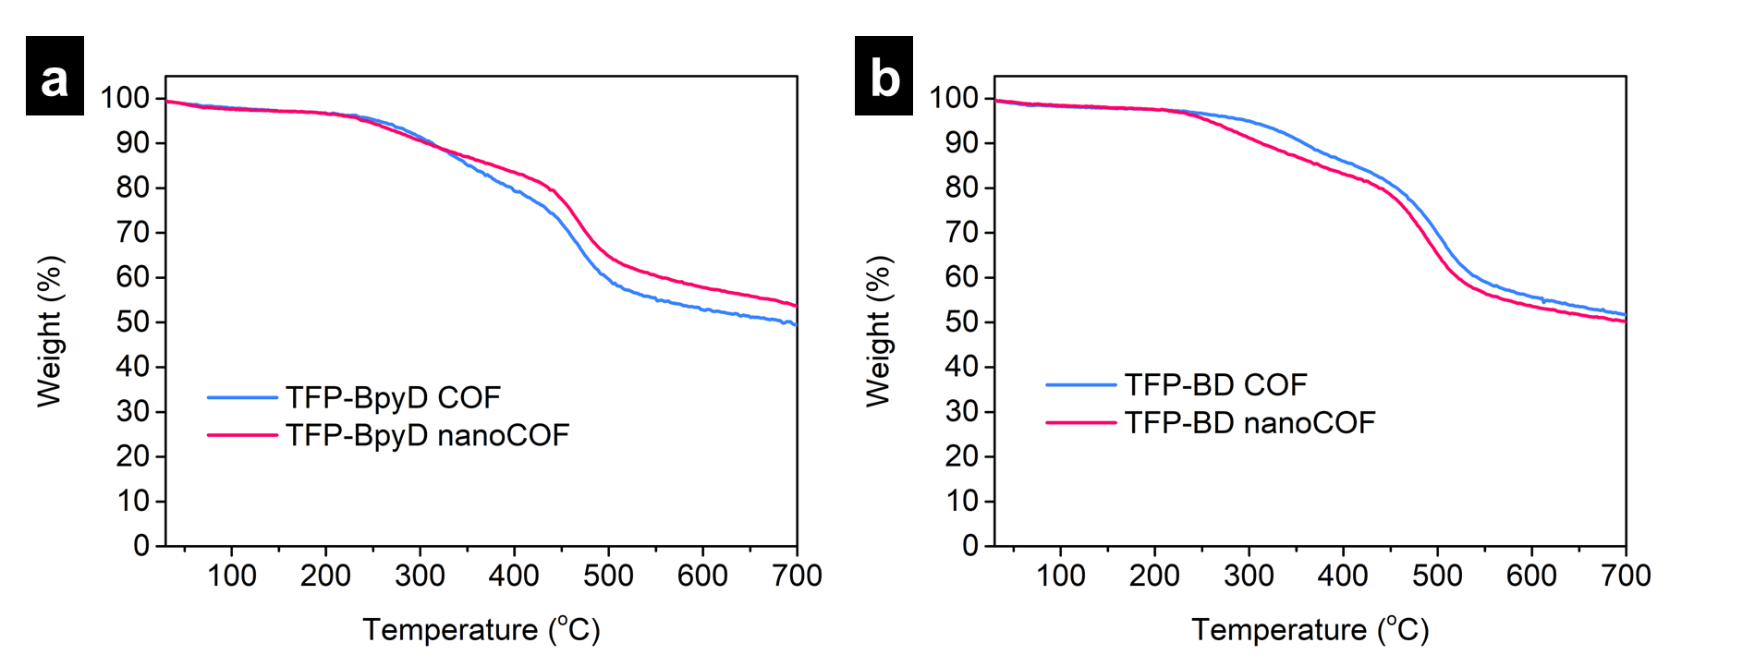
Supplementary Figure 11. TGA data of TFP-BpyD COF and TFP-BpyD nano-COF (a), and TFP-BD COF and TFP-BD nano-COF (b) measured under N₂.

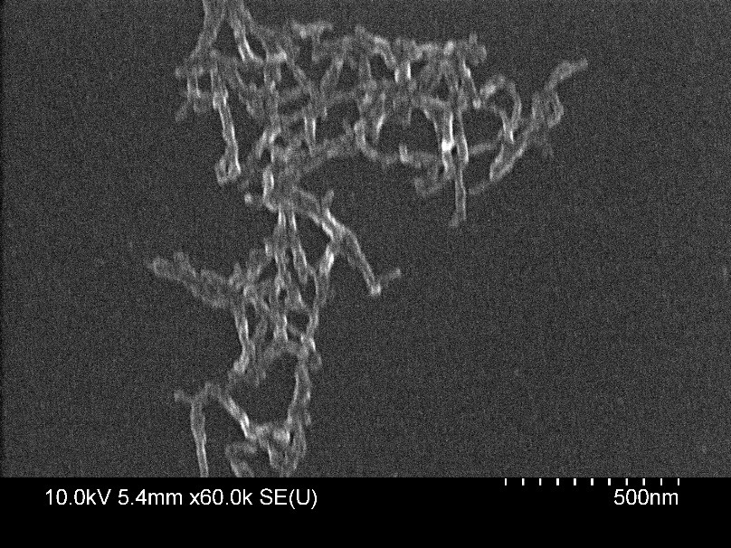
Supplementary Figure 12. SEM image of TFP-BpyD nano-COF.

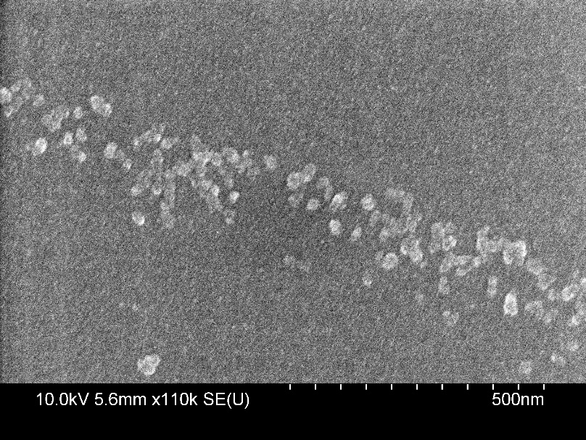
Supplementary Figure 13. SEM image of TFP-BD nano-COF.

Supplementary Figure 14. TEM images of TFP-BpyD nano-COF.

Supplementary Figure 15. TEM images of TFP-BD nano-COF.

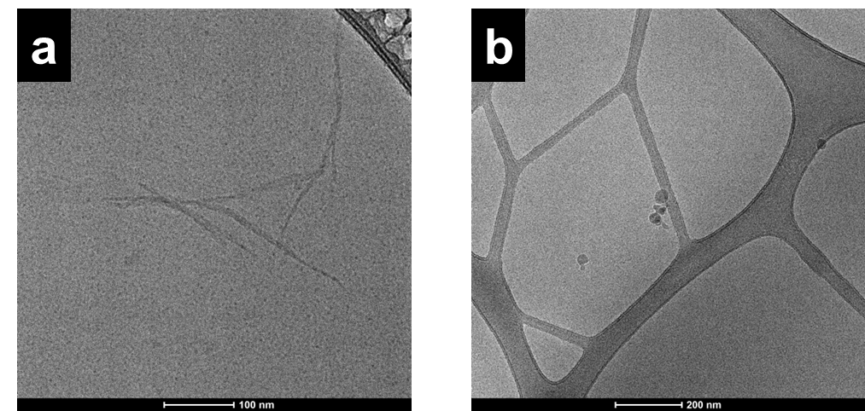
Supplementary Figure 16. Cryo-TEM images of TFP-BpyD nano-COF (a) and TFP-BD nano-COF (b).

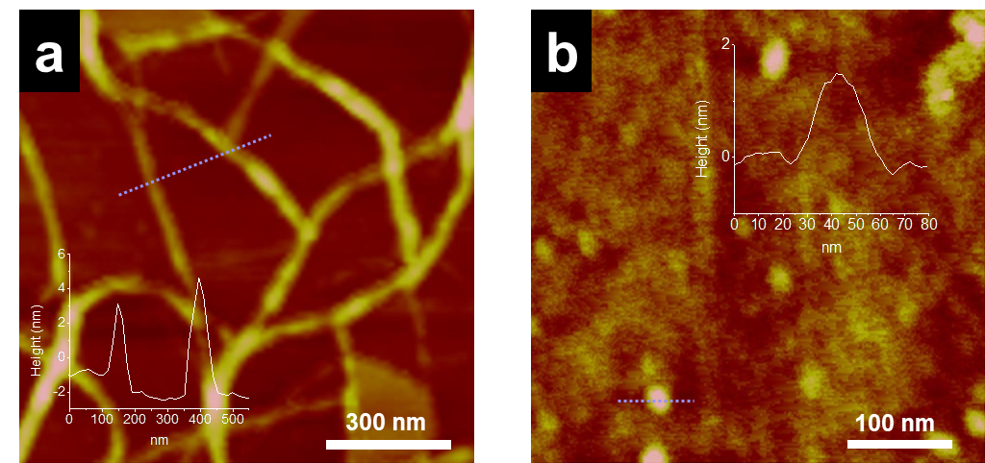
Supplementary Figure 17. AFM images of TFP-BpyD nano-COF (a) and TFP-BD nano-COF (b).

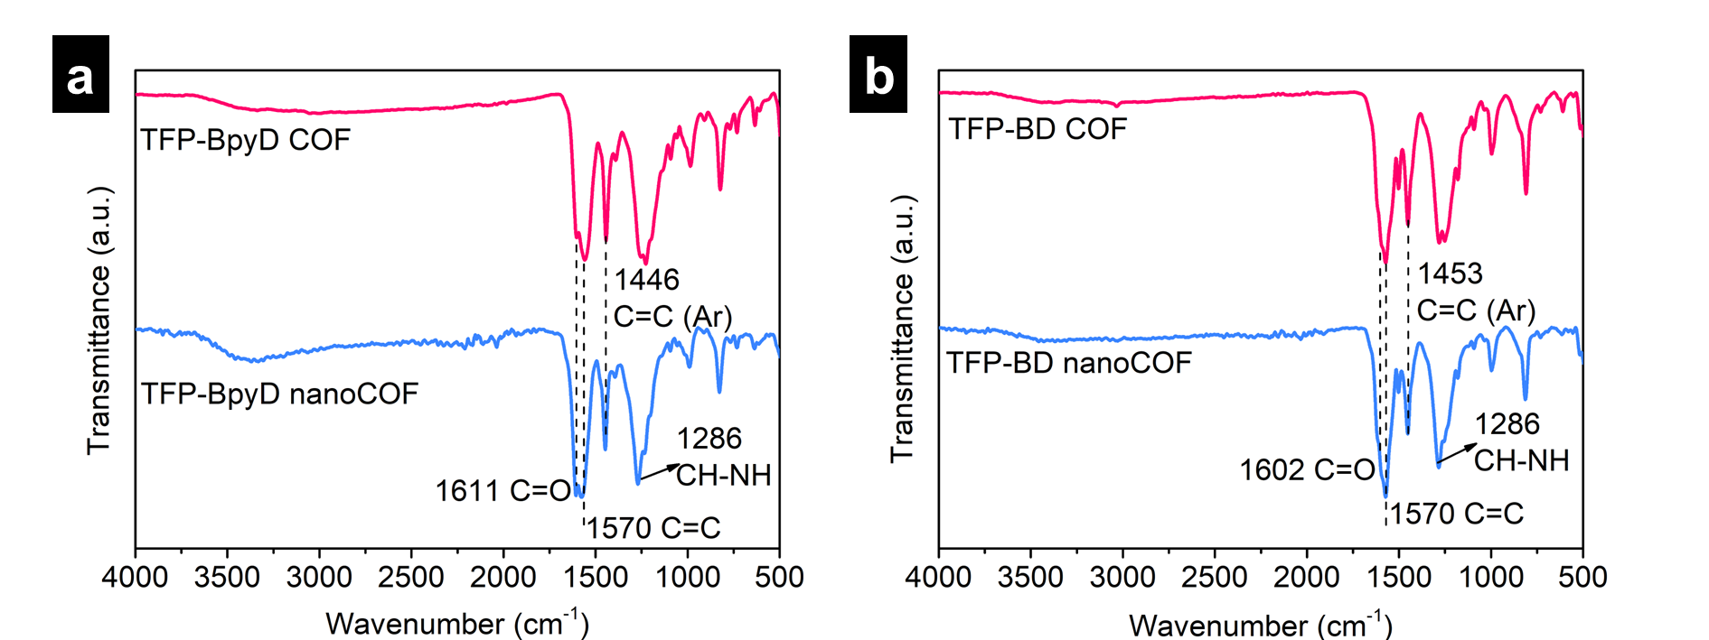
Supplementary Figure 18. FT-IR spectra of TFP-BpyD nano-COF (a) and TFP-BD nano-COF (b) compared with the spectra of the analogous bulk materials, TFP-BpyD COF and TFP-BD COF. FT-IR spectra revealed appearance of stretching bands at around 1570 cm⁻¹ and 1286 cm⁻¹, which are assigned to the C=C and CH–NH bonds, indicating the formation of β-ketoenamine linkage in the two nano-COFs. However, because of the peak broadening in the extended structure, all C=O peaks of these COFs at around 1610 cm^{–1} were merged with the C=C stretching band at 1570 cm^{–1} and appeared as a shoulder.

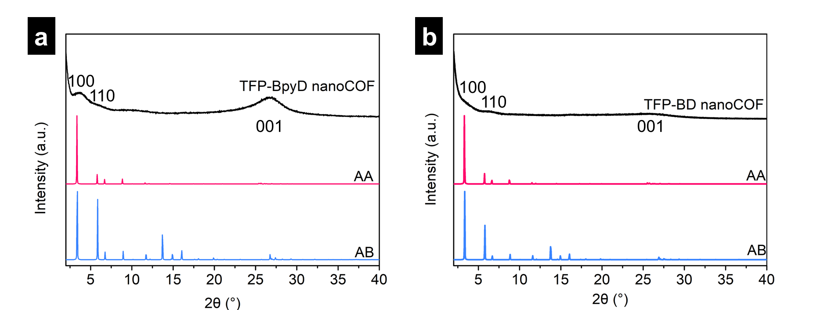
Supplementary Figure 19. PXRD patterns of TFP-BpyD nano-COF (a) and TFP-BD nano-COF (b), as compare with calculated models. Both nano-COFs show very little long-range order. The experimental PXRD pattern of TFP-BpyD nano-COF exhibited a relatively strong diffraction peak around at 3.4 °, which corresponds to the (100) reflection. Other reflection assignments are at best tentative given the very limited crystallinity in these nano-COFs.

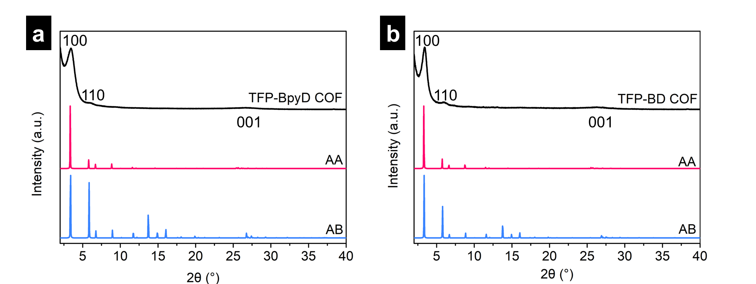
Supplementary Figure 20. Comparison of observed PXRD patterns of bulk TFP-BpyD COF (a) and TFP-BD COF (b) with calculated models. These materials are significantly more crystalline than the nano-COF equivalents (Supplementary Figure 19). The experimental PXRD patterns of TFP-BpyD and TFP-BD COF both exhibited strong diffraction peaks around at 3.4 ° and relatively weak signals at 5.9 °, which correspond to the (100) and (110) reflections, respectively. The assignments for the weak reflections are at best tentative given the very limited crystallinity in these nano-COFs.

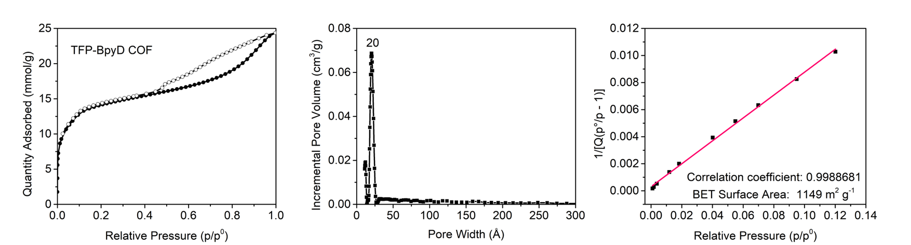
Supplementary Figure 21. N₂ adsorption and desorption profiles at 77.3 K, pore size distribution profile calculated by DFT, and BET surface area plot derived from N₂ sorption isotherm of TFP-BpyD COF.

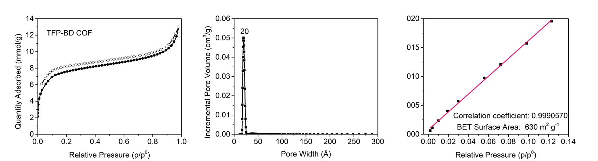
Supplementary Figure 22. N₂ adsorption and desorption profiles at 77.3 K, pore size distribution profile calculated by DFT, and BET surface area plot derived from N₂ sorption isotherm of TFP-BD COF.

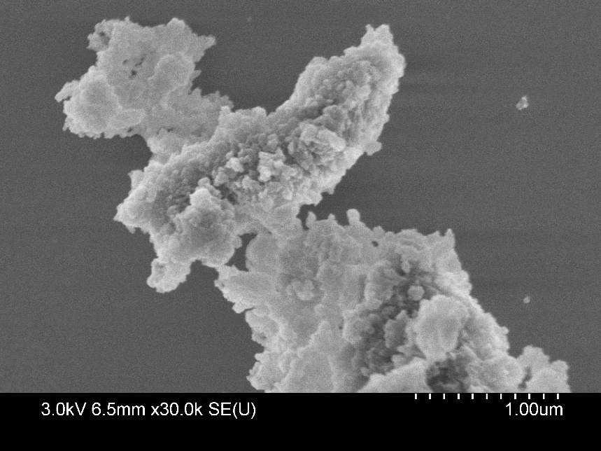
Supplementary Figure 23. SEM image of bulk TFP-BpyD COF.

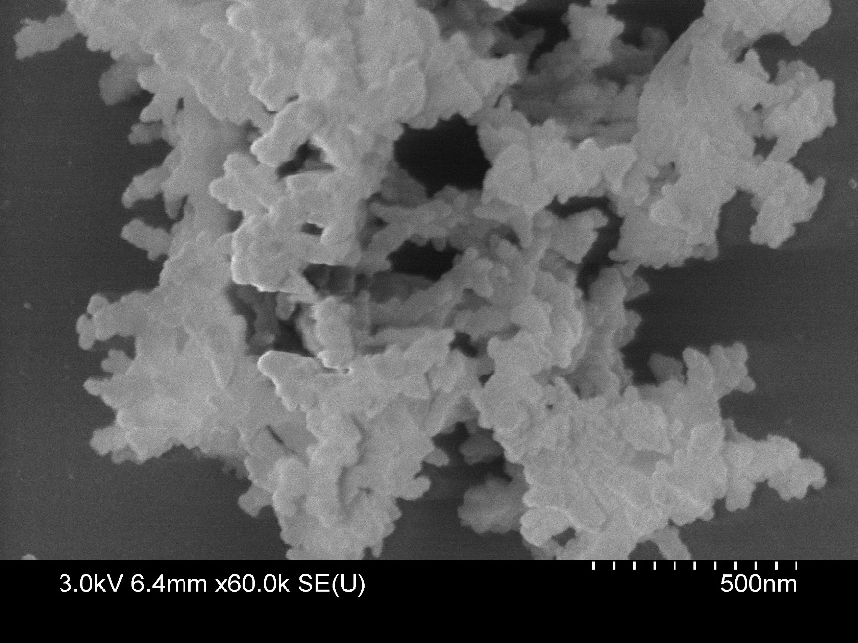
Supplementary Figure 24. SEM image of bulk TFP-BD COF.

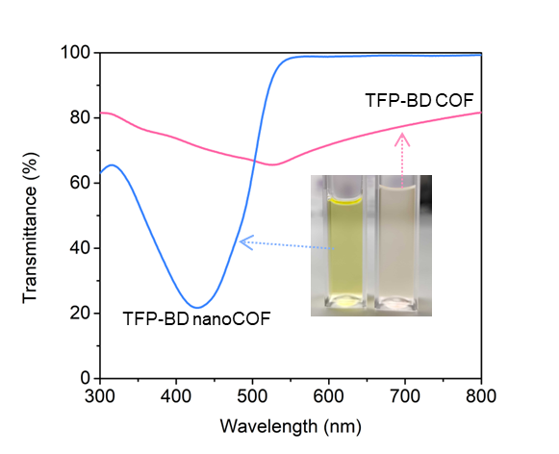
Supplementary Figure 25. Transmittance spectra of TFP-BD nano-COF as compared with bulk TFP-BD COF at the same concentration (5.67 μg / mL).

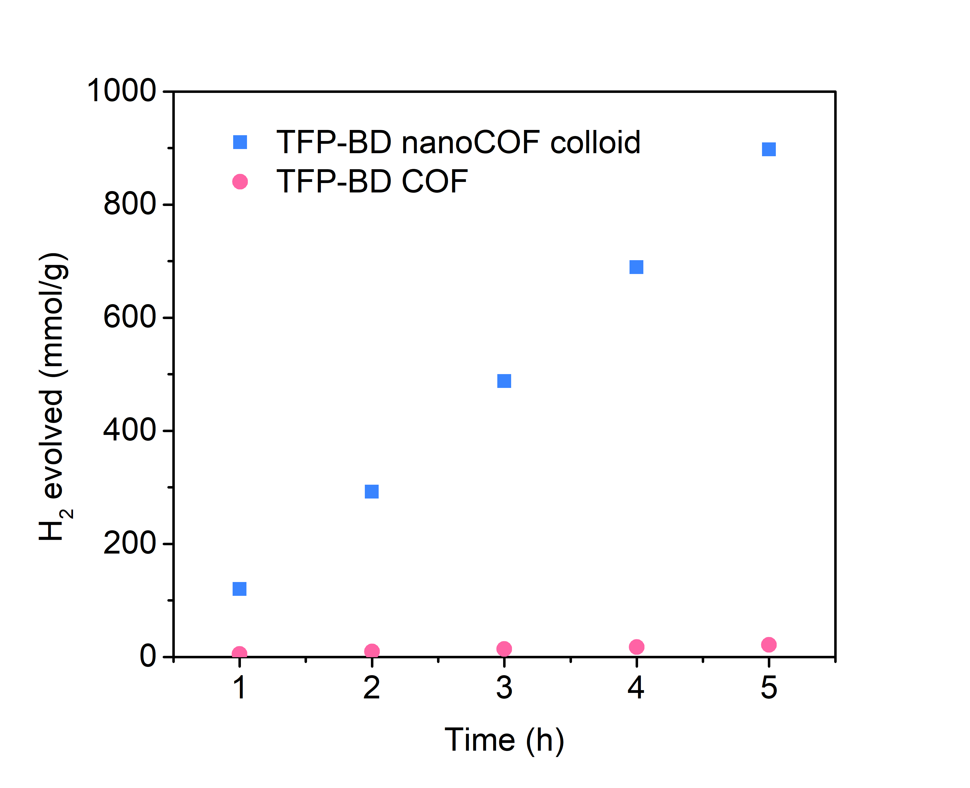
Supplementary Figure 26. Comparison of photocatalytic H₂ evolution of TFP-BD nano-COF with bulk TFP-BD COF over 5 h (conditions for nano-COF: 0.5 mL TFP-BD nano-COF in 24.5 mL water, diluted H₂PtCl₆ solution as a platinum precursor (15 wt % vs photocatalysts), 880 mg AA (overall concentration is 0.2 M), λ > 420 nm; conditions for bulk COFs: 5 mg of bulk COF catalyst in water, diluted H₂PtCl₆ solution as a platinum precursor (4 wt % vs photocatalysts), 0.2 M AA (25 mL), λ > 420 nm.

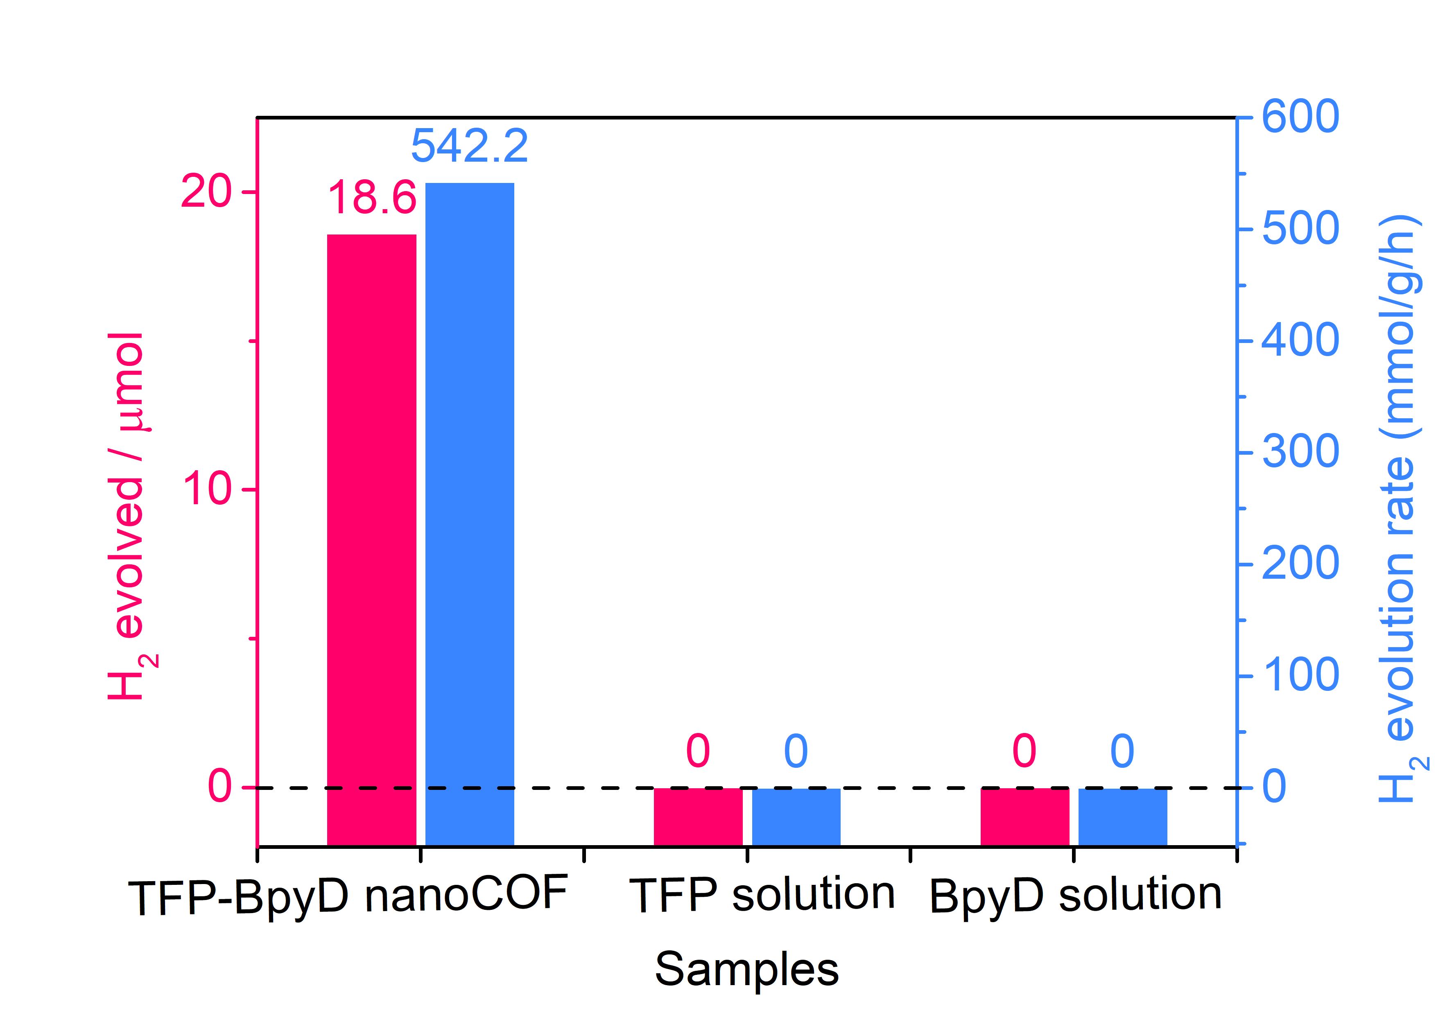
Supplementary Figure 27. Photocatalytic H₂ production for TFP-BpyD nano-COF colloid along with control samples (monomer solutions). Reaction conditions: TFP-BpyD nano-COF colloid (0.05 mL), TFP solution (0.05 mL) or BpyD solution (0.05 mL) in 0.2 M AA solution (5 mL total volume), 15 wt % Pt vs photocatalysts, 1 h illumination (Oriel Solar Simulator, 1.0 sun).

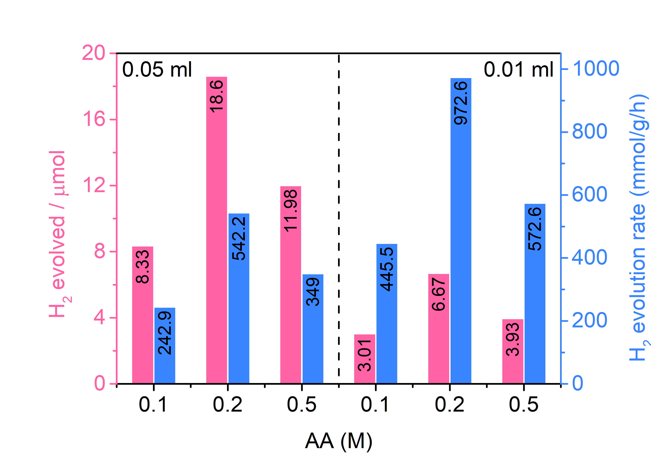
Supplementary Figure 28. TFP-BpyD nano-COF for sacrificial photocatalytic H₂ evolution at different concentrations. Condition: TFP-BpyD nano-COF (0.05 mL or 0.01 mL) in 0.1, 0.2 or 0.5 M AA solution (5 mL total volume), 15 wt % Pt vs photocatalysts, 2 h illumination (Oriel Solar Simulator, 1.0 sun). Blue bars: mass normalized H₂ evolution rate; pink bars: absolute H₂ amount evolved.

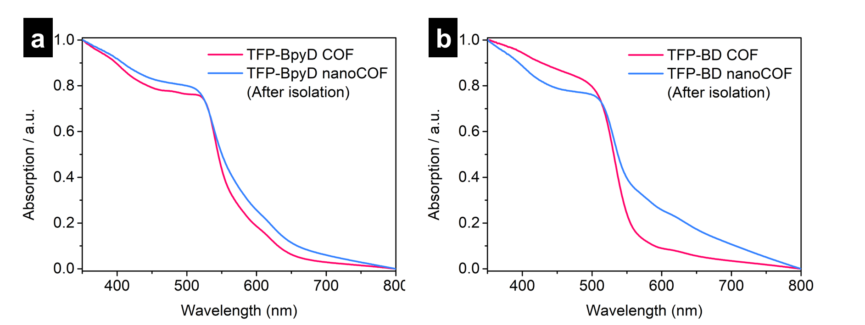
Supplementary Figure 29. UV-vis spectra of TFP-BpyD COF and solid TFP-BpyD nano-COF (a), and TFP-BD COF and solid TFP-BD nano-COF (b) (normalized absorption units).

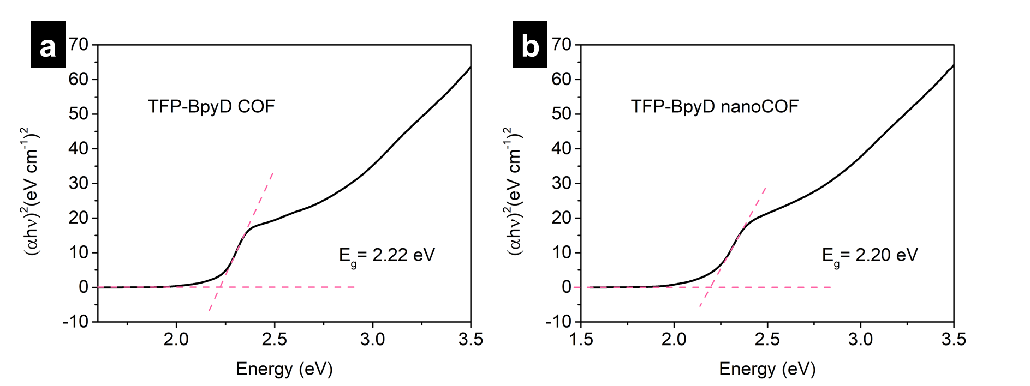
Supplementary Figure 30. Kubelka-Munk-transformed reflectance spectra of TFP-BpyD COF (a) and solid TFP-BpyD nano-COF (b) and calculated optical gaps.

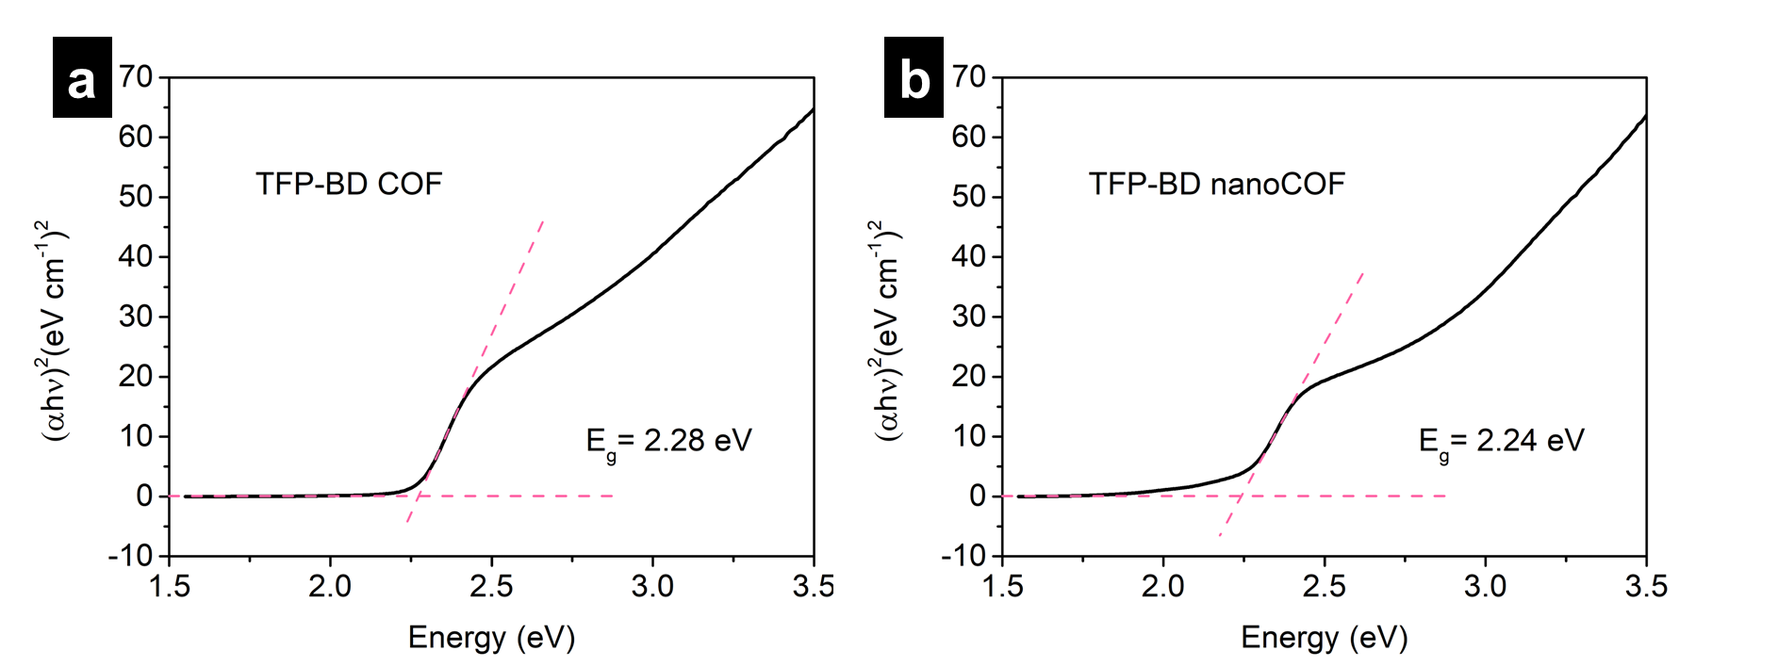
Supplementary Figure 31. Kubelka-Munk-transformed reflectance spectra of TFP-BD COF (a) and solid TFP-BD nano-COF (b) and calculated optical gaps.

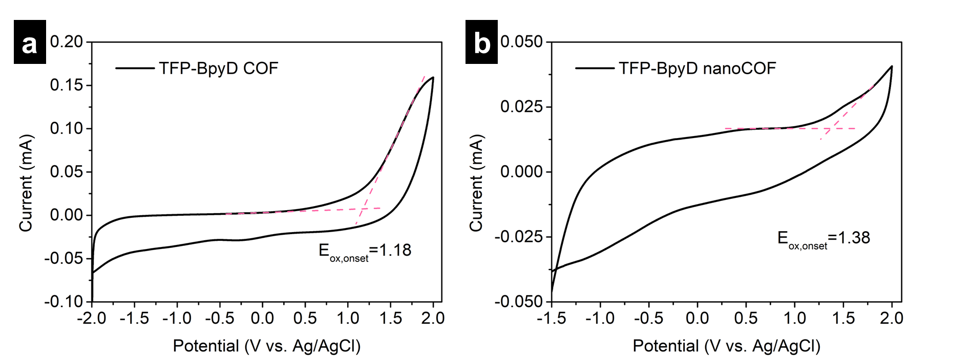
Supplementary Figure 32. Oxidation onset potential of TFP-BpyD COF (a) and solid TFP-BpyD nano-COF (b) as measured by cyclic voltammetry at a scan rate of 50 mV/s.

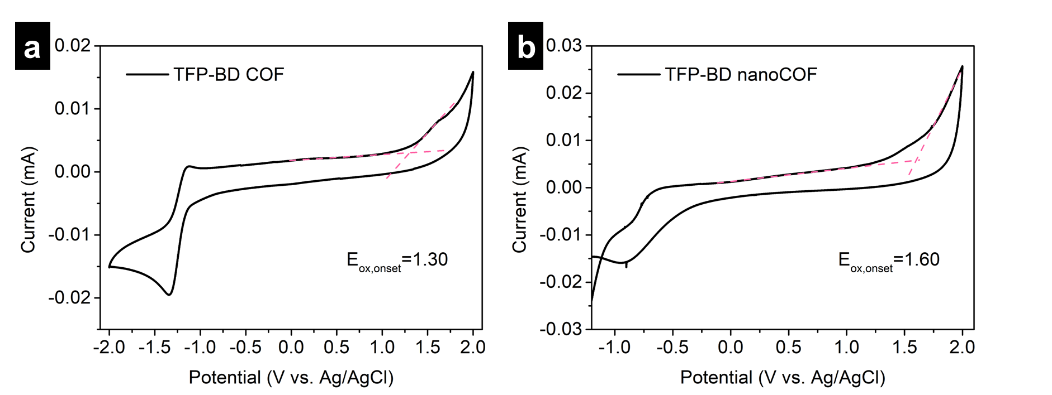
Supplementary Figure 33. Oxidation onset potential of TFP-BD COF (a) and solid TFP-BD nano-COF (b) as measured by cyclic voltammetry at a scan rate of 50 mV/s.

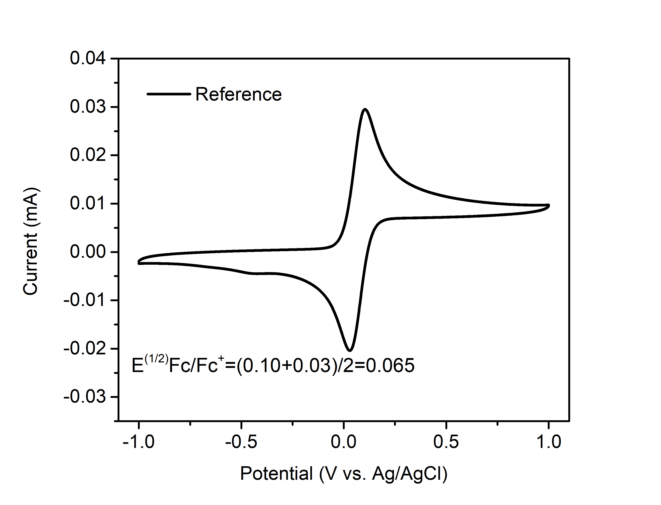
Supplementary Figure 34. Ferrocenium/ferrocene (Fc/Fc⁺) redox couple used as an external potential reference.

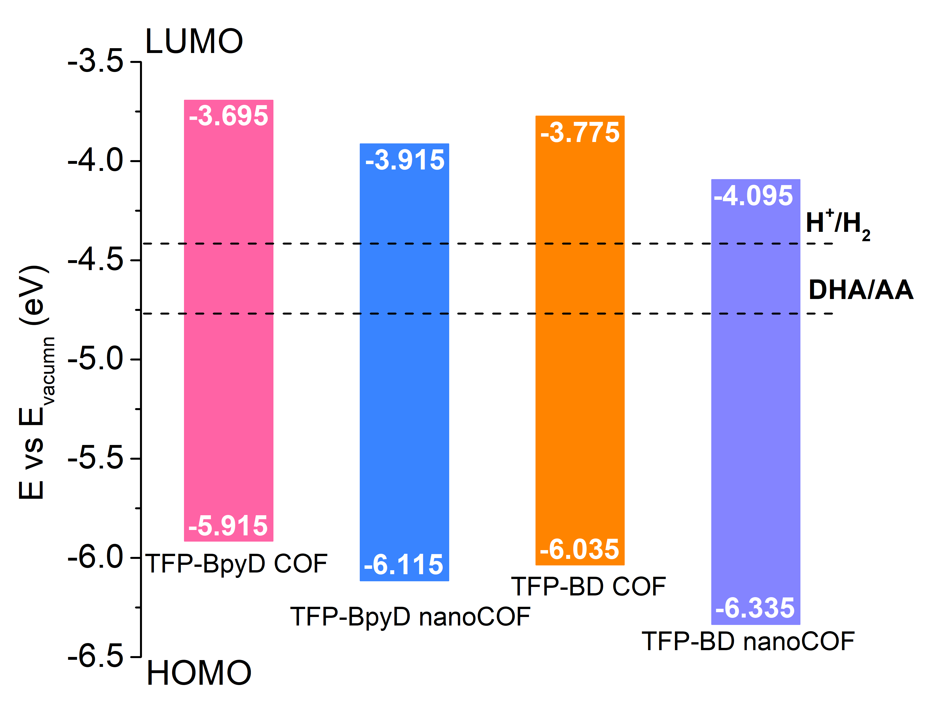
Supplementary Figure 35. Highest occupied and lowest unoccupied molecular orbital energy levels of TFP-BpyD COF, TFP-BpyD nano-COF, TFP-BD COF and TFP-BD nano-COF compared to the proton reduction potential (H⁺/H₂), based on experimental measurements (Supplementary Figures 29–34), and the calculated potential for the two-hole oxidation of ascorbic acid to dehydroascorbic acid in solution (DHA/AA)¹ as determined from CV and UV measurements (0 V versus SHE = −4.44 V versus vacuum).

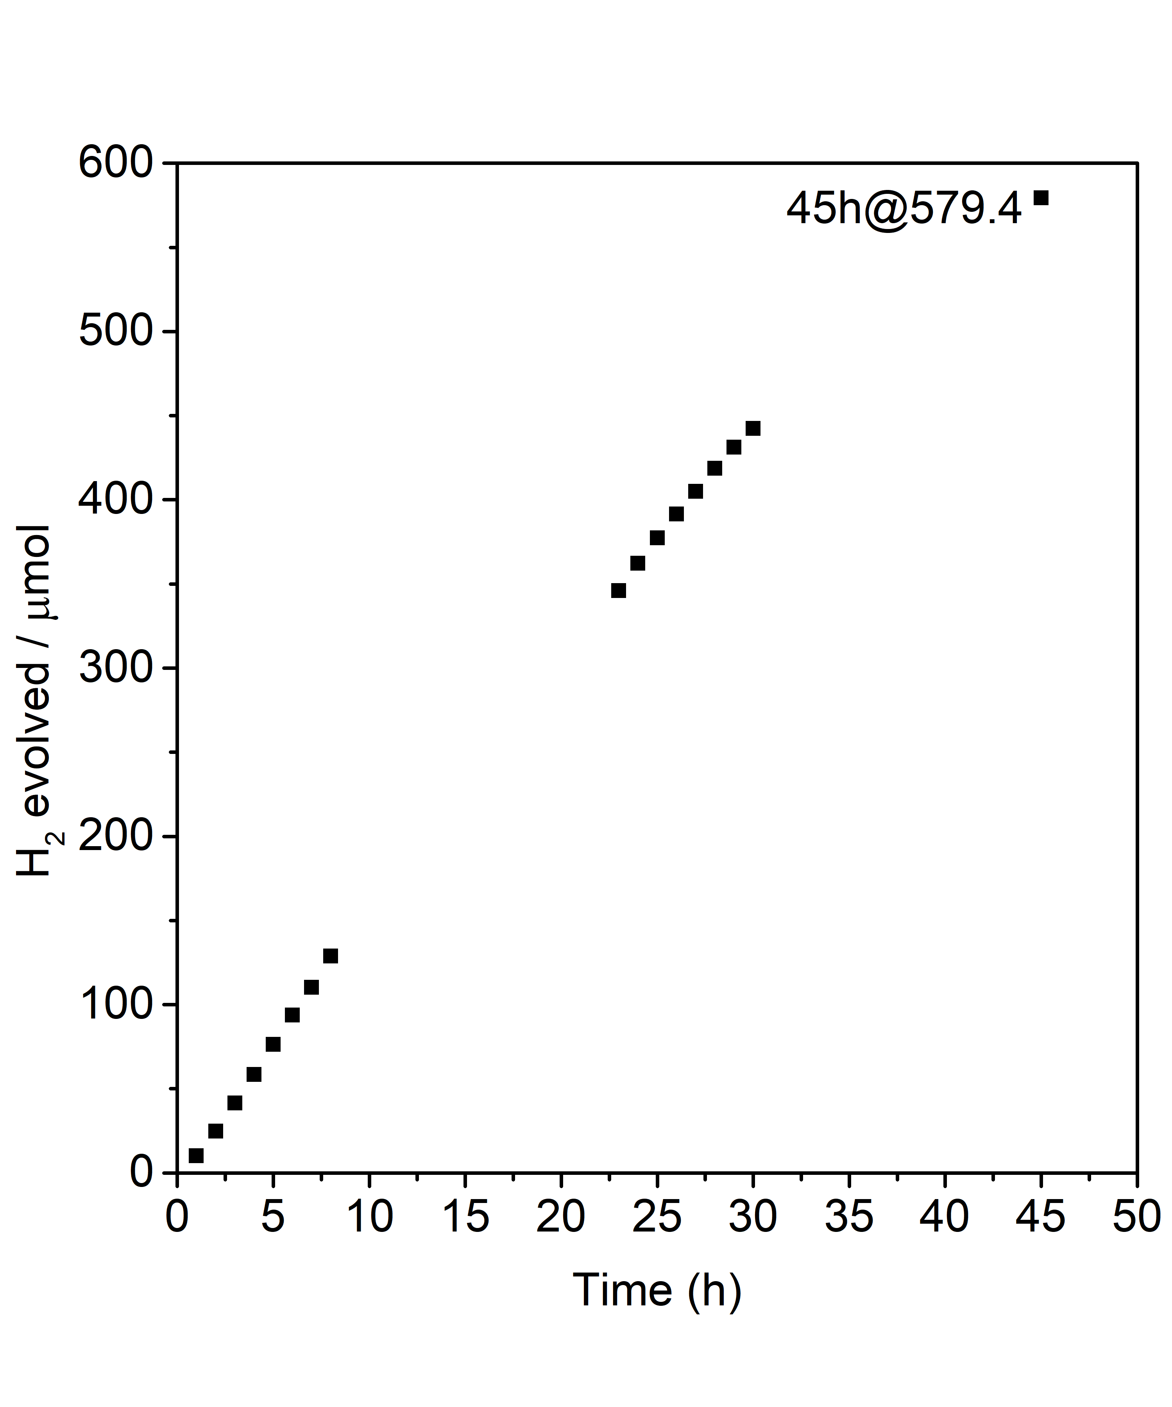
Supplementary Figure 36. Plot showing sacrificial photocatalytic H₂ evolution as a function of time for TFP-BD nano-COF over 45 h (0.5 mL TFP-BD nano-COF colloid in 24.5 mL water, diluted H₂PtCl₆ solution as a platinum precursor (15 wt% vs photocatalysts), 880 mg AA (overall concentration is 0.2 M), λ > 420 nm).

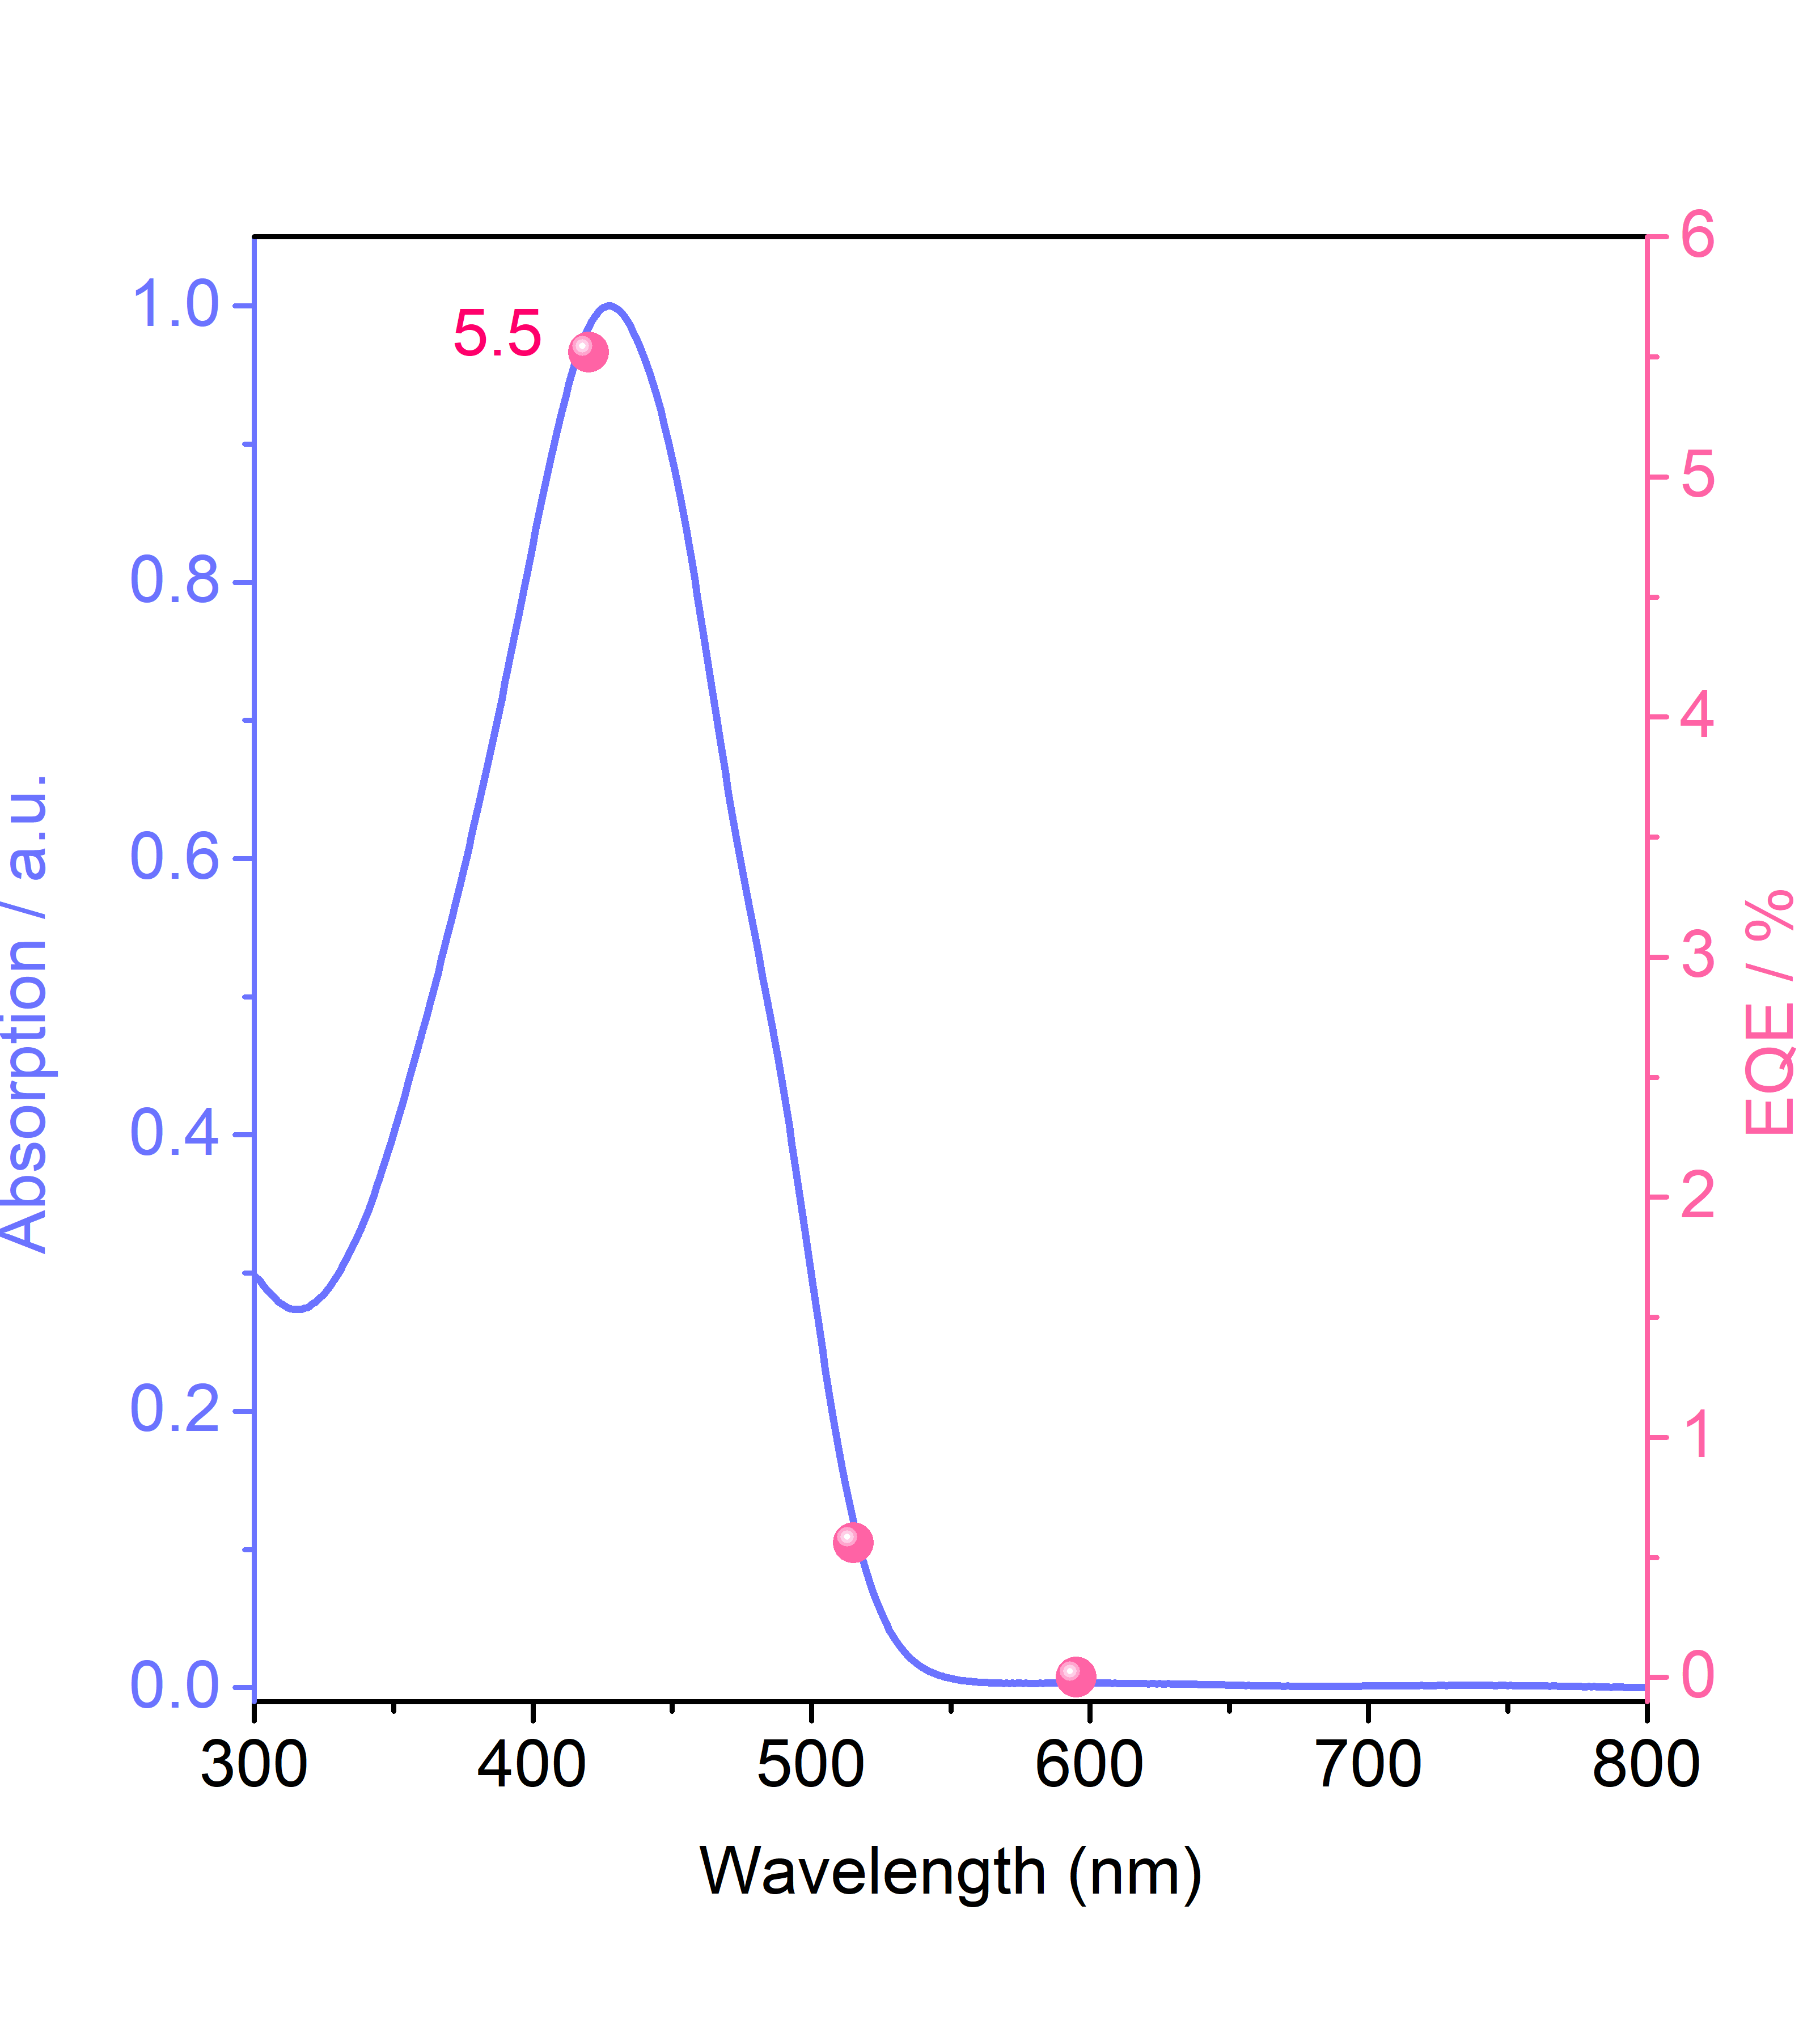
Supplementary Figure 37. Overlay of the UV/vis absorption spectrum for TFP-BD nano-COF with external quantum efficiency (EQE) at three different incident light wavelengths.

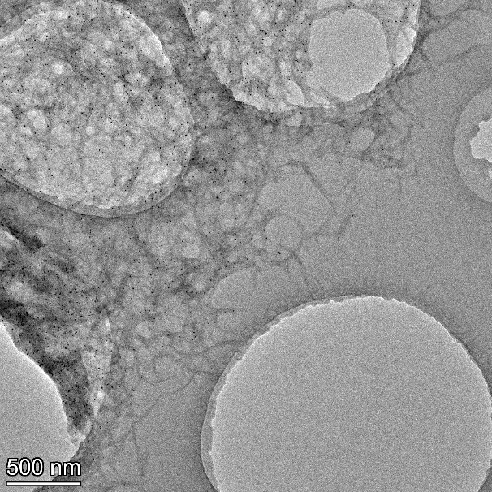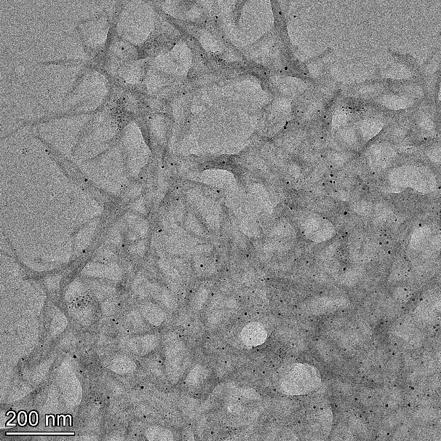
Supplementary Figure 38. TEM images for TFP-BpyD nano-COF decorated with photo-deposited Pt co-catalyst (dark / black spots).

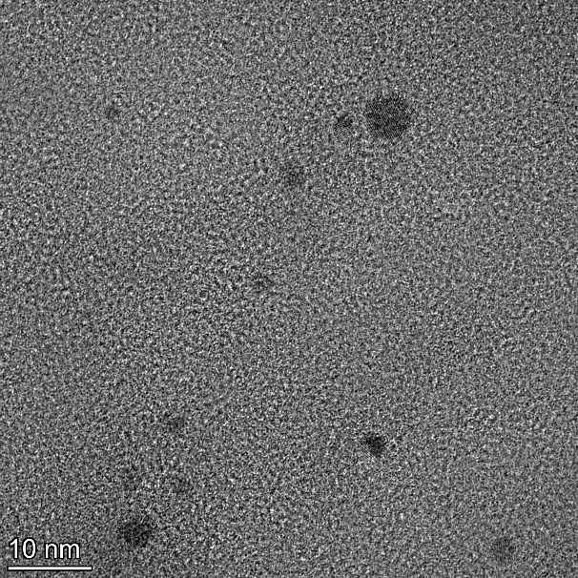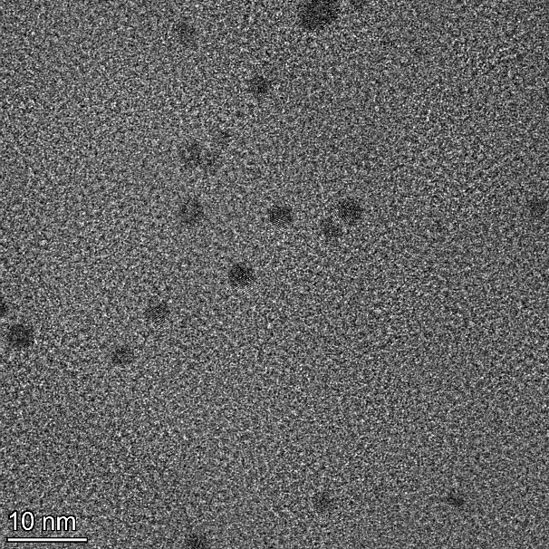
Supplementary Figure 39. TEM images for photo-deposited Pt co-catalyst on TFP-BpyD nano-COF (dark / black spots).

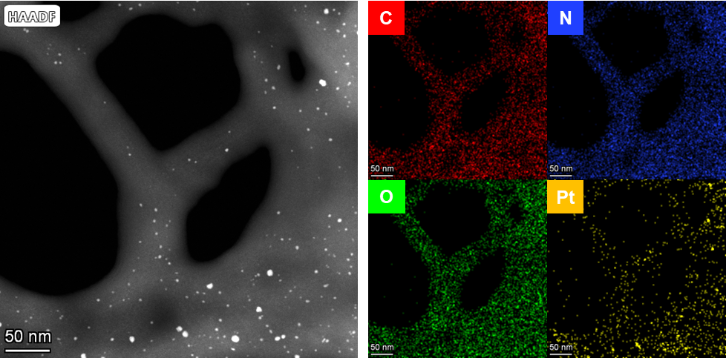
Supplementary Figure 40. High-angle annular dark field scanning transmission electron microscopy (HAADF-STEM) images and elemental mapping for TFP-BpyD nano-COF decorated with photo-deposited Pt co-catalyst.

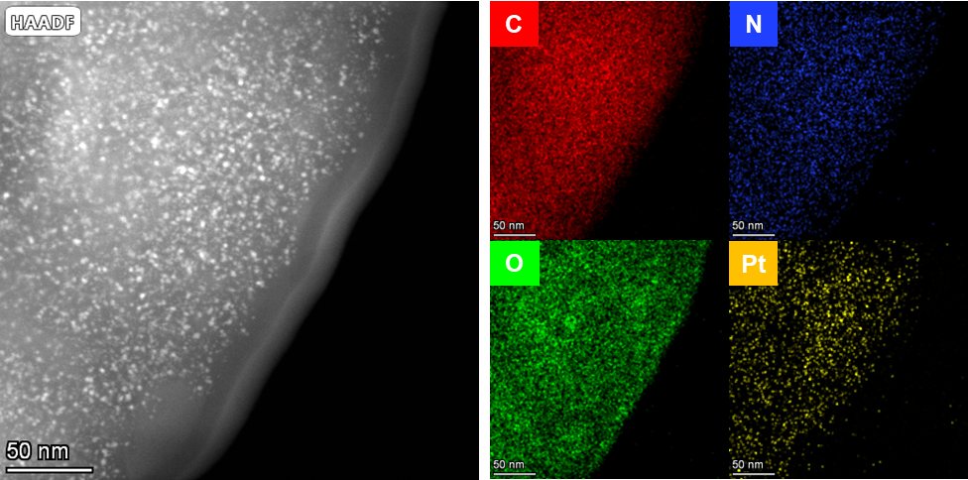
Supplementary Figure 41. High angle annular dark field scanning transmission electron microscopy (HAADF-STEM) images and elemental mapping for TFP-BD nano-COF decorated with photo-deposited Pt co-catalyst.

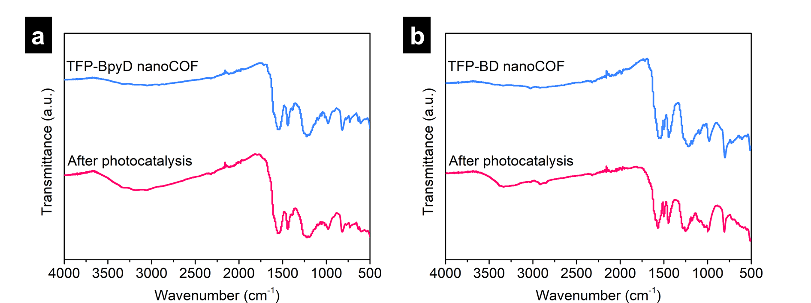
Supplementary Figure 42. FT-IR spectra of TFP-BpyD nano-COF (a) and TFP-BD nano-COF (b) before and after photocatalysis.

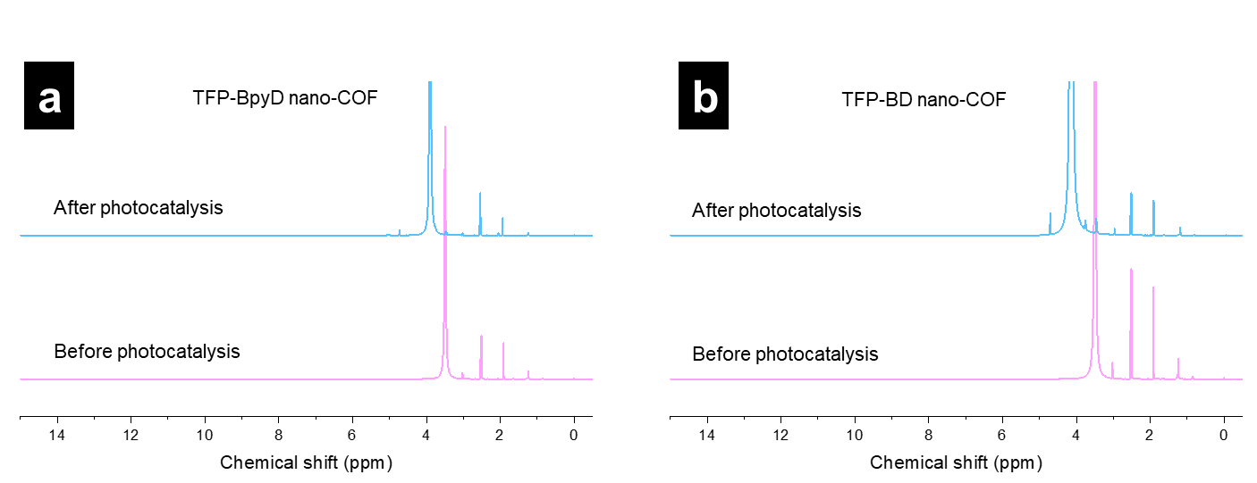
Supplementary Figure 43. NMR spectra of TFP-BpyD nano-COF (a) and TFP-BD nano-COF (b) before and after photocatalysis. No monomer signals were detected. The shift for water signals (~3.33 ppm) after photocatalysis was due to the presence of AA.

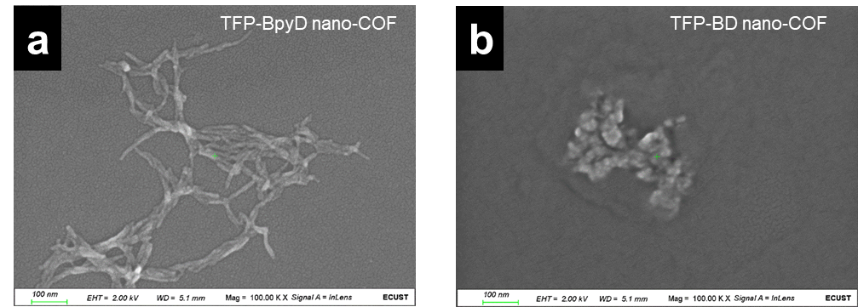
Supplementary Figure 44. SEM images of TFP-BpyD nano-COF (a) and TFP-BD nano-COF (b) after photocatalysis.

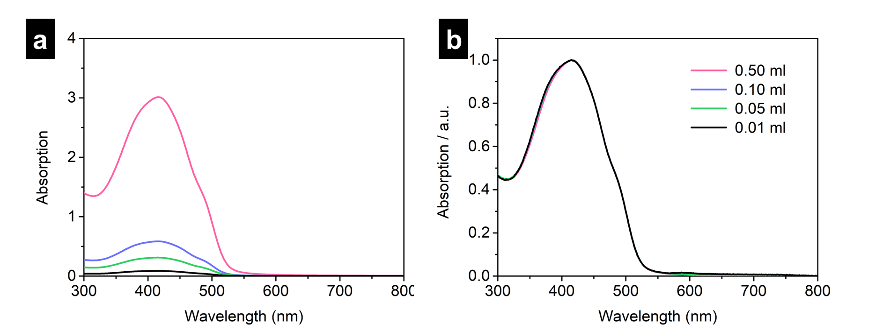
Supplementary Figure 45. UV-vis spectra of TFP-BpyD nano-COF at different concentrations before (a) and after (b) normalization. Conditions: 0.01, 0.05, 0.10 and 0.50 mL of TFP-BpyD nano-COF stock colloid solution were diluted by water to a total volume of 5 mL.

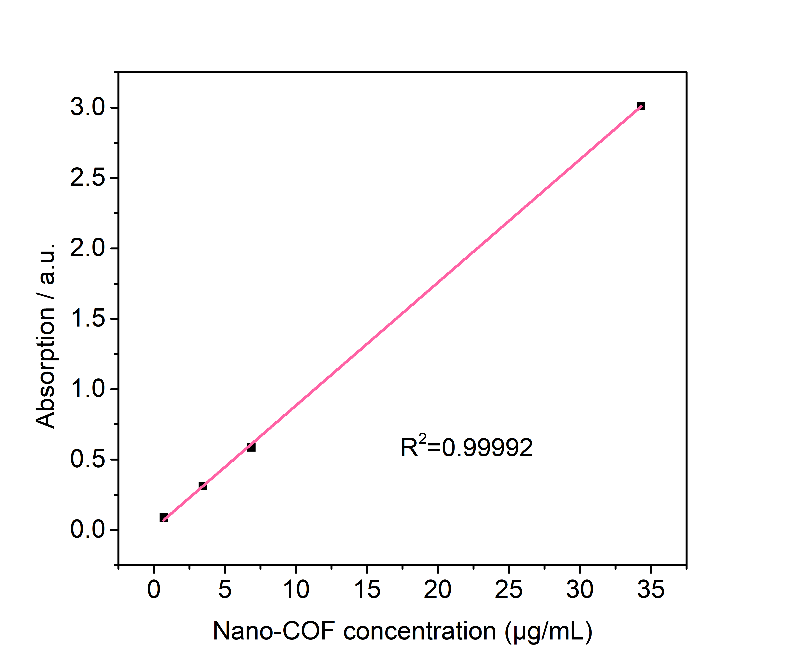
Supplementary Figure 46. Calibration curve for UV-vis spectra of TFP-BpyD nano-COF solutions using the absorption peak at 416 nm. Conditions: 0.01, 0.05, 0.10 and 0.50 mL TFP-BpyD nano-COF were diluted by water to a total volume of 5 mL.

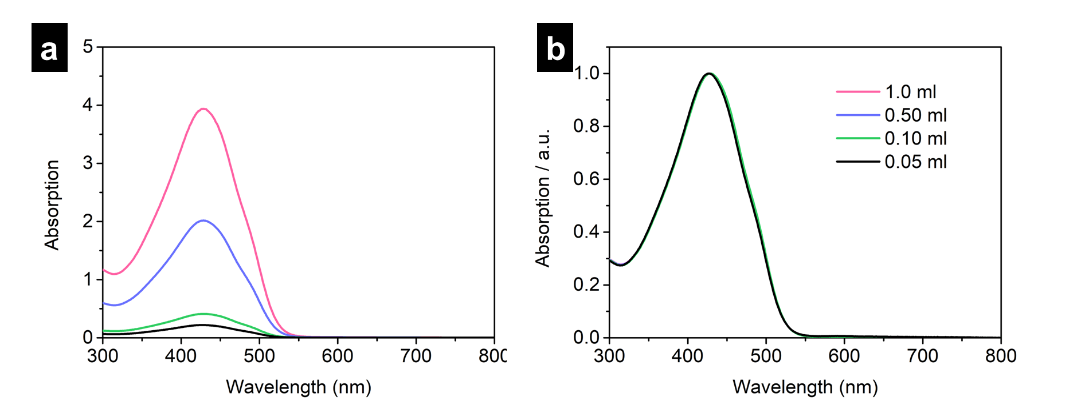
Supplementary Figure 47. UV spectra of TFP-BD nano-COF at different concentrations before (a) and after (b) normalization. Conditions: 0.05, 0.10, 0.50 and 1.0 mL TFP-BD nano-COF were diluted by water to a total volume of 5 mL.

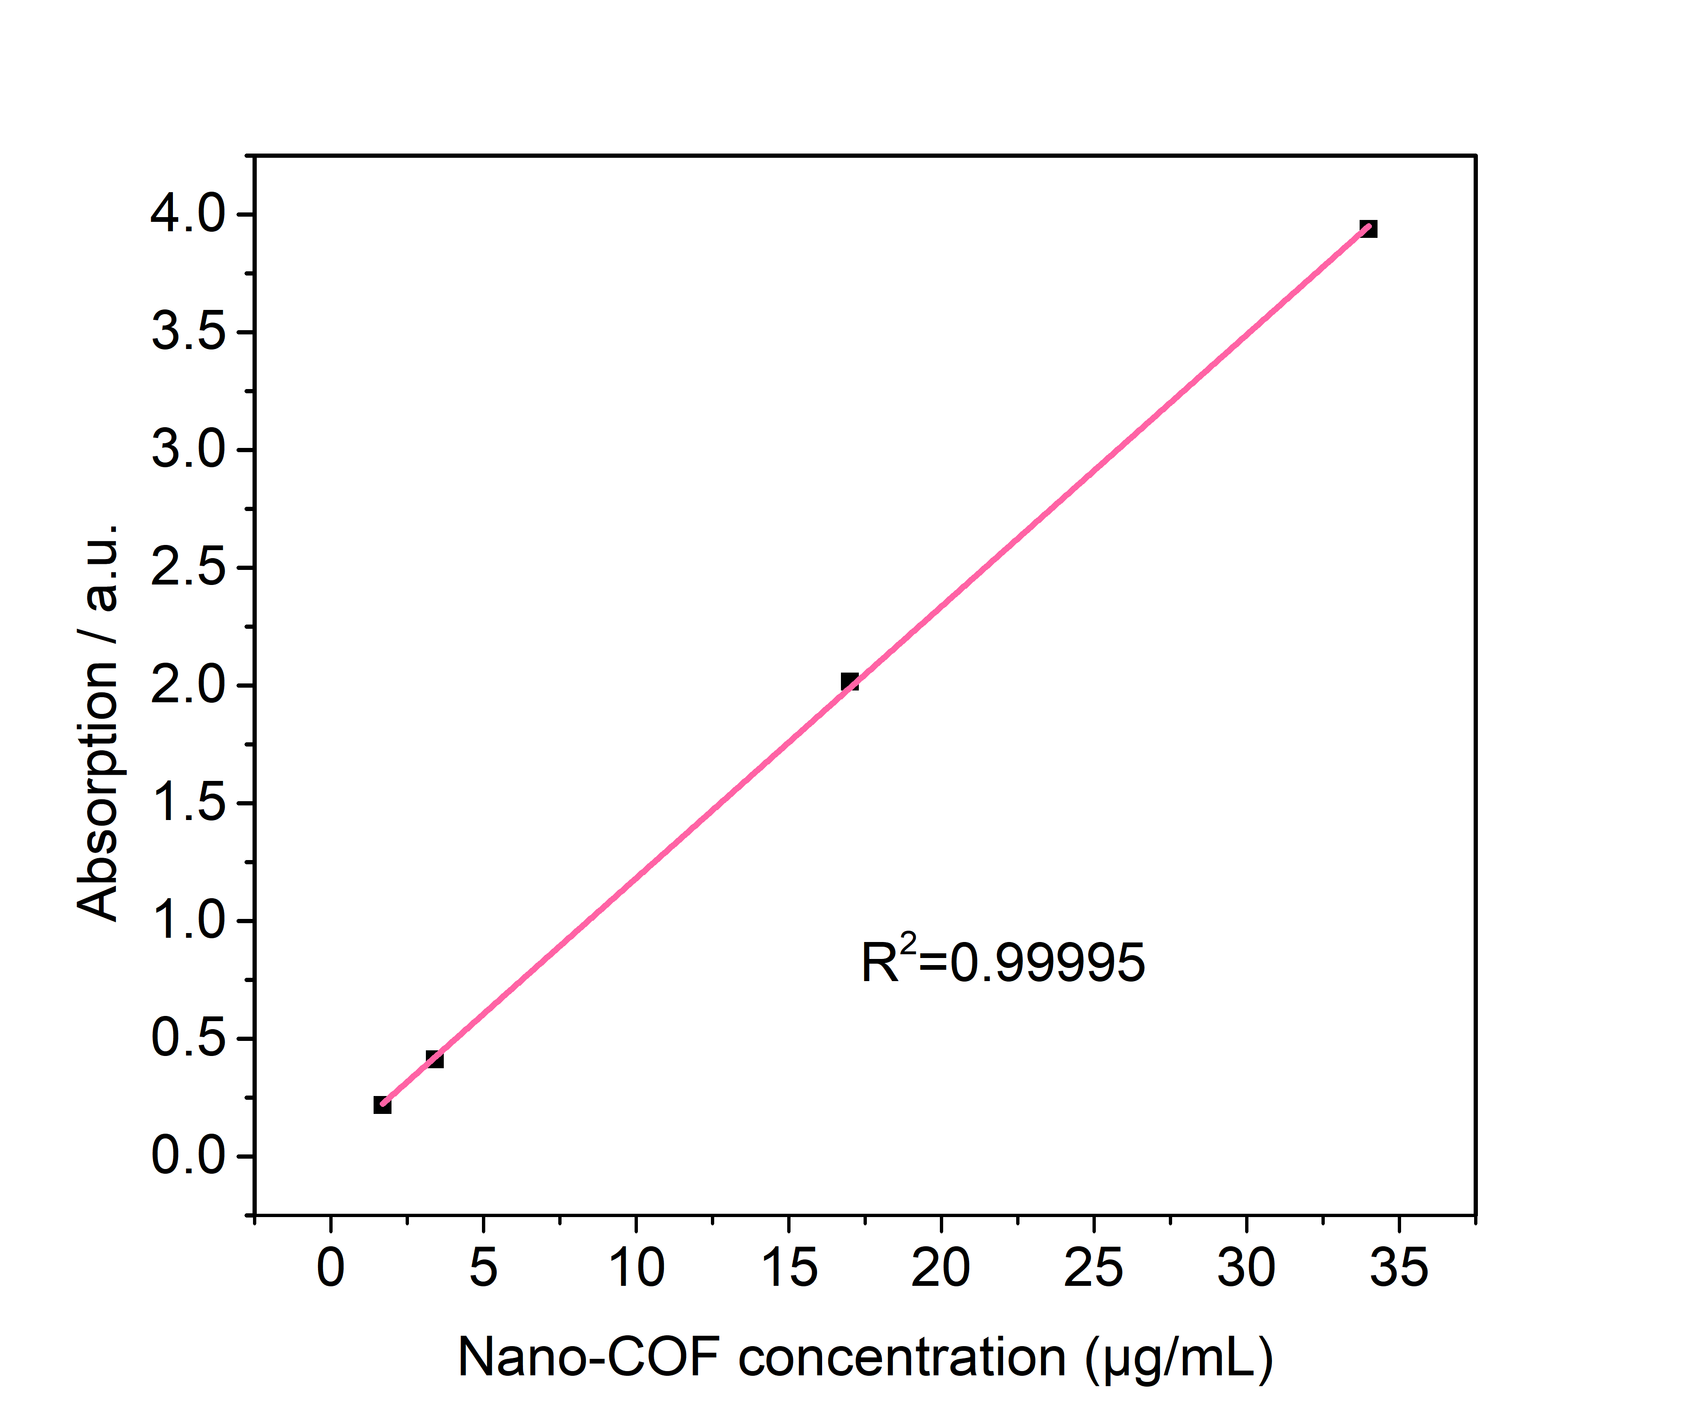
Supplementary Figure 48. Calibration curve for UV-vis spectra of TFP-BD nano-COF solutions using the absorption peak of 416 nm. Conditions: 0.05, 0.10, 0.50 and 1.0 mL TFP-BD nano-COF were diluted by water to a total volume of 5 mL.

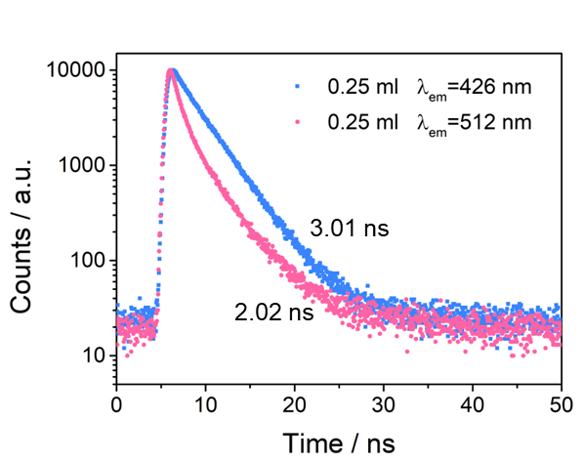
Supplementary Figure 49. TCSPC measurements of TFP-BpyD nano-COF with different emission wavelengths (conditions: 0.25 mL TFP-BpyD nano-COF were diluted by water to a total volume of 5 mL).

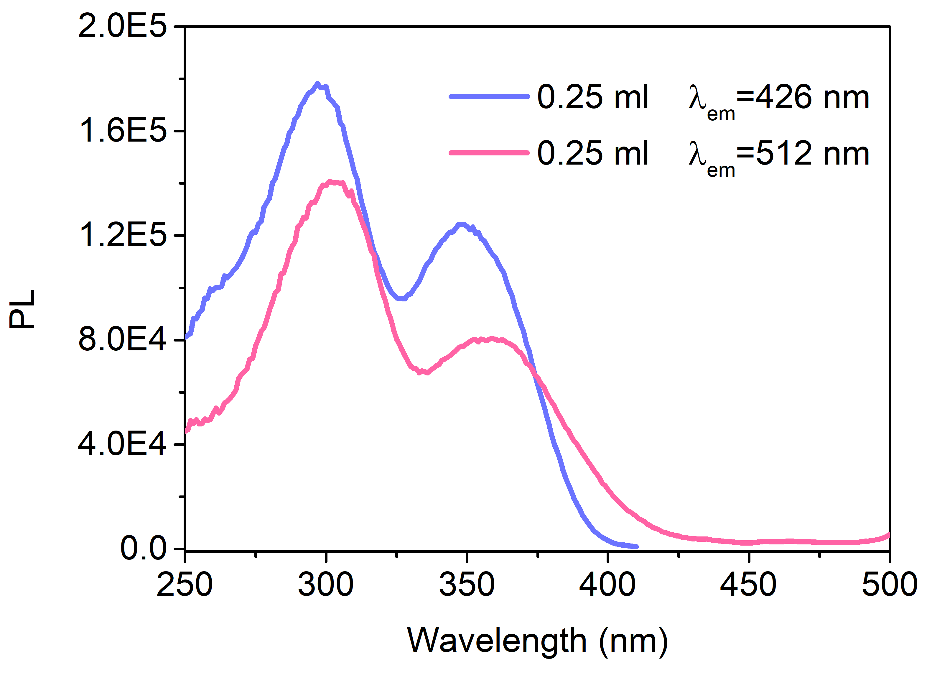
Supplementary Figure 50. Photoluminescence excitation spectra of TFP-BpyD nano-COF with different emission wavelengths (conditions: 0.25 mL TFP-BpyD nano-COF were diluted by water to a total volume of 5 mL).

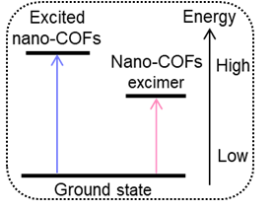
Supplementary Figure 51. Scheme for nano-COF excimer formation.

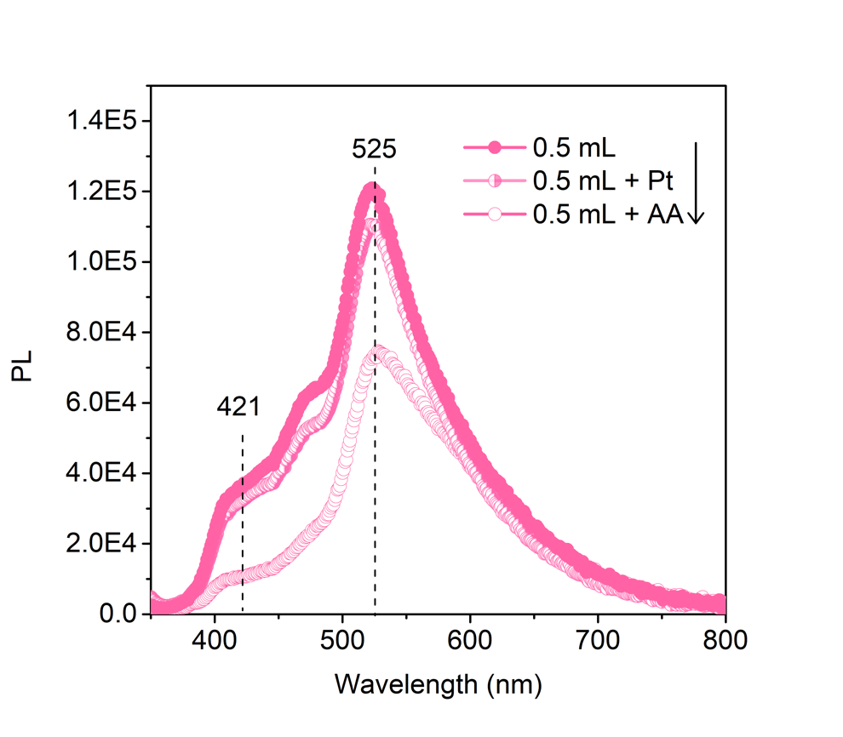
Supplementary Figure 52. Photoluminescence (PL) spectra of TFP-BpyD nano-COF with addition of (i) AA or (ii) Pt. Conditions: (i) 0.5 mL TFP-BpyD nano-COF colloid solution was diluted by 0.2 M AA (0.5 mL); (ii) 0.5 mL TFP-BpyD nano-COF colloid was diluted by water with Pt co-catalyst (15 wt% vs photocatalysts). The total volume was made up to 5 mL. To allow comparison at the same concentration, the 0.5 mL TFP-BpyD nano-COF colloid (solid symbols in plot) was diluted by water (0.5 mL).
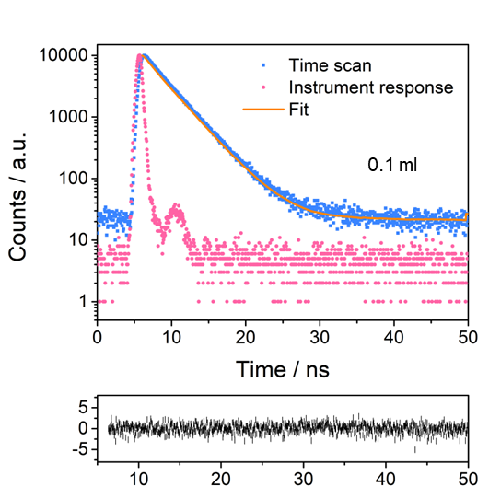
Supplementary Figure 53. TCSPC measurements of TFP-BpyD nano-COF (0.1 mL TFP-BpyD nano-COF was diluted by water to a total volume of 5 mL). The sample was excited with a λ_{ex} = 371 nm laser. The yellow line represents the fit and the black line are the weighted residuals of the fit.
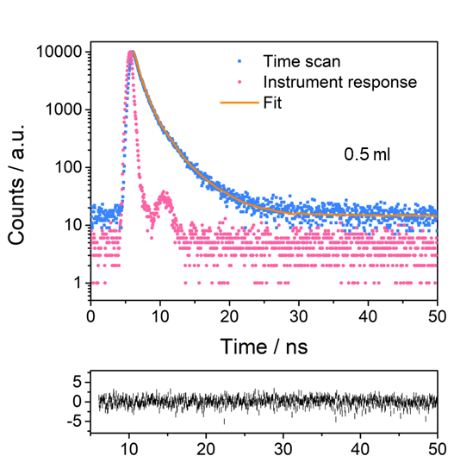
Supplementary Figure 54. TCSPC measurements of TFP-BpyD nano-COF (0.5 mL TFP-BpyD nano-COF was diluted by water to 5 mL). The sample was excited with a λ_{ex} = 371 nm laser. The yellow line represents the fit and the black line are the weighted residuals of the fit.
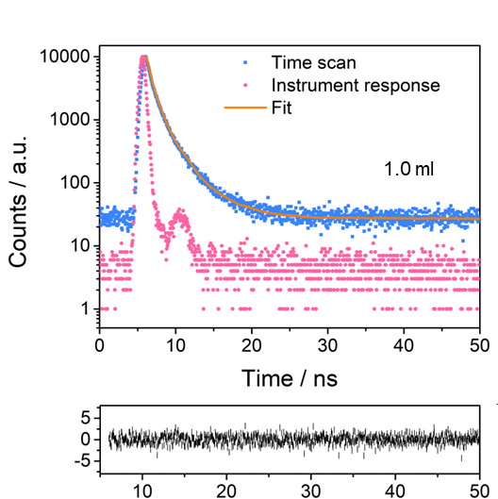
Supplementary Figure 55. TCSPC measurements of TFP-BpyD nano-COF (1.0 mL TFP-BpyD nano-COF was diluted by water a total volume of 5 mL). The sample was excited with a λ_{ex} = 371 nm laser. The yellow line represents the fit and the black line are the weighted residuals of the fit.
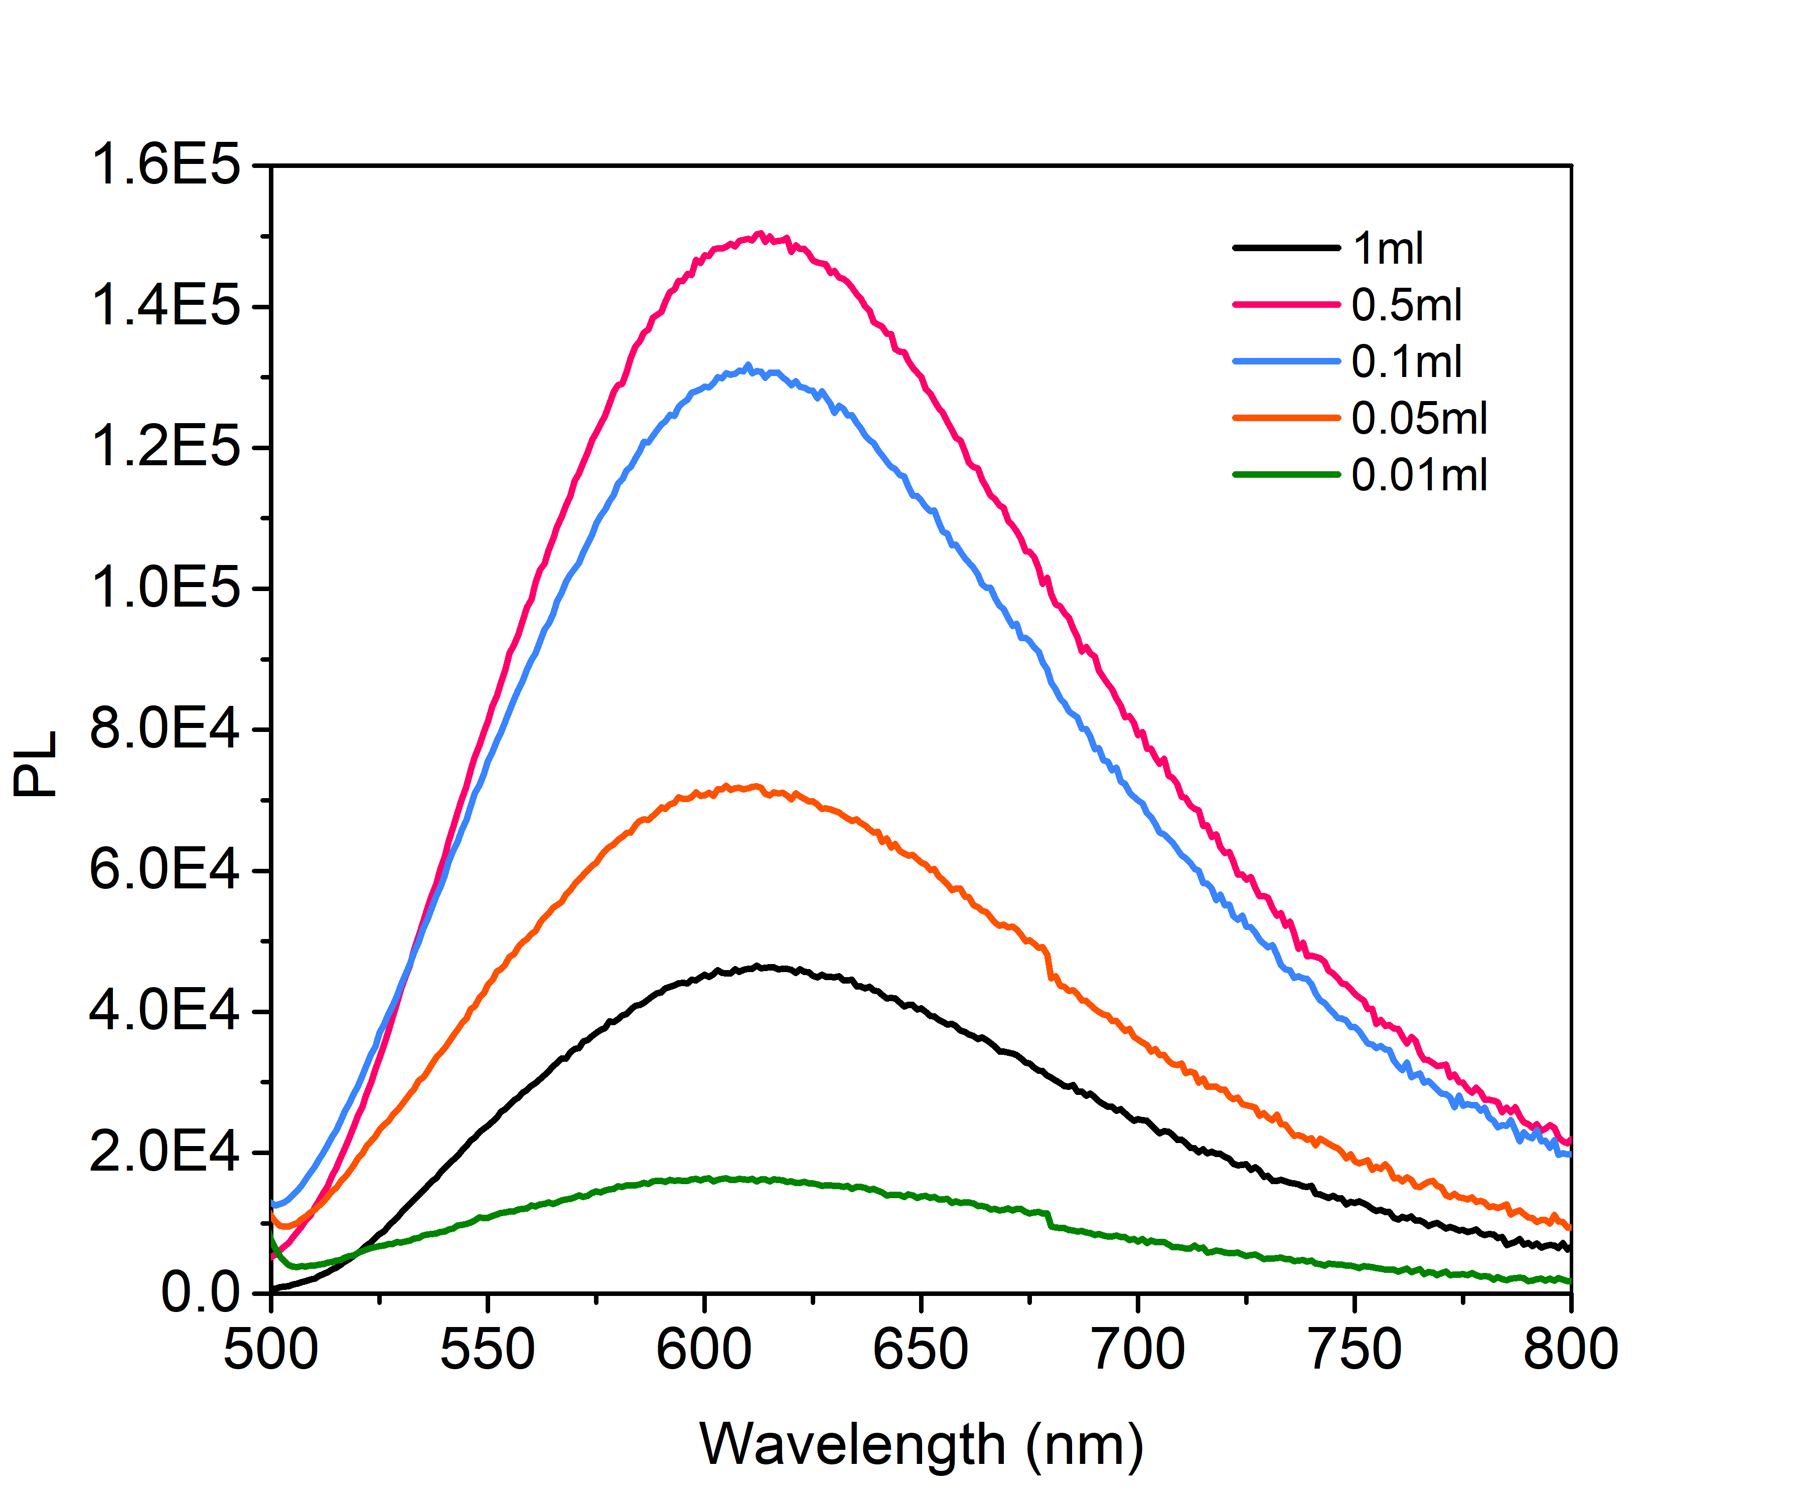
Supplementary Figure 56. Photoluminescence emission spectra of TFP-BD nano-COF colloids with different concentrations (conditions: 0.01, 0.05, 0.10, 0.50 and 1.00 mL TFP-BD nano-COF colloids were diluted by water to a total volume of 5 mL).
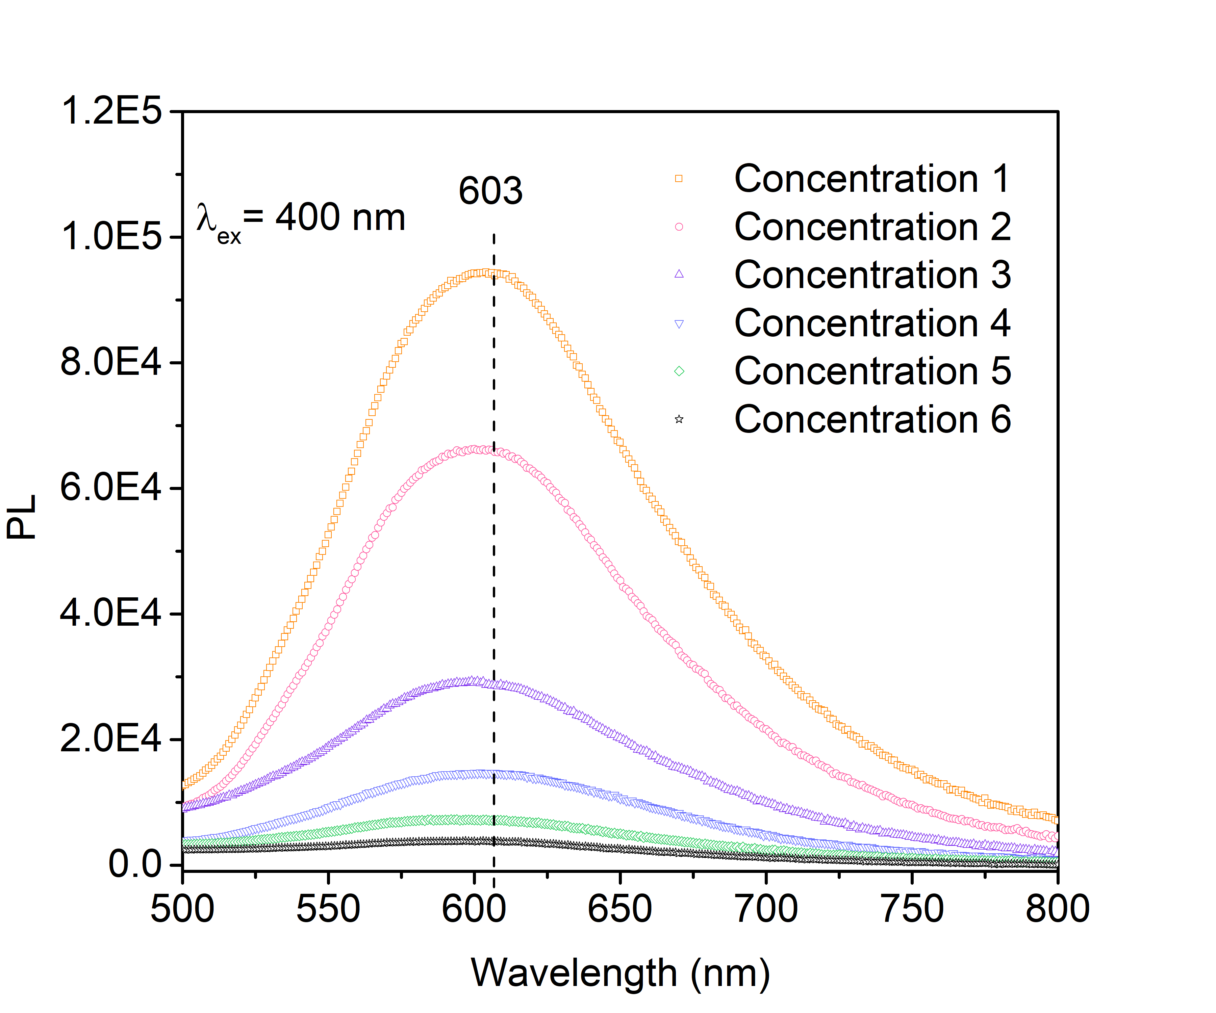
Supplementary Figure 57. Photoluminescence emission spectra of TFP-BpyD COF excited at 400 nm with different concentrations (concentration 1: 0.0686 mg/mL; concentration 2: 0.0343 mg/mL; concentration 3: 0.0172 mg/mL; concentration 4: 0.00686 mg/mL; concentration 5: 0.00343 mg/mL; concentration 6: 0.000686 mg/mL). These concentrations are consistent with those using 1, 0.5, 0.25, 0.1, 0.05 and 0.01 mL of the TFP-BpyD nano-COF stock solution, respectively.
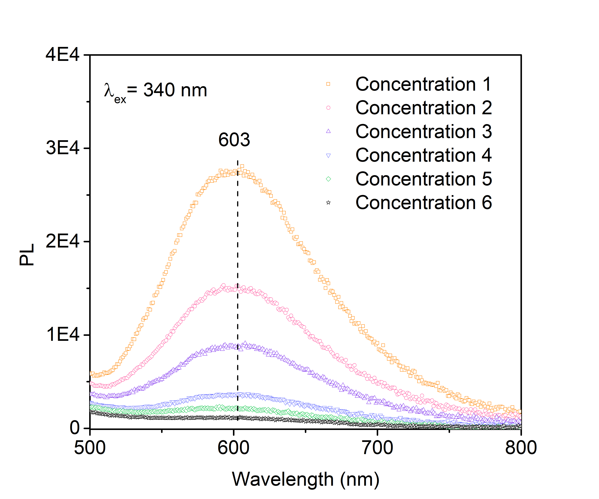
Supplementary Figure 58. Photoluminescence emission spectra of TFP-BpyD COF excited at 340 nm with different concentrations (concentration 1: 0.0686 mg/mL; concentration 2: 0.0343 mg/mL; concentration 3: 0.0172 mg/mL; concentration 4: 0.00686 mg/mL; concentration 5: 0.00343 mg/mL; concentration 6: 0.000686 mg/mL). These concentrations are consistent with those using 1, 0.5, 0.25, 0.1, 0.05 and 0.01mL TFP-BpyD nano-COF.

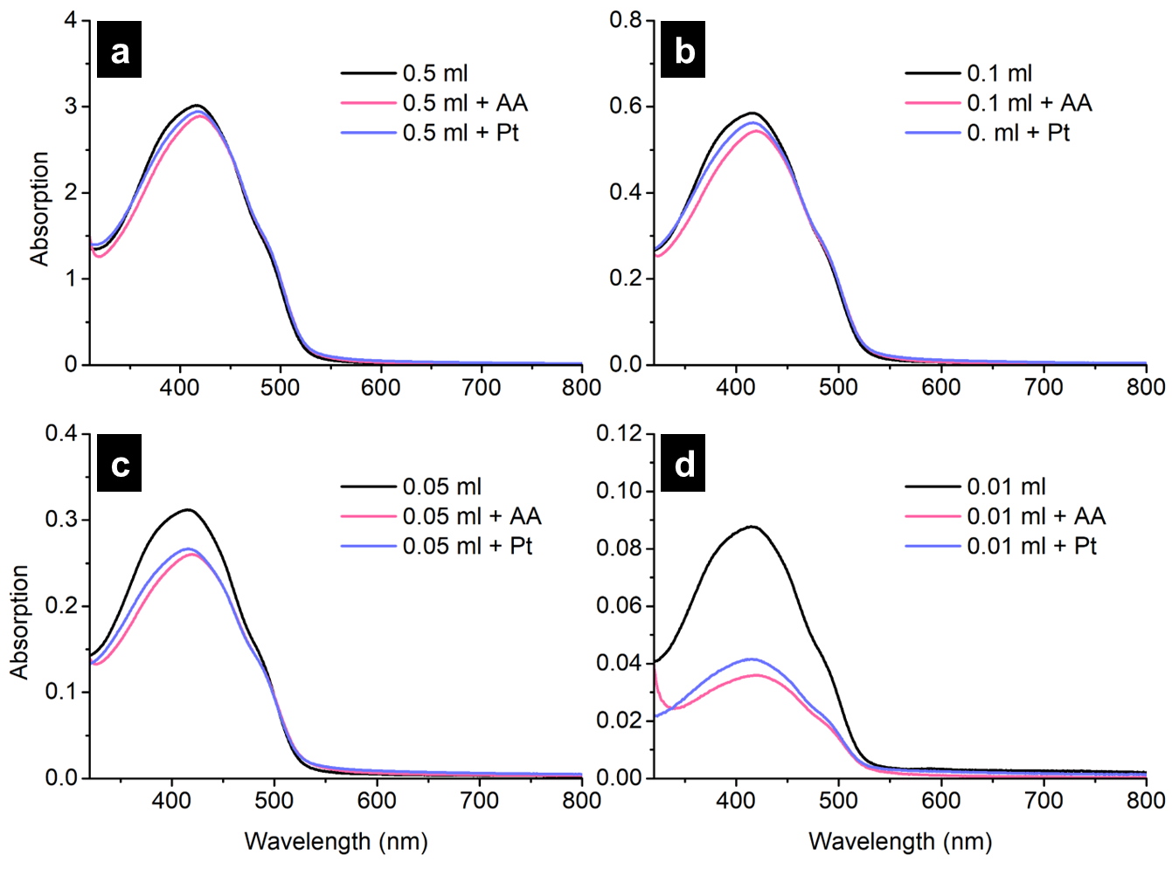
Supplementary Figure 59. UV spectra of TFP-BpyD nano-COF with ascorbic acid (AA) or co-catalyst (Pt) at different concentrations. Conditions (without AA and Pt): 0.01, 0.05, 0.10 and 0.50 mL TFP-BpyD nano-COF were diluted by pure water to a total volume of 5 mL; Conditions (AA): 0.01, 0.05, 0.10 and 0.50 mL TFP-BpyD nano-COF were diluted by 0.2 M AA to a total volume of 5 mL; Conditions (Pt): 0.01, 0.05, 0.10 and 0.50 mL TFP-BpyD nano-COF were diluted by water to a total volume of 5 mL and 15 wt. % Pt based on the mass of COF was added.
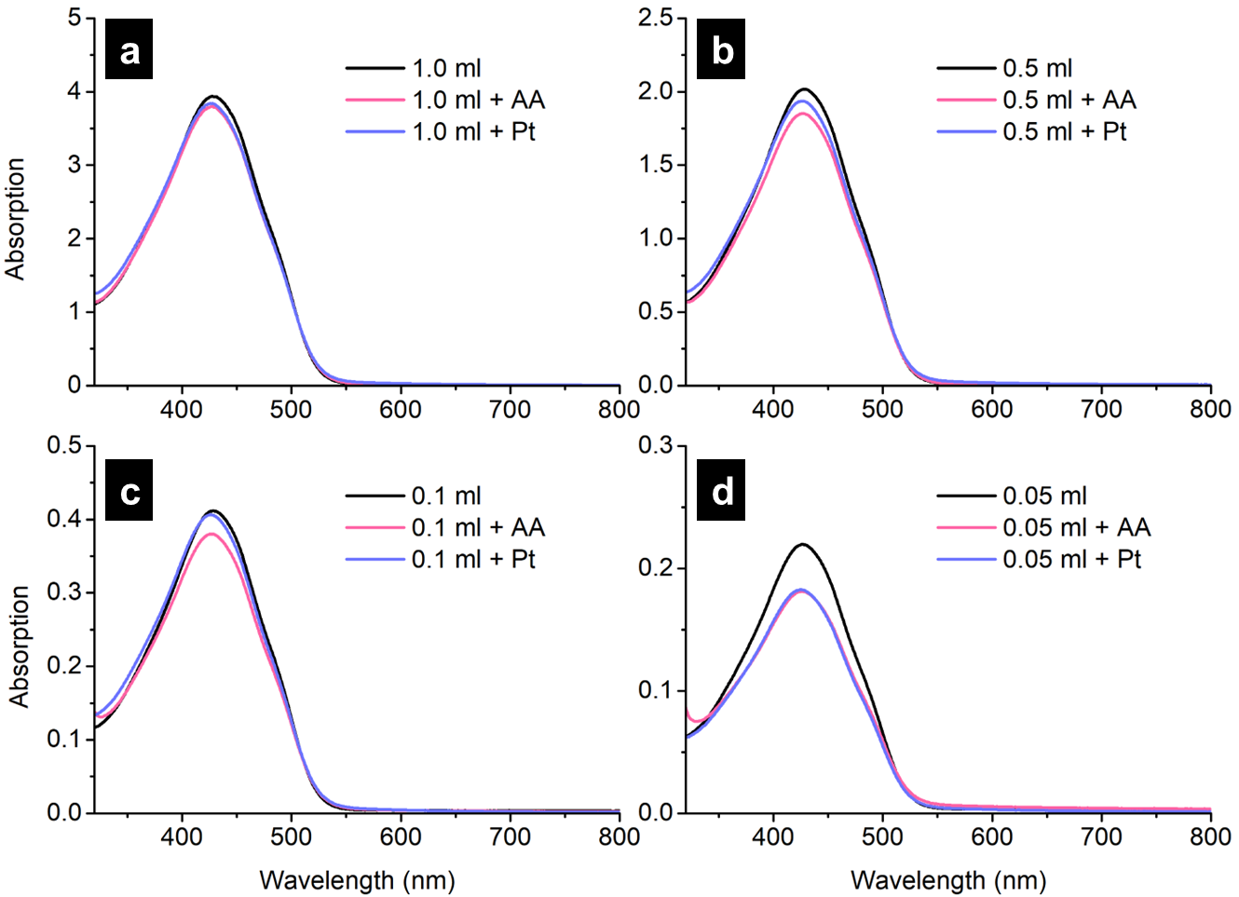
Supplementary Figure 60. UV spectra of TFP-BD nano-COF with ascorbic acid (AA) or co-catalyst (Pt) at different concentrations. Conditions (without AA and Pt): 0.05, 0.1, 0.5 and 1.0 mL TFP-BD nano-COF were only diluted by water and the totally volume is 5 mL; Conditions (AA): 0.05, 0.1, 0.5 and 1.0 mL TFP-BD nano-COF were diluted by 0.2 M AA and the totally volume is 5 mL; Conditions (Pt): 0.05, 0.1, 0.5 and 1.0 mL TFP-BD nano-COF were diluted by water. The total volume was 5 mL and 15 wt % Pt based on the mass of COF was added.

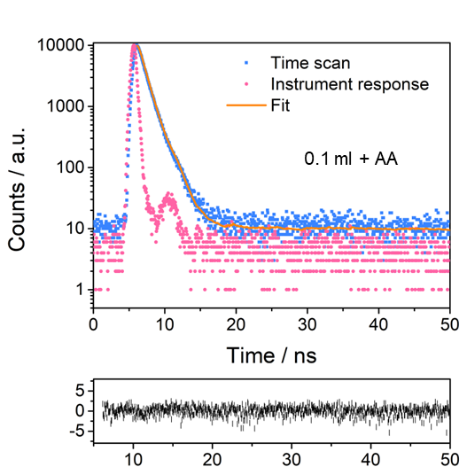
Supplementary Figure 61. TCSPC measurements of TFP-BpyD nano-COF (0.1 mL TFP-BpyD nano-COF was diluted by 0.2 M AA to 5 mL). The sample was excited with a λ_{ex} = 371 nm laser. The yellow line represents the fit and the black line are the weighted residuals of the fit.
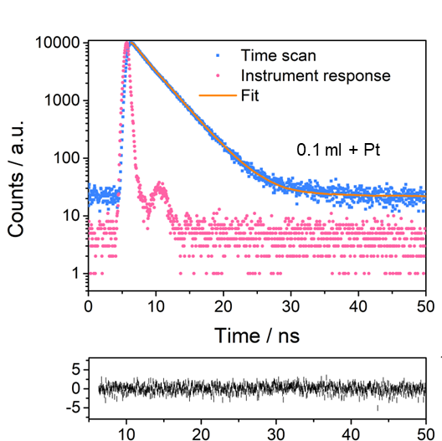
Supplementary Figure 62. TCSPC measurements of TFP-BpyD nano-COF (0.1 mL TFP-BpyD nano-COF was diluted by water to 5 mL and 15 wt% Pt was added). The sample was excited with a λ_{ex} = 371 nm laser. The yellow line represents the fit and the black line are the weighted residuals of the fit.
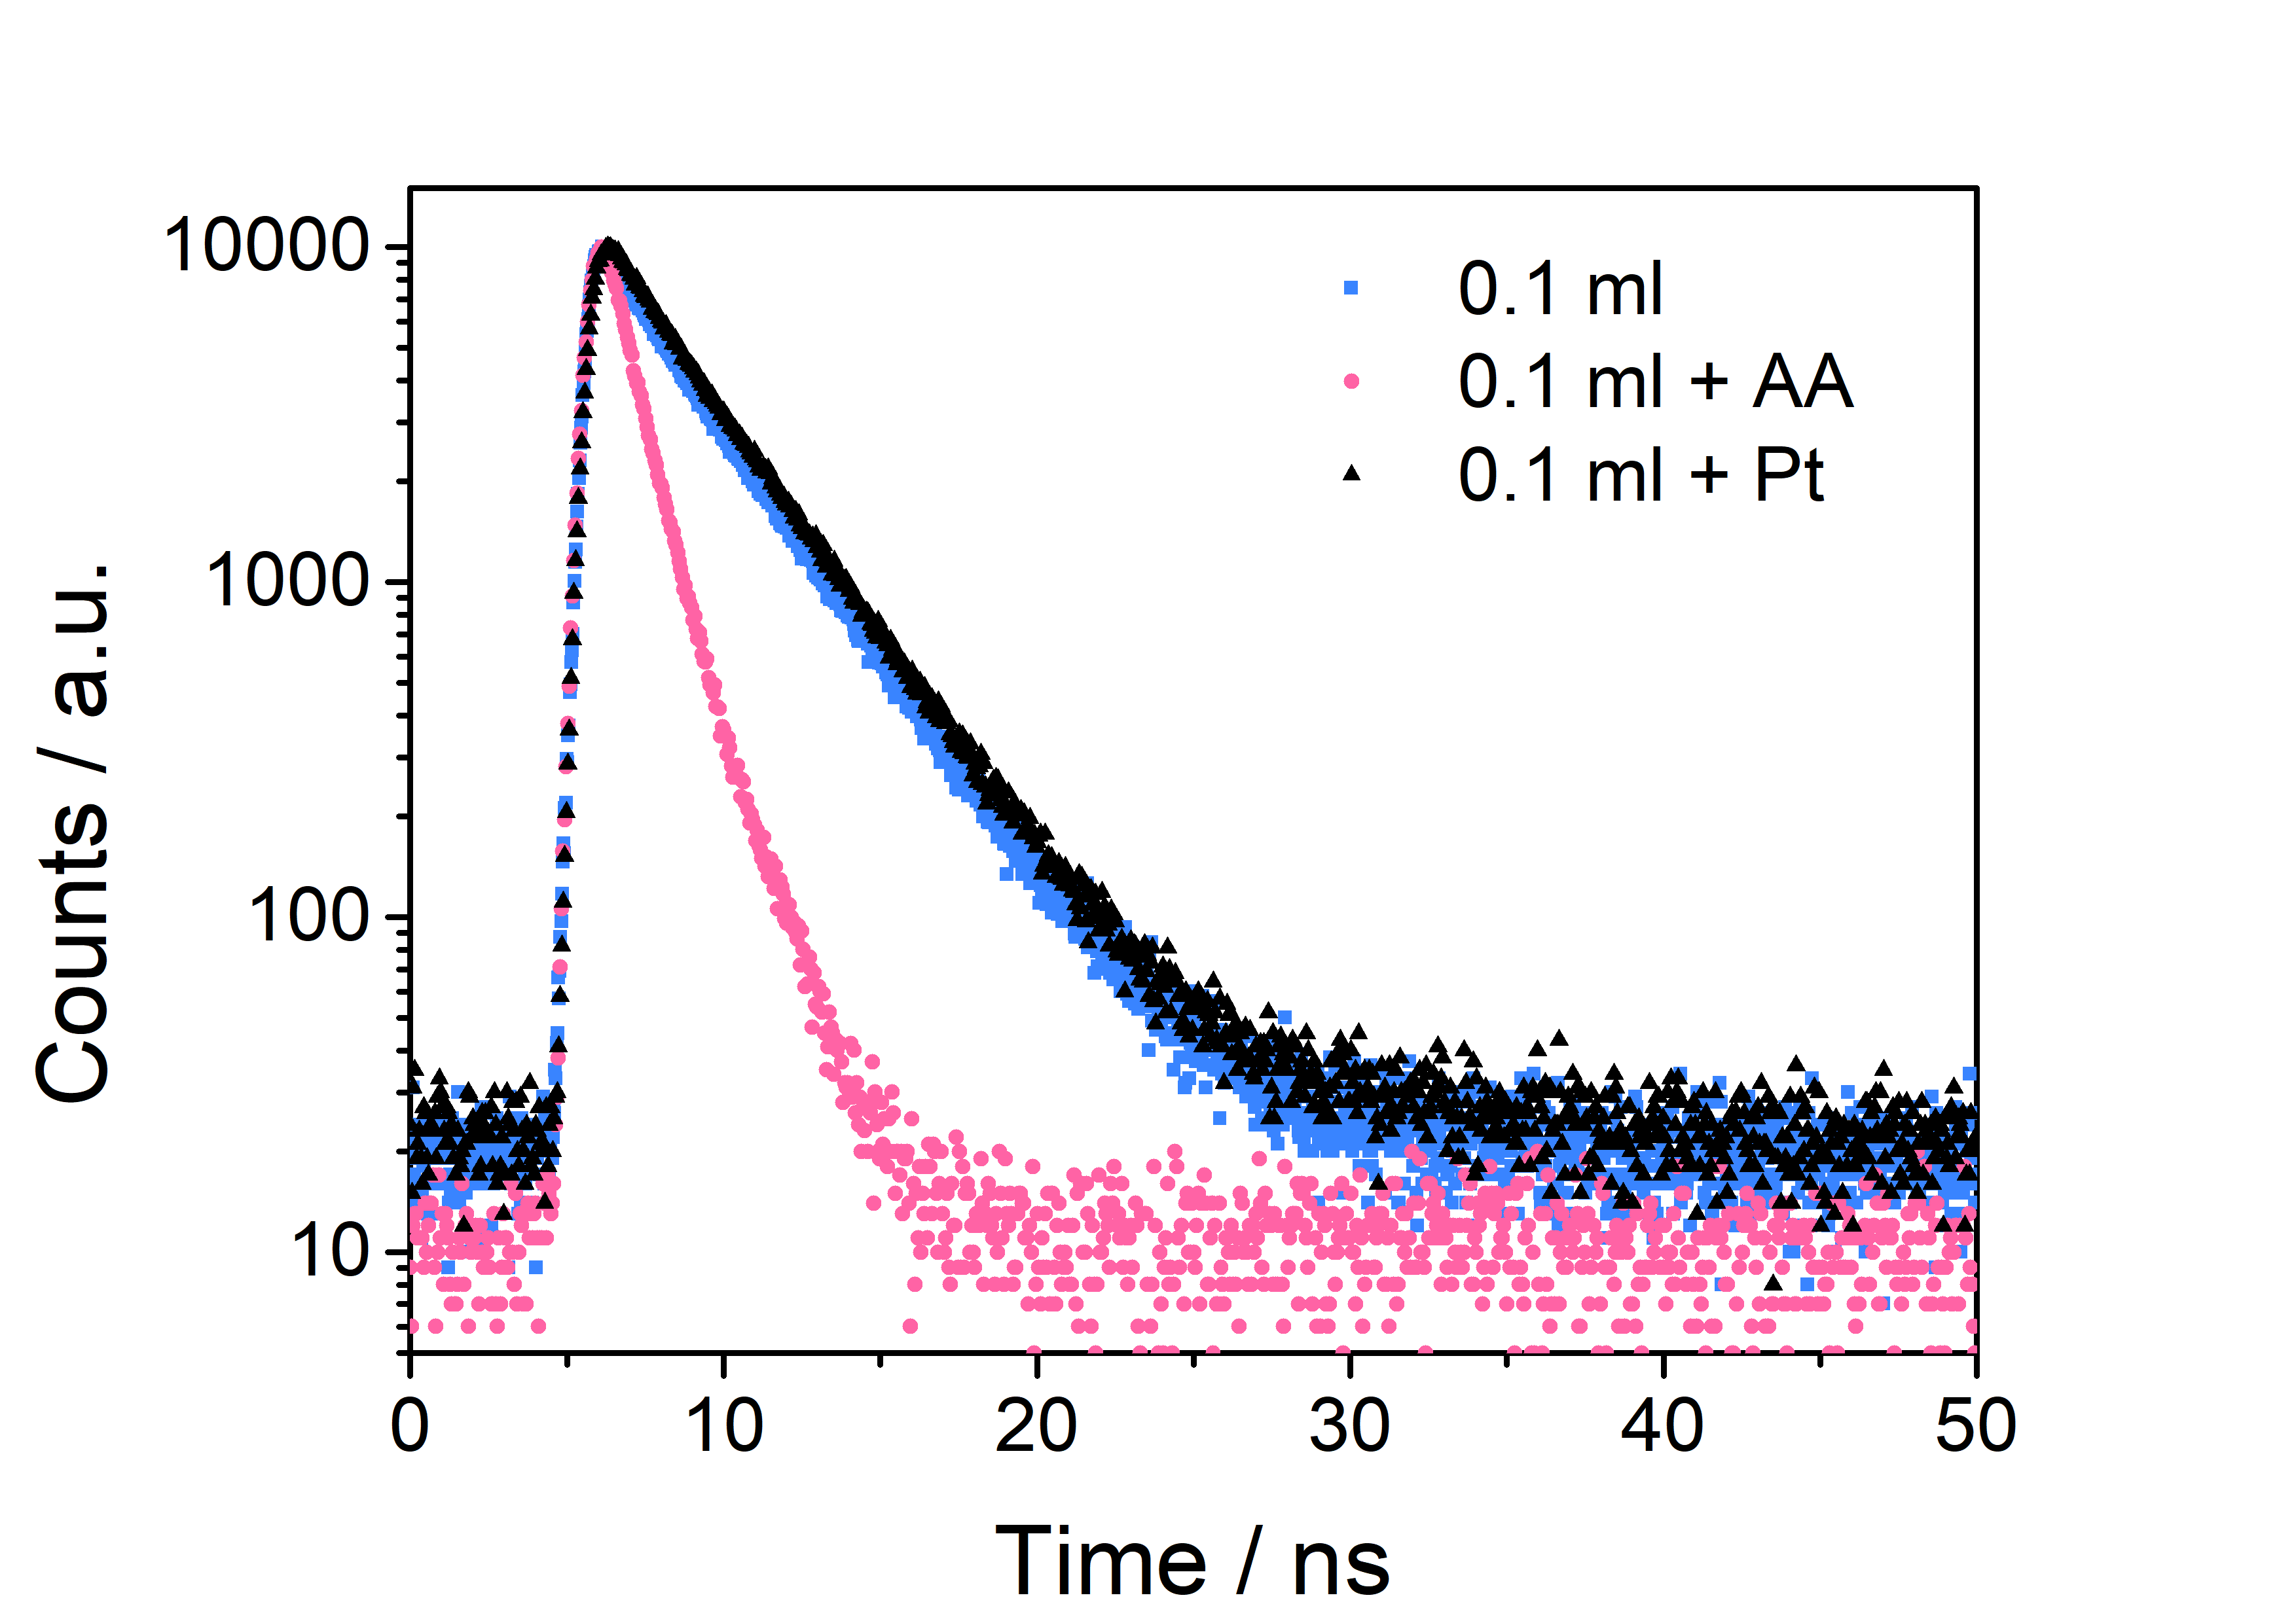
Supplementary Figure 63. TCSPC measurements of TFP-BpyD nano-COF with different conditions (conditions: 0.1 mL TFP-BpyD nano-COF were diluted by water, 0.2 M AA or water with 15 wt% Pt. The totally volume is 5 mL). The sample was excited with a λ_{ex} = 371 nm laser.

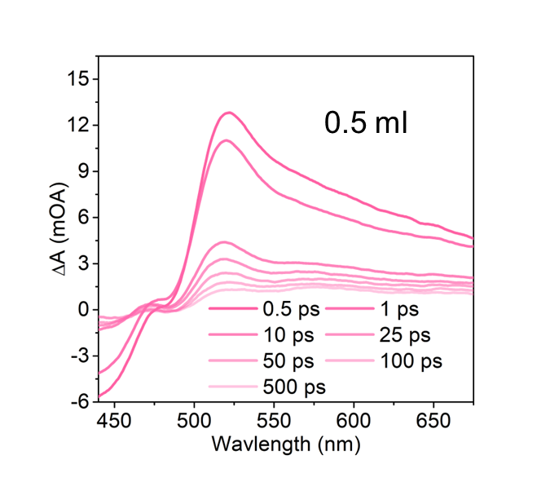
Supplementary Figure 64. TAS spectra of TFP-BpyD nano-COF under the following conditions: 0.5 mL TFP-BpyD nano-COF, diluted by water to a total volume of 5 mL.

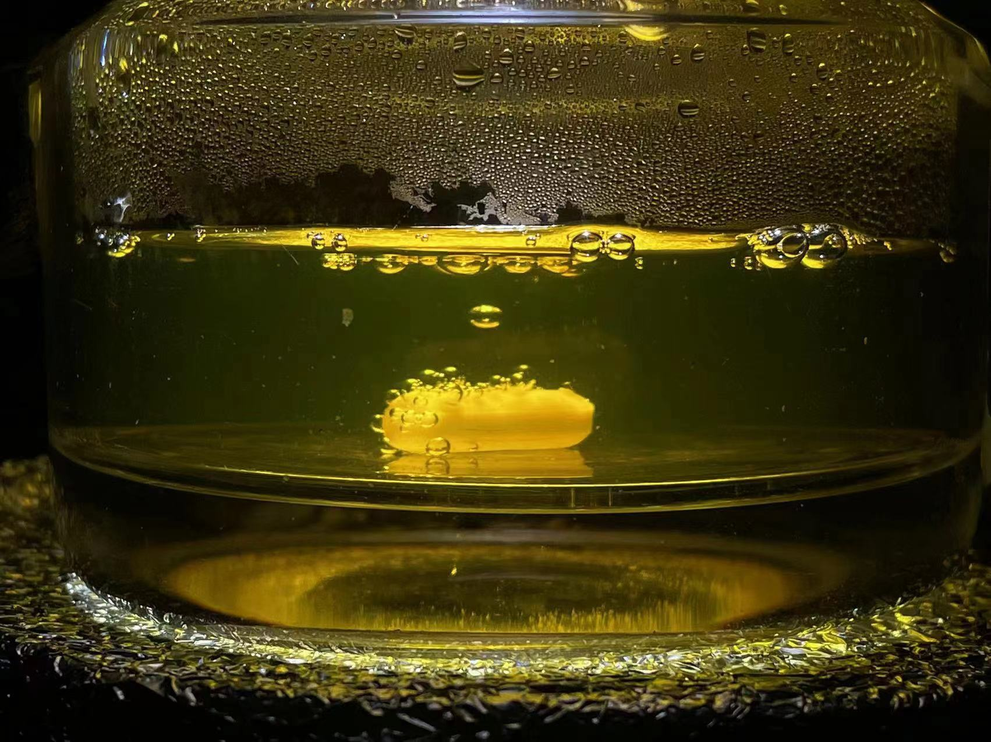
Supplementary Figure 65. Optical image of TFP-BpyD nano-COF for photocatalytic H₂ production.

Supplementary Table 1. Elemental analyses of the COFs.
Sample | C (wt%) |  | H (wt%) |  | N (wt%)
Sample | Calc. | Expt. | Calc. | Expt. | Calc. | Expt.
TFP-BD nano-COF  (After isolation) | 74.99 | 70.59 | 4.20 | 4.72 | 9.72 | 8.11
TFP-BD COF | 74.99 | 70.90 | 4.20 | 4.88 | 9.72 | 8.27
TFP-BpyD nano-COF  (After isolation) | 66.20 | 65.07 | 3.47 | 4.46 | 19.30 | 15.95
TFP-BpyD COF | 66.20 | 63.00 | 3.47 | 4.37 | 19.30 | 15.82
Calc. = calculated data, assuming idealized stoichiometry, infinite frameworks, and no physisorption of guests (e.g., N₂, H₂O in the COF pores); note that none of these assumptions are satisfied in the real materials, and hence elemental analyses for these porous solids can differ significantly from the idealized, calculated values; Expt. = experimental results.

Supplementary Table 2. Summary of synthetic details for sonochemical preparation of sonoCOFs.
COFs | Amines | Aldehydes | Concentration of aqueous AcOH | Volume of aqueous AcOH (mL) | Sonication power  (%) | Yield (%)
TFP-BpyD COF | BpyD 27.9 mg | TFP 21 mg | 12 M | 4 | 25 | 93
TFP-BD COF | BD 27.6 mg | TFP 21 mg | 12 M | 2 | 25 | 66

Supplementary Table 3. Summary of representative pristine COFs and other organic photocatalysts reported for sacrificial photocatalytic hydrogen evolution.
COFs | Band gap (eV) | Co-catalyst | Sacrificial agent | HER (mmol g⁻¹ h⁻¹) | AQY^{h} (%) | Ref.
SonoCOF-3 | 2.46 | Pt | AA | 16.6^{b} | 3.71 (420 nm)^{f} | 2
SonoCOF-3 | 2.46 | Pt | AA | 24.5^{c} | - | 2
N₃-COF | 2.6-2.7 | Pt | TEOA | 1.70 | 0.44 (450 nm)^{d} | 3
TP-COF | 1.97 | PVP-Pt | AA | 8.42 | 0.4 (475 nm)^{e} | 4
PTP-COF | 2.10 | Pt | TEOA | 0.08 | 0.87 (420nm) | 5
N₂-COF | - | Co-1ª | TEOA | 0.78 | 0.16^{d} | 6
TTB-COF | 2.8 | Au | TEOA | 0.15 | - | 7
TpDTz COF | 2.07 | NiME | TEOA | 0.94 | 0.2 (400 nm)^{e} | 8
BT-TAPT-COF | 2.35 | Pt | AA | 0.95 | 0.19 (410 nm)^{f} | 9
Py-HTP-BT-COF | 2.25 | Pt | AA | 1.08 | - | 10
Py-FTP-BT-COF | 2.34 | Pt | AA | 2.88 | - | 10
Py-ClTP-BT-COF | 2.36 | Pt | AA | 8.88 | 8.45 (420 nm)^{e} | 10
g-C₄₀N₃-COF | 2.36 | Pt | TEOA | 2.60 | 4.84 (420 nm) | 11
TpPa-2-COF | 2.52 | Pt | LA | 0.03 | - | 12
TpPa-2 | 2.07 | Pt | SA | 0.07 | - | 13
TpPa-COF-(CH₃)₂ | 2.06 | Pt | SA | 8.33 | - | 14
TP-BDDA | 2.31 | Pt | TEOA | 0.32 | 1.8 (520 nm)^{e} | 15
TpPa-1-COF | 2.02 | Pt | SA | 1.22 | - | 16
sp²c-COF | 1.9 | Pt | TEOA | 1.36 | - | 17
sp²c-COF_{ERDN} | 1.85 | Pt | TEOA | 2.12 | 0.48 (495 nm) | 17
TFPT-COF | 2.8 | Pt | TEOA | 1.97 | 2.2 (400 nm)^{g} | 18
FS-COF | 1.85 | Pt | AA | 10.1 | 3.2 (420 nm)^{f} | 19
g-C₁₈N₃-COF | 2.42 | Pt | TEOA | 0.29 | 1.06 (420 nm) | 20
TpPa-1-COF | 2.11 | MoS₂ | AA | 5.59 | 0.76 (420 nm)^{e} | 21
TpPa-1 | 2.11 | Pt | AA | 5.48 | - | 21
BtCOF150 | 2.10 | Pt | TEOA | 0.75 | 0.2 (420 nm) | 22
A-TEBPY-COF | 1.94 | Pt | TEOA | 0.10 | - | 23
NTU-BDA-THTA | 2.09 | Pt | AA | 1.13 | - | 24
PyTz-COF | 2.20 | Pt | AA | 2.07 | - | 25
NKCOF-108 | 1.82 | Pt | AA | 11.6 | 2.96 (520 nm) | 26
RC-COF-1 | - | Pt | AA | 27.9 | 6.4 (420 nm) | 27
PY-DHBD-COF | 2.28 | Pt | AA | 42.4 | 6.4 (420 nm) | 28
Tz-COF-3 | 1.96 | Pt | AA | 43.2 | 6.9 (420 nm) | 29
COF-JLU100 | 1.95 | Pt | TEOA | 107.4 | 5.1 (450 nm) | 30
[Mo₃S₁₃]^{2–}@ZnP-Pz-PEO-COF | - | - | AA | 11 | 3.6 (600 nm) | 31
COF-BBT | 2.0 | Pt | AA | 48.7 | 6.9 (420 nm)^{f} | 32
v-2D-COF-NO1 | 1.86 | Pt | AA | 1.97 | - | 33
COF-JLU35 | 1.85 | Pt | AA | 70.8 | 3.2 (500 nm) | 34
Ni-COF-SCAU-1 | - | Pt | AA | 197.5 | 43.2 (420 nm) | 35
BTT-BPy-PCOF | 1.41 | Pt | AA | 15.8 | 3.7 (500 nm)^{e} | 36
PS-PEG5 | - | Pt | AA | 37.2 | 5.3 (365 nm) | 37
F1 SC-NPs | - | Pt | AA | 152.6 | 6.9 (600 nm) | 38
PM6:PCBM | - | Pt | AA | 73.7 | 8.7 (400 nm) | 39
PTB7-Th/EH-IDTBR | - | Pt | AA | 64.4 | 6.2 (700 nm) | 1
CNP-f | 2.51 | Pt | AA | 31.9 | - | 40
TFP-BD nano-COF | 2.20 | Pt | AA | 183 | 5.5 (420 nm)^{f} | This work
TFP-BpyD nano-COF | 2.24 | Pt | AA | 392 | 10 (420 nm)^{f} | This work
ª Co-1: [Co(dmgH)₂pyCl]. ^{b}: 300 W Newport Xe light with a UV cutoff filter; ^{c}: solar simulator (AM1.5G); ^{d} PE: photonic efficiency. ^{e}AQE: apparent quantum efficiency. ^{f} EQE: external quantum efficiency. ^{g} QE: quantum efficiency; ^{h}: apparent quantum yield (AQY); TEOA: triethanolamine; TEA: triethylamine; AA: Ascorbic acid; SA: Sodium ascorbate; LA: Lactic acid. We note that absolute hydrogen evolution rates reported in different studies should be compared with caution because the details of the optical set up (light intensity, photolysis geometry, scale) are known to have a significant effect on rates. For the experiments performed here (e.g., nano-COFs vs bulk COFs), all tests were made under the same photolysis conditions and they are hence directly comparable.

Supplementary Table 4. Quantum yields analysis of TFP-BpyD nano-COF.
TFP-BpyD nano-COF | Water | Quantum yields |  | Average quantum yields
0.1 mL | 4.9 mL | Test 1 | 0.16% | 0.17%
0.1 mL | 4.9 mL | Test 2 | 0.18% | 0.17%
0.5 mL | 4.5 mL | Test 1 | 0.12% | 0.13%
0.5 mL | 4.5 mL | Test 2 | 0.13% | 0.13%
1.0 mL | 4.0 mL | Test 1 | 0.10% | 0.10%
1.0 mL | 4.0 mL | Test 2 | 0.10% | 0.10%
Note: Quantum yields of TFP-BpyD nano-COF at different concentrations followed a reverse concentration-dependent phenomenon as well. At lower concentration (0.1 mL), the quantum yield is 0.17 %. With the increase of concentration of TFP-BpyD nano-COF, the quantum yields decreased to 0.13 % (0.5 mL) and 0.10 % (1.0 mL).

References
1. Kosco, J. et al. Enhanced photocatalytic hydrogen evolution from organic semiconductor heterojunction nanoparticles. Nat. Mater. 19, 559-565 (2020).
2. Zhao, W. et al. Using sound to synthesize covalent organic frameworks in water. Nat. Synth. 1, 87-95 (2022).
3. Vyas, V. S. et al. A tunable azine covalent organic framework platform for visible light-induced hydrogen generation. Nat. Commun. 6, 8508 (2015).
4. Ming, J. et al. Hot π-electron tunneling of metal-insulator-COF nanostructures for efficient hydrogen production. Angew. Chem. Int. Ed. 58, 18290-18294 (2019).
5. Haase, F., Banerjee, T., Savasci, G., Ochsenfeld, C. & Lotsch, B. V. Structure-property-activity relationships in a pyridine containing azine-linked covalent organic framework for photocatalytic hydrogen evolution. Faraday Discuss. 201, 247-264 (2017).
6. Banerjee, T. et al. Single-site photocatalytic H₂ evolution from covalent organic frameworks with molecular cobaloxime co-catalysts. J. Am. Chem. Soc. 139, 16228-16234 (2017).
7. Li, L. et al. Thioether-functionalized 2D covalent organic framework featuring specific affinity to Au for photocatalytic hydrogen production from seawater. ACS Sustainable Chem. Eng. 7, 18574-18581 (2019).
8. Biswal, B. P. et al. Sustained solar H₂ evolution from a thiazolo[5,4-d]thiazole-bridged covalent organic framework and nickel-thiolate cluster in water. J. Am. Chem. Soc. 141, 11082-11092 (2019).
9. Wang, G. et al. A benzothiadiazole-based covalent organic framework for highly efficient visible-light driven hydrogen evolution. Chem. Commun. 56, 12612-12615 (2020).
10. Chen, W. et al. Modulating benzothiadiazole-based covalent organic frameworks via halogenation for enhanced photocatalytic water splitting. Angew. Chem. Int. Ed. 59, 16902-16909 (2020).
11. Bi, S. et al. Two-dimensional semiconducting covalent organic frameworks via condensation at arylmethyl carbon atoms. Nat. Commun. 10, 2467 (2019).
12. Thote, J. et al. A covalent organic framework-cadmium sulfide hybrid as a prototype photocatalyst for visible-light-driven hydrogen production. Chem. Eur. J. 20, 15961-15965 (2014).
13. Dong, H. et al. Boosting visible-light hydrogen evolution of covalent-organic frameworks by introducing Ni-based noble metal-free co-catalyst. Chem. Eng. J. 379, 122342 (2020).
14. Sheng, J. L. et al. Effect of different functional groups on photocatalytic hydrogen evolution in covalent‐organic frameworks. ChemCatChem. 11, 2313-2319 (2019).
15. Pachfule, P. et al. Diacetylene functionalized covalent organic framework (COF) for photocatalytic hydrogen generation. J. Am. Chem. Soc. 140, 1423-1427 (2018).
16. Zhang, F. et al. Rational design of MOF/COF hybrid materials for photocatalytic H2 evolution in the presence of sacrificial electron donors. Angew. Chem. Int. Ed. 57, 12106-12110 (2018).
17. Jin, E. et al. 2D sp² carbon-conjugated covalent organic frameworks for photocatalytic hydrogen production from water. Chem. 5, 1632-1647 (2019).
18. Stegbauer, L., Schwinghammer, K. & Lotsch, B. V. A hydrazone-based covalent organic framework for photocatalytic hydrogen production. Chem. Sci. 5, 2789-2793 (2014).
19. Wang, X. et al. Sulfone-containing covalent organic frameworks for photocatalytic hydrogen evolution from water. Nat. Chem. 10, 1180-1189 (2018).
20. Wei, S. et al. Semiconducting 2D triazine-cored covalent organic frameworks with unsubstituted olefin linkages. J. Am. Chem. Soc. 141, 14272-14279 (2019).
21. Gao, M. et al. Boosting visible-light-driven hydrogen evolution of covalent organic frameworks through compositing with MoS₂: a promising candidate for noble-metal-free photocatalysts. J. Mater. Chem. A. 7, 20193-20200 (2019).
22. Ghosh, S. et al. Identification of prime factors to maximize the photocatalytic hydrogen evolution of covalent organic frameworks. J. Am. Chem. Soc. 142, 9752-9762 (2020).
23. Stegbauer, L. et al. Tailor‐made photoconductive pyrene‐based covalent organic frameworks for visible‐light driven hydrogen generation. Adv. Energy Mater. 8, 1703278 (2018).
24. Wang, H. et al. Integrating suitable linkage of covalent organic frameworks into covalently bridged inorganic/organic hybrids toward efficient photocatalysis. J. Am. Chem. Soc. 142, 4862-4871 (2020).
25. Li, W. et al. Thiazolo[5,4-d]thiazole-based donor-acceptor covalent organic framework for sunlight-driven hydrogen evolution. Angew. Chem. Int. Ed. 60, 1869-1874 (2021).
26. Zhao, Z. et al. Fabrication of robust covalent organic frameworks for enhanced visible-light-driven H2 evolution. ACS Catal. 11, 2098-2107 (2021).
27. Zhang, W. et al. Reconstructed covalent organic frameworks. Nature. 604, 72-79 (2022).
28. Li, Y. et al. In situ photodeposition of platinum clusters on a covalent organic framework for photocatalytic hydrogen production. Nat. Commun. 13, 1355 (2022).
29. Liu, F. et al. Regulating excitonic effects in covalent organic frameworks to promote free charge carrier generation. ACS Catal. 12, 9494-9502 (2022).
30. Ma, S. et al. Photocatalytic hydrogen production on a sp²-carbon-linked covalent organic framework. Angew Chem. Int. Ed. 61, e202208919 (2022).
31. He, T. et al. Integrated interfacial design of covalent organic framework photocatalysts to promote hydrogen evolution from water. Nat. Commun. 14, 329 (2023).
32. Huang, W. et al. Highly crystalline and water-wettable benzobisthiazole-based covalent organic frameworks for enhanced photocatalytic hydrogen production. Natl. Sci. Rev. 10, 171 (2023).
33. Li, S. et al. Direct construction of isomeric benzobisoxazole-vinylene-linked covalent organic frameworks with distinct photocatalytic properties. J. Am. Chem. Soc. 144, 13953-13960 (2022).
34. Li, Z. et al. Three-component donor-π-acceptor covalent-organic frameworks for boosting photocatalytic hydrogen evolution. J. Am. Chem. Soc. 145, 8364-8374 (2023).
35. Shen, R., Li, X., Qin, C., Zhang, P. & Li, X. Efficient photocatalytic hydrogen evolution by modulating excitonic effects in Ni-intercalated covalent organic frameworks. Adv. Energy Mater. 13, 2203695 (2023).
36. Dai, L. et al. Enhancement of visible-light-driven hydrogen evolution activity of 2D π-conjugated bipyridine-based covalent organic frameworks via post-protonation. Angew Chem. Int. Ed. 62, e202300224 (2023).
37. Yu, M., Zhang, W., Guo, Z., Wu, Y. & Zhu, W. Engineering nanoparticulate organic photocatalysts via a scalable flash nanoprecipitation process for efficient hydrogen production. Angew. Chem. Int. Ed. 60, 15590-15597 (2021).
38. Zhu, Y. et al. Organic photovoltaic catalyst with extended exciton diffusion for high-performance solar hydrogen evolution. J. Am. Chem. Soc. 144, 12747-12755 (2022).
39. Kosco, J. et al. Generation of long-lived charges in organic semiconductor heterojunction nanoparticles for efficient photocatalytic hydrogen evolution. Nat. Energy. 7, 340-351 (2022).
40. Yang, H. et al. Packing-induced selectivity switching in molecular nanoparticle photocatalysts for hydrogen and hydrogen peroxide production. Nat. Nanotechnol. 18, 307-315 (2023).

