Biochemical test | Result
Gram staining | Gram-negative bacilli
TSI (A/ K/G/ H2S) | A/G-A
Oxidase | -
Catalase | +
Indole | +
Urease | -
Mannitol | +
Hemolysis on 5% sheep blood agar | α
Motility | +

Supplementary Table1: Morphological and biochemical identification of E.coli.

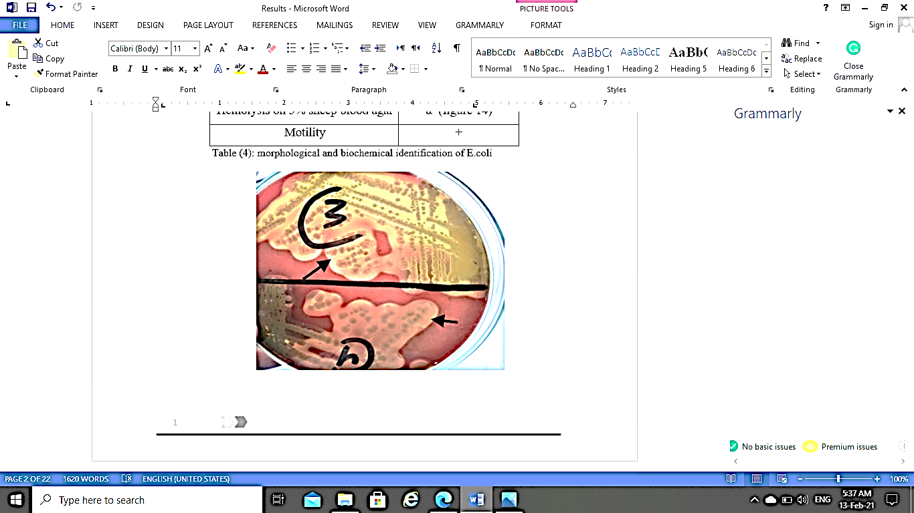
Supplementary Fig. 1: α- hemolysis (black arrows) of E.coli colonies on 5% sheep blood agar.

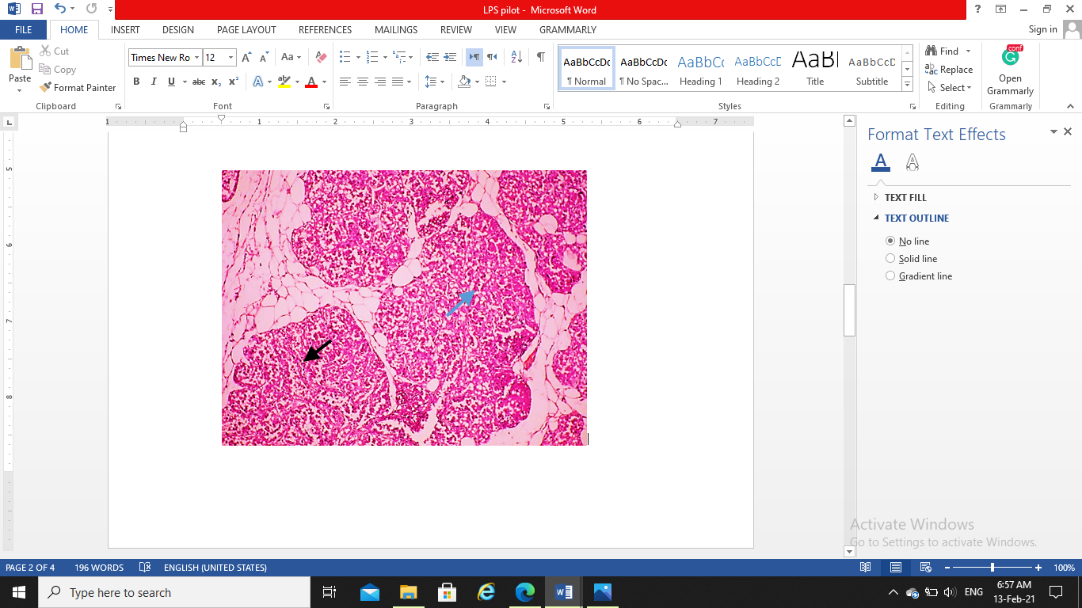  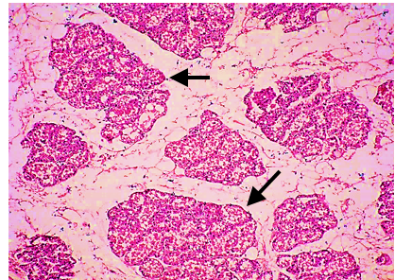  c  a | 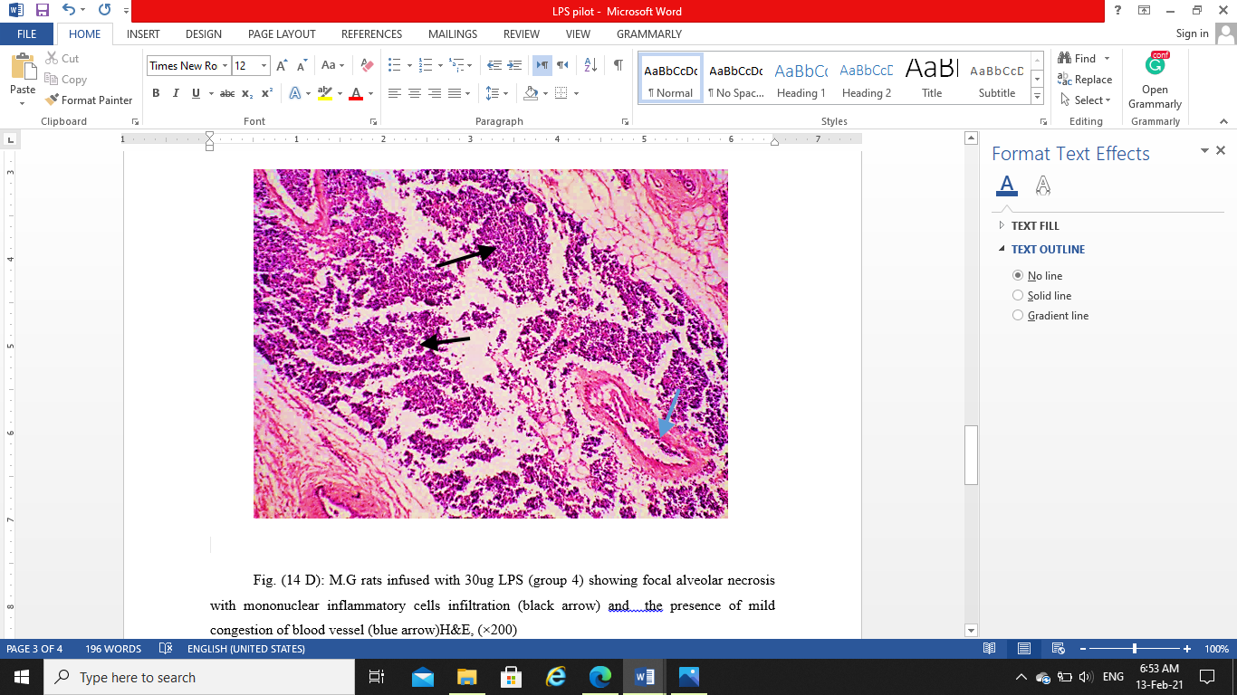  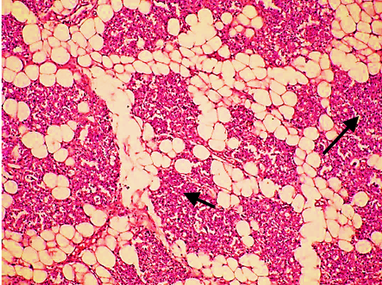  d  b

Supplementary Fig. 2: Photomicrograph of rat MG stained with HE (X.200)
(a) MG of control rats (group 1) showing the presence of normal architecture and details with the presence of normal intact glandular epithelium and presence of milk secretion remnant within the alveolar lumen (black arrows). (b) MG of rats infused with 10µg LPS (group 2) showing mild interlobular mononuclear inflammatory cells infiltration with the presence of apparently normal alveoli with intact glandular epithelium (black arrow). (c) MG of rats infused with 20µg LPS (group 3) showing focal interlobular mononuclear inflammatory cells infiltration (black arrow) and presence of some alveoli with desquamated glandular epithelium within the lumen (blue arrow). (d) MG of rats infused with 30µg LPS (group 4) showing focal alveolar necrosis with mononuclear inflammatory cells infiltration (black arrow) and the presence of mild congestion of blood vessel (blue arrow)

