Supplementary information

Phonons and Quantum criticality revealed by temperature linear resistivity in twisted double bilayer graphene
Yanbang Chu^{1,2}, Le Liu^{1,2}, Cheng Shen^{1,2}, Jinpeng Tian^{1,2}, Jian Tang^{1,2}, Yanchong Zhao^{1,2}, Jieying Liu^{1,2}, Yalong Yuan^{1,2}, Yiru Ji^{1,2}, Rong Yang^{1,3,4}, Kenji Watanabe⁵, Takashi Taniguchi⁶, Dongxia Shi^{1,2,3}, Fengcheng Wu⁷, Wei Yang^{1,2,3,4*}, Guangyu Zhang^{1,2,3,4*}

¹ Beijing National Laboratory for Condensed Matter Physics and Institute of Physics, Chinese Academy of Sciences, Beijing 100190, China
² School of Physical Sciences, University of Chinese Academy of Sciences, Beijing, 100190, China
³ Beijing Key Laboratory for Nanomaterials and Nanodevices, Beijing 100190, China
⁴ Songshan Lake Materials Laboratory, Dongguan, Guangdong, 523808, China
⁵Research Center for Functional Materials, National Institute for Materials Science, 1-1 Namiki, Tsukuba 305-0044, Japan
⁶ International Center for Materials Nanoarchitectonics, National Institute for Materials Science, 1-1 Namiki, Tsukuba 305-0044, Japan
⁷ School of Physics and Technology, and Key Laboratory of Artificial Micro- and Nano-structures of Ministry of Education, Wuhan University, Wuhan 430072, China
*Corresponding authors: wei.yang@iphy.ac.cn; gyzhang@iphy.ac.cn

- Band structure calculation of twisted double bilayer graphene

TDBG is composed by two Bernal stacked bilayers and there is a tiny twist angle between them. We label each layer carbon atoms A₁, B₁, A₂, B_{2,} A₃, B₃, A₄, B₄, where 1-4 represent top layer to bottom layer and A, B represent sublattice indices ^{[1]}.
We can construct the lattice structure of bilayer graphene before the rotation. $a_{1}=a\left(\frac{1}{2},-\frac{\sqrt{3}}{2}\right), a_{2}=a\left(\frac{1}{2},\frac{\sqrt{3}}{2}\right)$ are the lattice vectors, where $a≈0.246nm$. According to the lattice vectors, we can define the reciprocal vectors, $a_{1}^{*}=(2π/a)\left(1,-\frac{1}{\sqrt{3}}\right),a_{2}^{*}=(2π/a)\left(1,\frac{1}{\sqrt{3}}\right)$. In our calculation, the top layer is rotated clockwise by $\frac{θ}{2}$, and the bottom layer is rotated anticlockwise by $\frac{θ}{2}$ . After the rotation, reciprocal vectors are ${a_{i}^{*}}^{(l)}=R\left(∓\frac{θ}{2}\right)a_{i}^{*}$, where $l=1,2$ represent top and bottom layer. Dirac points in graphene are located at $K_{ξ}^{(l)}=-ξ[{a_{1}^{*}}^{(l)}+{a_{2}^{*}}^{(l)}]/3$, where $ξ=±1$ represents valley index.
Using the effective low energy continuum model ^{[1,2]}, we construct the Hamiltonian in the basis of Bloch states of AB stacked graphene, which can be expressed in second quantization formulation:$ψ_{k_{1}k_{2}}^{T}=(C_{A1}\left(k_{1}\right),C_{B1}\left(k_{1}\right),C_{A2}\left(k_{1}\right){,C}_{B2}\left(k_{1}\right),C_{A3}\left(k_{2}\right){,C}_{B3}\left(k_{2}\right),C_{A4}\left(k_{2}\right),C_{B4}\left(k_{2}\right))$. Hamiltonian can be expressed by

$$\begin{aligned}\left(\begin{matrix}H_{0}\left(k_{1}\right) & g^{†}\left( k_{1}\right) & 0 & 0 \\ g\left( k_{1}\right) & H_{0}^{'}\left(k_{1}\right) & T^{†} & 0 \\ 0 & T & H_{0}\left(k_{2}\right) & g^{†}\left( k_{2}\right) \\ 0 & 0 & g\left( k_{2}\right) & H_{0}^{'}\left(k_{2}\right)\end{matrix}\right)+V\#\left(1\right)\end{aligned}$$

Where $k_{l}=R(±θ/2)(k-K_{ξ}^{(l)})$, and
$$\begin{aligned}H_{0}\left(k\right)=\left(\begin{matrix}0 & -ℏv_{0}k_{-} \\ -ℏv_{0}k_{+} & ∆\end{matrix}\right),\#\left(2\right)\end{aligned}$$

$$\begin{aligned}H_{0}^{'}\left(k\right)=\left(\begin{matrix}∆ & -ℏv_{0}k_{-} \\ -ℏv_{0}k_{+} & 0\end{matrix}\right),\#\left(3\right)\end{aligned}$$

$$\begin{aligned}g\left(k\right)=\left(\begin{matrix}ℏv_{4}k_{+} & γ_{1} \\ ℏv_{3}k_{-} & ℏv_{4}k_{+}\end{matrix}\right),\#\left(4\right)\end{aligned}$$

Where $k_{±}=ξk_{x}±ik_{y}$, $ℏv_{i}=(\sqrt{3}/2)γ_{i}a$, we use the parameters from ref. ^{[3]}

$$\begin{aligned}\left(γ_{0},{ γ}_{1}, γ_{3}, γ_{4}, ∆\right)=\left(2610, 361, 283, 138, 15\right)meV\#\left(5\right)\end{aligned}$$

$γ_{0}$ is intralayer nearest-neighbor hopping term, ${ γ}_{1}$ is interlayer hopping term in bilayer graphene, from bottom layer A sublattice to top layer B sublattice. $γ_{3}$ will bring trigonal warping to this system, which could increase the bandwidth of low energy band. $γ_{4}$ and $∆$ make the valance band and conductance band asymmetrical, which is called electron-hole asymmetry.
The interlayer coupling between the two layers twisted relatively is

$$\begin{aligned}T\left(r\right)=T_{1}+T_{2}e^{iξG_{1}^{M}r}+T_{3}e^{iξG_{2}^{M}r}\#\left(6\right)\end{aligned}$$

$$\begin{aligned}T_{1}=\left(\begin{matrix}w_{AA} & w_{AB} \\ w_{AB} & w_{AA}\end{matrix}\right), { T}_{2}=\left(\begin{matrix}w_{AA} & w_{AB}e^{-iξφ} \\ w_{AB}e^{iξφ} & w_{AA}\end{matrix}\right), { T}_{3}=\left(\begin{matrix}w_{AA} & w_{AB}e^{iξφ} \\ w_{AB}e^{-iξφ} & w_{AA}\end{matrix}\right)\#\left(7\right)\end{aligned}$$

Where ${φ=2π/3, G}_{i}^{M}={a_{i}^{*}}^{(1)}-{a_{i}^{*}}^{(2)} (i=1,2)$, representing moiré reciprocal lattice vector. We set $w_{AA}=50meV, w_{AB}=85meV$ for adapting to our system, Mainly due to slightly larger angle 1.55° and the relaxation effect ^{[4]}.
TDBG is electric field adjustable. In our calculation, V represents on-site energy of every layer when the system is subjected to a perpendicular external electric field.
$$\begin{aligned}V=\left(\begin{matrix}\frac{3}{2}U \hat{1} & 0 & 0 & 0 \\ 0 & \frac{1}{2}U \hat{1} & 0 & 0 \\ 0 & 0 & -\frac{1}{2}U \hat{1} & 0 \\ 0 & 0 & 0 & -\frac{3}{2}U \hat{1}\end{matrix}\right)\#\left(8\right)\end{aligned}$$

Where U is electrostatic potential energy of each layer, and $\hat{1}$ is a $2×2$ unit matrix. Given a wave vector k, there are many states at$k+mG_{1}^{M}+nG_{2}^{M}$ engaging in the interlayer scattering, where the range of integer m and n is $[-N,N ]$. In our calculation, N is truncation value and assigned 4, so the dimensional of matrix is $2×4×{(2N+1)}^{2}=648$.

Reference:
[1] M. Koshino. Band structure and topological properties of twisted double bilayer graphene. Phys. Rev. B 99, 235406 (2019).
[2] R. Bistritzer and A. H. MacDonald. Moiré bands in twisted double-layer graphene. Proceedings of the National Academy of Sciences 108,12233 (2011).
[3] Jung, J. & MacDonald, A. H. Accurate tight-binding models for the π bands of bilayer graphene. Phys. Rev. B 89, 035405 (2014).
[4] M. Koshino, N. F. Q. Yuan, T. Koretsune, M. Ochi, K. Kuroki, and L. Fu. Maximally Localized Wannier Orbitals and the Extended Hubbard Model for Twisted Bilayer Graphene. Phys. Rev. X 8, 031087 (2018)

- Extended data

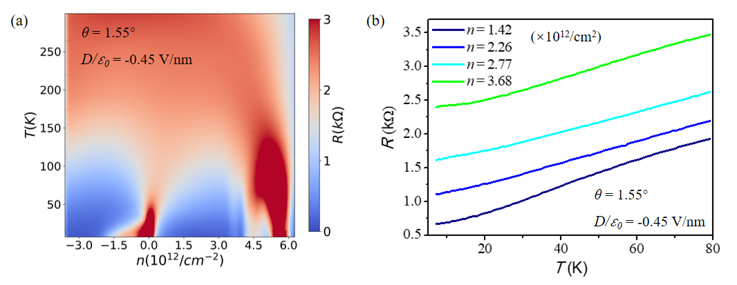
Supplement Figure 1. Resistance behavior at D/₀=-0.45V/nm in 1.55° device. (a) Longitudinal resistance as a function of n and T at D/₀=-0.45V/nm. (b) Resistance as a function of T at D/₀=-0.45V/nm.

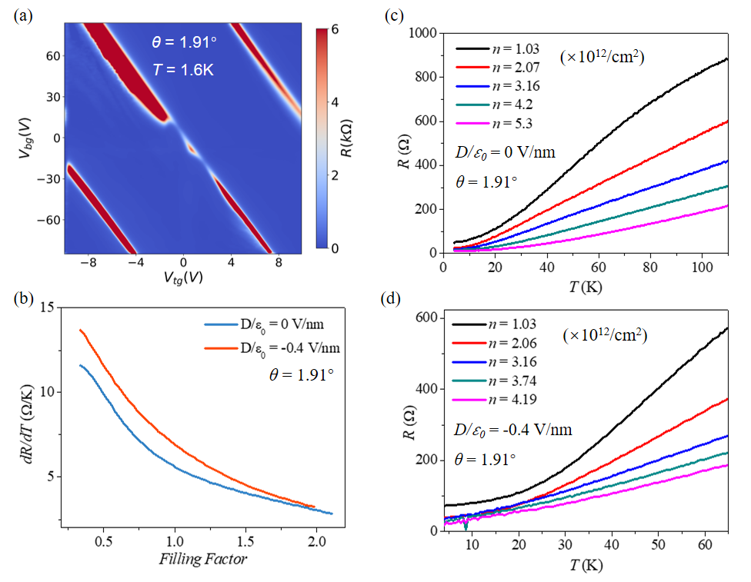
Supplement Figure 2. T-linear resistance behavior in 1.91° device. (a) Resistance as a function of V_{tg} and V_{bg}. (b) Extracted dR/dT as a function of v at D/₀=0V/nm (dark blue) and D/₀=-0.4V/nm (orange). (c-d) Resistance as a function of T at D/₀=0V/nm (c) and D/₀=-0.4V/nm (d).

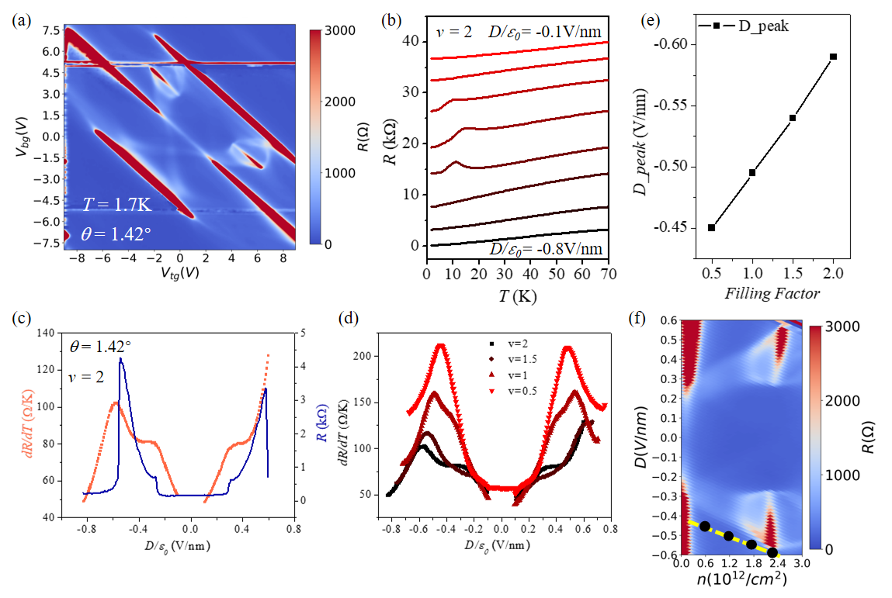
Supplement Figure 3. T-linear resistance behavior for 1.42° TDBG. (a) Resistance as a function of V_{tg} and V_{bg}. (b) Resistance as a function of T at v=2. (c). Extracted dR/dT and resistance as a function of D/₀ at v=2. (d) Extracted dR/dT as a function of D/₀ at various v. (e). The displacement field of the peak of dR/dT as a function of v. (f) Zoom in of the resistance as a function of v and D/₀ in 1.42° device. Black dots mark the position of the dR/dT peak, yellow dash line is the linear guide line for the eye.

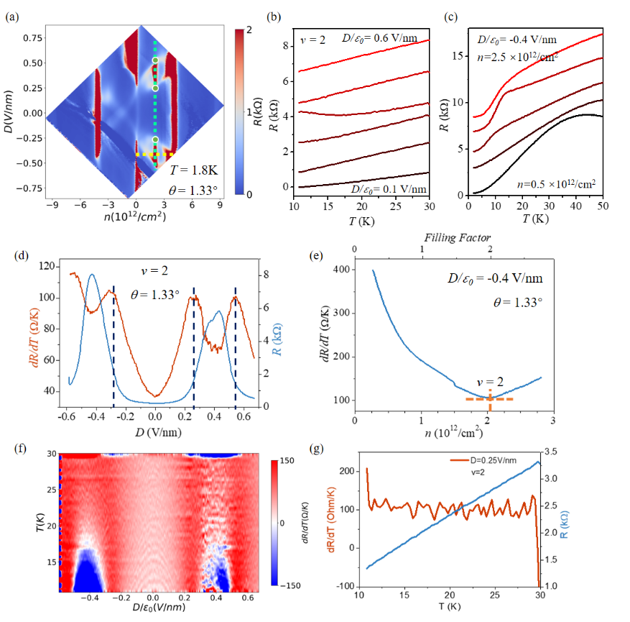

Supplement Figure 4. T-linear resistance behavior for 1.33° TDBG. (a) Resistance as a function of carrier density and displacement field in 1.33° device. (b-c) Resistance as a function of temperature at v=2 (b) and D/₀=-0.4V/nm (c). (d) Extracted dR/dT and Resistance as a function of displacement field at v=2. (e) Extracted dR/dT as a function of carrier density at D/₀=-0.4V/nm. (f) numerical derivate dR/dT as a function of displacement field and temperature at v=2. (g) Resistance and numerical dR/dT as a function of temperature near critical points at v=2, obtained from (f).

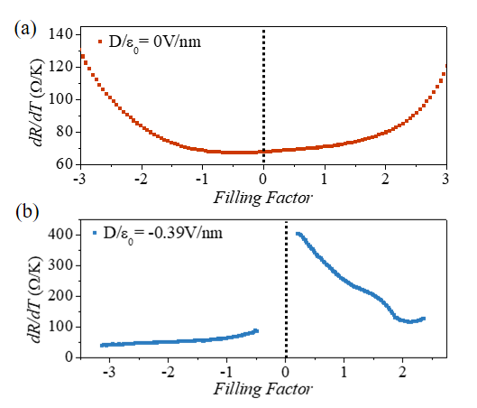
Supplement Figure 5. Carrier density dependence of dR/dT in 1.23° TDBG. (a-b) dR/dT as a function of v at D/₀=0V/nm (a) and D/₀=-0.39V/nm (b). For 1.23° device, because the overall smaller bandwidth of conduction band (CB) and valence band (VB), the T-linear resistance is observed in both electron and hole branches. At D/₀=0V/nm, the gap closing at CNP brings the conduction and valence moiré band together into a broader one. Because the Fermi velocity minimum locates at band edge in TDBG, the merged valence and conduction bands lead dR/dT to increase as approaching full filling of moiré band, leaving a flat minimum near CNP. At D/₀=-0.39V/nm, the CNP gap opening separates the CB and VB, leaving dR/dT decrease with n in both the two bands.

Supplement Figure 6. Carrier density scaling of dR/dT. For larger twist angle devices (1.55° and 1.91°), the extracted dR/dT scales linearly with $1/\sqrt{n}$ in (a-b,d), while scales with $1/n$ at D/₀=0V/nm in 1.55° device in (c). This suggests 1/n or $1/\sqrt{n}$ scaling of dR/dT is a signature of acoustic phonon scattering in TDBG. The different scaling of 1/n or $1/\sqrt{n}$ may root in field and twist angle tunable band structure in TDBG. For 1.23° device, (e,g) at D/₀=0V/nm, the dR/dT is linear in 1/n as well in both CB and VB. Here, n is relative value to full filling of moiré conduction (+n_{s}) and valence (-n_{s}) band, respectively. At D/₀=-0.39V/nm, (f) dR/dT is linear with 1/n in valence band. (h) But neither 1/n nor $1/\sqrt{n}$ can well capture the linear dependence of dR/dT in conduction band. On the contrary, (i) dR/dT obtained from 1.33° device at the same displacement field shows $1/\sqrt{n}$ scaling of dR/dT. This suggests sample variation and confirm the electron-phonon scattering in TDBG near 1.3°.

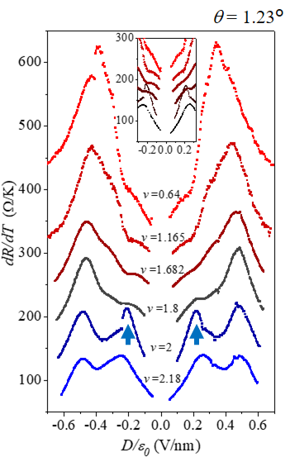
Supplement Figure 7. dR/dT as a function of displacement field at v=0.64, 1.16, 1.68, 2 and 2.18. The curves are offset for clarity with 45Ω/K. The black arrow marks the emergent dR/dT peak at v=2. The inset is the zoom-in of main figure at low displacement field. The curves in the inset are offset with 35Ω/K.

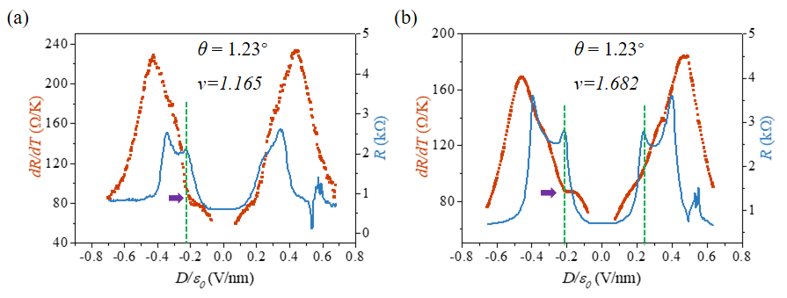
Supplement Figure 8. The correlation between the non-symmetric peak shape and halo structure. (a-b) dR/dT and resistance measured at base temperature as a function of displacement field for θ=1.23° at v=1.165 (a) and v=1.682 (b). The two-peak-shaped resistance curve comes from the halo structure. The vertical green dash lines mark the position of resistance peaks at low D/₀. It’s should be noted that these resistance peaks locate near the positions of tiny dR/dT peak at low D/₀, as the purple arrow shown.

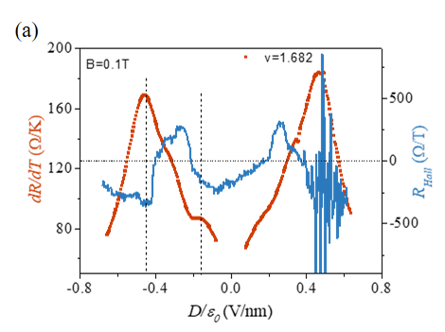
Supplement Figure 9. The correlation between the non-symmetric peak and critical points. (a) dR/dT and Hall resistance as a function of displacement field at v=1.682. Hall resistance are measured at B=0.1T. The vertical dash lines mark the positions of dR/dT peaks, which locate near the abrupt change of Hall resistance.

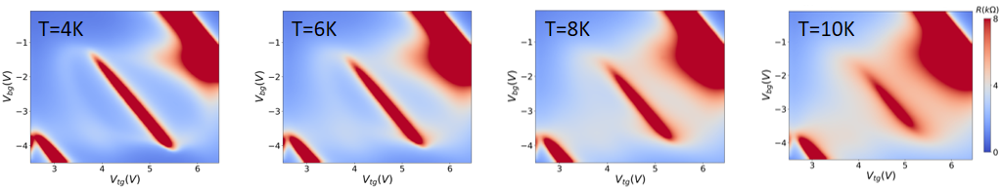
Supplement Figure 10. Temperature dependence of the halo structure. At T=8K, the halo structure has already been hard to distinguish.

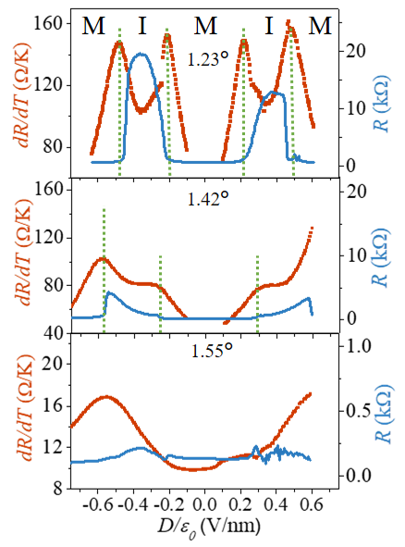
Supplement Figure 11. Twist angle dependence of dR/dT as a function of D/₀. dR/dT and resistance measured at base temperature as a function of displacement field at θ=1.23° (top panel), 1.42° (middle panel), 1.55° (bottom panel) at v=2. Link between the ‘M’ feature and correlated insulating states can be confirmed.

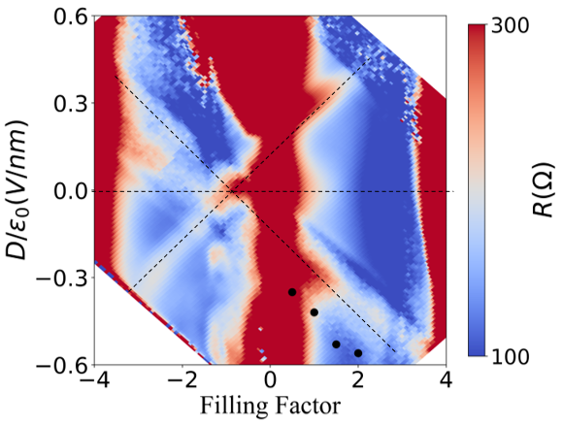
Supplement Figure 12. The cross-like high resistance van Hove Singularity in 1.55° device. The cross-like feature is similar to that in optimal twist angle, except much weaker intensity. The dR/dT peak is marked by black dots, which shifts parallel with the cross feature.

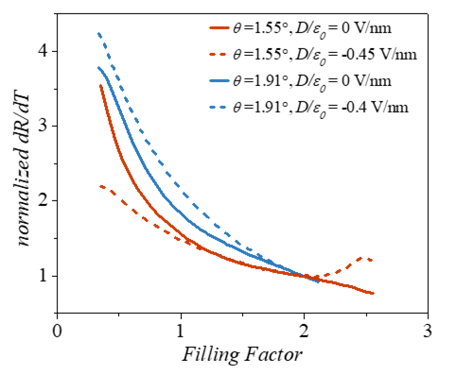
Supplement Figure 13. Normalized dR/dT as a function of v for larger twist angle devices. The curve is normalized by the value of dR/dT at v =2.

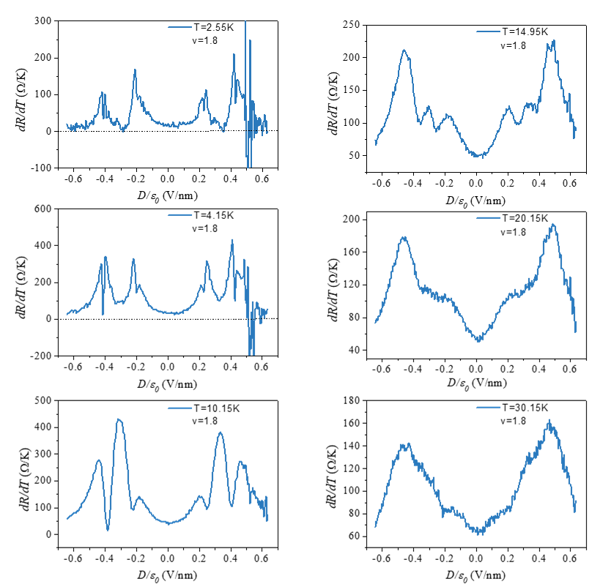
Supplement Figure 14. The numerical derivate dR/dT as a function of displacement field at various temperatures for v=1.8, 1.23° device. The dR/dT peaks related to critical points can be clearly seen near base temperature, and hints for the ‘M’ shape displacement field even hold up to 30K.

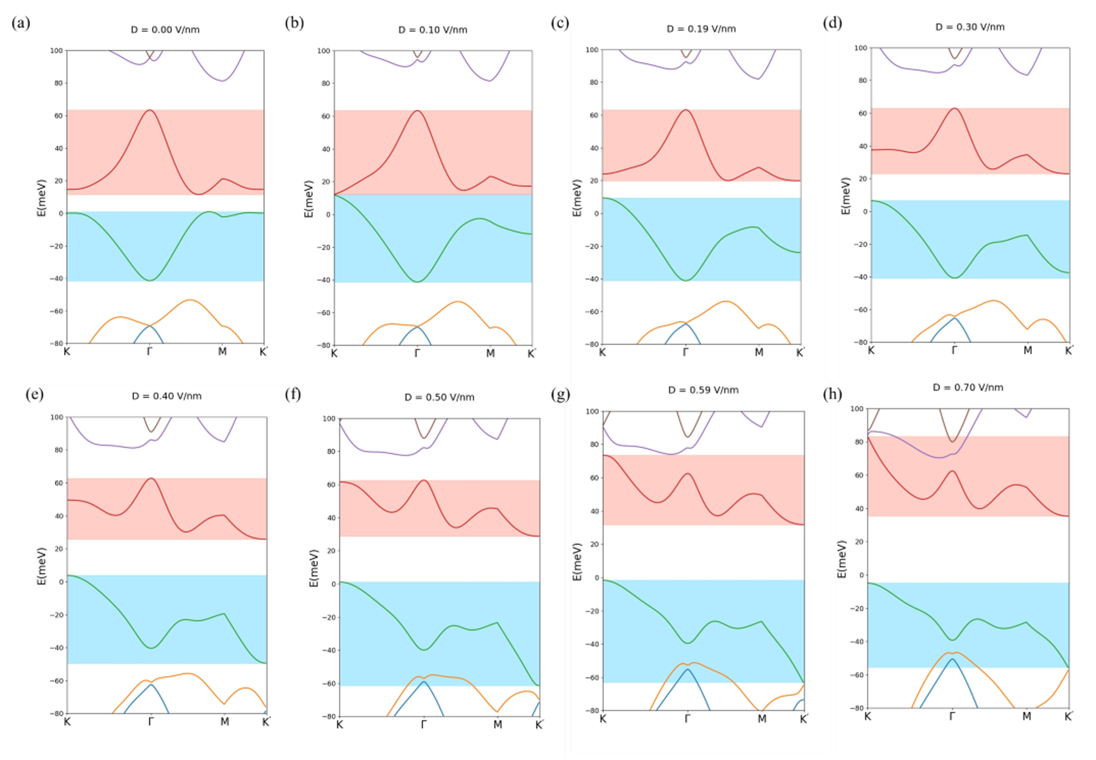
Supplement Figure 15. Effect of electric field on calculated band structure for 1.55°. (a-h) Calculated band structure for 1.55° TDBG based on full parameter continuum model with electric field uniformly distributed across the four layers.

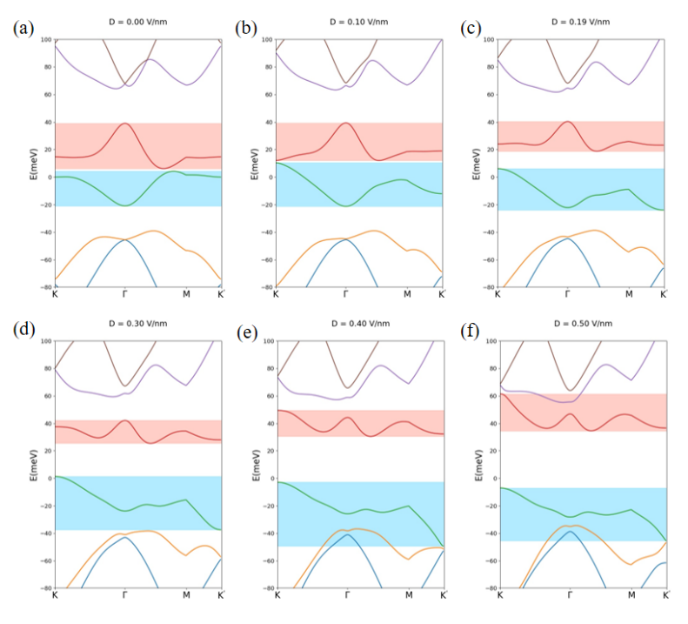
Supplement Figure 16. Effect of electric field on calculated band structure for 1.33°. (a-f) Calculated band structure for 1.33° TDBG based on full parameter continuum model with electric field uniformly distributed across the four layers.

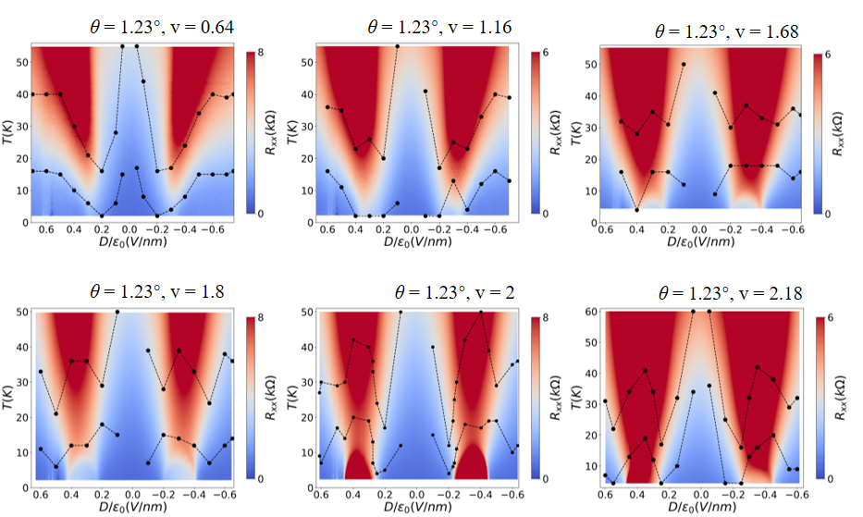
Supplement Figure 17. T-linear temperature range for 1.23° device at various filling factors. The black dots mark the upper and lower boundaries of T-linear temperature range at corresponding displacement field. Data near zero displacement field is neglected owning to the mergence of conduction band and valence band in this case.

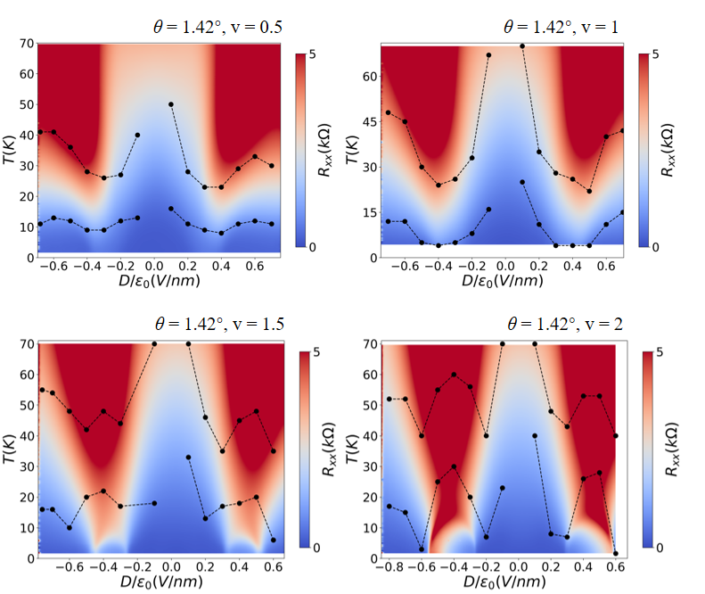
Supplement Figure 18. T-linear temperature range for 1.42° device at various filling factors. The black dots mark the upper and lower boundaries of T-linear temperature range at corresponding displacement field. Data near zero displacement field is neglected owning to the mergence of conduction band and valence band in this case.

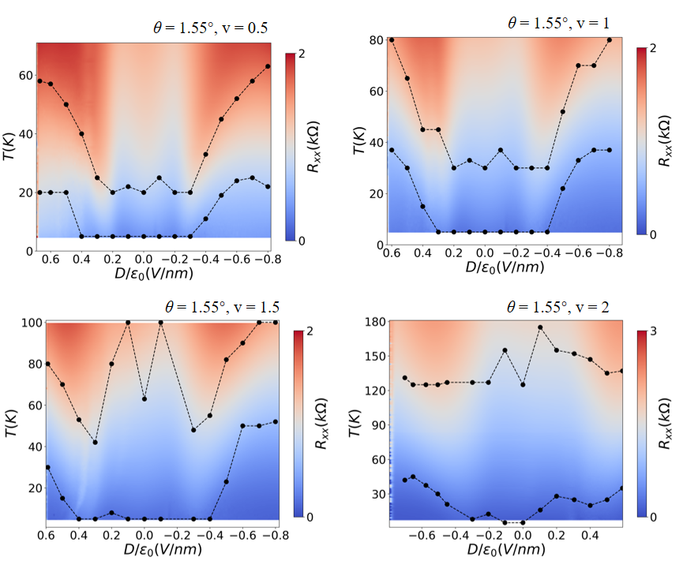
Supplement Figure 19. T-linear temperature range for 1.55° device at various filling factors. The black dots mark the upper and lower boundaries of T-linear temperature range at corresponding displacement field.

