Supplementary File: Latent growth curve models (LGCMs) of the rate of change

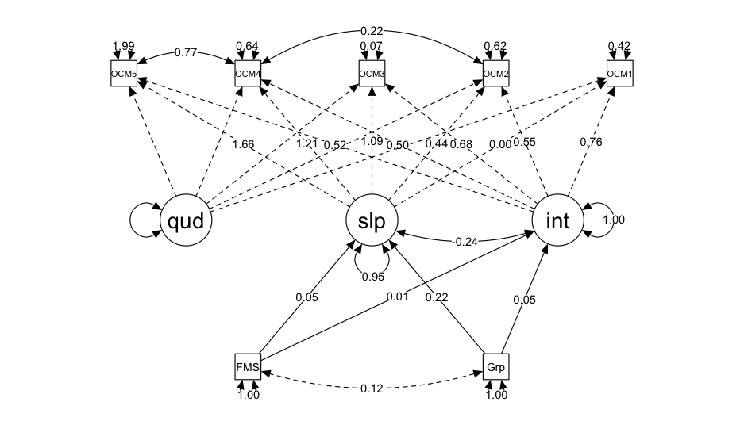
Fig. S1. Latent growth curve model for object control skills

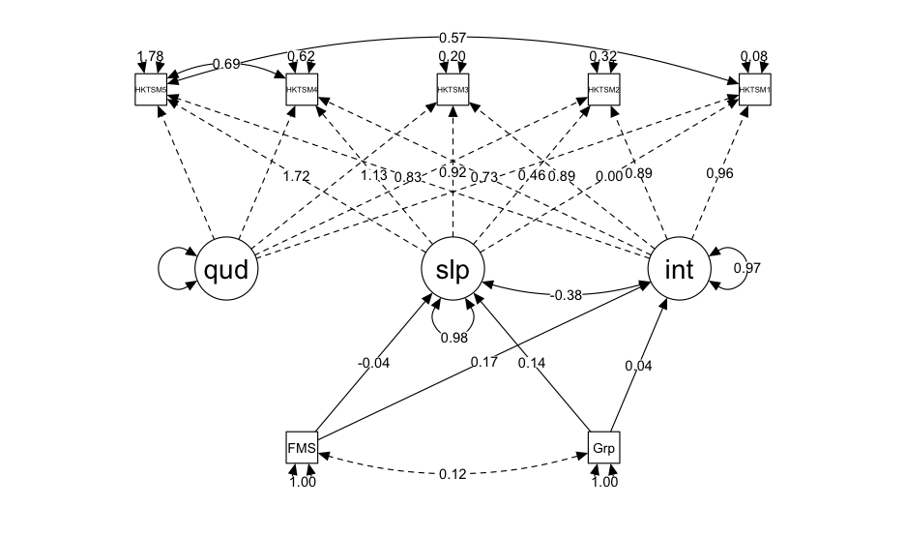
Fig. S2. Latent growth curve model for executive function
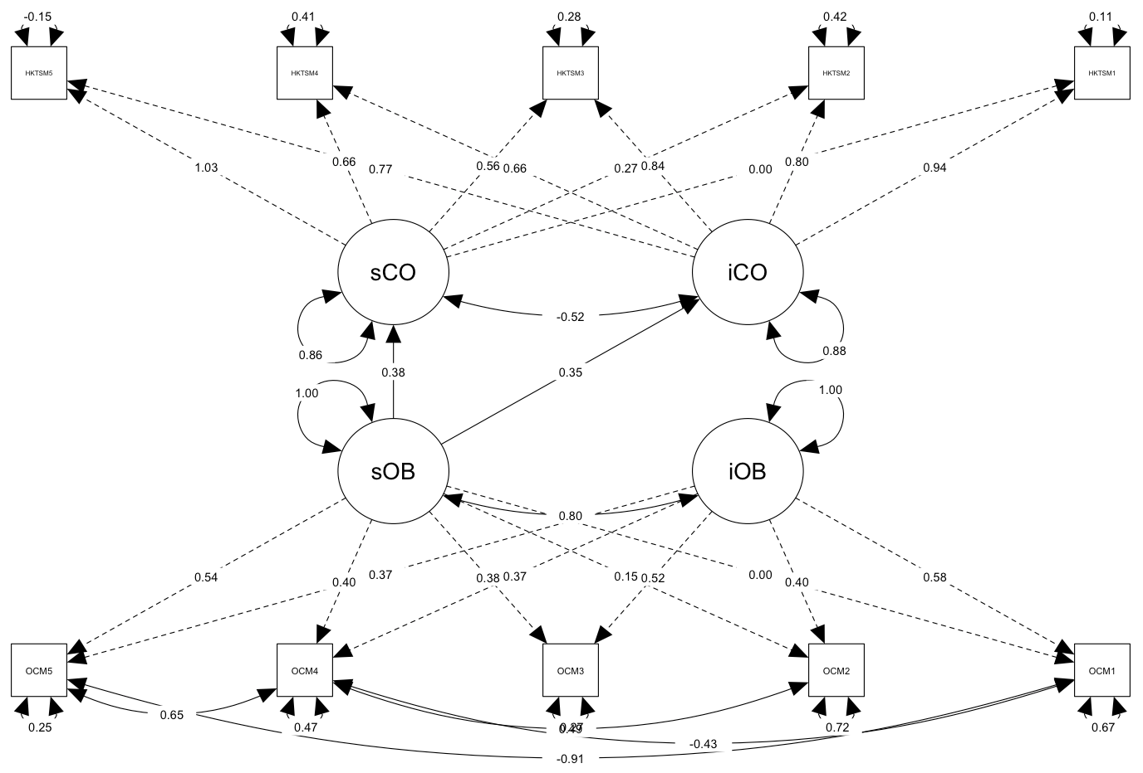
Fig S3. Latent growth curve model examining the dose‒response relationship between growth in object control skills, and baseline and growth in executive function.

