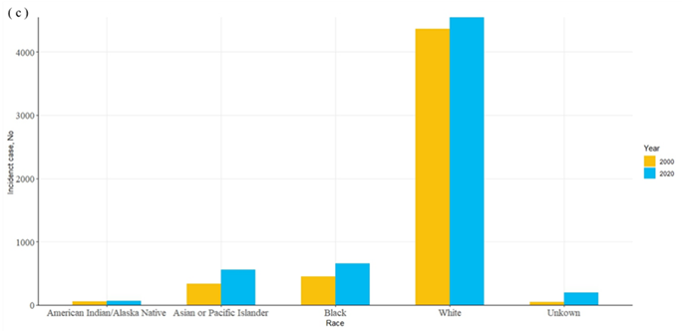
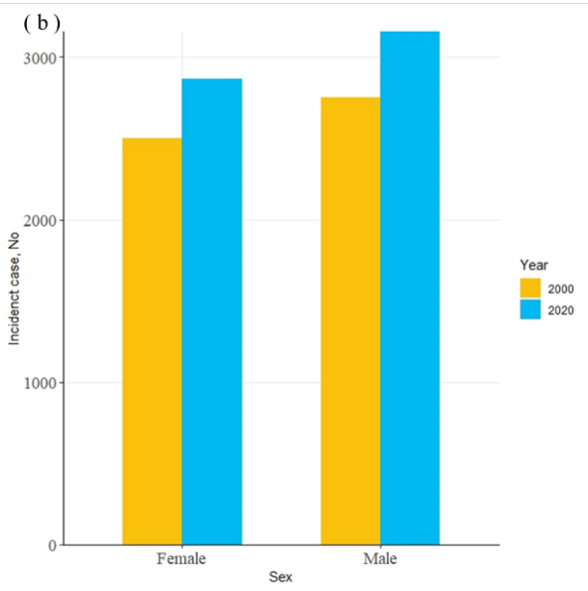
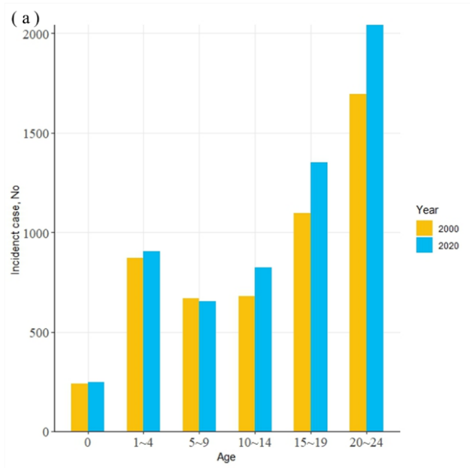
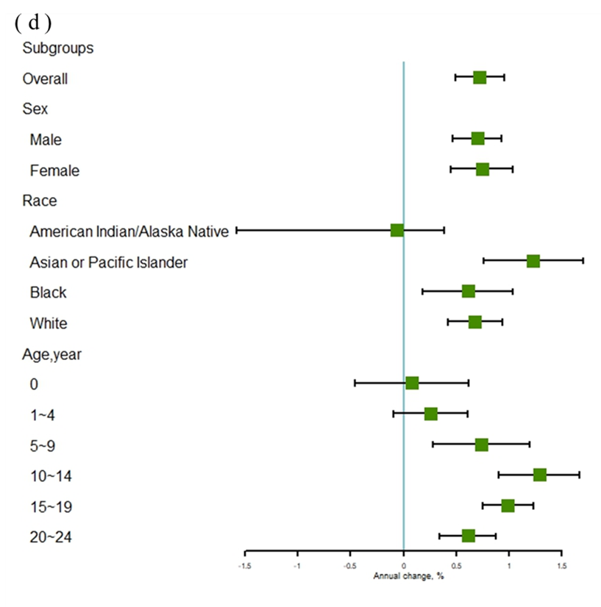
eFig 1 Incidence of cancers among people younger than 25 from 2000 to 2020
a. Incidence of cancers among people younger than 25 from 2000 to 2020, stratified by age.
b. Incidence of cancers among people younger than 25 from 2000 to 2020, stratified by sex.
c. Incidence of cancers among people younger than 25 from 2000 to 2020, stratified by race.
d. Forest plot of incidence of cancers among people younger than 25 from 2000 to 2020
eTable 1 Incidence and 5-year survival rate of 5 top cancers stratified by sex and cancer site among people younger than 25 from 2000 to 2020
 | Incidence |  | APC(95% CI) | 5-year Relative Survival Rate(%) (95%CI )
 | 2000 | 2020 |  | 2000 | 2015
Male
Leukemia | 574 | 685 | 0.71 (0.34 to 1.08)a | 51.8 (43.2 to 59.7) | 71.9 (65.0 to 77.1)
Lymphocytic Leukemia | 414 | 488 | 0.70 (0.34 to 1.08)a | 55.7 (43.2 to 66.5) | 68.5 (59.0 to 75.9)
Myeloid and Monocytic Leukemia | 146 | 179 | 0.73 (0.16 to 1.31)a | 52.0 (39.3 to 63.2) | 78.3 (67.7 to 85.1)
Lymphoma | 480 | 535 | 0.86 (0.26 to 1.46)a | 82.0 (77.3 to 85.9) | 93.9 (90.5 to 95.8)
Hodgkin Lymphoma | 232 | 264 | 0.23 (-0.33 to 0.79) | 92.0 (86.6 to 95.3) | 97.3 (93.5 to 98.6)
Non-Hodgkin Lymphoma | 248 | 271 | 0.86 (0.26 to 1.46)a | 70.0 (61.8 to 76.8) | 89.1 (82.5 to 93.0)
Male Genital System | 362 | 568 | 1.40 (0.87 to 1.92)a | 93.0 (89.6 to 95.3) | 94.9 (91.7 to 96.2)
Brain and Other Nervous System | 426 | 372 | -0.11 (-0.59 to 0.38)a | 68.0 (58.7 to 75.7) | 72.7 (64.0 to 79.0)
Brain | 381 | 334 | -0.21 (-0.65 to 0.24) | 68.1 (58.4 to 76.1) | 74.5 (65.5 to 80.8)
Cranial Nerves Other Nervous System | 45 | 38 | 0.63 (-0.80 to 2.08) | 66.9 (28.1 to 88.1) | 50.2 (18.4 to 76.3)
Endocrine System | 132 | 221 | 2.67 (2.14 to 3.20)a | 86.4 (74.1 to 93.1) | 97.5 (92.0 to 99.1)
Thyroid | 53 | 117 | 4.81 (3.87 to 5.75)a | 93.0 (79.4 to 97.7) | 100.0
Other Endocrine including Thymus | 79 | 104 | 0.57 (0.14 to 0.96) | 66.9 (37.6 to 84.8) | 84.3 (58.7 to 94.6)
Female
Leukemia | 490 | 487 | 0.47 (-0.07 to 1.02) | 48.8 (39.4 to 57.4) | 73.5 (65.3 to 79.8)
Lymphocytic Leukemia | 346 | 336 | 0.46 (-0.11 to 1.04) | 54.6 (40.6 to 66.6) | 72.1 (58.8 to 81.5)
Myeloid and Monocytic Leukemia | 135 | 136 | 0.38 (-0.45 to 1.22) | 44.1 (31.2 to 56.2) | 72.1 (60.2 to 80.7)
Endocrine System | 334 | 475 | 2.88 (2.02 to 3.74)a | 97.5 (94.5 to 98.7) | 99.2 (97.9 to 99.6)
Thyroid | 287 | 404 | 3.16 (2.18 to 4.14)a | 99.4 (96.8 to 99.8)b | 99.6 (98.2 to 99.8)
Other Endocrine including Thymus | 47 | 71 | 0.93 (0.02 to 1.85)a | 58.4 (27.0 to 80.1) | 84.7 (51.2 to 95.9)
Lymphoma | 358 | 387 | 0.46 (0.02 to 0.91)a | 88.2 (83.5 to 91.4) | 92.5 (88.4 to 95.0)
Hodgkin Lymphoma | 238 | 248 | 0.06 (-0.54 to 0.66)a | 93.4 (88.6 to 96.0) | 95.5 (90.8 to 97.6)
Non-Hodgkin Lymphoma | 120 | 139 | 1.16 (0.48 to 1.85)a | 74.8 (63.2 to 83.0) | 86.8 (77.7 to 92.2)
Brain and Other Nervous System | 365 | 338 | -0.09 (-0.67 to 0.50) | 72.2 (62.3 to 79.6) | 86.1 (78.4 to 91.1)
Brain | 322 | 304 | -0.07 (-0.62 to 0.49) | 73.4 (63.1 to 81.1) | 84.6 (76.2 to 90.0)
Cranial Nerves Other Nervous System | 43 | 34 | -0.11 (-1.49 to 1.30) | 60.0 (25.3 to 82.7) | 100.0
Digestive System | 83 | 244 | 6.63 (5.20 to 8.08)a | 53.6 (35.5 to 68.4) | 80.0 (72.4 to 85.4)
Colon and Rectum | —— | 133 | —— | 62.2 (36.3 to 79.8) | 89.1 (81.0 to 93.8)
Liver and Intrahepatic Bile Duct | —— | 31 | —— | 35.4 (0.60 to 91.0) | 50.0 (20.8 to 73.6)
Pancreas | —— | 35 | —— | 100.0 | 92.4 (56.6 to 98.9)b
Confidence interval: Log(-Log()) Transformation. The level is 95%.
a P＜0.05.
b the width of the confidence interval is more than 25% lager than if the normal approximation was applied
Abbreviations: APC, annual percentage change; CI: Confidence interval;

eTable 1 Incidence of cancers among people younger than 25 from 2000 to 2020, stratified by Cancer Site
 | ASIR per 100 000 cancers (95% CI)
Organ system | 2000 | 2020 | APC (95% CI) | P value
All Sites | 19.26 ( 18.74 to 19.79 ) | 21.47 ( 20.93 to 22.02 ) | 0.72 ( 0.49 to 0.96 ) | ＜0.001
Oral Cavity and Pharynx | 0.27 ( 0.21 to 0.34 ) | 0.32 ( 0.25 to 0.39 ) | 0.32 (-0.64 to 1.30 ) | 0.49
Tongue | 0.03 ( 0.01 to 0.05 ) | 0.05 ( 0.03 to 0.08 ) | 1.98 (-0.66 to 4.69 ) | 0.13
Salivary Gland | 0.09 ( 0.06 to 0.13 ) | 0.15 ( 0.11 to 0.20 ) | 0.97 (-0.34 to 2.31 ) | 0.14
Gum and Other Mouth | 0.04 ( 0.02 to 0.08 ) | 0.05 ( 0.03 to 0.09 ) | 0.82 (-1.22 to 2.90 ) | 0.41
Nasopharynx | 0.09 ( 0.06 to 0.14 ) | 0.07 ( 0.04 to 0.11 ) | -1.20 (-2.41 to 0.03 ) | 0.05
Digestive System | 0.60 ( 0.51 to 0.70 ) | 1.52 ( 1.38 to 1.68 ) | 5.44 ( 4.46 to 6.43 ) | ＜0.001
Stomach | 0.04 ( 0.02 to 0.08 ) | 0.08 ( 0.05 to 0.11 ) | 2.69 ( 1.46 to 3.93 ) | ＜0.001
Colon and Rectum | 0.16 ( 0.12 to 0.22 ) | 0.83 ( 0.73 to 0.95 ) | 10.02 ( 8.00 to 12.07 ) | ＜0.001
Colon excluding Rectum | 0.09 ( 0.06 to 0.14 ) | 0.75 ( 0.65 to 0.86 ) | 12.40 ( 9.77 to 15.09 ) | ＜0.001
Cecum | 0.00 ( 0.00 to 0.02 ) | 0.01 ( 0.00 to 0.04 ) | -0.61 (-3.88 to 2.78 ) | 0.71
Appendix | 0.01 ( 0.00 to 0.03 ) | 0.67 ( 0.58 to 0.78 ) | 22.03 ( 16.75 to 27.56 ) | ＜0.001
Ascending Colon | 0.01 ( 0.00 to 0.04 ) | 0.01 ( 0.00 to 0.03 ) | 0.86 (-2.16 to 3.98 ) | 0.56
Transverse Colon | 0.00 ( 0.00 to 0.02 ) | 0.00 ( 0.00 to 0.02 ) | -4.56 (-8.54 to -0.41 ) | 0.03
Sigmoid Colon | 0.03 ( 0.01 to 0.05 ) | 0.02 ( 0.01 to 0.04 ) | 1.21 (-1.41 to 3.90 ) | 0.35
Large Intestine，NOS | 0.00 ( 0.00 to 0.02 ) | 0.00 ( 0.00 to 0.02 ) | 0.29 (-3.60 to 4.33 ) | 0.88
Rectum and Rectosigmoid Junction | 0.07 ( 0.04 to 0.11 ) | 0.09 ( 0.06 to 0.13 ) | 0.84 (-0.89 to 2.59 ) | 0.33
Rectosigmoid Junction | 0.01 ( 0.00 to 0.03 ) | 0.02 ( 0.01 to 0.04 ) | -1.24 (-3.84 to 1.44 ) | 0.34
Rectum | 0.06 ( 0.04 to 0.10 ) | 0.07 ( 0.04 to 0.11 ) | 1.01 (-0.86 to 2.92 ) | 0.28
Liver and Intrahepatic Bile Duct | 0.22 ( 0.16 to 0.28 ) | 0.27 ( 0.21 to 0.34 ) | 1.10 ( 0.32 to 1.89 ) | 0.008
Liver | 0.22 ( 0.16 to 0.28 ) | 0.26 ( 0.20 to 0.33 ) | 0.99 ( 0.22 to 1.77 ) | 0.01
Pancreas | 0.04 ( 0.02 to 0.07 ) | 0.16 ( 0.12 to 0.21 ) | 10.05 ( 7.98 to 12.16 ) | ＜0.001
Retroperitoneum | 0.10 ( 0.07 to 0.14 ) | 0.13 ( 0.09 to 0.18 ) | 0.76 (-0.86 to 2.40 ) | 0.34
Respiratory System | 0.30 ( 0.24 to 0.37 ) | 0.28 ( 0.22 to 0.35 ) | -0.29 (-1.24 to 0.68 ) | 0.54
Nose, Nasal Cavity and Middle Ear | 0.04 ( 0.02 to 0.07 ) | 0.04 ( 0.02 to 0.07 ) | -0.27 (-3.90 to -0.21 ) | 0.03
Larynx | 0.01 ( 0.00 to 0.03 ) | 0.00 ( 0.00 to 0.02 ) | -2.20 (-5.38 to 1.09 ) | 0.18
Lung and Bronchus | 0.11 ( 0.07 to 0.16 ) | 0.13 ( 0.09 to 0.18 ) | 1.06 (-0.15 to 2.29 ) | 0.08
Trachea, Mediastinum and Other Respiratory Organs | 0.14 ( 0.10 to 0.20 ) | 0.10 ( 0.07 to 0.15 ) | -0.74 (-2.07 to 0.62 ) | 0.27
Bones and Joints | 0.76 ( 0.66 to 0.87 ) | 0.87 ( 0.76 to 0.99 ) | 0.11 (-0.57 to 0.79 ) | 0.75
Soft Tissue including Heart | 1.15 ( 1.03 to 1.29 ) | 1.08 ( 0.96 to 1.21 ) | -0.08 (-0.62 to 0.45 ) | 0.75
Skin excluding Basal and Squamous | 1.31 ( 1.18 to 1.45 ) | 0.62 ( 0.53 to 0.72 ) | -3.03 (-3.73 to -2.33 ) | ＜0.001
Melanoma of the Skin | 1.17 ( 1.05 to 1.31 ) | 0.53 ( 0.45 to 0.62 ) | -3.41 (-4.16 to -2.66 ) | ＜0.001
Other Non-Epithelial Skin | 0.14 ( 0.10 to 0.19 ) | 0.09 ( 0.05 to 0.13 ) | 0.05 (-1.48 to 1.61 ) | 0.94
Breast | 0.13 ( 0.09 to 0.18 ) | 0.15 ( 0.11 to 0.20 ) | 0.93 (-0.26 to 2.14 ) | 0.12
Female Genital System | 0.63 ( 0.54 to 0.74 ) | 0.66 ( 0.57 to 0.76 ) | -0.65 (-1.14 to -0.15 ) | 0.01
Cervix Uteri | 0.17 ( 0.12 to 0.22 ) | 0.04 ( 0.02 to 0.07 ) | -5.41 (-7.10 to -3.69 ) | ＜0.001
Corpus and Uterus, NOS | 0.04 ( 0.02 to 0.07 ) | 0.05 ( 0.03 to 0.08 ) | 2.78 ( 0.59 to 5.01 ) | 0.02
Corpus Uteri | 0.03 ( 0.68 to 5.04 ) | 0.04 ( 0.02 to 0.07 ) | 2.84 ( 0.68 to 5.04 ) | 0.01
Ovary | 0.38 ( 0.31 to 0.46 ) | 0.52 ( 0.44 to 0.61 ) | 0.60 ( 0.04 to 1.17 ) | 0.04
Vagina | 0.00 ( 0.00 to 0.02 ) | 0.01 ( 0.00 to 0.03 ) | -2.71 (-6.42 to 1.14 ) | 0.16
Other Female Genital Organs | 0.04 ( 0.02 to 0.08 ) | 0.02 ( 0.01 to 0.04 ) | -3.16 (-6.14 to -0.08 ) | 0.04
Male Genital System | 1.32 ( 1.19 to 1.47 ) | 1.59 ( 1.45 to 1.74 ) | 1.02 ( 0.60 to 1.44 ) | ＜0.001
Testis | 1.29 ( 1.16 to 1.43 ） | 1.55 ( 1.42 to 1.70 ) | 1.06 ( 0.62 to 1.51 ) | ＜0.001
Other Male Genital Organs | 0.02 ( 0.01 to 0.04 ) | 0.03 ( 0.01 to 0.05 ) | -0.56 (-3.55 to 2.52 ) | 0.70
Urinary System | 0.66 ( 0.57 to 0.76 ) | 0.74 ( 0.64 to 0.85 ) | 0.68 ( 0.13 to 1.23 ) | 0.02
Urinary Bladder | 0.11 ( 0.07 to 0.16 ) | 0.07 ( 0.05 to 0.11 ) | -1.23 (-3.20 to 0.78 ) | 0.21
Kidney and Renal Pelvis | 0.54 ( 0.46 to 0.64 ) | 0.66 ( 0.57 to 0.76 ) | 0.87 ( 0.18 to 1.56 ) | 0.02
Eye and Orbit | 0.34 ( 0.27 to 0.41 ) | 0.26 ( 0.21 to 0.33 ) | -0.40 (-1.21 to 0.42 ) | 0.32
Brain and Other Nervous System | 2.90 ( 2.70 to 3.11 ) | 2.60 ( 2.41 to 2.80 ) | -0.13 (-0.52 to 0.25 ) | 0.48
Brain | 2.57 ( 2.39 to 2.77 ) | 2.33 ( 2.15 to 2.52 ) | -0.19 (-0.55 to 0.17 ) | 0.29
Cranial Nerves Other Nervous System | 0.32 ( 0.26 to 0.40 ) | 0.27 ( 0.21 to 0.33 ) | 0.29 (-0.82 to 1.42 ) | 0.59
Endocrine System | 1.71 ( 1.56 to 1.87 ) | 2.43 ( 2.26 to 2.62 ) | 2.60 ( 2.01 to 3.19 ) | ＜0.001
Thyroid | 1.25 ( 1.12 to 1.39 ) | 1.79 ( 1.64 to 1.95 ) | 3.18 ( 2.39 to 3.97 ) | ＜0.001
Other Endocrine including Thymus | 0.46 ( 0.38 to 0.55 ) | 0.65 ( 0.56 to 0.75 ) | 0.79 ( 0.17 to 1.41 ) | 0.01
Lymphoma | 3.08 ( 2.87 to 3.30 ) | 3.24 ( 3.03 to 3.45 ) | 0.33 ( 0.06 to 0.60 ) | 0.02
Hodgkin Lymphoma | 1.73 ( 1.58 to 1.89 ) | 1.78 ( 1.63 to 1.94 ) | -0.08 (-0.49 to 0.33 ) | 0.68
Hodgkin - Nodal | 1.71 ( 1.56 to 1.88 ) | 1.77 ( 1.62 to 1.93 ) | -0.02 (-0.41 to 0.37 ) | 0.90
Hodgkin - Extranodal | 0.01 ( 0.00 to 0.04 ) | 0.01 ( 0.00 to 0.04 ) | -4.46 (-7.79 to -1.02 ) | 0.01
Non-Hodgkin Lymphoma | 1.35 ( 1.22 to 1.50 ) | 1.46 ( 1.32 to 1.60 ) | 0.83 ( 0.35 to 1.32 ) | 0.002
NHL - Nodal | 0.98 ( 0.87 to 1.11 ) | 0.89 ( 0.79 to 1.01 ) | 0.05 (-0.54 to 0.64 ) | 0.86
NHL - Extranodal | 0.37 ( 0.30 to 0.45 ) | 0.56 ( 0.48 to 0.66 ) | 2.18 ( 1.58 to 2.78 ) | ＜0.001
Myeloma | 0.00 ( 0.00 to 0.02 ) | 0.01 ( 0.00 to 0.03 ) | 0.54 (-4.55 to 5.90 ) | 0.83
Leukemia | 3.90 ( 3.67 to 4.14 ) | 4.30 ( 4.06 to 4.55 ) | 0.57 ( 0.31 to 0.84 ) | ＜0.001
Lymphocytic Leukemia | 2.78 ( 2.59 to 2.99 ) | 3.05 ( 2.84 to 3.26 ) | 0.59 ( 0.28 to 0.90 ) | 0.001
Acute Lymphocytic Leukemia | 2.76 ( 2.56 to 2.96 ) | 3.03 ( 2.83 to 3.24 ) | 0.57 ( 0.27 to 0.88 ) | 0.001
Myeloid and Monocytic Leukemia | 1.03 ( 0.91 to 1.16 ) | 1.13 ( 1.01 to 1.26 ) | 0.48 ( 0.07 to 0.88 ) | 0.02
Acute Myeloid Leukemia | 0.76 ( 0.66 to 0.87 ) | 0.82 ( 0.72 to 0.94 ) | 0.65 ( 0.16 to 1.13 ) | 0.01
Acute Monocytic Leukemia | 0.08 ( 0.05 to 0.12 ) | 0.02 ( 0.01 to 0.05 ) | -4.34 (-6.48 to -2.15 ) | 0.001
Chronic Myeloid Leukemia | 0.16 ( 0.12 to 0.22 ) | 0.27 ( 0.21 to 0.33 ) | 1.64 ( 0.69 to 2.60 ) | 0.002
Other Leukemia | 0.08 ( 0.05 to 0.13 ) | 0.12 ( 0.08 to 0.17 ) | 1.17 (-0.11 to 2.46 ) | 0.07
Other Acute Leukemia | 0.06 ( 0.03 to 0.10 ) | 0.09 ( 0.05 to 0.13 ) | 1.77 ( 0.47 to 3.09 ) | 0.01
Aleukemic, Subleukemic and NOS | 0.03 ( 0.01 to 0.05 ) | 0.04 ( 0.02 to 0.07 ) | 0.11 (-2.79 to 3.09 ) | 0.94
Kaposi Sarcoma | 0.01 ( 0.00 to 0.04 ) | 0.03 ( 0.01 to 0.06 ) | 1.64 (-1.87 to 5.28 ) | 0.34
Miscellaneous | 0.18 ( 0.14 to 0.24 ) | 0.76 ( 0.66 to 0.87 ) | 5.43 ( 3.63 to 7.25 ) | ＜0.001
a P value of APC from 2000 to 2020.
Abbreviations: APC, annual percentage change; ASIR, age-standardized incidence rate; NHL, non-Hodgkin lymphoma; NOS, not otherwise specified.

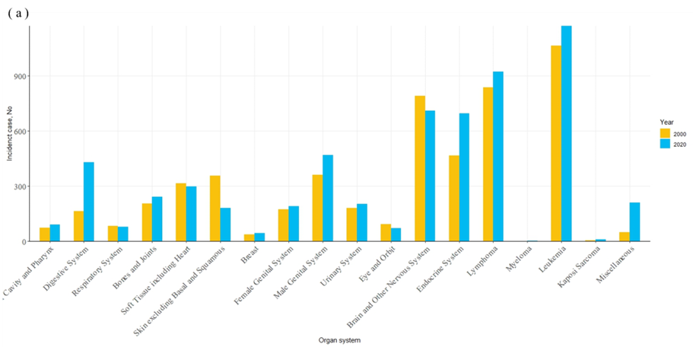
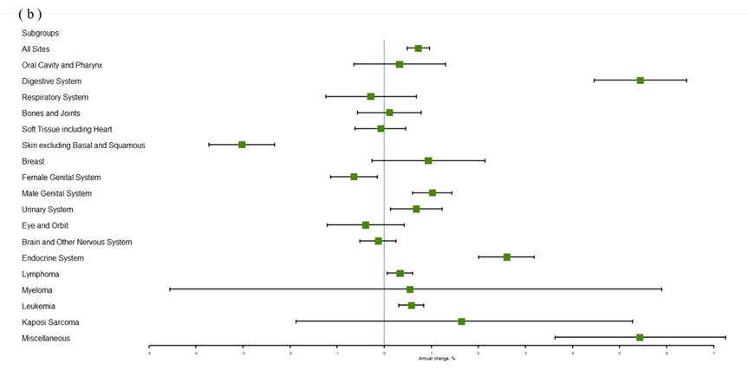
eFig 2. Incidence of cancers among people younger than 25 from 2000 to 2020, stratified by cancer site
a. Incidence of cancers among people younger than 25 from 2000 to 2020, stratified by cancer site
b. Forest plot of incidence of cancers among people younger than 25 from 2000 to 2020, stratified by cancer site

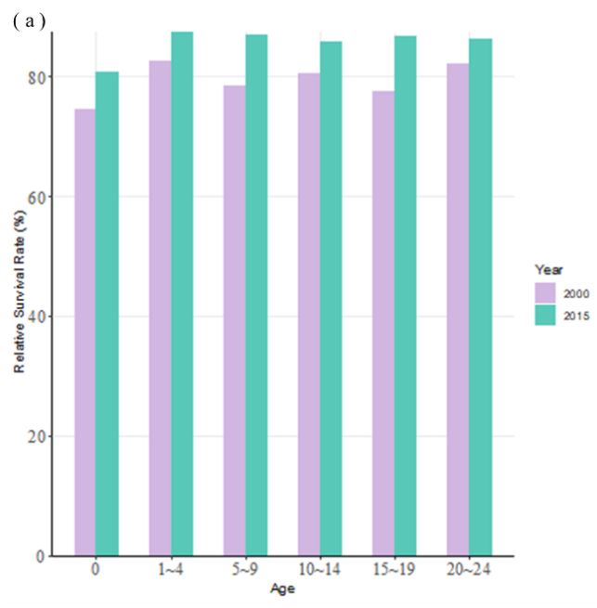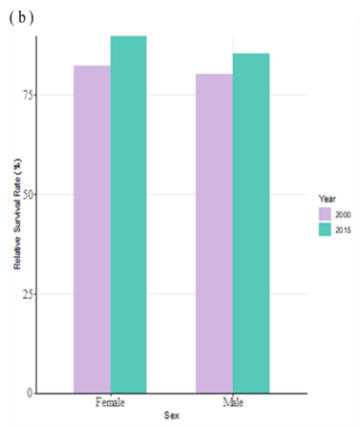
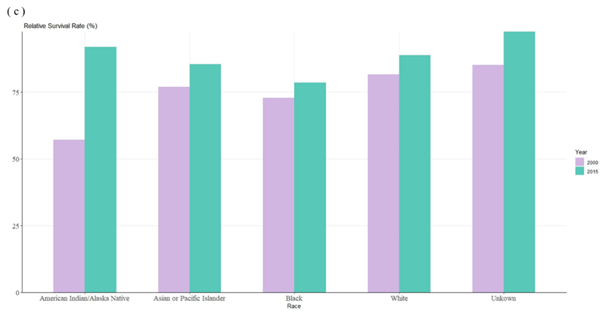
eFig3. 5-year relative survival rate of cancers among people than 25 years from 2000 to 2015.

a.5-year relative survival rate of cancers among people than 25 years from 2000 to 2015,stratified by age.
b. 5-year relative survival rate of cancers among people than 25 years from 2000 to 2015,stratified by sex.
c. 5-year relative survival rate of cancers among people than 25 years from 2000 to 2015,stratified by race.

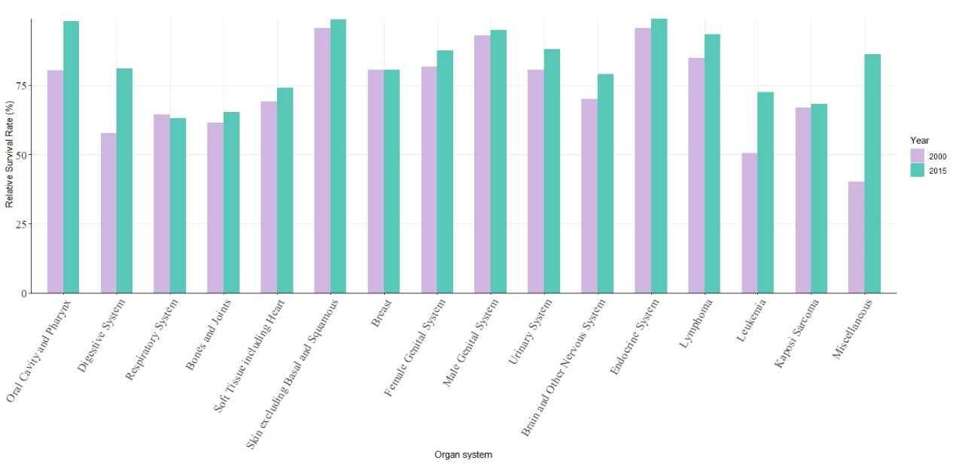eFig 4. 5-year relative survival rate of cancers stratified by cancer site among people younger than 25 from 2000 to 2015

