Supplementary Documents

Fig 6: Native page expression of SOD, Catalase and GPx

Fig 7: RT PCR study with mRNA expression:
The optimum A_{260/280} ratio were found in ranges between ~1.8 ± 2.0 for each samples.

p53
Sample | Average  CT | ΔΔCT | Fold difference
CON | 19.27 | 0 | 1.11
LET | 16.94 | -1.8 | 3.67
ARE100 | 17.06 | -1.53 | 2.98
ARE150 | 17.61 | -1.39 | 2.72
ARE 250 | 19.00 | 0.29 | 0.90
MET | 18.69 | -0.65 | 1.70
BCL2
Sample | Average  CT | ΔΔCT | Fold difference
CON | 13.84 | 0 | 1.06
LET | 15.88 | 2.57 | 0.17
ARE100 | 15.26 | 2.09 | 0.23
ARE150 | 14.67 | 1.09 | 0.48
ARE 250 | 13.91 | 0.63 | 0.72
MET | 14.38 | 0.46 | 0.78

BAX
Sample | Average  CT | ΔΔCT | Fold difference
CON | 13.71 | 0 | 1.39
LET | 10.15 | -3.03 | 8.74
ARE100 | 11.04 | -1.99 | 4.03
ARE150 | 10.94 | -2.51 | 5.92
ARE 250 | 11.54 | -1.60 | 3.36
MET | 11.26 | -2.52 | 6.21
TNFα
Sample | Average  CT | ΔΔCT | Fold difference
CON | 24.03 | 0 | 1.15
LET | 20.71 | -2.79 | 7.34
ARE100 | 20.97 | -2.38 | 5.50
ARE150 | 21.54 | -2.22 | 4.94
ARE250 | 22.13 | -1.33 | 2.80
MET | 21.72 | -2.37 | 5.47
NFkB
Sample | Average  CT | ΔΔCT | Fold difference
CON | 21.27 | 0 | 1.24
LET | 18.01 | -2.72 | 7.15
ARE100 | 18.19 | -2.39 | 5.36
ARE150 | 18.77 | -2.23 | 4.97
ARE 250 | 19.35 | -1.34 | 3.12
MET | 19.47 | -1.86 | 3.36

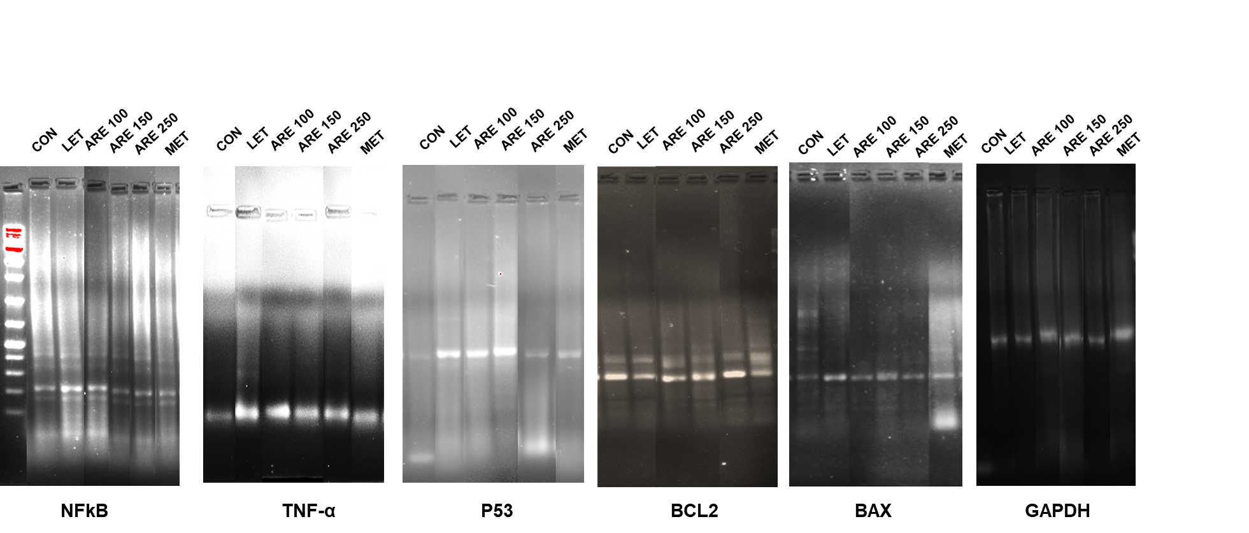

Fig 9: Quantification of immunostaining images:

