Supporting Information

Controlled sodium-water reaction and its application in long-duration energy storage
Da-Zhi Tan¹ *, Tong-tong Chen¹, Wen-Jie Fan²
1 Experimental Center of Chemistry, Faculty of Chemical, Environmental and Biological, Dalian University of Technology, Dalian 116024, P. R. China.
2 College of Marine Science and Environment Engineering, Dalian Ocean University, Dalian116023, People's Republic of China.
*Corresponding author. Email: tandz@dlut.edu.cn

Experimental
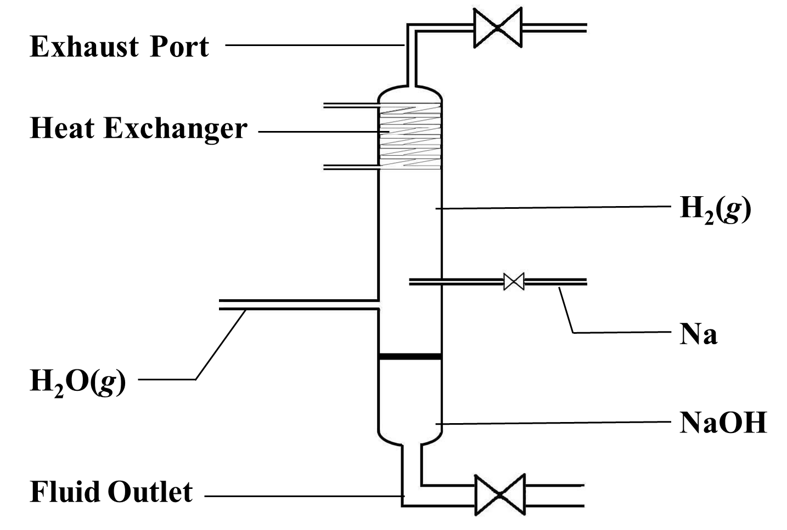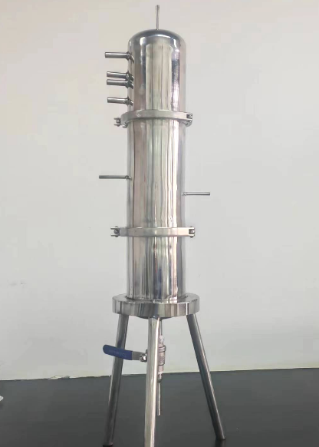
Fig. S1 The device to facilitate the safe reaction of sodium with water vapor.

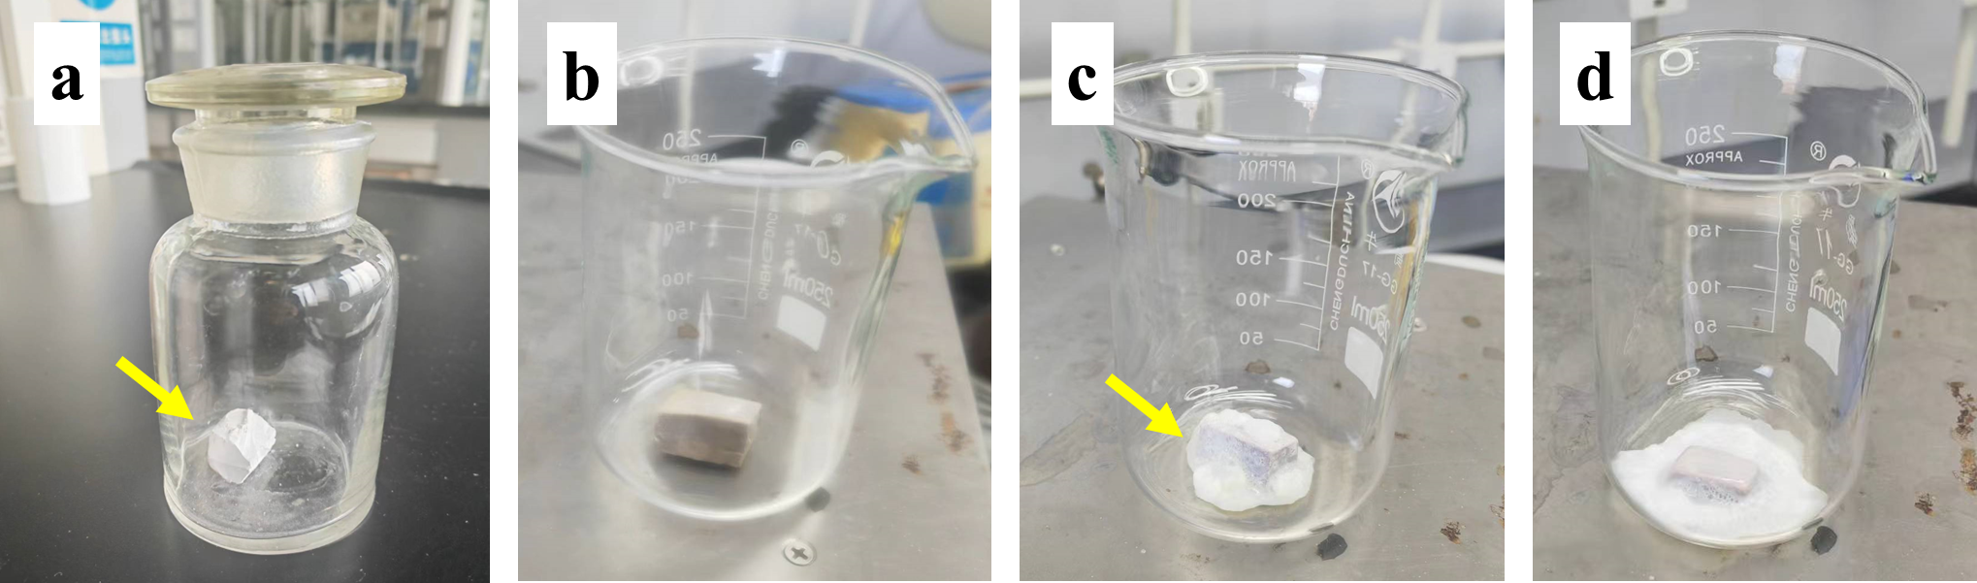
Fig. S2（a）Sodium sealing for six months. Sodium is exposed to air for (b) 1 hour, (c) 1 day, and (d) 3 days, respectively

Experimental VIDEOS
Video S1 shows the reaction between large blocks of sodium and water. After the sodium block is added, it reacts with water and quickly melts, swimming on the water surface, followed by flames, and then an explosion occurs. Due to the presence of phenolphthalein, the resulting sodium hydroxide turns the solution red.
Video S2 shows the reaction of a large lump of sodium metal with a mixture of water and kerosene. When the sodium block is pressed into the water, the sodium reacts with the water after rapid contact and produces many bubbles. The sodium changes from a solid to a liquid state and floats up quickly. The solution contains phenolphthalein and turns red.
Video S3 shows the reaction of sodium metal and water under reduced pressure. At this time, the boiling point of water is only 50 degrees, which cannot reach the melting point of sodium. The solid sodium lump bounces continuously on the water surface.
Video S4 displays the combustion of sodium in water vapor. Small pieces of sodium are put into a silicone tube containing water vapor, and the sodium burns and emits a bright red light.
Video S5 shows the reaction of sodium metal and boiling water. The sodium burns violently in the water vapor.
Video S6 shows the slow reaction with oxygen when exposed to air under the condition of heating (180 ℃)
The reaction of sodium block with oxygen in air is not fast, because the product Na₂O which covers the surface of sodium block prevents the sodium inside from coming into contact with air. As shown in the supporting material (Video S6), after the sodium was placed on a surface dish which was taken and pre-heated to 180 degrees, it can be observed that the sodium block instantly became soft. When the sodium was stirred with tweezers, it was found that the surface of the exposed silver-white sodium quickly turned greyish-white without burning. This shows that the sodium block is relatively safe in air, and it hardly reacts violently with oxygen even at higher temperatures.

