Additional File 1
A) Telomere relative quantification
Monochromatic multiplex real-time quantitative PCR (MMqPCR) assay for relative telomere length (RTL) was used to telomere relative quantification. This assay is based on the work of Cawthon et al. (Cawthon, 2009, Telomere length measurement by a novel monochrome multiplex quantitative PCR method) but with modifications of Hsieh et al.. The MMqPCR assay was performed for RTL amplifying the telomere (T) and the single-copy gene (S) beta-globin (HBB) as the reference gene in the same well. The primers used were: Tel_F = 5’-ACACTAAGGTTTGGGTTTGGGTTTGGGTTTGGGTTAGTGT-3’; Tel_R = 5’-TGTTAGGTATCCCTATCCCTATCCCTATCCCTATCCCTAACA-3’; HBB_F = 5’-CGGCGGCGGGCGGCGCGGGCTGGGCGGcttcatccacgttcaccttg-3’; and HBB_R = 5’-GCCCGGCCCGCCGCGCCCGTCCCGCCGgaggagaagtctgccgtt-3’. The final concentrations of reagents were 1X GoTaq qPCR Master Mix, 1mM DTT, and 0.15 µM of each of the four primers in a final volume of 13 µl per reaction well.
For each MMqPCR plate, a standard curve was included and was generated by serial dilution (1:3) of a pool of DNA extracted from plasma samples of 20 healthy individuals. Standard curve concentrations ranged from 0.32 ng/µl n to 77.4 ng/µl of DNA across six standards. The DNA samples of this standard curve also served as positive controls. The standard curve was run in duplicate for each run, together with a duplicated negative control. Each experimental sample was assayed in triplicate.

B) PCR cycling conditions
MMqPCR assays were performed in a QuantStudio™ 3 Real-Time PCR System (Applied Biosystems), following the thermal cycling profile and ramping temperature rates, which are shown in Additional File 2.
The thermal cycling profile was initiated with 95 °C enzyme activation (hot-start) incubation for 2 min. Next, two cycles of 94 °C for 3 s and 49 °C for 15 s, and 35 cycles of 94 °C for 15 s, 62 °C for 10 s, 74 °C for 15 s, 84 °C for 10 s, and 88 °C for 15 s were performed, with signal acquisitions at the end of the 74 °C and 88 °C stages. After cycling, a melting curve program was run, starting with a 95 °C incubation for 1 min, followed by continuous acquisitions every 0.2 °C from 45 °C to 95 °C. All temperature ramping rates were set at 3.66 °C/s or 2.2 °C/s where indicated, except the melting curve, which was ramping at 0.11 °C/s.
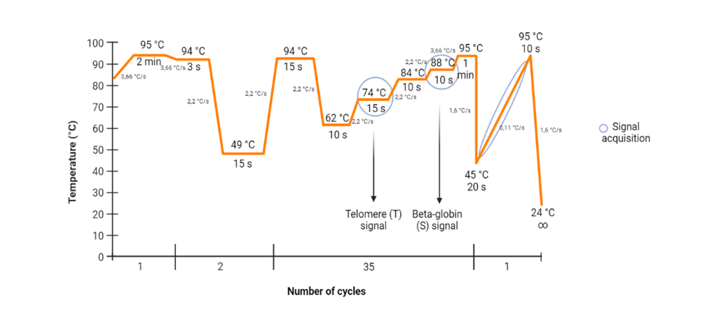
Additional File 2. MMqPCR thermal cycling profile. Signal acquisition represented by a blue circle. Created with BioRender.com

QuantStudio™ Design & Analysis Software v1.5.1 was used for data acquisition, which was exported separately (74 °C for T and 88 °C for S, from each of the acquisition steps) to Microsoft Excel to calculate the standard curve for each step. Both standard curves were calculated by averaging the raw C_{t} values extracted and plotting these C_{t} values against the logarithm of DNA concentration on an X/Y scatter plot. For this plot, a linear trend line was generated with an equation in the form of y = ax + b, where y was the logarithm of DNA concentration, a was the slope, x was the Ct value of each well, and b was the intercept. This equation was used to normalize each plate by the PCR efficiency of its standard curve. Once each plate was normalized, the linear DNA data for both the T and the S values was obtained by the equation: T or S = 10 ^ (log (DNA)), which corresponds to the telomere product and the single-copy gene, respectively. RTL was calculated by dividing T by S (T/S), and afterward, the RTL was averaged over the triplicates of each sample. Samples with a coefficient of variation (CV) greater than 0.15 were reanalyzed, discarding those samples that remained with a coefficient of variation greater than 0.15.

Additional File 3. A) Correlation between RTL baseline and age. B) Correlation between RTL at one-year visit and age
Statistics: R and p-value in the scatter plot were calculated using Spearman’s correlation. Statistical significance was determined as p ≤ 0.05. Abbreviations: RTL, relative telomere length.

Additional File 4. Association between RTL at baseline, during follow-up (ratio) and one-year visit and hospitalization variables and fibrosis at one-year visit.
 | Un-adjusted model |  | Adjusted model
Baseline RTL | AMR (95%CI) | p-value | aAMR (95%CI) | p-value
IMV | 1.13 (0.97-1.31) | 0.121 | 1.13 (0.97-1.30) | 0.116
IMV days | 1.00 (0.99-1.01) | 0.763 | 1.00 (0.99-1.01) | 0.612
ICU-LOS > 12 days | 1.10 (0.96-1.25) | 0.166 | 1.10 (0.97-1.26) | 0.132
ICU-LOS | 1.00 (0.99-1.01) | 0.344 | 1.00 (0.99-1.01) | 0.301
Prone position | 1.12 (0.98-1.28) | 0.093 | 1.11 (0.98-1.27) | 0.123
Pulmonary fibrosis | 0.93 (0.78-1.12) | 0.465 | 0.93 (0.78-1.12) | 0.465
Ratio RTL (one-year/baseline)
IMV | 0.77 (0.69-0.87) | <0.001 | 0.78 (0.69-0.88) | <0.001
IMV days | 1.00 (0.99-1.01) | 0.678 | 1.00 (0.99-1.01) | 0.678
ICU-LOS > 12 days | 0.82 (0.74-0.91) | <0.001 | 0.83 (0.74-0.92) | <0.001
ICU-LOS | 0.98 (0.97-0.99) | 0.030 | 0.98 (0.97-0.99) | 0.044
Prone position | 0.87 (0.79-0.99) | 0.051 | 0.88 (0.78-0.98) | 0.030
Pulmonary fibrosis | 0.83 (0.73-0.94) | 0.007 | 0.83 (0.73-0.94) | 0.007
One-year RTL
IMV | 0.87 (0.74-1.03) | 0.108 | 0.86 (0.74-1.01) | 0.070
IMV days | 0.99 (0.98-1.01) | 0.934 | 1.00 (0.99-1.01) | 0.818
ICU-LOS > 12 days | 0.91(0.79-1.05) | 0.188 | 0.91 (0.80-1.05) | 0.199
ICU-LOS | 0.99 (0.98-1.00) | 0.358 | 0.99 (0.98-1.00) | 0.369
Prone position | 0.99 (0.86-1.16) | 0.999 | 0.98 (0.85-1.13) | 0.813
Pulmonary fibrosis | 0.79 (0.64-0.98) | 0.040 | 0.79 (0.64-0.98) | 0.040

Statistics: Associations were calculated by Generalized Linear Models (GLM) with a gamma distribution. Significant differences are shown in bold. Abbreviations: AMR, the ratio of the arithmetic means; 95%CI, 95% of confidence interval; p-value, level of significance; IMV, invasive mechanical ventilation; ICU, intensive care unit; ICU-LOS, intensive care unit length of stay; RTL, relative telomere length.

Additional File 5. STROBE Statement—checklist of items that should be included in reports of observational studies.

 |  |  | Item No. | Recommendation |  | Page  No. |  |  | Relevant text from manuscript
Title and abstract |  |  | 1 | (a) Indicate the study’s design with a commonly used term in the title or the abstract |  | 1
 |  |  | 1 | (b) Provide in the abstract an informative and balanced summary of what was done and what was found |  | 4
Introduction
Background/rationale |  |  | 2 | Explain the scientific background and rationale for the investigation being reported |  | 5
Objectives |  |  | 3 | State specific objectives, including any prespecified hypotheses |  | 5
Methods
Study design |  |  | 4 | Present key elements of study design early in the paper |  | 6
Setting |  |  | 5 | Describe the setting, locations, and relevant dates, including periods of recruitment, exposure, follow-up, and data collection |  | 6
Participants |  |  | 6 | (a) Cohort study—Give the eligibility criteria, and the sources and methods of selection of participants. Describe methods of follow-up  Case-control study—Give the eligibility criteria, and the sources and methods of case ascertainment and control selection. Give the rationale for the choice of cases and controls  Cross-sectional study—Give the eligibility criteria, and the sources and methods of selection of participants |  | 6
 |  |  | 6 | (b) Cohort study—For matched studies, give matching criteria and number of exposed and unexposed  Case-control study—For matched studies, give matching criteria and the number of controls per case |  | NA
Variables |  |  | 7 | Clearly define all outcomes, exposures, predictors, potential confounders, and effect modifiers. Give diagnostic criteria, if applicable |  | 6
Data sources/ measurement |  |  | 8* | For each variable of interest, give sources of data and details of methods of assessment (measurement). Describe comparability of assessment methods if there is more than one group |  | 6
Bias |  |  | 9 | Describe any efforts to address potential sources of bias |  | 6-7
Study size |  |  | 10 | Explain how the study size was arrived at |  | 6
Quantitative variables |  | 11 |  | Explain how quantitative variables were handled in the analyses. If applicable, describe which groupings were chosen and why |  | 6
Statistical methods |  | 12 |  | (a) Describe all statistical methods, including those used to control for confounding |  | 6-7
 |  |  |  | (b) Describe any methods used to examine subgroups and interactions |  | 6-7
 |  |  |  | (c) Explain how missing data were addressed |  | NA
 |  |  |  | (d) Cohort study—If applicable, explain how loss to follow-up was addressed  Case-control study—If applicable, explain how matching of cases and controls was addressed  Cross-sectional study—If applicable, describe analytical methods taking account of sampling strategy |  | 6
 |  |  |  | (e) Describe any sensitivity analyses |  | NA
Results
Participants |  | 13* |  | (a) Report numbers of individuals at each stage of study—eg numbers potentially eligible, examined for eligibility, confirmed eligible, included in the study, completing follow-up, and analysed |  | 8
 |  |  |  | (b) Give reasons for non-participation at each stage |  | NA
 |  |  |  | (c) Consider use of a flow diagram |  | NA
Descriptive data |  | 14* |  | (a) Give characteristics of study participants (eg demographic, clinical, social) and information on exposures and potential confounders |  | 8
 |  |  |  | (b) Indicate number of participants with missing data for each variable of interest |  | Table 1
 |  |  |  | (c) Cohort study—Summarise follow-up time (eg, average and total amount) |  | 8
Outcome data |  | 15* |  | Cohort study—Report numbers of outcome events or summary measures over time |  | 6
 |  |  |  | Case-control study—Report numbers in each exposure category, or summary measures of exposure
 |  |  |  | Cross-sectional study—Report numbers of outcome events or summary measures
Main results |  | 16 |  | (a) Give unadjusted estimates and, if applicable, confounder-adjusted estimates and their precision (eg, 95% confidence interval). Make clear which confounders were adjusted for and why they were included |  | 7-9
 |  |  |  | (b) Report category boundaries when continuous variables were categorized |  | 8-9
 |  |  |  | (c) If relevant, consider translating estimates of relative risk into absolute risk for a meaningful time period |  | NA
Other analyses | 17 |  | Report other analyses done—eg analyses of subgroups and interactions, and sensitivity analyses |  | 9
Discussion
Key results | 18 |  | Summarise key results with reference to study objectives |  | 10
Limitations | 19 |  | Discuss limitations of the study, taking into account sources of potential bias or imprecision. Discuss both direction and magnitude of any potential bias |  | 12
Interpretation | 20 |  | Give a cautious overall interpretation of results considering objectives, limitations, multiplicity of analyses, results from similar studies, and other relevant evidence |  | 10-12
Generalisability | 21 |  | Discuss the generalisability (external validity) of the study results |  | 12
Other information
Funding | 22 |  | Give the source of funding and the role of the funders for the present study and, if applicable, for the original study on which the present article is based |  | 3

*Give information separately for cases and controls in case-control studies and, if applicable, for exposed and unexposed groups in cohort and cross-sectional studies.

Note: An Explanation and Elaboration article discusses each checklist item and gives methodological background and published examples of transparent reporting. The STROBE checklist is best used in conjunction with this article (freely available on the Web sites of PLoS Medicine at http://www.plosmedicine.org/, Annals of Internal Medicine at http://www.annals.org/, and Epidemiology at http://www.epidem.com/). Information on the STROBE Initiative is available at www.strobe-statement.org

