Supplementary Materials

Laser solid-phase synthesis of graphene shell-encapsulated high-entropy alloy nanoparticles

Yuxiang Liu, Jianghuai Yuan, Jiantao Zhou, Kewen Pan, Ran Zhang, Rongxia Zhao, Lin Li, Yihe Huang*, Zhu Liu*

Research Centre for Laser Extreme Manufacturing,
Ningbo Institute of Materials Technology and Engineering,
Chinese Academy of Sciences, Ningbo 315201, China

Fig. S1 Raman spectrum of the laser-induced graphene containing defects.

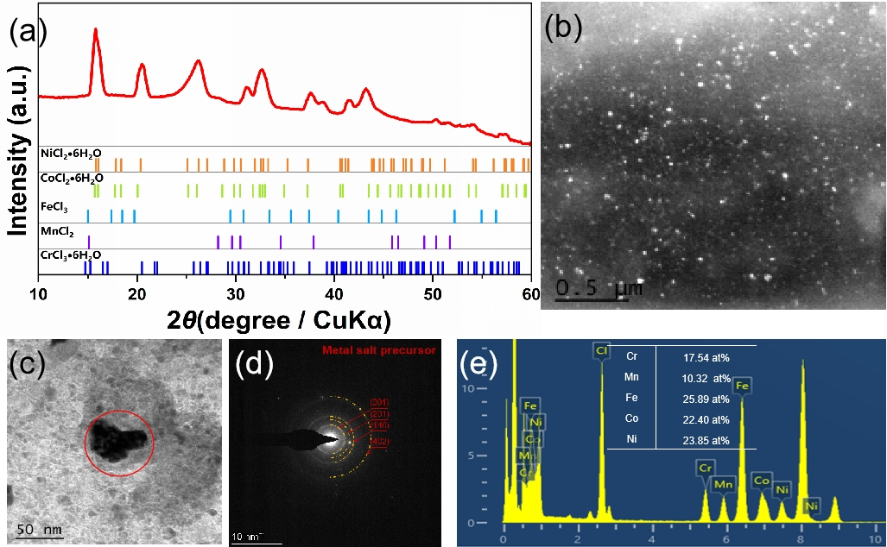
Fig. S2 Characterization of the mixed metal precursors. (a) XRD pattern (0.01 M), (b-e) TEM images, SAED pattern, and elemental compositions.

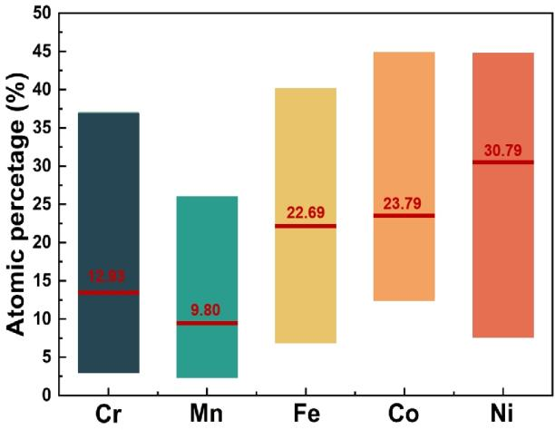
Fig. S3 Elemental ratios of the CrMnFeCoNi HEA nanoparticles obtained from EDS measurements.

(b)
(d)
(c)
(a)
Fig. S4 HRTEM images of (a) LIG and (b-d) CrMnFeCoNi HEA nanoparticles. Note: the nanoparticles are embraced by several graphene layers.

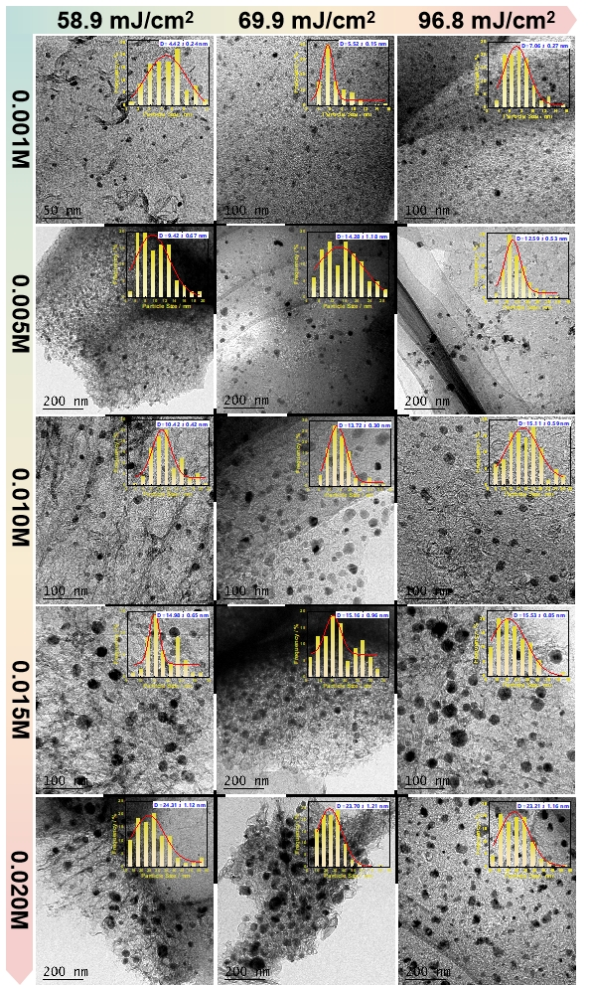
Fig.S5 TEM images and particle size distributions of CrMnFeCoNi HEA/LIG at different laser fluences (58.9, 69.9 and 96.8 mJ/cm²) and precursor concentrations (0.001, 0.005, 0.01, 0.015 and 0.02 M).
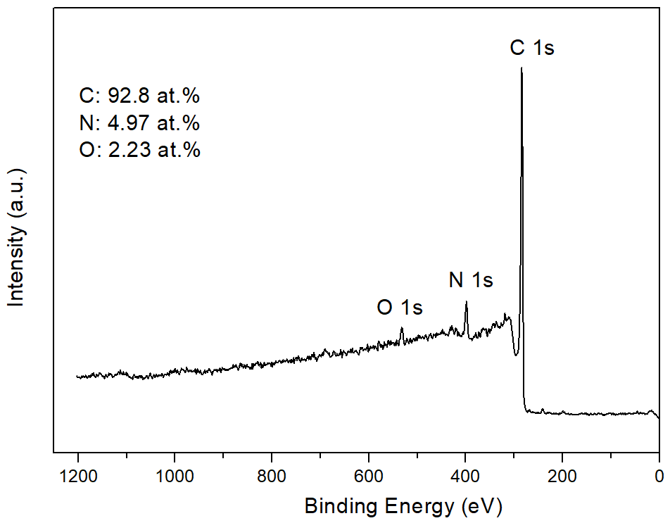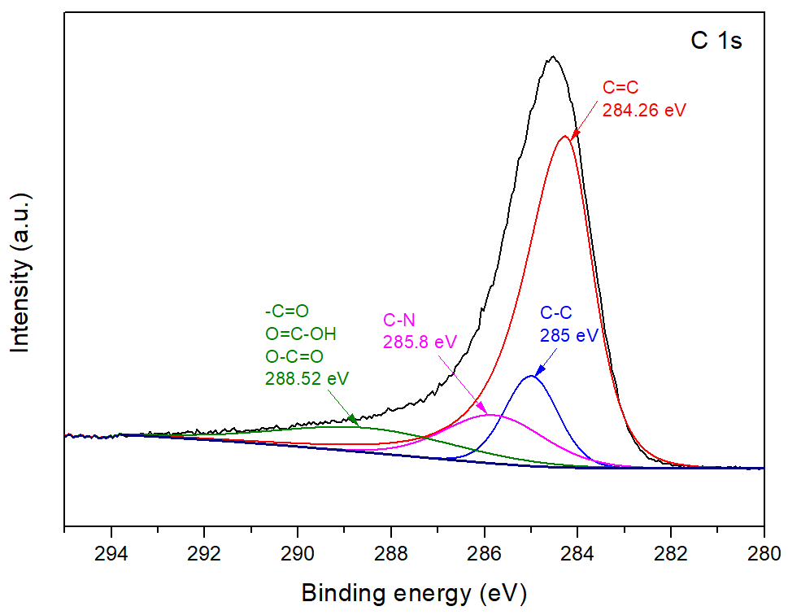
(b)
(a)
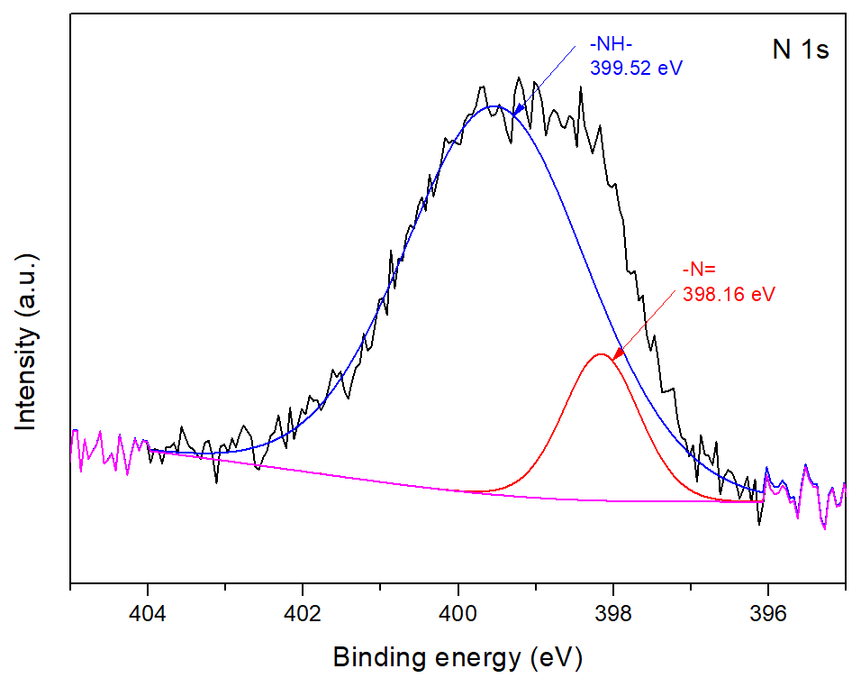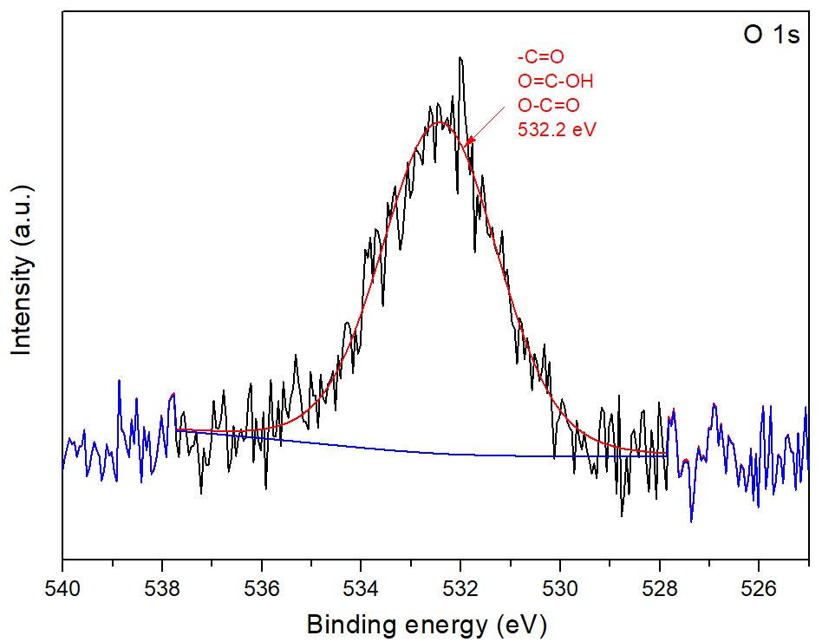
(d)
(c)
Fig. S6 XPS spectra. (a) wide spectra of the LIG, (b−d) characteristic peaks of C 1s, N 1s, and O 1s, respectively.

(b.1)
(b)
(a)
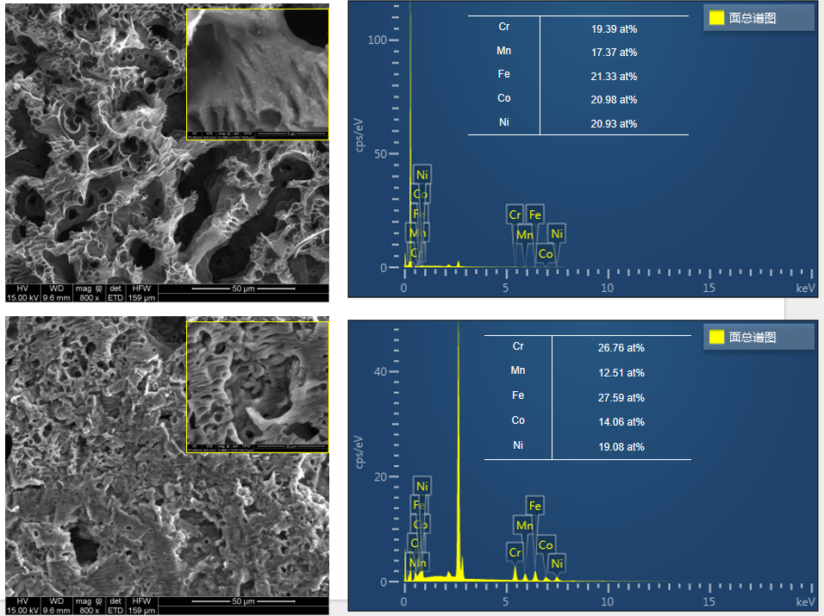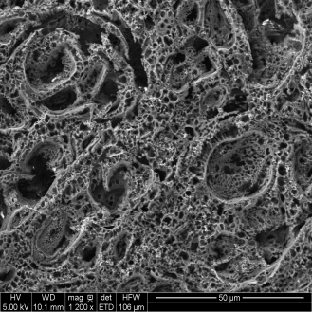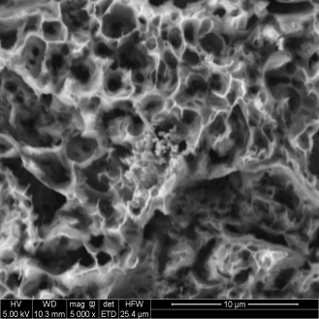
(d.1)
(d)
(c)
Fig. S7 SEM images of the metal precursor loaded LIG at the precursor concentration of 0.005 M (a, b) and 0.02 M (c,d), and the corresponding elemental distribution for the SEM images of c and d.
Fig. S8 UV-Vis transmittance of the mixed metal chlorides on silica glass and the precursor loaded LIG.

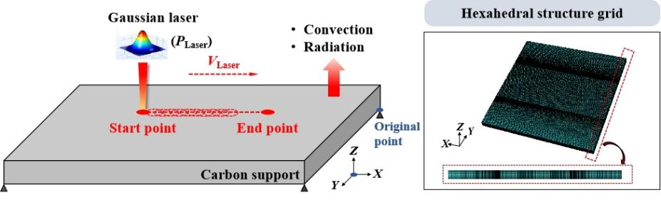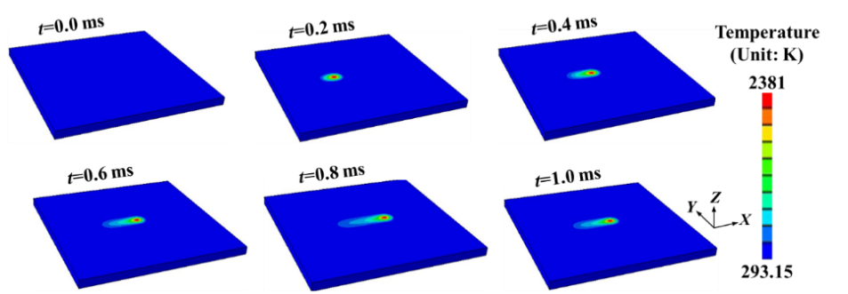
(a)
(b)
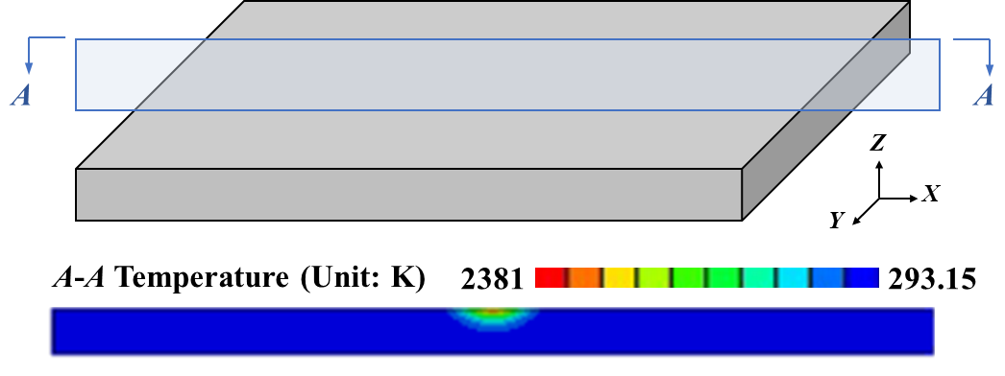
(c)
Fig. S9 Simulation results. (a) simulation model of laser irradiation of carbon-based support. (b) temperature distribution during laser irradiation of carbon support. (c) symmetrical temperature profile.

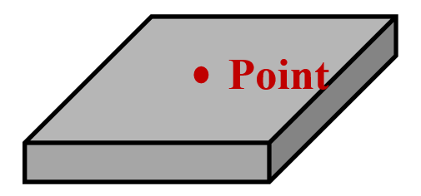
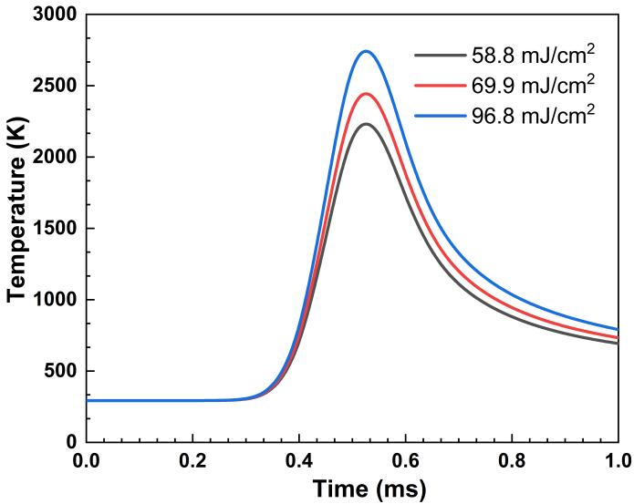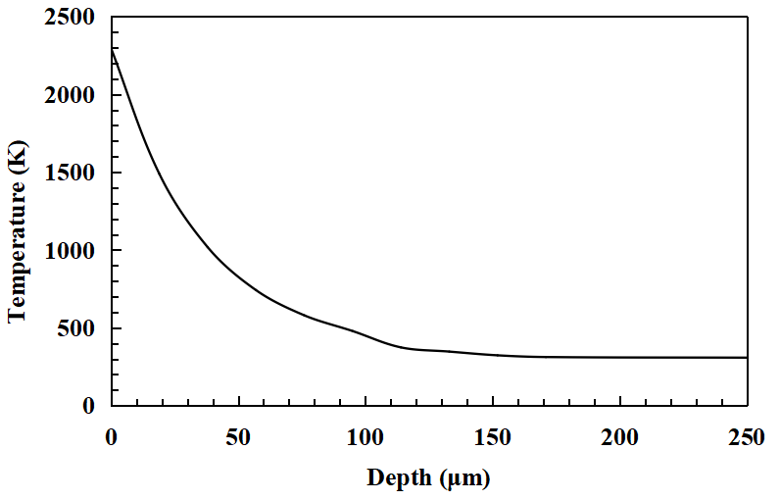
(b)
(a)
Fig. S10 Simulation results. (a) The transient thermal history for center point on the upper surface at different laser fluences. (b) Temperature gradient at the selected point along negative Z-axis.

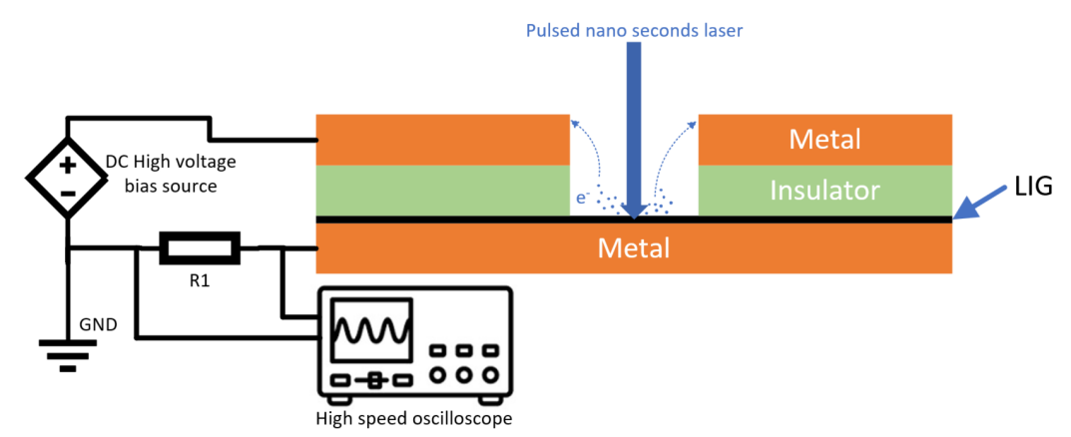
(a)
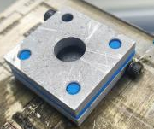
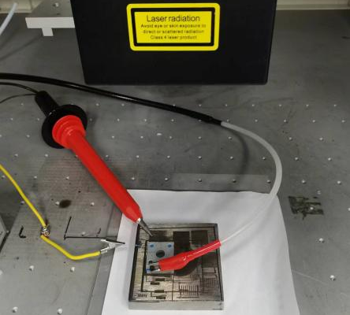
(c)
(b)
Fig. S11 Laser-induced thermionic emission measurements. (a) Measurement setup. (b) A custom-built cell to measure the laser-induced current flow. (c) Calculated emission current density as a function of local temperatures according to the Richardson's equation.

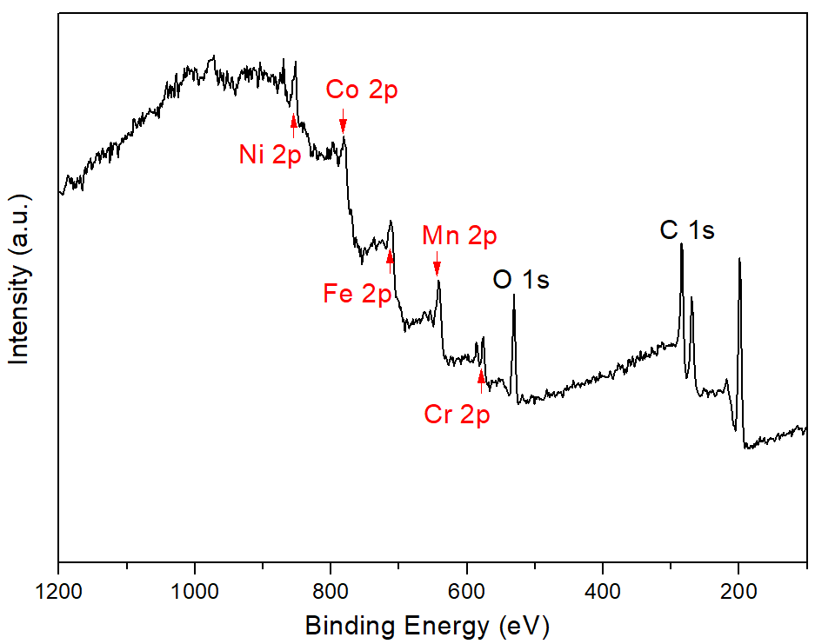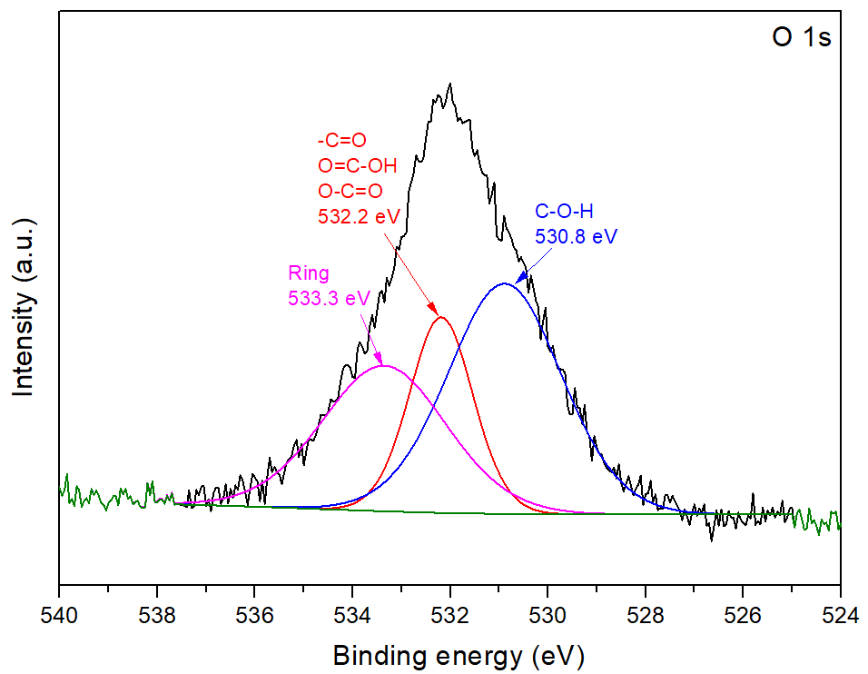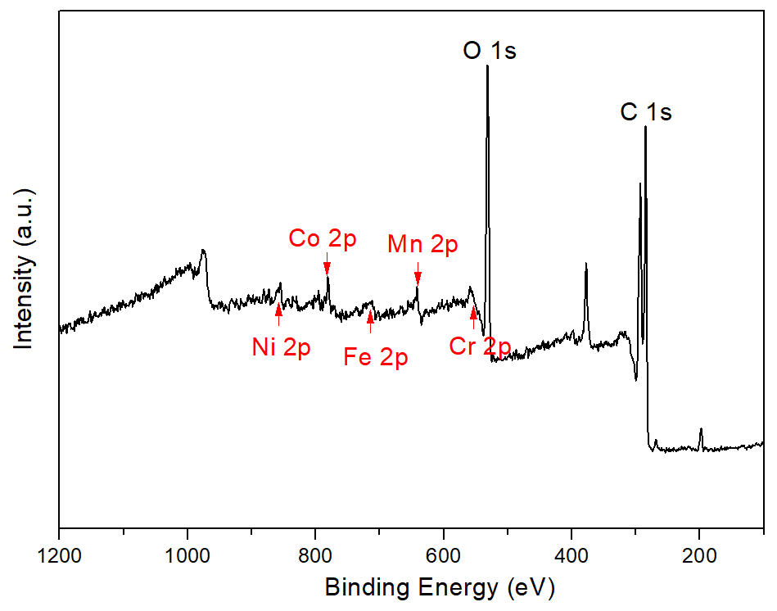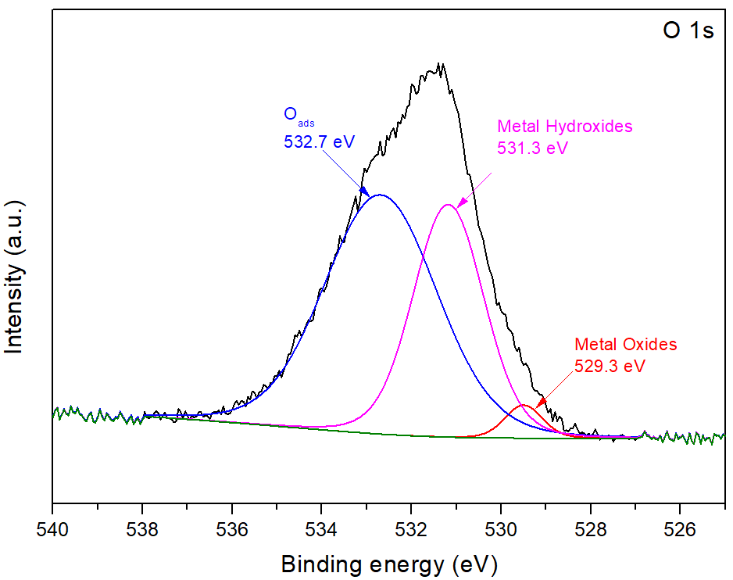
(d)
(c)
(b)
(a)
Fig. S12 (a) XPS wide spectra of HEA/LIG. (b) characteristic peaks of O 1s. (c) XPS wide spectra of IE-HEA/LIG after OER tests. (b) characteristic peaks of O 1s.

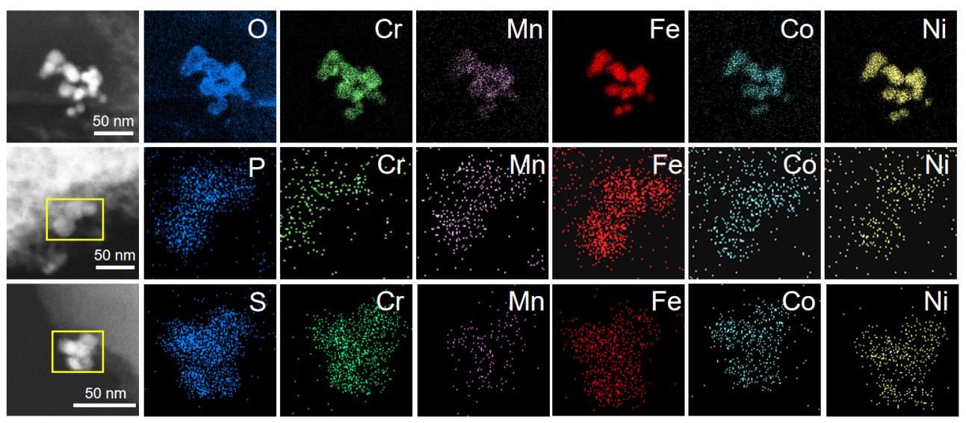
(a)
(c)
(b)
Fig. S13 TEM images and elemental mappings of (a) HEA-O, (b) HEA-P, and (c) HEA-S NPs on LIG.

Table S1 Material properties in the temperature simulation [1-3].
Property (unit) | Symbol | Value
Density (kg·m⁻³) | ρ_{s} | 1780
Melting point (K) | T_{l} | 613.15
Boiling point (K) | T_{v} | 3650
Latent heat of fusion (J·kg⁻¹) | L_{m} | 5.03 × 10⁵
Thermal conductivity (W·m⁻¹·K⁻¹) | λ | 50
Specific heat capacity (J·kg⁻¹·K⁻¹) | C_{P} | 875
Emission | ɛ | 0.14
Absorptivity | A | 0.56
Convection efficient (W·m²·K) | h_{c} | 20

Table S2 the pyrolysis temperature and chemical reduction potential of the precursors used in this study.
Metal chlorides | Pyrolysis temperature (K) | Chemical reduction potential (V)
CrCl₃ | ＞ 1573 | -0.407
MnCl₂ | ＞ 773 | -1.185
FeCl₃ | ＞ 588 | -0.44
CoCl₂ | 673~773 | -0.28
NiCl₂ | ＞ 1246 | -0.25

Table S3 Physical properties of Cr, Mn, Fe, Co, Ni.
Metal | Melting point (K) | Boiling point (K) | Electron configuration | Electro- negativity | Atomic radium (pm)
Cr | 2180 | 2944 | [Ar]3d⁵4s¹ | 1.66 | 128
Mn | 1519 | 2334 | [Ar]3d⁵4s² | 1.55 | 127
Fe | 1808 | 3343 | [Ar]3d⁶4s² | 1.83 | 126
Co | 1768 | 3200 | [Ar]3d⁷4s² | 1.88 | 125
Ni | 1728 | 3186 | [Ar]3d⁸4s²  [Ar]3d⁹4s¹ | 1.91 | 124

Table S4 Comparison of OER performance with the most recently reported HEA catalysts in 1 M KOH.
Catalysts | Electrolytes | Overpotential (mV)  @ 10mA/cm² | Tafel slope  (mV/dec) | Stability  (h) | Refs.
CoCrFeNiMo | 1 M KOH | 220 | 59 | 24 | 4
FeCoNiCrMn | 1 M KOH | 345  @50mA/cm2 | 81.3 | 20 | 5
FeCoNiMnCu | 1 M KOH | 280 | 59 | 40 | 6
MnFeCoNiCu | 1 M KOH | 263 | 43 | 24 | 7
AlNiCoFeMo | 1 M KOH | 240 | 46 | 50 | 8
AlFeCoNiCr | 1 M KOH | 240 | 52 | / | 9
AlCrCuFeNi | 1 M KOH | 270 | 77.5 | 35 | 10
FeNiMnCrCu | 1 M KOH | 314 | 58 | 10 | 11
MnFeCoNiCu | 1 M KOH | 245 | 54 | 48 | 12
CoFeGaNiZn | 1 M KOH | 370 | 71 | 10 | 13
CoCuFeNiMnMo | 1 M KOH | 375 | 125 | 72 | 14
FeCoNiMoW | 1 M KOH | 233 | 36.7 | 115 | 15
CrMnFeCoNi | 1 M KOH | 265 | 37.9 | 30 | 16
NiFeCoCuMn | 1 M KOH | 226 | 58.2 | 10 | 17
FeCoNiMnCr | 1 M KOH | 228 | 45.39 | 48 | 18
NiFeCuCoCe | 1 M KOH | 219 | 110 | 100 | 19
CrMnFeCoNi | 1 M KOH | 250 | 41.5 | 24 | 20
AlNiCoRuMo | 1 M KOH | 245 | 54.5 | 100 | 21
FeCoNiCuPtIr | 1 M KOH | 255 | 61.7 | 20 | 22
FeCoNiRu | 1 M KOH | 243 | 45 | 40 | 23
Pt₃₄Fe₅Ni₂₀Cu₃₁Mo₉Ru | 1 M KOH | 259 | 39 | 40h | 24
CrMnFeCoNi | 1 M KOH | 293 | 57.9 | 428 | This work

References
1. Nakamiya, T.; Ueda, T.; Ikegami, T.; Mitsugi, F.; Ebihara, K.; Sonoda, Y.; Iwasaki, Y.; Tsuda, R., Effect of a pulsed Nd:YAG laser irradiation on multi-walled carbon nanotubes film. Thin Solid Films 2009, 517 (14), 3854-3858.
2. Keuntje, J.; Mrzljak, S.; Gerdes, L.; Wippo, V.; Kaierle, S.; Walther, F.; Jaeschke, P., Finite Element Simulation and Experimental Assessment of Laser Cutting Unidirectional CFRP at Cutting Angles of 45° and 90°. Polymers 2023, 15 (18), 3851.
3. Deng, L.; Young, R. J.; Kinloch, I. A.; Sun, R.; Zhang, G.; Noé, L.; Monthioux, M., Coefficient of thermal expansion of carbon nanotubes measured by Raman spectroscopy. Applied Physics Letters 2014, 104 (5), 051907.
4. Tang, J.; Xu, J. L.; Ye, Z. G.; Li, X. B.; Luo, J. M., Microwave sintered porous CoCrFeNiMo high entropy alloy as an efficient electrocatalyst for alkaline oxygen evolution reaction. Journal of Materials Science & Technology 2021, 79, 171-177.
5. Li, H.; Zhu, H.; Sun, S.; Hao, J.; Zhu, Z.; Xu, F.; Lu, S.; Duan, F.; Du, M., Thermodynamically driven metal diffusion strategy for controlled synthesis of high-entropy alloy electrocatalysts. Chemical Communications 2021, 57 (78), 10027-10030.
6. Huang, K.; Peng, D.; Yao, Z.; Xia, J.; Zhang, B.; Liu, H.; Chen, Z.; Wu, F.; Wu, J.; Huang, Y., Cathodic plasma driven self-assembly of HEAs dendrites by pure single FCC FeCoNiMnCu nanoparticles as high efficient electrocatalysts for OER. Chemical Engineering Journal 2021, 425, 131533.
7. Huang, K.; Zhang, B.; Wu, J.; Zhang, T.; Peng, D.; Cao, X.; Zhang, Z.; Li, Z.; Huang, Y., Exploring the impact of atomic lattice deformation on oxygen evolution reactions based on a sub-5 nm pure face-centred cubic high-entropy alloy electrocatalyst. Journal of Materials Chemistry A 2020, 8 (24), 11938-11947.
8. Qiu, H.-J.; Fang, G.; Gao, J.; Wen, Y.; Lv, J.; Li, H.; Xie, G.; Liu, X.; Sun, S., Noble Metal-Free Nanoporous High-Entropy Alloys as Highly Efficient Electrocatalysts for Oxygen Evolution Reaction. ACS Materials Letters 2019, 1 (5), 526-533.
9. Fang, G.; Gao, J.; Lv, J.; Jia, H.; Li, H.; Liu, W.; Xie, G.; Chen, Z.; Huang, Y.; Yuan, Q.; Liu, X.; Lin, X.; Sun, S.; Qiu, H.-J., Multi-component nanoporous alloy/(oxy)hydroxide for bifunctional oxygen electrocatalysis and rechargeable Zn-air batteries. Applied Catalysis B: Environmental 2020, 268, 118431.
10. Liu, Q.; Duan, G.; Matsunaga, T.; Koshizuka, S.; Sun, Z., A Particle Shifting Model for Least Square Moving Particle Semi-Implicit Method with Numerical Integration on Wall Boundary Meshes. The Proceedings of The Computational Mechanics Conference 2021, 2021.34 (0), 125.
11. Cui, X.; Zhang, B.; Zeng, C.; Guo, S., Electrocatalytic activity of high-entropy alloys toward oxygen evolution reaction. MRS Communications 2018, 8 (3), 1230-1235.
12. Zhao, X.; Xue, Z.; Chen, W.; Bai, X.; Shi, R.; Mu, T., Ambient fast, large-scale synthesis of entropy-stabilized metal–organic framework nanosheets for electrocatalytic oxygen evolution. Journal of Materials Chemistry A 2019, 7 (46), 26238-26242.
13. Sharma, L.; Katiyar, N. K.; Parui, A.; Das, R.; Kumar, R.; Tiwary, C. S.; Singh, A. K.; Halder, A.; Biswas, K., Low-cost high entropy alloy (HEA) for high-efficiency oxygen evolution reaction (OER). Nano Research 2021, 15 (6), 4799-4806.
14. Asghari Alamdari, A.; Jahangiri, H.; Yagci, M. B.; Igarashi, K.; Matsumoto, H.; Motallebzadeh, A.; Unal, U., Exploring the Role of Mo and Mn in Improving the OER and HER Performance of CoCuFeNi-Based High-Entropy Alloys. ACS Applied Energy Materials 2024, 7 (6), 2423-2435.
15. He, R.; Yang, L.; Zhang, Y.; Jiang, D.; Lee, S.; Horta, S.; Liang, Z.; Lu, X.; Ostovari Moghaddam, A.; Li, J.; Ibáñez, M.; Xu, Y.; Zhou, Y.; Cabot, A., A 3d‐4d‐5d High Entropy Alloy as a Bifunctional Oxygen Catalyst for Robust Aqueous Zinc–Air Batteries. Advanced Materials 2023, 35 (46), 2303719.
16. He, R.; Yang, L.; Zhang, Y.; Wang, X.; Lee, S.; Zhang, T.; Li, L.; Liang, Z.; Chen, J.; Li, J.; Ostovari Moghaddam, A.; Llorca, J.; Ibáñez, M.; Arbiol, J.; Xu, Y.; Cabot, A., A CrMnFeCoNi high entropy alloy boosting oxygen evolution/reduction reactions and zinc-air battery performance. Energy Storage Materials 2023, 58, 287-298.
17. Bian, H.; Wang, C.; Zhao, S.; Han, G.; Xie, G.; Qi, P.; Liu, X.; Zeng, Y.; Zhang, D.; Wang, P., Preparation of highly efficient high-entropy alloy catalysts with electrodeposition and corrosion engineering for OER electrocatalysis. International Journal of Hydrogen Energy 2024, 57, 651-659.
18. Wang, Z.; Zhang, C.; Zhang, Y.; Hu, J., Ultrasound-Assisted Synthesis of High-Entropy Materials for Enhanced Oxygen Evolution Electrocatalysis. Metals 2024, 14 (4), 384.
19. Bian, H.; Qi, P.; Xie, G.; Liu, X.; Zeng, Y.; Zhang, D.; Wang, P., HEA-NiFeCuCoCe/NF through ultra-fast electrochemical self-reconstruction with high catalytic activity and corrosion resistance for seawater electrolysis. Chemical Engineering Journal 2023, 477, 147286.
20. Yang, P.; Jiang, Z.; Shi, Y.; Zhang, W.; Ren, X.; Liang, L.; Wang, M.; Zhu, K., Construction of high-entropy oxy/hydroxides with dense nanosheet array structures on FeCoNiCrMo electrode for efficient oxygen evolution reaction. Applied Physics Letters 2023, 123 (9), 091602.
21. Jin, Z.; Lyu, J.; Zhao, Y.-L.; Li, H.; Lin, X.; Xie, G.; Liu, X.; Kai, J.-J.; Qiu, H.-J., Rugged High-Entropy Alloy Nanowires with in Situ Formed Surface Spinel Oxide As Highly Stable Electrocatalyst in Zn–Air Batteries. ACS Materials Letters 2020, 2 (12), 1698-1706.
22. Lu, Y.; Huang, K.; Cao, X.; Zhang, L.; Wang, T.; Peng, D.; Zhang, B.; Liu, Z.; Wu, J.; Zhang, Y.; Chen, C.; Huang, Y., Atomically Dispersed Intrinsic Hollow Sites of M‐M1‐M (M1 = Pt, Ir; M = Fe, Co, Ni, Cu, Pt, Ir) on FeCoNiCuPtIr Nanocrystals Enabling Rapid Water Redox. Advanced Functional Materials 2022, 32 (19), 2110645.
23. Huang, K.; Xia, J.; Lu, Y.; Zhang, B.; Shi, W.; Cao, X.; Zhang, X.; Woods, L. M.; Han, C.; Chen, C.; Wang, T.; Wu, J.; Huang, Y., Self‐Reconstructed Spinel Surface Structure Enabling the Long‐Term Stable Hydrogen Evolution Reaction/Oxygen Evolution Reaction Efficiency of FeCoNiRu High‐Entropy Alloyed Electrocatalyst. Advanced Science 2023, 10 (14), 2300094.
24. Chen, Z.; Wen, J.; Wang, C.; Kang, X., Convex Cube‐Shaped Pt₃₄Fe₅Ni₂₀Cu₃₁Mo₉Ru High Entropy Alloy Catalysts toward High‐Performance Multifunctional Electrocatalysis. Small 2022, 18 (45), 2204255.

