Supplementary Information
Comprehensive profiling of phenolic compounds and triterpenoid saponins from Acanthopanax senticosus and their antioxidant, α-glucosidase inhibitory activities

Authors: Ryeong Ha Kwon ^{1,2}, Hyemin Na ¹, Ju Hyung Kim ¹, So Ah Kim ¹, Se Yeon Kim ², Hyun-Ah Jung ², Sang Hoon Lee ¹, Chi-Do Wee ¹, Kwang-Sik Lee ¹, and Heon-Woong Kim ^{1*}

Affiliations
¹ Department of Agrofood Resources, National Institute of Agricultural Sciences, Rural Development Administration, 55365, Wanju, Republic of Korea; haha8447@gmail.com (R.H.K.); gpals9713@gmail.com (H.N.); juuhkim0128@gmail.com (J.H.K.); soah0726@gmail.com (S.A.K.); spprigan@korea.kr (S.H.L.); cdwee@korea.kr (C.-D.W.); kslee84@korea.kr (K.-S.L.).
² Department of Food Science and Human Nutrition, Jeonbuk National University, Jeonju 54896, Korea; ksy002253@naver.com (S.Y.K.); jungha@jbnu.ac.kr (H.-A.J.).

Corresponding author:
Heon-Woong Kim, National Institute of Agricultural Sciences, Rural Development Administration, 55365, Wanju, Republic of Korea
E-mail: ksharrier@korea.kr; Tel.: +82-63-238-3565

Table S1. Optimized MRM condition in positive mode for 28 standards
Table S2. Regression equation, linear range, coefficient of determination LOD and LOQ, intra- and inter-day precision of 32 standard compounds
Figure S1. UPLC chromatograms of 37 standards. A) phenolic acid standards 15 mixture. B) flavonoid standards 10 mixture. C) saponin standards 12 mixture. P1, 1-O-caffeoylquinic acid; P2, neochlorogenic acid; P3, chlorogenic acid; P4, cryptochlorogenic acid; CA, caffeic acid; 1,3diCQA, cynarin; P9, 5-O-feruloylquinic acid; pCoA, p-coumaric acid; P13, chlorogenic acid methyl ester; FA, ferulic acid; P14, 1,4-di-O-caffeoylquinic acid; P15, isochlorogenic acid C; P16, 1,5-di-O-caffeoylquinic acid; P17, isochlorogenic acid A; P21, isochlorogenic acid B; F6, rutin; F7, hyperoside; F8, quercetin 3-O-glucuronide; F9, isoquercitrin; F12, guaijaverin; F14, quercetin 3-O-(6-O-malonyl)glucoside; F15, nicotiflorin; Q3Ara(f), avicularin; F16, astragalin; F19, quercitrin; CF, cauloside F; HC, hederacoside C; S22, cauloside D; DB, dipsacoside B; ASⅥ, asperosaponin Ⅵ; S39, ciwujianoside B; S46, ciwujianoside A₁; S57, hederasaponin B; S59, acanthopanaxoside B; S64, ciwujianoside C₃; S73, α-hederin; S80, calenduloside E.
Figure S2. UPLC chromatograms of 132 compounds from Acanthopanax senticosus A) shoots, B) leaves, C) fruits, and D) stems.
Figure S3. (+) ESI-MS spectra of phenolic acids.
Figure S4. (-) ESI-MS/MS spectra of phenolic acids acquired in IDA mode.
Figure S5. Proposed fragmentation patterns of 3-O-malonyl-1,5-di-O-caffeoylquinic acid.
Figure S6. (+) ESI-MS spectra of flavonoids
Figure S7. (+) ESI-MS spectra of triterpenoid saponins.
Figure S8. The shoots, leaves, fruits, and stems of Acanthopanax senticosus.

Table S1. Optimized MRM condition in positive mode for 28 standards
Paramethers | Transition | DP (volt) | CE (volt)
1CQA | 355.0 → 135.0 | 76 | 51
3CQA | 355.0 → 163.0 | 56 | 29
5CQA | 355.0 → 135.0 | 76 | 55
4CQA | 355.0 → 145.0 | 52 | 45
5CQA ME | 369.0 → 135.0 | 64 | 55
5FQA | 369.0 → 145.0 | 70 | 45
1,4diCQA | 517.0 → 517.1 | 81 | 9
3,4diCQA | 517.0 → 517.1 | 76 | 9
1,5diCQA | 517.0 → 517.1 | 76 | 9
3,5diCQA | 517.0 → 135.0 | 73 | 71
4,5diCQA | 517.0 → 135.0 | 71 | 71
Q3Rut | 611.0 → 611.1 | 20 | 11
Q3Gal | 465.0 → 153.0 | 64 | 69
Q3Gluc | 479.0 → 229.0 | 66 | 67
Q3Glu | 465.0 → 465.0 | 71 | 9
Q3Ara | 435.0 → 153.0 | 61 | 65
Q3(6Mal)Glu | 551.0 → 127.0 | 81 | 37
K3Rut | 595.0 → 595.1 | 20 | 11
K3Glu | 449.0 → 153.0 | 57 | 69
Q3Rham | 449.0 → 129.0 | 57 | 23
Cauloside D | 1075.3 → 1075.5 | 116 | 11
Ciwujianoside B | 1206.5 → 441.1 | 149 | 37
Ciwujianoside A₁ | 1238.5 → 1238.6 | 161 | 21
Hederasaponin B | 1222.5 → 439.2 | 146 | 49
Acanthopanaxoside B | 1280.5 → 1280.6 | 151 | 19
Ciwujianoside C₃ | 1076.4 → 439.2 | 129 | 43
α-hederin | 751.3 → 455.3 | 101 | 11
Calenduloside E | 650.2 → 633.4 | 106 | 15

Table S2. Regression equation, linear range, coefficient of determination LOD and LOQ, intra- and inter-day precision of 32 standard compounds
Compounds | Calibration Curveª | R² | Linear Range (μg/mL) | LOD (μg/mL) | LOQ (μg/mL) | RSD (%)
 |  |  |  |  |  | Intra-day (n =3) | Inter-day (n =3)
UPLC-Triple Q-MS/MS MRM analysis for targeted compounds quantification
1CQA | y = 28958.75 x + 1075.952 | 0.99996 | 0.1-10 | 0.04 | 0.13 | 0.35 | 0.50
3CQA | y = 2123583 x + 84155.11 | 0.99974 | 0.05-10 | 0.02 | 0.07 | 1.78 | 3.41
5CQA | y = 260893.7 x + 10188.17 | 0.99949 | 0.05-10 | 0.02 | 0.05 | 0.13 | 0.88
4CQA | y = 723846.9 x + 36084.77 | 0.99945 | 0.05-10 | 0.01 | 0.03 | 0.33 | 1.57
5CQA ME | y = 1382176 x + 37626.27 | 0.99995 | 0.05-10 | 0.01 | 0.03 | 0.91 | 1.76
5FQA | y = 1581130 x + 57824.17 | 0.99953 | 0.05-10 | 0.01 | 0.02 | 0.19 | 1.02
1,4diCQA | y = 290693.6 x + 7226.979 | 0.99993 | 0.05-10 | 0.01 | 0.02 | 0.28 | 1.30
3,4diCQA | y = 402289.6 x – 8347.094 | 0.99978 | 0.05-10 | 0.01 | 0.04 | 0.24 | 1.76
1,5diCQA | y = 317324.9 x + 4428.527 | 0.99978 | 0.05-10 | 0.03 | 0.09 | 0.68 | 1.39
3,5diCQA | y = 359660.8 x + 2144.633 | 0.99977 | 0.05-10 | 0.12 | 0.35 | 0.73 | 0.80
4,5diCQA | y = 380932.2 x – 4100.144 | 0.99980 | 0.05-10 | 0.07 | 0.21 | 0.39 | 1.24
Q3Rut | y = 2023062 x + 18107.14 | 0.99971 | 0.05-10 | 0.01 | 0.03 | 0.43 | 0.71
Q3Gal | y = 245889.1 x – 1299.478 | 0.99989 | 0.05-10 | 0.01 | 0.03 | 0.34 | 1.66
Q3Gluc | y = 214196.9 x – 6151.910 | 0.99980 | 0.05-10 | 0.02 | 0.05 | 1.08 | 1.21
Q3Glu | y = 2646803 x + 37189.37 | 0.99961 | 0.05-10 | 0.04 | 0.12 | 0.33 | 0.74
Q3Ara | y = 323809.3 x – 16291.06 | 0.99972 | 0.05-10 | 0.03 | 0.10 | 0.84 | 1.11
Q3(6Mal)Glu | y = 119300.4 x + 2852.487 | 0.99993 | 0.1-5 | 0.04 | 0.12 | 1.07 | 1.33
K3Rut | y = 2452443 x + 62038.42 | 0.99994 | 0.05-10 | 0.01 | 0.03 | 0.57 | 0.95
K3Glu | y = 465035.7 x + 13209.30 | 0.99994 | 0.05-10 | 0.01 | 0.03 | 0.81 | 1.02
Q3Rham | y = 318934.4 x + 2585.448 | 0.99998 | 0.05-10 | 0.01 | 0.02 | 0.32 | 0.46
Cauloside D | y = 23701.60 x – 664.8991 | 0.99997 | 0.1-10 | 0.13 | 0.38 | 4.72 | 4.85
Ciwujianoside B | y = 5618.569 x – 1362.723 | 0.99964 | 0.5-25 | 0.09 | 0.27 | 0.22 | 0.88
Ciwujianoside A₁ | y = 61816.38 x – 2201.967 | 0.99975 | 0.5-25 | 0.10 | 0.20 | 4.82 | 5.16
Hederasaponin B | y = 20937.54 x – 1726.401 | 0.99973 | 0.5-25 | 0.09 | 0.26 | 2.35 | 3.03
Acanthopanaxoside B | y = 57154.82 x – 26880.97 | 0.99953 | 0.5-25 | 0.17 | 0.52 | 3.97 | 4.00
Ciwujianoside C₃ | y = 152038.0 x – 11817.80 | 0.99998 | 0.5-25 | 0.07 | 0.22 | 1.33 | 1.82
α-hederin | y = 10732.30 x + 1639.170 | 0.99940 | 0.1-10 | 0.13 | 0.39 | 2.20 | 2.23
Calenduloside E | y = 1457.293 x + 1263.165 | 0.99991 | 0.5-10 | 0.07 | 0.20 | 3.70 | 4.95
UPLC-QToF-MS analysis for untargeted compounds relative quantification
1,3diCQA | y = 47676.96 x + 1263.165 | 0.99978 | 0.05-10 | 0.12 | 0.36 | 0.19 | 0.49
Q3Rut | y = 91515.03 x + 1972.455 | 0.99970 | 0.05-10 | 0.01 | 0.03 | 0.85 | 1.64
Q3Ara(f) | y = 283102.7 x + 4076.632 | 0.99952 | 0.05-10 | 0.01 | 0.03 | 0.19 | 1.52
Dipsacoside B | y = 35485.25 x + 5160.216 | 0.99960 | 0.1-50 | 0.02 | 0.05 | 1.76 | 2.26
Asperosaponin Ⅵ | y = 62862.88 x + 1258.051 | 0.99998 | 0.1-10 | 0.01 | 0.02 | 0.72 | 1.09
α-hederin | y = 84176.51 x + 9447.974 | 0.99952 | 0.1-10 | 0.01 | 0.04 | 0.23 | 0.68
ª y, peak area; x, concentration, ppm.

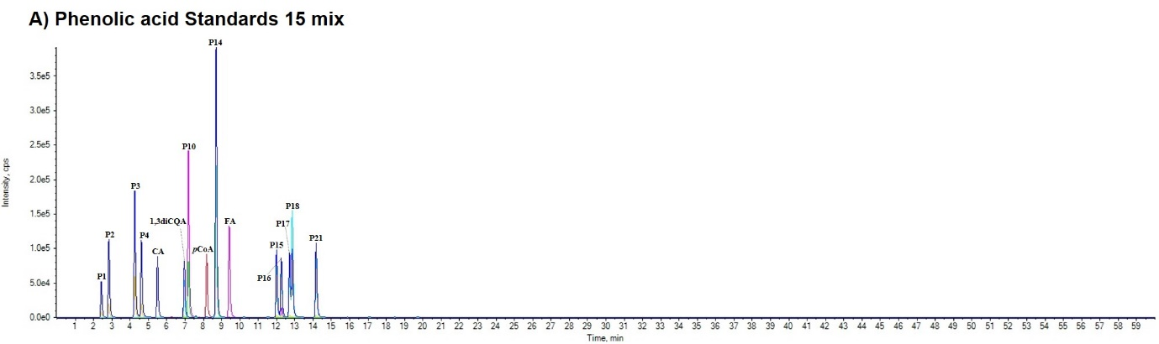
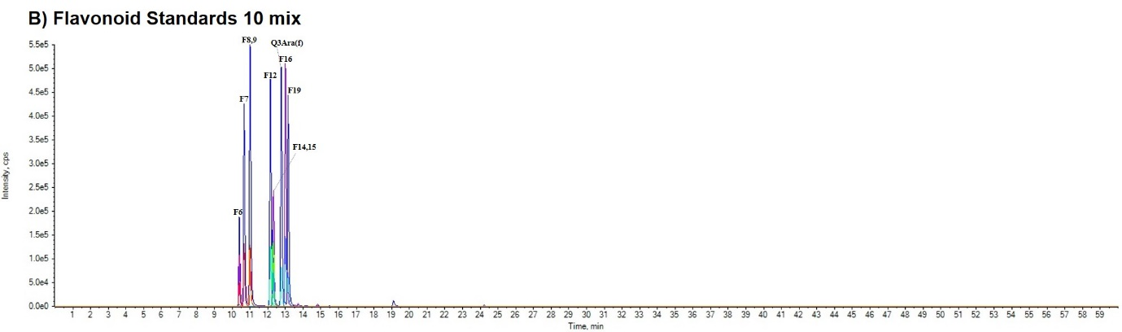
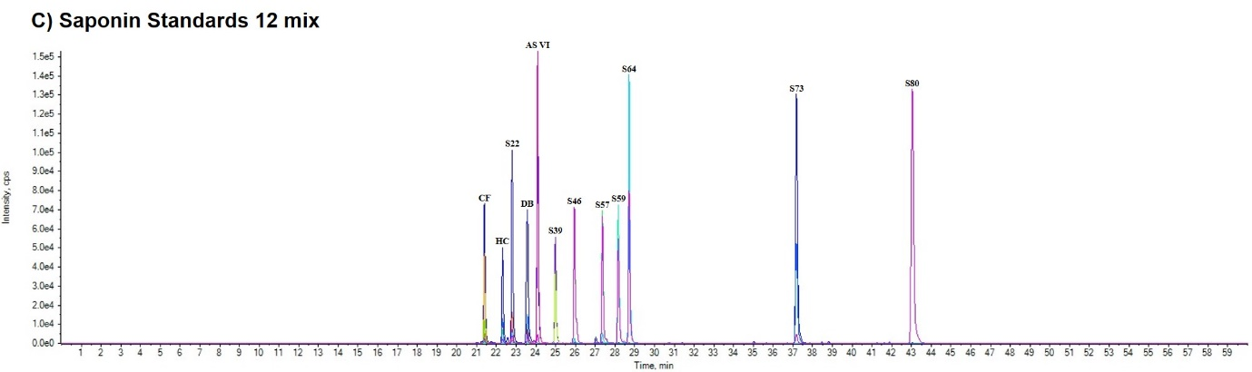
Figure S1. UPLC chromatograms of 37 standards. A) phenolic acid standards 15 mixture. B) flavonoid standards 10 mixture. C) saponin standards 12 mixture. P1, 1-O-caffeoylquinic acid; P2, neochlorogenic acid; P3, chlorogenic acid; P4, cryptochlorogenic acid; CA, caffeic acid; 1,3diCQA, cynarin; P9, 5-O-feruloylquinic acid; pCoA, p-coumaric acid; P13, chlorogenic acid methyl ester; FA, ferulic acid; P14, 1,4-di-O-caffeoylquinic acid; P15, isochlorogenic acid C; P16, 1,5-di-O-caffeoylquinic acid; P17, isochlorogenic acid A; P21, isochlorogenic acid B; F6, rutin; F7, hyperoside; F8, quercetin 3-O-glucuronide; F9, isoquercitrin; F12, guaijaverin; F14, quercetin 3-O-(6-O-malonyl)glucoside; F15, nicotiflorin; Q3Ara(f), avicularin; F16, astragalin; F19, quercitrin; CF, cauloside F; HC, hederacoside C; S22, cauloside D; DB, dipsacoside B; ASⅥ, asperosaponin Ⅵ; S39, ciwujianoside B; S46, ciwujianoside A₁; S57, hederasaponin B; S59, acanthopanaxoside B; S64, ciwujianoside C₃; S73, α-hederin; S80, calenduloside E.

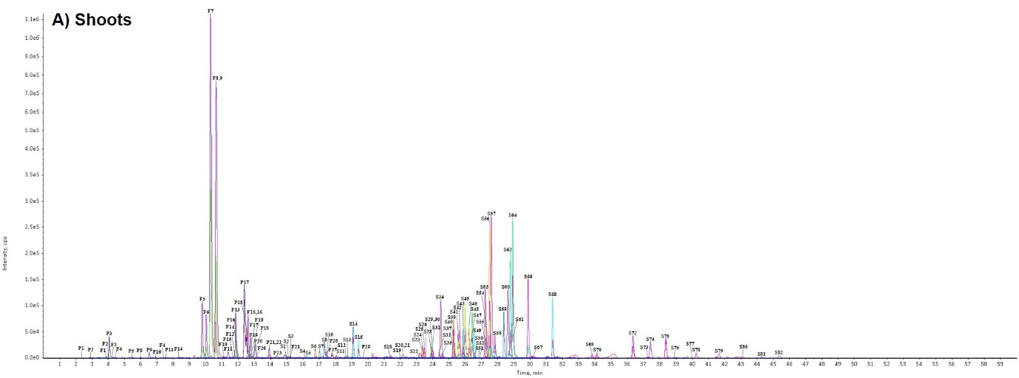
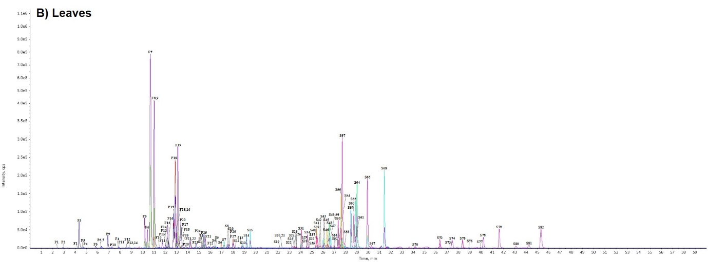
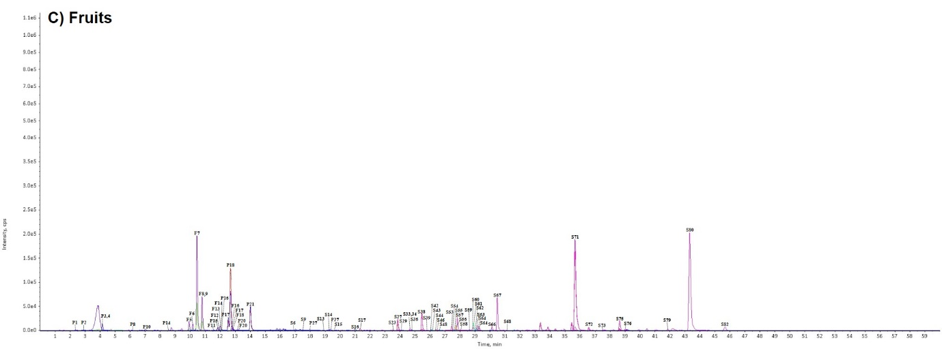
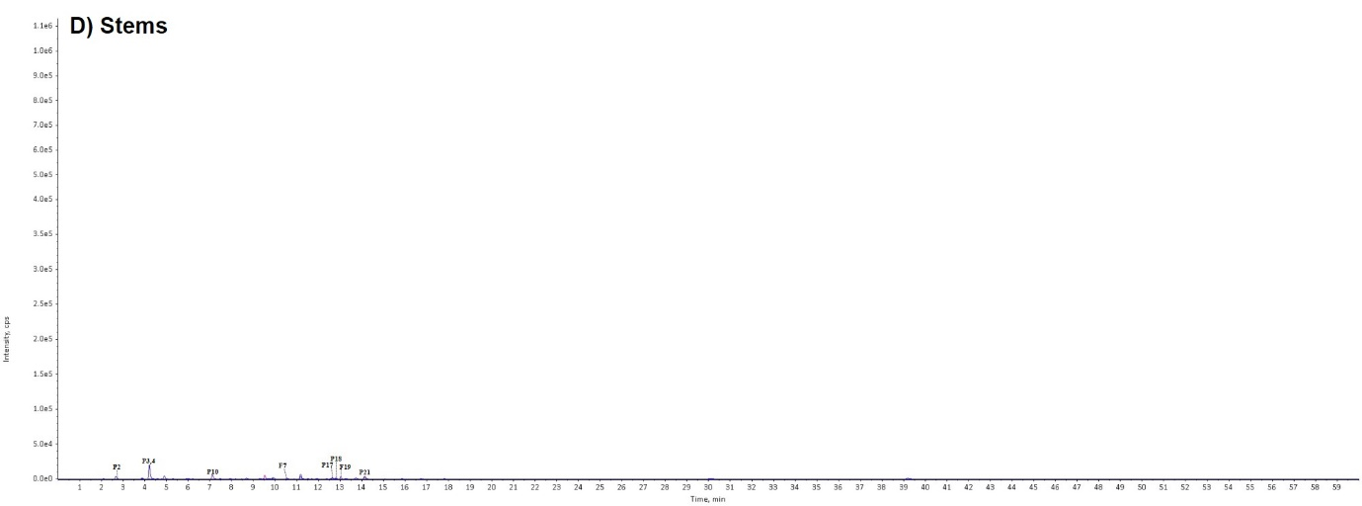
Figure S2. UPLC chromatograms of 132 compounds from Acanthopanax senticosus A) shoots, B) leaves, C) fruits, and D) stems.

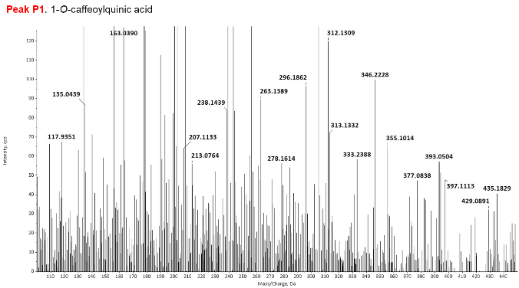 | 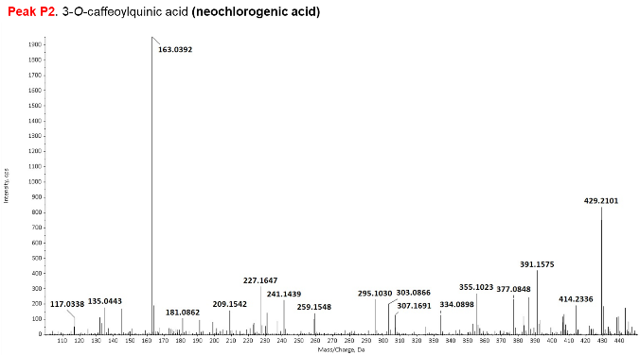
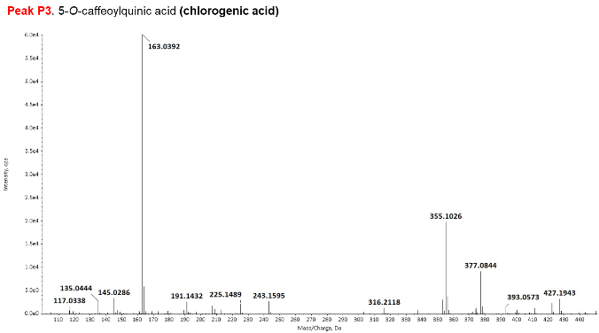 | 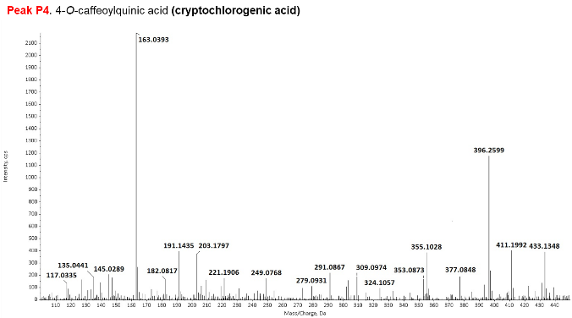
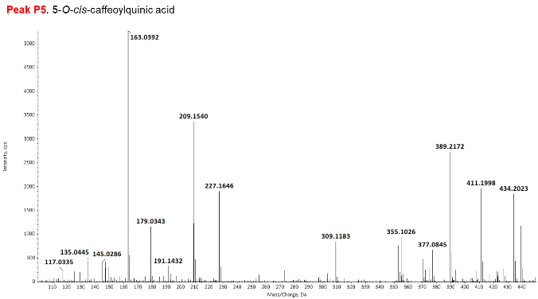 | 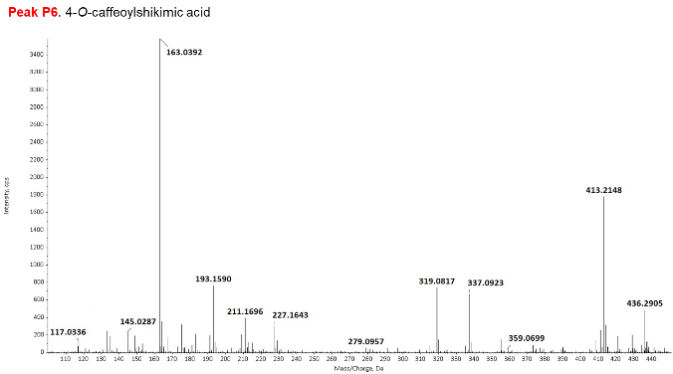
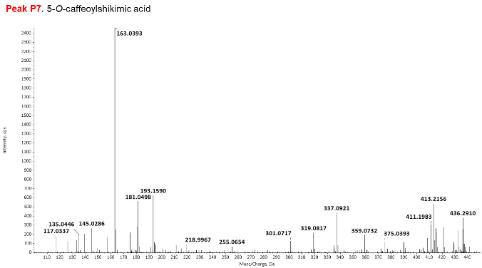 | 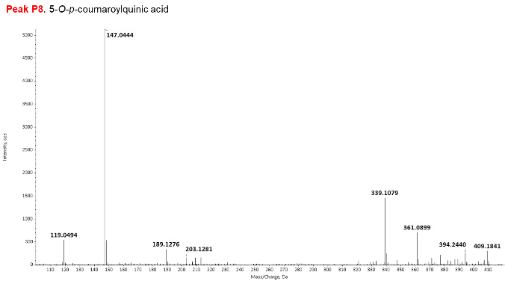
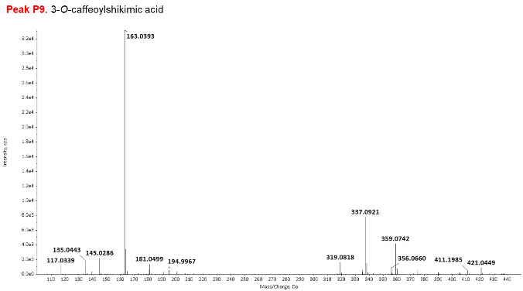 | 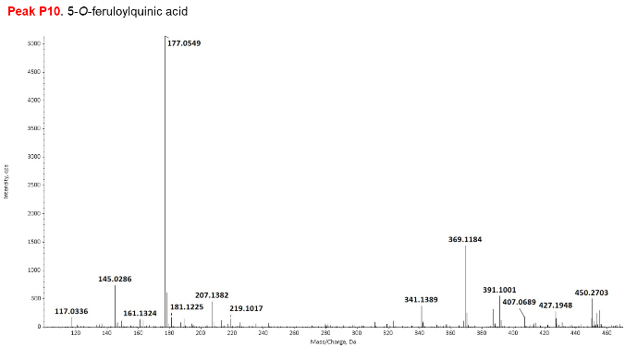
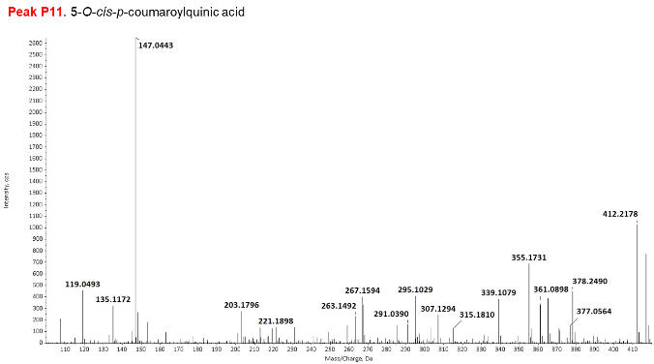 | 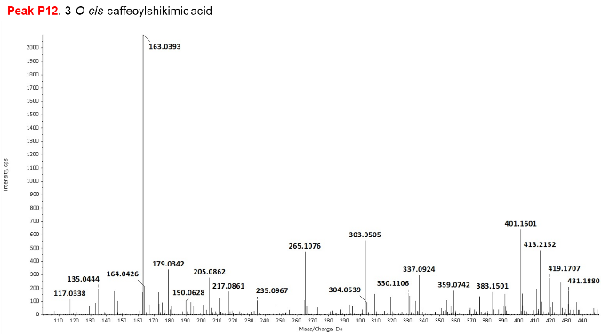
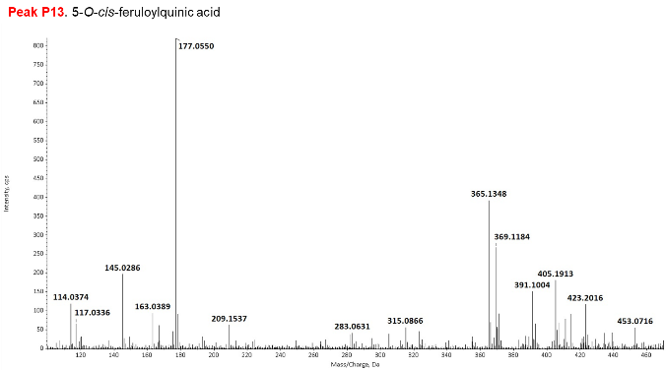 | 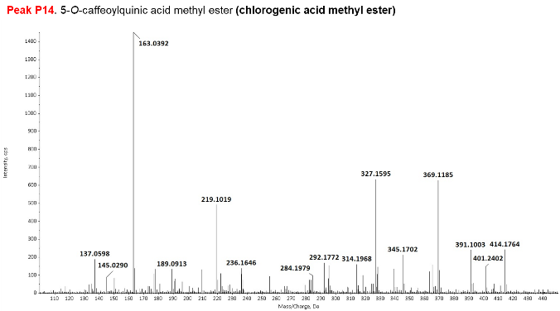
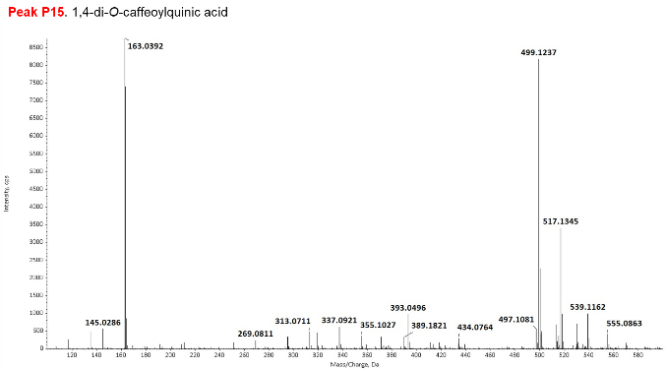 | 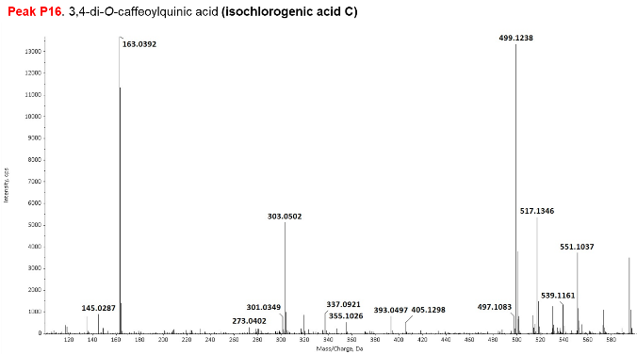
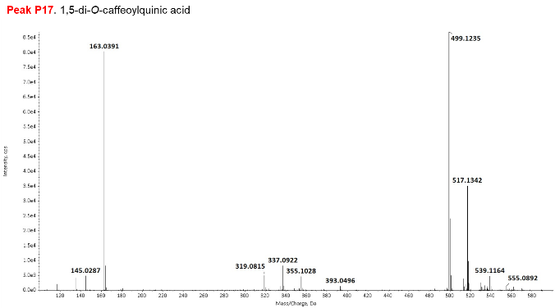 | 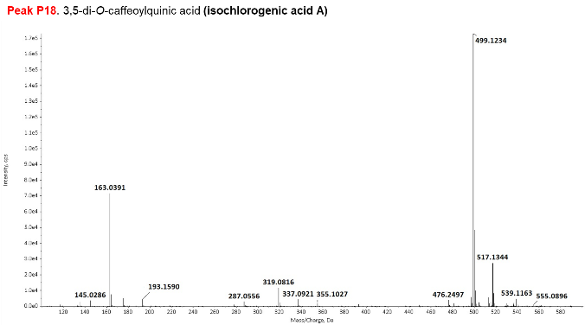
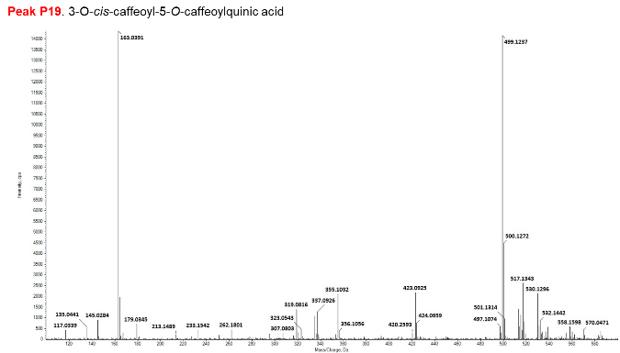 | 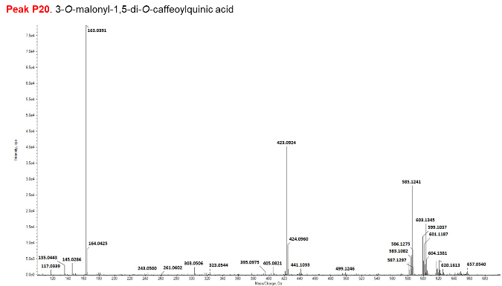
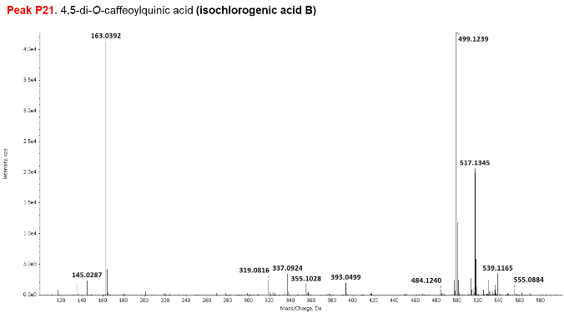 | 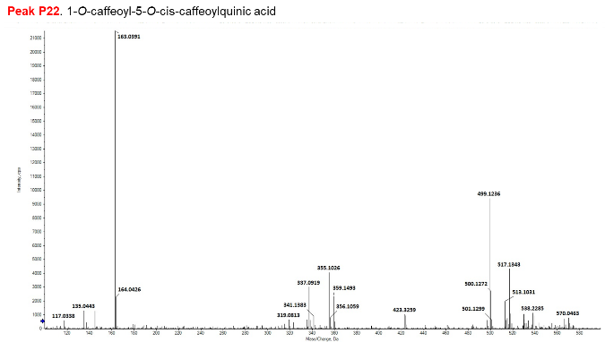
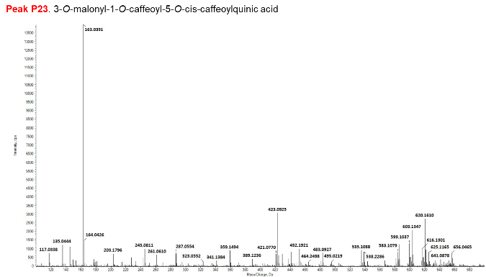 | 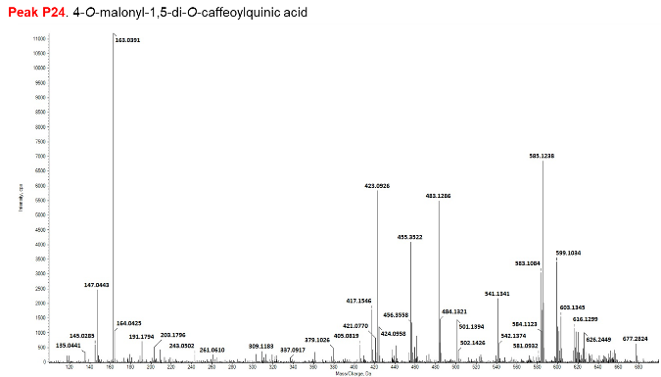
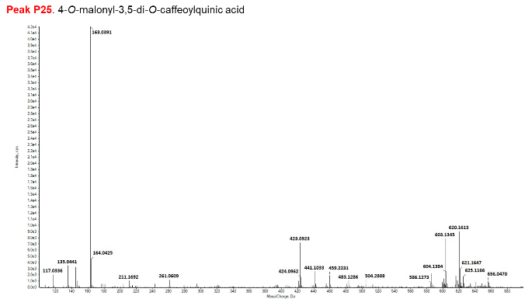 | 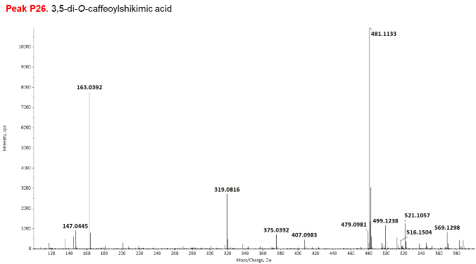
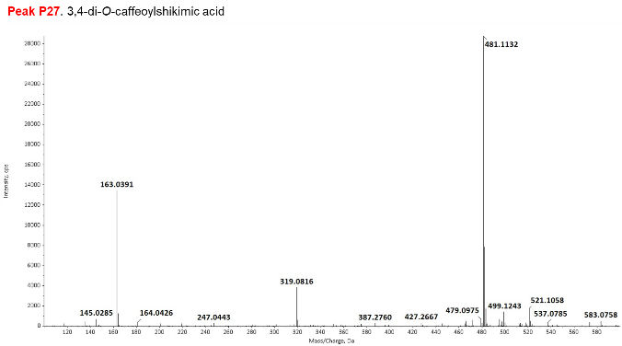 | 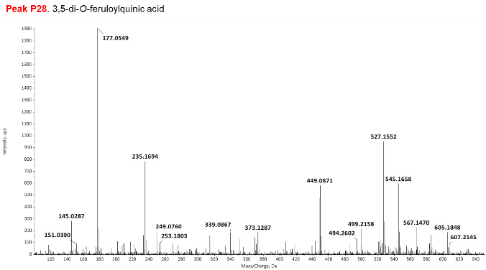
Figure S3. (+) ESI-MS spectra of phenolic acids.

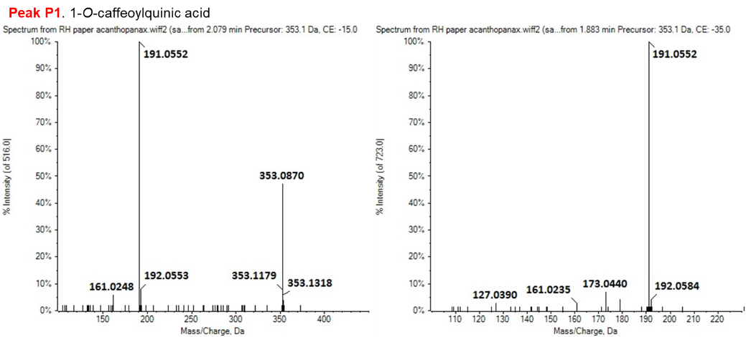
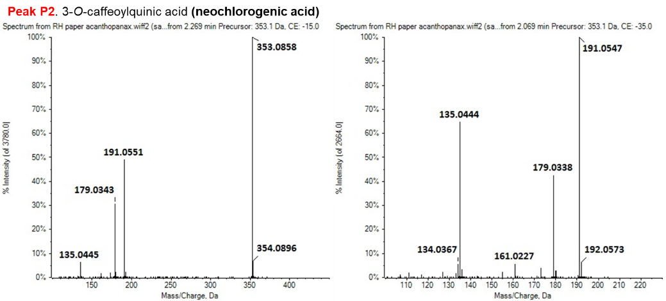
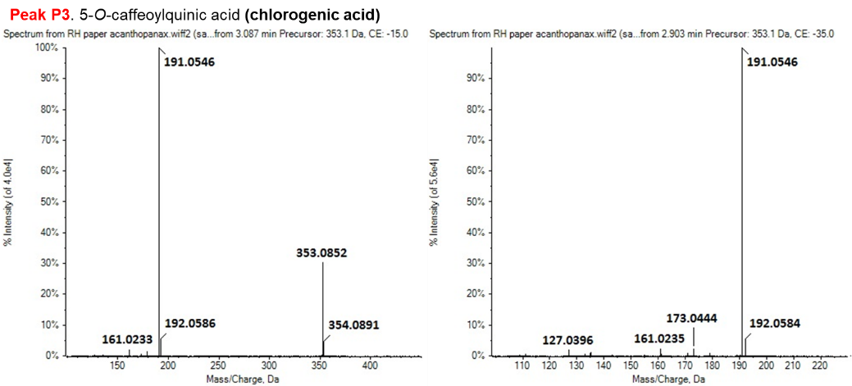
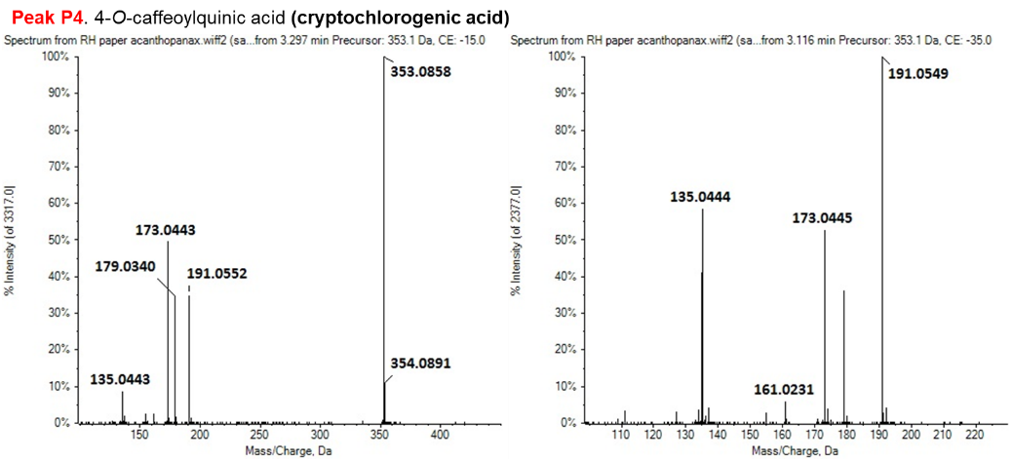
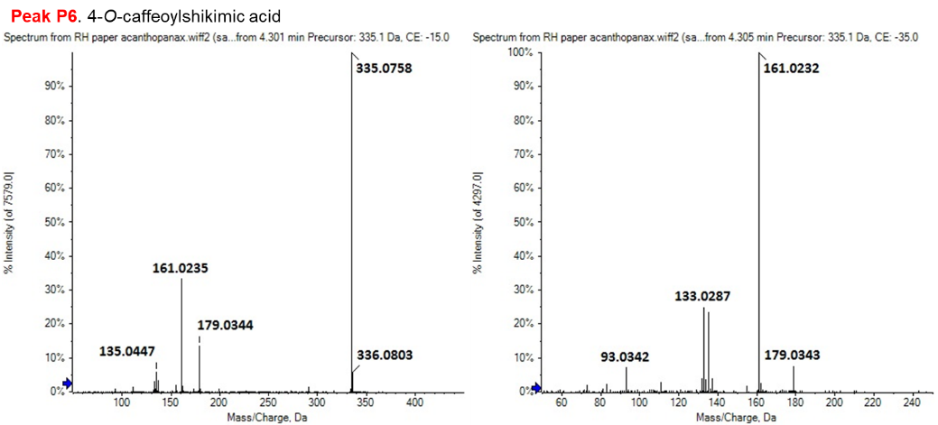
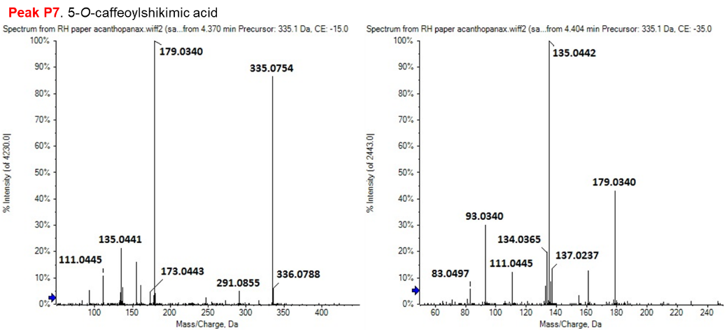
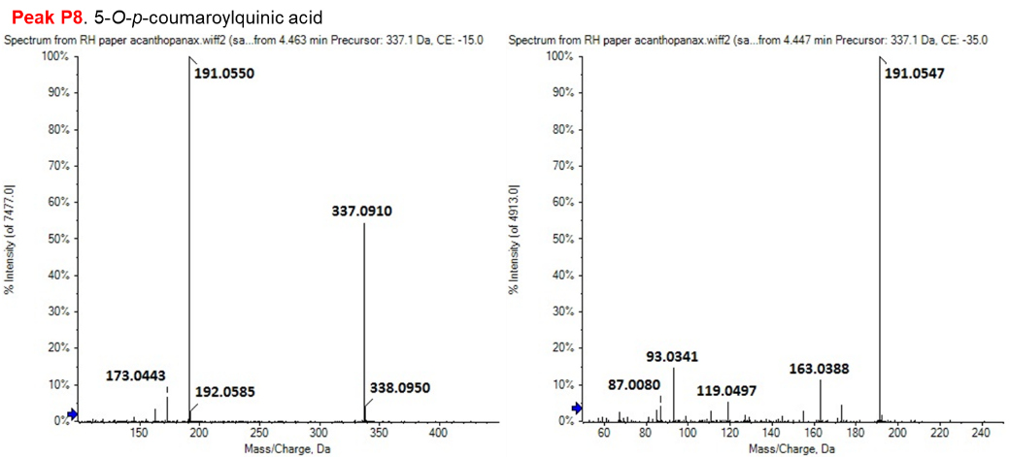
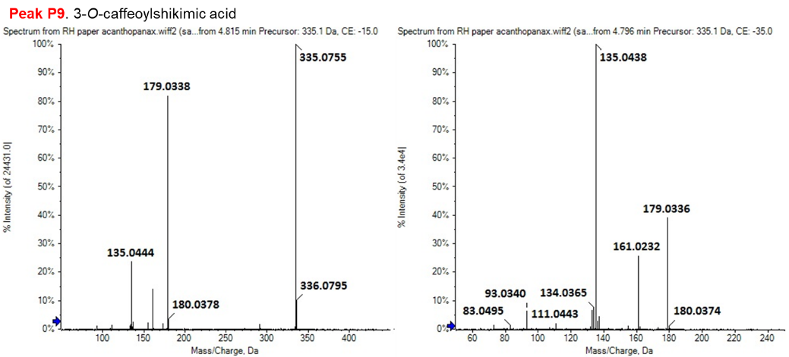
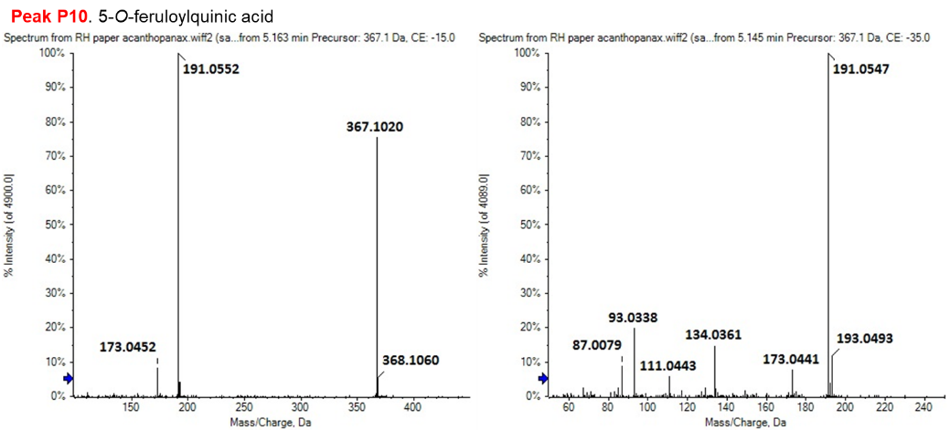
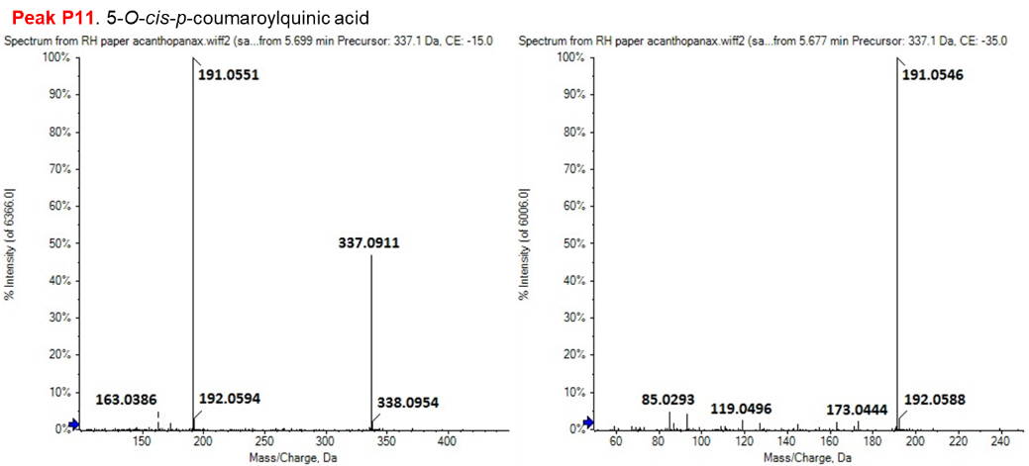
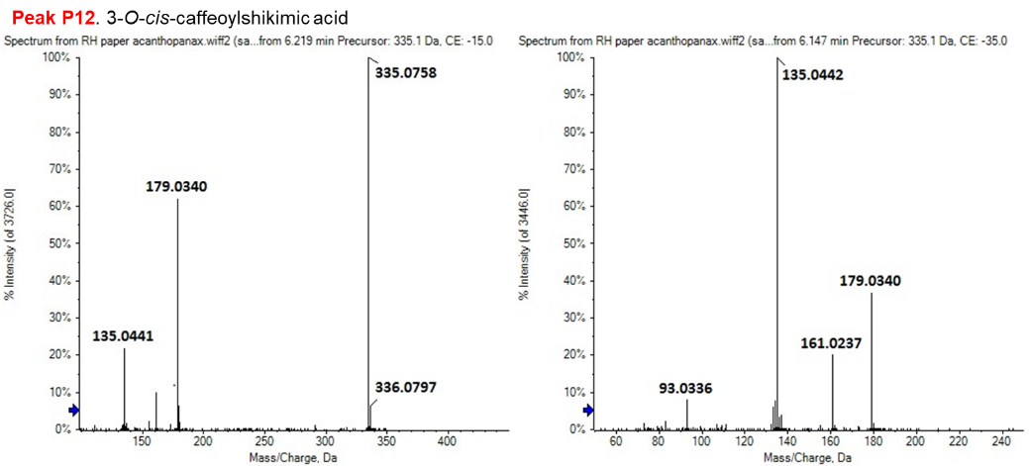
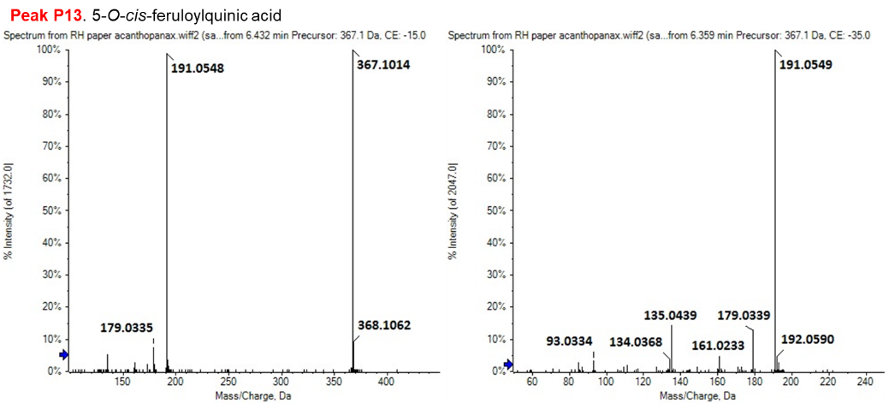
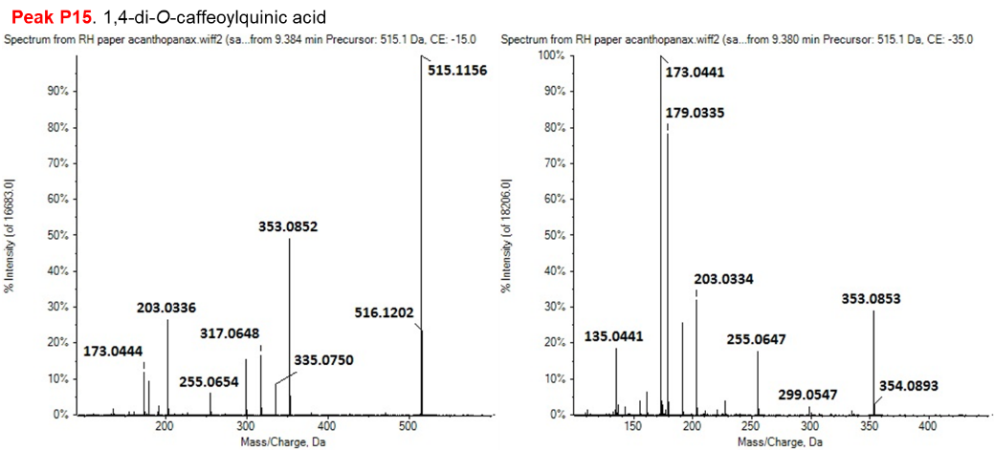
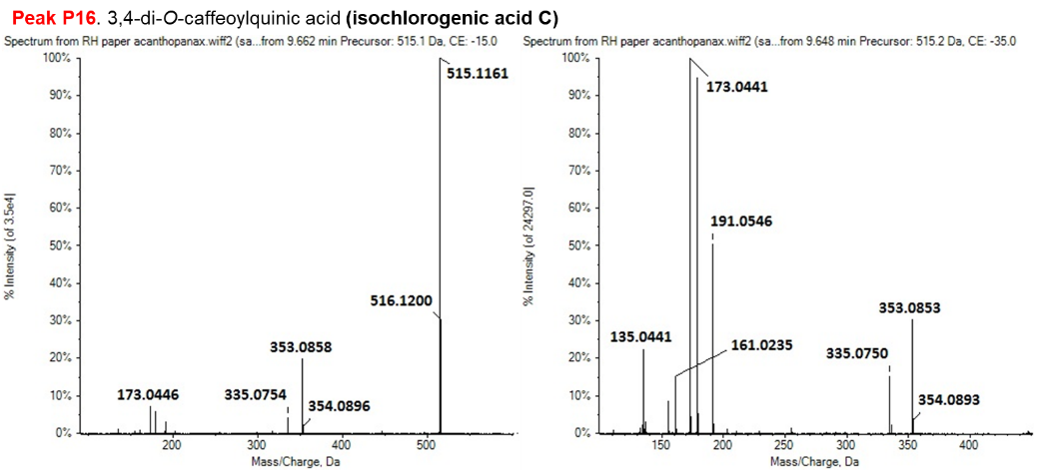
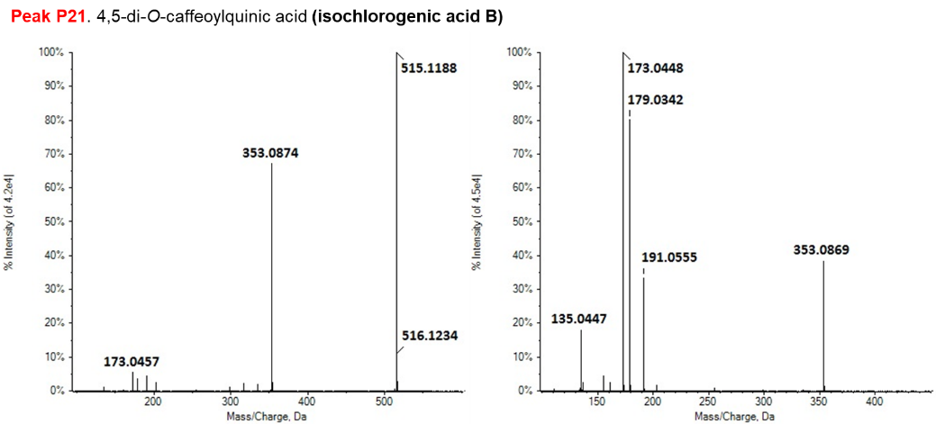
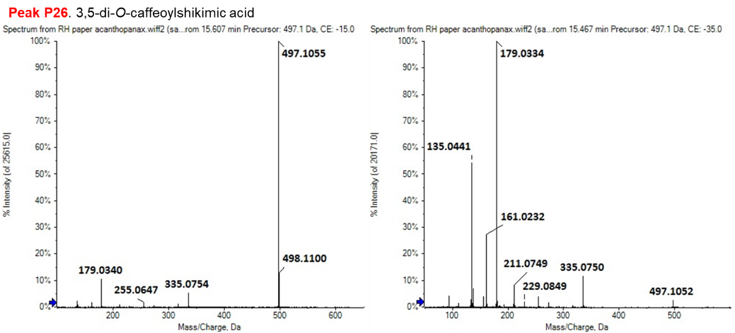
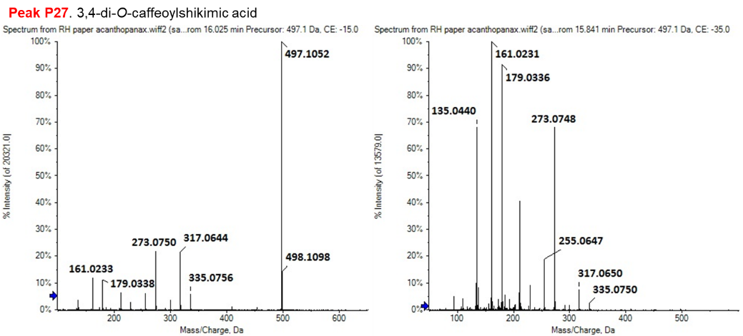
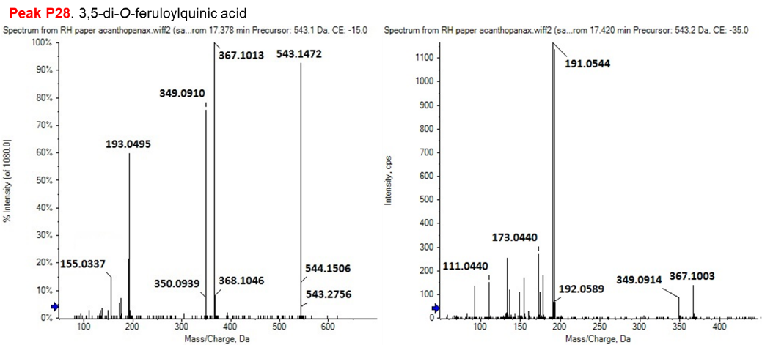
Figure S4. (-) ESI-MS/MS spectra of phenolic acids acquired in IDA mode.

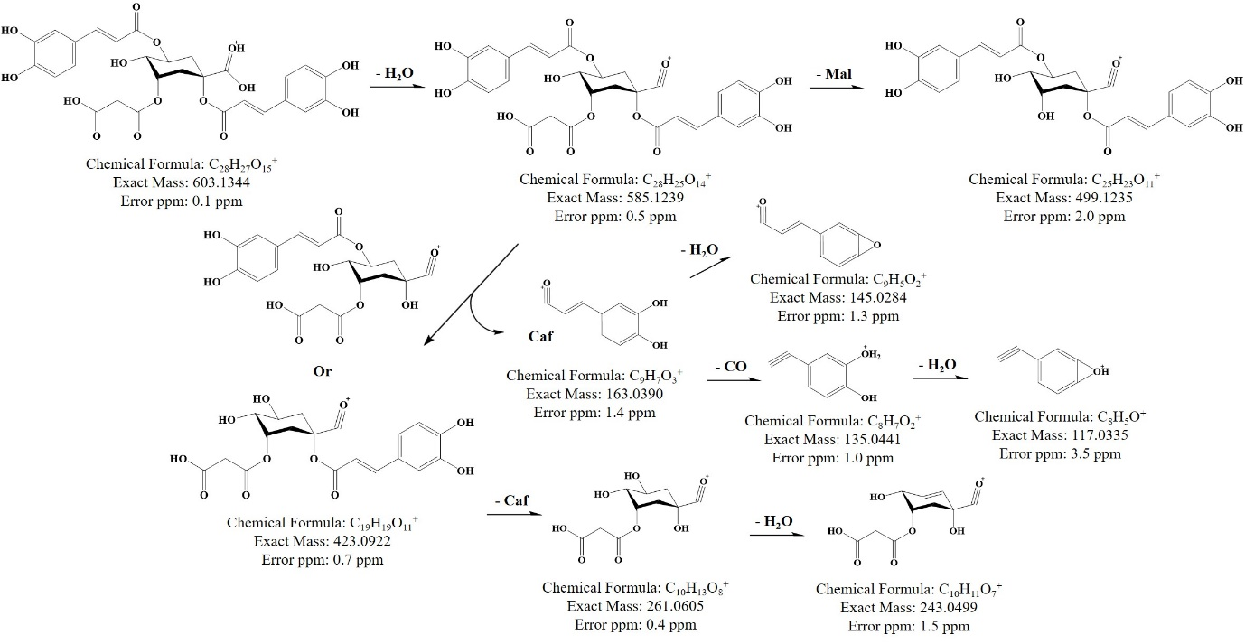
Figure S5. Proposed fragmentation patterns of 3-O-malonyl-1,5-di-O-caffeoylquinic acid.

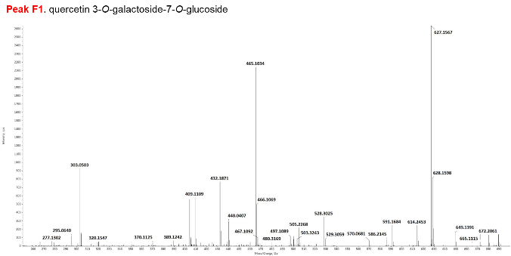 | 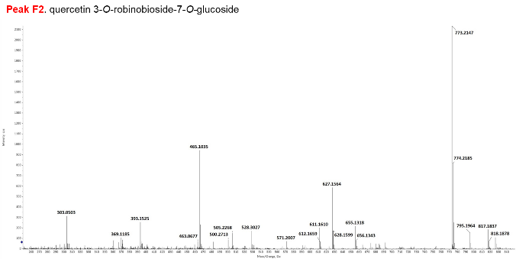
 | 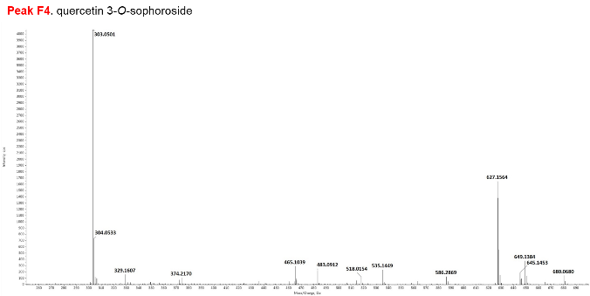
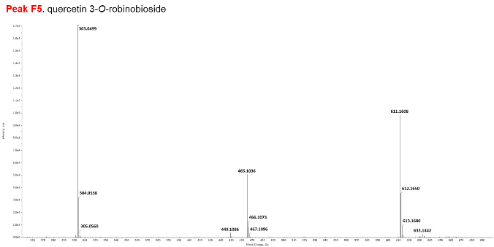 | 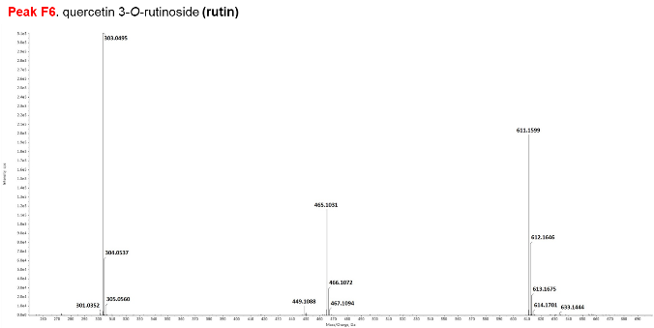
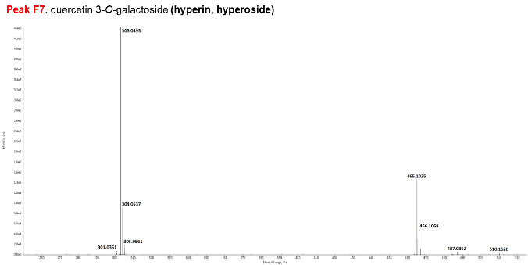 | 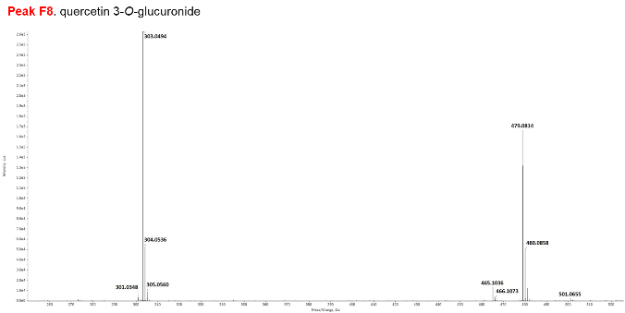
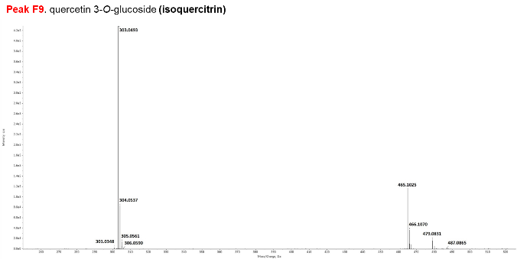 | 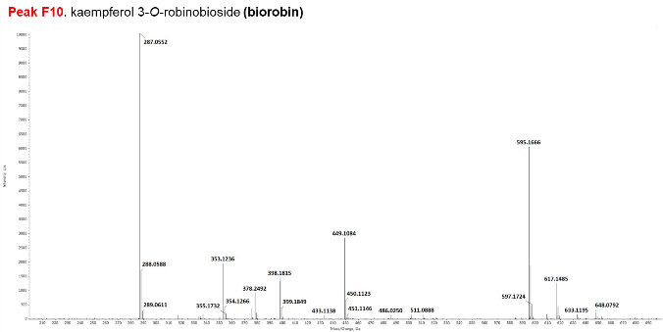
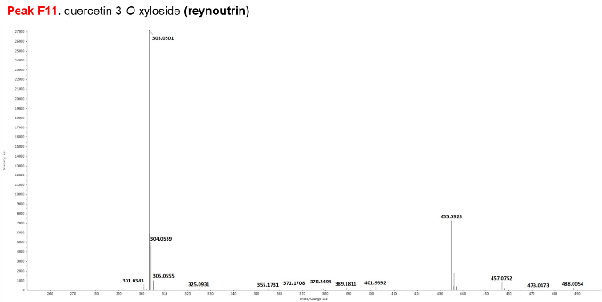 | 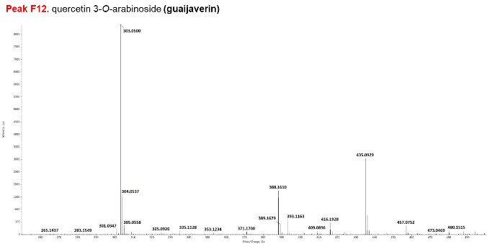
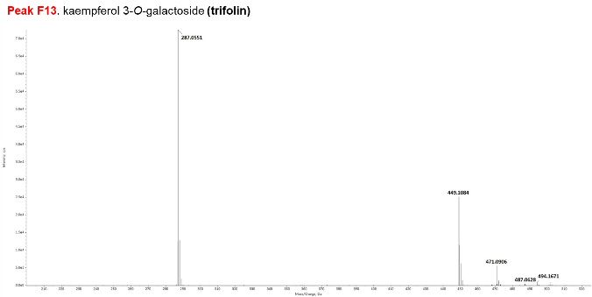 | 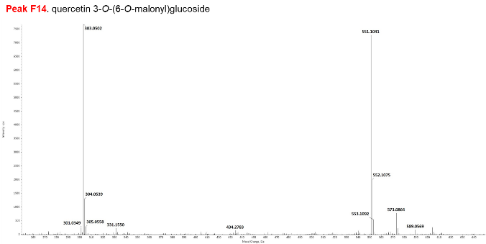
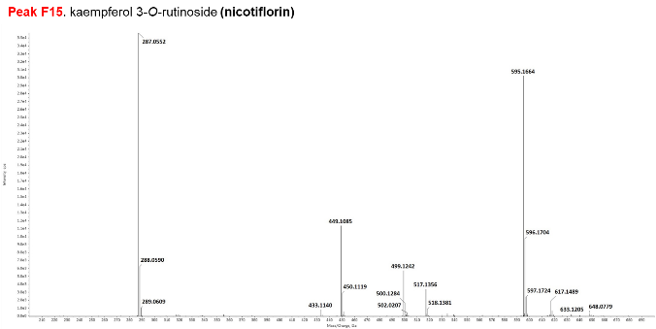 | 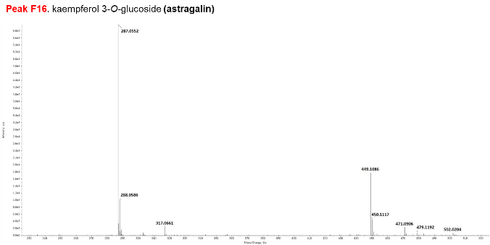
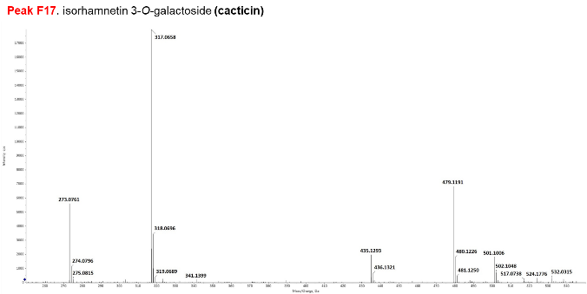 | 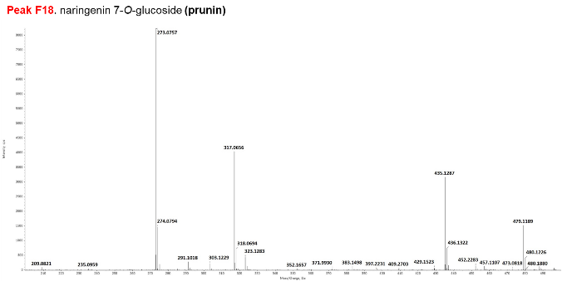
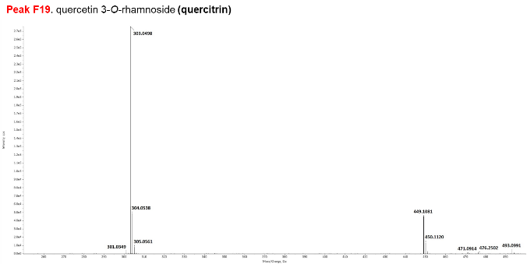 | 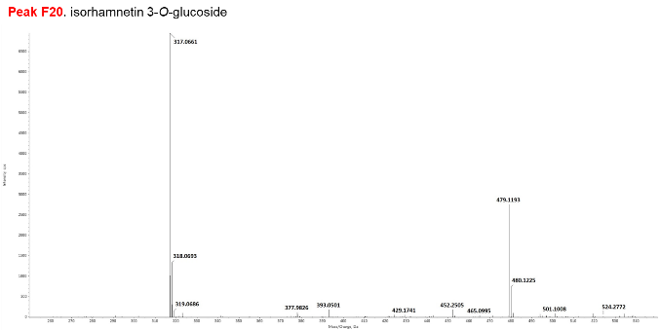
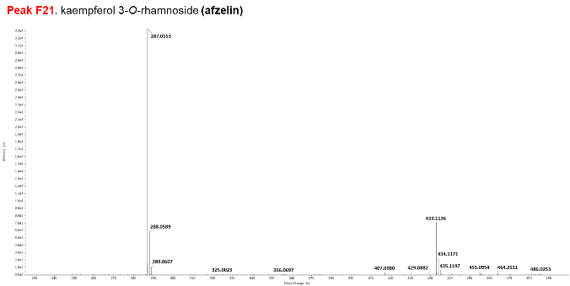 | 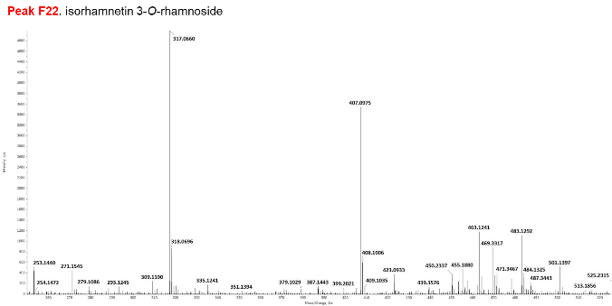
Figure S6. (+) ESI-MS spectra of flavonoids
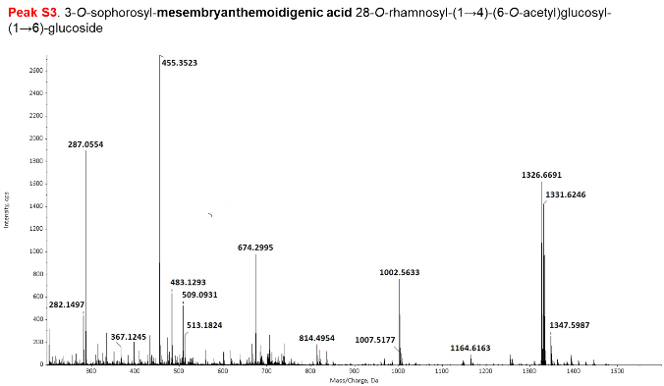 | 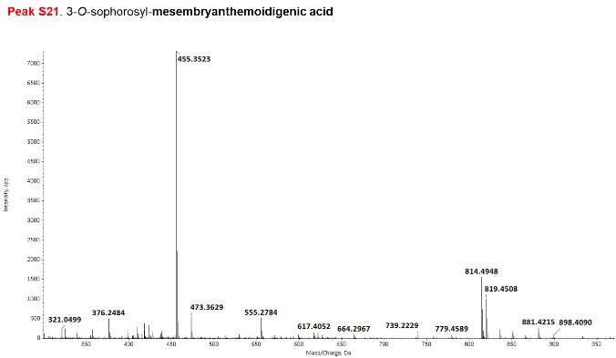
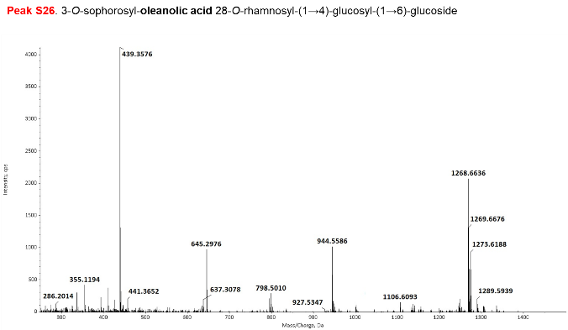 | 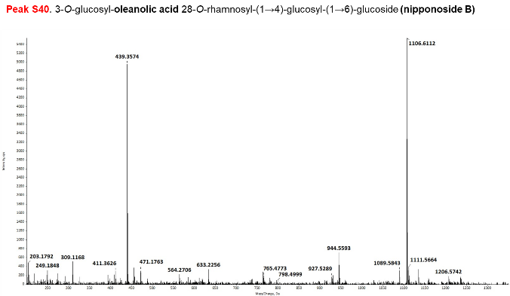
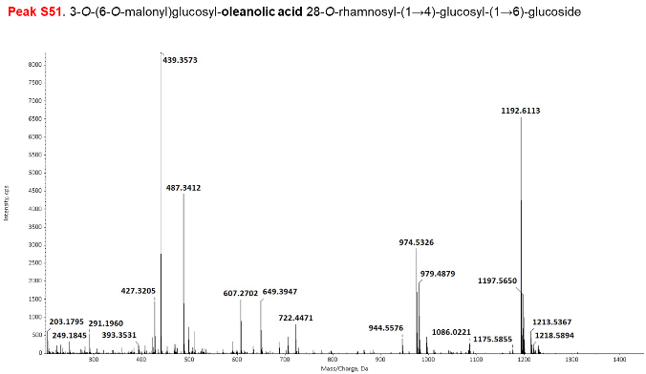 | 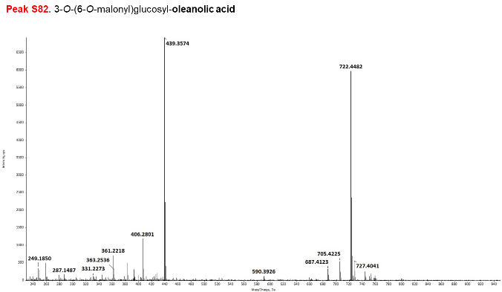
Figure S7. (+) ESI-MS spectra of triterpenoid saponins.
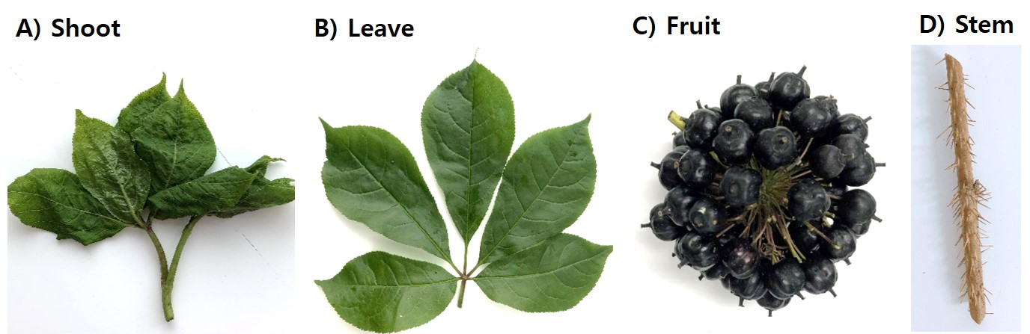
Figure S8. The shoots, leaves, fruits, and stems of Acanthopanax senticosus.

