Content
Appendix A – Supplementary tables & figures 2
A.1. Validation - Internal 2
A.1.1. Validation – Internal - Description 2
A.1.2. Validation – Internal - Input 3
A.2. Validation - External 4
A.2.1. Validation – External - Description 4
A.2.2. Validation - Input - External 4
A.3. Validation - Cross 5
A.3.1. Validation – Cross – Description 5
A.3.2. Validation – Cross - Input 6
A.4. Univariate sensitivity analyses 7
A.4.1. Univariate sensitivity analyses - Input 7
A.4.2. Univariate sensitivity analyses 8
A.5. Probabilistic sensitivity analysis 10
A.5.1. Probabilistic sensitivity analysis – Input 10
A.5.2. Probabilistic sensitivity analyses – Output 11
A.6. Overview scenarios output 12
Appendix B – SimDCIS 13
B.1. Calculation transition probabilities 13
B.1.1. P1 - Death probability 13
B.1.2. P2 - DCIS onset probability 13
B.1.3. P3 – DCIS regression probability 14
B.1.4. P4 – DCIS progression to IBC probability 14
B.2. Model output 15
B.2.1. Model output - Codebook 15
B.2.2. Model output – Example output 16
References 17

Appendix A – Supplementary tables & figures

A.1. Validation - Internal

A.1.1. Validation – Internal - Description
Internal validation was done by comparison of observed Netherlands Cancer Registry (NCR) data of the Dutch screening in 2019 to simulated output of SimDCIS (1). For this simulation, the Dutch cancer screening setting was mimicked. Input parameters were determined as close to the Dutch population as possible (Appendix A1.2). During construction of the model, best estimates were collected for the probability of DCIS onset, regression, and progression to invasive breast cancer (Appendix A1.2, Appendix B1). Raw output of the simulation was given as number of DCIS and number of mammograms (Appendix B2). The raw output was used to calculate the detection rate per 1,000 screened women given by N(DCIS)/N(mam)*1,000, with N(DCIS) number of DCIS, N(mam) number of mammograms. To calculate the observed detection rate from the number of DCIS obtained from NCR data, the number of screened women per age group was obtained from the National Evaluation Team for Breast cancer (2). Output was stratified by age group (50-54, 55-59, 60-64, 65-69, 70-74 years) and by grade (1, 2, 3). To check if observed data matched simulated data, the 95% confidence intervals (95%CI) of the simulated detection rates were compared to observed detection rates. The 95%CIs were determined with probabilistic sensitivity analysis.

A.1.2. Validation – Internal - Input
Parameter |  |  | Base value |  |  | Reference
The Netherlands |  | Age
Transition | All-cause death probability  (*10⁻² / year) | 0 | 0.324 |  |  | (3)
Transition | All-cause death probability  (*10⁻² / year) | 1-9 | 0.050 – 0.008 |  |  | (3)
Transition | All-cause death probability  (*10⁻² / year) | 10-19 | 0.008 – 0.018 |  |  | (3)
Transition | All-cause death probability  (*10⁻² / year) | 20-29 | 0.019 – 0.027 |  |  | (3)
Transition | All-cause death probability  (*10⁻² / year) | 30-39 | 0.032 – 0.064 |  |  | (3)
Transition | All-cause death probability  (*10⁻² / year) | 40-49 | 0.070 – 0.201 |  |  | (3)
Transition | All-cause death probability  (*10⁻² / year) | 50-59 | 0.233 – 0.496 |  |  | (3)
Transition | All-cause death probability  (*10⁻² / year) | 60-69 | 0.538 – 1.137 |  |  | (3)
Transition | All-cause death probability  (*10⁻² / year) | 70-79 | 1.210 – 3.441 |  |  | (3)
Transition | All-cause death probability  (*10⁻² / year) | 80-89 | 3.972 – 12.55 |  |  | (3)
Transition | All-cause death probability  (*10⁻² / year) | 90-99 | 14.33 – 32.30 |  |  | (3)
Transition | All-cause death probability  (*10⁻² / year) | 100 | 100.0 |  |  | (3)
Transition | DCIS onset  (*10⁻³ / year) | Age | Grade 1 | Grade 2 | Grade 3 | (1,4)
Transition | DCIS onset  (*10⁻³ / year) | 0-19 | 0.0000 | 0.0000 | 0.0000 | (1,4)
Transition | DCIS onset  (*10⁻³ / year) | 20-24 | 0.0016 | 0.0003 | 0.0013 | (1,4)
Transition | DCIS onset  (*10⁻³ / year) | 25-29 | 0.0019 | 0.0043 | 0.0075 | (1,4)
Transition | DCIS onset  (*10⁻³ / year) | 30-34 | 0.0017 | 0.0127 | 0.0199 | (1,4)
Transition | DCIS onset  (*10⁻³ / year) | 35-39 | 0.0119 | 0.0221 | 0.0406 | (1,4)
Transition | DCIS onset  (*10⁻³ / year) | 40-44 | 0.0213 | 0.0516 | 0.0526 | (1,4)
Transition | DCIS onset  (*10⁻³ / year) | 45-48 | 0.0398 | 0.0600 | 0.0665 | (1,4)
Transition | DCIS onset  (*10⁻³ / year) | 49-54 | 0.2095 | 0.3105 | 0.3250 | (1,4)
Transition | DCIS onset  (*10⁻³ / year) | 55-59 | 0.0859 | 0.1805 | 0.2558 | (1,4)
Transition | DCIS onset  (*10⁻³ / year) | 60-64 | 0.0948 | 0.2396 | 0.3002 | (1,4)
Transition | DCIS onset  (*10⁻³ / year) | 65-69 | 0.1016 | 0.2674 | 0.2857 | (1,4)
Transition | DCIS onset  (*10⁻³ / year) | 70-75 | 0.1540 | 0.3556 | 0.3703 | (1,4)
Transition | DCIS onset  (*10⁻³ / year) | 76-79 | 0.0307 | 0.0630 | 0.0491 | (1,4)
Transition | DCIS onset  (*10⁻³ / year) | 80-95 | 0.0361 | 0.0585 | 0.0452 | (1,4)
Transition | DCIS onset  (*10⁻³ / year) | 95+ | 0.0000 | 0.0000 | 0.0000 | (1,4)
Transition | DCIS regression (/year) | 20+ | 0.0488 | 0.0488 | 0.0488 | (4–6)
Transition | Progression to IBC  (/year) | 0-19 | 0.000 | 0.000 | 0.000 | (4,7)
Transition | Progression to IBC  (/year) | 20-39 | 0.187 | 0.294 | 0.342 | (4,7)
Transition | Progression to IBC  (/year) | 40-49 | 0.073 | 0.115 | 0.133 | (4,7)
Transition | Progression to IBC  (/year) | 50-59 | 0.056 | 0.088 | 0.103 | (4,7)
Transition | Progression to IBC  (/year) | 60-69 | 0.063 | 0.100 | 0.116 | (4,7)
Transition | Progression to IBC  (/year) | 70-79 | 0.074 | 0.116 | 0.134 | (4,7)
Transition | Progression to IBC  (/year) | 80+ | 0.144 | 0.226 | 0.262 | (4,7)
Screening | Mammographic sensitivity |  | 86% |  |  | (8)
Screening | Screening frequency |  | Biennial |  |  | (9)
Screening | Screening age |  | 50-74 years |  |  | (9)
Screening | Participation rate |  | 76% |  |  | (9)
Clinical detection |  |  | 5% |  |  | (10)
Appendix A.1.2 – Input parameters for SimDCIS for the Dutch population. DCIS = ductal carcinoma in situ, IBC = invasive breast cancer.

A.2. Validation - External

A.2.1. Validation – External - Description
External validation was done to evaluate the performance of the model in a different screening setting. For this, observed National Health Service (NHS) data of screening in the United Kingdom (UK) in 2021 was compared to simulated output of SimDCIS (11). For this simulation, UK screening setting was simulated. In order to simulate UK screening, death probability and screening frequency, age, and participation were adjusted (Appendix A2.2). Death probability was based on data from 2021 per age group (12). Participation rate was averaged for 2010 up to and including 2019 for women aged 50-70 years (11). Transition probability of DCIS onset, regression, and progression were assumed similar for the UK and Dutch population. Raw output was transformed to detection rate per 1,000 screened women. Both number of DCIS and number of mammograms in the UK were available from NHS data, and were used to calculate detection rate per 1,000 screened women (11). Output was stratified by age groups (50-54, 55-59, 60-64, 65-69, 70-74 years). To check if observed data matched simulated data, the 95% confidence intervals (95%CI) of the simulated detection rates were compared to observed detection rates. The simulated 95%CIs were determined with univariate sensitivity analysis (Appendix A4).

A.2.2. Validation - Input - External
Parameter |  |  | Base value | Reference
The United Kingdom |  |   Age
Transition | All-cause death probability  (*10⁻² / year) | 0 | 0.340 | (12)
Transition | All-cause death probability  (*10⁻² / year) | 1-9 | 0.230 – 0.010 | (12)
Transition | All-cause death probability  (*10⁻² / year) | 10-19 | 0.010 – 0.020 | (12)
Transition | All-cause death probability  (*10⁻² / year) | 20-29 | 0.020 – 0.038 | (12)
Transition | All-cause death probability  (*10⁻² / year) | 30-39 | 0.042 – 0.096 | (12)
Transition | All-cause death probability  (*10⁻² / year) | 40-49 | 0.104 – 0.226 | (12)
Transition | All-cause death probability  (*10⁻² / year) | 50-59 | 0.244 – 0.512 | (12)
Transition | All-cause death probability  (*10⁻² / year) | 60-69 | 0.558 – 1.246 | (12)
Transition | All-cause death probability  (*10⁻² / year) | 70-79 | 1.364 – 3.698 | (12)
Transition | All-cause death probability  (*10⁻² / year) | 80-89 | 4.172 – 12.36 | (12)
Transition | All-cause death probability  (*10⁻² / year) | 90-99 | 13.80 – 84.20 | (12)
Transition | All-cause death probability  (*10⁻² / year) | 100 | 100.0 | (12)
Mammography | Screening frequency |  | Triennial | (11)
Mammography | Screening age |  | 50-71 years | (11)
Mammography | Participation rate |  | 72% (65% - 80%) | (11)
Appendix A.2.2 – Adjusted input parameters for SimDCIS for the United Kingdom compared to the Dutch screening setting.

A.3. Validation - Cross

A.3.1. Validation – Cross – Description
Cross validation was done to evaluate performance of the model compared to another existing model. For cross validation, SimDCIS output was compared to output from the MISCAN-Fadia model and to observed data from the UK Frequency Trial (13). To simulate UK screening setting, UK death probability was used (Appendix A3.2). Transition probabilities of DCIS onset, regression, and progression were assumed independent of the population. The UK Frequency trial invited women of 50 to 62 years old to participate in screening. Both control and study arms of the UK frequency trial were simulated (Appendix A3.2). The study arm screened women at baseline and three subsequent screens with an annual interval, with participation rates of 78%, 78% and 81%, respectively. The control arm screened women at baseline and one time with a triennial interval with a participation rate of 85%. Only women at baseline were included in analyses, so a baseline participation rate of 100% was used in the simulation. If women were above 50 at baseline, they had the opportunity to participate in the population-based screening program. Therefore, regular screening was also simulated for these women before trial started, with a participation rate of 75% (14). Results were averaged for age groups 53-56, 56-59, and 59-62 years. Total detected DCIS was calculated by adding the number of screen- and clinically detected DCIS and divide by the mammogram factor to adjust for the actual number of mammograms. The mammogram factor was calculated by dividing the simulated number of mammograms by the observed number. To check if observed data matched simulated data, 95% confidence intervals (95%CI) of the simulated detection rates were compared to observed detection rates. The simulated 95%CIs were determined from variation in 10 iterations.

A.3.2. Validation – Cross - Input
Parameter |  |  | Base value | Reference
The United Kingdom |  | Age
Transition | All-cause death probability  (*10⁻² / year) | 0 | 0.340 | (12)
Transition | All-cause death probability  (*10⁻² / year) | 1-9 | 0.230 – 0.010 | (12)
Transition | All-cause death probability  (*10⁻² / year) | 10-19 | 0.010 – 0.020 | (12)
Transition | All-cause death probability  (*10⁻² / year) | 20-29 | 0.020 – 0.038 | (12)
Transition | All-cause death probability  (*10⁻² / year) | 30-39 | 0.042 – 0.096 | (12)
Transition | All-cause death probability  (*10⁻² / year) | 40-49 | 0.104 – 0.226 | (12)
Transition | All-cause death probability  (*10⁻² / year) | 50-59 | 0.244 – 0.512 | (12)
Transition | All-cause death probability  (*10⁻² / year) | 60-69 | 0.558 – 1.246 | (12)
Transition | All-cause death probability  (*10⁻² / year) | 70-79 | 1.364 – 3.698 | (12)
Transition | All-cause death probability  (*10⁻² / year) | 80-89 | 4.172 – 12.36 | (12)
Transition | All-cause death probability  (*10⁻² / year) | 90-99 | 13.80 – 84.20 | (12)
Transition | All-cause death probability  (*10⁻² / year) | 100 | 100.0 | (12)
Mammography - Control | Screening frequency |  | Triennial | (13)
Mammography - Control | Screening age |  | 50-62 years | (13)
Mammography - Control | Participation rate,  screening round | previous | 75% | (14)
Mammography - Control | Participation rate,  screening round | 1 | 100% | (13)
Mammography - Control | Participation rate,  screening round | 2 | 85% | (13)
Mammography - Study | Screening frequency |  | Annual | (13)
Mammography - Study | Screening age |  | 50-62 years | (13)
Mammography - Study | Participation rate,  screening round | previous | 75% | (14)
Mammography - Study | Participation rate,  screening round | 1 | 100% | (13)
Mammography - Study | Participation rate,  screening round | 2 | 78% | (13)
Mammography - Study | Participation rate,  screening round | 3 | 78% | (13)
Mammography - Study | Participation rate,  screening round | 4 | 81% | (13)
Appendix A.3.2 – Adjusted input parameters for SimDCIS for the United Kingdom compared to the Dutch screening setting.

A.4. Univariate sensitivity analyses

A.4.1. Univariate sensitivity analyses - Input
Parameter |  | Base case (95% CI)
 | Age | Grade 1 | Grade 2 | Grade 3
DCIS onset  (*10⁻³ /year) | 0-19 | 0.0000 (0.0000 - 0.0001) | 0.0000 (0.0000 - 0.0000) | 0.0000 (0.0000 - 0.0000)
DCIS onset  (*10⁻³ /year) | 20-24 | 0.0016 (0.0014 - 0.0018) | 0.0003 (0.0002 - 0.0003) | 0.0013 (0.0012 - 0.0015)
DCIS onset  (*10⁻³ /year) | 25-29 | 0.0019 (0.0017 - 0.0021) | 0.0043 (0.0038 - 0.0047) | 0.0075 (0.0067 - 0.0082)
DCIS onset  (*10⁻³ /year) | 30-34 | 0.0017 (0.0015 - 0.0018) | 0.0127 (0.0114 - 0.0140) | 0.0199 (0.0179 - 0.0219)
DCIS onset  (*10⁻³ /year) | 35-39 | 0.0119 (0.0107 - 0.0131) | 0.0221 (0.0199 - 0.0243) | 0.0406 (0.0365 - 0.0447)
DCIS onset  (*10⁻³ /year) | 40-44 | 0.0213 (0.0191 - 0.0234) | 0.0516 (0.0465 - 0.0568) | 0.0526 (0.0474 - 0.0579)
DCIS onset  (*10⁻³ /year) | 45-48 | 0.0398 (0.0358 - 0.0438) | 0.0600 (0.0540 - 0.0661) | 0.0665 (0.0598 - 0.0731)
DCIS onset  (*10⁻³ /year) | 49-54 | 0.2095 (0.1885 - 0.2304) | 0.3105 (0.2795 - 0.3416) | 0.3250 (0.2925 - 0.3575)
DCIS onset  (*10⁻³ /year) | 55-59 | 0.0859 (0.0773 - 0.0945) | 0.1805 (0.1624 - 0.1985) | 0.2558 (0.2302 - 0.2813)
DCIS onset  (*10⁻³ /year) | 60-64 | 0.0948 (0.0853 - 0.1043) | 0.2396 (0.2156 - 0.2635) | 0.3002 (0.2702 - 0.3302)
DCIS onset  (*10⁻³ /year) | 65-69 | 0.1016 (0.0915 - 0.1118) | 0.2674 (0.2407 - 0.2942) | 0.2857 (0.2571 - 0.3143)
DCIS onset  (*10⁻³ /year) | 70-75 | 0.1540 (0.1386 - 0.1694) | 0.3556 (0.3201 - 0.3912) | 0.3703 (0.3332 - 0.4073)
DCIS onset  (*10⁻³ /year) | 76-79 | 0.0307 (0.0277 - 0.0338) | 0.0630 (0.0567 - 0.0693) | 0.0491 (0.0442 - 0.0540)
DCIS onset  (*10⁻³ /year) | 80-95 | 0.0361 (0.0324 - 0.0397) | 0.0585 (0.0527 - 0.0644) | 0.0452 (0.0407 - 0.0497)
DCIS onset  (*10⁻³ /year) | 95+ | 0.0000 (0.0000 - 0.0013) | 0.0000 (0.0000 - 0.0013) | 0.0000 (0.0000 - 0.0026)
DCIS regression (/year) | 20+ | 0.0488 (0.000 - 0.0952) | 0.0488 (0.000 - 0.0952) | 0.0488 (0.000 - 0.0952)
Progression to IBC  (/year) | 0-19 | 0.000 (0.000 - 0.000) | 0.000 (0.000 - 0.000) | 0.000 (0.000 - 0.000)
Progression to IBC  (/year) | 20-40 | 0.187 (0.122 - 0.241) | 0.294 (0.193 - 0.380) | 0.342 (0.224 - 0.441)
Progression to IBC  (/year) | 40-49 | 0.073 (0.058 - 0.087) | 0.115 (0.091 - 0.137) | 0.133 (0.105 - 0.159)
Progression to IBC  (/year) | 50-59 | 0.056 (0.045 - 0.066) | 0.088 (0.071 - 0.103) | 0.103 (0.082 – 0.120)
Progression to IBC  (/year) | 60-69 | 0.063 (0.051 - 0.075) | 0.100 (0.080 - 0.119) | 0.116 (0.093 - 0.138)
Progression to IBC  (/year) | 70-79 | 0.074 (0.056 - 0.090) | 0.116 (0.088 - 0.141) | 0.134 (0.102 - 0.164)
Progression to IBC  (/year) | 80+ | 0.144 (0.069 - 0.207) | 0.226 (0.109 - 0.327) | 0.262 (0.126 - 0.379)
Sensitivity |  | 86% (83% - 89%)
Clinical detection |  | 5% ( 0% - 10%)
Participation rate |  | 76% (NL: 70% - 80%; UK: 65-80%)
Appendix A.4.1 – Input parameters for the univariate sensitivity analyses with 95% confidence intervals (95%CI) of SimDCIS in the Dutch population. For each parameter, the lower and upper 95%CI were individually changed. DCIS = ductal carcinoma in situ, IBC = invasive breast cancer.

A.4.2. Univariate sensitivity analyses

A.4.2.1 – USA plot: screen-detected DCIS total
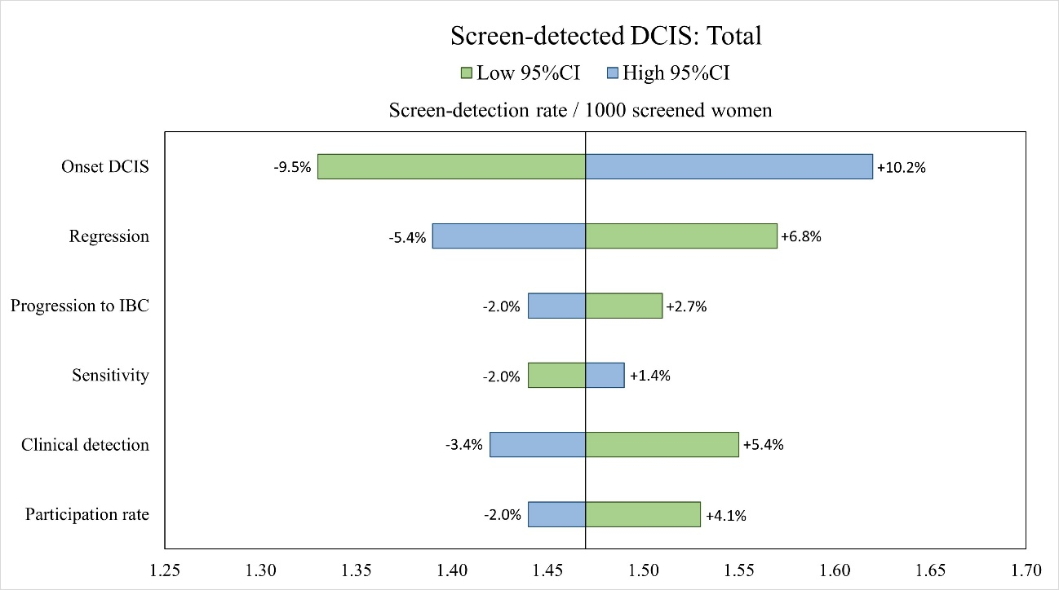
Appendix A.4.2.1 – Tornado plot of the univariate sensitivity analyses and the resulting variation in screen-detection rate per 1000 screened women in Dutch screening setting.

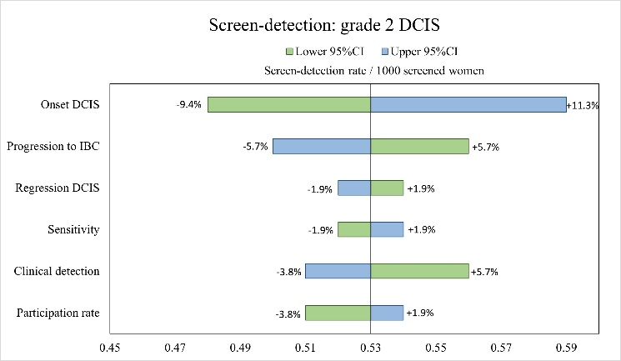
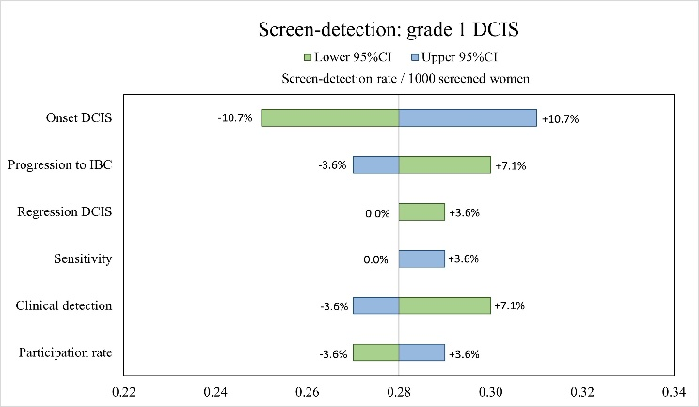
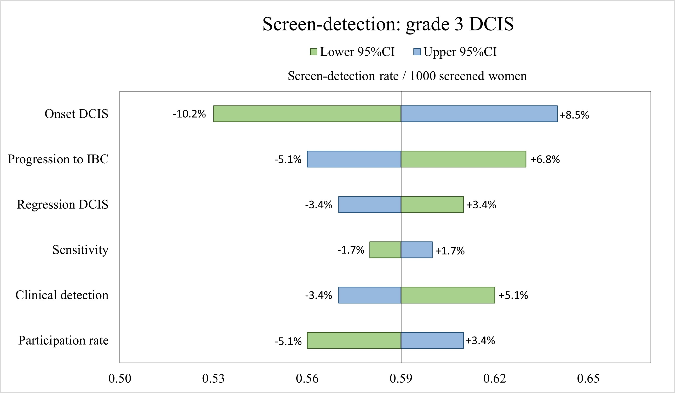
A.4.2.2 – USA plot: screen-detected DCIS stratified by grade
(A)
(B))
(C))

Appendix A.4.2.2 – Tornado plot of the univariate sensitivity analyses and the resulting variation in screen-detection rate per 1000 screened women of DCIS grade 1 (A), 2 (B), and 3 (C) in Dutch screening setting.

A.4.2.3 – USA plot: screen-detected DCIS stratified by age group

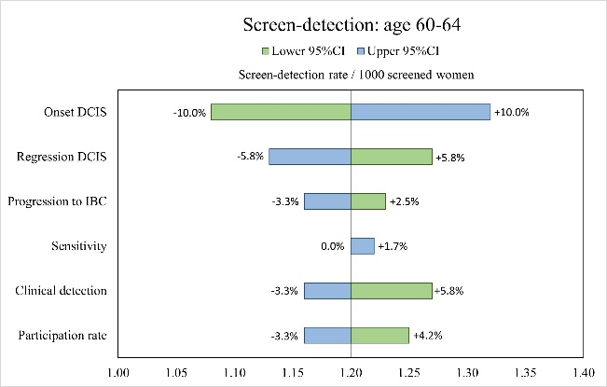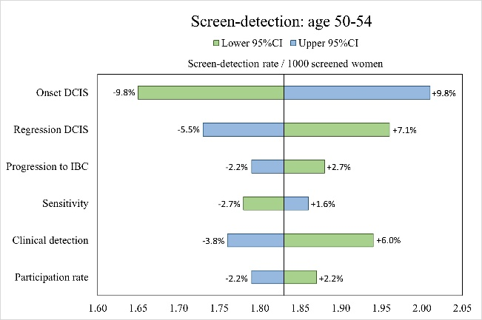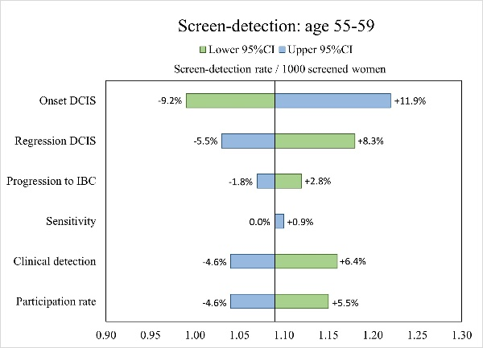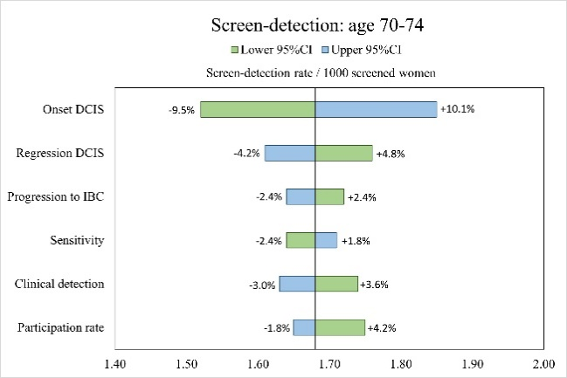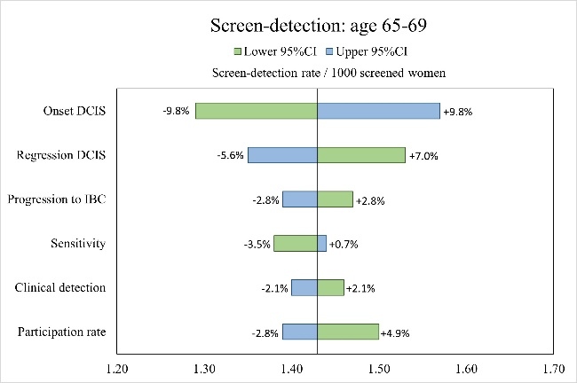
(A))
(B))
(C))
(D))
(E))

Appendix A.4.2.3 – Tornado plot of the univariate sensitivity analyses and the resulting variation in screen-detection rate per 1000 screened women in women aged 50-54 (A), 55-59 (B), 60-64 (C), 65-69 (D), 70-74 (E) in Dutch screening setting.

A.5. Probabilistic sensitivity analysis

A.5.1. Probabilistic sensitivity analysis – Input
Parameter |  | Average (range)
 | Age | Grade 1 | Grade 2 | Grade 3
DCIS onset  (*10⁻³ /year) | 0-19 | 0.0000 (0.0000 - 0.0001) | 0.0000 (0.0000 - 0.0000) | 0.0000 (0.0000 - 0.0000)
DCIS onset  (*10⁻³ /year) | 20-24 | 0.0016 (0.0015 - 0.0018) | 0.0003 (0.0002 - 0.0003) | 0.0013 (0.0012 - 0.0014)
DCIS onset  (*10⁻³ /year) | 25-29 | 0.0019 (0.0017 - 0.0020) | 0.0043 (0.0038 - 0.0047) | 0.0075 (0.0068 - 0.0082)
DCIS onset  (*10⁻³ /year) | 30-34 | 0.0016 (0.0015 - 0.0018) | 0.0127 (0.0116 - 0.0139) | 0.0199 (0.0182 - 0.0217)
DCIS onset  (*10⁻³ /year) | 35-39 | 0.0118 (0.0108 - 0.0130) | 0.0221 (0.0201 - 0.0241) | 0.0404 (0.0368 - 0.0440)
DCIS onset  (*10⁻³ /year) | 40-44 | 0.0213 (0.0193 - 0.0232) | 0.0514 (0.0472 - 0.0562) | 0.0525 (0.0480 - 0.0576)
DCIS onset  (*10⁻³ /year) | 45-48 | 0.0401 (0.0362 - 0.0433) | 0.0597 (0.0543 - 0.0657) | 0.0663 (0.0605 - 0.0726)
DCIS onset  (*10⁻³ /year) | 49-54 | 0.2087 (0.1923 - 0.2252) | 0.3106 (0.2839 - 0.3388) | 0.3235 (0.2958 - 0.3545)
DCIS onset  (*10⁻³ /year) | 55-59 | 0.0862 (0.0787 - 0.0944) | 0.1806 (0.1644 - 0.1964) | 0.2564 (0.2316 - 0.2776)
DCIS onset  (*10⁻³ /year) | 60-64 | 0.0946 (0.0863 - 0.1035) | 0.2396 (0.2181 - 0.2602) | 0.2968 (0.2724 - 0.3269)
DCIS onset  (*10⁻³ /year) | 65-69 | 0.1023 (0.0925 - 0.1108) | 0.2673 (0.2427 - 0.2890) | 0.2858 (0.2573 - 0.3097)
DCIS onset  (*10⁻³ /year) | 70-75 | 0.1538 (0.1404 - 0.1668) | 0.3545 (0.3257 - 0.3867) | 0.3683 (0.3366 - 0.4005)
DCIS onset  (*10⁻³ /year) | 76-79 | 0.0307 (0.0280 - 0.0334) | 0.0624 (0.0569 - 0.0675) | 0.0491 (0.0445 - 0.0535)
DCIS onset  (*10⁻³ /year) | 80-95 | 0.0360 (0.0327 - 0.0387) | 0.0587 (0.0530 - 0.0639) | 0.0454 (0.0410 - 0.0493)
DCIS onset  (*10⁻³ /year) | 95+ | 0.0000 (0.0000 - 0.0000) | 0.0000 (0.0000 - 0.0000) | 0.0000 (0.0000 - 0.0000)
DCIS regression (/year) | 20+ | 0.0428 (0.0076 - 0.0906) | 0.0428 (0.0076 - 0.0906) | 0.0428 (0.0076 - 0.0906)
Progression to IBC  (/year) | 0-19 | 0.000 (0.000 - 0.000) | 0.000 (0.000 - 0.000) | 0.000 (0.000 - 0.000)
Progression to IBC  (/year) | 20-40 | 0.182 (0.133 - 0.233) | 0.285 (0.204 - 0.370) | 0.333 (0.236 - 0.440)
Progression to IBC  (/year) | 40-49 | 0.073 (0.058 - 0.087) | 0.116 (0.094 - 0.134) | 0.135 (0.109 - 0.156)
Progression to IBC  (/year) | 50-59 | 0.056 (0.046 - 0.065) | 0.088 (0.074 - 0.102) | 0.102 (0.084 – 0.120)
Progression to IBC  (/year) | 60-69 | 0.063 (0.052 - 0.072) | 0.099 (0.082 - 0.118) | 0.116 (0.094 - 0.136)
Progression to IBC  (/year) | 70-79 | 0.073 (0.058 - 0.088) | 0.114 (0.090 - 0.138) | 0.135 (0.104 - 0.162)
Progression to IBC  (/year) | 80+ | 0.128 (0.079 - 0.189) | 0.213 (0.117 - 0.313) | 0.257 (0.147 - 0.368)
Sensitivity |  | 86% (83% - 89%)
Clinical detection |  | 5% ( 0% - 9%)
Participation rate |  | 75% (70% - 80%)
Appendix A.5.1 – Average and range of input parameters for 100 simulations of the probabilistic sensitivity analysis of SimDCIS in the Dutch population after random sampling from an inverse beta distribution of the lower and upper 95% confidence intervals with an alpha and beta of 2. DCIS = ductal carcinoma in situ, IBC = invasive breast cancer.

A.5.2. Probabilistic sensitivity analyses – Output

A.5.2.1 – PSA plot: screen-detected DCIS total
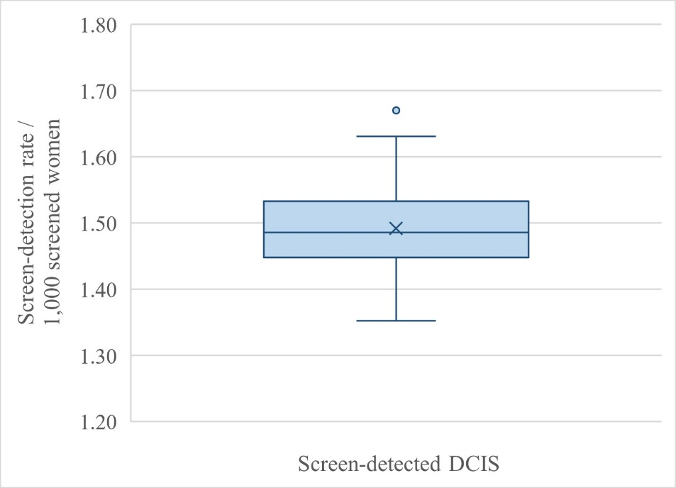
Appendix A.5.2.1 – Box-and-whisker plot of the probabilistic sensitivity analyses and the resulting variation in screen-detection rate per 1,000 screened women.

A.5.2.2 – PSA plot: screen-detected DCIS stratified by grade
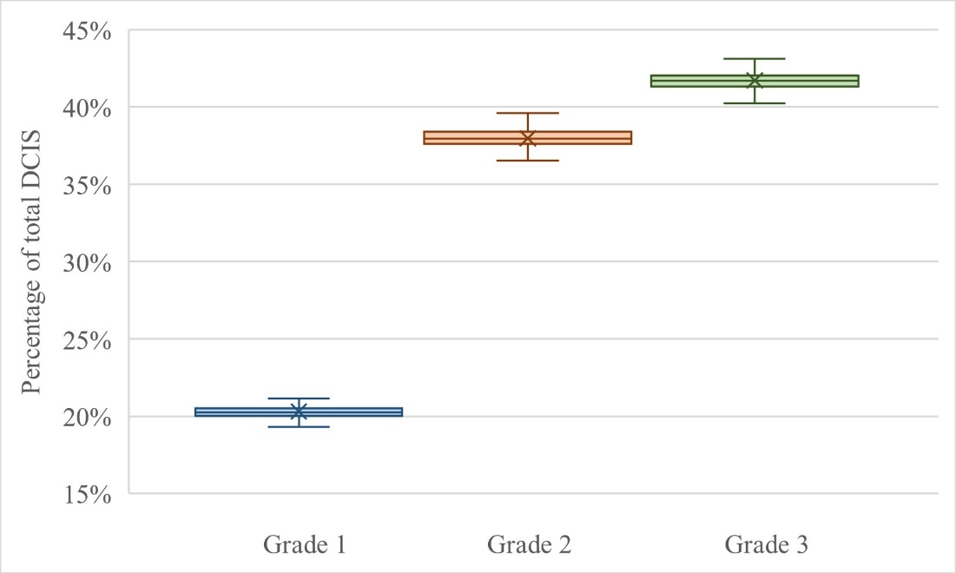
Appendix A.5.2.2 – Box-and-whisker plot of the probabilistic sensitivity analyses and the resulting variation in screen-detection rate per 1000 screened women stratified by grade for DCIS grade 1, 2, and 3.

A.6. Overview scenarios output
A.6.1 – Percentiles output all scenarios
 | Regress | Progress to IBC | Clinically detected | Screen-detected | Grade distribution*
 |  |  |  |  | Screen-detected DCIS
 |  |  |  |  | 1 | 2 | 3
Validation
NL | 7% | 19% | 7% | 63% | 20% | 38% | 42%
UK | 11% | 26% | 12% | 46% | 21% | 38% | 41%
Univariate sensitivity analyses
mean | 7% | 19% | 7% | 63% | 20% | 38% | 42%
min | 0% | 15% | 0% | 59% | 20% | 38% | 41%
5% | 4% | 16% | 4% | 60% | 20% | 38% | 42%
25% | 7% | 18% | 7% | 61% | 20% | 38% | 42%
50% | 7% | 19% | 7% | 63% | 20% | 38% | 42%
75% | 8% | 21% | 8% | 64% | 20% | 38% | 42%
95% | 11% | 22% | 10% | 66% | 20% | 38% | 42%
max | 14% | 22% | 13% | 67% | 20% | 38% | 42%
Probabilistic sensitivity analysis
mean | 7% | 20% | 7% | 63% | 20% | 38% | 42%
min | 1% | 17% | 2% | 58% | 19% | 36% | 40%
5% | 2% | 17% | 2% | 59% | 19% | 37% | 42%
25% | 4% | 18% | 5% | 62% | 20% | 38% | 41%
50% | 6% | 19% | 8% | 63% | 20% | 38% | 42%
75% | 9% | 21% | 10% | 65% | 20% | 38% | 42%
95% | 12% | 23% | 12% | 67% | 20% | 39% | 44%
max | 14% | 24% | 14% | 68% | 21% | 40% | 44%
Appendix A.6.1 – Overview of DCIS estimates for validation, and min, 5th, 25th, 50th, 75th, 95th, and max percentiles for univariate and probabilistic sensitivity analyses of the Dutch screening setting. All percentages are rounded. min = minimum, max = maximum.*DCIS = ductal carcinoma in situ, IBC = invasive breast cancer.

Appendix B – SimDCIS

B.1. Calculation transition probabilities

B.1.1. P1 - Death probability
Death probability (P1) was used in the transition of healthy to death and of DCIS to death. Death probability was calculated from Dutch mortality data of 2011 from the Central Bureau of Statistics (3). The death probability per year of age was calculated from the number of women who died and were alive per year of age in 2011. This resulted in an age-dependent yearly death probability. To ensure all women leave the model, death probability at 100 years was set to 1.0. The death probability is population-dependent and should be adjusted when SimDCIS is used in other populations.

B.1.2. P2 - DCIS onset probability
DCIS onset probability (P2) was used in the transition of healthy to DCIS. To calculate DCIS onset probability, data from the Netherlands Cancer Registry (NCR) was used (1). Data on all DCIS (screen- and not screen-detected) per grade (1, 2, 3, unknown) and 5-year age group from 2015 up to and including2022 was requested. Data from 2020 was excluded because of variations in data due to the COVID-19 pandemic. Unknown grade was also excluded. DCIS onset rate was calculated by the average number of DCIS per 5-year age group and grade (1, 2, 3) divided by the number of women alive in the Netherlands in 2018 (3). DCIS onset rate r was transformed to DCIS onset probability p using the following formula (4):
p = 1-exp(-rt) (Formula 1)
with t = 1 for a yearly transition rate.

To obtain the final DCIS onset probability, a few assumptions were made. Firstly, Dutch DCIS data had some deviations in 5-year age groups, and these groups were used as data was provided: 0-19, 45-48, 49-54, 70-75, 76-79, 95+ years. Secondly, the number of women alive in 2018 was only available for 10-year age groups. Therefore, the assumption was that the number of women per 10-year age group was equally divided to obtain 5-year age groups. Thirdly, the oldest age group with known number of women alive was 80+. Therefore, DCIS of 80-94 was summed and divided by the 80+ women, and probability of women 95+ years old was set to 0.

B.1.3. P3 – DCIS regression probability
DCIS regression probability (P3) was used in the transition of DCIS to healthy. Regression from invasive breast cancer (IBC) to DCIS was assumed not possible. As the natural history of DCIS is currently unobservable, the true number of DCIS that regress is unknown. A regression rate of 5% per year was chosen based on regression estimates ranging from 1-10% (5), and a previous modelling study (10). This 5% was adjusted to a transition probability with the previous formula (Appendix B1.2). Regression probability was not adjusted for age and grade to avoid unnecessary assumptions.

B.1.4. P4 – DCIS progression to IBC probability
DCIS progression to IBC probability (P4) was used in the transition of DCIS to IBC. Data from BreastScreen Australia contained 1 to 10-year probabilities of progression for age groups <40, 40-49, 50-59, 60-69, 70-79, and 80+ (7). The probabilities were first calculated to yearly rates using Formula 1, with t = 1-10, depending on years probability is based on (4). The probability for 0-19 year old women was set to 0, in line with DCIS onset being 0 for this age group. The yearly rates were then averaged within each age group to contain a more stable estimate. The yearly age-dependent rates were transformed back to transition probabilities using Formula 1 (Appendix B1.2). A different t was used, dependent on the size of the age-group: 20 for 20-40 and 80+ years, and 10 for the other age groups. This resulted in an age-dependent progression probability. To also account for the difference in progression probability per grade, a grade dependency factor was calculated and used to calculate grade-dependent probabilities. The average grade dependency within age groups was calculated, and normalized to have an average of 1.0 over all estimates. This resulted in a grade dependency factor of 0.68, 1.07, and 1.24 for DCIS grade 1, 2, and 3, respectively. The grade dependency factor was multiplied with the calculated age-dependent progression probability, resulting in the final age- and grade-dependent progression probability.

B.2. Model output

B.2.1. Model output - Codebook
Code | State | DCIS grade | Description
00 | Healthy | None | Healthy, no tumour present
01 | Healthy | Previous 1 | Healthy, previous grade 1 DCIS that regressed
02 | Healthy | Previous 2 | Healthy, previous grade 2 DCIS that regressed
03 | Healthy | Previous 3 | Healthy, previous grade 3 DCIS that regressed
10 | Death | None | Death, no tumour present
11 | Death | 1 | Natural death with grade 1 DCIS present
12 | Death | 2 | Natural death with grade 2 DCIS present
13 | Death | 3 | Natural death with grade 3 DCIS present
21 | DCIS | 1 | Grade 1 DCIS present
22 | DCIS | 2 | Grade 2 DCIS present
23 | DCIS | 3 | Grade 3 DCIS present
31 | IBC | 1 | Grade 1 IBC present
32 | IBC | 2 | Grade 2 IBC present
33 | IBC | 3 | Grade 3 IBC present
41 | Screen-detected | 1 | Grade 1 DCIS, detected in population-based screening
42 | Screen-detected | 2 | Grade 2 DCIS, detected in population-based screening
43 | Screen-detected | 3 | Grade 3 DCIS, detected in population-based screening
51 | Clinically detected | 1 | Grade 1 DCIS, detected outside of screening
52 | Clinically detected | 2 | Grade 2 DCIS, detected outside of screening
53 | Clinically detected | 3 | Grade 3 DCIS, detected outside of screening
Appendix B.2.1. – Code with definitions of the raw output of SimDCIS. DCIS = ductal carcinoma in situ, IBC = invasive breast cancer.

B.2.2. Model output – Example output
Raw output
40 00 00 10
77 00 00 00 00 00 00 00 00 00 00 00 00 00 00 00 00 00 00 00 00 00 00 00 00 00 00 00 00 00 00 00 00 00 00 00 00 00 00 00 00 00 00 00 00 00 00 00 00 00 00 00 00 00 00 00 00 00 00 00 00 00 22 22 22 22 22 22 22 42
185 00 00 00 00 00 00 00 00 00 00 00 00 00 00 00 00 00 00 00 00 00 00 00 00 00 00 00 00 00 00 00 00 00 00 00 00 00 00 00 00 00 00 00 00 00 00 22 32
206 00 00 00 00 00 00 00 00 00 00 00 00 00 00 00 00 00 00 00 00 00 00 00 00 00 00 00 00 00 00 00 00 00 00 00 00 00 00 00 00 00 00 00 00 00 00 00 00 00 00 00 00 00 00 00 00 00 00 00 00 00 00 00 00 00 00 00 00 00 00 00 00 00 00 23 53
1074 00 00 00 00 00 00 00 00 00 00 00 00 00 00 00 00 00 00 00 00 00 00 00 00 00 00 00 00 00 00 00 00 00 00 00 00 00 00 00 00 00 00 00 00 00 00 00 00 00 00 00 00 00 00 23 03 03 03 03 03 03 03 03 03 03 03 03 03 03 03 03 03 03 03 03 03 03 03 03 03 03 03 03 03 03 03 13
Appendix B.2.2. – Raw output of SimDCIS with the first number counting the women and the following numbers indicating the state and grade of this woman per year. Examples given: Woman 40 dies at age 2. Woman 77 develops DCIS grade 2 at age 61 and is screen-detected at age 68. Woman 185 develops DCIS grade 2 at 46 that progresses to IBC at 47. Woman 206 develops DCIS grade 3 at age 74 and is clinically detected at age 75. Woman 1074 develops DCIS grade 3 at age 54 that regresses at age 55 after which she dies at age 86.

References
1. IKNL. iknl.nl/nkr-cijfers. NKR cijfers borstkanker.
2. Landelijk Evaluatie Team voor bevolkingsonderzoek naar Borstkanker (LETB). Landelijke evaluatie van bevolkingsonderzoek naar borstkanker in Nederland LETB XIII. 2014.
3. CBS. https://opendata.cbs.nl/#/CBS/nl/. StatLine: Nederland in cijfers.
4. Gidwani R, Russell LB. Estimating Transition Probabilities from Published Evidence: A Tutorial for Decision Modelers. Pharmacoeconomics. 2020 Nov 1;38(11):1153–64.
5. Poelhekken K, Lin Y, Greuter MJW, van der Vegt B, Dorrius M, de Bock GH. The natural history of ductal carcinoma in situ (DCIS) in simulation models: A systematic review. Vol. 71, Breast. Churchill Livingstone; 2023. p. 74–81.
6. Segnan N, Minozzi S, Armaroli P, Cinquini M, Bellisario C, González-Lorenzo M, et al. Epidemiologic evidence of slow growing, nonprogressive or regressive breast cancer: A systematic review. Vol. 139, International Journal of Cancer. Wiley-Liss Inc.; 2016. p. 554–73.
7. Australian Institute of Health and Welfare. Risk of invasive breast cancer in women diagnosed with ductal carcinoma in situ in Australia between 1995 and 2005 (full publication) (AIHW). In 2010. Available from: www.nbocc.org.au.
8. Ernster VL, Ballard-Barbash R, Barlow WE, Zheng Y, Weaver DL, Cutter G, et al. Detection of Ductal Carcinoma In Situ in Women Undergoing Screening Mammography. J Natl Cancer Inst. 2002;94(20).
9. IKNL. Monitor bevolkingsonderzoek borstkanker 2020-2021. 2021.
10. van Luijt PA, Heijnsdijk EAM, Fracheboud J, Overbeek LIH, Broeders MJM, Wesseling J, et al. The distribution of ductal carcinoma in situ (DCIS) grade in 4232 women and its impact on overdiagnosis in breast cancer screening. Breast Cancer Research. 2016 May 10;18(1).
11. NHS. Breast Screening Programme, England 2019-20. 2021.
12. Statista. Age-specific death rate per 1,000 population in the United Kingdom in 2021 by gender. 2022.
13. Van Ravesteyn NT, Heijnsdijk EAM, Draisma G, De Koning HJ. Prediction of higher mortality reduction for the UK Breast Screening Frequency Trial: A model-based approach on screening intervals. Br J Cancer. 2011 Sep 27;105(7):1082–8.
14. Sasieni P. Evaluation of the UK breast screening programmes. Annals of Oncology. 2003 Aug 1;14(8):1206–8.

