Supplementary information
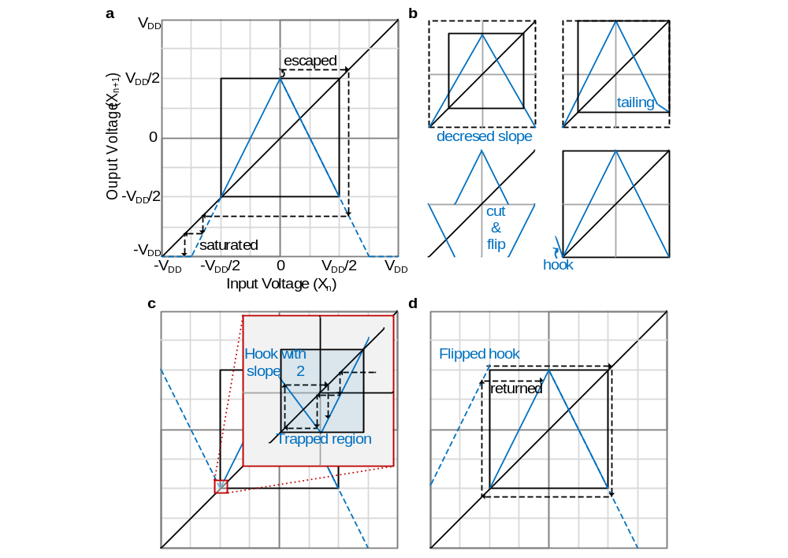Supplementary Fig. S2| Tent map state escape issue and the solutions. a, Without compensation, the output of the tent-map chaotic oscillator may escape the map due to non-ideal implementation or noise, and fail to return back to the map. b, Four compensation methods² preventing escaping issue. Except for method using the hook, the rest of the methods will affect the statistics of the tent map. c, For the hook, non-ideal breakpoint may occur trapping issue if the slope magnitude of the hook is two or lower. Therefore, using the identical slope of two used for the tent-map is prohibited for the slope of the hook, which makes the expensive implementation. d, Flipped hook, proposed by this work, can be implemented with identical slope of the tent map. Even with non-ideal breakpoint, the state returns back to the tent map.
a |  | b |  | c |  | d
 | Tent map  $$R=0.9$$  $$X_{n+1}=$$  $$\left\{\begin{aligned}+SX_{n}+R,(X_{n}<0) \\ -SX_{n}+R, (0≤X_{n})\end{aligned}\right.$$ |  | Bernoulli map  $$R=0.9$$  $$X_{n+1}=$$  $$\left\{\begin{aligned}+SX_{n}+R,(X_{n}<0) \\ +SX_{n}-R, (0≤X_{n})\end{aligned}\right.$$ |  | Bernoulli-shift map  $$R=0.9$$  $$X_{n+1}=$$  $$\left\{\begin{aligned}+SX_{n}+2R, \left(X_{n}<R/2\right) \\ +SX_{n},\left(-R/2≤X_{n}<R/2\right) \\ +SX_{n}-2R, \left(R/2≤X_{n}\right) \end{aligned}\right.$$ |  | Zig-zag map  $$R=0.9$$  $$X_{n+1}=$$  $$\left\{\begin{aligned}+SX_{n}+2R, \left(X_{n}<R/2\right) \\ -SX_{n},\left(-R/2≤X_{n}<R/2\right) \\ +SX_{n}-2R, \left(R/2≤X_{n}\right) \end{aligned}\right.$$
e |  | f |  | g |  | h
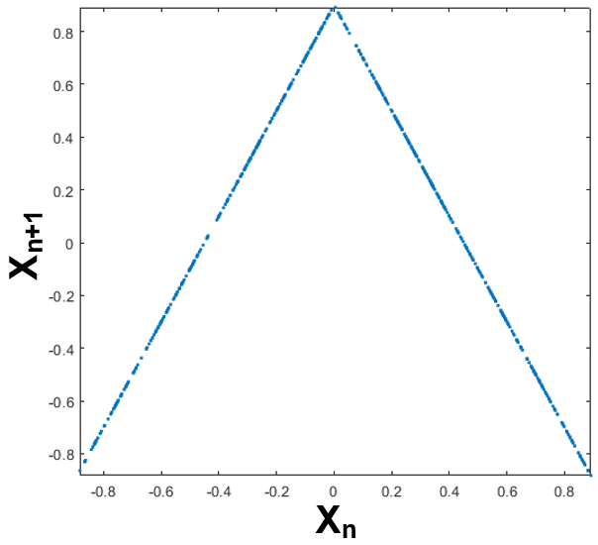 |  | 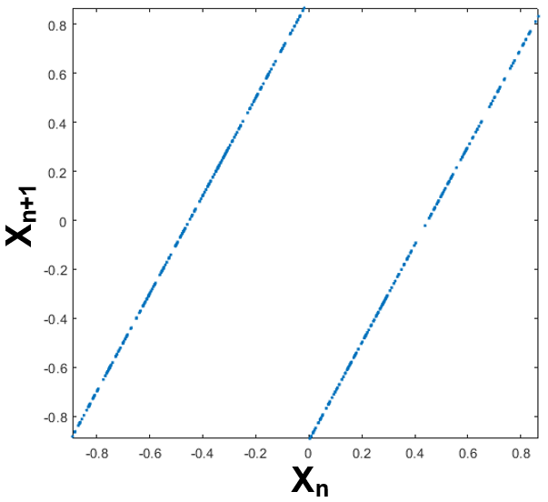 |  | 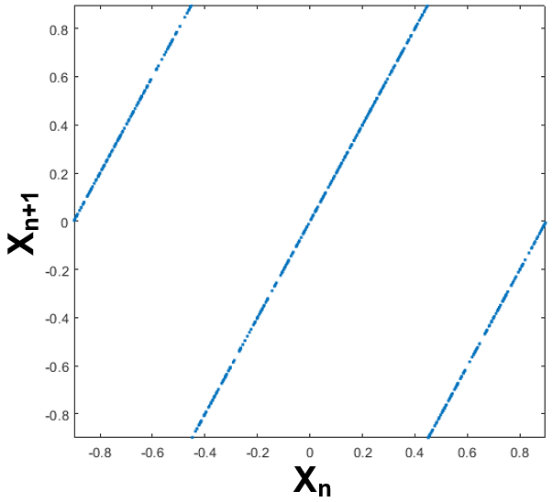 |  | 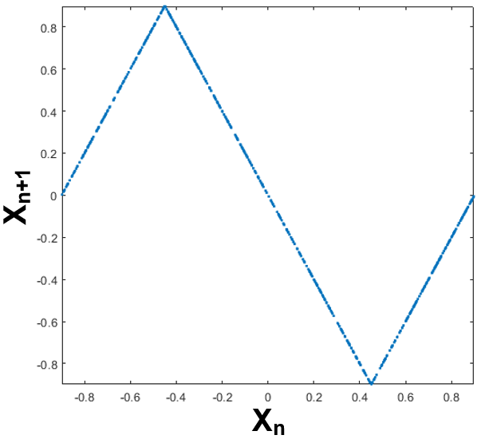
Supplementary Fig. S1| The attractors of one-dimensional linear PWAM. a-d, Functions for four well-known one-dimensional linear PWAM chaos maps with slope parameter, “S”. e-h, Attractors of each map, simulated by the functions of a-d, with S value of 1.99999. Thanks to ref.¹, chaos map properties, such as attractor, histogram, PSD, and etc., can be easily simulated.
Correlation-free large-scale probabilistic computing with true-random chaotic oscillator p-bit
Woojin Lee^{e1}, Hyunjin Kim, Hyundo Jung, Yohan Choi, Jinwoo Jeon, and Chulwoo Kim^{e2}
Korea University, Seoul, Korea
e1: woojin1514@korea.ac.kr, e2: ckim@korea.ac.kr
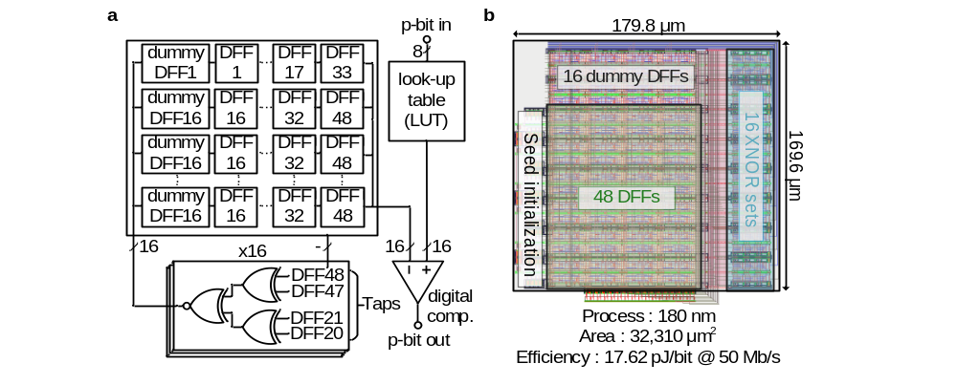
Supplementary Fig. S4| Top block diagram and the layout of the 48-bit LFSR. a, Simplified schematic of 48-bit LFSR. Sixteen dummy D flip flops (DFFs) are needed to update 16 bits in a single clock cycle. b, Tightly designed layout of 48-bit LFSR on a 180 nm CMOS process. The post-layout simulation results of energy efficiency and area consumption are shown at the bottom of the figure.
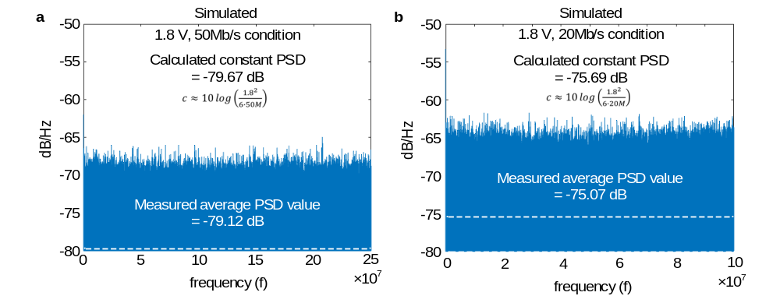Supplementary Fig. S3| Simulated PSD result of the chaotic oscillator output. a, 1.8 V supply voltage and 50 Mb/s bitrate condition. The calculated flat PSD value is -79.67 dB, while the measured result is -79.12 dB. b, 1.8 V supply voltage and 20 Mb/s bitrate condition. The calculated flat PSD value is -75.69 dB, while the measured result is -75.07 dB. Both results are measured with 1,000,000 consecutive samples of chaotic oscillator output.
References
- Cristea, B. (2019) demo_chaos [Source code]. https://github.com/cristeab/demo_chaos
- Kennedy, M., Rovatti, R., & Setti, G. Chaotic Electronics in Telecommunications (CRC Press, 2000).

