Supplementary Information

Supplementary Figures

Figure S1. The spatial transcriptome clustering and imputation of the DenoiseST model.
Figure S2. Identifying functionally highly variable genes of the DenoiseST model.
Figure S3. Clustering performance comparison of our proposed DenoiseST and other state-of-the-art methods (BayesSpace, SpaGCN, DeepST, STAGATE, and GraphST) on the 12 slices of the DLPFC dataset.
Figure S4. DenoiseST estimates the number of clusters on 12 benchmark spatial transcriptomic datasets.
Figure S5. The deviation distributions of gene expression levels for 12 datasets.
Figure S6. The ARI score of the clustering results is calculated based on the count of distinct features and the number of neighbors in the linear denoising model's 12 datasets, where the number of neighbors is divided by the radius.
Figure S7. The ARI score of the clustering results is calculated based on the count of distinct features and the number of neighbors in the nonlinear denoising model's 12 datasets.
Figure S8. Comparisons of ARI scores for different feature sets. On 12 datasets, the ARI scores were calculated for six feature sets individually, and the weight consensus clustering results were based on the combination of six feature sets.
Figure S9. Visualization of the original metric matrix and the Consensus metric matrix of the top 5,000 features in the linear denoising model in the nonlinear denoising model on 12 datasets.
Figure S10. The original feature UMAP (Uniform Manifold Approximation and Projection) map of the top 5,000 features in the nonlinear denoising model and the denoised UMAP in the nonlinear denoising model on 12 datasets.
Figure S11. Functionally variable genes analysis.
Figure S12. The GO enrichment analysis of FVGs.
Figure S13. Clustering visualization of 151673 slice, anterior mouse brain, and posterior brain data by estimating the number of clusters.
Figure S14. Gene expression patterns for 20 FVGs that were detected by DenoiseST in the human dorsolateral prefrontal cortex 10x Visium dataset.
Figure S15. Gene expression patterns for 20 FVGs that were detected by DenoiseST in the posterior brain data.
Figure S16. Gene expression patterns for 20 FVGs that were detected by DenoiseST in the anterior mouse brain.
Figure S17. Compare the functionally variable genes identified by DenoiseST with the spatial variable genes identified by four other algorithms (SPARK, SpatialDE, Trendseek, and nnSVG).
Figure S18. Enrichment analysis of the top 500 gold standard genes for FVGs and SVGs.
Figure S19. High-resolution spatial transcriptomic data.
Figure S20. DenoiseST improves the identification of known tissue structures in high-resolution spatial transcriptomic data.
Figure S21. Visualization of domain30 two-dimensional scatter plot clustering results and visualization of immune-related genes in cluster 7 and other regions for breast cancer slice 2.
Figure S22. Breast cancer spatial transcriptome data slice 2 related analysis.

Supplementary Tables

Table S1. 18 Datasets used for validations.
Table S2. Technical summary information of several clustering methods compared in this study.
Table S3. DenoiseST on different percentages of artificial dropout noise.
Table S4. GraphST on different percentages of artificial dropout noise.
Table S5. STAGATE on different percentages of artificial dropout noise.
Table S6. DeepST on different percentages of artificial dropout noise.
Table S7. SpaGCN on different percentages of artificial dropout noise.
Table S8. BayesSpace on different percentages of artificial dropout noise.

Supplementary Notes

Note S1. Data Description
Note S2. Supplementary clarification on functionally variable gene

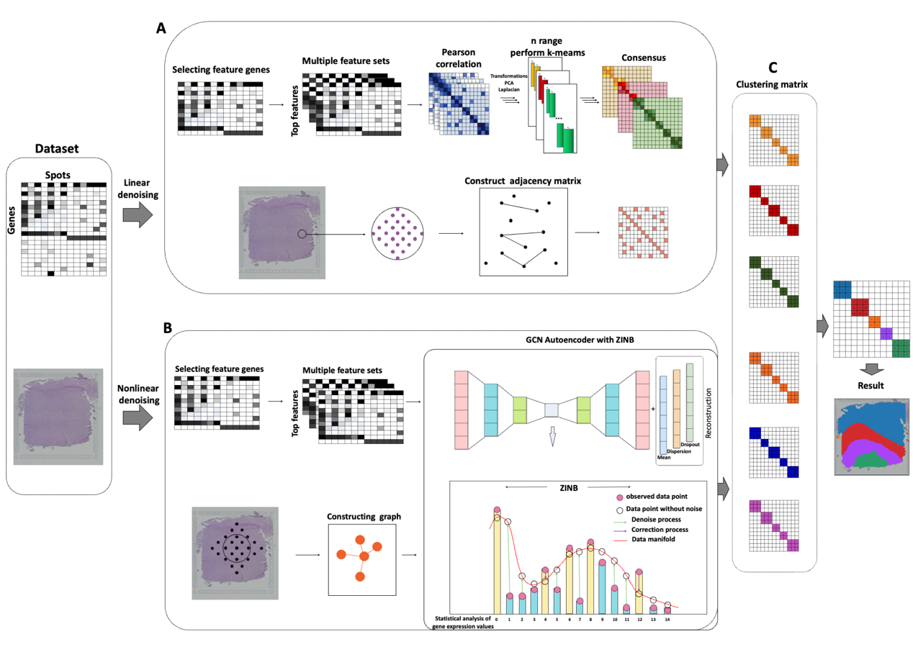
Figure S1. The spatial transcriptome clustering and imputation of the DenoiseST model. (A) Constructing a linear denoising model. (B) Constructing a nonlinear denoising model. (C) Constructing weight consensus clustering matrix.

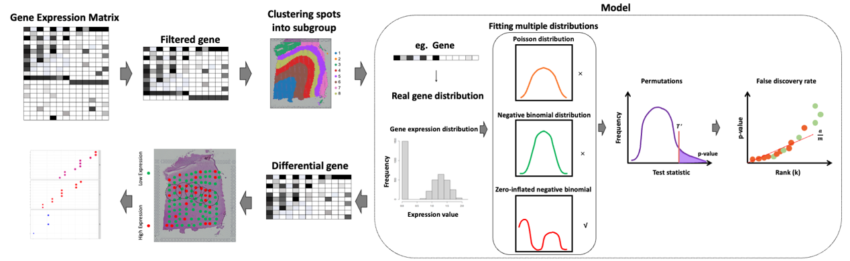
Figure S2. Identifying functionally highly variable genes of the DenoiseST model. Based on the final clustering results, fitting the data to three common distributions was performed, and the optimal fitting distribution under two experimental conditions was calculated. Permutation tests were conducted to calculate p-values to obtain confidence in the Bhattacharyya distance scores. The purpose of these analyses is to identify differential genes. Finally, functionally variable genes were filtered based on spatial location information, and enrichment analysis was conducted.

A
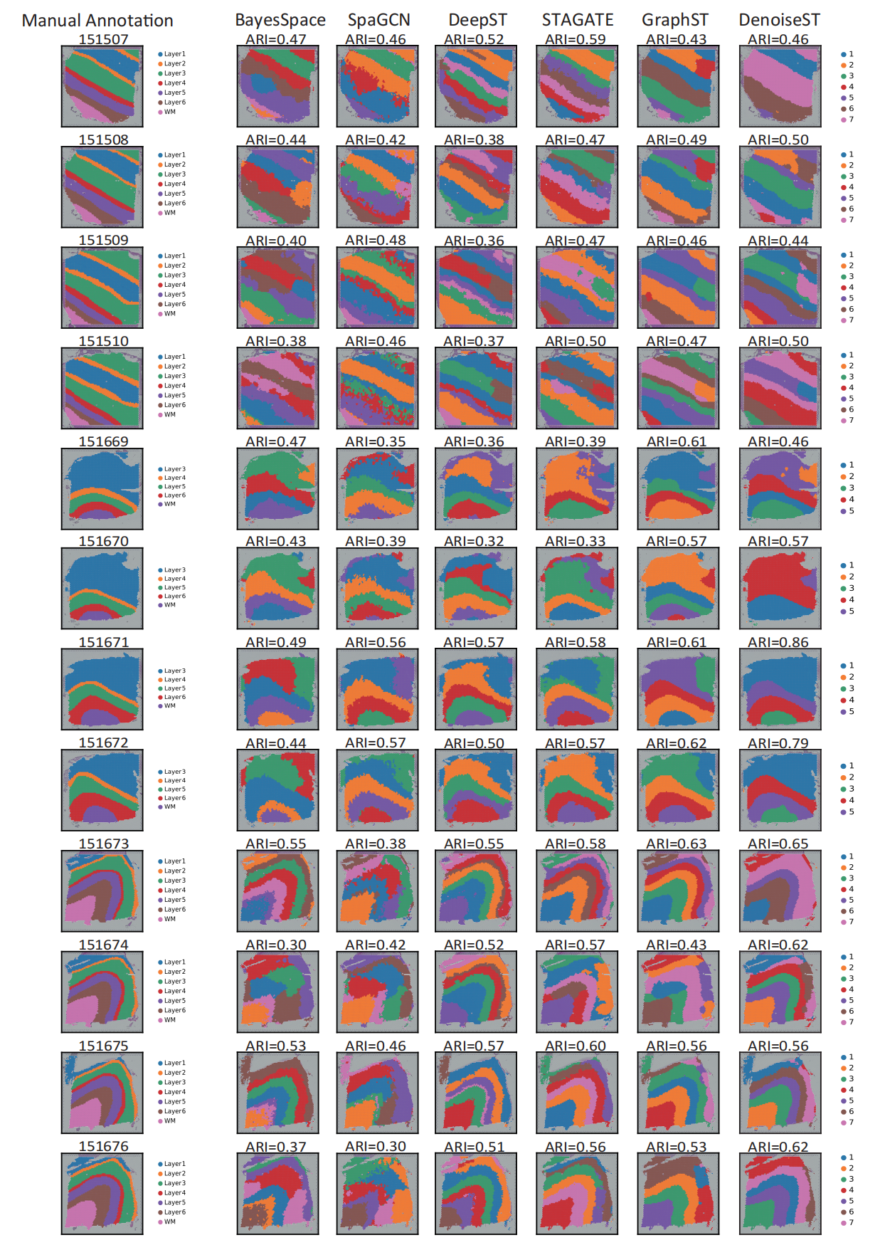
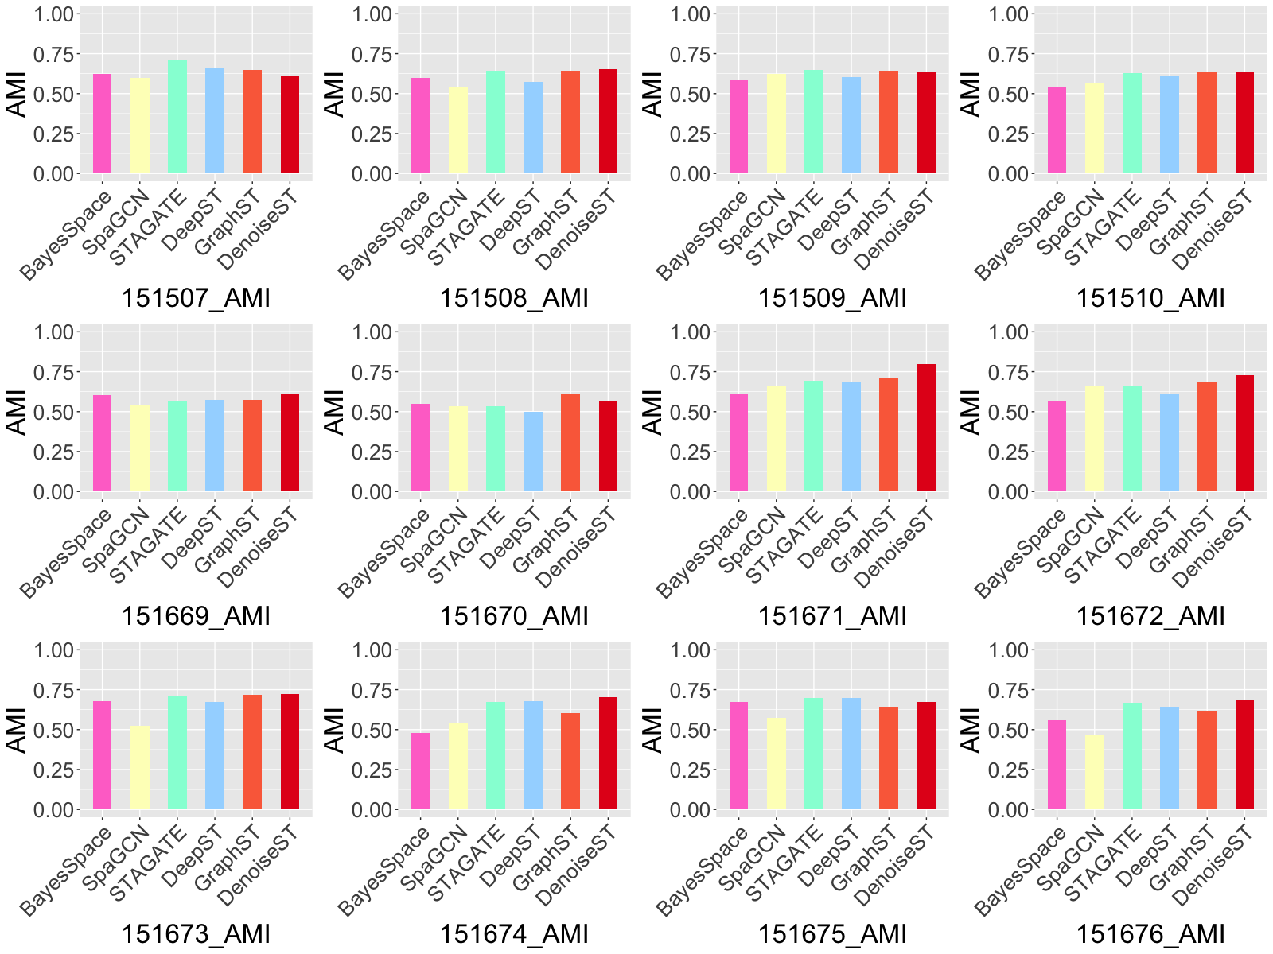
C
B
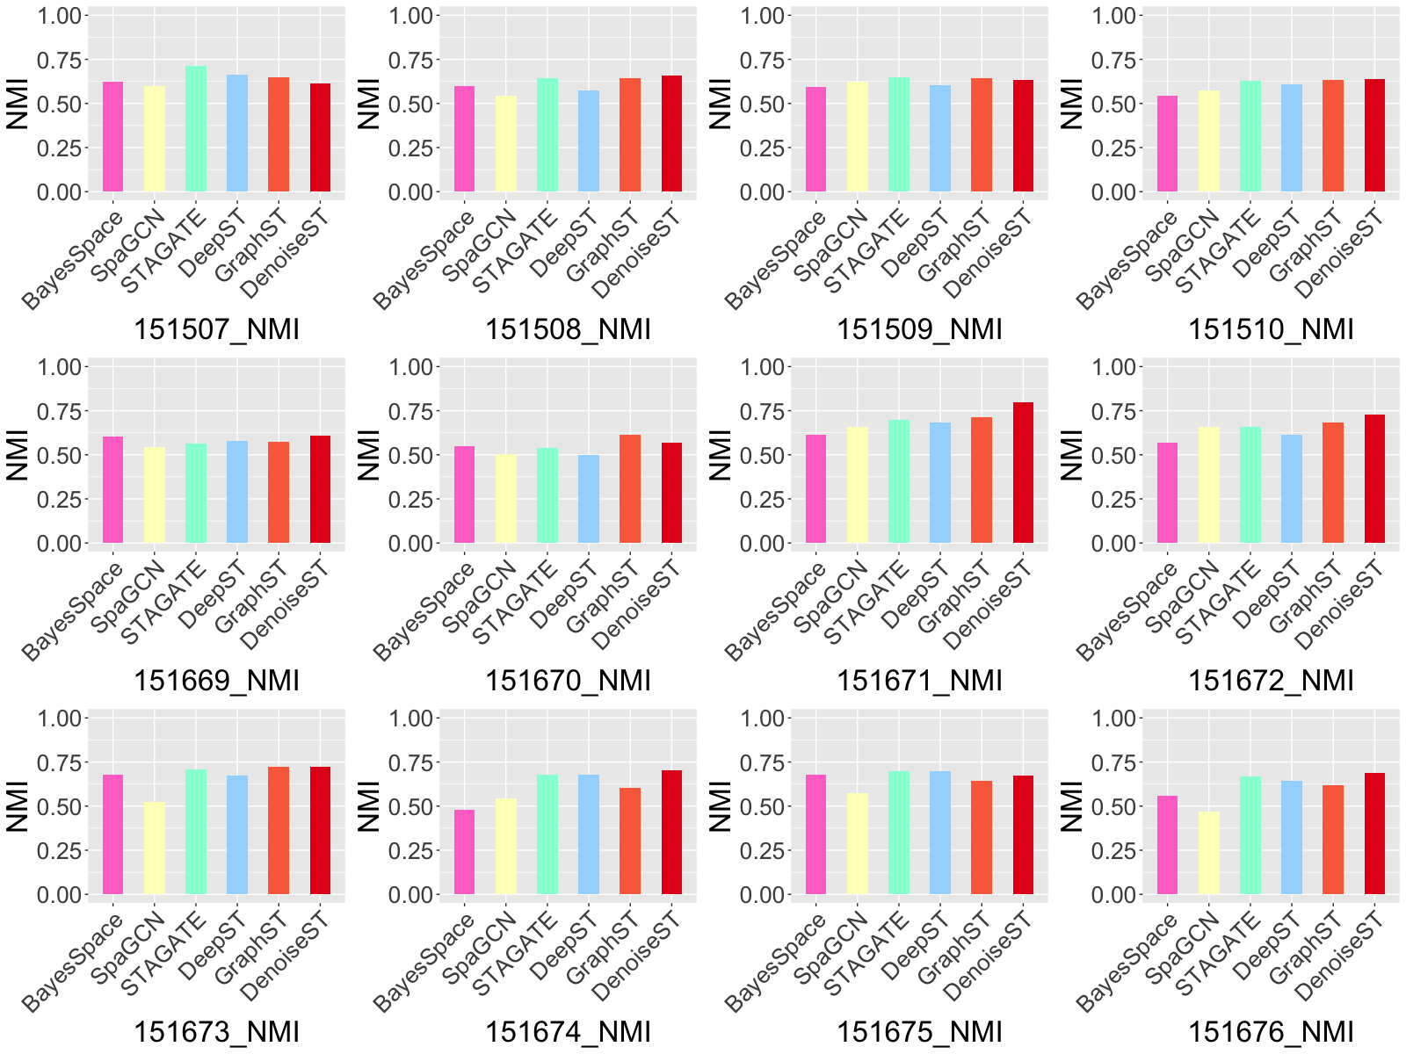
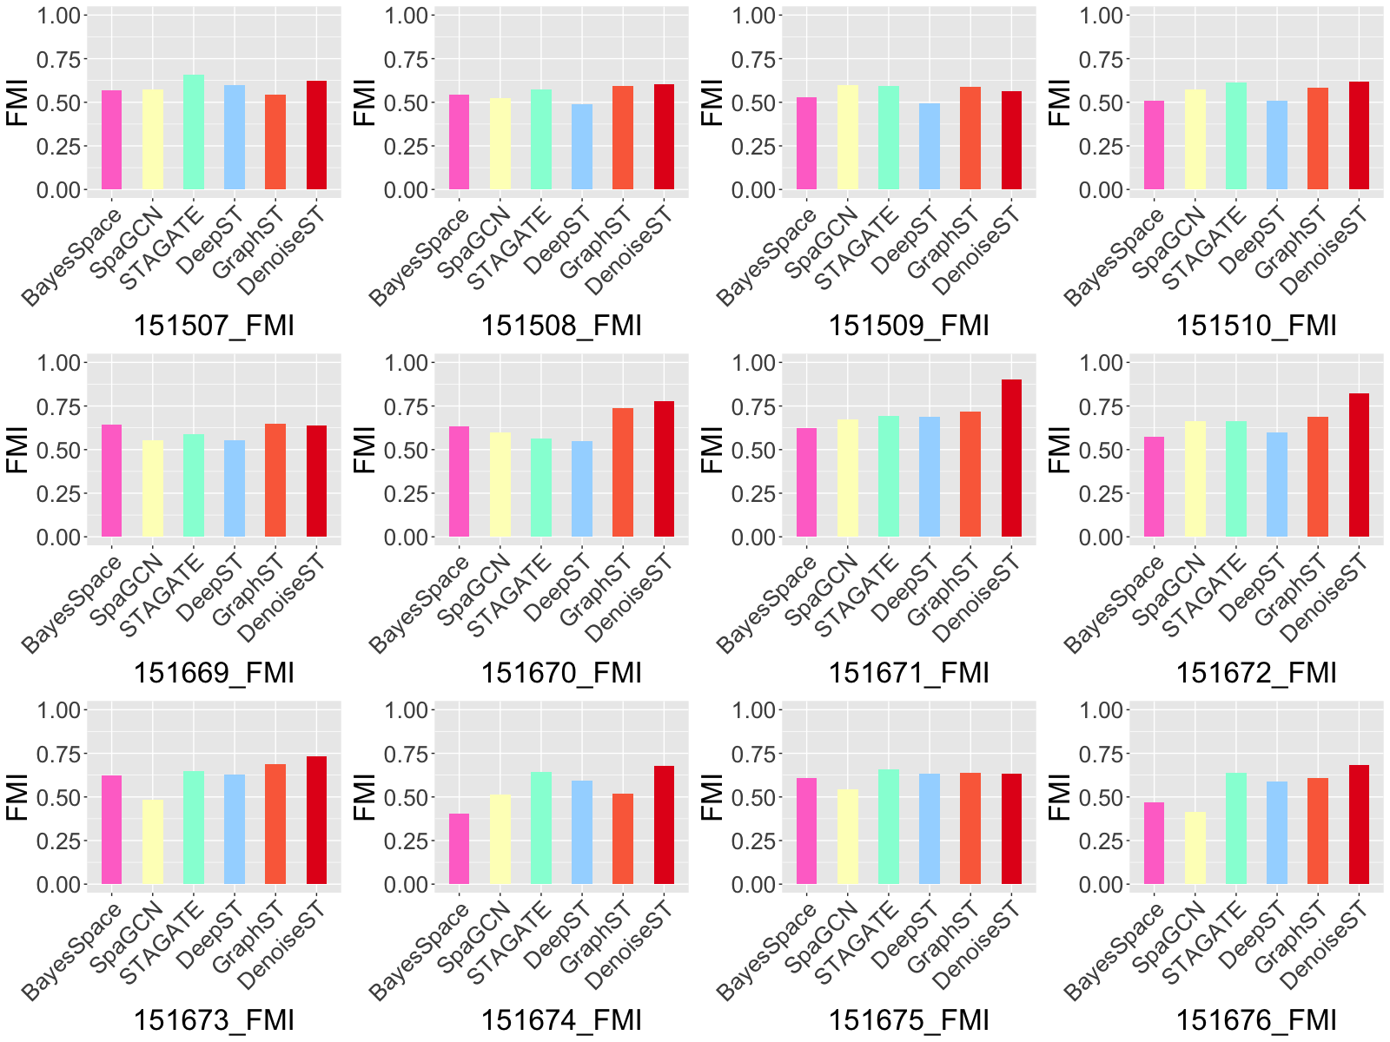
E
D
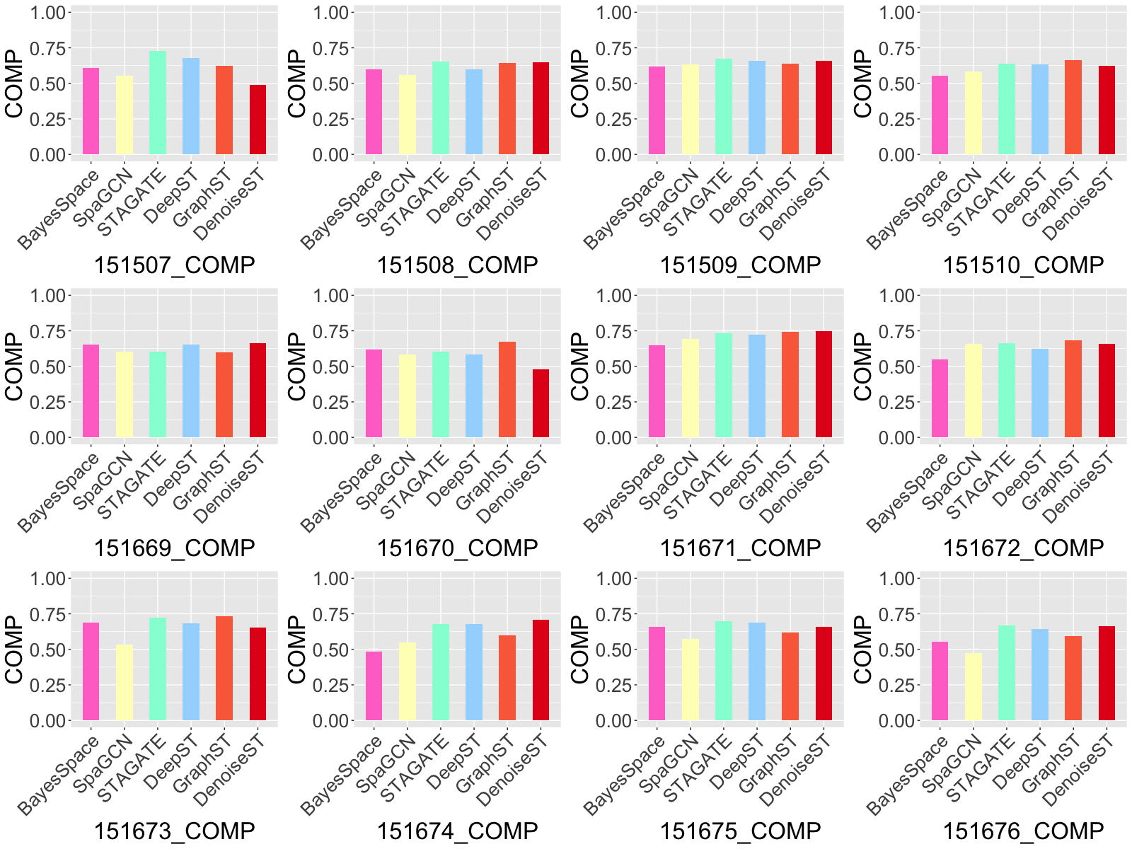
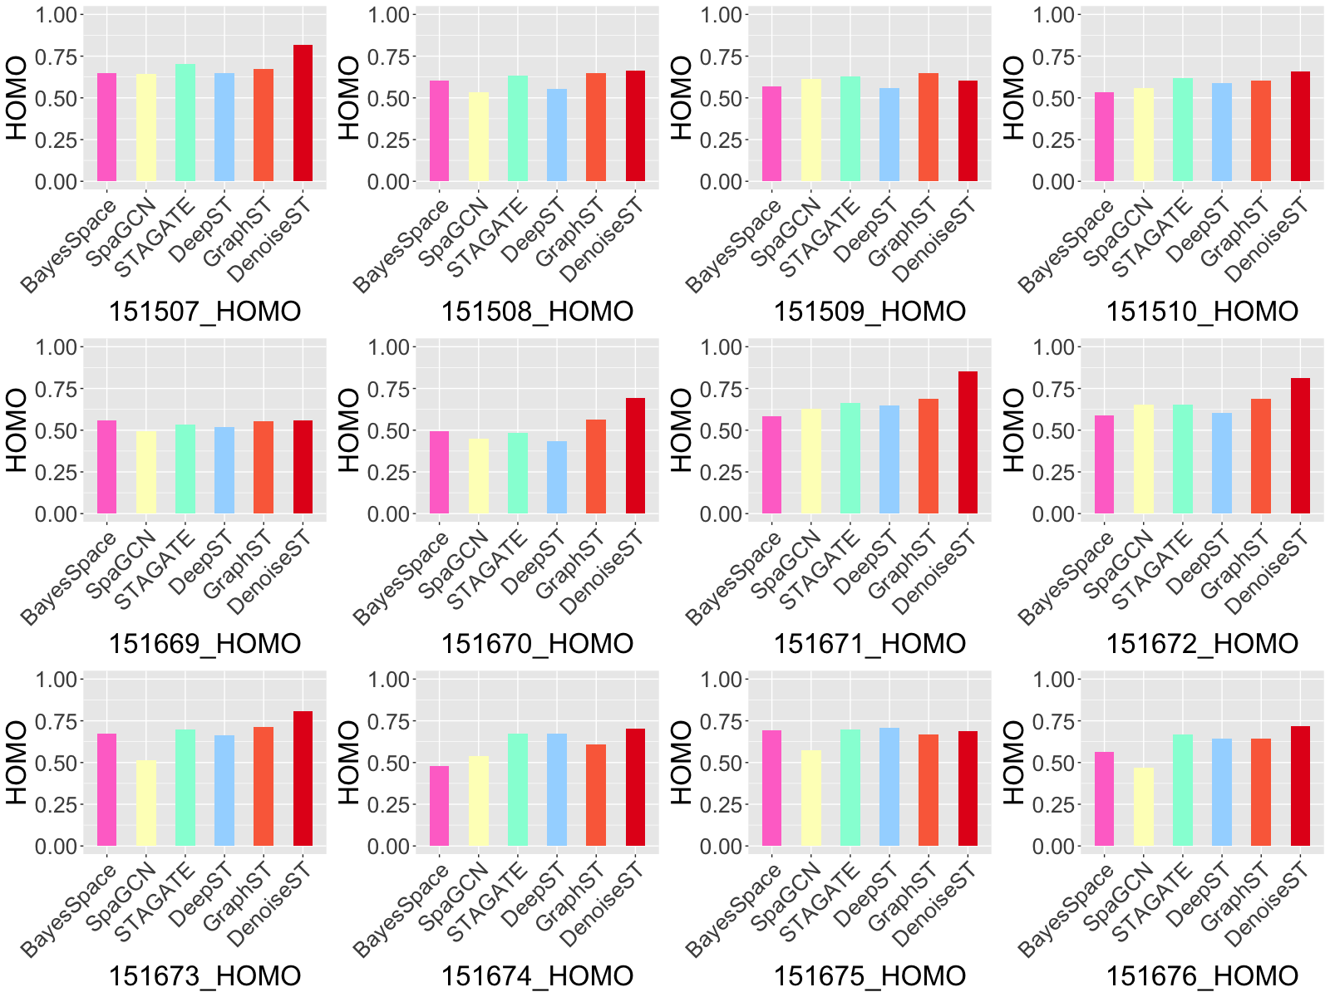
F
Figure S3. (A) Clustering performance comparison of our proposed DenoiseST and other state-of-the-art methods (BayesSpace, SpaGCN, DeepST, STAGATE, and GraphST) on the 12 slices of the DLPFC dataset. (B) Compare clustering performance based on the adjusted mutual information. (C) Compare clustering performance based on the normalized mutual information. (D) Compare clustering performance based on the Fowlkes-Mallows index. (E) Compare clustering performance based on the completeness. (F) Compare clustering performance based on the homogeneity.

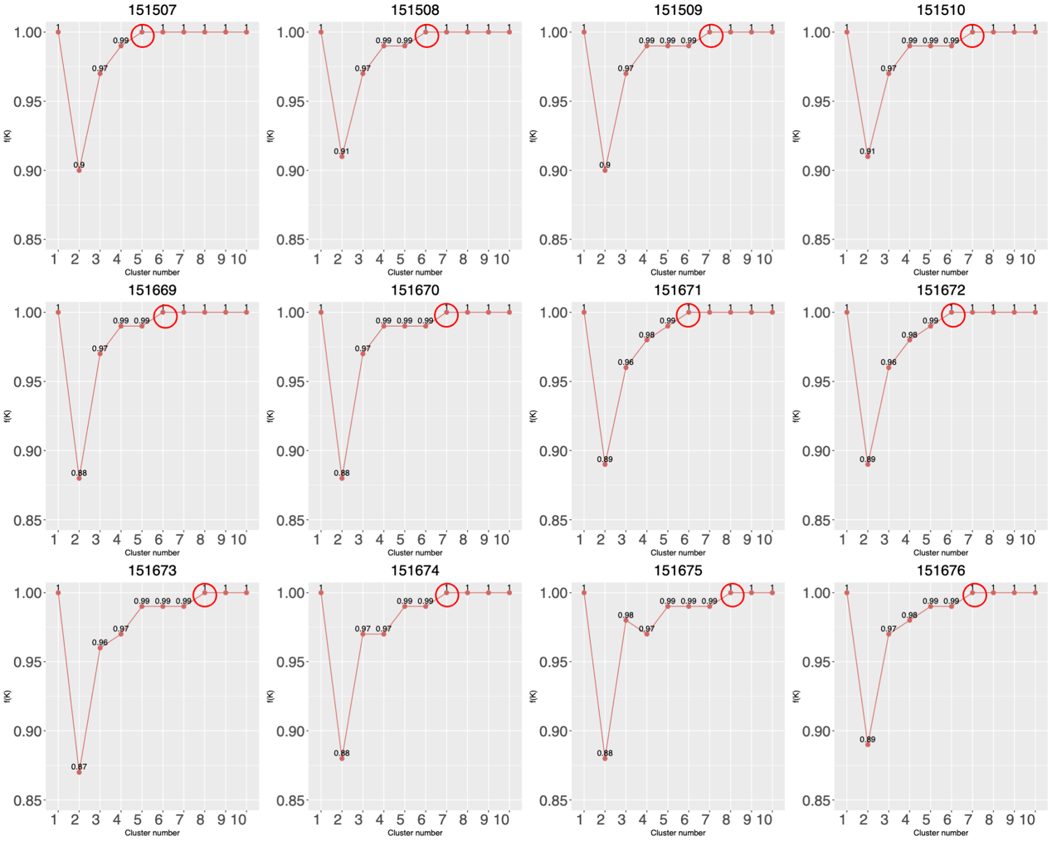
Figure S4. DenoiseST estimates the number of clusters on 12 benchmark spatial transcriptomic datasets. Utilizing the ClusterR package, we employed the ‘Optimal_Clusters_KMeans’ function on the top 5000 selected features, allowing for the automatic estimation of the number of clusters. Subsequently, we selected the fixed threshold (f(K)) that second reaches a value of 1 for the determined number of k.

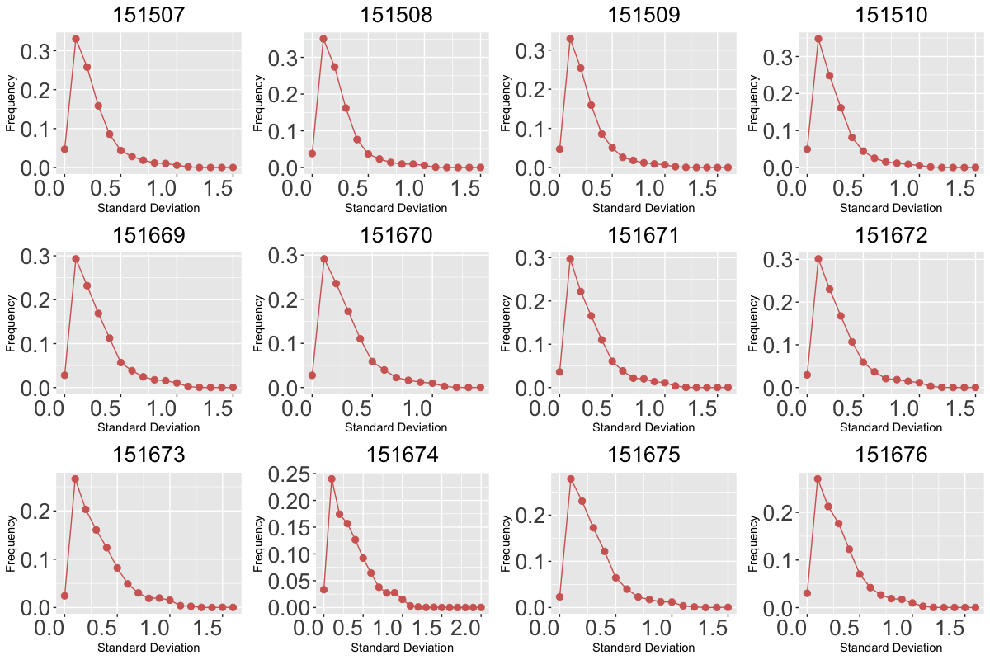
Figure S5. The deviation distributions of gene expression levels for 12 datasets.
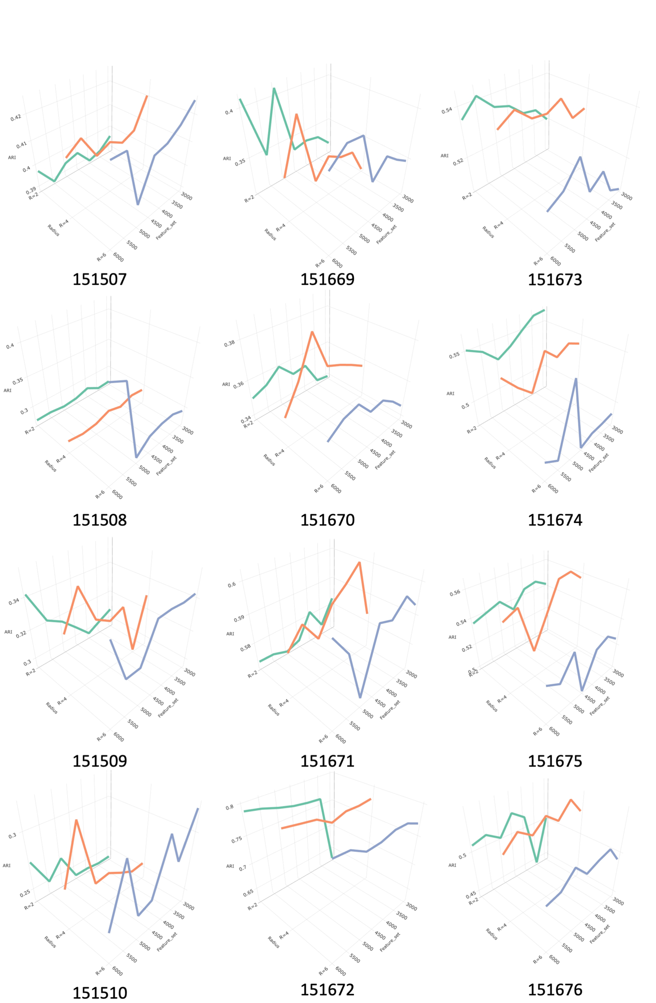
Figure S6. The ARI score of the clustering results is calculated based on the count of distinct features and the number of neighbors in the linear denoising model’s 12 datasets, where the number of neighbors is divided by the radius.
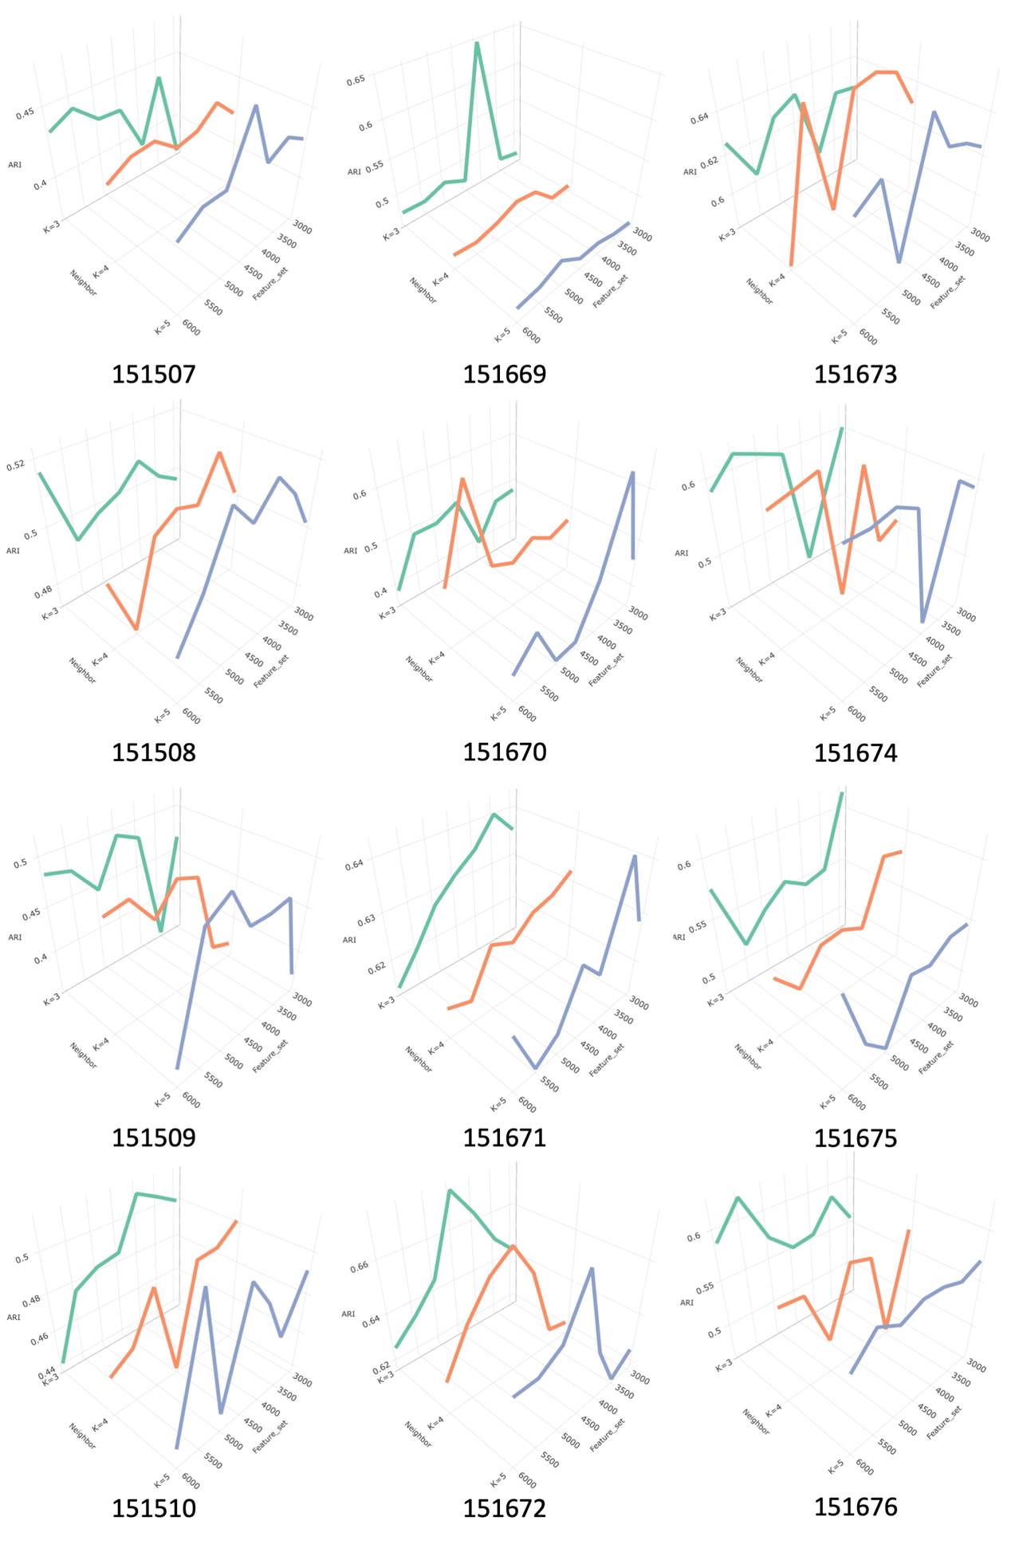

Figure S7. The ARI score of the clustering results is calculated based on the count of distinct features and the number of neighbors in the nonlinear denoising model’s 12 datasets.
Figure S8. Comparisons of ARI scores for different feature sets. On 12 datasets, the ARI scores were calculated for six feature sets individually, and the weight consensus clustering results were based on the combination of six feature sets.

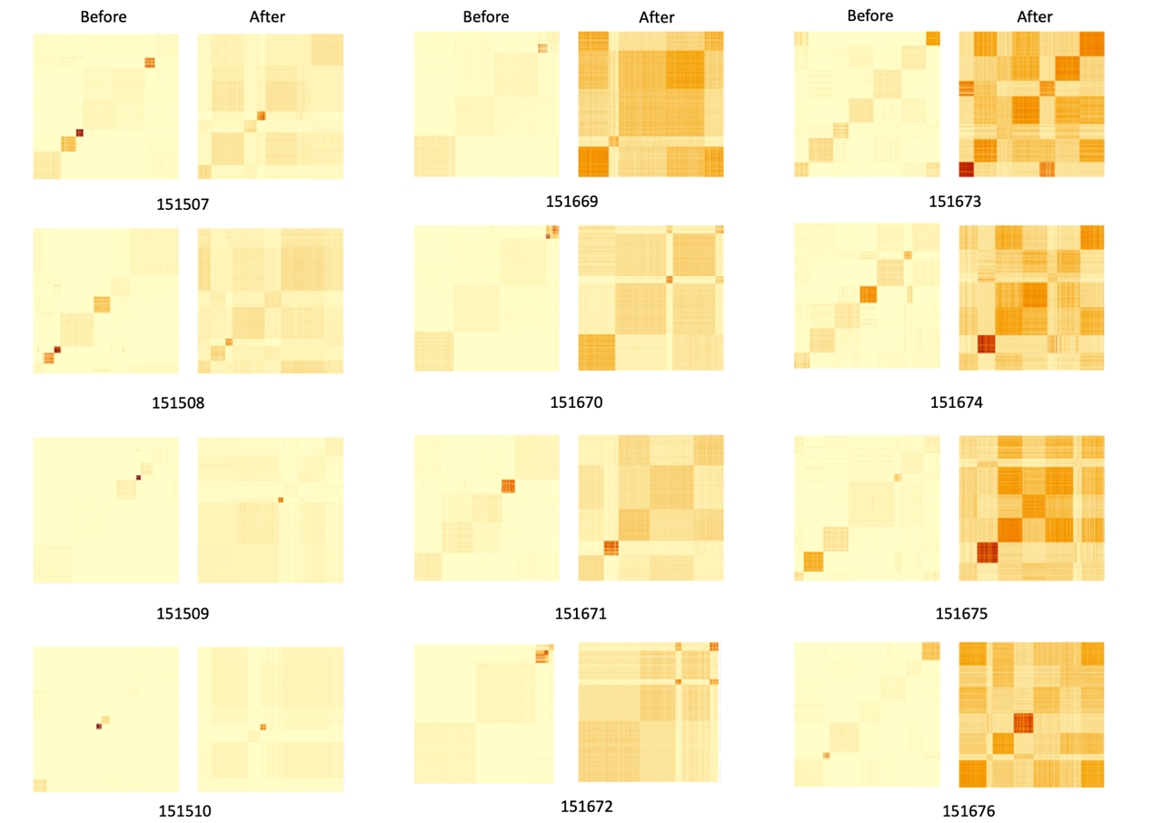

Figure S9. Visualization of the original metric matrix and the Consensus metric matrix of the top 5,000 features in the linear denoising model in the nonlinear denoising model on 12 datasets.

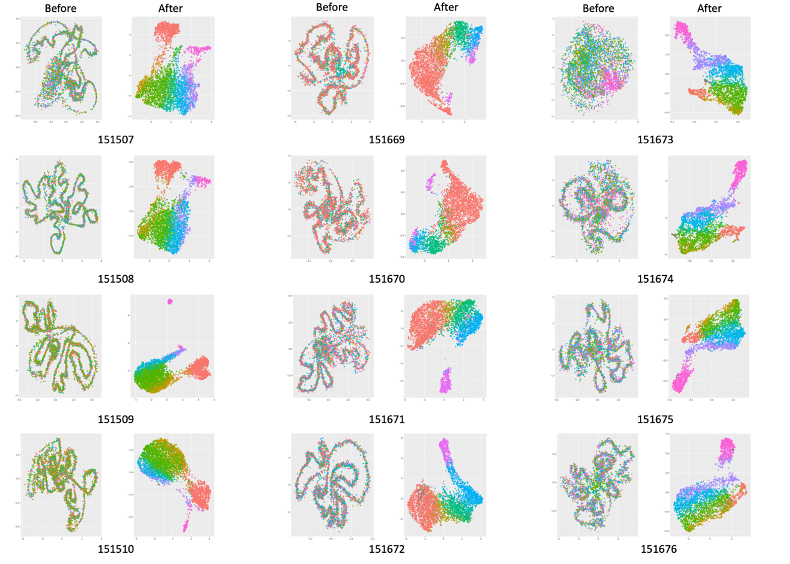
Figure S10. The original feature UMAP (Uniform Manifold Approximation and Projection) map of the top 5,000 features in the nonlinear denoising model and the denoised UMAP in the nonlinear denoising model on 12 datasets.

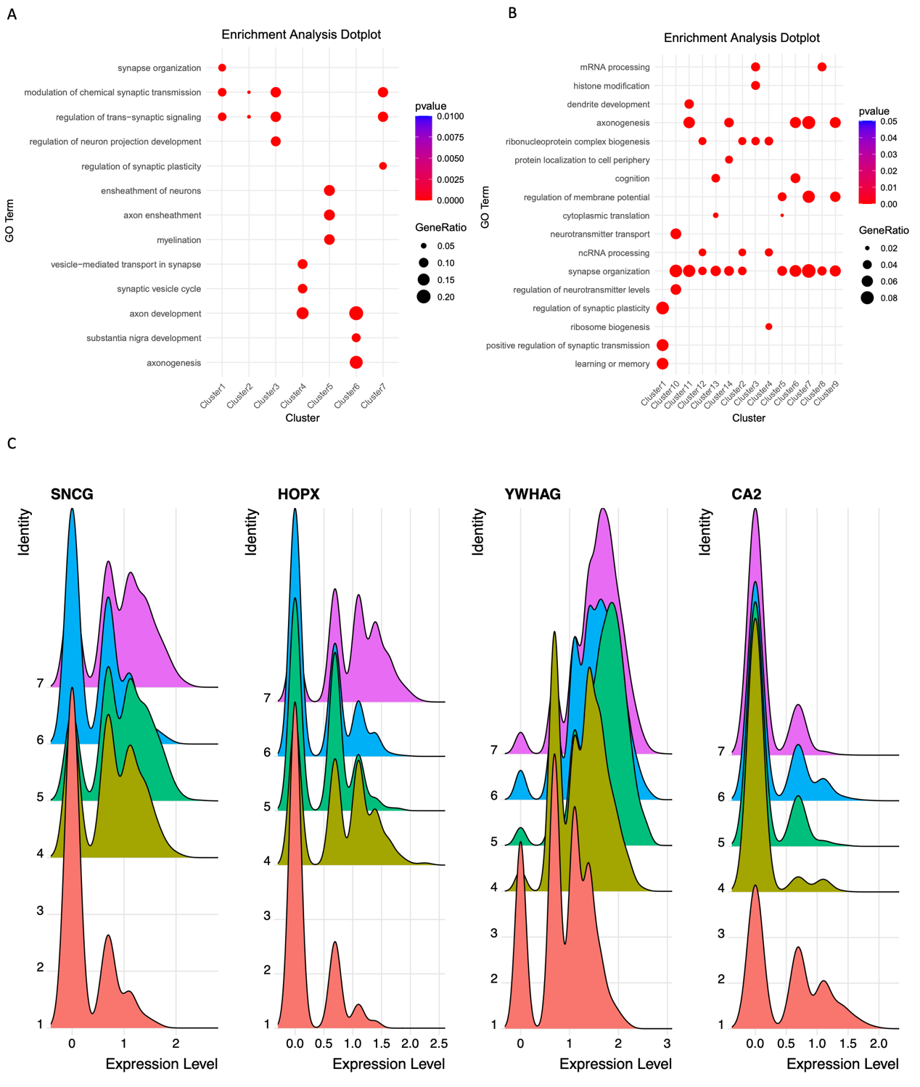
Figure S11. Functionally variable genes analysis. (A) Enrichment analysis dot plot in human dorsolateral prefrontal cortex 10x Visium dataset. (B) Enrichment analysis dot plot in mouse posterior brain slice. (C) Visualized the expression distribution of the SNCG, HOPX, YWHAG, and CA2 genes in each cluster on the 151673 slice.

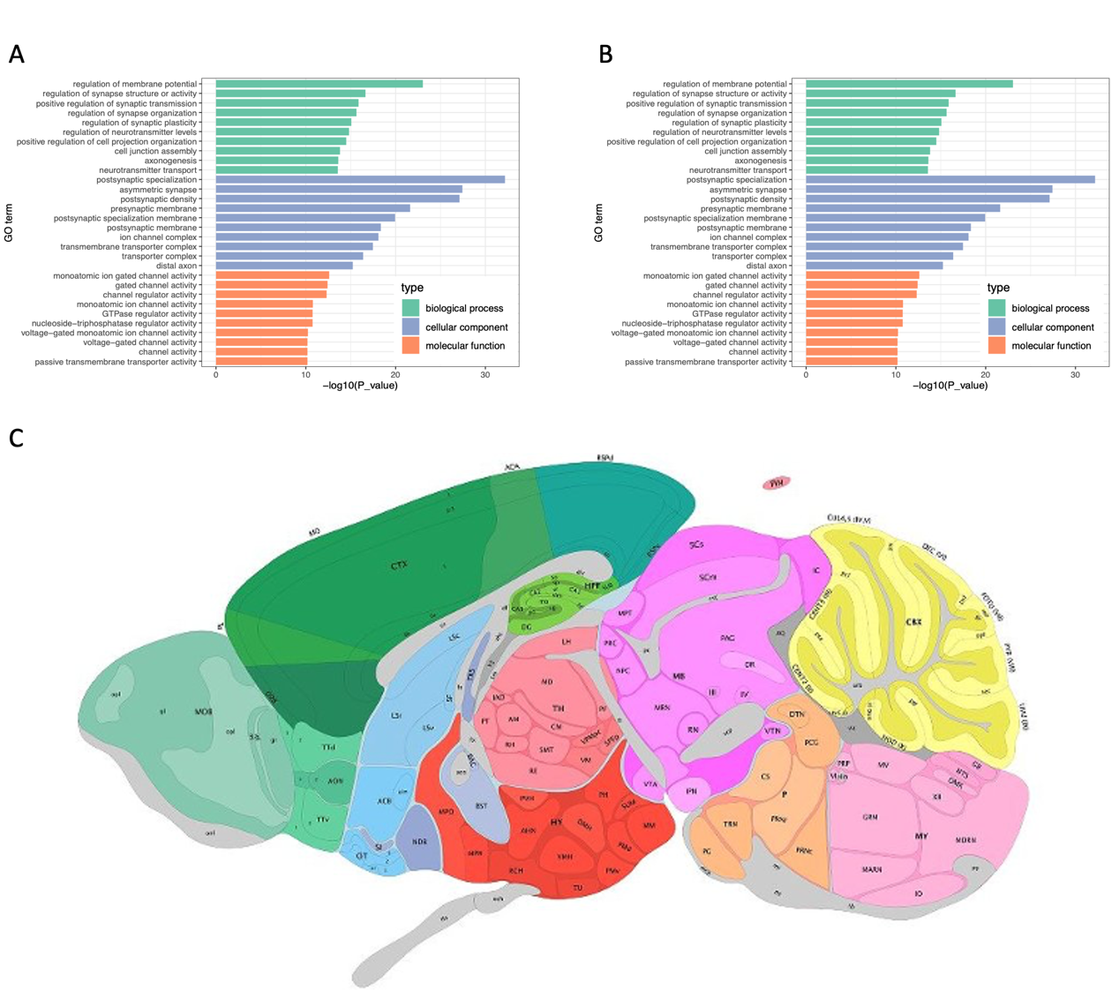
Figure S12. The GO enrichment analysis of FVGs. (A) GO enrichment analysis in human dorsolateral prefrontal cortex 10x Visium dataset and the annotated brain slice image. (B) GO enrichment analysis in mouse posterior brain slice. (C) The annotated brain slice image from the Allen Mouse Brain Atlas.

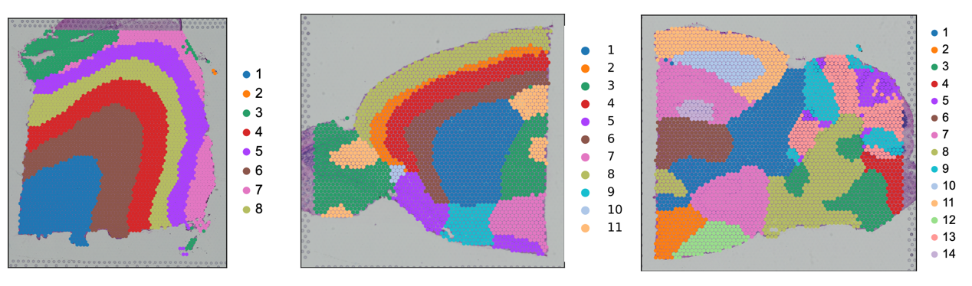
Figure S13. Clustering visualization of 151673 slice, anterior mouse brain, and posterior brain data by estimating the number of clusters.

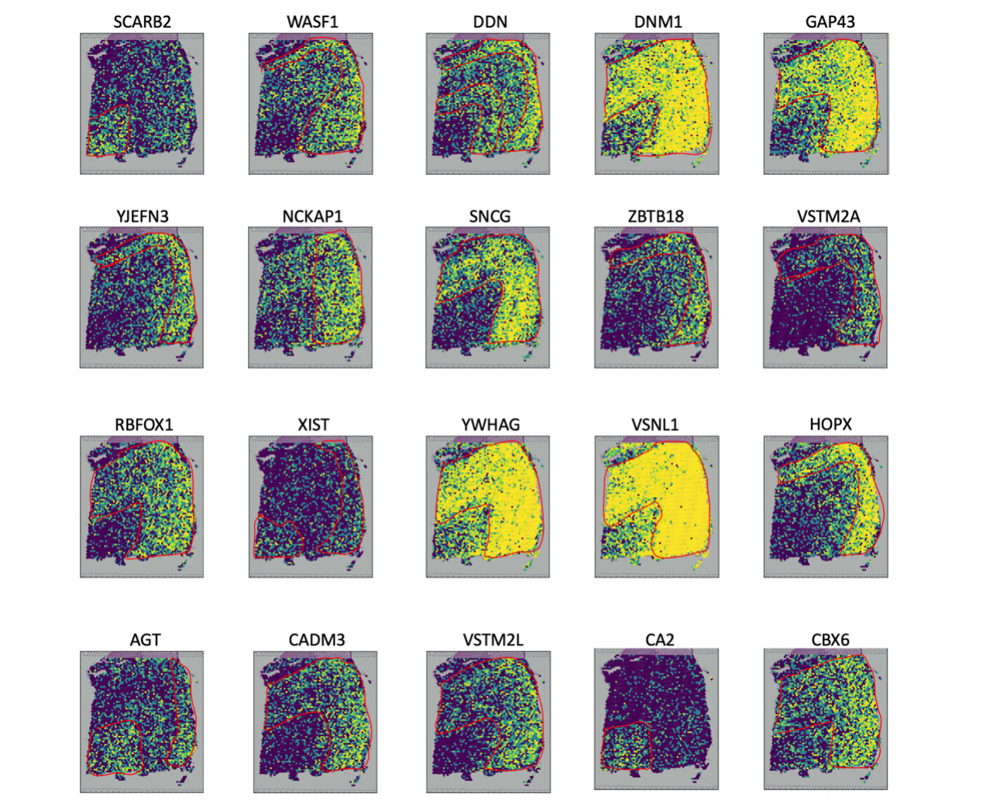
Figure S14. Gene expression patterns for 20 FVGs that were detected by DenoiseST in the human dorsolateral prefrontal cortex 10x Visium dataset.

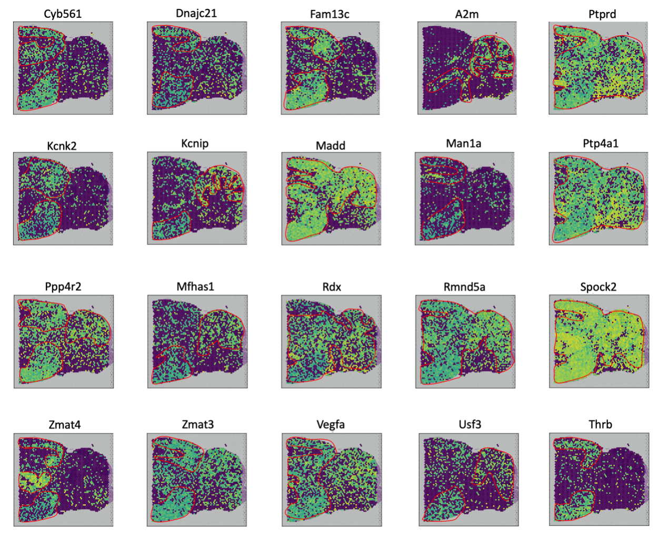
Figure S15. Gene expression patterns for 20 FVGs that were detected by DenoiseST in the posterior brain data.

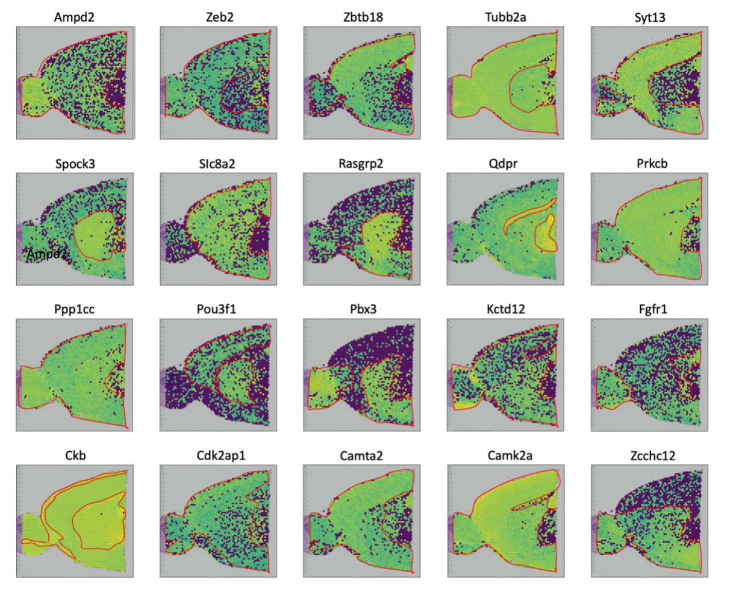
Figure S16. Gene expression patterns for 20 FVGs that were detected by DenoiseST in the anterior mouse brain.

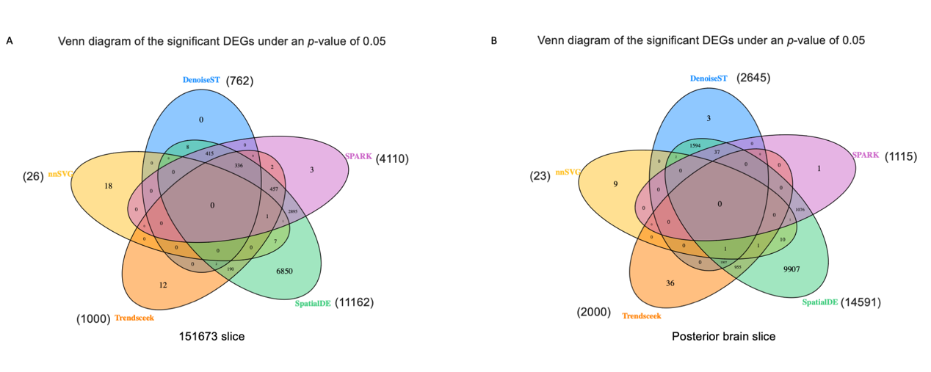
Figure S17. Compare the functionally variable genes identified by DenoiseST with the spatial variable genes identified by four other algorithms (SPARK, SpatialDE, Trendseek, and nnSVG). (A) Venn diagram of FVGs and SVGs on 151673 slice with p-values less than 0.05. (B) Venn diagram of FVGs and SVGs on posterior brain data with p-values less than 0.05.

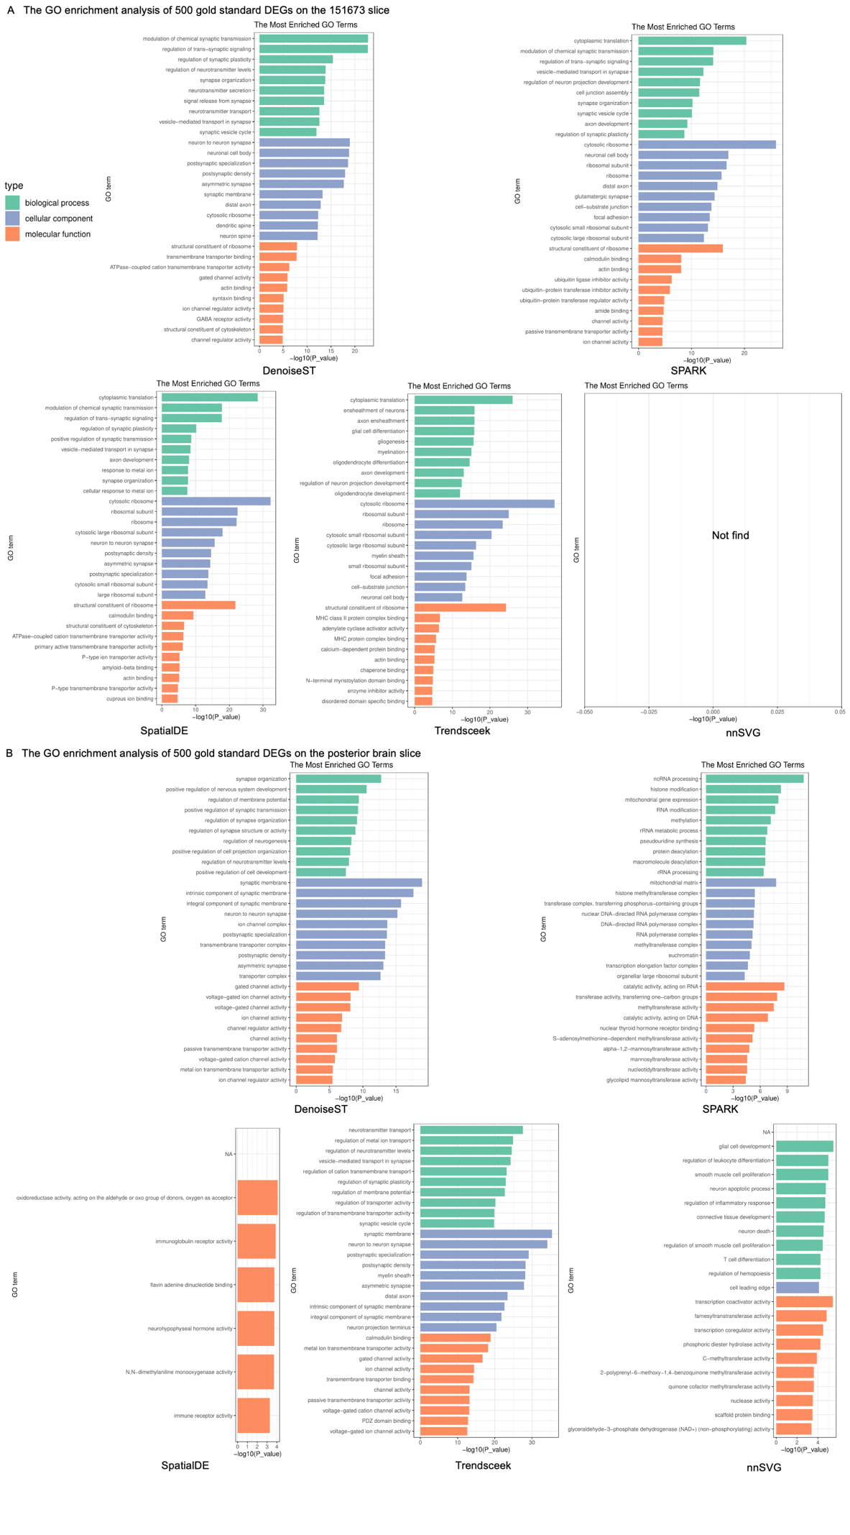
Figure S18. Enrichment analysis of the top 500 gold standard genes for FVGs and SVGs. (A) Enrichment analysis of the top 500 gold standard genes for FVGs and SVGs on 151673 slice. (B) Enrichment analysis of the top 500 gold standard genes for FVGs and SVGs on posterior brain data.

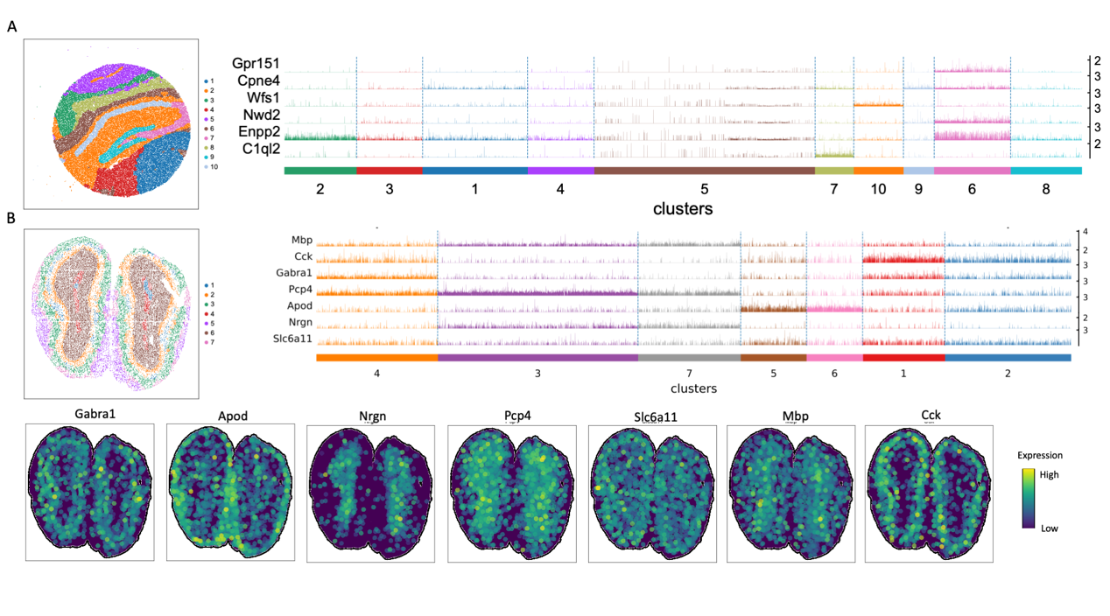
Figure S19. High-resolution spatial transcriptomic data. (A) Visualization of spatial domains identified by DenoiseST and corresponding marker gene generate heatmaps. (B) Laminar organization of mouse olfactory bulb annotated by the Allen Reference Atlas and Laminar organization of mouse olfactory bulb annotated in the DAPI-stained image generated by Stereo-seq. Spatial domains generated by DenoiseST, GraphST and STAGATE in the Stereo-seq mouse olfactory bulb tissue section.
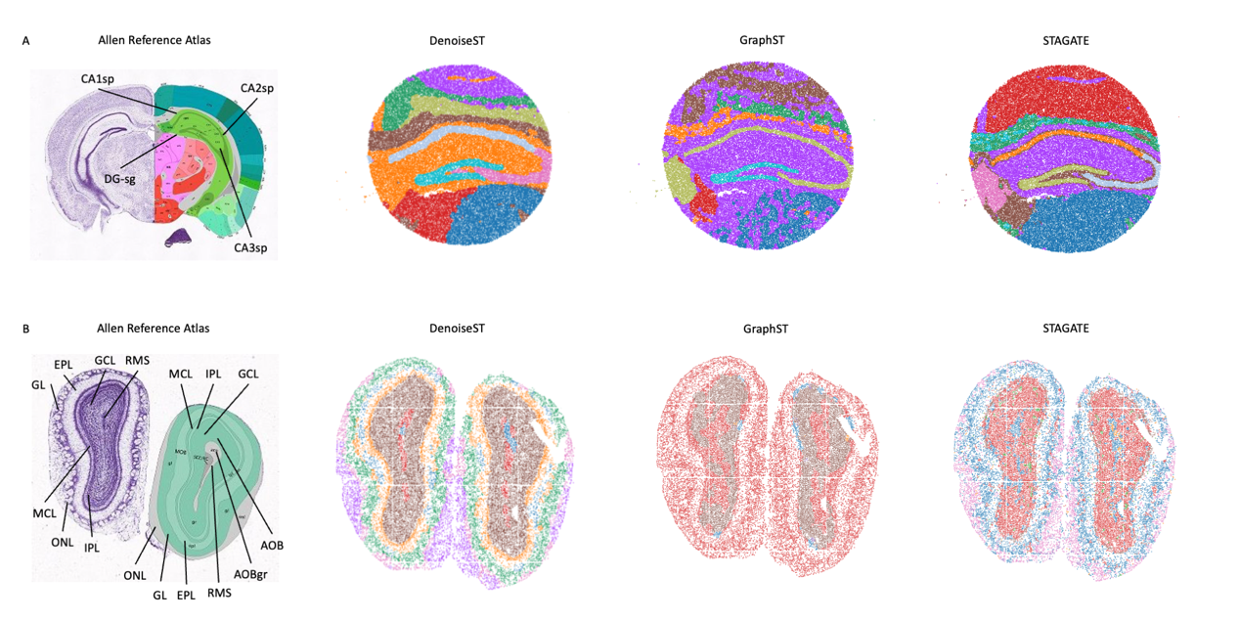
Figure S20. DenoiseST improves the identification of known tissue structures in high-resolution spatial transcriptomic data. (A) The annotation of hippocampus structures from the Allen Reference Atlas of an adult mouse brain. Spatial domains generated by DenoiseST, GraphST and STAGATE in the Slide-seqV2 hippocampus section. (B) Laminar organization of mouse olfactory bulb annotated by the Allen Reference Atlas and Laminar organization of mouse olfactory bulb annotated in the DAPI-stained image generated by Stereo-seq. Spatial domains generated by DenoiseST, GraphST and STAGATE in the Stereo-seq mouse olfactory bulb tissue section.

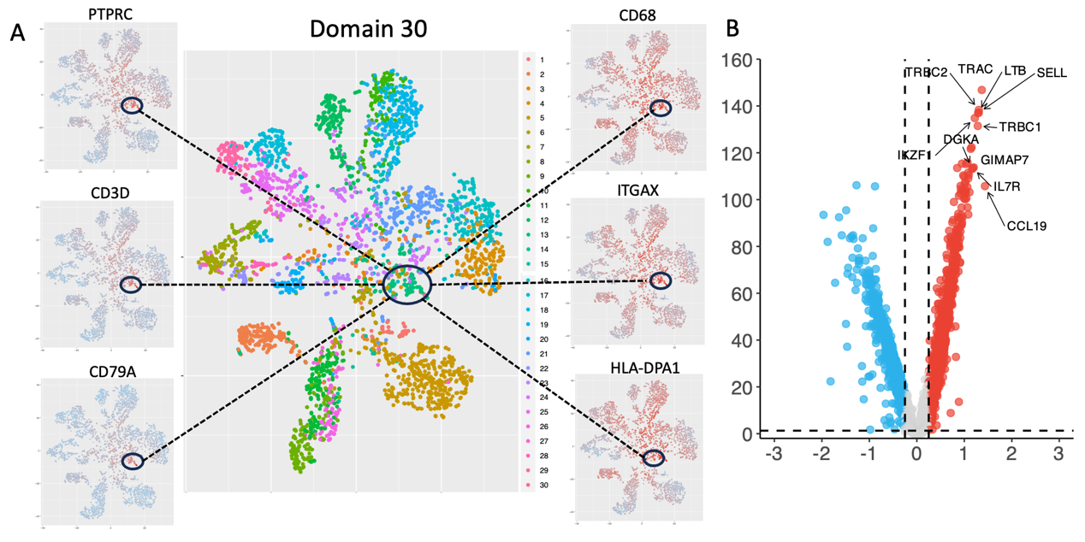
Figure S21. Visualization of domain30 two-dimensional scatter plot clustering results and visualization of immune-related genes in cluster 7 and other regions for breast cancer slice 2.
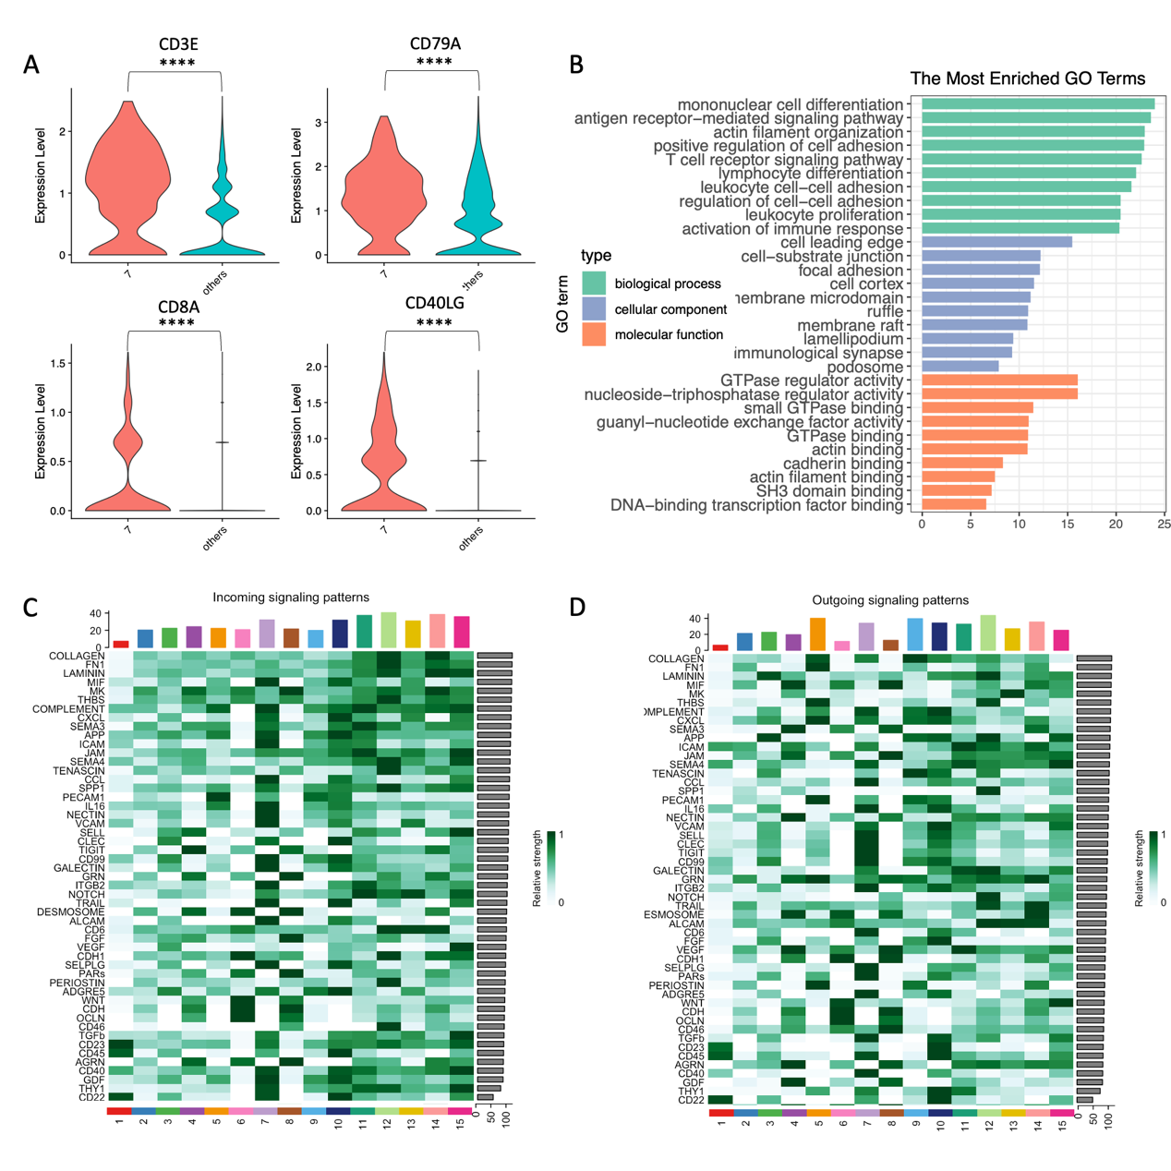
Figure S22. Breast cancer spatial transcriptome data slice 2 related analysis.

Supplementary Tables

Table S1. 18 Datasets used for validations.
Datasets | Spots | Genes | Dropout rate | Platform | Data Format
(DLPFC)151507 | 4226 | 33538 | 0.96 | Visium | h5
(DLPFC)151508 | 4384 | 33538 | 0.96 | Visium | h5
(DLPFC)151509 | 4789 | 33538 | 0.96 | Visium | h5
(DLPFC)151510 | 4634 | 33538 | 0.96 | Visium | h5
(DLPFC)151669 | 3661 | 33538 | 0.95 | Visium | h5
(DLPFC)151670 | 3498 | 33538 | 0.95 | Visium | h5
(DLPFC)151671 | 4110 | 33538 | 0.94 | Visium | h5
(DLPFC)151672 | 4015 | 33538 | 0.95 | Visium | h5
(DLPFC)151673 | 3639 | 33538 | 0.93 | Visium | h5
(DLPFC)151674 | 3673 | 33538 | 0.92 | Visium | h5
(DLPFC)151675 | 3592 | 33538 | 0.95 | Visium | h5
(DLPFC)151676 | 3460 | 33538 | 0.94 | Visium | h5
Mouse_Brain_Posterior | 3353 | 20524 | 0.78 | Visium | h5
Mouse_Brain_Anterior | 2695 | 21334 | 0.72 | Visium | h5
Human_Breast_Cancer1 | 3798 | 36601 | 0.85 | Visium | h5
Human_Breast_Cancer2 | 4169 | 17957 | 0.71 | Visium | h5
Human Colorectal Cancer | 137051 | 18085 | 0.99 | Visium HD | h5
Mouse_Olfactory | 19109 | 27106 | 0.99 | Stereo-seq | h5ad
Mouse_Hippocampus_Tissue | 53208 | 23264 | 0.98 | Slide-seq | h5ad

Table S2. Technical summary information of several clustering methods compared in this study.
Name | Language | Method | Strengths | Limitations | Download Links
DenoiseST | Python.  R | Linear denoising model;  Nonlinear denoising model; Weight consensus cluster | High accuracy, automatic estimation of cluster numbers | High complexity | https://github.com/cuiyaxuan/DenoiseST
BayesSpace | R | Bayesian statistical method | Intuitively easy to understand | Low accuracy | https://github.com/edward130603/BayesSpace
SpaGCN | Python | Graph convolutional network;  Iterative clustering | Making full use of image information | Low accuracy, does not provide a stable result | https://github.com/jianhuupenn/SpaGCN
DeepST | Python | Variational graph autoencoder network | Making full use of image information | Low accuracy, does not provide a stable result | https://github.com/JiangBioLab/DeepST
STAGATE | Python.  R | Graph-attention autoencoder network | High accuracy, automatic estimation of cluster numbers | High complexity, not scalable | https://github.com/zhanglabtools/STAGATE
GraphST | Python.  R | Graph self-supervised contrastive learning | High accuracy,  automatic estimation of cluster numbers | High complexity, not scalable | https://github.com/JinmiaoChenLab/GraphST

Table S3. DenoiseST on different percentages of artificial dropout noise.
Slice | Median | Mean | Max | Min | Standard deviation | Variance
(DLPFC)151507 | 0.4335 | 0.4281 | 0.456 | 0.392 | 0.024813101 | 0.00061569
(DLPFC)151508 | 0.496 | 0.4886 | 0.503 | 0.46 | 0.01478648 | 0.00021864
(DLPFC)151509 | 0.458 | 0.4521 | 0.46 | 0.44 | 0.008502353 | 7.229E-05
(DLPFC)151510 | 0.5005 | 0.4874 | 0.504 | 0.434 | 0.023273161 | 0.00054164
(DLPFC)151669 | 0.5135 | 0.5117 | 0.521 | 0.498 | 0.007861934 | 6.181E-05
(DLPFC)151670 | 0.464 | 0.509 | 0.665 | 0.451 | 0.078273878 | 0.0061268
(DLPFC)151671 | 0.632 | 0.6729 | 0.856 | 0.616 | 0.091337232 | 0.00834249
(DLPFC)151672 | 0.7725 | 0.7407 | 0.801 | 0.642 | 0.063345166 | 0.00401261
(DLPFC)151673 | 0.6505 | 0.63031 | 0.661 | 0.541 | 0.039184243 | 0.001535405
(DLPFC)151674 | 0.618 | 0.614 | 0.629 | 0.564 | 0.01733782 | 0.0003006
(DLPFC)151675 | 0.563 | 0.5701 | 0.592 | 0.555 | 0.013382451 | 0.00017909
(DLPFC)151676 | 0.584 | 0.5809 | 0.621 | 0.539 | 0.027153085 | 0.00073729

Table S4. GraphST on different percentages of artificial dropout noise.
Slice | Median | Mean | Max | Min | Standard deviation | Variance
(DLPFC)151507 | 0.428 | 0.4147 | 0.444 | 0.372 | 0.027088928 | 0.00073381
(DLPFC)151508 | 0.4765 | 0.4811 | 0.501 | 0.463 | 0.012541531 | 0.00015729
(DLPFC)151509 | 0.4445 | 0.4499 | 0.51 | 0.384 | 0.040473325 | 0.00163809
(DLPFC)151510 | 0.4845 | 0.4956 | 0.543 | 0.465 | 0.026937706 | 0.00072564
(DLPFC)151669 | 0.4285 | 0.4803 | 0.611 | 0.397 | 0.083539272 | 0.00697881
(DLPFC)151670 | 0.4045 | 0.4457 | 0.573 | 0.357 | 0.083645741 | 0.00699661
(DLPFC)151671 | 0.5785 | 0.5597 | 0.614 | 0.456 | 0.051464648 | 0.00264861
(DLPFC)151672 | 0.6035 | 0.5876 | 0.65 | 0.5 | 0.050042382 | 0.00250424
(DLPFC)151673 | 0.628 | 0.6322 | 0.668 | 0.614 | 0.013898201 | 0.00019316
(DLPFC)151674 | 0.4915 | 0.5071 | 0.617 | 0.423 | 0.075072565 | 0.00563589
(DLPFC)151675 | 0.5775 | 0.5767 | 0.611 | 0.55 | 0.019697969 | 0.00038801
(DLPFC)151676 | 0.559 | 0.554 | 0.608 | 0.446 | 0.044723596 | 0.0020002

Table S5. STAGATE on different percentages of artificial dropout noise.
Slice | Median | Mean | Max | Min | Standard deviation | Variance
(DLPFC)151507 | 0.531 | 0.5319 | 0.59 | 0.479 | 0.031331933 | 0.00098169
(DLPFC)151508 | 0.5175 | 0.5089 | 0.552 | 0.433 | 0.034648088 | 0.00120049
(DLPFC)151509 | 0.4825 | 0.472 | 0.514 | 0.324 | 0.051965373 | 0.0027004
(DLPFC)151510 | 0.497 | 0.5068 | 0.569 | 0.467 | 0.030749959 | 0.00094556
(DLPFC)151669 | 0.399 | 0.3921 | 0.529 | 0.241 | 0.092706472 | 0.00859449
(DLPFC)151670 | 0.381 | 0.3519 | 0.457 | 0.201 | 0.076078183 | 0.00578789
(DLPFC)151671 | 0.587 | 0.5858 | 0.589 | 0.582 | 0.002785678 | 7.76E-06
(DLPFC)151672 | 0.5695 | 0.5687 | 0.59 | 0.555 | 0.009241753 | 8.541E-05
(DLPFC)151673 | 0.56 | 0.5584 | 0.6 | 0.497 | 0.030741503 | 0.00094504
(DLPFC)151674 | 0.594 | 0.5482 | 0.677 | 0.373 | 0.102589278 | 0.01052456
(DLPFC)151675 | 0.5435 | 0.5397 | 0.601 | 0.441 | 0.052076962 | 0.00271201
(DLPFC)151676 | 0.5085 | 0.5216 | 0.612 | 0.431 | 0.064634666 | 0.00417764

Table S6. DeepST on different percentages of artificial dropout noise.
Slice | Median | Mean | Max | Min | Standard deviation | Variance
(DLPFC)151507 | 0.487 | 0.477 | 0.555 | 0.394 | 0.06506612 | 0.0042336
(DLPFC)151508 | 0.41 | 0.4184 | 0.501 | 0.367 | 0.045009332 | 0.00202584
(DLPFC)151509 | 0.3985 | 0.4245 | 0.571 | 0.363 | 0.062779376 | 0.00394125
(DLPFC)151510 | 0.4375 | 0.4394 | 0.488 | 0.398 | 0.031591771 | 0.00099804
(DLPFC)151669 | 0.3175 | 0.3227 | 0.394 | 0.268 | 0.039354923 | 0.00154881
(DLPFC)151670 | 0.3025 | 0.2922 | 0.349 | 0.226 | 0.038004737 | 0.00144436
(DLPFC)151671 | 0.485 | 0.4812 | 0.584 | 0.392 | 0.060524045 | 0.00366316
(DLPFC)151672 | 0.4815 | 0.4875 | 0.589 | 0.407 | 0.054115155 | 0.00292845
(DLPFC)151673 | 0.5175 | 0.5161 | 0.576 | 0.452 | 0.04316816 | 0.00186349
(DLPFC)151674 | 0.471 | 0.4676 | 0.58 | 0.348 | 0.070592068 | 0.00498324
(DLPFC)151675 | 0.5145 | 0.5055 | 0.577 | 0.39 | 0.057993534 | 0.00336325
(DLPFC)151676 | 0.4695 | 0.4877 | 0.562 | 0.442 | 0.041552497 | 0.00172661

Table S7. SpaGCN on different percentages of artificial dropout noise.
Slice | Median | Mean | Max | Min | Standard deviation | Variance
(DLPFC)151507 | 0.443 | 0.4332 | 0.469 | 0.38 | 0.028864511 | 0.00083316
(DLPFC)151508 | 0.426 | 0.4248 | 0.47 | 0.349 | 0.034677947 | 0.00120256
(DLPFC)151509 | 0.4165 | 0.4077 | 0.474 | 0.349 | 0.042023922 | 0.00176601
(DLPFC)151510 | 0.4505 | 0.4467 | 0.497 | 0.388 | 0.035054386 | 0.00122881
(DLPFC)151669 | 0.232 | 0.2598 | 0.364 | 0.205 | 0.054298803 | 0.00294836
(DLPFC)151670 | 0.2505 | 0.2644 | 0.365 | 0.217 | 0.045821829 | 0.00209964
(DLPFC)151671 | 0.5365 | 0.51984 | 0.5604 | 0.452 | 0.040730706 | 0.00165899
(DLPFC)151672 | 0.5775 | 0.58 | 0.605 | 0.565 | 0.011419282 | 0.0001304
(DLPFC)151673 | 0.492 | 0.4954 | 0.543 | 0.454 | 0.030539155 | 0.00093264
(DLPFC)151674 | 0.4105 | 0.4014 | 0.502 | 0.335 | 0.043490689 | 0.00189144
(DLPFC)151675 | 0.4315 | 0.431 | 0.494 | 0.361 | 0.040794607 | 0.0016642
(DLPFC)151676 | 0.381 | 0.3824 | 0.461 | 0.322 | 0.040642835 | 0.00165184

Table S8. BayesSpace on different percentages of artificial dropout noise.
Slice | Median | Mean | Max | Min | Standard deviation | Variance
(DLPFC)151507 | 0.4 | 0.42 | 0.538 | 0.332 | 0.061346557 | 0.0037634
(DLPFC)151508 | 0.455 | 0.4425 | 0.474 | 0.311 | 0.046691006 | 0.00218005
(DLPFC)151509 | 0.459 | 0.4391 | 0.46 | 0.333 | 0.03903191 | 0.00152349
(DLPFC)151510 | 0.422 | 0.4279 | 0.501 | 0.381 | 0.02792293 | 0.00077969
(DLPFC)151669 | 0.248 | 0.3362 | 0.471 | 0.247 | 0.108637747 | 0.01180216
(DLPFC)151670 | 0.4285 | 0.3672 | 0.432 | 0.234 | 0.078320878 | 0.00613416
(DLPFC)151671 | 0.502 | 0.5249 | 0.746 | 0.489 | 0.073798984 | 0.00544629
(DLPFC)151672 | 0.439 | 0.53829 | 0.771 | 0.438 | 0.151694419 | 0.023011197
(DLPFC)151673 | 0.549 | 0.5494 | 0.551 | 0.549 | 0.000663325 | 4.4E-07
(DLPFC)151674 | 0.2965 | 0.3224 | 0.382 | 0.295 | 0.039097826 | 0.00152864
(DLPFC)151675 | 0.5285 | 0.4922 | 0.552 | 0.382 | 0.072321228 | 0.00523036
(DLPFC)151676 | 0.378 | 0.3788 | 0.503 | 0.249 | 0.060418209 | 0.00365036

Supplementary Notes

Note S1. Data Description

For spatial clustering, We conducted a comprehensive analysis of the spatial transcriptomic dataset employed in our study (see Supplementary Table S1 for details). The initial dataset encompasses the human dorsolateral prefrontal cortex (DLPFC) from the Lieber Institute for Brain Development (LIBD), comprising 12 tissue slices obtained through the utilization of 10x Visium technology. (http://research.libd.org/spatialLIBD/). The number of spots on each slice ranges from 3,460 to 4,789, with a total of 33,538 genes captured. Each slice was manually annotated to contain 5 to 7 regions, specifically the DLPFC layer and white matter. The second dataset, representing mouse brain tissue, was downloaded from the public 10x genomic data repository (https://www.10xgenomics.com/resources/datasets). The third dataset consists of breast cancer tissue and was downloaded from the public 10x genomic data repository (https://www.10xgenomics.com/resources/datasets). The fourth dataset for the mouse olfactory bulb was acquired using Stereo-seq, subsequently processed, and annotated. This dataset contains 19,109 spots and 14,376 genes. The fifth dataset, focusing on the mouse hippocampus, was acquired with Slide-seqV2 and can be downloaded from (https://portals.broadinstitute.org/single_cell/study/slide-seq-study).

Note S2. Supplementary clarification on functionally variable gene

Our designed method for identifying functionally variable genes takes into account the differential distribution of different genes, considers prior knowledge at the clustering level, and simultaneously addresses the potential overreliance of the algorithm on clustering-level prior knowledge, thereby overlooking differences between clustering results and the true ground truth.

From a biological perspective, we conducted Gene Ontology (GO) analysis on functionally variable genes identified from 151673 slices, anterior mouse brain, and posterior brain data. We found that these functionally variable genes can enrich the relevant neural pathways accurately.

From a computational perspective, genes identified by functionally variable gene analysis may exhibit greater applicability and rationality. As shown in Figure S13, genes such as SCARB2, DNM1, YWHAG, VSNL1, and CA2 on the 151673 slice may exhibit more noticeable differences between WM and layer1, layer2, layer3, layer4, layer5, and layer6. We hypothesize that these genes are more likely to distinguish between WM and the regions layer1, layer2, layer3, layer4, layer5, and layer6 during the clustering process. Genes such as GAP43, RBFOX1, YWHAG, VSNL1, and CBX6 show differences between WM, layer1, and layer2, layer3, layer4, layer5, layer6. We hypothesize that these genes are more likely to distinguish between WM, layer1, and layer2, layer3, layer4, layer5, and layer6 during the clustering process. The genes YJEFN3 and HOPX exhibit differences among layer1, layer2, and layer3, layer4, layer5, layer6, WM. We hypothesize that these genes are more likely to distinguish between layer1, layer2, and layer3, layer4, layer5, layer6, WM during the clustering process. Genes VSTM2A and ZBTB18 show differences among layer1, layer2, layer3, and layer4, layer5, layer6, WM. We hypothesize that these genes are more likely to distinguish between layer1, layer2, layer3, and layer4, layer5, layer6, WM during the clustering process.

As shown in Figure S14, genes such as Ampd2, Zbtb18, Slc8a2, Prkcb, Ppp1cc, and Kctd12 on the anterior mouse brain data slices may exhibit more noticeable differences in cluster3 compared to other regions. Genes Zeb2, Tubb2a, and Spock3 may exhibit more noticeable differences in cluster1 and cluster3 compared to other regions. The Pou3f1 gene may exhibit more noticeable differences in cluster2, cluster4, and cluster1 compared to other regions. The Rasgrp gene may exhibit more noticeable differences in cluster1, cluster5, cluster7, and cluster9 compared to other regions. As shown in Figure S15, genes such as Cyb561, Kcnk2, Zmat4, Dnajc21, and Zmat3 on the posterior brain data slices may exhibit more noticeable differences in cluster2, cluster7, cluster11, and cluster12 compared to other regions. Genes A2m, Kcnip, and Mfhas1 may exhibit more noticeable differences in cluster9, and cluster13 compared to other regions.

