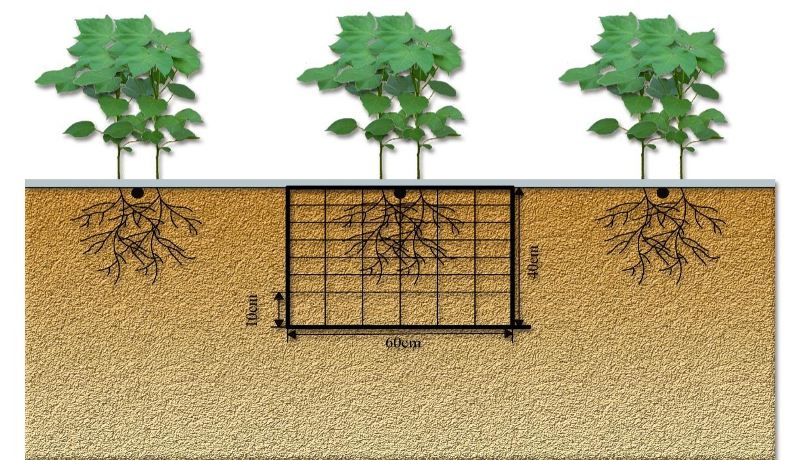

FIGURE S1 Schematic diagram of root collection

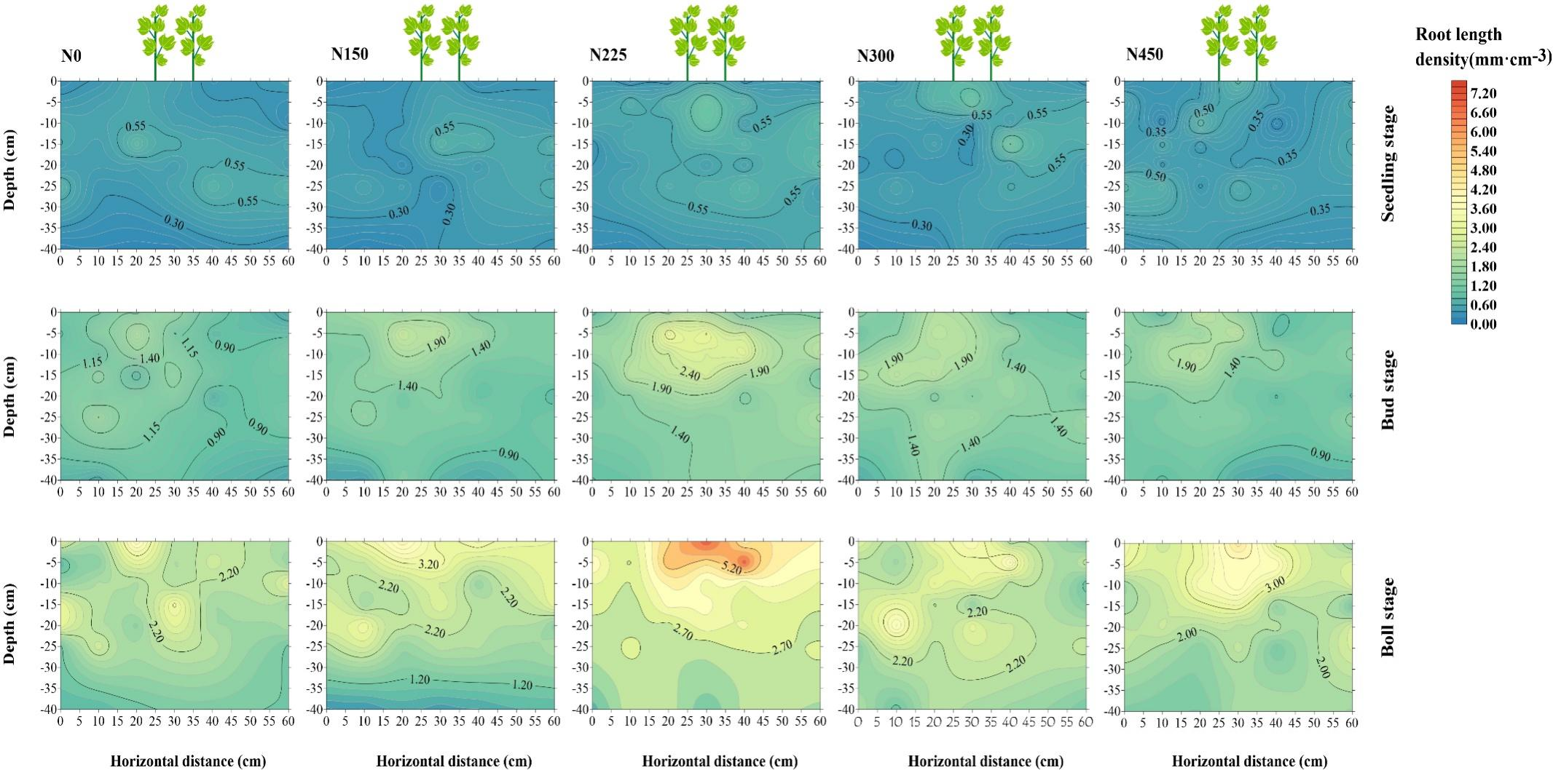
FIGURE S2 Effects of different nitrogen application rates on the spatial distribution of fine root length density at seedling, bud and the peak boll stages in 2021
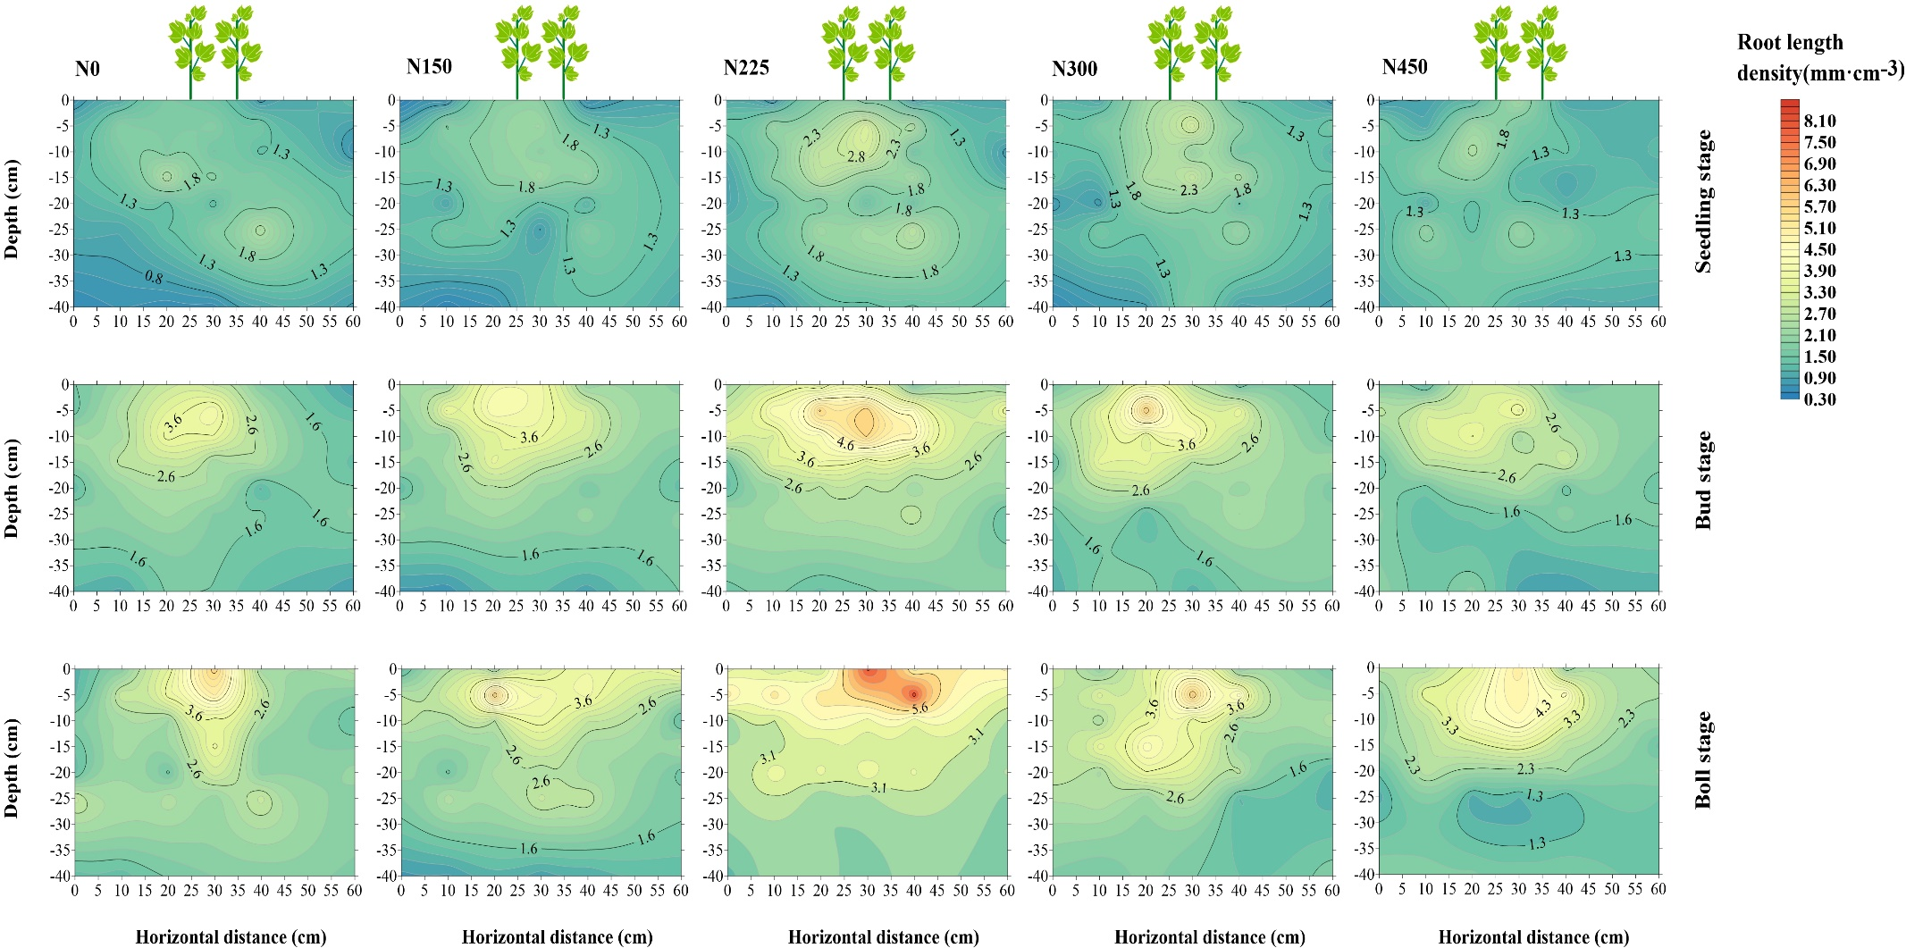
FIGURE S3 Effects of different nitrogen application rates on the spatial distribution of fine root length density at seedling, bud and the peak boll stages in 2022

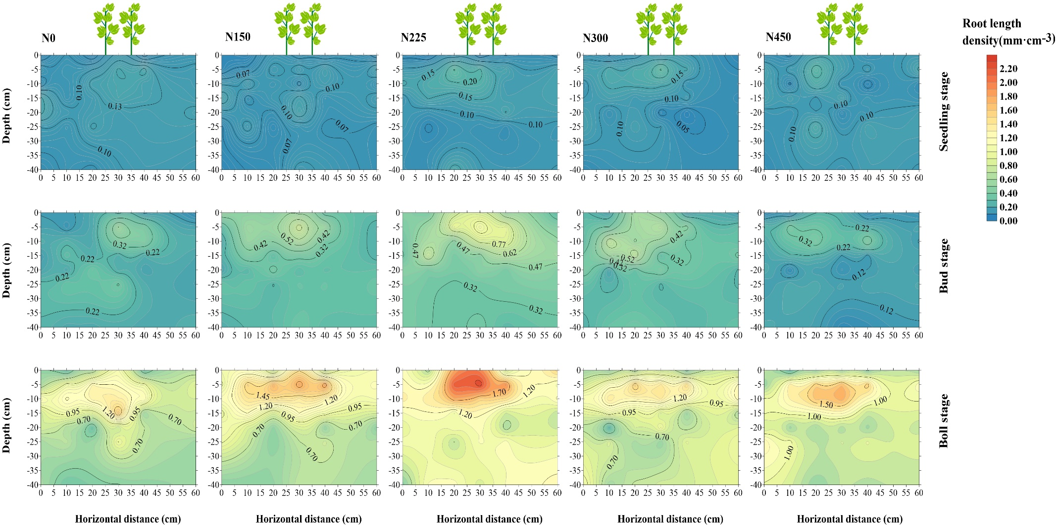
FIGURE S4 Effects of different nitrogen application rates on the spatial distribution of middle root length density at seedling, bud and the peak boll stages in 2021
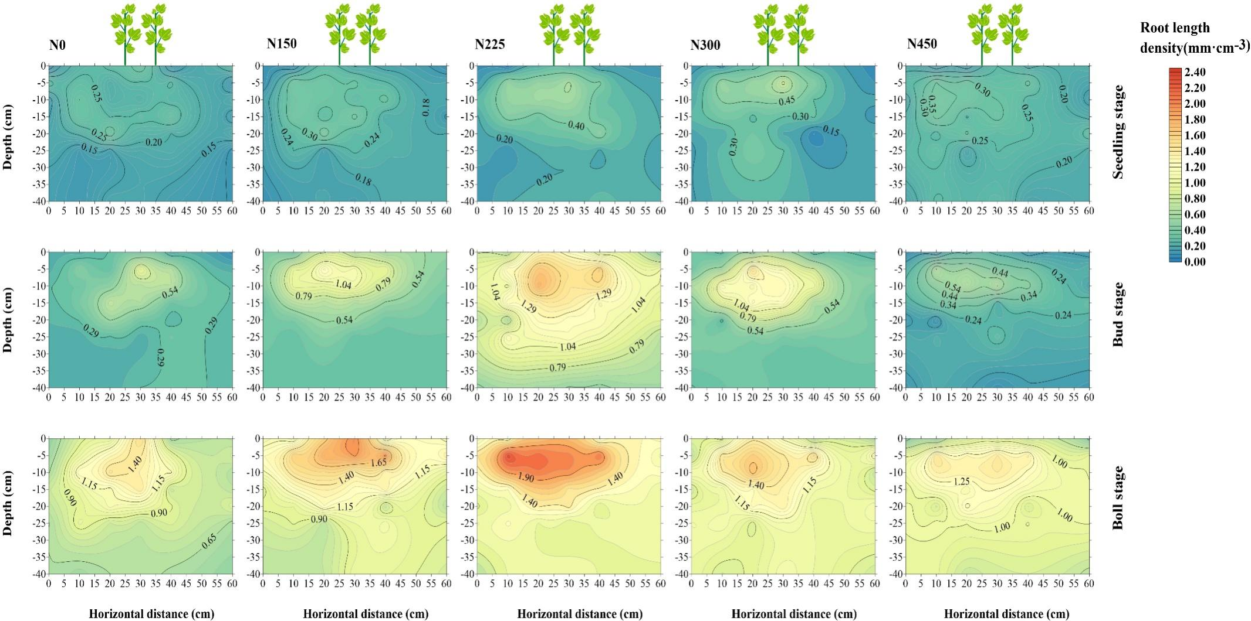
FIGURE S5 Effects of different nitrogen application rates on the spatial distribution of middle root length density at seedling, bud and the peak boll stages in 2022

