Supporting Information
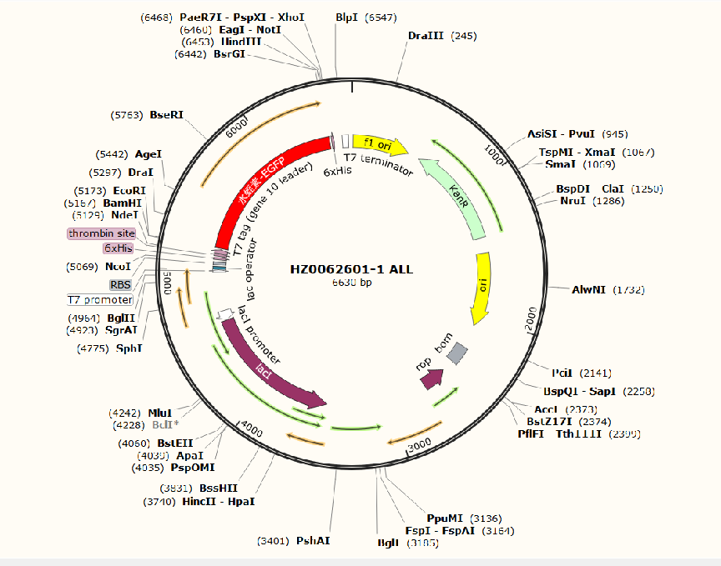
Figure S1.SO@AHG Plasmid Map

Table S1. Primers used to construct pET-28a+@adiA/HV/GFP.

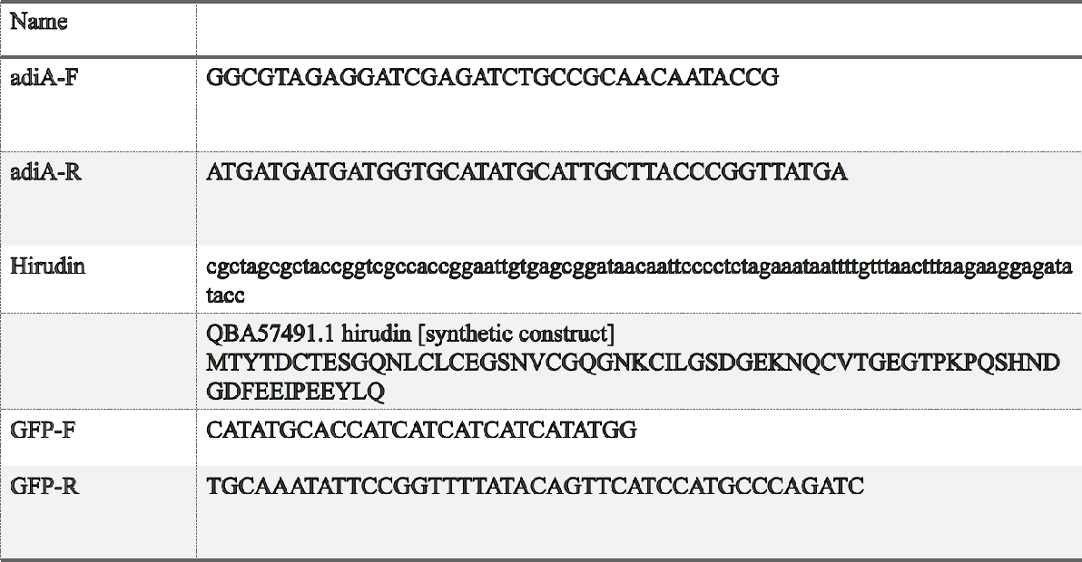

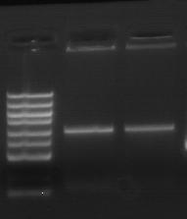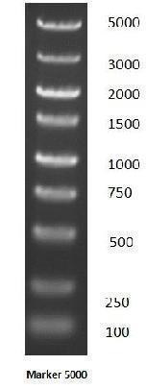
Figure S2.Gel purification of PCR products verification
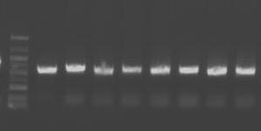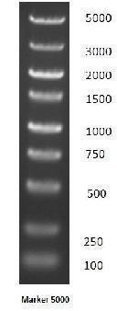
Figure S3.Colony Screening Experiment:
- Pick a single colony from the overnight agar plate.
- Perform colony PCR using T7/T7TER primers.
c. Verify positive clones by gel electrophoresis.
d. Randomly select 4 positive colonies and cultivate them in 4 mL individual tubes at 37℃ on a shaker overnight.

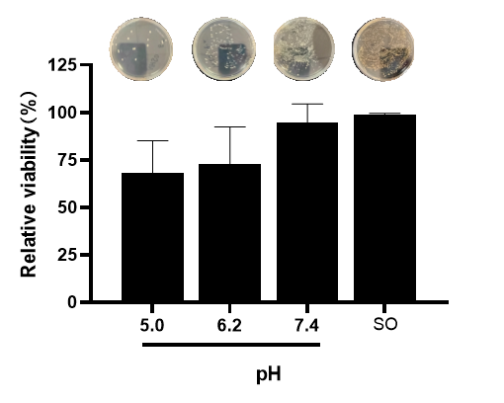
Figure S4.Relative viability of SO@AHG at various pH values.
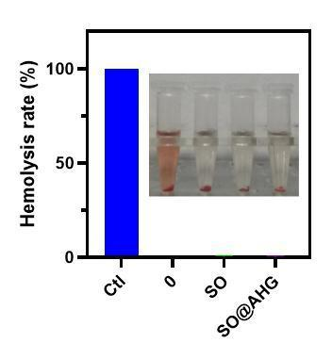
Figure S5. Hemolysis Assay
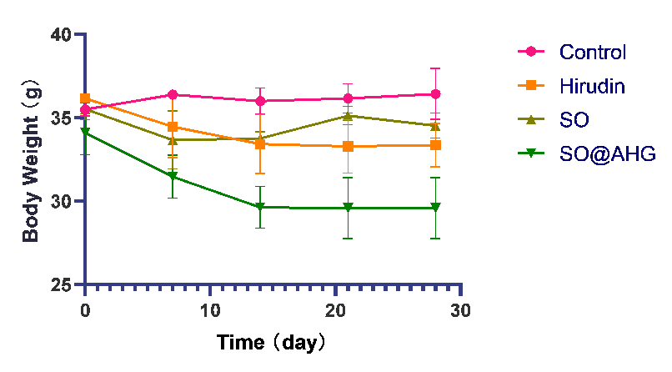
Figure S6. Body Weight Analysis

