Supplemental data

A novel machine learning-based approach for the computational functional assessment of pharmacogenomic variants

Maria-Theodora Pandi ^{1,2,#}, Maria Koromina^{3,4,#}, Iordanis Tsafaridis¹, Sotirios Patsilinakos⁵, Evangelos Christoforou¹, Peter J van der Spek², George P. Patrinos^{3,6,7,}*

¹ Katharsis Technologies Inc.; ² Erasmus University Medical Center, Faculty of Medicine and Health Sciences, Department of Pathology, Bioinformatics Unit, Rotterdam, the Netherlands; ³ Laboratory of Pharmacogenomics and Individualized Therapy, Department of Pharmacy, School of Health Sciences, University of Patras, Patras, Greece; ⁴ The Golden Helix Foundation, London, UK; ⁵ Konstantopouleion General Hospital, Athens, Greece; ⁶ Zayed Center of Health Sciences, United Arab Emirates University, Al-Ain, United Arab Emirates; ⁷ Department of Pathology, College of Medicine and Health Sciences, United Arab Emirates University, Al-Ain, United Arab Emirates; #: These authors contributed equally to this work

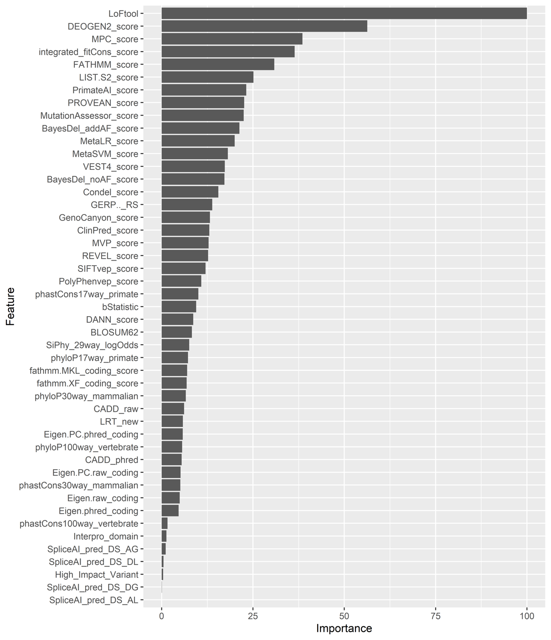
Figure S1. Annotation features examined as training variables in the machine learning model for the functional assessment of pharmacogenomics variants. These features are ranked according to their suggested interpretational significance from least (bottom) to most important (top).

Table S1. *excel supplemental file*
Prediction functionality classes and prediction probabilities for the targeted PGx data for the Greek cohort of 304 individuals. The dataset includes 195 known (i.e., existing variation) and 148 novel variants, of which 86 (44.1%) and 70 (47.3%) were ultimately evaluated by the classifier (156 in total). Additional variant information is provided such as genomic locus, Ensembl transcript, alternative allele, gene symbol and gene Ensembl identified as well as gnoMAD frequency are provided. Moreover, there is an extra column to indicate whether the SO consequence corresponds to a LoF variant.

Table S2. List of the represented pharmacogenes, which were included in the training dataset of the assessed machine learning models (AdaBoost, Multinomial logistic regression, Random Forest, XGBoost).

Pharmacogene | Description (HGNC) | Category
CYP2B6 | cytochrome P450 family 2 subfamily B member 6 | drug-metabolizing enzymes
CYP2C9 | cytochrome P450 family 2 subfamily C member 9 | drug-metabolizing enzymes
CYP2C19 | cytochrome P450 family 2 subfamily C member 19 | drug-metabolizing enzymes
CYP2D6 | cytochrome P450 family 2 subfamily D member 6 | drug-metabolizing enzymes
CYP2C8 | cytochrome P450 family 2 subfamily F member 8 | drug-metabolizing enzymes
DPYD | dihydropyrimidine dehydrogenase | drug-metabolizing enzymes
UGT1A1 | UDP glucuronosyltransferase family 1 member A1 | drug-metabolizing enzymes
NUDT15 | nudix hydrolase 15 | drug transporters and  non–drug metabolizing enzymes
RYR1 | ryanodine receptor 1 | drug transporters and  non–drug metabolizing enzymes
SLCO1B1 | solute carrier organic anion transporter  family member 1B1 | drug transporters and  non–drug metabolizing enzymes
TPMT | thiopurine S-methyltransferase | drug-metabolizing enzymes

Table S3. Summary of the parameters and metric values for the tree-based models (AdaBoost, Random Forest, XGBoost), as tested in the present study. Parameters denoted with an asterisk (*) were tuned according to the achieved accuracy.

Approach | Parameters | Selected values
Random Forest | Number of trees (ntree)  *Number of variables randomly sampled as candidates at each split (mtry) | 1,000  2
AdaBoost | Maximum tree depth (maxdepth)  *Number of trees (mfinal)  *Coefficient type (coeflearn) | 5  1,000  Zhu
XGBoost | *Boosting Iterations (nrounds)  Maximum Tree Depth (max_depth)  *Shrinkage (eta)  Minimum Loss Reduction (gamma)  Subsample Ratio of Columns (colsample_bytree)  Minimum sum of Instance Weight (min_child_weight)  Subsample percentage (subsample) | 150  5  0.1  0  0.8  1  1

