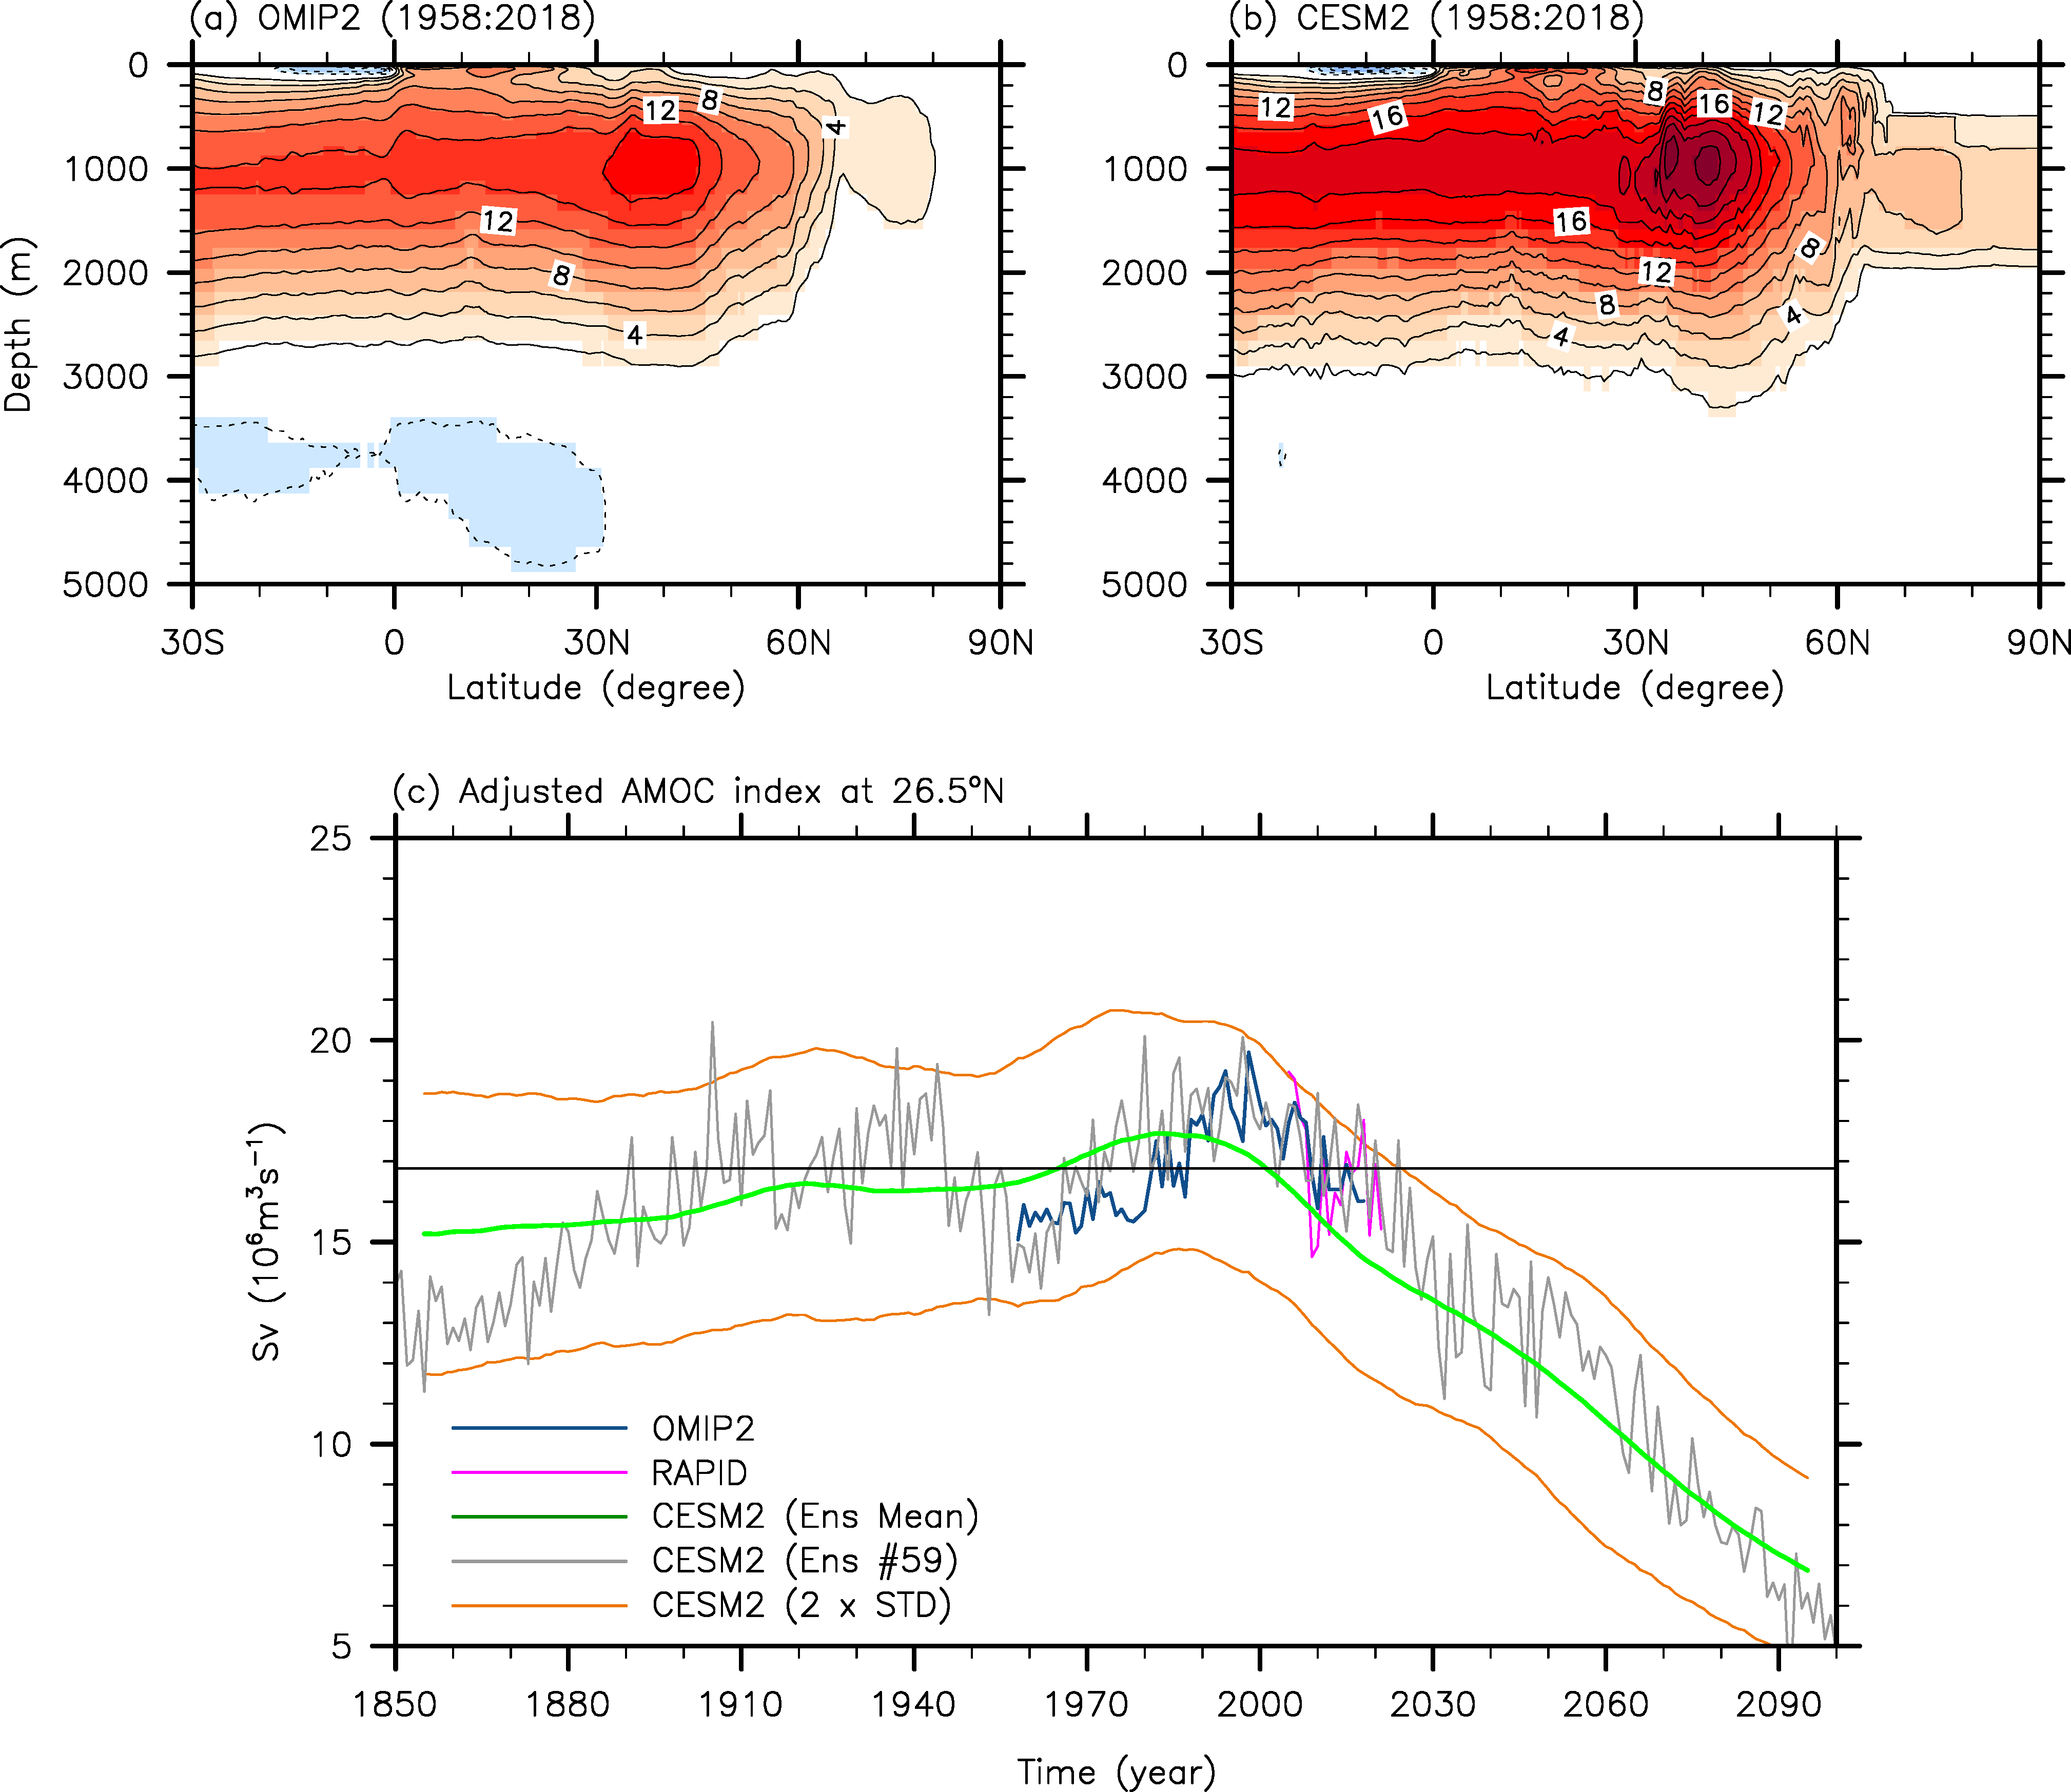
Supplementary Figures 1. Time-averaged AMOC and yearly time series of the AMOC at 26.5°N derived from OMIP2, RAPID and CESM2. (a-b) Time-averaged AMOC transport streamfunction during 1958 – 2018 derived from (a) OMIP2 and (b) the ensemble-mean CESM2. (c) The adjusted AMOC time series for OMIP2 (blue), RAPID (magenta), and the ensemble-mean CESM2 (green). The gray line in (c) indicates the adjusted AMOC at 26.5°N derived from the CESM2 ensemble #59, an example of the 80 realizations that contain both externally forced signal and natural variability (Methods). The orange lines indicate the 95% limits of the adjusted CESM2 ensemble spread (Methods), meaning that about 95% of the adjusted 80 ensembles reside within the two orange lines. The units are Sv (10⁶ m³sec⁻¹).

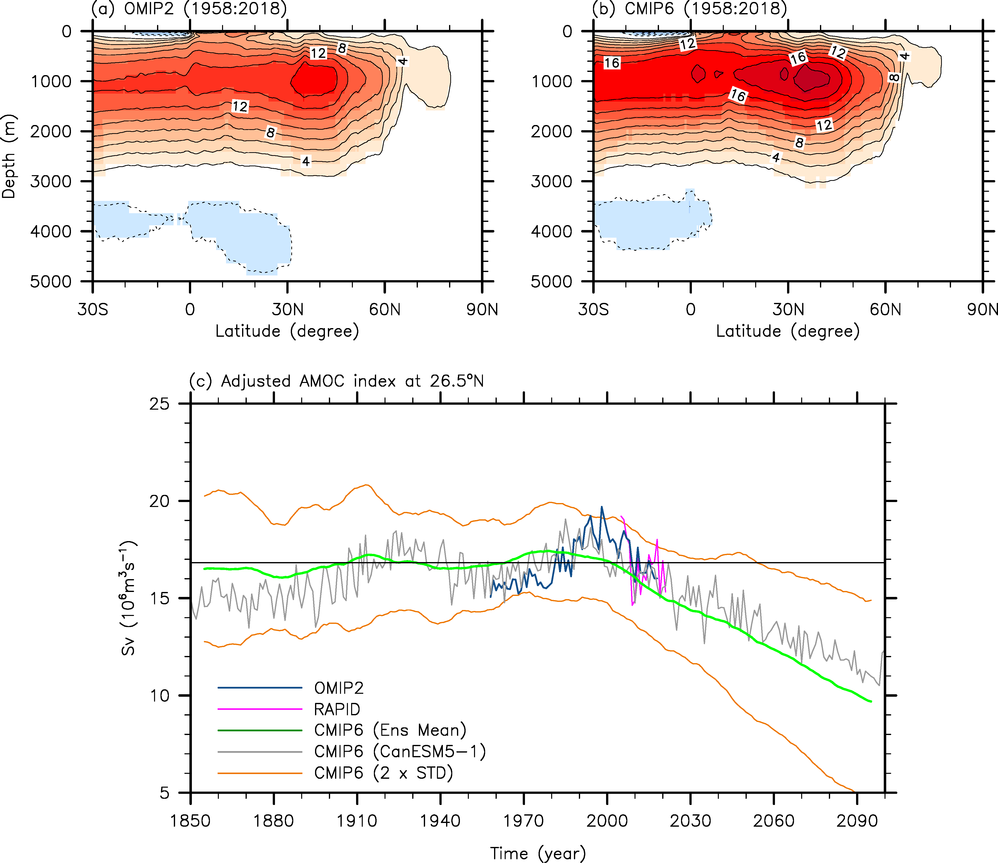
Supplementary Figures 2. Time-averaged AMOC and yearly time series of the AMOC at 26.5°N derived from OMIP2, RAPID and CMIP6. (a-b) Same as Supplementary Figure 1a-b but the externally forced AMOC component is derived from CMIP6. The gray line in (c) indicates the adjusted AMOC at 26.5°N derived from CanESM5-1, an example of the 20 CMIP6 model simulations that contain both externally forced signal and natural variability. The orange lines indicate the 95% limits of the CMIP6 multi-model spread, meaning that about 95% of the CMIP6 models reside within the two orange lines. The units are Sv (10⁶ m³sec⁻¹).

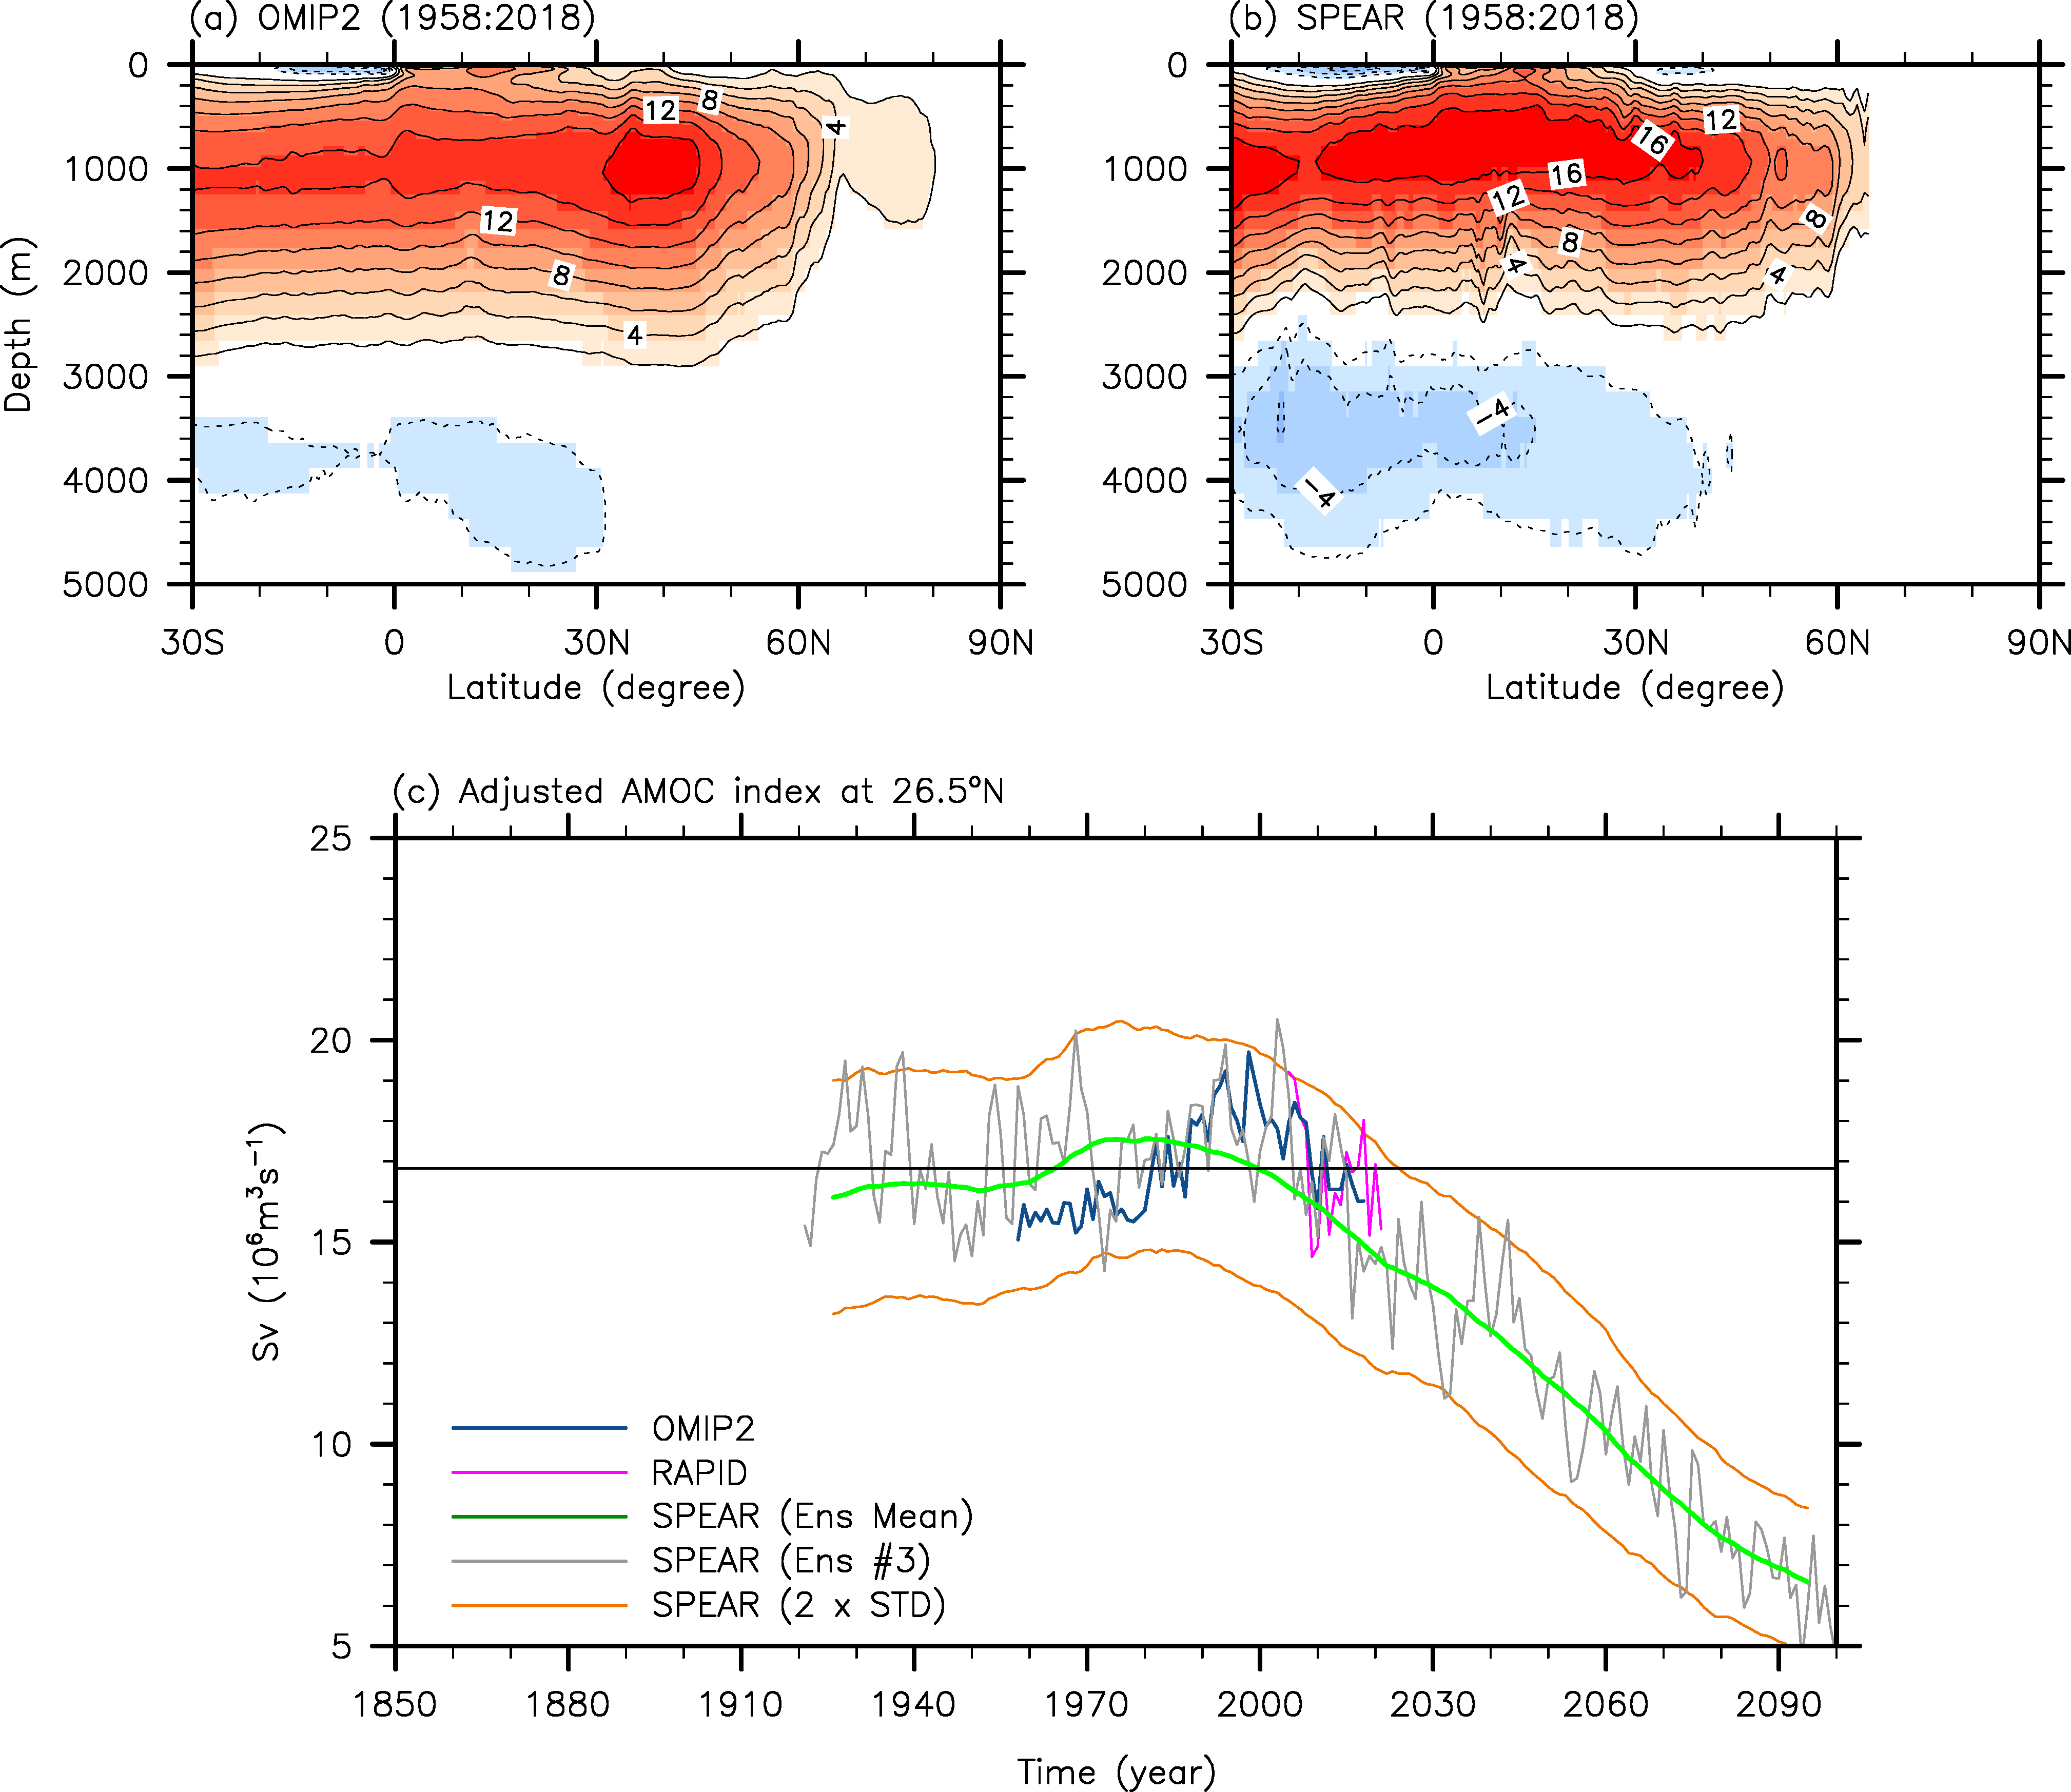
Supplementary Figures 3. Time-averaged AMOC and yearly time series of the AMOC at 26.5°N derived from OMIP2, RAPID and SPEAR. (a-b) Same as Supplementary Figure 1a-b but the externally forced AMOC component is derived from SPEAR. The gray line in (c) indicates the adjusted AMOC at 26.5°N derived from the SPEAR ensemble #3, an example of the 30 realizations that contain both externally forced signal and natural variability. The orange lines indicate the 95% limits of the adjusted SPEAR ensemble spread (Methods), meaning that about 95% of the adjusted 30 ensembles reside within the two orange lines. The units are Sv (10⁶ m³sec⁻¹).

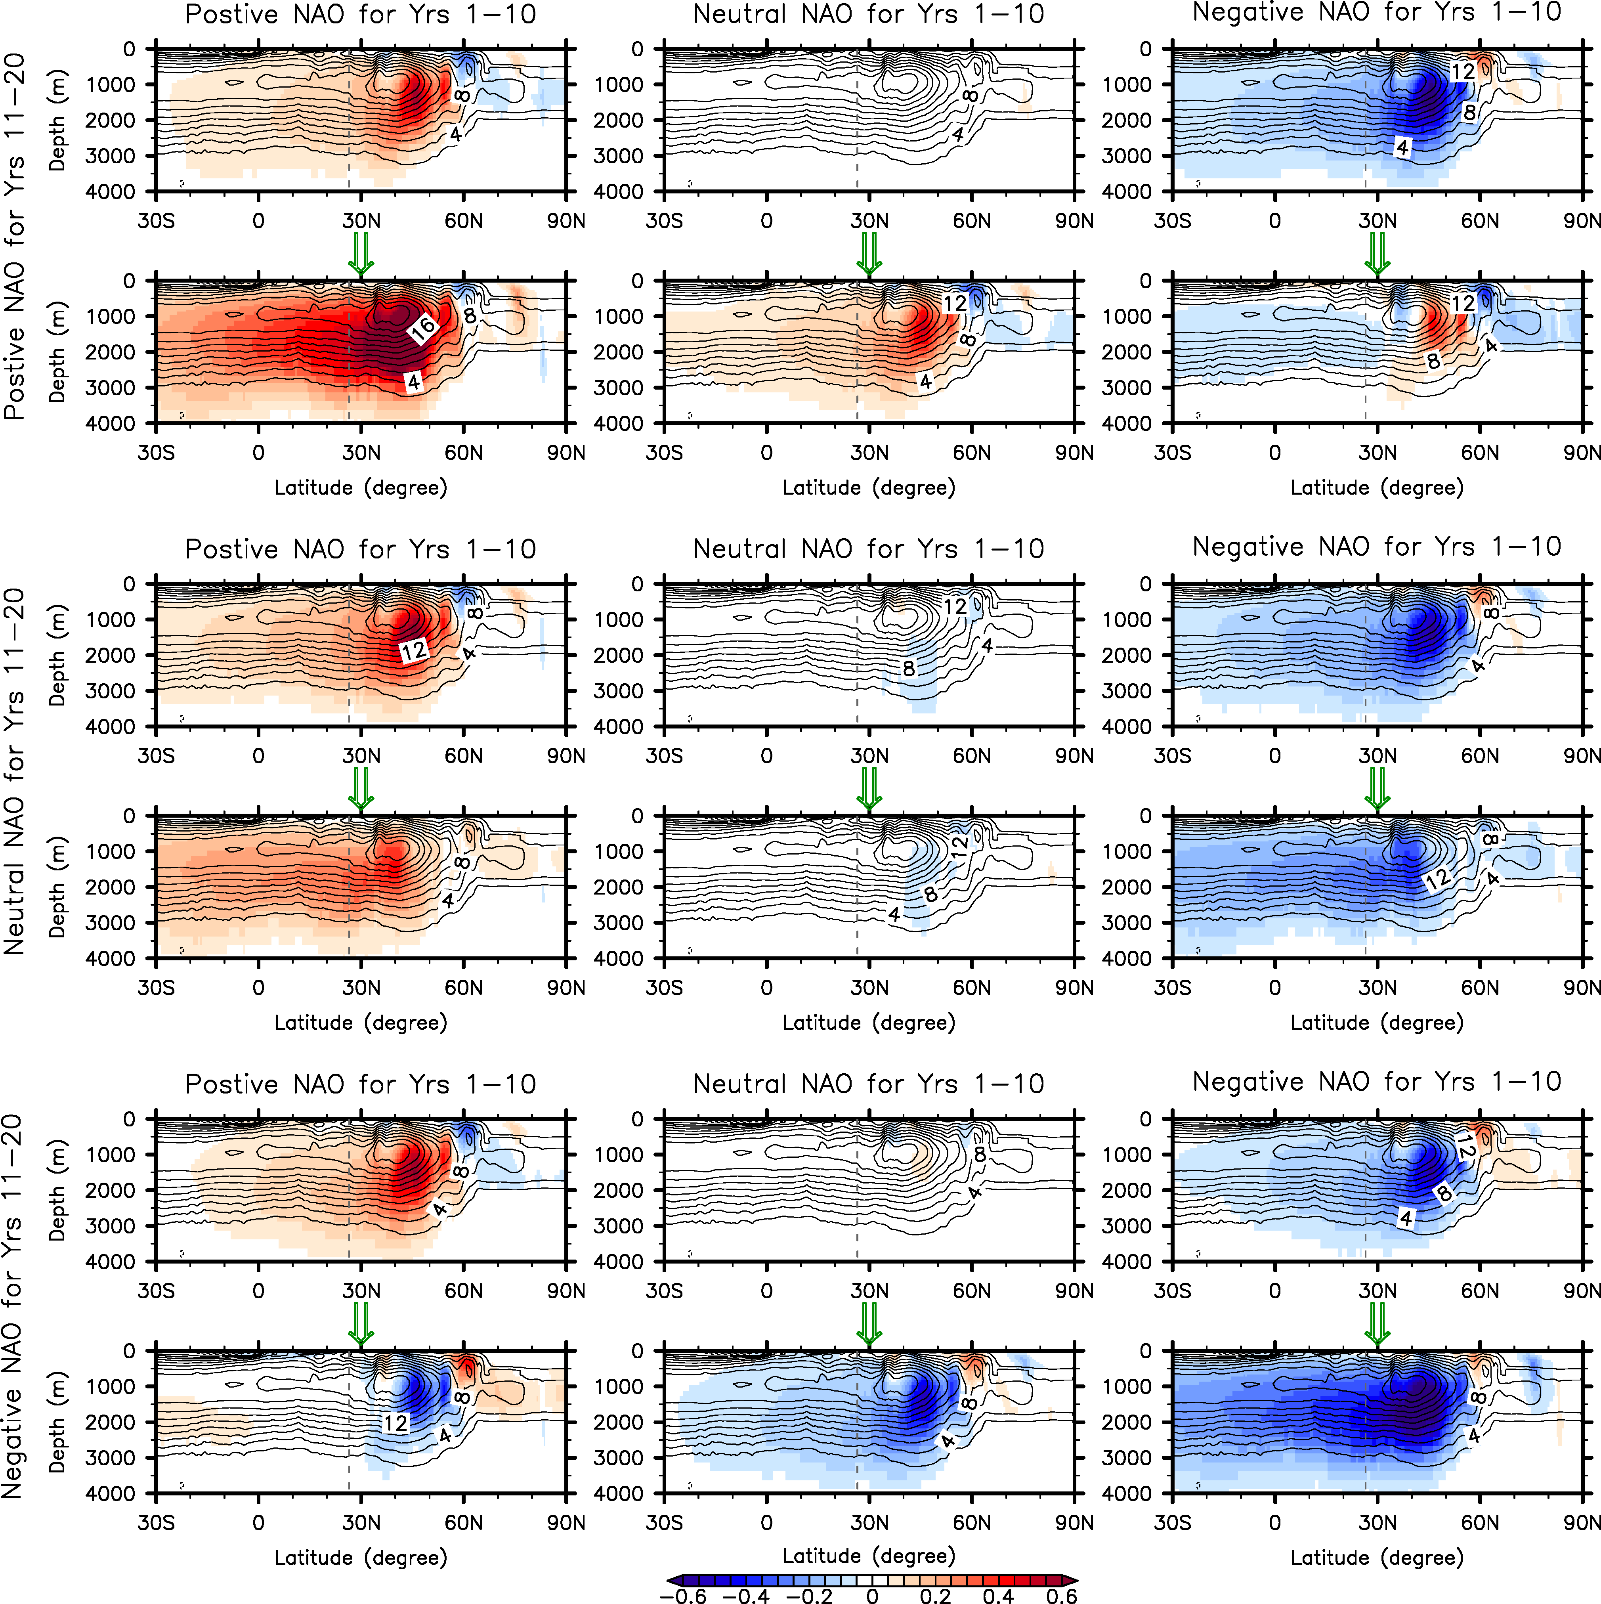
Supplementary Figure 4. Residual AMOC response to interdecadal NAO variability. The composite maps of residual AMOC response to nine different possible cases of interdecadal NAO variability derived from CESM2. The units are Sv (10⁶ m³sec⁻¹).

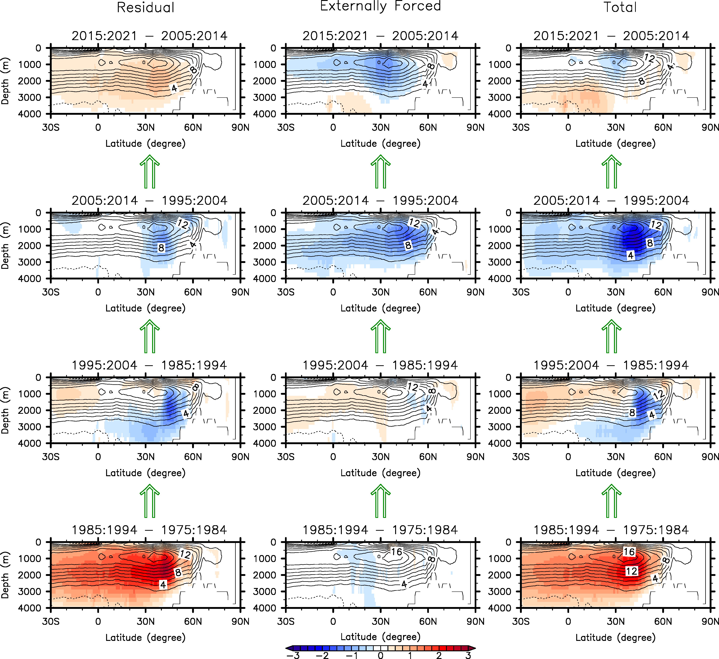
Supplementary Figure 5. Same as Figure 6, but the externally forced AMOC component is derived from CMIP6. The units are Sv (10⁶ m³sec⁻¹).

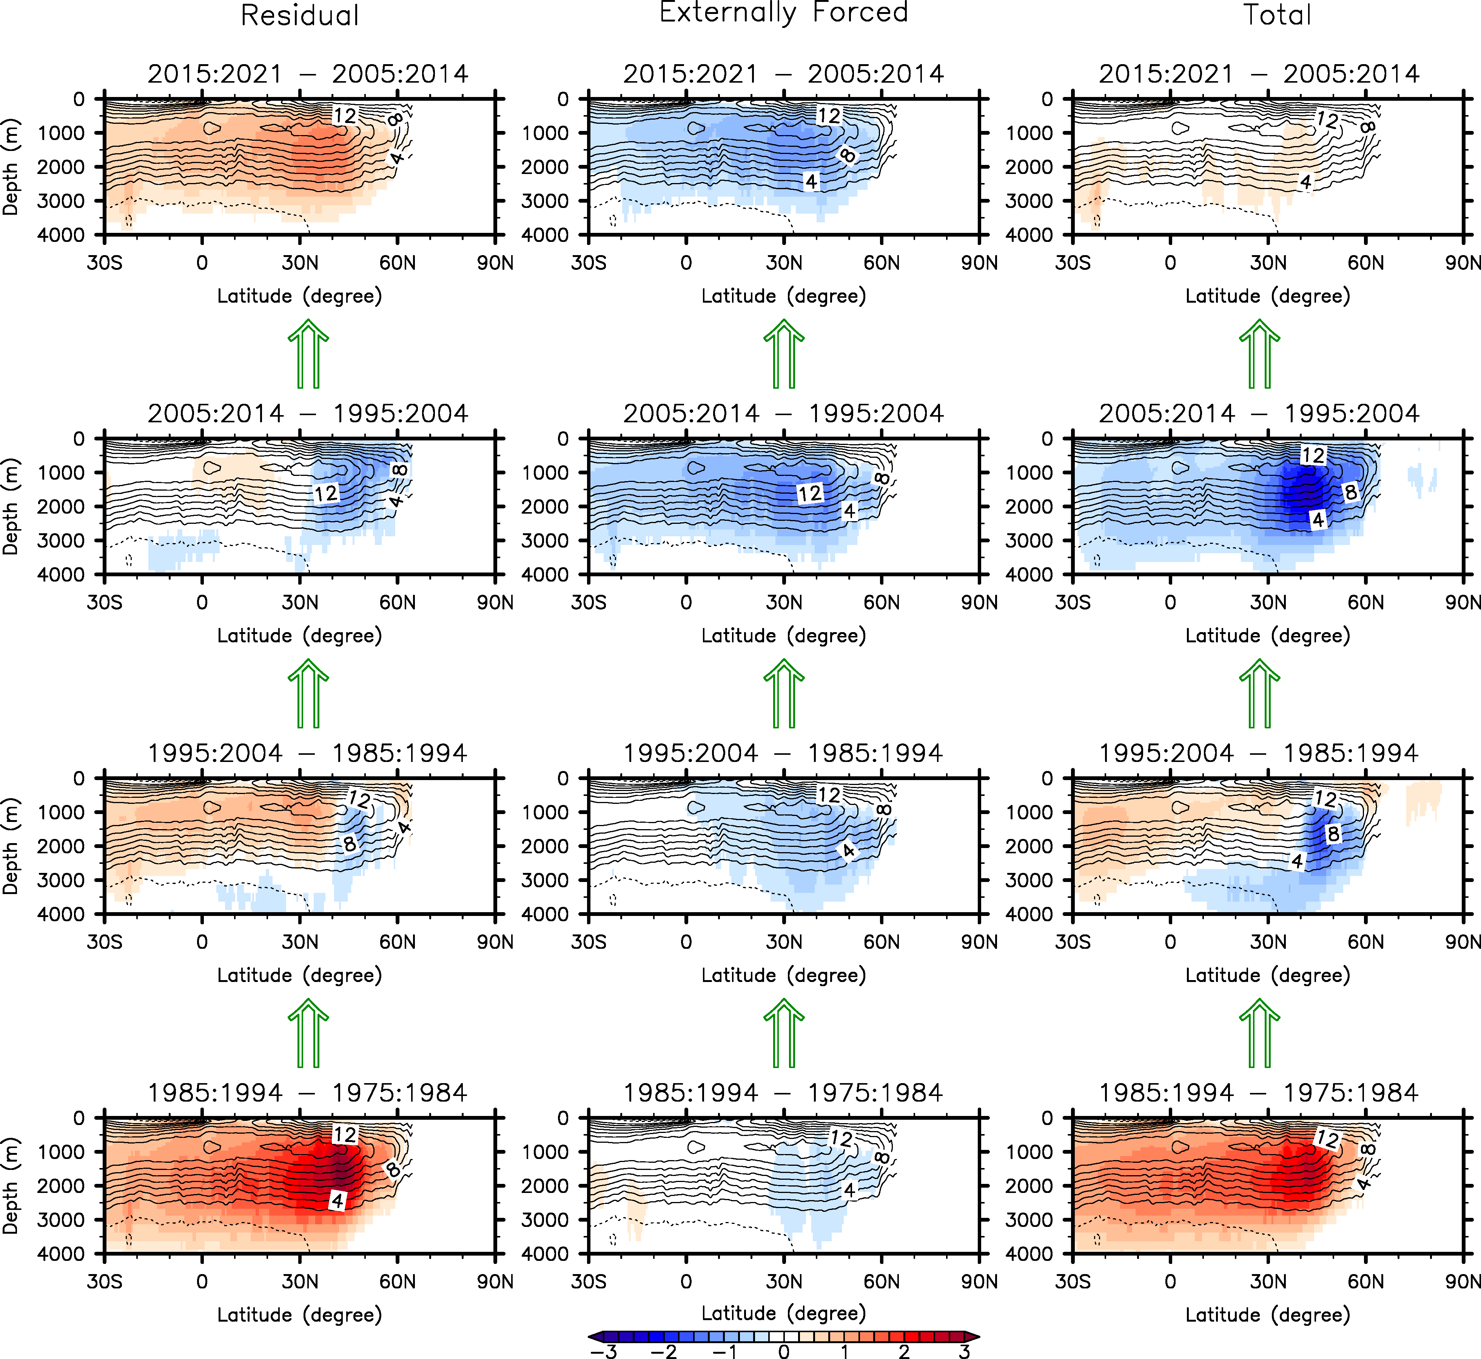
Supplementary Figure 6. Same as Figure 6, but the externally forced AMOC component is derived from SPEAR. The units are Sv (10⁶ m³sec⁻¹).

Supplementary Table 1. List of OMIP2 models. List of 10 OMIP2 models analyzed in this study and their AMOC values at 26.5°N averaged during 1958-2018. The units are Sv (10⁶ m³sec⁻¹) for the AMOC
AMOC  Model | AMOC at 26.5°N  (1958-2018)
ACCESS-OM2 | 14.0
ACCESS-OM2-025 | 14.0
CESM2 | 14.9
EC-Earth3 | 15.1
FGOALS-f3-H | 21.2
FGOALS-f3-L | 15.7
GFDL-CM4 | 14.1
MIROC6 | 16.0
MRI-ESM2-0 | 13.2
NorESM2-LM | 19.5

Supplementary Table 2. Summary of CMIP6 models. Summary of 29 CMIP6 models used in this study. An open circle indicates that the corresponding CMIP6 model is used for the specific scenario, while the × symbol indicates that the model is not used. The units are Sv (10⁶ m³sec⁻¹) for the AMOC.
Description  Model | Preindustrial  (500 years) | Historical  (1850-2014) | SSP-370  (2015-2100) | AMOC (26.5°N) (1958-2018)
ACCESS-CM2 | ○ | ○ | ○ | 19.5
ACCESS-ESM1-5 | ○ | ○ | ○ | 19.4
CanESM5 | ○ | ○ | ○ | 13.6
CanESM5-1 | ○ | ○ | ○ | 13.0
CAS-ESM2-0 | × | ○ | ○ | 19.5
CESM2 | ○ | × | × | -
CESM2-FV2 | ○ | × | × | -
CESM2-WACCM | ○ | ○ | ○ | 19.7
CESM2-WACCM-FV2 | ○ | × | × | -
CMCC-CM2-SR5 | ○ | ○ | ○ | 17.3
CMCC-ESM2 | ○ | ○ | ○ | 17.5
E3SM-1-0 | ○ | × | × | -
EC-Earth3-AerChem | ○ | ○ | ○ | 19.7
EC-Earth3 | ○ | × | × | -
EC-Earth3-CC | ○ | × | × | -
FGOALS-f3-L | × | ○ | ○ | 20.7
FGOALS-g3 | × | ○ | ○ | 27.8
GFDL-ESM4 | × | ○ | ○ | 18.9
HadGEM3-GC31-LL | ○ | × | × | -
HadGEM3-GC31-MM | ○ | × | × | -
INM-CM4-8 | × | ○ | ○ | 21.0
INM-CM5-0 | ○ | ○ | ○ | 19.6
MIROC6 | ○ | ○ | ○ | 14.4
MPI-ESM-1-2-HAM | ○ | × | × | -
MPI-ESM1-2-HR | ○ | ○ | ○ | 17.2
MPI-ESM1-2-LR | ○ | ○ | ○ | 18.7
MRI-ESM2-0 | ○ | ○ | ○ | 19.2
NorESM2-LM | × | ○ | ○ | 22.5
NorESM2-MM | × | ○ | ○ | 22.5

