Evaluation of AAV capsids and delivery approaches for hereditary hemorrhagic telangiectasia gene therapy

Alka Yadav, PhD¹, Rich Liang, BS¹, Kelly Press, BS¹, Annika Schmidt, BM¹, Zahra Shabani, PhD¹, Kun Leng, MD, PhD^{1,2}, Calvin Wang, BS¹, Abinav Sekhar, BS¹, Joshua Shi, BS¹, Garth W Devlin, BS³, Trevor Gonzalez PhD³, Aravind Asokan, PhD^{3,4}, Hua Su, MD^{1,5}

¹Center for Cerebrovascular Research, Department of Anesthesia and Perioperative Care, University of California, San Francisco, California, USA.
²Medical Scientist Training Program, University of California, San Francisco, California, USA
³Department of Surgery, Duke University School of Medicine, Durham, North Carolina, USA
⁴Department of Biomedical Engineering, Duke University, Durham, North Carolina, USA

⁵Corresponding Author
Hua Su, MD
Department of Anesthesia and Perioperative Care
University of California, San Francisco
2540 23rd Street, Box 1363
San Francisco, CA 94143
Phone: 415-476-0141
Email: hua.su@ucsf.edu
ORCID: 0000-0003-1566-9877

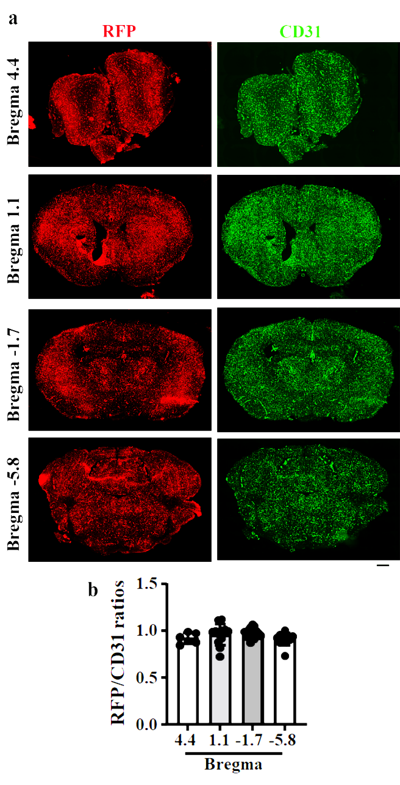
Supplemantery Figures

Supplementary Fig. 1. AAV.cc84 transduced cells were spread evenly throughout the brain after intravenous delivery. (a) Images show transduced cells expressing RFP protein (Red, stained by an anti-RFP antibody). Brain endothelial cells were stained by an anti-CD31 antibody (green). Scale bar: 1 mm. (b) Quantification of the ratio of RFP⁺ cells to endothelial cells (CD31⁺) in different brain regions. n=6-18.

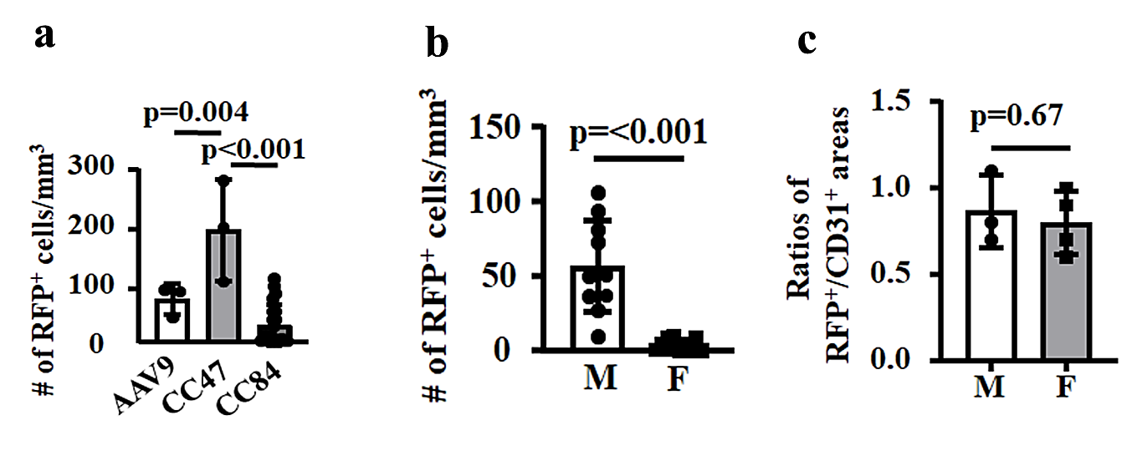

Supplementary Fig. 2. Hepatocyte transduction after intravenous injection. (a) Quantification of RFP⁺ hepatocytes. AAV.cc47 infected more hepatocytes than AAV9 and AAV.c84 after i.v. delivery. n=3-12. (b) AAV.cc84 transduce more hepatocytes in male mice (n=10) than in female mice (n=12). (c) Equal numbers of brain endothelial cells were transduced by AAV.cc84 after i.v. injection. n=6. M: male mice: F: female mice.
Supplementary Fig. 3. AAV.cc84 transduced neurons, astrocytes, vascular smooth muscle cells, and pericytes in the brain, and cardiomyocytes and smooth muscle cells on the wall of the intestine after intravenous delivery. AAV.cc84 positive cells were identified by RFP expression (red). Neurons were labeled by an anti-NeuN antibody (green). Astrocytes were labeled by an anti-GFAP antibody (green), Vascular smooth muscle cells in the brain were labeled by an anti-SMA antibody (green). Pericyte in the brain were labeled by an anti-NG2 antibody (green). Endothelial cells in the heart and intestine were labeled by an anti-CD31 antibody (green). * indicates the outside of intestine wall. Arrow indicates RFP⁺ smooth muscle in the intestine well. Scale bars=30 μm.

Supplementary Fig. 4. AAV.cc84 transduced neurons, astrocytes, vascular smooth muscle cells and pericytes in the brain; and bronchial epithelial cells in the lung after intra-nasal delivery. (a) AAV.cc84 transduced cells were identified by RFP expression (red). Neurons were labeled by an anti-NeuN antibody (green). Astrocytes were labeled by an anti-GFAP antibody (green), Vascular smooth muscle cells were labeled by an anti-SMA antibody (green). Pericytes in the brain were labeled by an anti-NG2 antibody (green). Endothelial cells in the lung and liver were labeled by an anti-CD31 antibody (green). The nuclei in the heart were stained by DAPI (blue). Scale bars=30 μm. (b) Quantification of percentage of RFP and NG2 double positive cells among total RFP positive cells. n=6; IV: Intra-venous injection of AAV.cc84-RFP, IN: Intra-nasal delivery of AAV.cc84-RFP.

Supplementary Fig. 5. AAV.cc84 transduced cells were spread evenly throughout the brain after intra-nasal delivery. (a) Images show transduced cells expressing RFP protein (Red, stained by an anti-RFP antibody). Brain endothelial cells were stained by an anti-CD31 antibody (green). Scale bar: 1 mm. (b) Quantification of the ratios of RFP⁺ cells to endothelial cells (CD31⁺) in different brain regions. n=6-18.

Supplementary Fig. 6. Liver and kidney function in AAV.cc84-RFP transduced mice. Quantifications of a. alkaline phosphatase activity (ALP), b. alanine transaminase activity (ALT), and c. creatinine levels (Cr). C: untreated mice; IV: mice received intravenous injection of AAV.cc84-RFP. IN: mice received intra-nasal delivery of AAV.cc84-RFP. n=6.

